PREDICTION OF HEART DISEASE USING NEURAL NETWORK
Suchitra Devi A¹, Rajat Ranjan², Harsh Vardhan³, Nikhil Kr. Singh⁴, Kislay Kumar⁵
¹ASST PROFESSOR, DEPT. OF CSE, SAMBHRAM INSTITUTE OF TECHNOLOGY, BENGALURU-560097
^{2,3,4,5}EIGHT SEMESTER, DEPT. OF CSE, SAMBHRAM INSTITUTE OF TECHNOLOGY, BENGALURU-560097, INDIA

---------------------------------------------------------------------***---------------------------------------------------------------------

Abstract — According to a recent WHO study, cardiovascular diseases are on the rise. As a result of which we can see that people dies in a year is approx. 17.9 million. With the growing population, it becomes more and more difficult to diagnose and begin treatment early. But thanks to recent advances in technology, machine learning techniques have accelerated the health sector through more research. Thus, the purpose of this project is to construct an ML model for predicting heart disease based on related parameters. We used the UCI heart prediction benchmark database for this research project, which covers 14 different heart-related parameters. In our study we also tried to find correlations between the various features found in the database with the help of standard Mechanical Learning. Methods and use them effectively in predicting the risk of heart disease. This model can be useful to medical staff at their clinic as a decision support system.
keyword—Machine Learning, WHO, CVD

1.INTRODUCTION
By the help of this ML we can easily predict the Heart Disease by the help of information provided by user. It finds user’s disease by the information that they enters on the web system or provides result depends on that information. If the patient is not very serious then the user just have to understand the type of disease, he had gone through it. It is a program that provides ideas and tips for caring for the health of the patient and provide a way to diagnose diseases using this prediction method. Therefore, by incorporating the symptoms and all of the other information the user will gain an understanding of the disease they are affected so the healthcare industry can also get to enjoy this process by simply asking the user for symptoms and logging into the system. and in just a few seconds they will be able to accurately and to some extent accurately diagnose diseases [1]. This type of the Machine learning program is been used by most of the other organizations, but our motive is to make it more unique and more useful for the users who will use this program. The Measurement of Heart Disease using Mechanical learning is done entirely with the help of the learning Machine algorithm and the python programming language which has its own Flask Interface and using previously available databases that hospitals use to predict the disease. Modern physicians use a wide range of technologies and techniques to not only diagnose the common ailments, also a number of life seeking diseases.
The exact analysis is often the result of effective way of treatment. If doctor fails to make informed decisions when diagnosing a patient, diagnostic programs using ML algorithms may be helpful. This project of disease prediction by using ML has been designed to overcome common diseases in the early stage of life, we all know that in the competitive environment of the economic development, humanity had become involved in very much of what it does not care about. According to a study, 40% of people ignore common diseases, leading to serious illnesses in future. The very most common reason for avoiding is the less motivation to contact the doctor. In mean time, the people became so absorbed in their work that did not have the time to call for a meet or to see a doctor, which could result in life-threatening illness. According to a study, 70% of Indians suffers from chronic diseases, and 25% people dies from premature ejaculation. The main purpose of designing this project is that the user is able to spend time with him and check his health. The user interface is designed in a way that any user can easily use it and test it.
2. LITERATURE SURVEY
Tom Mitchell said that mechanical learning such as "Computer virus is said to learn from previous experience and from a few other functions and functions, as measured, improves knowledge". ML is a combination of relationship, many live ML algorithms related to finding and or exploiting interactions in the data sets. Once ML algorithms are able to identify in a particular relationship, the model may use this relationship to predict the further observations or to make the information similar to produce the interesting patterns [2]. ML has many types of algorithms such as retreat, line deceleration, Logistic drop, Naive Bayes Classifier, Bayes theorem, KNN (IK-Nearest Neighbor Classifier), Decision Tress, Entropy, i - ID3, SVM (Vector Support Machines), K - means algorithm, random forest and more.
ML is made our minds 1959 by Arthur Samuel. ML explores the research and development of algorithm that we will learn from user’s information and generate predictions on info. ML is most closely related to process statistics, which in also focuses on the creation of computerized guesses [3]. Cubic centimeter has a strong relationship with mathematical efficiency, which brings out the strategies, theory and backgrounds used in the field. ML is often combined with data processing, whenever the underground storage area is heavily focused on test data analysis (EDA) also known as unregulated reading.
In the fields of structured data, Machine Learning is also a sub-method which are used for complex model and algorithm dedicated to predicting what is known as the forecasting statistics. These analytical model is been used to allow researchers, data engineers, data scientists and data analysts to “produce good repetitive options and results” and finds “hidden patterns” by study the from past links and data study [4].
3. PROBLEM STATEMENT
Heart disease can be managed effectively with a combination of lifestyle changes, medicine and, in some cases, surgery. With the right treatment, the symptoms of heart disease can be reduced and the functioning of the heart improved. The predicted results can be used to prevent and thus reduce cost for surgical treatment and other expensive. There are instruments available which can predict heart disease but either they are expensive or are not efficient to calculate chance of heart disease in human. Early detection of cardiac diseases can decrease the mortality rate and overall complications. However, it is not possible to monitor patients every day in all cases accurately and consultation of a patient for 24 hours by a doctor is not available since it requires more sapience, time and expertise. Since we have a good amount of data in today’s world, we can use various machine learning or deep learning algorithms to analyze the data for hidden patterns. The hidden patterns can be used for health diagnosis in medicinal data.
The problem is that developing accurate prediction models for heart disease using machine learning techniques can be challenging, particularly when dealing with complex and large datasets. Additionally, there is a need to ensure that such models can be integrated into clinical practice to assist in early detection and diagnosis of heart disease. Specifically, the problem involves designing and training neural network models that can accurately classify patients as either having heart disease or not based on their clinical and demographic information. The models must be capable of handling missing data and accounting for potential confounding variables, such as age, gender, and lifestyle factors.
4. SYSTEM DESIGN

Problem or Disease prognosis used by ML finds the presence of user-directed disease by variety of symptoms and the additional information that user provides such as plasma levels, Glucose levels and many other common indicators. System diagnostic planning using machine learning involves multiple data sets so we will compare user characteristics and predict it, and then the data sets reconfigured into smaller sets and subsequently segmented based on subsequent classification algorithms. For predicting all sick input from the user mentioned above [5]. Then when the future user information and processed information are fully compiled it is compiled within the system guessing model and finally predicts illness. The design diagram may be a clear illustration of the research ideas group, which is the parts of the an design and also the terms, components and elements. This diagram explains about the computer code in seeing the system summary
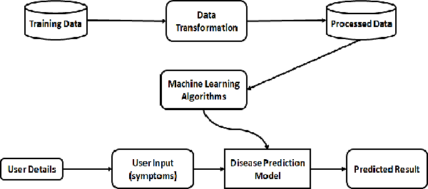
Fig. 1. System design
5. IMPLEMENTATION

5.1 DATASET
- Age
- Sex
- Chest pain type (4 values)
  - Value 0: typical angina
  - Value 1: atypical angina
  - Value 2: non-anginal pain
  - Value 3: asymptomatic
- Trestbps: resting blood pressure (in mm hg on admission to the hospital)
- Chol: serum cholestoral in mg/dl
- Fbs: (fasting blood sugar > 120 mg/dl) (1 = true; 0 = false)
- Restecg: resting electrocardiographic results
  - Value 0: normal
  - Value 1: having st-t wave abnormality (t wave inversions and/or st elevation or depression of > 0.05 mv)
  - Value 2: showing probable or definite left ventricular hypertrophy by estes' criteria
- Thalach: maximum heart rate achieved
- Exang: exercise induced angina (1 = yes; 0 = no)
- Oldpeak = st depression induced by exercise relative to rest
- Slope: the slope of the peak exercise st segment
  - Value 1: upsloping
  - Value 2: flat
  - Value 3: downsloping
- Ca: number of major vessels (0-3) colored by flourosopy
- Thal: 3 = normal; 6 = fixed defect; 7 = reversable defect
- Target: 0=less chance of heart attack, 1=more chance of heart attack
5.2 Data Preprocessing
One of the most crucial milestones in the process of
putting deep learning models into practice is this one. To
make the dataset more appealing and practical for the model
training phase, we deliberately applied all data cleaning
strategies to our dataset[9]. We removed all the unnecessary
and irrelevant data from our dataset throughout the data
cleaning process.
- Data cleaning had the following goals in mind-
- Removal of missing data
- Removal of duplicate entries
- Remove rows with NaN values

5.3 Exploratory Data Analysis
Exploratory data analysis is a strategy for examining datasets to highlight their key properties, frequently utilising
statistical tools and other techniques for data visualisation. it
aids we better comprehend our dataset[11]. Executing EDA on our dataset assisted us in:
- Recognize and handle NULL values.
- Recognize and eliminate outliers.
- Identify the underlying relationships and structure.
Additionally, we created a word cloud and several graphs.
to learn more about the data.

6. TRAINING
After preprocessing and EDA, we had the final dataset that had been thoroughly cleaned and analysed. The 80-20 train-test validation method was used, which specifies that 80% of the information is used for planning and 20% is used for testing. The sklearn library is used to divide the data into training and testing portions. Out of 303 samples, 242 examples or instances are chosen and used to create the model [5]. The remaining 61 samples are used as testing data to judge how well the constructed model performs.

To implement the model, we proceeded forward. We carried out two distinct sorts of experiments during the implementation. Both the considered deep neural network and the artificial neural network were implemented individually. As a result, we were able to determine how accurately each of these models performed.

A Deep neural network has multiple hidden layers. Whereas the Artificial Neural network has one or two hidden layers in it.

The activation of neurons is present at the output layer
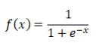
In the output layer, the sigmoid activation function is applied. The dataset's redundant features are removed using feature selection. Feature extraction and feature selection are different. Finding relevant components from the existing data is called feature extraction. By removing unnecessary features through feature selection, the neural network is fed with pertinent information.
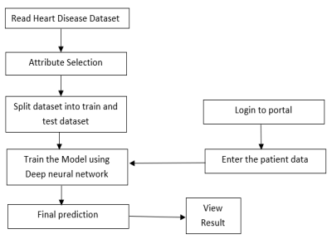
Fig System Architecture

6.2 TESTING

I. How Many People Have Heart Disease, And How Many Don't Have Heart Disease In This Dataset?

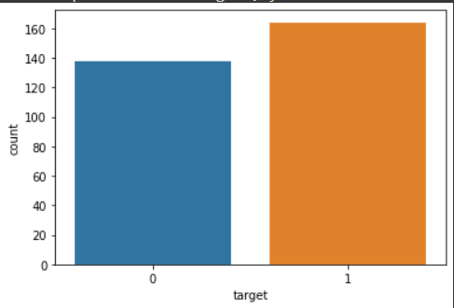
II. Which Sex Has The Most Heart Disease [ Male or Female]
. 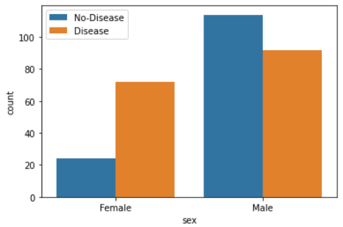 Fig 4
III. Heart Disease Compared to Age and Maximum Heart Rate
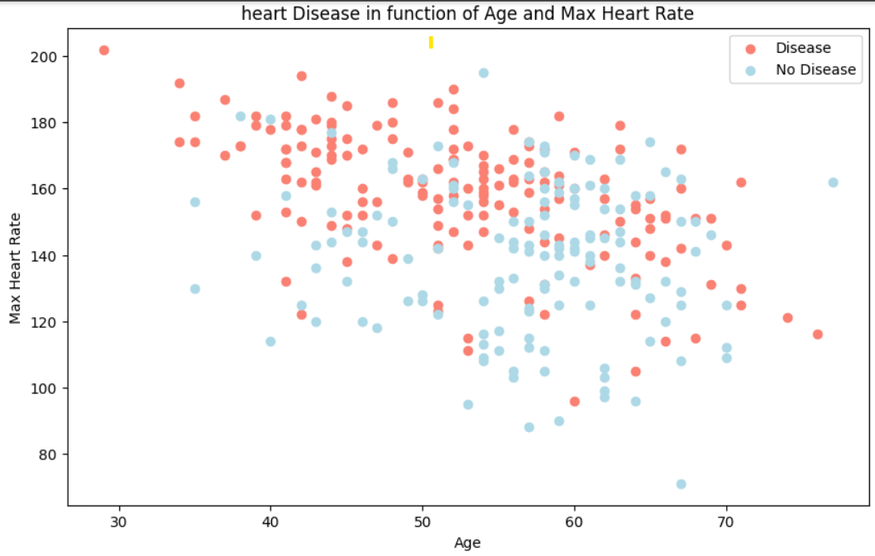
IV. Check Age Distribution In The Dataset
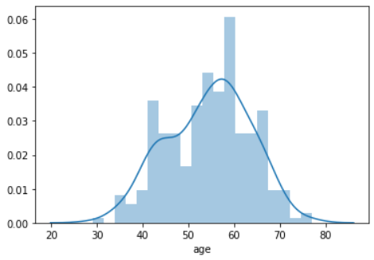
V.Check Chest Pain Type
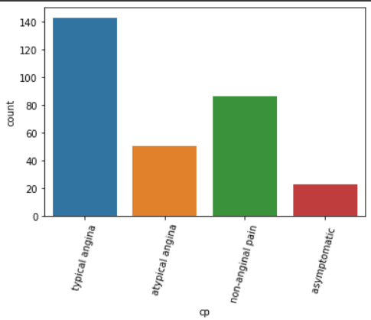
7. RESULTS
The outcomes that we found after testing and putting the suggested algorithms into practice will be covered in this part.
The Deep neural network with the more hidden layer performs better than that of Artificial neural network. Accuracy of artificial neural network is 70% and accuracy of deep neural network is 95%. So the KNN is more accurate than that of ANN

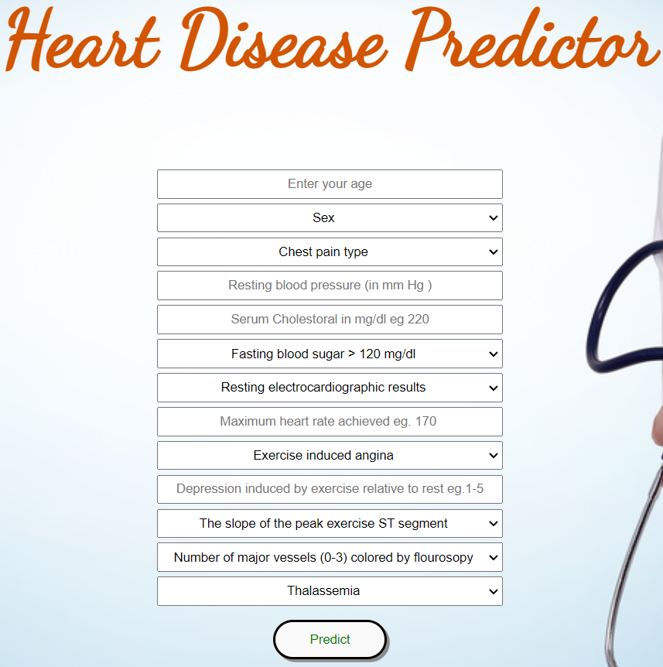

8. CONCLUSION AND FUTURE SCOPE
Therefore, I concludes here by saying that this project Disease Predictive Therapy is very useful for everyone in their daily life and is very important in the healthcare sector, because of their ones who use these daily programs to predict patients based on their general knowledge and symptoms. Nowadays the healthcare sector also plays an important role in the treatment of patient’s diseases so this is often useful in the health sector to inform the users and is helpful to the user as long as he does not want to leave. The hospitals and other clinics, here by inserting symptom and all other useful information in the user form he or she can diagnose his or her disease so the healthcare industry can also get to enjoy this procedure by just asking. Signals from the users end login in the system in just a few second it will tell you the correct and almost accurate diagnoses. When the healthcare industry adopts this project it means that doctors' work may reduce and then it can easily predict a patient's illness. Disease Predict is to provide predictions of various and common diseases that if left unchecked can sometimes turn into a deadly disease and cause many problems for the user or patient. It will update this program in the future by just adding additional attributes in the database and additional interactions for the patient and it would be done by using a mobile app. We will fix the system issues by contacting it to the hospitals website.

REFERENCES

[1] Savita ganga sharma (2020)." A Review on machine
learning techniques for prediction of cardiovascular
diseases". 2020 Sixth international conference on parallel,
Distributed and Grid computing.

[2] Singh, A., & Kumar, R. (2010). "Heart Disease Prediction
Using Machine Learning Algorithms". 2020 International
Conference on E. "Ali, Liaqat, "An optimized stacked
support vector machines based expert system for the
effective prediction of heart failure." IEEE Access
7(2019): 54007-54014.

[3] "Santhana Krishnan. J, Geetha S. "Prediction of Heart
Disease Using Machine Learning Algorithms", 2019 Ist
International Conference on Innovations in Information
and Communication Technology (ICIICT).

[4] “Mohan, Senthilkumar, Chandrasegar Thirumalai, and
Gautam Srivastava, "Effective heart disease prediction
using hybrid machine learning techniques." IEEE Access
7(2019): 81542-81554.

[5] Singh, Yeshvendra K., Nikhil Sinha, and Sanjay K. Singh,
"Heart Disease Prediction System Using Random Forest",
International Conference on Advances in Computing and
Data Sciences. Springer, Singapore, 2018.

[6] Purushottam, Kanak Saxena and Richa Sharma, "Efficient
heart disease prediction system. "Procedia Computer
Science 85(2016): 962-969.

[7] K. Bharathi; M. Udaya Naga Bhagyasri; Garnepudi Maha
Lakshmi; Hanmath Sai Javvaji (2021). "Heart Disease
prediction using machine learning", Revista Geintec,
ISSN: 2237-0722 Vol. 11 No.4(2021)

[8] Snehal B. Gavande, Pramil M. Chawan, “Heart Disease
Prediction using Deep Learning Techniques”, Volume: 08
Issue: 11 | Nov 2021.

