**IOT BASED THERMAL POWER PLANT SAFETY AND HEALTH MONITORING SYSTEM USING LORAWAN**

**K.Elamathi1, S.Mohanapriya2, S.Keerthika3 , R.Gyarhiri4, A.Abirami5**

1 K.Elamathi. Assistant Professor, Department of Electronics And Communication

Engineering, Vivekanandha Collegeof Technology for Women, TamilNadu, India.

2,3,4,5 Students, Department of Electronics And Communication Engineering, Vivekanandha College of Technology for Women, Namakkal, TamilNadu, India.

**ABSTRACT**

The safety of thermal workers is a major issue today. Workers' health and live lihoods are power less in the face of some of the under lying problems related to the working environment, and their impact is lagging behind. At this time, when the value of the smoke detector exceeds the threshold range, the microcontroller will warn people with a buzzer and send the information to the revenue, reducing utility costs in consideration of worker safety. We need creative and innovative methods. The proposed system consists of two sections, one for monitoring the heat worker status and the other forover all monitor. Twos moke sensors are used to monitor different types of smoke in the spa. Semiconductor gas sensors are used to monitor the concentration of hazardous gases. When the monitoring section is received by the LoRaWAN moduleandmonitor, the received data will be uploaded to his website via his IoT. LoRaWAN is a mediaaccesscontrol(MAC) and multipoint protocol for wide area networks.

**Keywords:** Security Engineering, Internet of Things(IoT)

1. **INTRODUCTION**

The process of the thermal industry with human labor is a highly uncertain scenario and the risks are greater the farther you get off the ground. Unsafe thermal manipulation is due to the different methods workers use to extract different minerals. The longer the thermal power plant, the greater the danger. Especially in the thermal industry, the implementation of safety measures is very poor. Coal is an essential resource for any country as it has many commercial uses. The most importantusesof coal are for thermal energy generation, cement and steel production, and as a fuel for various applications.Thermal power plants have many hazardous conditions, including hot, humid conditions and destructive gas emissions that make the environment dangerous for the professionals working there. Many employees leave their jobs at the hot springs. This creates an umber of challenges in retaining employees for thermal power plants. The safety of workers working at thermal power plants is improving day by day with technology. Advances in innovation that enable safety and health monitoring methods to be come more and more sophisticated. Accidents caused by disasters in thermal power plants are mainly due to the harsh environment and dangerous working conditions. This necessitates a high level of employee health management system in the workplace. This task can be easily accomplished with the help of economically viable wireless communication devices placed at required locations in thermal power plants. The proposed model uses less energy and employs efficient sensors to record workers' heart rate, respiratory effort, and hazardous gases emitted through out the environment. These hazardous gas levels are continuously analyzed to report dangerous situations in a timely manner for the safety of heating personnel. Due to the complexity and feasibility of wired networks, wireless networks are highly favored in current scenarios. The main purpose of this propos a list omonitor the health parameters of thermal power workers and the level of toxic gases in thermal power plants Due to the complexity and feasibility of wired networks, wireless networks are highly favored in current scenarios. The main purpose of this proposal is to monitor the health parameters of thermal workers and the level of toxic gases around thermal power plants. Data from the worker area is sent to the website via his IoT using his LoRaWAN technology that establishes wireless communication(LoRaWAN) and updates the website with data from sensors.

1. **METHODOLOGY**

We know that over 90% of incidents are due to unsafe behavior, dangerous situations, or substandard behavior. His HSE management in the work place has under gone a dramatic shift from classical to rational and from rational to action-based. Among all these dangerous behaviors by employees, there are some that go unnoticed. Therefore, it is imperative to recognize such risky behavior and correct it in a timely manner. It is in the administrator's best interests to initiate behavior-based safe guards to stop these vulnerable or dangerous behaviors and align them with behaviors supported by processes. Controlling unsafe behaviors is one of the keys to successful accident prevention, but many organizations, even those with low accident rates, are frustrated by their inability to control them. Traditionally, organizations have relied on acombination of publicity campaigns, safety education, and discipline to change people's attitudes to change their behavior. While these approaches have merit, they are not efficient ways to deal with attitude shifts and risky behavior. The best way to deal with insecure behavior or poor security settings and bring about the necessary changes is to focus only on security behaviors and not on security settings. Attitudinal changes automatically follow behavioral changes, but behavioral changes do not necessarily follow attitude changes. By adopting safety behavior as acounter measure, organizations can use proven management techniques to bring about significant and lasting improvements in safety culture. This requires a collaborative approach to problem solving involving both management and employees to identify key groups of safe and unsafe behaviors. These are used to create a safety behavior inventory that employees use to systematically monitor the ongoing safety behavior of their colleagues in a participatory atmosphere. Based on peer monitoring results, the working group will set its own common safety improvement goals. Informational feedback is then provided to help work groups track progress against security goals.Organizations that adopt this approach typically become proactive safety managers and are typically rewarded with fewer incidents, consistent safety management, better communication, and greater involvement in teamwork.

* 1. **LORAWAN**

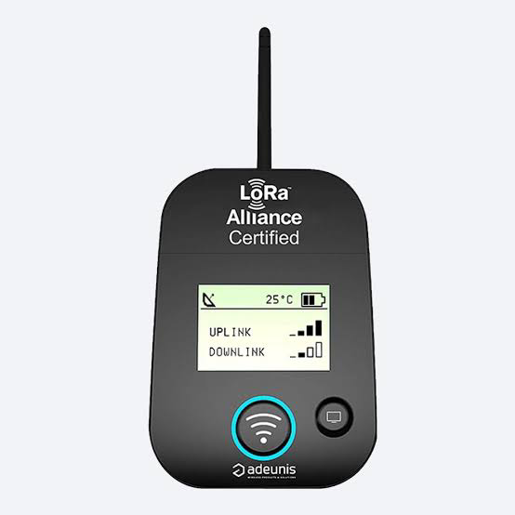

LoRaWAN stands for Long Range Wide Area Network. This is an open network protocol introduced by the LoRa Alliance that enables the network's Media Access Control(MAC) layer. The LoRaWAN protocol was first introduced in 2015 and has undergone several updates since then. The lower physical layer was called LoRa and the upper network layer was flawed. LoRaWAN has advanced to define the upper layers of the network. LoRaWAN is a cloud-based medium access control(MAC) layer protocol that primarily acts as a network layer protocol to handle connections between LPWAN gateways and end node devices as arouting protocol. LoRaWAN defines a communication protocol and system architecture for networks. LoRa's physical layer supports long-distance communication connections.

1. **MODELING AND ANALYSIS**

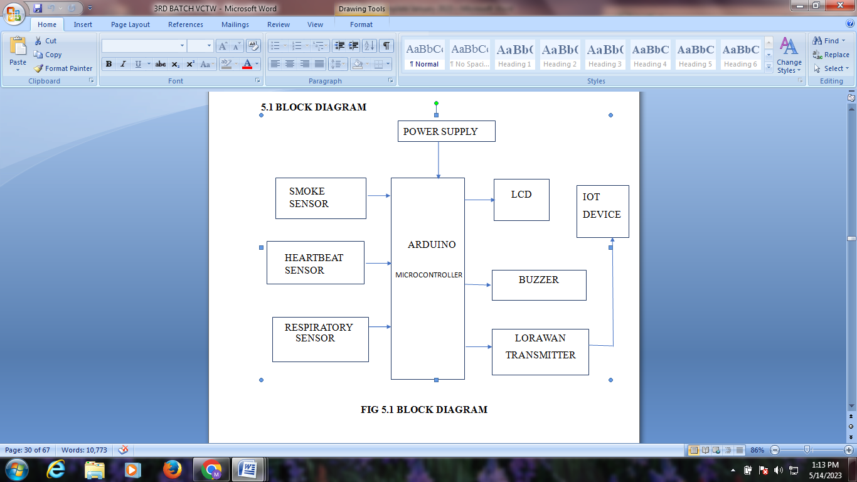

**Figure1:**Block diagram

As a result, wearable technology can improve work place safety, monitor the health of workers engaged in hazardous activities in real time, and analyze the data collected for immediate emergency response. Wearable devices, on the other hand, must meet a variety of criteria, including easy of use, price, easy of sensor setup, and easy of data acquisition. Scientists and companies are interested in wearable devices that use different types of sensors to collect features related to different quantifiable domains. Continuous monitoring of the user's health, which is influenced by behavior, physiology, psychology, and most importantly environmental parameters, has been shown to be particularly effective for these technologies. In addition to traditional wearables that can only measure parameters in one domain, hybrid solutions have been developed to monitor multiple parameters. For example, devices that can assess both biophysical and environmental aspects. Hybrid solutions are transforming worker safety in many industries, including metallurgy, chemicals, mining, and the food industry. In these areas, workers are regularly exposed to dangerous situations that can affect their health. The most common hazards in the metallurgical industry include exposure to dangerous gas leaks caused by combustion processesor steel making additives, and exposure to high temperatures. Similarly, both the food and chemical industries, where chemicals are often used to preserve and process food, are at constant risk of exposure to toxic fumes caused by chemical reactions. Additionally, thermal workers are at constant risk of falls and injuries from cave-insand exposure to gases released during excavation . As a result, wearable technology can improve work place safety, monitor the health of workers engaged in hazardous activities in realtime, and analyze the data collected for immediate emergency response.However, wearables must meet many requirements, including easy of use, sensor setup, cost, and easy of dat access.

1. **RESULTS**

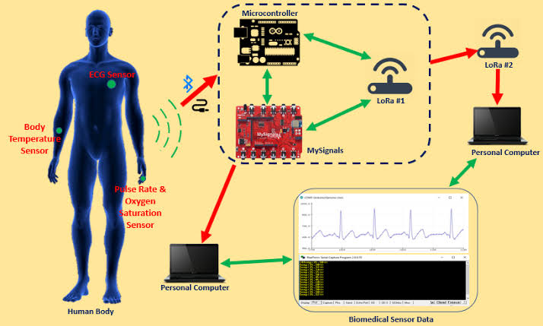

1. **CONCLUSION**

A thermal energy security system is implemented using smoke, respiration and heart rate sensors to obtain health parameters and environmental conditions. For worker safety, an intelligent warning system has been implemented to warn workers to flee the thermal environment in the event of an accident. The system constantly monitors thermal performance and alerts workers and authorized personnel from the ground station using LORAWAN technology. Environmental and health status of heat workers are continuously updating the IoT webpage. The system, where miners' medical data is captured and used for further medical predictions based on artificial intelligence, is cost-effective and efficient. Therefore, the proposed system reduces mortality and disease warnings for workers in the thermal power industry.

1. **REFERENCES**

[1] Geetha, A. (2014). Intelligent helmet for coal miners with voice over ZigBee and environmental monitoring. World Applied Sciences Journal.[2] R. K. Kodali and B. S. Sarjerao,” A low cost smart irrigation system using MQTT protocol,” 2017 IEEE Region 10 Symposium (TENSYMP), Cochin, India, 2017.[3] R. K. Kodali and A. Sahu,” An IoT based soil moisture monitoring on Losant platform,” 2016 2nd International Conference on Contemporary Computing and Informatics (IC3I), Greater Noida,

usage by using Internet of Things,’’ in Proc. Int. Conf. Inf.,Communication., Eng. Technology. (ICICET), Pune, Indian, Aug. 2018, pp. 1–4.