**AN ECO-FRIENDLY APPROACH FOR THE SYNTHESIS AND CHARACTERIZATION OF COPPER NANOPARTICLES USING *Amaranthus spinosus* LEAVES**

**Muthu Mani M1, Thulasi M2, Shinyguruce A3 and Eswara Priya B4**

1M.Tech, Dept. of Biotechnology, St. Michael College of Engineering and Technology, Kalayarkoil, Sivaganga District, TamilNadu, India

2M.Sc, Dept. of Microbiology, Alagappa University, Karaikudi, Sivaganga District, TamilNadu, India

3Associate Professor, Dept. of Biotechnology, St. Michael College of Engineering and Technology, Kalayarkoil, Sivaganga District, TamilNadu, India

4Corresponding author, Professor & Head, Biotechnology, St. Michael College of Engineering and Technology, Kalayarkoil, Sivaganga District, TamilNadu, India

**ABSTRACT**

An eco-friendly approach has been taken in the present study to synthesize copper nanoparticles from their salts (CuSO4) using Amaranthus spinosus. The leaf extract of Amaranthus spinosus involves the reduction of copper ions and also acts as a capping agent. Initially, the synthesis of copper nanoparticles was confirmed by visual observation, i.e., colour change (dark green colour), and it was characterized primarily by UV-vis spectroscopy and Fourier Transform Infrared spectroscopy. Further, the formation of the crystalline phase was analyzed by X-Ray Diffraction pattern. The size and morphology of the synthesized Copper nanoparticles was characterized by Field Emission Scanning Electron Microscopy and the elemental composition was analyzed by EDAX. The results of the present study confirmed that the leaf extract of Amaranthus spinosus is capable of producing nanoparticles.

**Keywords:** Amaranthus spinosus, copper nanoparticles, green synthesis, eco-friendly synthesis.

1. **INTRODUCTION**

Nanotechnology plays a key role in different aspects of science and technology, and it is applied in all fields as well as for environmental remediation. In addition, bio-nanotechnology is a recent trend in studying nanoparticle synthesis using biological approaches, which is a clean and eco-friendly method. Traditionally, metal nanoparticles were synthesized by means of physical and chemical methods, but these methods usually explore large areas and employ harsh chemicals, creating environmental degradation that includes contamination from the chemicals and the use of hazardous products. Thus, the interest in green fabrication approaches for metal nanoparticle synthesis is increasing, and nanoparticles have been found to be relevant to numerous emerging technologies.

Phytomediated synthesis of metal nanoparticles has gained great attention because of the growing need to design environmentally benign processes for material synthesis. The advantages of using plant and plant-derived materials for the biosynthesis of metal nanoparticles have interested researchers to investigate mechanisms of metal ion uptake and bioreduction by plants and to understand the possible mechanism of metal nanoparticle formation in plants. Considering all of the above, the present study is aimed at synthesizing copper nanoparticles using *Amaranthus spinosus*.

1. **METHODOLOGY**

The present work is primarily concerned with the synthesis of copper nanoparticles. Secondly, the syntheisized nanoparticle was characterized by various techniques.

* 1. **Collection of sample**

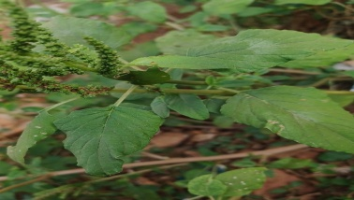The leaves of *Amaranthus spinosus* were collected from Kalayarkoil, Sivaganga District. The leaves were washed thoroughly with tap water, and rinsed with distilled water then allowed to air dry at room temperature.

**Figure1:** *Amaranthus spinosus* Leaves.

* 1. **Synthesis of Copper Nanoparticles**

The 5 gms of leaves were used in mortar and pestel crine with 100 ml of deionized water for 30 minutes. The extract was cooled down and filtered with Whatman filter paper no. 1, and the extract was stored in a refrigerator at 4°C. The CuNPs were prepared by adding 10 ml of an aqueous extract of plant material to 50 ml of a 1 mM aqueous solution of copper sulphate. The reaction mixture was centrifuged at 5000 rpm for 15 minutes, and the residue was dried at room temperature.

* 1. **Characterization of Copper Nanoparticles**

The optical properties of the synthesized copper nanoparticles were measured and confirmed using a Systronics 118 (UV-vis double beam spectrophotometer) with a wavelength range of 200–800 nm and a resolution of 2nm. FTIR analysis was used to determine the functional groups present in the leaf extract that are responsible for the reduction of copper ions, with a spectrum range of 400–4000 cm1. The NICOLET iS5 from Thermo Scientific, USA, captured the FTIR spectrum. X-ray diffraction spectroscopy (PW3040/60 X'pert PROPANalytical, Netherlands) was used to determine the crystalline structure of the copper nanoparticles. A Field Emission Scanning Electron Microscope (FESEM) (Quanta 250-FEG Co. Ltd.) at an accelerating voltage of 10.0 kV was used to examine the size and morphology of the synthesised CuNPs. The sample's spectrum was examined using energy dispersive absorption X-ray spectroscopy (EDAX) on Oxford IE150 equipment.

1. **RESULTS AND DISCUSSION**

Nanotechnology deals with the production, characterization, and manipulation of materials at the nanoscale. The synthesis of copper nanoparticles through a green method has attracted great interest in this area. Among the various methods, the biological and green methods are considerably preferred for the biosynthesis of copper nanoparticles using plant extracts that possess phytochemicals with strong antioxidant properties. Plants provide a better platform for nanoparticle synthesis as they are free from toxic chemicals and provide natural capping agents. Moreover, the use of plant extracts also reduces the cost of microorganism isolation and culture media, enhancing the cost-competitive feasibility of nanoparticle synthesis by microorganisms. Keeping all this in mind, in the present study, copper nanoparticles were synthesized using *Amaranthus spinosus*.

* 1. **Synthesis of Copper Nanoparticles**

Copper nanoparticles have received attention due to their physical, chemical, and biological properties that are attributed to their catalytic activity and bactericidal effects (Pham et al., 2009). They are used as catalysts, and they are used in electronic items as conductors. Figure 2 shows the results of the present study, which indicated that the addition of leaf extract of *Amaranthus spinosus* resulted in the formation of a dark green colour solution after the incubation, which indicated the green synthesis of copper nanoparticles (CuNPs).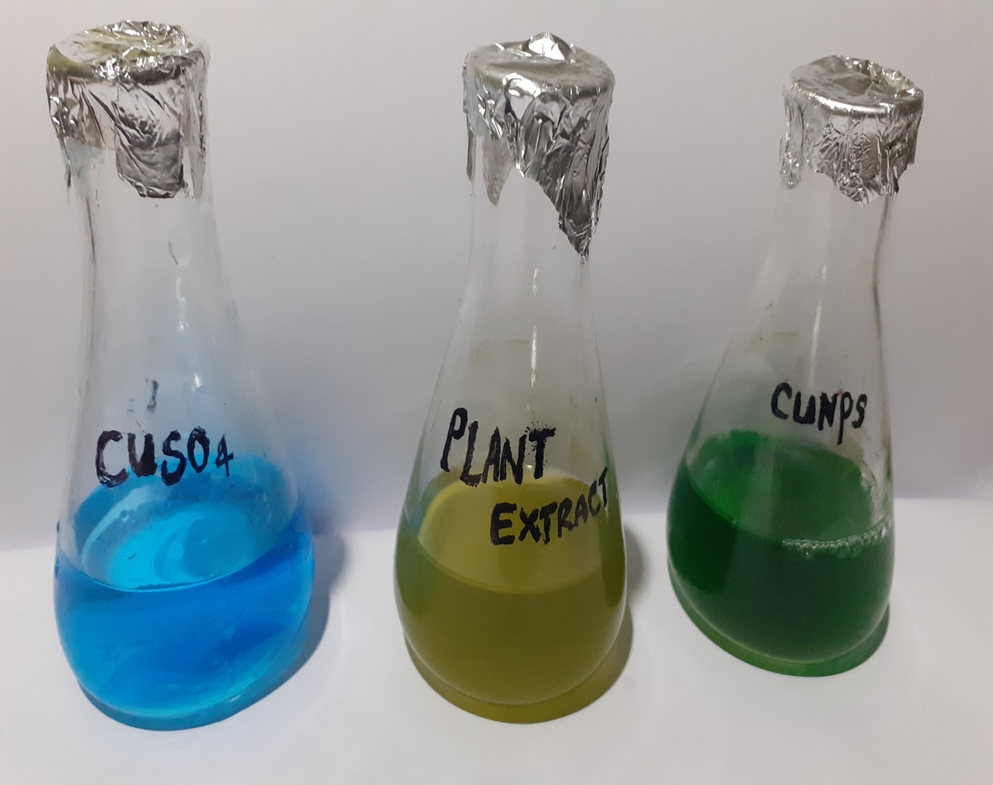

**Figure2: Synthesis of Copper Nanoparticles using Amaranthus spinosus**

* 1. **Characterization of Copper Nanoparticles**

The UV-Vis absorption spectra of CuNPs prepared from leaf extracts of Amaranthus spinosus are shown in Figure 3. The absorption band of CuNPs occurs at 567 nm. The absorption bands for CuNPs have been reported to be in the range of 500–600 nm (Sathyavathi *et al.*, 2010). The absorption peak ascribed to the surface plasmon resonance of Cu particles formed here. The intensity of the peak increases as a function of time in both cases.

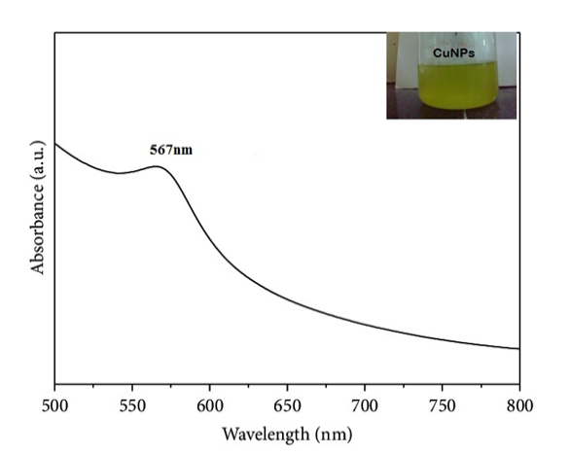

**Figure 3: UV- Visible Spectrum of CuNPs**

Results of the FT-IR study of biosynthesized CuNPs showed sharp absorption peaks located at 3305.9, 2890.6, 1570, and 1276.2. The absorption peak at 3,388.6 cm1 is assigned to N-H stretching in amines and phenolic compounds. The absorption peak at 1,570 cm1 is close to that reported for native proteins, which suggests that proteins are interacting with green synthesized copper nanoparticles. The absorption peak at 1,276.2 cm1 is assigned to the ether arising from C-O stretch. The results of the FTIR spectroscopic study confirmed that the carbonyl group of amino acid residues present in the leaf extract of *Amaranthus spinosus* has a strong binding ability with copper, suggesting the formation of a layer covering copper nanoparticles and acting as a capping agent to prevent agglomeration and provide stability to the medium. These results confirm the presence of possible proteins acting as reducing and stabilizing agents.

X-ray diffraction (XRD) is an effective technique used to determine the crystalline phases present in materials and study the structural properties of these phases. Evidence of the synthesis of crystalline CuNPs was detected by XRD. Figure 4 shows the XRD pattern of CuNPs, and the peaks were detected at 110, 111, 200, and 220.

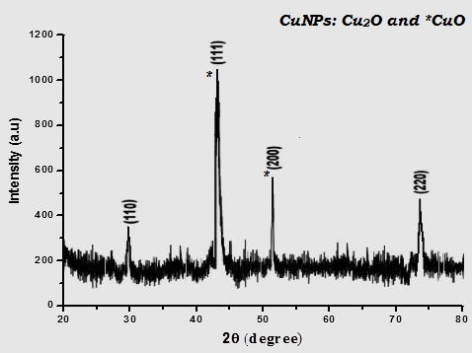

**Figure 4: X-ray Diffraction image of CuNPs**

FESEM analysis shows uniformly distributed copper nanoparticles on the surfaces of the cells (Figure 5). The copper nanoparticles were spherical in shape, with particle sizes ranging from 20 to 100 nm. The larger CuNPs may be due to the aggregation of the smaller ones, according to the FESEM measurements.

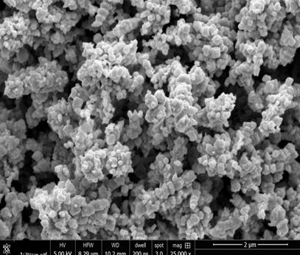

**Figure 5: Field Emission Scanning Electron Microscopy image of CuNPs**

Energy dispersive analysis of X-rays (EDAX) is a chemical microanalysis technique. EDAX analysis was used to determine the elemental composition of the CuNPs. The technique utilizes X-rays that are emitted from the sample through bombardment by the electron beam to characterize the elemental composition of the CuNPs. EDAX analysis gives the quantitative and qualitative status of elements that may be involved in the formation of nanoparticles. Figure 6 shows the elemental profile of nanoparticles synthesized using Amaranthus spinosus, and it confirms that the synthesized nanoparticles are copper nanoparticles. Specific elemental peaks at 1.00, 8.00, and 9.00 keV for copper No other metallic peaks were detected, which indicated that it was composed entirely of copper (Saranyadevi, 2010). Hence, the present study confirmed that the synthesized nanoparticles were copper nanoparticles.

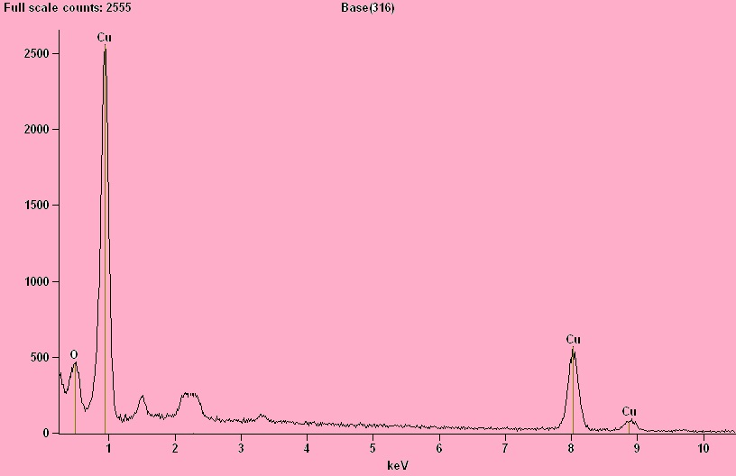

**Figure 6: Energy Dispersive Analysis of X- rays image of CuNP**

The results obtained from the characterization techniques strongly confirmed that the produced nanoparticles were copper nanoparticles. In the future, the biological activity of the copper nanoparticles will be evaluated.

1. **CONCLUSION**

The present study highlights the importance of eco friendly methods for the synthesis of copper nanoparticles using plant extract. The exploitation of reducing agents in nanoparticle synthesis has opened a crucial pathway that threatens environmental sustainability and also limits the uses of these noble materials towards biological applications. The use of hazardous chemicals and the amount of capital involved in the synthesis process lead to an energy-intensive process, which eliminates conventional methods from being environmentally friendly. Therefore, an attempt was made to synthesize copper nanoparticles using *Amaranthus spinosus*.

1. **REFERENCES**
2. Ankamwar B., Damle C., Ahmad A., Sastry M. Biosynthesis of gold and silver nanoparticles using *Emblica officinalis* fruit extract, their phase transfer and transmetallation in an organic solution. *J. Nanosci. Nanotechnol.*Vol. *5, 2*005, pp. 1665–1671. doi: 10.1166/jnn.2005.184.
3. Chung I.M., Abdul Rahuman A., Marimuthu S., Vishnu Kirthi A., Anbarasan K., Padmini P., Rajakumar G. Green synthesis of copper nanoparticles using *Eclipta prostrata* leaves extract and their antioxidant and cytotoxic activities. *Exp. Ther. Med. Vol. 14,* 2017, pp. 18–24.
4. Cushnie T.T., Lamb A.J. Antimicrobial activity of flavonoids. *Int. J. Antimicrob. Agents.*Vol. *26,* 2005, pp. 343–356. doi: 10.1016/j.ijantimicag.2005.09.002.
5. G. Ren, D. Hu, E. W.C. Cheng, M.A. Vargas-Reus, P. Reip and R.P. Allaker, Characterisation of copper oxide nanoparticles for antimicrobial applications, The International Journal of Antimicrobial Agents, Vol. 33, Issue. 6, 2009, pp. 587–590.
6. H. Bar, D. K. Bhui, G. P. Sahoo, P. Sarkar, S. Pyne, and A. Misra,“Green synthesis of silver nanoparticles using seed extract of Jatropha curcas,” Colloids and Surfaces A: Physicochemical and Engineering Aspects, vol. 348, Issue.1, 2009, pp. 212–216.
7. Hase J., Bharati G., Deshmukh K., Phatangre K., Rahane N., Dokhe Shital A. Synthesis and characterization of Cu nanoparticles of *Leucas chinensis* L plant. *Eur. J. Pharm. Med Res. Vol. 13,* 2016, pp. 241–242.
8. K.Saranyaadevi, V. Subha, R. S. Ernest Ravindran, S. Renganathan. Synthesis and Characterization of Copper Nanoparticle using Capparis Zeylanicaleaf Extract. Vol. 6, Issue. 10, 2014, pp. 4533- 4541.
9. Karimi J., Mohsenzadeh S. Copper Nanoparticles Using Flower Extract of *Aloe Vera*. *Synth. React. Inorg. Met. Org. Nano Met. Chem.*2015; 45: pp. 895–898. doi: 10.1080/15533174.2013.862644.
10. Kulkarni V., Kulkarni P. Synthesis of copper nanoparticles with *Aegle marmelos* leaf extract. *Nanosci. Nanotechnol. Vol. 8,* 2014, pp. 401–404.
11. Narayanan, K.B & Sakthivel, N 2010, 'Biological synthesis of metal nanoparticles by microbes', Advances in Colloid and interface science, Vol. 156,  pp. 1-13.
12. Nethra Devi C, Sivakumar P, Renganathan S. Green synthesis of silver nanoparticles using Datura metelflower extract and evaluation of their antimicrobial activity. Inter.J. Nanomat.Biostruct. Vol. 2, Issue. 2, 2012, pp. 16 –21.
13. Pham, V.A & Ting, Y.P. 'Gold bioleaching of electronic waste by cyanogenic bacteria and its enhancement with bio-oxidation', Advanced Materials Research, 2009, pp. 71-73.
14. R. Sathyavathi, M. B. Krishna, S. V. Rao, R. Saritha, and D. Narayana Rao. “Biosynthesis of silver Nanoparticles using Coriandrum Sativum leaf extract and their application in nonlinear optics,” Advanced Science Letters, vol. 3, Issue. 2, 2010, pp. 138–143.
15. Rai, M & Yadav, A. copper nanoparticles as a new generation of antimicrobials', Biotechnology advances. Vol. 12, Issue. 1, 2012, pp. 76 - 83.
16. Rajendran, P 2007, 'Nanotechnology for Bioremediation of Metals', Nanotech for Bioremediation,  pp. 211-221.
17. S. Yallappa, J.Manjanna, M. A. Sindhe, N. D. Satyanarayan, S. N.Pramod, and K. Nagaraja. “Microwave assisted rapid synthesis and biological evaluation of stable copper nanoparticles using T. Arjuna bark extract,”Spectrochimica Acta Part A: Molecular and Biomolecular Spectroscopy, vol. 110, 2013 pp. 108–115.
18. Sharma V.K., Yngard R.A., Lin Y. Silver nanoparticles: Green synthesis and their antimicrobial activities. *Adv. Colloid Interface Sci.*Vol. 145, 2009, pp. 83–96. doi: 10.1016/j.cis.2008.09.002.
19. Shrivastava V, Tomar RS, Mishra RK, Jyoti A and Kaushik S. Medicinal potential of some mythologically important plants of India: A Review International Journal of Multidisciplinary and Current Research. Vol. 2, 2014, pp. 2321-2326
20. Vinod Vellora Thekkae Padil Miroslav Černík. Green synthesis of copper oxide nanoparticles using gum karaya as a biotemplate and their antibacterial application, International Journal of Nanomedicine, Issue, 8, 2013, pp. 889–898.
21. Yao L.H., Jiang Y.M., Shi J., Tomas-Barberan F.A., Datta N., Singanusong R., Chen S.S. Flavonoids in food and their health benefits. *Plant Food Hum. Nutr.*Vol. 59, 2004, pp. 113–122. doi: 10.1007/s11130-004-0049-7.