**DESIGN AND ANALYSIS OF A G+5 RESIDENTIAL BUILDING USING ETABS &**

**COMPARING BETWEEN CONVENTIONAL SLABS AND FLAT SLABS**

**R.V.R.K. Prasad1, Akash S. Rathod2, Anooj M. Motghare3, Ishita S. Kamble4, Dnyaneshwari S. Thute5, Piyush P. Bhagadkar6, Anshul G. Nagose7**

*Department of Civil Engineering, K.D.K. College of Engineering* Nagpur, India

**ABSTRACT**

In the traditional approach, the slab is supported by a beam with a considerable beam depth and a modest slab thickness. Columns receive the weight that was previously on beams. The flat slab technique places the slab flat against the columns. Wherever a partition wall is required, it may be built thanks to the flat slab. To carry heavy loads, the thickness of the slab close to the column's support is raised; these are referred to as drops, or the heads of the columns are given with an increase in size; these are known as column heads. Since there is no beam in a flat slab, the ceiling is plain, which improves the appearance of the architecture. These days, flat slab buildings are employed because they provide numerous advantages that a typical slab construction does not. This project's goals are to contrast multi-story residential buildings with flat slabs with those with traditional slabs. ETABS software is used for design and analysis. Reasonable information regarding the stability of a flat slab is provided by the current work.

**Keywords:** *Flat Slab, Conventional Slab, Normal Slab, Comparison, Drop Panel, ETABS*

1. **INTRODUCTION**

The typical conventional slab is made up of beams, slabs, and columns. However, under that situation, it could be viable to start building without supplying beams. The flat slab building method places the slab directly on the columns. The column receives the weight directly, and the foundation receives the load after that. The central strip, column head, and column drops make up the flat slab. It is employed in areas like shopping centers, eateries, homes, and parking lots, among others. The standard IS Code is used to determine the 150mm slab thickness. A thickness of 125mm might be regarded as the minimum. In reality, using a flat slab is favorable and creates more room in areas where height limits are important. Flat slabs have the advantages of taking up less space during construction, lowering the height from floor to floor, and having a pleasing architectural appearance.

Column drops, also known as droop panels, are thicker portions of the slab that cover columns in order to support large loads.

There are rectangular column drops available. No side's height shall be less than one-third of the panel on the side.

Extended 3D Analysis of Building System, or ETABS, is a software programmer used to design the building.

**1.1 SCOPE AND STUDY**

The scope of the study is to produce good structural work which is economical and for performing analysis and design for a building.

**1.2 OBJECTIVES**

• To comprehend fundamental structural concepts utilizing Indian Standard Codes.

• The goal is to analyses the forces, stress, strain, deflection, and bending moment on the structural system.

• The goal is to use ETABS to design the structural system of the G+5 building.

• Developing a grasp of the specifications for structural design components such beams, columns, and slabs.

• Using the E-TABS Software for in-depth study and design, create a 3D model of the structure.

1. **METHODOLOGY**

Both flat and conventional slab constructions were examined using ETABS software. A structure's required elements, such as its material characteristics, loads, load combinations, member sizes, response spectrum, etc., must all be determined before analysis can begin. The results of the study, including displacement, storey shear, bending moment, drift ratio, and axial pressures, may be used to compare the performance of flat and conventional slab structures. The flow chart below shows the method ETABS utilized to carry out their analysis.

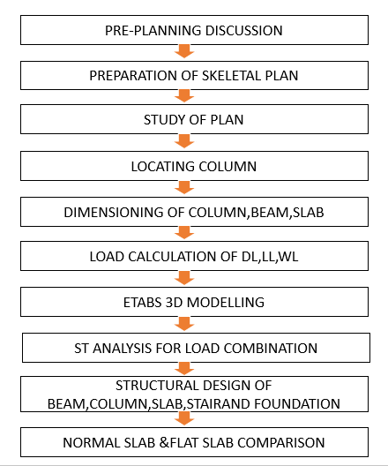

1. **MODELING AND ANALYSIS**

**3.1 PROJECT INFORMATION CONSIDERATION**

Height: 21.9 m; Residential Building Type: G+5 Storeys of Floors; 8 Structural Floors

**3.2 PROPERTIES OF MEMBERS**

* Materials used:
  + Grade of concrete = M25 for all member.
  + Grade of steel = Fe500 for all member

Conventional Slab Structure:-

* Frame sections provided:
  + B230x500 M25 – primary beams (230x500 mm)
  + B150x300 M25 – secondary beams (150x300 mm)
  + C300x600 M25 – column  
    (300x600 mm)
* Slab sections provided:
  + S125 M25 – general slab & wc slab
  + St200 M25 – staircase

Flat Slab Structure:-

* Frame sections provided:
  + C650x650 M25 – column  
    (650x650 mm)
* Slab sections provided:
  + S300 M25 – general slab & wc slab
  + St200 M25 – staircase
* Drop panel provided:
  + Thickness = 550mm
* 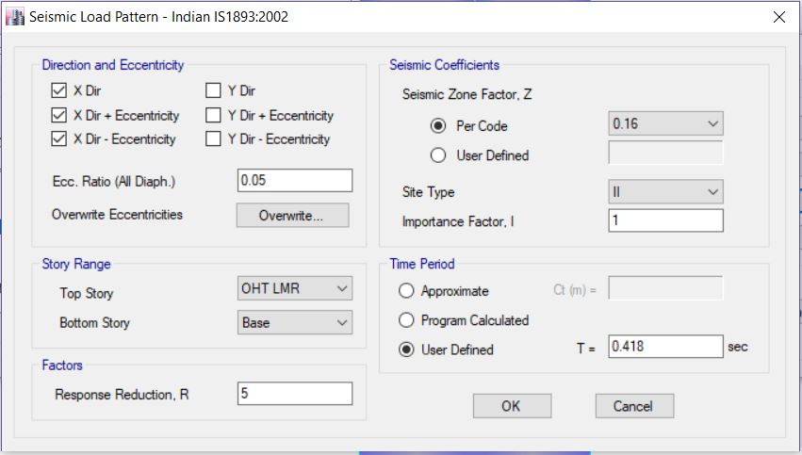Earthquake load data:   
  {IS: 1893 (part-1): 2016}

**Figure 1:** Load Pattern

1. Zone = III. …. Clause Annex E (pg. no.36)

2. Zone Factor = 0.16. ….. Clause 6.4.2

3. Importance Factor = 1 …. Clause 7.2.3

4. Response Reduction Factor = 5. ….. Clause 6.4.2

5. Soil Type = II …. Clause 6.4.2.1

1. **LOAD CALCULATION**

|  |  |  |  |  |  |
| --- | --- | --- | --- | --- | --- |
| **Load name** | **Load type** | **Dead load (D.L)  for conventional slab** | **Dead load (D.L)  for flat slab** | **Live load (L.L)** | **Reference** |
| General load | General load | 1.5 kN/m² | 2.876 kN/m² | 2 kN/m² | Is:875(p2)-1987, t1 |
| St load | Stair case load | 3 kN/m² | 2.5 kN/m² | 4 kN/m² | From prob. Statement |
| Wc & bath | Water closet & bath load | 2 kN/m² | 2 kN/m² | 2 kN/m² | Is:875 (p2)-1987, t1 |

1. **COMPARSION**

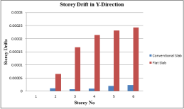

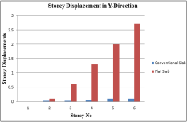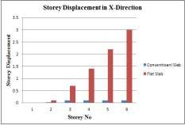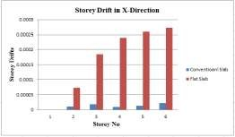

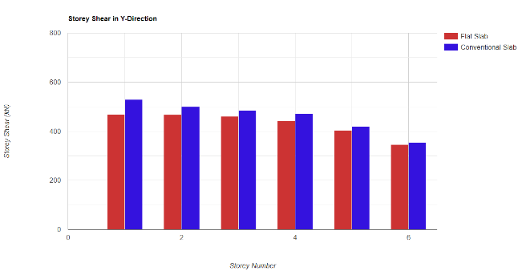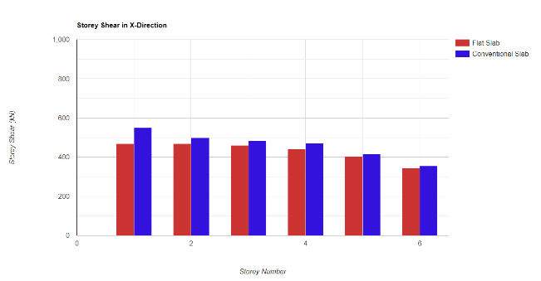

1. **SCOPE OF WORK**

By introducing a flat floor to limit the overall height of the building, it is possible to provide additional floors within the design height.

In this project, the main materials required and recommended by the project are used to compare smooth, conventional and flat ceilings.

1. **CONCULSION**

• Flat slab construction is a growing industry in India. Because flat panels offer many advantages over traditional panels, they can be an excellent choice for modern buildings that require structural stability as well as a modern aesthetic and look.

• The weight of flat slab constructions is relatively higher than that of normal slab constructions.

• The highest displacement of storeys occurs at roof level as compared to ground level. Comparatively speaking, the flat slab construction displaces less space than a normal slab building. Because of this, the flat slab building in this research has a higher story displacement than a typical slab. Additionally, the structures of flat slab buildings and traditional slab buildings are compared with storey drift. When compared to a conventional slab building, the flat slab here also has the greatest amount of storey drift for all number of storeys.

**ACKNOWLEDGEMENTS**

All of my professors and friends who assisted me in organizing my research report are much appreciated. For their assistance and direction during the study process, I am grateful to my mentor Prof. RVRK Prasad and the head of the civil engineering department at KDKCE College. Additionally, I'm grateful to my parents for constantly providing both material and moral support.

1. **REFERENCES**
2. Manu K, Naveen Kumar B, Priyanka S “Proportional reading of Flat slab and Conservative slab in high Seismic Zones” Intercontinental Investigation Magazine of Engineering and Technology Volume: 02 Issue: 06, Sep-2015
3. Ms. Navyasshree K and Sahanaa T S “Use, of flat slab in multi storey commercial building situated in high seismic zone” Internationally Journal in Research in Engineering and Technology (IJRET) ISSN: 2321-7308, Volume: 3, Issue: 8 August 2014
4. Ravi Kumar Makode “Comparison of flat slab and grids slab structure” International Journals of Engineering Research and Presentations. Volume: 4, Issue: 2 February 2012
5. James B Daton “Design and Analysis of Reinforced Concrete Flat Systems Based of the Results of Determinate Element Exploration.
6. Anuja Walavekar, H S Jadhaav (2014) “Parametrical studies of Flat slab structure with and withouts shear wall to seismic performance”.
7. R S Moore, V S Sawanth: (2013) “Analyses Of Flat Slab” (IJIRET), Volume: 2, Issue: 9
8. R P Apostolska, G S Necevska-Cvetanovska, J P Cvetanovska and N Mircic (2008) “Seismic Performance of Flat Slabs Building” International Journal of Advanced Structural Engineering 2012. The 14th World Conferences on Earthquake Engineering October 12/17, 2008, Beijing , China
9. Mohamed Abdel Bassef “Modelling of Shear Wall Symmetrical Flat Plate Reinforced Concrete Building. 15 Wcee Lisboa 2012