The effect of Toll Plaza on delay and fuel consumption

Abhimanyu Rathee1**,**Miss Shivani**2 ,** Himanshu3**,**

1M.tech Scholar, Satpriya group of institutions, Rohtak, India.

2Assistant Professor, Satpriya group of institutions, Rohtak, India.

3M.tech Scholar, Satpriya group of institutions, Rohtak, India.

***ABSTRACT***

India has the second largest road network in the world with a stretch of more than 5.5 million km. These roads carry a huge volume of traffic, more than 40% of the total traffic is carried by national highway having length less than 2% of total road length in India. Thus the national highways contribute to carrying a great proportion of traffic density. With the great significance of national highways, existing checkpoints in Indian road like toll plaza, intersection, cause a halt in the vehicular movement. Further, the ever increases traffic volume causes delay in journey time and hence result in extra fuel consumption.

Keywords: national highway, intersection, highway capacity manual, congestion.

**I. INTRODUCTION**

In the current study, delay in journey time and the resulting extra fuel consumption at Gharaunda toll plaza (Haryana) is estimated on NH 44 (earlier NH 1). The delay in journey time is computed by using Control Delay Method of Highway Capacity Manual (HCM 2000). The control delay method has initial delay, queue time, stop delay and acceleration delay. Considering this control delay method, a stretch of total 400 meters around the toll plaza is taken for the delay time assessment study, that is, a point from where vehicle start decelerating from 80% of design speed, moving towards zero speed and again accelerating to the 80% of design speed. The study includes surveys of traffic volume for determination of Lean Hours, Average Hours and Peak Hours, called as Congestion levels. The survey is conducted during weekdays and weekend both, to minimize the abruptions in experimental data. Assessment of total delay during Peak Hours, Average Hours and Lean Hours is done manually using stopwatch. And, the extra fuel consumption of different type of vehicles due to a specific non optimum speed range is calculated. For assessing the fuel consumption at non optimum speed, values of fuel consumption are taken from the graph of Speed v/s Fuel Consumption curves from CRRI Annual Data Report, 2009-10. Computed extra fuel consumption and delay give a better insight into comparing the results at different level of congestion and thus providing a base for better planning of road infrastructure.

**II. LITERATURE REVIEW**

Pal and Sarkar (2012), determined delay, noise pollution and fuel loss during idling in Agartala city. This is done experimentally by filling the fuel tanks and running them at idling condition. As per the study results it is analyzed that the delay at all intersections under study during peak nours is more than 60 seconds/ vehicle. Another study at Agartala shows a wastage of 389.68 liters of diesel and 810.38 liters of petrol per day during vehicle idling.

Sekhar et. al. [2013] estimated the delay and fuel losses during the idling of vehicles at signalized intersection in Ahmedabad through a 16 hour classified traffic volume count survey at four intersections. To find the delay characteristics and existing speed on the selected patch, GPS based velocity box (V-Box) was installed in the car. It was done by using VISSIM micro simulation software with the help of GEH statistics. GEH is a widely used statistics for comparing the modeled values and observed values evolved through simulation tools.  
  
Tiwari et. al. [2013] also estimated fuel wastage due to idling of vehicle at road traffic signal in Indore, Madhya pradesh. The classified traffic volume study was conducted for 12 hours (8:00a.m. to 10:00p.m.). The study is conducted at seven signalized intersection in Indore for a complete week (Monday to Sunday) to estimate the extra fuel consumption because of idling of vehicles on signalized intersection. This study shows that about 5.9 x 10' liters per year petrol & diesel (3.6 x 10 liters petrol and 2.3 x 10 liters diesel) are being wasted.  
  
Parida and Gangopadhyay estimates the fuel loss when vehicles are in idling condition at signalized intersection in Delhi. 12 signalized intersections of varying traffic volume are considered to estimate fuel loss of vehicles in idling condition. Out of these 12 intersection 2 were of low volume, 2 were of medium volume and 8 were of heavy volumes. The intersections having< 75000 vehicles per day were categorized as low volume, 75000-100000 were as medium volume and> 100000 were taken as high volume intersection. To collect the classified traffic volume data, 24 hours traffic survey is conducted at high volume intersection and 16 hours survey at low and medium volume intersection. For idling fuel consumption measurement, FP213S detectors, DF210A for two wheelers including two stock and four stock engine respectively are used, also FP214OH flow detector and DF 210 for four wheeler fuel consumption are utilised. The study shows that 0.37 million kilograms of CNG, 0.41 million liters of petrol and 0.13 million liters of diesel is wasted due to idling of vehicles every day in Delhi. Worth of this much amount of fuel is Rs. 27.25 million per day and Rs. 9944.5 million per annum.  
  
**II.EXPERIMENTAL INVESTIGATION**

FUEL CONSUMPTION AND COST ANALYSIS

A number of studies have been reported regarding Fuel Consumption at different speeds and in idling condition (when vehicle is not moving but ignition is on). Fuel Consumption follows a U shape with speed. It is observed that fuel consumption in case of cars is comparable a 10kmph and in idling condition. However Fuel Consumption is considerably low during idling condition (about 10%) as compared to at a speed of 10kmph in case of HCV.  
  
At signalized intersections vehicles stop when signal is red and keep their engine on during the  
period of red light. At these intersections fuel wastage can be estimated using idling fuel consumption data given by CRRI.

But, at toll plaza, vehicles stop only for a very small interval, they keep on moving in a queue at a very low speed. That is why we need to know that non optimum speed range during which vehicle crosses toll plaza and results in delay of journey time. The non-optimum speed is the speed at which fuel consumption is more than optimum fuel consumed. As seen from Fig. ?

‘-=[‘’’1 and Fig. 2, non-optimum speed for car is less than 30 km/hr and more than 40 km/hr, while for HCV, it is less than 35 km/hr and more than 45 km/hr.  
  
Due to presence of toll plaza, vehicle starts decelerating while approaching the toll plaza, moves with halts at a very low speed and again starts to accelerate after it crosses the toll plaza. During this movement, it travels at non optimum levels of speed due to which fuel consumption is more than those of optimum values. This study strives to compare the distance that is travelled in presence of toll plaza and the distance that could have been travelled with the same fuel consumption if toll plaza were not there. This comparison is made for a speed of 10 km/hr as it is the minimum speed available from the CRRI Fuel Consumption Curve at which fuel consumption is maximum (as seen from Fig. 1 and Fig. 2). Using these compared distances, cost analysis for the extra fuel consumption is done.  
  
FUEL CONSUMPTION  
  
Radar gun is used to determine the distance travelled at a speed of less than equal to 10 km/hr by the vehicle.  Speed v/s Fuel Consumption Curve is used to calculate the fuel consumption. For this fuel consumption, comparison of distance travelled and the distance that could have been travelled is done.  
  
 Fuel consumption

To estimate fuel consumption for the comparison of distances, study of Speed v/s Fuel Consumption Curve, CRRI Annual Report 2009-10 is done. The various curves shown in graph represent:  
  
1. Green-Modeled Fuel Consumption Equation on the basis of 2001 data (FC Eq. 2001).

2. Brown - developed fuel consumption equation for 2010 parameters (Developed FC Eq. 2010).

3. Red updated fuel consumption equation 2010 considering technological advances, engine advancement, fuel and lubricant changes etc. (Updated FC Eq. 2010) Out of these three fuel consumption curves, updated fuel consumption curve 2010 is considered for the calculations. Fig. 1 and Fig. 2 show the Speed v/s Fuel Consumption curves for car and HCV respectively.  
  
From the graphs, fuel consumption for cars and HCV at a speed of 10 km/hr is calculated (fuel consumption x speed=65lt. /1000km x 10 km/h 10.83 ml/min. for cars) and is shown in Table 1. Because of limited information on fuel consumption data, petrol and diesel are considered as fuel for car and HCV respectively.

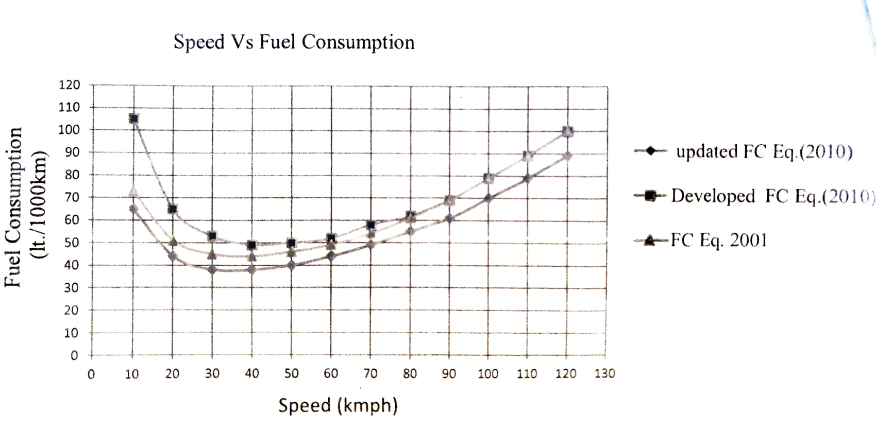

Fig. 1 Speed v/s fuel consumption of cars

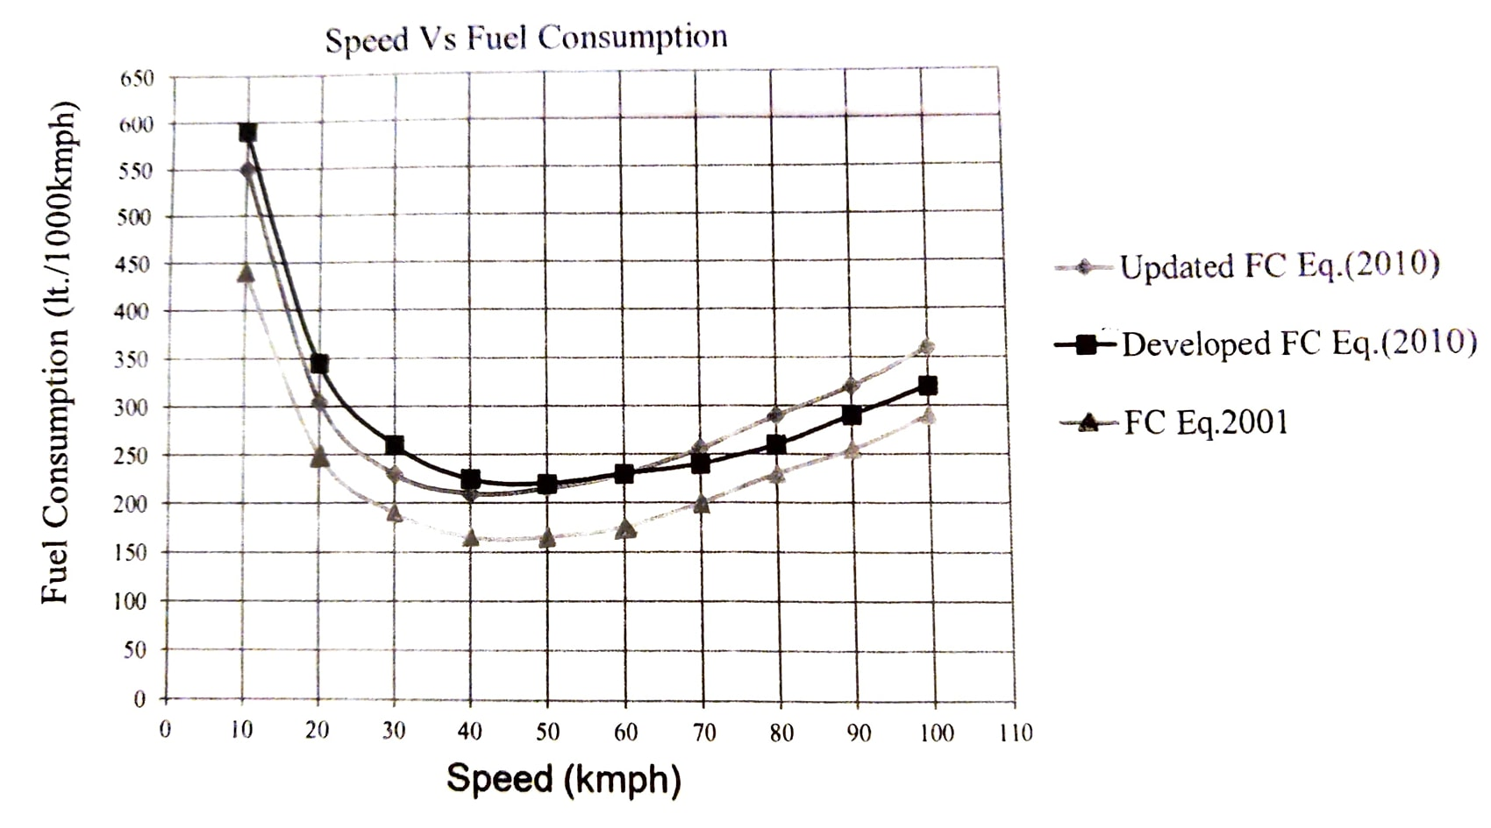

Fig.2 Speed v/s Fuel Consumption of HCV

Table 1. Fuel consumption per minute per vehicle for a speed of 10km/hr

|  |  |
| --- | --- |
| Vehicles | Fuel Consumption (ml/min.) |
| Cars (petrol) | 10.83 |
| HCV (diesel) | 91.67 |

Using the fuel consumption data given in table 1, the total fuel consumed per vehicle while travelling at the stretch where its speed is less than or equal to 10k/hr. [fuel consumption x per vehicle time taken= 10.83x3 (lean hours)=32.49ml] is shown in Table 2.

Table 2. Total fuel consumption at non optimum speed per vehicle

|  |  |  |  |
| --- | --- | --- | --- |
| Time for which vehicle moves at or below the speed of 10Km/h | | Corresponding fuel consumption per vehicle (ml) | |
| Congestion Level | Time (mins) | Cars (petrol) | HCV (diesel) |
| Lean Hours | 3 | 32.49 | 275.01 |
| Average Hours | 5 | 54.15 | 458.35 |
| Peak Hours | 8 | 86.64 | 733.36 |

**IV CONCLUSION**

The study presented in dissertation has been conducted to evaluate the effect of toll plaza on delay and fuel consumption. The site selected for the study is Gharaunda toll plaza on NH 44 (earlier NH1) in Karnal. Following main conclusion are drawn from the work:  
  
i. It is observed that the variation of traffic on NH 44 at Gharaunda toll plaza indicates an average of maximum 992 vehicles (1843 PCUs) passing during 1:00p.m. to 2:00 p.m. (peak hour) and a minimum of 615 vehicles (1476 PCUs) during 7:00 a.m. to 8:00 am. (lean hour) from Panipat to Jalandhar.  
  
ii. The average hourly traffic data reflects the variation of traffic on NH 44 at Gharaunda toll plaza indicating a maximum 2221 PCUS (908 vehicles) passing during 11:00 p.m. to 12:00 a.m. (peak hour) and a minimum of 1452 PCUS (780 vehicles) during 9:00a.m. to 10:00 am. (lean hour) from Panipat to Jalandhar. This may be attributed to the more number of buses and LCVs plying from 11:00 pm to 12:00a.m..  
  
iii. Further, variation of traffic on NH 44 at Gharaunda toll plaza shows a of maximum 980 vehicles (2284 PCUs) passing in the span of 8:00p.m. to 9:00p.m. (peak hour) and a minimum of 537 vehicles (1096 PCUs) passing during 8:00 a.m. to 9:00 a.m. (lean hour) from Jalandhar to Panipat.  
  
iv. Classification of PCU data is done in different congestion levels: 4:00 a.m. to 5:00a.m. and 7:00 a.m. to 10:00 a.m. are Morning Lean Hours, 3:00 p.m. to 4:00 p.m. and 5:00 p.m. to 8:00 p.m. are Evening Lean Hours (total 8 hours). 5:00 am to 7:00 a.m. and 10:00a.m. to 12:00 p.m. are Morning Average Hours, 12:00 p.m. to 1:00 p.m., 2:00 p.m. to 3:00 p.m. and 4:00 p.m. to 5:00 p.m. are Evening Average Hours. In addition to this, 2:00 a.m. to 3:00 a.m. are Average Night Hours (total 8 hours). 1:00 p.m. to 2:00 p.m. are Evening Peak Hours, 8:00 p.m. to 2:00 a.m. and 3:00 a.m. to 4:00 a.m. are Night Peak Hours (total 8 hours) for Panipat to Jalandhar traffic flow.

v. Similarly for Jalandhar to Panipat stretch, classification of congestion levels is as follows, 8:00 a.m. to 12:00 p.m.- Morning Lean Hours and 12:00 p.m. to 4:00p.m.- Evening Lean Hours (total 8 hours). 4:00 a.m. to 7:00 a.m.- Morning Average Hours, 4:00 p.m. to 8:00 - Evening Average Hours and 3:00 a.m. to 4:00 a.m. are Night Average Hour (total 8 p.m.- hours). Observed Peak Hours are 7:00 a.m. to 8:00 a.m. during morning and 8:00 p.m. to 3:00 a.m. during night (total 8 hours)

**V REFERENCES**

1. Gangopadhyay S. and Parida P. (2009), "Estimation of Fuel Loss during Idling at Signalized Intersections in Delhi, Indian Roads Congress", (IRC), Vol.12  
  
2. Pal Manish and Sarkar Dipankar (2012) "Delay, fuel loss and noise pollution during idling of vehicles at signalised intersection in agartala city". Civil and Environmental Research, ISSN 2222-1719 (Paper) ISSN 2222-2863 (Online), Vol 2, No.6, 2012.

3. Tiwari K. P. Singh R. N and Balwanshi J. B. (2013) "Fuel wastage and emission due to idling of vehicles at road traffic signals". IJRET: International Journal of Research in Engineering and Technology, Volume: 02 Issue: 10, Oct-2013.  
  
4. Indian Roads Congress (2014) Manual of Specifications and Standards for Four Laning of Highway Through Public Private Partnership (2014), First revision  
  
5. <http://www.hindustantimes.com/gurgaon/commuters-waste-fuel-worth-rs-54-crore-ever> year-due-to-jams/story-mEUIQUUFeBe6 VrgrgfONPI.html  
  
6. <http://timesofindia.indiatimes.com/city/mumbai/Toll-relief-prompts-smoother-traffic->fuel-saving-of-Rs-60000cr/articleshow/47507872.cms  
  
7. <http://www.tcil.com/tcil/pdf/TC1%2011M%20Study%20Report-2011-12.pdf>  
  
8. <http://erridom.gov.in/sites/default/files/annual-report/2009-10/CHAPTER-8.pdf>