IOT BASED UNDERGROUND CABLE FAULT DETECTOR

**K.Muthuraman B.E**

Sree Sowdambika College of Engineering , Aruppkottai, Tamil Nadu India

**Dr. R. Sivasangari**

Professor, Sree Sowdambika College of Engineering , Aruppkottai,,Tamil Nadu India

**ABSTRACT:**

*Underground cables are prone to a wide variety of faults due to underground conditions, wear and tear, rodents etc. Diagnosing fault source is difficult and entire cable should be taken out from the ground to check and fix faults. The project work is intended to detect the location of fault in underground cable lines from the base station in km using a PIC16F877A controller. To locate a fault in the cable, the cable must be tested for faults. This prototype uses the simple concept of Ohms law. The current would vary depending upon the length of fault of the cable. In the urban areas, the electrical cables run in underground instead of overhead lines. Whenever the fault occurs in underground cable it is difficult to detect the exact location of the fault for process of repairing that particular cable. The proposed system finds the exact location of the fault. The prototype is modeled with a set of resistors representing cable length in km and fault creation is made by a set of switches at every known distance to cross check the accuracy of the same. In case of fault, the voltage across series resistors changes accordingly, which is then fed to an ADC to develop precise digital data to a programmed PIC IC that further displays fault location in distance. The fault occurring distance, phase, and time is displayed on a 16X2 LCD interfaced with the microcontroller. IoT is used to display the information over Internet using the Wi-Fi module ESP8266.A webpage is created using HTML coding and the information about occurrence of fault is displayed in a webpage.*

**Keywords:** Underground Cable, Fault Location, Location Methods, Microcontroller, webpage.

# INTRODUCTION

Power supply networks are growing continuously and their reliability getting more important than ever. The complexity of the whole network comprises numerous components that can fail and interrupt the power supply for end user. For most of the worldwide operated low voltage and medium voltage distribution lines, underground cables have been used for many decades. Underground high voltage cables are used more and more because they are not influenced by weather conditions, heavy rain, storm, snow and pollution. Even though the

Cable manufacturing technology is improving steadily; there are still influences which may cause cable to fail during test and operation. A cable in good condition and installed correctly can last a lifetime of about 30 years. However cables can be easily damaged by incorrect installation or poorly executed jointing, while subsequent third party damage by civil works such as trenching or curb edging [1,2].

## Types of Faults in Cables

### Open Circuit Fault

When there is a break in the conductor of the cable, it is called open circuit fault of the cable. The open circuit fault can be checked by megger. For this purpose, the three conductors of the 3-core cable at the far end are shorted and earthed. Then resistance between each conductor and earth is measured by a megger. The megger will indicate zero resistance in the circuit of the conductor that is not broken. However, if the conductor is broken, the megger will indicate infinite resistance in its circuit.

### Short Circuit Fault

When two conductors of a multi-core cable come in electrical contact with each other due to insulation failure, it is called short-circuit fault. The two terminals of the megger are connected to any two conductors. If the megger gives zero reading, it indicates short-circuit fault between these two conductors. The same step can be repeated for other conductors taking two at a time.

### Earth Fault

When the conductor of the cable comes in contact with earth, it is called earth fault or ground fault. To identify this fault, one terminal of the megger is connected to the conductor and the other terminal connected to earth. If megger indicates zero reading, it means the conductor is earthed. The same procedure is repeated for other conductors of the cable [4,6].

This project is used to detect the location of fault in digital way. Locating the faulty point in an underground cable helps to facilitate quicker repair, improve the system reliability and reduced outage period. The article has been organised as follows. Section 2 discuss about different methods used to detect the location of fault in underground cables. Section 3 describes the basic principle of the proposed fault locating method. Section 4 briefly explains the working of the proposed system with a help of flow chart. Section 5 presents the circuit which is a prototype model for the proposed system. Section 6 gives the simulation of the

Iot Based Underground Cable Fault Detector

work using Proteus 8.5 Professional software. The section also explains the hardware implementation and the results. Section 7 Provides conclusion and future scope of the work.

# LITERATURE SURVEY

## 2.1 Sectionalizing

This procedure reduces cable reliability, because it depends on physically cutting and splicing the cable. Dividing the cable into successively smaller sections and measuring both ways with an ohmmeter or high-voltage insulation resistance (IR) tester enable to narrow down search for a fault. This laborious procedure normally involves repeated cable excavation [2,8].

## Thumping

When high voltage is supplied to faulty cable, the resulted high current arc makes a noise loud enough to hear above ground. While this method eliminates the sectionalizing method’s cutting and splicing, it has its own drawback. Thumping requires a current on the order of tens of thousands of amps at voltages as high as 25 kV to make an underground noise loud enough to hear above ground. The heating from this high current often causes some degradation of the cable insulation. The limit of damage can be reduced by passing minimum required power to conduct the test [2].

## Time-Domain Reflectometry

The Time domain reflectometer (TDR) is an electronic instrument that uses time domain reflectometry to characterize and locate faults in metallic cables. The TDR sends a low- energy signal through the cable, causing no insulation degradation. A theoretically perfect cable returns that signal in a known time and in a known profile. Impedance variations in a “real-world” cable alter both the time and profile, which the TDR screen or printout graphically represents. One weakness of TDR is that it does not pinpoint faults.

## Arc Reflection Method

This method is often referred to as a high voltage radar technique that overcomes the 200 Ω limitation of low-voltage radar. In addition to the TDR, an arc reflection filter and surge generator is required. The surge generator is used to create an arc across the shunt fault which creates a momentary short circuit that the TDR can display as a downward-going reflection. The filter protects the TDR from the high voltagepulse generated by the surge generator and routes the low-voltage pulses down the cable. Arc reflection is the most accurate and easiest pre location method. The fault is displayed in relation to other cable landmarks such as splices, taps and transformers and no interpretation is required. Arc reflection makes it possible for the TDR to display “before” and “after” traces or cable signatures. The “before” trace is the low-voltage radar signature that shows all cable landmarks but does not show the downward reflection of a high resistance shunt fault. The “after” trace is the high-voltage signature that includes the fault location even though its resistance may be higher than 200 Ω. This trace is digitized, stored and displayed on the screen and the cursors are positioned in order to read the distance to the high resistance fault [8].

## Blavier Test

When a ground fault occurs in a single cable and there is no other cable, then blavier test can be performed to locate the fault in a single cable. In other words, in the absence of a sound cable to locate fault in the cable, then measurement of the [resistance](http://www.electricaltechnology.org/2014/01/what-is-difference-between-ac-and-dc-resistance.html) from one side or end is called blavier test. Ground fault of a single cable can be located using Blavier’s test. In this

kind of test, low voltage supply, an ammeter and voltmeter are used in a bridge network. Resistance between one end of the cable (Sending End) and earth is measured while “Far End” is isolated from the earth [2, 8].

# INTERNET OF THINGS

The evaluation of IoT in the electrical Power Industry transformed the way things performed in usual manner. IoT increased the use of wireless technology to connect power industry assets and infrastructure in order to lower the power consumption and cost. The applications of IoT are not limited to particular fields, but span a wide range of applications such as energy systems, homes, industries, cities, logistics, heath, agriculture and so on. Since 1881, the overall power grid system has been built up over more than 13 decades, meeting the ever increasing demand for energy. Power grids are now been considered to be one of the vital components of infrastructure on which the modern society depends. It is essential to provide uninterrupted power without outages or losses. It is quiet hard to digest the fact that power generated is not equal to the power consumed at the end point due to various losses. It is even harder to imagine the after effects without power for a minute. Power outages occur as result of short circuits. This is a costly event as it influences the industrial production, commercial activities and consumer lifestyle. Government & independent power providers are continuously exploring solutions to ensure good power quality, maximize grid uptime, reduce power consumption, increase the efficiency of grid operations and eradicate outages, power loss & theft. Most importantly, the solution should provide a real-time visibility to customers on every penny paid for their energy. There is an increasing need of a centralized management solution for more reliable, scalable, and manageable operations while also being cost effective, secure, and interoperable. In addition, the solution should enable power providers and utilities to perform effective demand forecasting and energy planning to address the growing need for uninterrupted quality power [5].

The goal of IoT is not just only connecting things such as machines, devices and appliances, but also allowing the things to communicate, exchanging control data and other necessary information while executing applications. It consists of IoT devices that have unique identities and are capable of performing remote sensing, monitoring and actuating tasks. These devices are capable of interacting with one another directly or indirectly. Data collection is performed locally or remotely via centralized servers or cloud based applications. These devices may be data collection devices to which various sensors are attached such as temperature, humidity, light, etc., or they may be data actuating devices to which actuators are connected, such as relays.

IoT system is composed of three layers: the perception layer, the network layer, and the application layer as shown in Figure 1. The perception layer includes a group of Internet-enabled devices that can percept, detect objects, collect systems information, and exchange information with other devices through the Internet communication networks. Sensors, Global Positioning Systems (GPS), cameras, and Radio Frequency Identification Devices (RFID) are examples of devices that exist at perception layer. The network layer is responsible of forwarding data from perception layer to the application layer under the constraints of devices’ capabilities, network limitation and the applications’ constraints. IoT systems use a combination of Internet and short-range networks based on the communicated parties. Short-range communication technologies such as Bluetooth and ZigBee are used to carry the information from perception devices to a nearby gateway. Other technologies such as Wi-Fi, 2G, 3G, 4G, and Power line Communication (PLC) carry the information for long distances based on the application. The upper layer is the application layer, where incoming information is

Iot Based Underground Cable Fault Detector

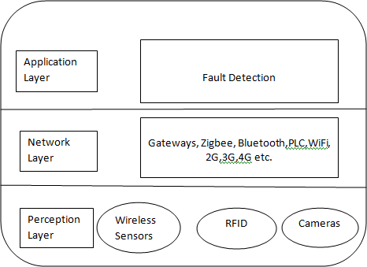processed to induce insights for better power’s distribution design and management strategies.

**Figure 1** Architecture of IoT

## Online Monitoring of Power Lines

As more buildings and areas are being covered with power line systems, the number and severity of power outages become more serious leading to lower system’s reliability. Reliability is important as it causes serious negative impacts on public health and economical systems. Integration of IoTs technology together with the power grid, aims to improve the reliability of power grids through a continuous monitoring of transmission lines status; in addition to environmental behaviours and consumers activities to send periodic reports to the grid control units. The control units process and extract information from the reported data in order to detect faults, isolate the fault, and then resolve faults intellectually performing energy restoration in smart grid must take into the account the location criticality of blackouts. For examples, it is critical to guarantee high reliability for health and industrial systems. The restoration problem becomes a very complex problem when taking into the consideration the large number of combinations of switching operations which exponentially increases with the increase in system’s components. Designing the smart grid in a hierarchical model divides the problem into multiple control units in charge of restoring power within its region or scope. This enhances the time needed to process the data and speeds up the restoration process. If some control units fail to restore energy in some regions within their scope, they forward the problem to upper levels for better action and handling as higher levels have a larger system’s view [5].

## Demand-Side Energy Management

Demand-Side Energy Management (DSM) is the change in consumers energy consumption profiles according to varying electricity price over time, and other payment’s incentives from utility companies. Demand response is used to minimize consumer’s electricity bill, shift peak’s load demand, minimize operation cost of the power grid, and minimize energy loss and greenhouse’s gas emissions. IoT components collect energy requirements of different home appliances and send them to smart meters. The control unit in smart grid schedules energy consumption of homes’ appliances according to the user’s preferences in a strategy that minimizes the electricity bill. The DSM problem can be solved at different levels of the hierarchical smart grid infrastructure. It can be solved at the level of home premises to preserve consumers privacy. Also it can be solved at higher levels to generate more effective scheduling plan that do not only benefit consumers but also the utility company [5].

## Integration of Distributed Energy Sources

Renewable energy generators are being integrated into today’s power grid because of environmental reasons, climate change, and its low cost. This reduces emissions of greenhouse gases that rises the Earth temperature. In recent years, many governments, organizations, and individuals started to install solar cells and wind turbines to satisfy part of their power requirements. Germany for example plans fully fulfil their power demands using renewable energy sources by 2050. IoT technology uses wireless sensors to collect real-time weather information to help in predicting the energy availability in the near future. Accuracy of the forecasted power amounts during the next time intervals is crucial for energy scheduling models. Different strategies and optimization solutions have been developed in research to efficiently manage renewable energy sources within the smart grid[5].

## Integration of Electric Vehicles

Electric Vehicles (EVs) are used as energy storage devices while they are idle. Also they provide efficient and clean transportation services. Developing efficient scheduling techniques for charging and discharging of electric vehicles can potentially lead to reduce emissions, shave peak load, and increase the used percentage of generated renewable. Perception devices collect information about electric vehicles identity, battery state, location, etc, to improve the efficiency of charging and discharging scheduling algorithms [5].

## Smart Homes

The system and appliances include sensors and actuators that monitor the environment and send surveillance data to a control unit at home. The control unit enables the householders to continuously monitor and fully control the electrical appliances. It also uses the surveillance data to predict future activities to be prepared in advance for a more convenient, comfortable, secure, and efficient living environment [5].

# PROPOSED SYSTEM

The proposed system is an IoT enabled underground cable fault detection system. The basic principle behind the system is Ohms law. When fault occurs in the cable, the voltage varies which is used to calculate the fault distance. The system consists of Wi-Fi module, Microcontroller, and Real-Time Clock. The block diagram of the fault detection system is shown in the Figure 2.The power supply is provided using step-down transformer, rectifier, and regulator. The current sensing circuit of the cable provides the magnitude of voltage drop across the resistors to the microcontroller and based on the voltage the fault distance is located [1,2].

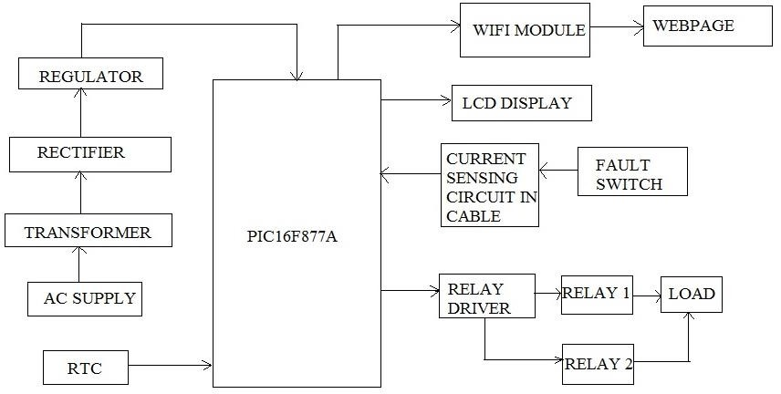

**Figure 2** Block Diagram of Fault Detection system

Iot Based Underground Cable Fault Detector

# FLOW CHART

The flow chart of the logic behind the fault detecting system is given in Figure 3. The input and output ports of Microcontroller, LCD display, RTC and Wi-Fi module of the system are configured and initialized. When fault occurs (switch is pressed), the fault distance, time and phase are displayed corresponding to that fault. The above fault information will be displayed in the webpage using Wi-Fi module [9,10].

# CIRCUIT DESCRIPTION

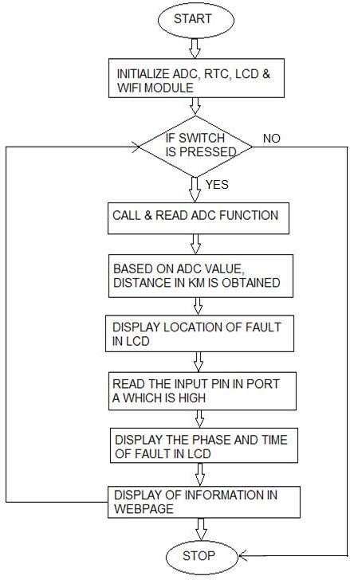The prototype uses resistors to represent the cable length. The resistors RR1 to RR5 represents R phase of the cable. Similarly RY1 to RY5 and RB1 to RB5 represent Y and B phase of the cable. RN1 to RN12 are used to represent the neutral lines. To represent the occurrence of fault in underground cables switches are used. Each phase is connected with a relay which in turn is connected to Port C of Microcontroller. When there is no fault, the LEDs connected to each relay glows.

**Figure 3** Flow Chart of Fault Detection System

When a switch connected to a particular phase is closed, the LED connected to the particular phase alone glows. The resistance connected to that particular phase adds up and the voltage drop thus generated is given to Port A of the Microcontroller. The voltage drop is converted to distance as per Table 1 and is displayed in the LCD. Additionally, the pin of Port C connected to that particular LED goes high and the name of the faulted phase is displayed in the LCD. The cable side circuit diagram is shown in the Figure 4.

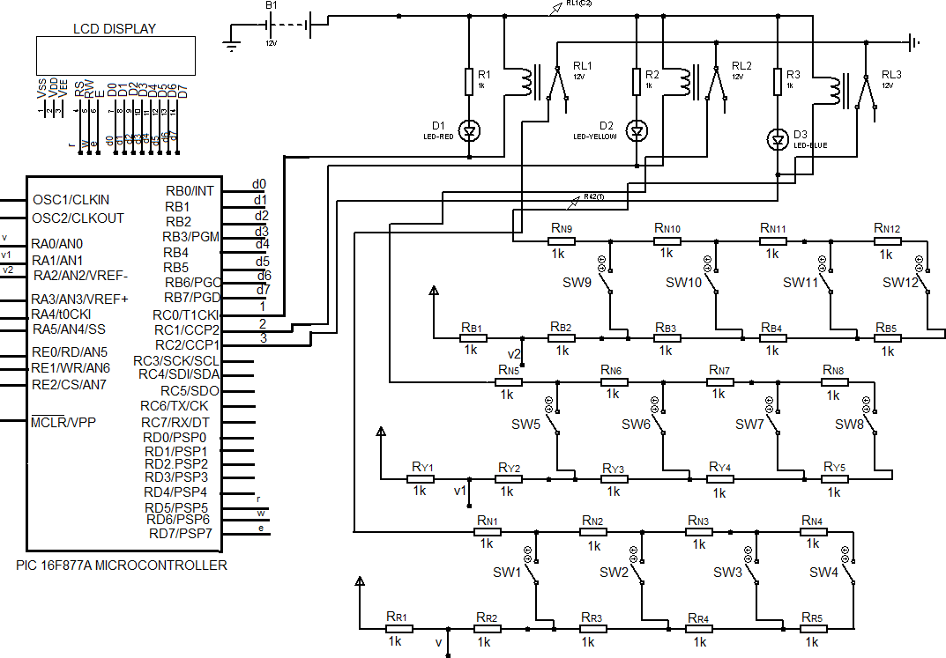

**Figure 4** Cable Side - Circuit Diagram

|  |  |  |  |  |
| --- | --- | --- | --- | --- |
| **S.No.** | **Switch** | **Analog** | **Fault** | **ADC** |
| 1. | SW 1 | 3.33 V | 1 km | 682 |
| 2. | SW 2 | 3.99 V | 2 km | 818 |
| 3. | SW 3 | 4.28 V | 4 km | 876 |
| 4 | SW 4 | 4.4 V | 8 km | 909 |

**Table 1** Mapping Table for Fault Identification

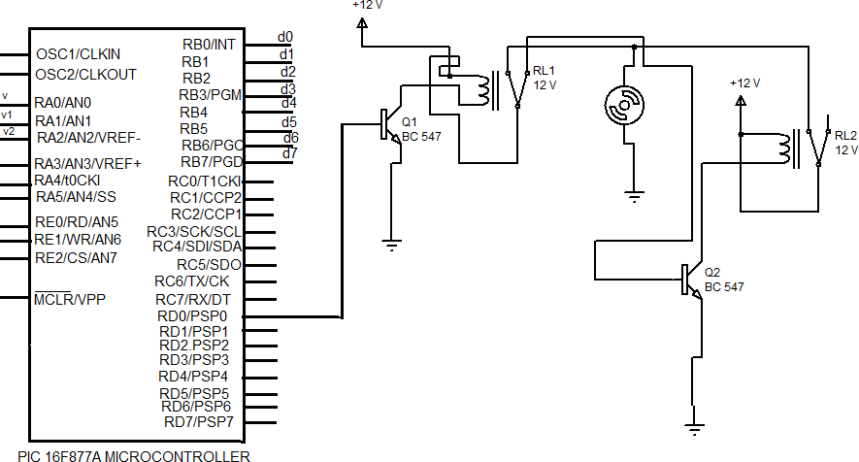

**Figure 5** Switch Over Connection- Circuit Diagram

Iot Based Underground Cable Fault Detector

The Real Time Clock DS1307 is connected to Port C of the Microcontroller to display the time at which fault has occurred. For every clock period the time gets incremented. During fault, SCL pin of RTC synchronizes the data and SDA pin transmits data to the Microcontroller which is displayed in the LCD. The switch over connection is activated during fault period of the cable to transmit uninterrupted power supply which is shown in figure 5.

# OBSERVATION AND RESULT

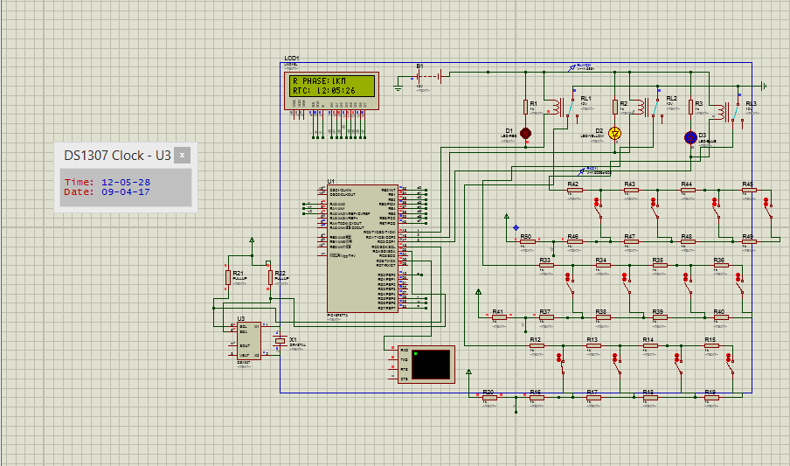The fault detection system is simulated using Proteus 8.5 professional software and the fault information is displayed in the LCD. The simulation and hardware setup of the fault detection system are shown in the Figure 6 and Figure 7 respectively. The Fault display message is shown in the table 2. The work “IoT Based Underground Cable Fault Detector” is an efficient system as it reduces the time to detect the exact location of fault.

**Figure 6** Simulation of the System using Proteus

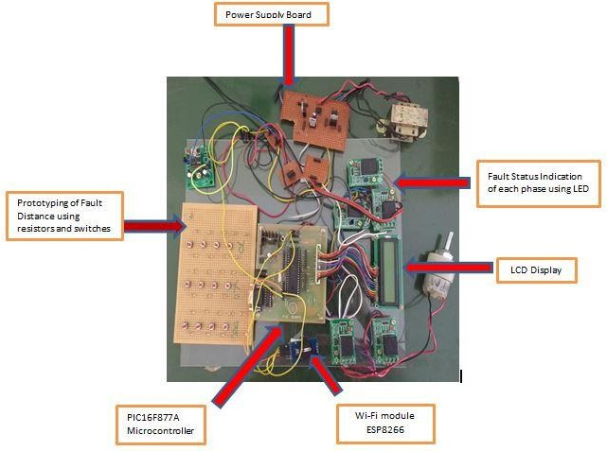

**Figure 7** Hardware Setup of the System

|  |  |  |
| --- | --- | --- |
| **HARDWARE STATUS** | | |
| **Problem Affected in R Phase in Time 12:04:35PM** | | |
| **Phase** | **Relay switch Over ring** | **Distance (in km)** |
| R Phase | R2 | 8 km |
| Y Phase | R | 0 km |
| B Phase | R | 0 km |

# CONCLUSION

**Table 2** Fault Display Message in the Webpage

The short circuit fault at a particular distance in the underground cable is located to rectify the fault efficiently using simple concepts of Ohms law. The work automatically displays the phase, distance and time of occurrence of fault with the help of PIC 16F877A and ESP8266 Wi - Fi module in a webpage. The benefits of accurate location of fault are fast repair to revive back the power system, it improves the system performance, it reduce the operating expense and the time to locate the faults in the field.

# FUTURE SCOPE

The work can be extended for open circuit fault, short circuit Line to Line Fault (LL) and double Line to Ground Fault (LLG). The open circuit fault can be detected using a capacitor in ac circuit which measures the change in impedance and calculate the distance of fault.

Iot Based Underground Cable Fault Detector

# REFERENCES

1. [Xiaoning Kang](http://ieeexplore.ieee.org/search/searchresult.jsp?searchWithin=%22Authors%22%3A.QT.Xiaoning%20Kang.QT.&newsearch=true); [Xiuda Ma](http://ieeexplore.ieee.org/search/searchresult.jsp?searchWithin=%22Authors%22%3A.QT.Xiuda%20Ma.QT.&newsearch=true); [Shuai Jiang](http://ieeexplore.ieee.org/search/searchresult.jsp?searchWithin=%22Authors%22%3A.QT.Shuai%20Jiang.QT.&newsearch=true); [Xiaoyun Qu,](http://ieeexplore.ieee.org/search/searchresult.jsp?searchWithin=%22Authors%22%3A.QT.Xiaoyun%20Qu.QT.&newsearch=true) [Chao Zhang](http://ieeexplore.ieee.org/search/searchresult.jsp?searchWithin=%22Authors%22%3A.QT.Chao%20Zhang.QT.&newsearch=true); [Xiaoning Kang](http://ieeexplore.ieee.org/search/searchresult.jsp?searchWithin=%22Authors%22%3A.QT.Xiaoning%20Kang.QT.&newsearch=true); [Xiuda Ma](http://ieeexplore.ieee.org/search/searchresult.jsp?searchWithin=%22Authors%22%3A.QT.Xiuda%20Ma.QT.&newsearch=true); [Shuai Jiang](http://ieeexplore.ieee.org/search/searchresult.jsp?searchWithin=%22Authors%22%3A.QT.Shuai%20Jiang.QT.&newsearch=true); [Xiaoyun Qu](http://ieeexplore.ieee.org/search/searchresult.jsp?searchWithin=%22Authors%22%3A.QT.Xiaoyun%20Qu.QT.&newsearch=true) [2016 IEEE PES Asia-Pacific Power and Energy](http://ieeexplore.ieee.org/xpl/mostRecentIssue.jsp?punumber=7764660) [Engineering Conference (APPEEC)](http://ieeexplore.ieee.org/xpl/mostRecentIssue.jsp?punumber=7764660)
2. Gilbert Cheung, Yuan Tian, Tobias Neier, Technics of Locating Underground Cable Faults inside conduits, International Conference on Condition Monitoring and Diagnosis IEEE (CMD 2016)
3. Nikhil Kumar Sain, Rajesh Kajla, and Mr.Vikas Kumar, Underground Cable Fault Distance Conveyed Over GSM, International Organization of Scientific Research Journal of Electrical and Electronics Engineering, Volume 11, Issue 2, Mar-April 2016.
4. C.Bharatiraja, S.Jeevananthan, J.L. Munda, A Timing Correction Algorihm based extended SVM for three level Neutral point clamped MLI in Over Modulation Zone IEEE Journal of Emerging and Selected topics in Power Electronics.
5. Manar Jaradat, Moath Jarrah, Abdel Kader Bousselham, Yaser Jararweh, Mahmoud Al- Ayyoub The Internet of Energy: Smart Sensor Networks and Big Data Management for Smart Grid, Procedia Computer Science Elsevier, July 2015.
6. Dhivya Dharani. A and Sowmya. T, Development of a Prototype of Underground Cable Fault Detector, International Journal Electrical, Electronics, and Computer Systems, Volume-2, 2014.
7. Md. Fakhrul Islam, Amanullah M T O, Salahuddin. A. Azad, Locating Underground Cable Faults: A Review and Guideline for New Development, 2013 IEEE Conference
8. M.Fonseca_Badillo, L. Negrete_Navarrete, A. Gonzalez_parada, A. Castaneda_Miranda, Simulation and analysis of underground power cables faults, 2012 Elsevier Procedia Engineering
9. Abishek Pandey, Nicolas H. Younan Underground cable fault detection and identification using Fourier analysis, 2010 IEEE Conference
10. Tobias Neier, Cable fault location practical experience, HV Technologies, version-1, June 2006.
11. M.S. Choi, D.S. Lee, and X. Yang, A Line to Ground Fault Location Algorithm for Underground Cable System, Korean Institute of Electrical Engineers International Transactions on Power Engineering, pp. 267 – 273, Jun 2005.
12. K.K. Kuan, Prof. K. Warwick, Real-time expert system for fault location on high voltage underground distribution cables, IEEE Proceedings-C, Volume. 139, No. 3, MAY 1992.
13. Ashlesha A. Patil and Dr. S. R. Suralkar. Review on-IOT Based Smart Healthcare System. International Journal of Advanced Research in Engineering and Technology, 8(3), 2017, pp 37–42
14. Snehal R. Shinde, A. H. Karode and Dr. S. R. Suralkar, Review onIOT Based Environment Monitoring System, International Journal of Electronics and Communication Engineering and Technology, 8(2), 2017, pp. 103–108
15. Viswanath Naik.S1 , S.Pushpa Bai1 , Rajesh.P , Mallikarjuna Naik.B, IOT Based Green House Monitoring System, International Journal of Electronics and Communication Engineering & Technology (IJECET), Volume 6, Issue 6, June (2015), pp. 45-47