**Title:-** **XERODERMA PIGMENTOSUM**

**Name of Author:- Suraj Shivraj Jadhav 1st, Nikhil Chandrakant Chaudhari 2nd, Prafull Ravsaheb Chavan 3rd, Shaikh Habiburrehman 4th, Mohammad Awais 5th, Sana Ur Rahman 6th, Saeed Ahmad Iqbal Ahmad 7th, Nikhil Sanjay Chimkar 8th.**

**Abstract**

RARE DISEASE CAUSES AN EXTREME SENSITIVITY TO SUNLIGHT

Everyone has sun-sensitive skin. It’s the reason we tan and sunburn. It’s why freckles, age spots, and skin cancers appear. Some people are born more sun sensitive than others. People who have an extreme sensitivity to sunlight are born with a rare disease known as xeroderma pigmentosum (XP). They must take extreme measures to protect their skin from ultraviolet (UV) light. Anything that emits UV light, including the sun and some lightbulbs, can damage their skin.

When people with XP go outdoors during daylight, they need to cover up. Dermatologists recommend that they wear clothing that offers maximum protection from UV light. To protect their face and eyes, they should put on UV-protective sunglasses, goggles, or a face shield. Beneath this outer protective layer, they have sunscreen, which is necessary should any skin become uncovered.

When you have a rare disease called XP, you must take extreme precautions to protect your skin from the sun.

**Keywords:-**xeroderma pigmentosum, nucleotide excision repair, personalized medicine, liposomes, Dimericine

**INTRODUCTION:-**

Xeroderma pigmentosa (XP) was described in Vienna by a Hungarian professor of dermatology Moriz Kaposi in 1870 (Hebra and Kaposi, 1874). The disorder was first called ‘‘xeroderma or parchment skin’’ and in 1882, the term ‘‘pigmentosum’’ was added to emphasize the striking pigmentary abnormality (Kaposi, 1883). Neisse (1883) described two siblings who had XP with progressive neurological degeneration beginning in the second decade. In 1932 two Italian physicians, Carlos Desanctis and Aldo Cacchione described three brothers with cutaneous features of XP with progressive neurological degeneration beginning at 2 years of age associated with dwarfism and immature sexual development, the so called DeSanctise Cacchione syndrome (Reed et al., 1977). The first description of XP in a black African was published in Loewnthal and Trowell (1938). In an American black the first description was by King and Hamilton (1940).

Xeroderma pigmentosum (XP) is a rare autosomal recessive disorder characterized by a deficiency in nucleotide excision repair (NER) caused by single-nucleotide mutations .Sunlight exposure is usually the trigger for UV-induced damage to DNA, which normally is repaired through the NER pathway, consisting in more than 30 proteins responsible for DNA damage recognition, incision, ligation, and resynthesis .

The location of the affected gene in the NER pathway Does not confer the severity of DNA repair deficiency and Subsequent clinical manifestation of the disease. Therefore,Accurate diagnosis of XP, CS, and TTD currently relies on Clinical assessment and identification of mutations in the NER genes.

**Nucleotide Excision Repair:-**

The nucleotide excision repair (NER) pathway can start withDNA damage recognition in two different ways:

1.globalGenome (GG)

2.transcription-coupled (TC)

Via global genome, the damage detection occurs across

STEP 1:-The remainder of the genome and involves XPC and the.Damage DNA-binding protein 1 and 2 (DDB1/DDB2) complex.

STEP 2:-Otherwise, the transcription-coupled system detects,DNA damage during transcription when RNA polymerase,II stalls at a site of damage recruiting Cockayne syndrome,Group A and B proteins (CSA, CSB).After the DNA damage is detected via GG or TC, the Remainders of the XP proteins are involved in DNA unwinding (XPA, XPB, and XPD)

STEP 3:-and excision of the damage (XPF, ERCC1, and XPG)

STEP 4:-Next, the DNA polymerase delta (Pol δ) initiates missing,Strand synthesis recruiting the proliferating cell nuclear antigen (PCNA), the cofactor for DNA clamping, while the DNA ligase connects the two strands by forming a bond Between the phosphate group of one strand and the deoxyribose group on another, so maintaining DNA integrity during the repair process .

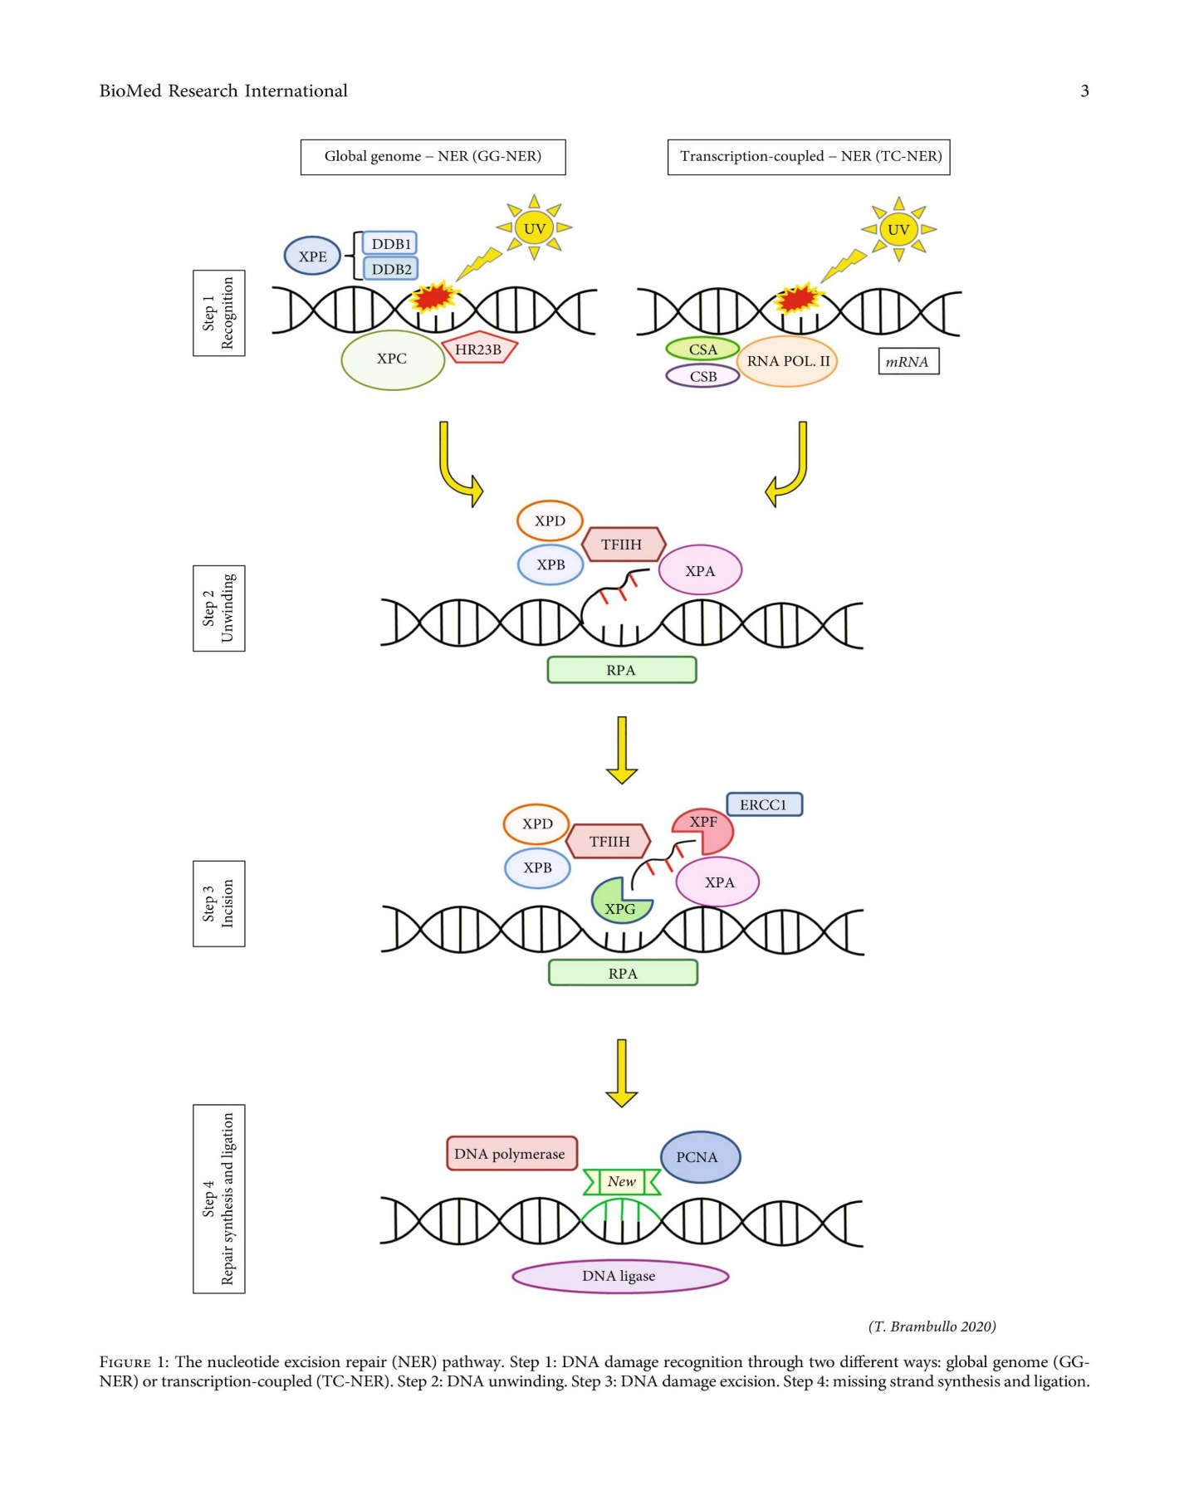

**Figure The nucleotide excision repair (NER) pathway.**

Step 1: DNA damage recognition through two different ways: global genome (GGNER) or transcription-coupled (TC-NER).

Step 2: DNA unwinding.

Step 3: DNA damage excision.

Step 4: missing strand synthesis and ligation**.**

**BIOCHEMISTRY OF DIAGONISTIC:-**

ognized in nuclear DNA within different functional domains (Figure ) . Damage in transcriptionally inactive regions is detected by the damage DNA-binding protein complex DDB1/DDB2 (DDB2 is also known as XPE) and by XPC/homologous recombination protein 23B (HR23B)/centrin2. Damage in transcriptionally active regions is detected through arrest of the transcriptional machinery involving RNA polymerases I and II, and requires the CSA and CSB proteins that are mutated in the CS disorder. The damaged site is then remodeled through a series of preincision complexes . XPA, replication protein A (RPA), XPC, and the transcription DNA repair factor IIH (TFIIH) assemble in a random but cooperative order on the damaged site. They form an unstable preincision complex that is stabilized once the DNA is unwound by the ATPase activity of XPB and the ATPase/helicase activity of XPD in TFIIH . TFIIH is a 10-component transcription factor containing XPB and XPD. XPC recruits XPG and is displaced from the complex. Cleavage then occurs on both sides of the damaged site, firstly by the XPG 3′ nuclease and then by the XPF/excision repair cross-complementing protein 1 (ERCC1) 5′ nuclease. The nucleases are anchored by the XPA/RPA complex, which serves to define the cleavage sites and strand specificity. Once the damaged oligonucleotide is removed, a patch is resynthesized by the proliferating cell nuclear antigen, the polymerases delta, epsilon, or kappa (δ, εor κ), and a ligase enzyme . In quiescent cells, ligation involves X-ray repair cross-complementing protein 1 (XRCC1) and ligase III; in proliferating cells, ligation involves ligase I.

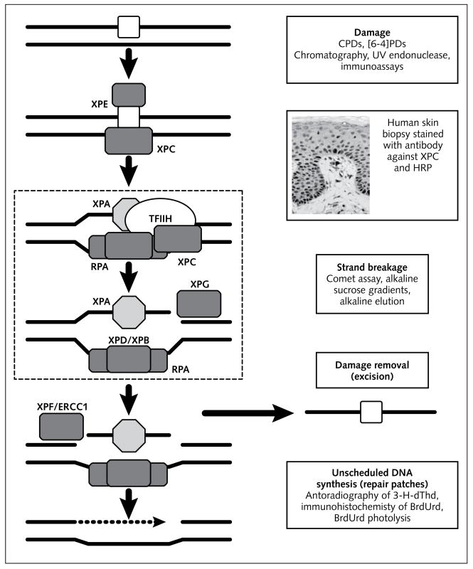NER can remove DNA damage before DNA replication begins and, consequently, plays a major role in reducing the amount of damage that becomes fixed as mutations during replication . Specialized polymerases are required to replicate DNA photoproducts because the normal DNA polymerases – alpha, delta, and epsilon (α, δ, and ε) – cannot accommodate large distortions such as DNA photoproducts or adducts in their active sites . These damage-specific polymerases have relaxed substrate specificity, and the most important is the low-fidelity polymerase Pol eta (η) . This is mutated in the XPV condition, which is often clinically indistinguishable from NER-deficient XP

Pathways of nucleotide excision repair and diagnostic methods. The proteins indicated are the main ones involved in XP; binding partners and other components are omitted for clarity.

Left column: schematic of NER. The initial damage (top) is recognized by the XPE and XPC DNA-binding proteins. The damaged site is then remodeled through a series of preincision complexes, indicated within the hatched box . XPA, RPA, and XPC/TFIIH form an initial preincision complex that is stabilized once the DNA is unwound by the ATPase activity of XPB and ATPase/helicase activity of XPD in TFIIH . XPC recruits XPG and is displaced from the complex. Cleavage then occurs on both sides of the damaged site, firstly by the XPG 3′ nuclease and then by the XPF/ERCC1 5′ nuclease. Once the damaged oligonucleotide is removed, a patch is resynthesized and is completed by polymerases and ligases.

Right column: steps in NER that have been addressed for diagnosing repair by (top to bottom) damage detection, protein expression by immunohistochemistry, strand breakage, damage removal, and unscheduled DNA synthesis.

BrdUrd: bromodeoxyuridine; dThd: tritiated thymidine; ERCC1: excision repair cross-complementing protein 1; HRP: horseradish peroxidase counter stain for XPC antibody; NER: nucleotide excision repair; RPA: replication protein A; TFIIH: transcription/DNA repair factor IIH; UV: ultraviolet; XP: xeroderma pigmentosum

**MANAGAMENT :-**

At present, there is no cure for XP. Therefore, prevention of complications is crucial for this disfiguring and potentially lethal disease. Strict and consistent sun avoidance and protection and early detection and treatment of premalignant and malignant skin lesions are the mainstays of management. These and other treatment options are summarized as follows. Regular paediatric, dermatological, ophthalmological and neurological follow-up is essential.

**Treatment options for xeroderma pigmentosum:-**

1. Sun avoidance and sun protection
   1. Sun avoidance
   2. Sun protection (regular use of broad-spectrum sunscreens)
2. Chemoprevention of skin cancers
   1. Oral isotretinoin
   2. Topical imiquimod
   3. Topical fluorouracil
3. Treatment of poikiloderma
   1. Chemical peeling
   2. Dermabrasion
   3. Carbon dioxide (CO2) or erbium-YAG laser resurfacing
4. Treatment of actinic keratosis
   1. Cryotherapy
   2. Topical imiquimod
   3. Topical 5-fluorouracil
   4. Chemical peeling
   5. Excision
   6. CO2 or erbium-YAG laser resurfacing
   7. Fractional/pulsed laser therapy
   8. Photodynamic therapy
5. Treatment of skin cancers
   1. Photodynamic therapy
   2. Curettage with electrodessication
   3. Aggressive cryosurgery
   4. Surgical excision
   5. Oral vismodegib, pembrolizumab, nivolumab and cemiplimab
   6. Ocular management
   7. Methylcellulose eyedrops
   8. Soft UV-protective contact lens
   9. For ocular surface squamous neoplasia
      1. Surgical resection and intraoperative cryotherapy
      2. Subconjunctival injection of IFNα2b with topical cycles of mitomycin C eyedrops
6. Neurological management
   1. May need hearing aids, speech therapy, physical therapy and occupational therapy
   2. No effective treatment for neurodegeneration
7. Investigational therapies
   1. Topical T4 endonuclease-V
   2. Oral vismodegib
   3. Oral nicotinamide
   4. Oral Polypodium leucotomos extract
   5. Oral coenzyme Q10
   6. Gene therapy
8. Genetic counselling
9. Psychological counselling

**CONCLUSION:-**

Skin tumors may be not “appealing” for genetic researchers with respect to gastrointestinal or lung or breast cancer, but their impact on the patient’s quality of life can be tremendous, especially when skin cancer starts occurring during childhood without ever ending.

Patients and their families experience the tragedy of a sunless life, since the major triggers for skin cancer development are UV rays.

Despite efforts made to avoid sun exposure with clothes and sunscreens, from adolescence on melanoma and NMSC have great chance to occur on all the body surfaces, even if the head and neck area and dorsum of the hands remain the more subjected to disease.

Studies with better scientific evidence are needed. Randomized trials or prospective cohort studies should be encouraged in care centers of patients with xeroderma pigmentosum.

Far from obtaining conclusive results, this analysis has some strengths.

First, this is a systematic review specifically focused on correlation between XP and skin cancers that was never been conducted before.

Second, the quality of eligible studies included in the current review was satisfactory and met our inclusion criteria.

Third, we succeeded in pointing out the lack of studies and research in the literature on this field, taking into account that many meta-analyses report the same studies, now dated, and characterized by similar publication bias.

Undoubtedly, the absence of a statistical analysis of the stratified sources to obtain adjusted estimates and the small sample of investigations analysed represent the limits of this study.

**References:-**

1. Black JO. Xeroderma Pigmentosum. Head Neck Pathol. 2016 Jun;10(2):139-44. [PMC free article] [PubMed].
2. Cleaver JE. Defective repair replication of DNA in xeroderma pigmentosum. Nature. 1968 May 18;218(5142):652-6. [PubMed].
3. Reed WB, Landing B, Sugarman G, Cleaver JE, Melnyk J. Xeroderma pigmentosum. Clinical and laboratory investigation of its basic defect. JAMA. 1969 Mar 17;207(11):2073-9. [PubMed].
4. DiGiovanna JJ, Kraemer KH. Shining a light on xeroderma pigmentosum. J Invest Dermatol. 2012 Mar;132(3 Pt 2):785-96. [PMC free article] [PubMed].
5. Lehmann AR, McGibbon D, Stefanini M. Xeroderma pigmentosum. Orphanet J Rare Dis. 2011 Nov 01;6:70. [PMC free article] [PubMed].
6. Robbins JH, Kraemer KH, Lutzner MA, Festoff BW, Coon HG. Xeroderma pigmentosum. An inherited diseases with sun sensitivity, multiple cutaneous neoplasms, and abnormal DNA repair. Ann Intern Med. 1974 Feb;80(2):221-48. [PubMed].
7. Bradford PT, Goldstein AM, Tamura D, Khan SG, Ueda T, Boyle J, Oh KS, Imoto K, Inui H, Moriwaki S, Emmert S, Pike KM, Raziuddin A, Plona TM, DiGiovanna JJ, Tucker MA, Kraemer KH. Cancer and neurologic degeneration in xeroderma pigmentosum: long term follow-up characterises the role of DNA repair. J Med Genet. 2011 Mar;48(3):168-76. [PMC free article] [PubMed]
8. Brooks BP, Thompson AH, Bishop RJ, Clayton JA, Chan CC, Tsilou ET, Zein WM, Tamura D, Khan SG, Ueda T, Boyle J, Oh KS, Imoto K, Inui H, Moriwaki S, Emmert S, Iliff NT, Bradford P, Digiovanna JJ, Kraemer KH. Ocular manifestations of xeroderma pigmentosum: long-term follow-up highlights the role of DNA repair in protection from sun damage. Ophthalmology. 2013 Jul;120(7):1324-36. [PMC free article] [PubMed]
9. Karass M, Naguib MM, Elawabdeh N, Cundiff CA, Thomason J, Steelman CK, Cone R, Schwenkter A, Jordan C, Shehata BM. Xeroderma pigmentosa: three new cases with an in depth review of the genetic and clinical characteristics of the disease. Fetal Pediatr Pathol. 2015 Apr;34(2):120-7. [PubMed]
10. Kraemer KH, DiGiovanna JJ, Moshell AN, Tarone RE, Peck GL. Prevention of skin cancer in xeroderma pigmentosum with the use of oral isotretinoin. N Engl J Med. 1988 Jun 23;318(25):1633-7. [PubMed]
11. Natale V, Raquer H. Xeroderma pigmentosum-Cockayne syndrome complex. Orphanet J Rare Dis. 2017 Apr 04;12(1):65. [PMC free article] [PubMed]
12. Suzumura H, Arisaka O. Cerebro-oculo-facio-skeletal syndrome. Adv Exp Med Biol. 2010;685:210-4. [PubMed]
13. Xeroderma pigmentosum support group. [http://joomla.xpsupportgroup.org.uk].
14. XP family support group [http://www.xpfamilysupport.org] and xeroderma pigmentosum society. [http://www.xps.org/].
15. Enfants de la lune. [http://asso.orpha.net/AXP].
16. XP Freu(n)de. [http://www.xerodermapigmentosum.de].
17. Human DNA repair genes. [http://sciencepark.mdanderson.org/labs/wood/DNA_Repair_Genes.html].
18. Lindahl T and Wood RD: Quality control by DNA repair.Science 286: 1897-1905, 1999.
19. Wood RD, Mitchell M, Sgouros J and Lindahl T: Human DNA repair genes. Science 291: 1284-1289, 2001.
20. Scharer OD: Nucleotide excision repair in eukaryotes. Cold Spring Harb Perspect Biol 5: a012609, 2013.
21. Schubert S, Lehmann J, Kalfon L, Slor H, Falik-Zaccai TC and Emmert S: Clinical utility gene card for: Xeroderma pigmentosum. Eur J Hum Genet 22: e1-e4, 2014.
22. Emmert S: Xeroderma pigmentosum, Cockayne’s syndrome, and trichothiodystrophy. In: Harper’s Textbook of Pediatric Dermatology. Irvine AD, Hoeger P and Yan A (eds.). WileyBlackwell, Oxford (UK): Chapt. 135, pp. 135.1-135.24, 2011.
23. Kraemer KH, DiGiovanna JJ, Moshell AN, Tarone RE and Peck GL: Prevention of skin cancer in xeroderma pigmentosum with the use of oral isotretinoin. N Engl J Med 318: 1633-1637, 1988.
24. Moshell AN: Prevention of skin cancer in xeroderma pigmentosum with oral isotretinoin. Cutis 43: 485-490, 1989.
25. Tanaka K, Sekiguchi M and Okada Y: Restoration of ultravioletinduced unscheduled DNA synthesis of xeroderma pigmentosum cells by the concomitant treatment with bacteriophage T4 endonuclease V and HVJ (Sendai virus). Proc Natl Acad Sci USA 72: 4071-4075, 1975.
26. Zahid S and Brownell I: Repairing DNA damage in xeroderma pigmentosum: T4N5 lotion and gene therapy. J Drugs Dermatol 7: 405-408, 2008.Moscarella E, Argenziano G, Longo C and Aladren S:
27. Management of cancerization field with a medical device containing photolyase: a randomized, double-blind, parallelgroup pilot study. J Eur Acad Dermatol Venereol 31: e401-e403,2017.
28. Fife D, Laitinen MA, Myers DJ and Landsteiner PB: Vismodegib therapy for basal cell carcinoma in an 8-year-old Chinese boy with xeroderma pigmentosum. Pediatr Dermatol 34:163-165, 2017.
29. Hauschild A, Eichstaedt J, Mobus L, Kahler K, Weichenthal M,Schwarz T and Weidinger S: Regression of melanoma metastases and multiple non-melanoma skin cancers in xeroderma pigmentosum by the PD1-antibody pembrolizumab.Eur J Cancer 77: 84-87, 2017.
30. Ikeda S, Goodman AM, Cohen PR, Jensen TJ, Ellison CK,Frampton G, Miller V, Patel SP and Kurzrock R: Metastatic basal cell carcinoma with amplification of PD-L1: exceptional response to anti-PD1 therapy. NPJ Genom Med 1: 1-12, 2016.
31. Warrick E, Garcia M, Chagnoleau C, Chevallier O, Bergoglio V,Sartori D, Mavilio F, Angulo JF, Avril MF, Sarasin A, Larcher F, Del Rio M, Bernerd F and Magnaldo T: Preclinical corrective gene transfer in xeroderma pigmentosum human skin stem cells.Mol Ther 20: 798-807, 2012.
32. Dupuy A, Valton J, Leduc S, Armier J, Galetto R, Gouble A,Lebuhotel C, Stary A, Paques F, Duchateau P, Sarasin A and Daboussi F: Targeted gene therapy of xeroderma pigmentosum cells using meganuclease and TALEN. PLoS One 8: e78678,2013.
33. Lehmann J, Seebode C and Emmert S: Research on genodermatoses using novel Genome Editing Tools. J Dtsch Dermatol Ges 15: 783-789, 2017.
34. L, Heidenreich M, Banerjee A, Habib N, Li Y, Trombetta J, Sur M and Zhang F: In vivo interrogation of gene function in the Swiech mammalian brain using CRISPR-Cas9. Nat Biotechnol 33:102-106, 2015.
35. Lin, X. Pu, W. Wang et al., “Case-control analysis of nucleotide excision repair pathway and the risk of renal cell carcinoma,” Carcinogenesis, vol. 29, no. 11, pp. 2112–2119, 2008.
36. Jelonek, A. Gdowicz-Kłosok, M. Pietrowska et al., “Association between single-nucleotide polymorphisms of selected genes involved in the response to DNA damage and risk of colon,head and neck, and breast cancers in a Polish population,” Journal of Applied Genetics, vol. 51, no. 3, pp. 343–352, 2010.
37. F. T. Gonçalves, G. Francisco, S. P. de Souza et al., “European ancestry and polymorphisms in DNA repair genes modify the risk of melanoma: a case-control study in a high UV index region in Brazil,” Journal of Dermatological Science, vol. 64,no. 1, pp. 59–66, 2011.
38. C. Oliveira, J. A. Rinck-Junior, G. J. Lourenço, A. M. Moraes,and C. S. P. Lima, “Assessment of the XPC (A2920C), XPF (T30028C), TP53 (Arg72Pro) and GSTP1 (Ile105Val) polymorphisms in the risk of cutaneous melanoma,” Journal of Cancer Research and Clinical Oncology, vol. 139, no. 7,pp. 1199–1206, 2013.
39. R. C. Sobti, S. Kaur, V. L. Sharma, S. K. Singh, S. A. Hosseini,and R. Kler, “Susceptibility of XPD and RAD51 genetic variants to carcinoma of urinary bladder in North Indian population,” DNA and Cell Biology, vol. 31, no. 2, pp. 199–210, 2012.
40. Shen, S. I. Berndt, N. Rothman et al., “Polymorphisms in the DNA nucleotide excision repair genes and lung cancer risk in Xuan Wei, China,”International Journal of Cancer, vol. 116,no. 5, pp. 768–773, 2005.
41. E. Gershenwald, R. A. Scolyer, K. R. Hess et al., “Melanoma staging: evidence-based changes in the American Joint Committee on Cancer Eighth Edition Cancer Staging Manual,”CA: a Cancer Journal for Clinicians, vol. 67, no. 6, pp. 472–492, 2017.
42. P. V. Dickson and J. E. Gershenwald, “Staging and prognosis of cutaneous melanoma,” Surgical Oncology Clinics of North America, vol. 20, no. 1, pp. 1–17, 2011.
43. Dinnes, L. F. di Ruffano, Y. Takwoingi et al., “Ultrasound,CT, MRI, or PET-CT for staging and re-staging of adults with cutaneous melanoma,” Cochrane Database of Systematic Reviews, vol. 7, no. 7, article CD012806, 2019.
44. R. N. Amaria, A. M. Menzies, E. M. Burton et al., “Neoadjuvant systemic therapy in melanoma: recommendations of the International Neoadjuvant Melanoma Consortium,” The Lancet Oncology, vol. 20, no. 7, pp. e378–e389, 2019.
45. W. C. Lambert and M. W. Lambert, “Development of effective skin cancer treatment and prevention in xeroderma pigmentosum,” Photochemistry and Photobiology, vol. 91, no. 2,pp. 475–483, 2015.
46. Loncaster, R. Swindell, F. Slevin, L. Sheridan, D. Allan, and E. Allan, “Efficacy of photodynamic therapy as a treatment for Gorlin syndrome-related basal cell carcinomas,” Clinical Oncology (Royal College of Radiologists), vol. 21, no. 6,pp. 502–508, 2009.
47. V. Madan, J. Loncaster, D. Allan et al., “Systemic photodynamic therapy with Photofrin for naevoid basal cell carcinoma syndrome–a pilot study,” Photodiagnosis and Photodynamic Therapy, vol. 2, no. 4, pp. 273–281, 2005.
48. D. K. Cohen and P. K. Lee, “Photodynamic therapy for nonmelanoma skin cancers,” Cancers, vol. 8, no. 10, article 90,2016.
49. W. E. Love, J. D. Bernhard, and J. S. Bordeaux, “Topical imiquimod or fluorouracil therapy for basal and squamous cell carcinoma: a systematic review,” Archives of Dermatology,vol. 145, no. 12, pp. 1431–1438, 2009.
50. E. Davis, S. C. Shalin, and A. J. Tackett, “Current state of melanoma diagnosis and treatment,” Cancer Biology & Therapy, vol. 20, no. 11, pp. 1366–1379, 2019.
51. S. Marabondo and H. L. Kaufman, “High-dose interleukin-2 (IL-2) for the treatment of melanoma: safety considerations and future directions,” Expert Opinion on Drug Safety,vol. 16, no. 12, pp. 1347–1357, 2017.
52. R. Payne, L. Glenn, H. Hoen et al., “Durable responses and reversible toxicity of high-dose interleukin-2 treatment of melanoma and renal cancer in a Community Hospital Biotherapy Program,” Journal for Immunotherapy of Cancer, vol.2, no. 1,article 13, 2014.
53. http://www.cancer.org/.[49] D. B. Johnson, I. Puzanov, and M. C. Kelley, “Talimogene laherparepvec (T-VEC) for the treatment of advanced melanoma,” Immunotherapy, vol. 7, no. 6, pp. 611–619, 2015.
54. Sun, M. J. Carr, and N. I. Khushalani, “Principles of targeted therapy for melanoma,” The Surgical Clinics of North America,vol. 100, no. 1, pp. 175–188, 2020.
55. S. M. Lee, D. C. Betticher, and N. Thatcher, “Melanoma: chemotherapy,” British Medical Bulletin, vol. 51, no. 3, pp. 609–630, 1995.
56. Y. Song, A. N. Bruce, D. L. Fraker, and G. C. Karakousis, “Isolated limb perfusion and infusion in the treatment of melanoma and soft tissue sarcoma in the era of modern systemic therapies,” Journal of Surgical Oncology, vol. 120, no. 3,pp. 540–549, 2019.
57. D. Moreno-Ramirez, L. de la Cruz-Merino, L. Ferrandiz,R. Villegas-Portero, and A. Nieto-Garcia, “Isolated limb perfusion for malignant melanoma: systematic review on effectiveness and safety,” The Oncologist, vol. 15, no. 4, pp. 416–427,2010.
58. E. M. Noorda, B. Takkenberg, B. C. Vrouenraets et al., “Isolated limb perfusion prolongs the limb recurrence-free interval after several episodes of excisional surgery for locoregional recurrent melanoma,” Annals of Surgical Oncology, vol. 11,no. 5, pp. 491–499, 2004.
59. S. J. Oiseth and M. S. Aziz, “Cancer immunotherapy: a brief review of the history, possibilities, and challenges ahead,” Journal of Cancer Metastasis and Treatment, vol. 3, no. 10, p. 250,2017.
60. Guminski and B. Stein, “Immunotherapy and other systemic therapies for cutaneous SCC,” Oral Oncology, vol. 99,article 104459, 2019.
61. Okamura, M. Toyoda, K. Hata, K. Nakabayashi, and A. G.Umezawa, “Whole-exome sequencing of fibroblast and its iPS cell lines derived from a patient diagnosed with xeroderma pigmentosum,” Genomics Data, vol. 6, pp. 4–6, 2015.
62. D. Ding, Y. Zhang, H. Yu et al.,“Genetic variation of XPA gene and risk of cancer: a systematic review and pooled analysis,”International Journal of Cancer, vol. 131, no. 2, pp. 488–496,2012.
63. J. H. Robbins, “Xeroderma pigmentosum,” Annals of Internal Medicine, vol. 80, no. 2, pp. 221–248, 1974.
64. W. J. Kleijer, V. Laugel, M. Berneburg et al., “Incidence of DNA repair deficiency disorders in Western Europe: xeroderma pigmentosum, Cockayne syndrome and trichothiodystrophy,” Cockayne Syndrome and Trichothiodystrophy. DNA Repair (Amst), vol. 7, no. 5, pp. 744–750, 2008.
65. Y. Hirai, Y. Kodama, S. Moriwaki et al., “Heterozygous individuals bearing a founder mutation in the XPA DNA repair gene comprise nearly 1% of the Japanese population,” Mutation Research, vol. 601, no. 1-2, pp. 171–178, 2006.
66. Zghal, N. El-Fekih, B. Fazaa et al., “Xeroderma pigmentosum. cutaneous, ocular, and neurologic abnormalities in 49 Tunisian cases,” La Tunisie Médicale, vol. 83, no. 12,pp. 760–763, 2005.
67. D. Bootsma, K. H. Kraemer, J. E. Cleaver, and J. H. J. Hoeijmakers, “Nucleotide excision repair syndromes: xeroderma pigmentosum and trichothiodystrophy,” in The Genetic Basis of Human Cancer, B. Vogelstein and K. W. Kinzler, Eds.,pp. 245–274, McGraw-Hill; New York, NY, USA, 1998.
68. Ben Rekaya, N. Laroussi, O. Messaoud et al., “A founder large deletion mutation in xeroderma pigmentosum-variant form in Tunisia: implication for molecular diagnosis and therapy,” BioMed Research International, vol. 2014, Article ID 256245, 8 pages, 2014.
69. J. Zhao, S. Chen, H. Zhou et al., “XPGrs17655 G>C polymorphism associated with cancer risk: evidence from 60 studies,”Aging (Albany NY), vol. 10, no. 5, pp. 1073–1088, 2018.
70. T. Bradford, A. M. Goldstein, D. Tamura et al., “Cancer and neurologic degeneration in xeroderma pigmentosum: long term follow-up characterises the role of DNA repair,” Journal of Medical Genetics, vol. 48, no. 3, pp. 168–176, 2011.