**A study on the Attrition and Absenteeism in the Garment Industry of Odisha**

**\*Dr Sushree Sangita Ray, *Dr Rachita Ota**

*Assistant Professor, Amity Global Business School, Bhubaneswar

**Abstract**

Managing absenteeism and attrition is an important aspect of human resource management, as it can have significant implications for the success of an organization. Garment industries cannot afford absenteeism and attrition as it affects the productivity of the factory. The objective of the study is to identify the reason behind absenteeism and attrition. The study was conducted with the help of both primary and secondary data. The process included consistent observation of behaviour patterns of employees from different sections, face to face interviews with the help of a structured questionnaire. With the help of certain secondary data in the form of a content analysis the researcher attempted to compare between the different garment industry located in Odisha. The study highlights major reasons for attrition and absenteeism, which is affecting the efficiency and productivity of these industries. Organizations need to develop effective strategies to manage absenteeism and attrition. This further results in the improvement of productivity, reduce costs, and retain valuable talent. This may involve creating a positive work environment, providing opportunities for professional development, offering competitive compensation and benefits, and improving communication between management and employees.

**Keywords:** Attrition, Absenteeism, Garment, Organizational Efficiency, Productivity

**Introduction:**

Absenteeism and attrition are two important concepts in the field of human resource management. Absenteeism refers to the habitual or intentional absence of employees from work without any valid reason, while attrition refers to the process of employees leaving an organization due to various reasons, such as retirement, resignation, or termination. Absenteeism can have a negative impact on an organization in several ways. It can disrupt work schedules, decrease productivity, and affect the morale of other employees. Moreover, it can increase labor costs, as companies may need to hire temporary staff or pay overtime to cover for absent employees. Attrition, on the other hand, can also have significant consequences for an organization. It can lead to a loss of valuable talent and skills, as well as a decline in productivity. It can also increase recruitment costs and decrease employee morale.

The garment industry is one of the largest and most important industries in many countries, providing employment opportunities for millions of people. However, it is also an industry that is prone to high levels of attrition and absenteeism. In the garment industry, attrition can occur for various reasons. These may include poor working conditions, low wages, lack of career development opportunities, or the availability of better job opportunities elsewhere. High levels of attrition can result in a loss of valuable talent, increased recruitment and training costs, and decreased productivity.

Absenteeism is also a common challenge in the garment industry. Workers may be absent from work due to illness, family emergencies, or personal reasons. However, in some cases, absenteeism may be due to dissatisfaction with work conditions, low morale, or a lack of motivation. To address these challenges, garment industry employers need to develop effective strategies to manage attrition and absenteeism. This may include improving working conditions, offering competitive wages and benefits, providing opportunities for professional development and career growth, and creating a positive work environment that fosters employee engagement and motivation.

Additionally, implementing effective HR policies and practices can help to manage absenteeism and attrition. For example, organizations can implement attendance management programs to monitor and reduce absenteeism or introduce employee engagement programs to increase employee motivation and satisfaction.

Aditya Birla Fashion and Retail Limited is one of the top subsidiaries of Aditya Birla Group, a US $ 48.3 billion Indian Multinational Company. ABFRL is anchored by an extraordinary workforce of over 25,000 employees in retail and 12,000 employees across 9 manufacturing facilities in the States of Odisha, Karnataka, and Tamil Nadu. In Odisha, ABFRL established a 66-crore worth project factory in Mancheswar on 23rd October 2018, manufacturing Ready-Made Garments of its brand “Peter England, Van Heusen, Louis Philippe & Allen Solly”. In the Mancheswar factory, 75% of production is done for Peter England, and 25% of production is done for the rest of the brands.

As per FY 21, 28 lac pcs are produced annually and are planning to expand the production capacity up to 43.2 lac pcs within FY 23. The factory has anchored 24 sewing lines, 988 machinery, and potential hardworking employees. As it is a female-centric organization the ratio of females is higher than males.

In leading a female-centric organization, the role of industrial relations does not contribute much to the rate of major conflict and Strick does not take place. But attrition and absenteeism occur a lot often at an average rate of 1.87% (2021-2022) and 10% (2021-2022). As a manpower-based organization, it cannot afford to entertain the maximum rate of absenteeism but rather slam the rate as lower as possible.

**Literature Review**

Absenteeism and Attrition are simple terms, we can even guess the reasons behind them but that makes it more difficult to control. Absenteeism is an act done by a person staying away from the workplace. There can be any reason such as sick, family function, vacation, and so on. Absenteeism is not considered to be a bad practice but getting habituated is not a nightmare for the organization but for your own career.

Attrition on the other hand is the employee who attempts to leave the organization. It may be because of better opportunities, conflicts, job satisfaction, and so on. Any organization cannot afford to lose potential and talented employees. it is really important to the working environment as friendly as possible and to control conflict among the employee-employer and the group.

K.Vishnupriya, N.S.Suganya, P.Bhuvaneswari (September 2012) in his paper titled - “A study on absenteeism among the employees of Textiles Industries” identified that the employees are the least interested to come for work due to lack of monetary and monetary motivation. The paper suggested that in order to reduce absenteeism, the organization need to create a friendly relationship between the employer and employee with a proper inclusion of monetary benefits. There has been multiple factors which triggers Absenteeism as mentioned in the paper titled - “Factors affecting Employee Absenteeism” by Tekin Akgeyik in the year 2014. Among the various demographic factors Gender, Age, Education, Demography, and Astrological sign, the astrological signs had a greater impact on Absenteeism followed by education. Other studies have also highlighted few more factors such as bad relationship with their supervisor, unsatisfactory wages and compensation (T.S. Nanjundeswaraswamy, 2016). Studies stated that in case of garment industry, workplaces are frequently congested and have insufficient workstations, which can lead to occupational dangers such as musculoskeletal ailments and communicable diseases. Fires and building collapse frequently cause injuries, fatalities, disabling conditions, and death in the RMG industry. There can be different at different organizational levels to reduce the absenteeism and to reduce the attrition (Paul, 1996). T. Karibasaapa (2020) did similar research on an industry in Bengaluru. He suggested to the organization some changes like flexible working hours, improving the working environment and compensation, making separate sick leave to take employee’s absenteeism, and make some disciplinary action who miss utilizing sick leaves and unauthorized leave. Khan (2011) argued that social compliance concerns and labor norms should be strengthened in order to increase wages, working conditions, overtime pay, job security, the ability to establish unions, social security, and occupational health and safety in order to lower absenteeism among employees.

**Objective:**

With the extensive review of different literatures, the researchers have been able to frame the objective of the study which is as follows:

*“To study the various factors affecting the attrition and absenteeism of the workforce at the garment industry”.*

**Research Methodology:**

This is a descriptive research study based on quantitative analysis meant to identify the factors affecting the productivity at the garment industry. The study comprised of both primary and secondary data analysis. The primary data collection was done with the help of a structured questionnaire. The responses were collected through a survey with the help of the research instrument (Structured Questionnaire). The primary survey was confined to the workforce of Aditya Birla Fashion & Retail Limited. A total of 50 sample was identified through random stratified sampling method, where 10 random respondents were identified from different operational departments (Cutting, Parts, Assembly Line, Finishing, Warehouse). The data collected from the survey was further analysed through various descriptive statistics and the secondary data was used for an extensive content analysis. The content analysis was focused to provide a detailed comparison of the attrition and absenteeism at various garment industries in Odisha.

**Analysis & Interpretation**

The Primary Research was mainly confined to Aditya Birla Fashion & Retail Limited workforce, where through a face-to-face interview with the help of a structured questionnaire the responses were collected. Further the responses underwent a descriptive research statistic to interpret the data collected. The first section of the analysis comprises of the demographic profiling and descriptive analysis of the responses collected through the survey.

Demographic Profiling

This demographic profiling provides a detailed description of the demographic status of the respondents as well as the occupational details which has been considered as independent variables of the study. These independent variables include age, marital status, education, department, and years of job.

Out of 50 respondents, 80% i.e., 40. were less than or equal to the age 26, whereas20% were above the age 26, 10. In case of Marital Status, out of 50 respondents, 80% of the employees i.e., 40 employees were unmarried and out of those employees are uncertain whether they will continue their job or not after they get married. So here we can say the attrition is certain. But on the bright side, there were employees out of 18% i.e. 9 who continue their job after their marriage. They love to work in the organization and got lucky enough to get married in a place where their in-laws were supportive and encourage to continue with their job.

In case of education, out of 50, 48% of the employees have studied till 10th and 12th. But there were employees who completed or continued their graduation with their job. They appreciated the support provided by the organization. Giving encouragement and respect for their choice of completing their education.

According to the data, most of the employees belong to different districts, staying away from their families. It is obvious in festival holidays there is a good chance of unauthorized absenteeism which is a threat call for any garment industry.

Further, for getting an equal percentage of responses from different departments, equal number of respondents were identified from every section. A total of 10 respondents each from the five sections – Cutting, Sewing, Parts, Assembly line, Finishing and Warehouse. 54% of the employees have been associated with this job for more than 2 years. Some of them were working here since day one. While 22% of the employee are working for more than a year and 24% were the freshers who recently joined and working here for around 6 to 9 months. For this study, the researchers mostly preferred freshers, even though they have not spent much time but they surely identify their feeling regarding the organization whether they are like working here or not and if they have any second thoughts or any problem, they are facing but hesitate to speak up.

The study also attempted to take responses regarding the various occupational aspects of the workforce to understand their attitude towards continuing their job in this organization.

Interpretation regarding the breaks and sanitary facilities

To start with, their opinion towards the frequent breaks at the organization was taken into consideration. The question on breaks sounds simple and unimportant but observing the working process from different sections it is quite evident that all the departments except the sewing department work for 8 hours per day in a standing position. Talking about the Sewing department they sit and work. Working for 8 hrs either in Sitting or Standing position is very tiring and even cause through body stress. So, it is important to get breaks in between and it is crystal clear that the breaks provided by the organization are sufficient for the employee from every department.

According to the Factories act, 1948, section 19(3) the State Government prescribed the organization to have 1 washroom for 25 employees.

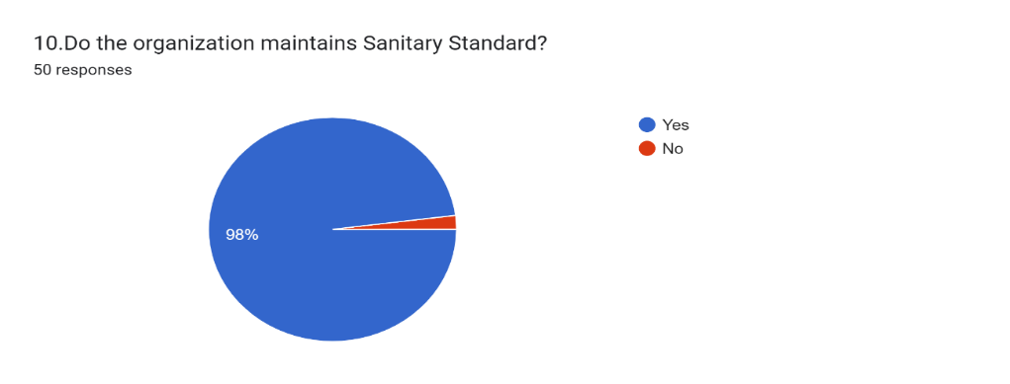

According to the respond and my personal observation, the organization has well maintained their washrooms and constants cleaning has been taken on a serious note. As per the survey the majority of the respondents agreed that the organization has proper sanitary facilities.

Interpretation regarding Unauthorised Absenteeism

Unauthorized absenteeism refers to situations where an employee is absent from work without obtaining prior approval from their supervisor or manager. It can occur for a variety of reasons, such as illness, personal emergencies, family issues, or simply not showing up for work.

Unauthorized absenteeism can have negative consequences for both employees and employers. For employees, it can lead to disciplinary action, loss of pay, and damage to their reputation. For employers, it can result in decreased productivity, increased labor costs, and disruption of work schedules.

To address unauthorized absenteeism, employers need to develop effective policies and procedures to manage attendance. This may include clearly communicating attendance expectations and consequences, tracking and monitoring attendance, and providing support to employees who may be struggling with attendance issues. The study have attempted to understand the opinion of the workforce regarding communicating about their leaves and the unauthorised leaves if taken further the reasons behind them.

A good cordial relationship between employees and their employer can act as a solution to most of the issues cropped up in an organization, which depends on a barrier free effective communication.

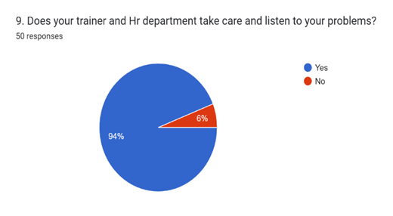

The study highlights that a small percent of 6, among the respondents from different sections are not having a good relationship with their trainer/In-change/line leader and this 6% of respondents fall under the category of less than or equal to 26. Their conflicts between Trainer/In-charge/line leader are a combination of ego and immaturity.

Considering the availing of the unauthorized leaves, majority of the respondents agreed that they have availed it and the statistics of the same is clearly depicted in the figure below.

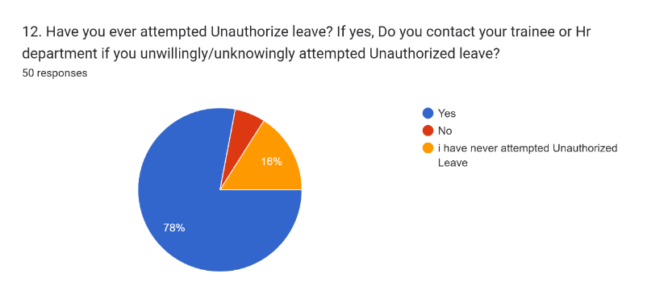

78% of employees admitted it clarified the reason behind it. 16% of employees did not attempt it. Remain 6% of the employee were freshers who were not having any idea of the same.

Discussing about the different reasons behind the unauthorized absenteeism, the following responses were collected from the identified respondents.

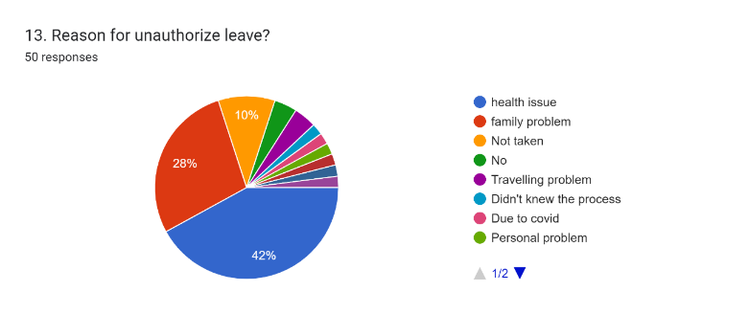

The above figure displays the various reasons behind unauthorized absenteeism and among all the reasons the most frequent one is the health issues which carried 42% and Family problem, carrying 28% of weightage. Well, these two reasons cannot be taken into consideration as these problems are unpredictable and unavoidable. And remaining were the on-spot problems certainly could not battle out rather informed to their respectable In-charge.

Interpretation regarding Attrition

Attrition is a common challenge in the garment industry, where turnover rates tend to be high. There are several reasons why employees may leave the garment industry, including poor working conditions, low wages, lack of career development opportunities, or the availability of better job opportunities elsewhere.

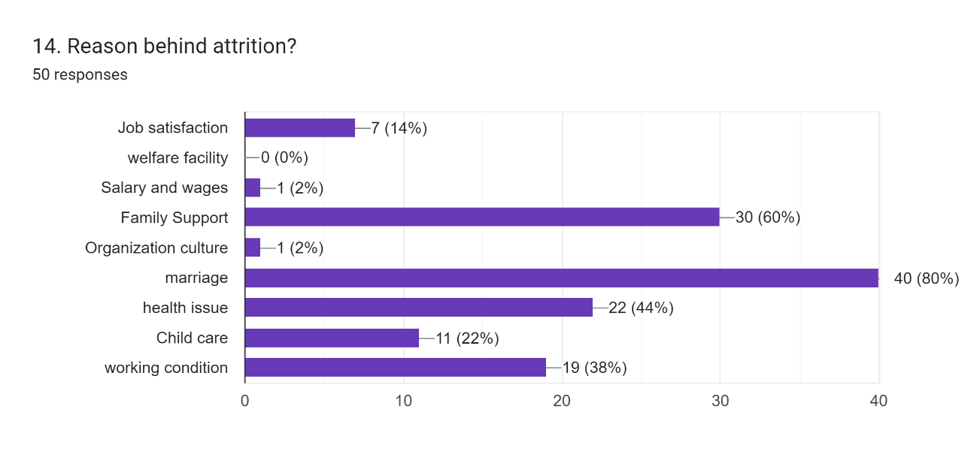

Out of the predicted reasons. Marriage and family support is the common reason behind attrition. The unmarried respondents were not even sure whether they will continue or not.

**Content Analysis**

This segment comprises of a comparison between the flagship companies of Aditya Birla Group i.e., Aditya Birla Fashion & Retail Limited, and Hindalco Industries.

Hindalco Industries Limited is the metals flagship company of the Aditya Birla Group. A US$26 billion metals powerhouse, Hindalco is an industry leader in aluminium and copper.

* Looking at the Employee ratio, Male employees are fewer than females in ABFRL as compared to the Hindalco of Aditya Birla Group.
* Absenteeism rate at ABFRL is 10% per month whereas the Metal facility of Hindalco is around 3% per month. Out of absenteeism, the rate of unauthorized attempts is 3% in ABFRL whereas the metal flagship industry employees have not attempted unauthorized leaves.
* Attrition of ABFRL is 1.83% per month. But at Hindalco metals attrition rate is less than 2% in a year.

Comparing both the industry, it has been interpreted that immaturity and unprofessionalism, or in simple words, lack of dedication and enthusiasm spirit are the cause behind hikes in the rate of absenteeism. The reason behind Attrition is the custom of the Indian culture, married women are projected as ‘homemakers’ responsible for taking care of the entire family. So, it’s considered as the most probable reason behind Attrition at the garment industry.

Comparing ABFRL with the other local industries

Shahi Export was established in the year 1974 by Mrs. Sarla Ahuja. It has grown to become Indians largest apparel manufacturer, operating more than 50 factories and 3 processing mills across 9 states. It has over 1,13,000 employees, including 77,000 women. They are committed to serving our customers through design-led innovation, vertically integrated operations, and positive social and environmental business practices.

Shahi Export launched an apparel manufacturing unit in Odisha to be set up with an investment of Rs 36 crore on 13 August 20015The apparel unit, with a capacity of three lakh dresses per month, will provide direct employment for about 2,500 people.  
While comparing both the Garment factories set up in Odisha. These are the point I got through.

* Looking at the Employee ratio, as both the companies are female-centric, Male candidates are fewer in both the companies. Based on the male ratio, Shahi export has more male employees as compared to ABFRL.
* Absenteeism rate at ABFRL is 10% per month whereas the absenteeism rate at Shahi Export is around 12% per month. Out of absenteeism, the rate of unauthorized attempts is 3% in ABFRL whereas the employees from Shahi Export have attempted at the rate is 4%.
* Attrition of ABFRL is 1.83% per month and at Shahi Export attrition rate is around 4%.

Both companies are the same by nature Both share the same industry and both are female-centric. But the rate of absenteeism and attrition differs. Well, it makes it clear that marriage and personal problems are not the only reason for absenteeism and attrition. There are some other factors which make an employee does not come to a working place.

To find out the factors behind it, information were gathered regarding absenteeism and attrition from FY 2021-22, which helped in creating a better understanding regarding the probable reasons why employees attempt to unauthorize absenteeism and leave the organization.

Going through the data from FY2021-22. In the case of Absenteeism, divided employees into 2 groups age-wise, above 26, and 26 or below 26. The total absenteeism rate is around 53% in the operation department i.e., cutting, sewing, finishing, and warehouse. As you can see in the chart mentioned below. Employees age 26 or below attempt to make unauthorized leave compared to the other age group, especially the new joiners.

Fig: Trend of Absenteeism based on Age

The figure mentioned below tells the reasons behind attrition. Out of other reasons, 2% - 3% of the employee gets terminated by the organization for there in disciplinary action.

Fig: Reasons behind the Attrition in the Industry

**Discussion**

Managing absenteeism is a critical aspect of HR management in the garment industry. To address absenteeism, employers need to develop effective policies and procedures that promote attendance, monitor absenteeism, and provide support to employees who may be struggling with attendance issues.

Here are some strategies that can help manage absenteeism in the garment industry:

Develop clear attendance policies: Employers should develop clear policies that outline attendance expectations, including how and when to report absences, consequences of absenteeism, and procedures for managing and approving leave.

Monitor attendance: Regularly tracking attendance can help identify patterns of absenteeism and allow employers to address attendance issues proactively. Attendance monitoring can be done manually or using an automated system that tracks attendance and generates reports.

Provide support: Employers should provide support to employees who may be struggling with attendance issues. This can include counseling or employee assistance programs to help address personal or family issues that may be impacting attendance.

Encourage open communication: Creating a culture of open communication can help employees feel comfortable discussing attendance issues with their supervisors. Employers should encourage employees to speak up if they are experiencing challenges that may impact their attendance.

Offer incentives: Employers can offer incentives or rewards to encourage good attendance and punctuality. For example, offering bonuses or extra vacation time to employees who maintain good attendance records can be an effective way to promote attendance.

One major factor that contributes to attrition in the garment industry is the low wages paid to workers. Many garment industry employees earn minimum wage or only slightly above, making it difficult to support themselves and their families. This can lead to dissatisfaction and a lack of motivation, which can ultimately result in employees leaving their jobs.

Another factor that contributes to attrition is poor working conditions. Garment industry employees may work long hours in hot, cramped, or poorly ventilated environments, which can be physically and mentally exhausting. Additionally, they may face safety hazards and health risks, such as exposure to chemicals or injury from machinery.

To address these challenges, garment industry employers need to prioritize the well-being of their employees and create a positive work environment that fosters engagement, motivation, and productivity. This may involve improving working conditions, offering competitive wages and benefits, providing opportunities for professional development and career growth, and creating a culture of respect and collaboration.

Additionally, employers may consider implementing employee engagement programs, providing support for workers' health and safety, and offering benefits such as healthcare and retirement plans.

Overall, managing attrition in the garment industry requires a multifaceted approach that addresses the root causes of turnover and prioritizes the well-being and satisfaction of employees. By creating a positive work environment and investing in employee retention strategies, garment industry employers can reduce attrition, improve productivity, and create a more sustainable and successful business.

**Conclusion:**

Referring to research papers, analysing the questionnaire, and observing the behavioural patterns. One can conclude that Absenteeism and Attrition cannot be cured completely but we can at least bring them to a minimum percentage that will not affect the productivity of the organization.

Employees make or break the organization. In short, they are the backbone of the organization. If we respect them, they will respect us. If we appreciate and respect their views, they will take an interest and respect our decision as well. Absenteeism and attrition lean towards the failure of productivity. Happy employees will never let a dent of loss and pray for your success always.

References:

K.Vishnupriya, N.S.Suganya, P.Bhuvaneswari, September 2012, Vol 2, Issue 9, ISSN 2249-1058, IJMT, A study on absenteeism among the employees of Textiles Industries, Coimbatore District.

Tekin Akgeyik, Vol. 14(13), Oct 2014: 69-76, European Journal of Management, Factors affecting Employee Absenteeism.

T.Karibasappa, 2020, Vol. S, No. 2, 4910-4915, Malaya Journal of Matematik, A study on employee absenteeism in garment industries with special reference to Bengaluru.

T.S. Nanjundeswaraswamy, February 2016, [www.GrowingScience.com/msl](http://www.GrowingScience.com/msl) ,An empirical study on absenteeism in garment industry.

Paul-Majumder, P. (1996). Health Impact of Women's Wage Employment: A Case Study of the Garment Industry of Bangladesh. The Bangladesh Development Studies, 24(1/2), 59-102.

Chandra, P. (2005). The textile and apparel industry in India. Indian Institute of Management, Ahmedabad.

Paul-Majumder, P., & Begum, S. (2000). The gender impacts of growth of export-oriented manufacturing in Bangladesh: case study: Ready made garment industry Bangladesh. A background paper prepared by the Bangladesh Institute of Development Studies (BIDS) for the World Bank, Dhaka, Bangladesh.

Quddus, M., & Rashid, S. (2000). Entrepreneurs and Economic Development: the remarkable story of garment exports from Bangladesh. University Press.

Dasgupta, S. (2002). Attitudes towards trade unions in Bangladesh, Brazil, Hungary and Tanzania. International Labour Review, 141(4), 413-440.

Khan, S. (2011). Labour unrest and compliance issue in garment sector. Financial Express, 18(231). Likert, R. (1932). A technique for the measurement of attitudes. Archives of psychology.