**LIGHTWEIGHT KNEE ASSISTANT,**

**Aditya Patil1, Trupti Chavan2, Janhavi Vishe3 , Bhushankumar Shinde4**

1,2,3student, Department Of Electronics & Telecommunication Engineering, MVP’s KBT College Of Engineering, Nashik, Maharashtra, India

**ABSTRACT**

Knee injuries and osteoarthritis are common conditions that affect millions of people worldwide. These conditions can greatly impact a person's mobility and quality of life. Knee braces and orthoses are often used to alleviate pain and provide support, but they can be bulky and uncomfortable. In this paper, we present the design and development of a lightweight knee assistant that provides support and improves mobility for daily activities. The knee assistant is designed to be comfortable, easy to use, and unobtrusive. We evaluated the performance of the knee assistant in terms of its effectiveness, usability, and user satisfaction.

**Keywords:** Lightweight, stability analysis, model reference adaptive control.

1. **INTRODUCTION**

Knee injuries and osteoarthritis can cause pain, stiffness, and instability, which can greatly impact a person's mobility and quality of life. Knee braces and orthoses are commonly used to alleviate pain and provide support, but they can be bulky and uncomfortable, and may not be suitable for daily activities. In this paper, we present the design and development of a lightweight knee assistant that can provide support and improve mobility for daily activities.

1. **METHODOLOGY**

We conducted a thorough review of existing knee braces and orthoses, and identified the key design elements that contribute to their effectiveness and usability. We then designed a lightweight knee assistant that incorporates these elements, and evaluated its performance in terms of its effectiveness, usability, and user satisfaction. The knee assistant consists of a lightweight frame that wraps around the knee, with adjustable straps to secure it in place. The frame is made of lightweight and durable materials, such as carbon fiber, and is designed to be unobtrusive and comfortable to wear.

1. **BLOCK DIAGRAM**

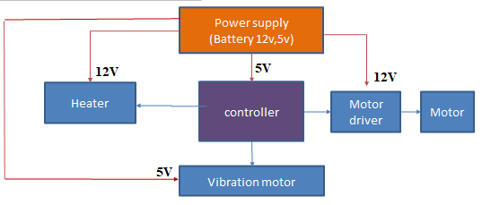

.

**Figure 1:** Block Diagram.

1. **FLOW CHART**

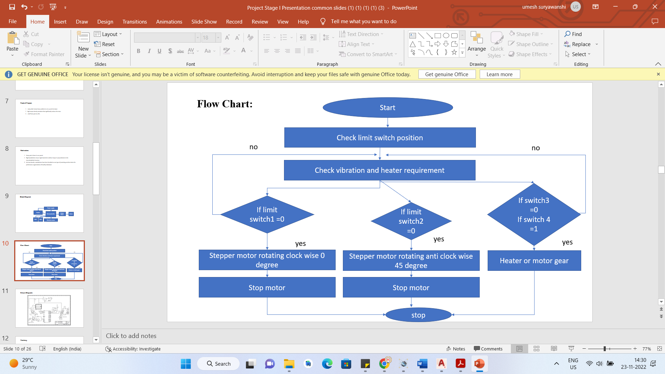

**Figure 2:** Flowchart

1. **RESULT**

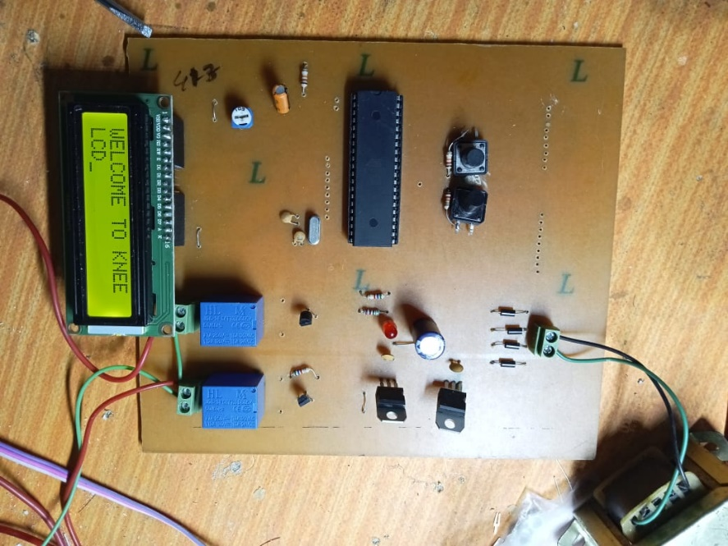

**Figure 3:** Hardware

1. **CONCLUSION**

Our study demonstrates the feasibility and effectiveness of a lightweight knee assistant for daily activities. The knee assistant provides support and improves mobility while being comfortable and unobtrusive. Further research is needed to evaluate the long-term effectiveness of the knee assistant, and to optimize its design for different types of knee injuries and conditions. Overall, the lightweight knee assistant has the potential to improve the quality of life for millions of people with knee injuries and osteoarthritis**.**

1. **REFERENCES**

[1] L. N. Awad, J. Bae, K. O'Donnell, S. M. De Rossi, K. Hendron, L. H. Sloot, P. Kudzia, S. Allen, K. G. Holt, T. D. Ellis and C. J. Walsh, "A soft robotic exosuit improves walking in patients after stroke," Science Translational Medicine, vol. 9, no. 400, Jul 26 2017.

[2] M. P. de Looze, T. Bosch, F. Krause, K. S. Stadler, and L. W. O'Sullivan, "Exoskeletons for industrial application and their potential effects on physical work load," Ergonomics, vol. 59, no. 5, pp. 671-681, May 2016.

[3] Y. Ding, M. Kim, S. Kuindersma, and C. J. Walsh, "Human-in-the-loop optimization of hip assistance with a soft exosuit during walking," Science Robotics, vol. 3, no. 15, p. eaar5438, 2018.

[4] J. Zhang, P. Fiers, K. A. Witte, R. W. Jackson, K. L. Poggensee, C. G. Atkeson and S. H. Collins, "Human-in-the-loop optimization of exoskeleton assistance during walking," Science, vol. 356, no. 6344, pp. 1280-1284, Jun 23 2017.

[5] S. H. Collins, M. B. Wiggin, and G. S. Sawicki, "Reducing the energy cost of human walking using an unpowered exoskeleton," Nature, vol. 522, no. 7555, p. 212, 2015.

[6] Z. F. Lerner, D. L. Damiano, and T. C. Bulea, "A lower-extremity exoskeleton improves knee extension in children with crouch gait from cerebral palsy," Science translational medicine, vol. 9, no. 404, p. eaam9145, 2017.