**AUTOMATIC POWER FACTOR CORRECTION**

**BY USING ARDUINO UNO**

**BALA MURUGAN.A 1, Mrs.A.MARIYA CHITHRA MARY., M.E.,2 .**

1Research Scholar, Electrical and Electronics Engineering, Sree Sowdambika College of Engineering,

Anna University, Virudhunagar District, Tamil nadu, India

2 Professor, Electrical and Electronics Engineering, Sree Sowdambika College of Engineering, Aruppukottai, Virudhunagar District, Tamil nadu, India.

**ABSTRACT**:

Efficient generation of power at present is crucial as wastage of power is a global concern. Power factor measures a system’s power efficiency and is an important aspect in improving the quality of supply. In most power systems, a poor power factor resulting from an increasing use of inductive loads is often overlooked. A power factor correction unit would allow the system to restore its power factor close to unity for economical operation. The advantages of correcting power factor include reduced power system losses, increased load carrying capabilities, improved voltages and much more. The aim of this project is to build an Automatic Power Factor Correction (APFC) Unit, which is able to monitor the energy consumption of a system and automatically improve its power factor. An open source energy monitoring library was implemented in the design for accurate power calculation. The APFC device calculates the reactive power consumed by a system’s inductive load and compensates the lagging power factor using capacitance from a capacitor bank.

Keywords:A.C–Alternating current; PF–Power Factor; PFC– Power Factor Correction; A.P.F.C–Automated Power Factor Correction; Emonlib–Energy Monitoring Library; C.T–Current Transformer; P.T–Potential Transformer.

I.INTRODUCTION

Power factor is defined as the ratio between the KW (actual load power) and the KVA (apparent load power) drawn by an electrical load. It is simply a measure of how efficiently the load current is being converted into useful work output [1]. The lower the power factor of a system, the less economically it operates. A low power factor can be the result of a significant phase difference between voltage and current at load terminals, a high harmonic content, or even a distorted current waveform. Generally it is the use of inductive loads such as induction motors, power transformers or induction furnaces that causes a current to lag behind voltage. A poor power factor resulting from inductive loads can be improved by power factor correction method, but a poor power factor resulting from distorted current waveform requires a change in equipment design or addition of harmonic filters [3]. Since power factor in inductive loads is generally lower, they have to be supplied with reactive power in order to reduce increased power consumption of the machine. All inductive loads require active power (KW) to perform the actual work, and reactive power (KVAR) to maintain the magnetic field. This reactive power is necessary for the equipment to operate, but imposes an undesirable burden on the supply, causing the current to be out of phase with the voltage (current lags the voltage) [5]. Low power factor can also result when inactive motors operate at less than full load-such as a surface grinder performing a light cut, a circular saw that is only spinning, an air compressor that is unloaded etc. Losses caused by poor power factor are due to the reactive current flowing in the system and can be eliminated using PFC [3-5]. Power factor correction (PFC) is the process of compensating a lagging current by a leading current, through connecting capacitance to the supply. Capacitors contained in most power factor correction system draws current that leads voltage and produces a leading power factor. A sufficient capacitance is connected so that power factor is adjusted as close to unity as possible. Theoretically, capacitors could provide 100% of the needed reactive power, however, practically, correcting power factor much nearer to unity may result in harmonic distortion. If capacitors are connected to a circuit that operates nominally at a lagging power factor, the extent to which the circuit lags will reduce proportionately. Power factor correction is applied to neutralize as much of the magnetizing current as possible and to reduce losses in the distribution system. It offers many benefits to the commercial electrical consumer, including reduced utility bills by eliminating charges on reactive power, reduced losses making extra KVA available from the existing supply. Thus, it improves energy efficiency [6]. The rest of the paper is organized as follows: section II discusses the existing methods of PFC and how they work, section III demonstrates our proposed system design, section IV discusses the modules required, section V describes the technical design of the system, section VI shows the system flow chart, section VII shows the results and analysis, finally section VIII draws conclusion of the project.

II. EXISTING METHODS

There are several existing procedures for power factor correction in modern days.

A. Synchronous Condenser

It is a synchronous motor that rotates under no load condition. Asynchronous motor shows capacitive behaviour while operating in over-excited mode. By controlling the field excitation power factor can be adjusted continuously. It provides step-less PF correction and not affected by system harmonics. But its installation and maintenance is costly .

B. Static Capacitor Bank

Capacitors causes leading power factor as it shifts current ahead of the voltage. So to correct lagging power factor, it is a convenient method for which this method is practiced worldwide vastly. Though it has some limitations like the inability to absorb harmonics and doesn’t provide step-less correction, it is a popular choice for PFC for its low cost of installation and maintenance .

III. PROPOSED SYSTEM

The proposed system takes 230v 50Hz mains supply as a power source and steps down the voltage level to 12v through a PT. The power supply unit, then converts this 12v AC into two different DC power consisting of +9v and +5v. The sample voltage signal is obtained from this 12v AC signal and processed through the voltage sensor circuit for microcontroller input. A current signal sample is also obtained from the mains supply by a current transformer and processed by a current sensor circuit for another microcontroller input. The microcontroller performs power factor calculations and switches capacitors from the bank. The results are displayed on a 20x4 LCD display. The functional block diagram of the complete project is shown in the following figure.

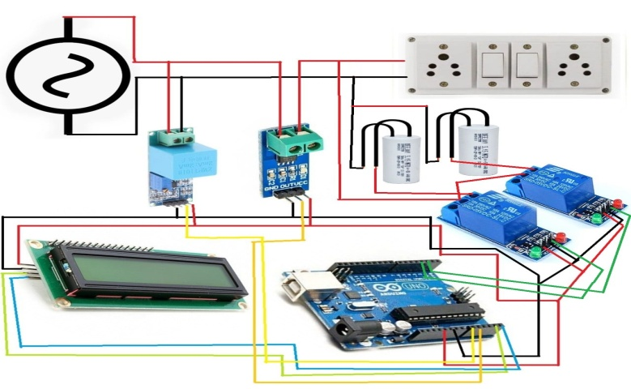

IV.DESIGN METHODOLOGY

The whole APFC unit consists of eight modules. They collectively work together to gain a power factor correction. These modules are given as follows:

* Power supply.
* Voltage sensor circuit.
* Current sensor circuit
* Microcontroller.
* Inductive load network
* Relay driver. o Display.
* Capacitor Bank.

A.Power supply

The AC mains can supply an AC power of 230v at 50Hz frequency. But it requires DC power in order to operate the modules. A voltage transformer is used to step down the 230v supply to 12v. This AC signal is then converted to DC through a bridge rectifier followed by filtering capacitors. The final stable DC outputs are achieved using voltage regulator ICs. Fig. 2 Power supply unit circuit diagram

A.Voltage sensor

The mains 230v AC is stepped down to 12v AC. A voltage divider circuit divides this 12v in 1:10 ratio, which provides around 1.2v sinusoid signal. A DC offset of 2.5v is applied to the sinusoidal signal. As a result the whole sinusoid can be observed in the positive boundary (0-5v) and the microcontroller can read the whole sinusoid signal through its analog input. The circuit diagram of the voltage sensor circuit is shown below

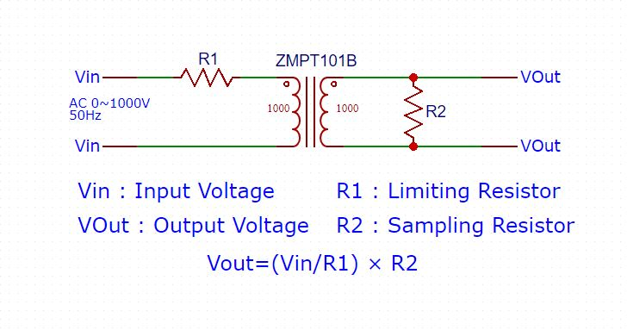

C. Current sensor circuit

The current signal flowing through the mains is retrieved through a current transformer. A burden resistor transforms the current signal into a voltage form that represents the properties of the current sinusoid. A DC offset voltage of 2.5v is applied to the sinusoidal signal so that the reference point is lifted up and the whole sinusoid can be read in analog mode within its operating range (0-5v). The circuit diagram of the current sensor circuit is shown in following figure .

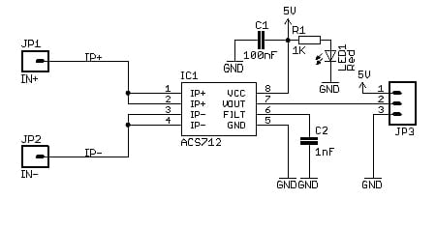

D. Microcontroller

A microcontroller is a small computer on a single integrated circuit containing processor core, memory, and programmable input/output peripherals [8]. An Arduino UNO microcontroller (based on ATmega328p) is used in this project, which has lots of libraries developed and available online for free. A program was developed for calculation and automatic actions of the project and burned on the microcontroller using Arduino IDE. Mains voltage, mains current, real power, apparent power and power factor of the network are calculated through the developed program .

E. Inductive load network

The inductive load network is a combination of loads having inductive characteristics and consuming huge electrical power due to lagging power factor. The network collectively simulates a highly inductive load operating at a very poor power factor.

F. Relay drivers

The loads and capacitors are connected to a high voltage circuit. In order to incorporate these high voltage components with microcontroller relay is used for switching operation on capacitors in high voltage circuit through the control signal from microcontroller keeping the microcontroller safe and electrically isolated from high voltage .

G. Display

The calculated power parameters current power factor, mains voltage, mains current, real and apparent power are continuously displayed on a 20x4 Liquid Crystal Display monitor.

H. Capacitor Bank

Capacitor bank is the collection of capacitors of different values. Series and parallel combination of different capacitors provide a range of capacitance required to compensate poor power factor. The sizing of capacitors is determined based on the required KVAR demand by the load network. The following figure shows the completely implemented design of the project.

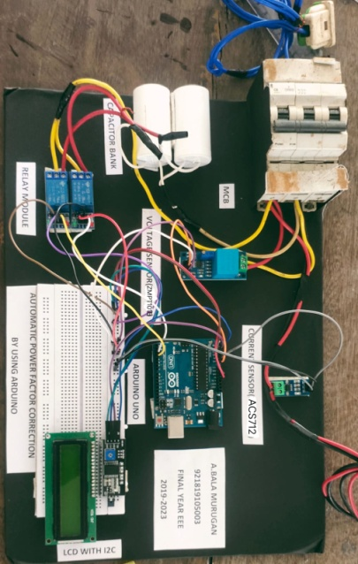

V. TECHNICAL DESIGN

The technical design of the system can be described in four main steps, namely, Emonlib library inclusion, calibration of Emonlib, KVAR calculation, and capacitor switching.

A.Emonlib library inclusion

Emonlib is an open source library developed for energy monitoring purpose. The Emonlib library is capable of reading analog voltage and current signals and it can calculate the mains voltage, mains current, real power, reactive power, apparent power and power factor. The built in methods of the library are provided by the Emonlib developers which can be used in order to retrieve required power parameters mentioned above [7].

B. Calibration process

Some factors are needed to be determined based on the components used in the voltage and current sensor circuits. These factors values are put as the arguments of Emonlib methods for accurate power calculations. Voltage and current calibration constants are determined based on the stepdown and voltage divider ratios of PT and CT. For the developed APFC system the voltage and current calibration constants are determined as 184 and 1.5 respectively. The phase calibration constant 1 gives no phase correction and the values 0 and 2 provide 7° of correction in opposite direction. The exact phase calibration is done using pure resistive load and adjusting the phase constant until power factor measured is 1.0 .

C. Required KVAR Calculation

The calculated power parameters are used to determine the required KVAR. If the current power factor and targeted power factor is cosφ then, Required KVAR = P (tanφ1- tanφ2) Capacitance in Farad, Where, P = Real power in KW, f is the frequency and V is the voltage of the power system .

D. Capacitor Switching

The microcontroller itself takes the decision of required KVAR demand and automatically switches the capacitors of desired value from the capacitor bank. Multiple channel relay module is used to perform this switching action.

VII.RESULTS ANALYSIS

To demonstrate the working process of the APFC and Energy Monitoring system some highly inductive loads were installed to create a load network. The loads were connected in a manner of combination such that different power factors could be introduced to the system. The load network consisted of some inductors having high inductance value in series with some combination of resistors. As the resistance level is decreased keeping the inductance constant, the proportion of inductance compared to resistive component increased, and the power factor falls down. A decreasing power factor was thus created in the system. The system can detect and measure the exact power factor of a load network. The pre-programmed microcontroller can determine the required VAR demand for raising the power factor up to 0.97. It then switches on capacitors from the capacitor bank based on the VAR demand. The following table illustrates the data recorded from the system

RESULT ANALYSIS

|  |  |  |  |  |  |
| --- | --- | --- | --- | --- | --- |
| BEFORE CORRECTION | | | AFTER CORRECTION | | |
| PF | I(A) | A.P (VA) | PF | I(A) | A.P (VA) |
| 0.85 | 0.77 | 171 | 0.96 | 0.70 | 156 |
| 0.72 | 1.02 | 229 | 0.96 | 0.79 | 177 |
| 0.60 | 1.22 | 271 | 0.96 | 0.80 | 178 |
| 0.50 | 1.35 | 301 | 0.95 | 0.76 | 172 |

Besides correcting power factor of an electrical network, the designed system also performs real time power monitoring. The 20x4 Liquid Crystal Display shows the power consumption of the electrical network continuously. It shows the user the immediate voltage, current flow, real power and reactive power consumption, and the immediate power factor of the electrical system. These energy parameters are also available at the serial port of the microcontroller. So using serial communication, it is possible to retrieve these values live for any other operation

VIII. CONCLUSION

Automatic power factor correction techniques can be applied in industries, commercial lines and power distribution system to increase stability and efficiency of the system. Care should be taken so that the capacitors are not subject to rapid onoff-on conditions as well as overcorrection otherwise the lifespan of capacitor bank decreases significantly. The APFC device helps to pull in high current drawn from the system and reduce charges on utility bills. A reduced power consumption results in lower greenhouse gas emissions and fossil fuel depletion by power stations and would benefit the environment.

ACKNOWLEDGMENT

The authors would like to express their gratitude to ECE lab officers of North South University (NSU) for their supports in conducting the research. The authors also thank some senior scholars of ECE department of NSU for their motivations and directions throughout the research completion.

REFERENCES

[1] “Power Factor Technical”. Available at [http://www.kwsaving.co.uk/Business/pfc/pfc-simple.html]

[2] Alexander, C. K., & Sadiku, M. N. (2007). Fundamentals of electric circuits. Boston: McGraw-Hill Higher Education.

[3] Ware, John. "POWER FACTOR CORRECTION." IET Electrical. IEE Wiring Matters, spring 2006. Web. 14 July 2016. Available at [www. electrical.theiet.org/wiring-matters/18/power-factor.cfm?type=pdf]

[4] Stephen, J. C. (1999). “Electric Machinery and Power System Fundamentals.” 3rd.ed. United State of America: McGraw-Hill Companies, Inc.

[5] "POWER FACTOR CORRECTION." www.nhp.com.au. NHP Catalogue - PFC-SFC, Nov. 2007. Web. 14 July 2016. Available at [https://portal.nhp.com.au/power-quality]

[6] "Power Factor Correction: A Guide for the Plant Engineer." www.eaton.com/. Eaton Corporation, Aug. 2014. Web. 14 July 2016. Available at [www.eaton.com/ecm/groups/public/@pub/.../sa02607001e.pdf]

[7] Hudson, Glyn. "OpenEnergyMonitor". [https://openenergymonitor.org/emon/modules/emonTxV3] N.p., n.d. Web. 14 July 2016.

[8] "Microcontroller." Wikipedia [https://en.wikipedia.org/wiki/Microcontroller]. Wikipedia Foundation, n.d. Web. 14 July 2016.

[9] Evans, Brian. Beginning Arduino Programming. New York: Apress, 2011. Print.

[10] Monk, Simon. Programming Arduino: Getting Started with Sketches. New York: McGraw-Hill, 2012. Print.

[11] "ARDUINO", [https://www.arduino.cc/]. N.p., n.d. Web. 14 July 2016.

[12] "Hobbyist.co.nz." Interfacing the Relay Modules to the Arduino [http://www.hobbyist.co.nz/interfacing-relay-modules-to-arduino]. N.p., n.d. Web. 14 July 2016.

[13] Mehta, V. K., and Rohit Mehta. Principles of Power System: (including Generation, Transmission, Distribution, Switchgear and Protection). 4th ed. Chapter 9, New Delhi: S. Chand, 2005.