**FUEL CELL AND SOLAR POWER BASED HYBRID ELECTRIC VEHICLE**

**M. Arun Kumar 1, J. Ganesan., M.E.,2.**

1Research Scholar, Electrical and Electronics Engineering, Sree Sowdambika College of Engineering,

Anna University, Virudhunagar District, Tamil Nadu, India

2 Professor, Electrical and Electronics Engineering, Sree Sowdambika College of Engineering,

Anna University, Virudhunagar District, Tamil Nadu, India.

**ABSTRACT**

This paper investigates the feasibility study of a fuel cell hybrid electric vehicle through a model-driven approach and yields two main initial contributions. PVFCHEV (Photovoltaic Fuel cell Hybrid Electric Vehicle) system, including the vehicle's power supply, controllers and electric vehicle is modeled in detail environment. A controller is designed which aims to the effective utilization of fuel cell at different levels of irradiation and battery charge state. In the PV irradiation and battery are inputs and output are the adaptable function for the fuel cell.

1. **INTRODUCTION**

# A hybrid electric vehicle (HEV) is a type of vehicle that uses both an electric engine and a conventional internal combustion engine. This type of vehicle is considered to have better performance and fuel economy compared to a conventional one.

# HEVs propel through a combination of two different power sources (conventional ICE and a battery/electric motor). The electric battery supplies electricity to the drive train, so as to optimize the operating efficiency of the combustion engine. The battery in an HEV can be charged by the engine or through captured kinetic braking energy from regenerative braking. Since 1995, when HEVs experienced a renewed interest from competing manufacturers, several variations to the HEV technology have been developed.

**These include micro HEVs, mild HEVs, full HEVs, and PHEV.**

* ***Micro HEVs*:** A micro HEV is a vehicle with an electric motor in the form of an integrated alternator/starter that uses start/stop technology, to shut down the engine, when the vehicle comes to a complete stop, and start it up when the driver releases the brake pedal.

During cruising, the vehicle is propelled only by the ICE. Examples of micro hybrids on the road today are the BMW 1 and 3 series, Fiat 500, SMART car, Peugeot Citroen C3, Ford Focus and Transit, and Mercedes-Benz A-class (Technology CFAA, 2018).

* ***Mild HEVs*:** The mild HEV has a lot of similarities to a micro HEV, but with an increased size of the integrated alternator/starter motor and a battery which permits power assist during vehicle propulsion. Typical fuel efficiency increases for mild HEVs are around 20%−25% for real-world driving compared to a nonhybrid. Examples of mild HEVs on the market include the BMW 7 Series Active Hybrid, Buick La Crosse with e-Assist, Chevrolet Malibu with e-Assist, Honda Civic and Insight Hybrid, and the Mercedes-Benz S400 Blue Hybrid (Technology CFAA, 2018).

1. **METHODOLOGY:**

HEVs are also known as series hybrid or parallel hybrid. HEVs have both engine and electric motor. The engine gets energy from fuel, and the motor gets electricity from batteries. The transmission is rotated simultaneously by both engine and electric motor. This then drives the wheels. To find out more about HEVs, click below.

**Main Components of HEV:** Engine, Electric motor, Battery pack with controller & inverter, Fuel tank, Control module

**Working Principles of HEV:** The fuel tank supplies energy to the engine like a regular car. The batteries run on an electric motor. Both the engine and electric motor can turn the transmission at the same time.

**Examples of HEV:** Engine, Electric motor, Battery pack with controller & inverter, Fuel tank, Control module

1. **MODELLING OF PROJECT**
   1. **COMPONENTS DESCRIPTION** 
      1. **SOLAR PANEL SYSTEM:**

A solar panel system is a system of interconnected assembly (also known as an array) of photovoltaic (PV) [solar cells.](https://www.theengineerspost.com/solar-cell-types-working/) The energy produced by the solar panel is measured in volts or watts, it will vary according to the type of system and solar cell that you are using. Each of the solar panels (modules) in the array consists of a group of solar cells packed jointed in a metal frame.

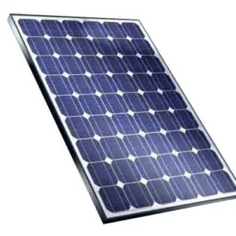

A single solar panel typically consists of 60, 72, or 96 solar cells. Every solar cell includes an inverter to convert the direct current produced into the [alternating current electricity](https://en.wikipedia.org/wiki/Alternating_current#:~:text=Alternating%20current%20(AC)%20is%20an,flows%20only%20in%20one%20direction.) used in the home. The placed inverter can be large and centralized.

## **Working of Solar Panel:**

Solar panels receive the sunlight as a source of energy to produce electricity or heat. A photovoltaic module is usually a connected combination of photovoltaic solar cells.

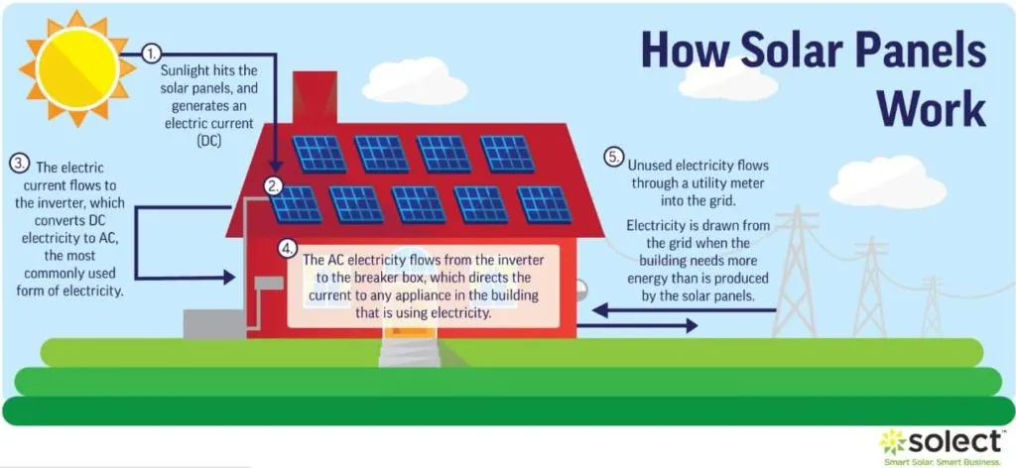

Photovoltaic modules constitute the photovoltaic array of a photovoltaic system that generates and supplies solar electricity in many applications. Each module is rated under standard test conditions by its DC output power and typically ranges from 100 to 365 watts.

The efficiency of a module given the same rated output, as 8% efficient 230W module will have twice the area of a 16% efficient 230W module. There are some commercially available solar modules that exceed 22% capacity and reportedly even exceed 24%.

A single solar module can provide only an inadequate amount of power, most of the installations include multiple modules. A photovoltaic system includes an array of PV (photovoltaic) modules, an inverter, interconnection wiring, a battery pack for storage, and optionally a solar tracking mechanism. The most general application of solar panels is solar water heating systems.

**3.1.2**  **FUEL CELL:**

A fuel cell can be defined as an electrochemical cell that generates electrical energy from fuel via an electrochemical reaction. These cells require a continuous input of fuel and an [oxidizing agent](https://byjus.com/chemistry/oxidizing-agent/) (generally oxygen) to sustain the reactions that generate the electricity. Therefore, these cells can constantly generate electricity until the supply of fuel and oxygen is cut off.

Despite being invented in the year 1838, fuel cells began commercial use only a century later when they were used by NASA to power space capsules and satellites. Today, these devices are used as the primary or secondary source of power for many facilities including industries, commercial buildings, and residential buildings.

A fuel cell is similar to  [electrochemical cells](https://byjus.com/chemistry/electrochemical-cell/), which consists of a cathode, an anode, and an electrolyte. In these cells, the electrolyte enables the movement of the protons.

## **Working of Fuel Cell**:

The reaction between hydrogen and oxygen can be used to generate electricity via a fuel cell. Such a cell was used in the Apollo space program and it served two different purposes – It was used as a fuel source as well as a source of drinking water (the water vapor produced from the cell, when condensed, was fit for human consumption).

The working of this fuel cell involved the passing of hydrogen and oxygen into a concentrated solution of sodium hydroxide via carbon electrodes. The cell reaction can be written as follows:

* Cathode Reaction: **O2 + 2H2O + 4e– → 4OH–**
* Anode Reaction: **2H2 + 4OH– → 4H2O + 4e–**
* Net Cell Reaction: **2H2 + O2 → 2H2O**

However, the reaction rate of this electrochemical reaction is quite low. This issue is overcome with the help of a catalyst such as platinum or palladium. To increase the effective surface area, the catalyst is finely divided before being incorporated into the electrodes.

A block diagram of this fuel cell is provided below.

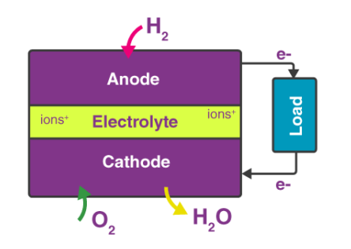

The efficiency of the fuel cell described above in the generation of electricity generally approximates to 70% whereas thermal power plants have an efficiency of 40%. This substantial difference in efficiency is because the generation of electric current in a thermal power plant involves the conversion of water into steam, and the usage of this steam to rotate a turbine. Fuel cells, however, offer a platform for the direct conversion of chemical energy into electrical energy.

**3.1.3**  **SOFTWARE REQUIREMENTS**:

The software requirements document is the specification of the system. It should include both a definition and a specification of requirements. It is a set of what the system should do rather than how it should do it. The software requirements provide a basis for creating the software requirements specification. It is useful in estimating cost, planning team activities, performing tasks and tracking the teams and tracking the team’s progress throughout the development activity.

**Software Requirements:**

* Software - Arduino
* OS - Windows 7 32bit

**3.1.4 PIC MICROCONTROLLER:**

PIC microcontroller was developed in the year 1993 by microchip technology. The term PIC stands for Peripheral Interface Controller. Initially this was developed for supporting PDP computers to control its peripheral devices, and therefore, named as a peripheral interface device. These microcontrollers are very fast and easy to execute a program compared with other microcontrollers. [PIC Microcontroller architecture](https://www.elprocus.com/introduction-to-pic-microcontrollers-and-its-architecture/) is based on Harvard architecture. PIC microcontrollers are very popular due to their ease of programming, wide availability, easy to interface with other peripherals, low cost, large user base and serial programming capability (reprogramming with flash memory), etc.

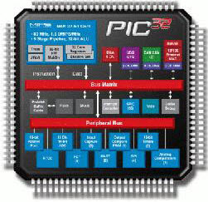

We know that the microcontroller is an integrated chip which consists of CPU, RAM, ROM, timers, and counters, etc. In the same way, PIC microcontroller architecture consists of RAM, ROM, CPU, timers, counters and supports the protocols such as SPI, CAN, and UART for interfacing with other peripherals. At present PIC microcontrollers are extensively used for industrial purpose due to low power consumption, high performance ability and easy of availability of its supporting hardware and software tools like compilers, debuggers and simulators.

**3.1.5 BATTERY:**

This is a rechargeable lead-acid battery. They are also commonly known as sealed batteries or maintenance-free batteries. It is made of a few lead-acid cells wired in series in a single container. Lead-acid cells have two plates of lead hang in a fluid-like electrolyte solution of sulfuric acid. We can use this type of battery in any position or orientation we like without the fear of spillage. The cover of the battery is built from polypropylene material. Thus, prevent the battery from the impacted in harsh conditions. Also, this battery does not require any water top-up throughout its service life.

**4.1.1 Description:**

PIC (Programmable Interface Controllers) microcontrollers are the world smallest microcontrollers that can be programmed to carry out a huge range of tasks. These microcontrollers are found in many electronic devices such as phones, computer control systems, alarm systems, [embedded systems](https://www.watelectronics.com/classification-of-embedded-systems/), etc. Various types of [microcontrollers](https://www.watelectronics.com/8051-microcontroller-architecture/) exist, even though the best is found in the GENIE range of programmable microcontrollers. These microcontrollers are programmed and simulated by a circuit-wizard software.

Every PIC microcontroller architecture consists of some registers and stack where registers function as Random Access Memory (RAM) and stack saves the return addresses. The main features of PIC microcontrollers are RAM, flash memory, Timers/Counters, EEPROM, I/O Ports, USART, CCP (Capture/Compare/PWM module), SSP, Comparator, ADC (analog to digital converter), PSP(parallel slave port), LCD and ICSP (in circuit serial programming) The 8-bit PIC microcontroller is classified into four types on the basis of internal architecture such as Base Line PIC, Mid-Range PIC, Enhanced Mid-Range PIC and PIC18.

**3.1.5 HARDARE REUIREMENTS:**

The hardware requirements may serve as the basis for a contract for the implementation of the system and should therefore be a complete and consistent specification of the whole system. They are used by software engineers as the starting point for the system design.

**Hardware Requirements**:

* Solar Panel
* Battery
* Fuel Cell
* Power Supply
* Vehicle

1. **BLOCK DIAGRAM:**

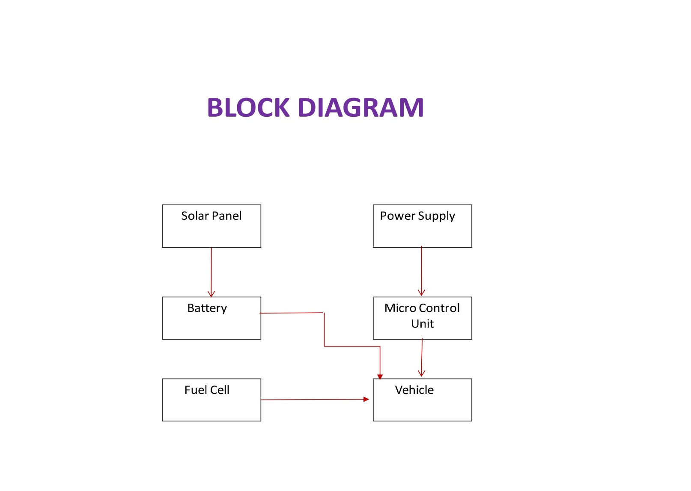**BLOCK DIAGRAM EXPLAINATION:**

* **Gain a deep thrust to the Electric Vehicle – Program specific & from the coding point.**
* **Have a better understanding on the Interfacing of Peripherals & Sensors to the Controllers.**

1. **CIRCUIT DIAGRAM:** 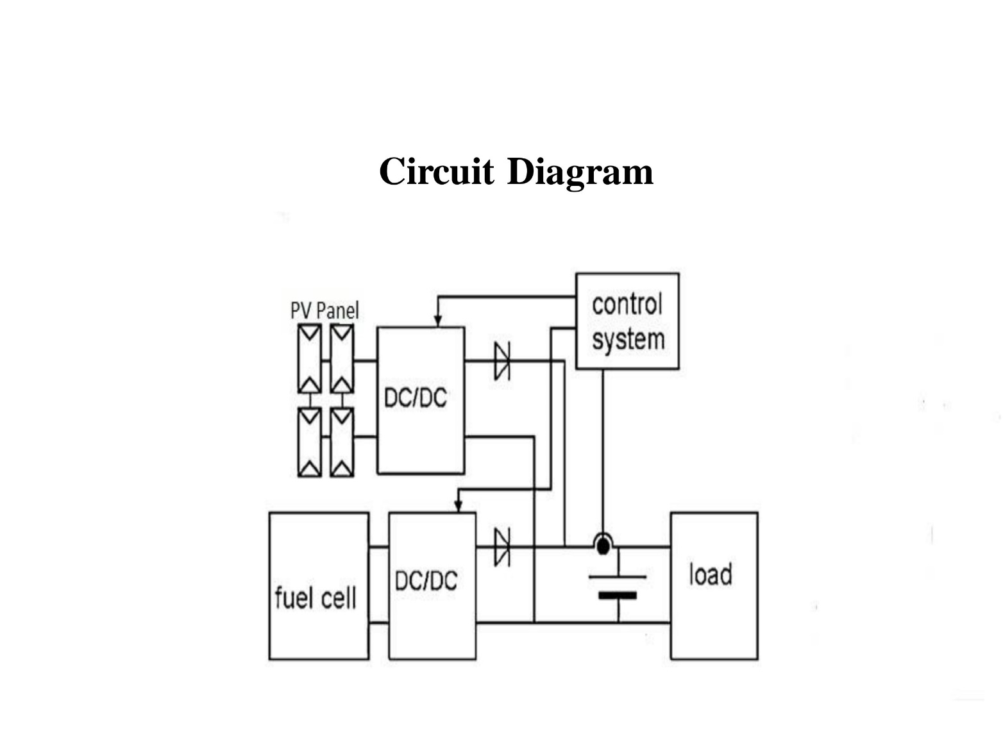
2. **CONCLUSION:**

In this work solar powered and fuel cell hybrid vehicle has been successfully fabricated built in with internal combustion engine. Generally, the electric hybrid vehicles are disadvantageous during long distance travels also required periodic plug in of their batteries. These kinds of problems have been solved using hybrid solar vehicle which gives a car, self-charging potential from the solar panels. The efficiency of the solar panels which is used is 15-20%, but there are various means to increase the efficiency of the panels by changing their silicon materials. The future of energy sector lies solely on alternative energy resources. The cost of HSVs is more than the conventional cars but they are more efficient and cause less exhaust emissions. This challenge now can turn out to be a good scope for further development of a pollution free vehicle.

1. **ACKNOWLEDGEMENT:**

I am extremely grateful thank to our Head of the Department **Dr. R. SIVASANGARI., M.E., Ph.D.,** professor of EEE forherable guidance, continuous encouragement, and moral support throughout the project work.

I wish to express my deep sense of gratitude to my internal Project Guide **Mr. J. GANESAN., ME., AP/EEE.,** Professor, Department of EEE for his able guidance continuous encouragement and moral support throughout the project work.

1. **REFERENCES:**

* H. Afrakhte and P. Bayat, ‘‘A contingency based energy management strategy for multi-microgrids considering battery energy storage systems and electric vehicles,’’ J. Energy Storage, vol. 27, Feb. 2020, Art. no. 101087.
* M. P. Bonkile and V. Ramadesigan, ‘‘Physics-based models in PV-battery hybrid power systems: Thermal management and degradation analysis,’’ J. Energy Storage, vol. 31, Oct. 2020, Art. no. 101458
* Mosavi, S. N. Qasem, M. Shokri, S. S. Band, and A. Mohammadzadeh, ‘‘Fractional-order fuzzy control approach for photovoltaic/battery systems under unknown dynamics, variable irradiation and temperature,’’ Electronics, vol. 9, no. 9, p. 1455, Sep. 2020.
* M. M. Ismail and A. F. Bendary, ‘‘Smart battery controller using ANFIS for three phase grid connected PV array system,’’ Math. Comput. Simul., vol. 167, pp. 104–118, Jan. 2020.
* X. Ge, F. W. Ahmed, A. Rezvani, N. Aljojo, S. Samad, and L. K. Foong, ‘‘Implementation of a novel hybrid BAT-fuzzy controller based MPPT for grid-connected PV-battery system,’’ Control Eng. Pract., vol. 98, May 2020, Art. no. 104380
* Ulutas, I. H. Altas, A. Onen, and T. S. Ustun, ‘‘Neuro-Fuzzy-Based model predictive energy management for grid connected microgrids,’’ Electronics, vol. 9, no. 6, p. 900, May 2020.