**RFID BASED PETROL PUMP AUTOMATION SYSTEM**

**M.Maheswari 1, Mrs.B.S.Nanthini, M.E.,2 .**

1Research Scholar, Electrical and Electronics Engineering, SreeSowdambika College of Engineering,

Anna University, Virudhunagar District,Tamil nadu,India

2Professor,Electrical and Electronics Engineering,SreeSowdambika College of Engineering, Aruppukottai, Virudhunagar District, Tamil nadu, India.

**ABSTRACT**

The project's major goal is to build a dispensing system that can automatically distribute gasoline for the amount specified by the customer. Petrol distribution systems can be found in a variety of settings in our daily lives, including offices, bus stops, railway stations, and schools. Here, we'll advocate a modern-day gasoline delivery system that uses RFID technology to operate. This project involves using RFID technology to create a prepaid card for a petrol bunk system as well as a petrol delivery system. In recent years, all gas stations have been manually operated. These manual gasoline pumps take longer to operate and require more manpower. Normally, locating petrol stations in remote areas is prohibitively expensive in order to give quality service to customers.the customers All of these issues can be solved by using an unmanned power pump, which takes less time to operate, is effective, and can be mounted almost anyplace. The consumer can take use of the service, which requires the use of an electronic clearing system

**1. INTRODUCTION**

The main aim of this paper is todeal with all stated problems by developing an automated petrol dispensing system using RFID technology. Such a system enables a user to use a RFID based prepaid card to access petrol at fuel stations. Whenever the user wants to fill the tank from the fuel dispenser, user has to enter the amount first And then place the RFID card near the RFID reader. The Arduino Uno manages to read the data from the RFID reader and perform action according to the customer requirements as well as the amount deducted from the users card.

**2. METHODOLOGY**

* At the petrol station the smart card processed by the customer is been scanned by the RFID reader.
* The identification process is carried out by the tallying the database.
* The valid customer has allow to enter.
* The customer has to enter the time period of petrol to be dispensed ( 100rs = 1 lit ).
* The customer receives the petrol from the dispensing system.
* The respective money is been deducted from smartcard.

1. **MODELLING OF PROJECT** 
   1. **COMPONENTS DESCRIPTION**
      1. **ARDUINO UNO MICROCONTROLLER**

Arduino Uno Rev. 3 Microcontroller Board is based on the Microchip Technology ATmega328 8-bit Microcontroller (MCU). The user can get started by connecting the Uno to a computer with the USB cable or by powering it with an AC/DC adapter or battery. The Uno can be programmed with Arduino Software (Integrated Development Environment).

**3.1.2PUMP MOTOR**

Power The DC 3-6V Mini Micro Submersible Water Pump is a low cost, small size Submersible Pump Motor. It operates with a 2.5 to 6V power supply. It can pump up to 120 litres per hour with a very low current consumption of 220mA. Just connect the tube pipe to the motor outlet, submerge it in water, and power it.

**3.1.3RFID READER :**

The RC522 RAFID reader has a radio transponder that act as an antenna and ranges 125KHzTo 2.4 GHz that uses electromagnetic field to identify the signals corresponding to the RFID tag.

**3.1.4 RELAY**

A relay is used as electrically operated switch. Relay is used to turn on the water pump in order to maintain the moisture level of the crop.This relay switches the logic for the DC motor to turn either ON or OFF.

**3.1.5 LCD DISPLAY**

Numbers, Text, and artwork can all be displayed.LED can only display numbers and few characters.Character and graphics programming is simple**.**

**3.1.6 POWER SUPPLY**

A POWER SUPPLY is an electronic device that provides electrical energy to an electrical load. Power supplies are sometimes referred to as electric power converters since their principal job is to convert one form of electrical energy to another. Some power supplies are standalone units, while others are integrated into bigger units with their loads. Power supply seen in desktop computers and consumer electronics devices are examples of the latter. The power supply is 5 volts.

**CIRCUIT DIAGRAM**

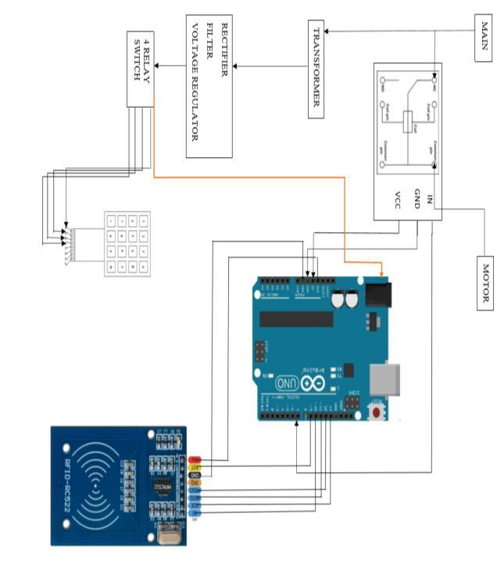

1. **PROPOSED SYSTEM**

We are employing RFID cards to access petrol at different petrol stations of different petrol firms across the country and here in this proposed petrol pump automation system. We simply insert the RFID card near the RFID readerwhenever we wish to fill the tank from the fuel dispenser. The microcontroller then examines the data from the RFID reader and takes the appropriate action based on the customer's needs. This computerized petrol pump system also provides customers with security when filling up at gas stations by avoiding the participation of humans, hence reducing the risk of carrying cash at all times. The Atmega328 microcontroller, RFID module, LCD display, pump, and GSM are all included in this petrol pump system. When an RFID tag is placed in front of an RFID reader, the reader reads the card and determines how much money is on the card. If the card has sufficient funds, the petrol will be filled based on the number of taps. For example, if we tap the fuel dispenser once, one liter of gasoline will be spilled, and if we press twice, two liters of gasoline will be pumped. Through GSM technology, the total amount debited and the number of liters consumed will be sent to a cell phone.

1. **APPLICATION**

* Fully automatic.
* Monitoring of petrol sales is up to date.No paper work.
* Can be implemented in all places.
* Less human work.

**6. ADVANTAGES**

* Man power is conservatively reduced because of automated self-service.
* Due to use of RFID technology robbery of the fuel from the bunk is avoided.
* The time taken by the systemis very less.
* Low power only consumed.
* Accuracy in the amount of petrol is maximum.
* Highly sensitive device.

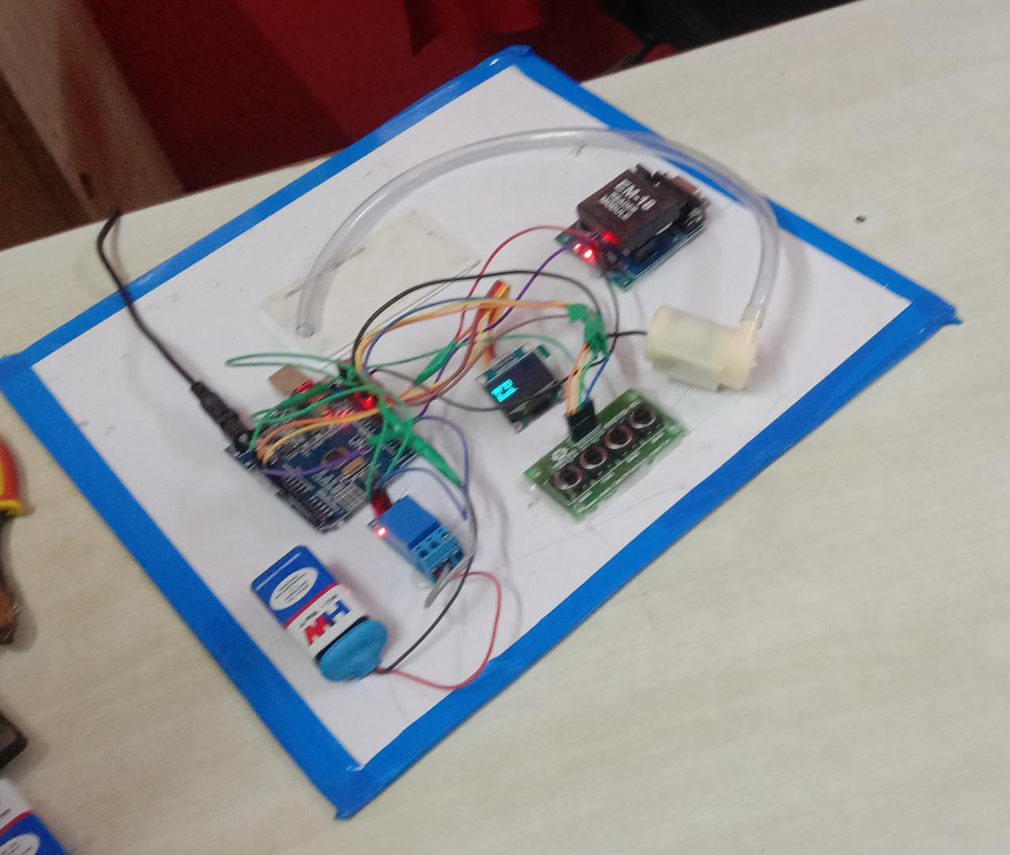

**7.CONCLUSION**

The above mentioned model proposes to remove all the shortcomings of the manually operated petrol pumps by replacing them with automated ones. RFID is a versatile technology , easy to use and it can be efficiently used in this real time application. The proposed model consists of certain goals like ensuring right amount of fuel dispensed, removing all human errors by the use of RFID cards and ensuring customer's trust for a fair sale of the product . These automated fuel stations provide a lot more advantages as they reduces man power with the automated self service.

**8. ACKNOWLEDGEMENT**

I am extremely grateful thank to our Head of the Department **Dr.R.SIVASANGARI.,M.E.,Ph.D,** professor of EEE forherable guidance, continuous encouragement and moral support throughout the project work.

I wish to express my deep sense of gratitude to my internal Project Guide **Mrs.B.S.NANTHINI., ME., AP/EEE.,** Professor, Department of EEE for his able guidance continuous encouragement and moral support throughout the project work.

**REFERENCES**

Kulkarni Amruta M., and Tawar Sachin S., (2011), Embedded Security System Using RFID and GSM Module, International Journal of Computer Technology andElectronics Engineering, Volume 2, Issue 1,(Pg164-168).Patil Aishwarya M., Phuke Sayali J, Tapase Snehal B., (2016), College Access and Student Attendance using RFID technology, Volume 5, Issue1. Wavekar Asrar A., Patel Tosif N., Pathan Saddam I., Pawar H., (2016), RFID Based Automated Fuel station, International Journal for Scientific Research and Development, Volume 4, Issue1. 4. Jadhav Aniket H., Pawar Rajan S., Pathare Priyanka M, Pawar Kishori D., Patil P., (2014),Multi-Automized Fuel Pump With User Security, International Journal Of Science And Technology Research, Volume 3, Issue5.