Pregnancy monitoring system

Mr, velmurugan map/ece. Priyadarshini.s, shivani.m, vinitha.m, nandhini. a

Vivekananda college of technology for women

ABSTRACT:

In this paper, we present a device that is used to measure the fetal heart rate during the time of pregnancy. The major component used for this detection is Fetal Digital stethoscope sensor which is to be placed on the abdomen of the pregnant and the signals are processed by the microcontroller used and the accurate fetal heart rate is identified and sent as a text message to the respective mobile phone through the usage of GSM module and also by the usage of EMG sensor the uterus contraction also be simulated as the output on the desktop. This system is very flexible and low cost helps the patient to monitor the fetal heart rate in home.

INTRODUCTION:

In this present scenario, there are different techniques used for fetal health monitoring at the time of pregnancy. There are methods like CTG, ACOG and many methods based on acoustic techniques. In this paper, we have described about the design and development of advice that consists of a fetal digital stethoscope sensor which is made up of three electrodes anode, cathode, and a reference electrode. In this model, these are placed on the abdomen.

Thus the ECG signals are fetched from these electrodes and are pre-processed and then analysed through different standards. To be informative we are using a GSM module to transmit the fetal heart rate values to the required mobile. The message can also be followed up the doctors. Thus by using these kinds of methodologies, one can reduce the stress felt by a pregnant woman due to the movements from here and there. The heart of this process can be defined as the microcontroller used. The microcontroller controls the whole process from fetching the electrode signals and preprocessing the signals and accurate fetal heart rate is sent to the consultant’s mobile by GSM. The usage of this microcontroller can also be extended to the other applications. Thus the objective of this paper is to design and develop a device that helps the pregnant women to monitor the fetal heart rate, and baby kicking by using a fetal EMG sensor with the same microcontroller to get the analog view of uterus contraction.

PROPOSED SYSTEM:

In this methodology, we get input from the pregnant lady by placing the two sensors namely fetal digital stethoscope sensor and EMG sensor near the abdomen of the lady. Thus the electrodes that are present with the sensors fetch the fetal heart rate of the child and the signals are amplified by the amplifier and transmit the corresponding electrical signal to the microcontroller. As per the below diagram, we can obtain the readings from the lady. In this method, the microcontroller is programmed such that to get low noise data. After the successful fetching of the signals, they are pre-processed as per the written guidelines in the program through the microcontroller. Later the information from the microcontroller is transmitted through the GSM module to send the text message for the required mobile phone and we can obtain the graphical representation of the fetal heart rate. And also from the EMG graphical representation of the uterus

contraction is obtained

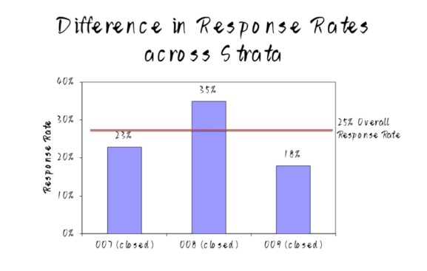

SYSTEM DESCRIPTION AND WORKING:

The system incorporates an ATMega328 MICRO CONTROLLER,

GSM Module, Digital stethoscope, EMG or MEMS sensor, Liquid Crystal Display.

AT MEGA 328 MICROCONTROLLER:

The Arduino Uno is a microcontroller board based on the ATmega328 (datasheet). It has 14 digital input/output pins (of which 6 can be used as PWM outputs), 6 analog inputs, a 16 MHz ceramic resonator, a USB connection, a power jack, an ICSP header, and a reset button. It contains everything needed to support the microcontroller; simply connect it to a computer with a USB cable or power it with a AC-to-DC adapter or battery to get started.

GSM MODULE:

GSM system was developed as a digital system using time division multiple access (TDMA) technique. GSM digitizes and reduces the data, then sends it down through a channel with two different streams of client data, each in its own particular time slot. The digital system has an ability to carry a data rate of 64 kbps to 120 Mbps.

LIQUID CRYSTAL DISPLAY:

A form of visual display used in electronic devices, in which a layer of a liquid crystal is sandwiched between two transparent electrodes. This display contains two internal byte wise resisters, one for the commands (RS=0) and second for character to be displayed (RS=1). It also contains a user programmed RAM area (the character RAM) that can be programmed to generate any desired character that can form using a dot matrix.



POWER SUPPLY:

Power Adaptor 12 Volt 1 Amp Charger AC INPUT 100-240V DC OUTPUT 12V 1A Product Description: Professional 12 Volt DC 1 Amp power supply is suitable for powering a wide range of applications including CCTV cameras and wireless routers. Features: 100% Brand New Excellent Quality Short Circuit, Over

Voltage & Over Current Protection. Meet CEC Energy Efficiency Level IV. Incredibly Low Fault Rates No Minimum Load. This power supply is a regulated Centre Positive power supply and has a 2.1mm x 5.5mm Jack It's plug design is for Indian power socket. So, no plug converter is required.

DIGITAL STETHOSCOPE:

The stethoscope is an acoustic device that transmits the sounds from the chest piece through an air-filled hollow tube to the listener’s ears. The French physician René Laennec first invented it in the 1800s. The design was modest and consisted of a hollow wooden tube that was monaural. Around the same time period, a British physician, Golding Bird, described his version of the stethoscope that comprised flexible tubing that was also monaural. Later, an Irish physician, Arthur Leared advanced the design and a binaural stethoscope emerged.

EMG SENSOR:

Electromyography (EMG) is an electro diagnostic medicine technique for evaluating and recording the electrical activity produced by skeletal muscles. EMG is performed using an instrument called an electromyography to produce a record called an electromyogram. An electromyography detects the electric potential generated by muscle cells when these cells are electrically or neurologically activated. The signals can be analysed to detect medical abnormalities, activation level, or recruitment order, or to analyse the biomechanics of human or animal movement.



RESULTS AND DISCUSSION:

The pregnancy women health monitoring system has been designed and developed successfully and it has been tested in real time. the hardware setup of the system which is housed with digital stethoscope to measure the fetal heart rate, EMG sensor to measure the baby kicking and the microcontroller to process the sensor readings.

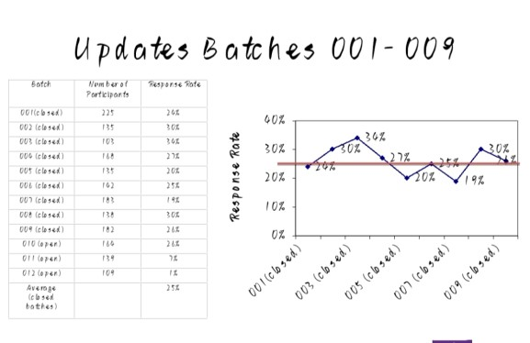

SYSTEM INTEGRATION SETUP: The Figure 4 shows the waveform obtained from the digital stethoscope that measures the fetal heart rate and the movement of the baby per seconds. Through the IOT concept, the node MCU sends the vital information to the registered mobile phone as SMS.

CONCLUSION:

This system is purely related to the Health Care sector. The data provided world Health Organization, UNICEF, and United Nations Population Fund states about MMR. This Maternal Mortality refers to deaths due to complications from pregnancy or childbirth are due to poverty, distance to facilities, lack of knowledge and poor medical facilities in rural areas. With these real time wearable systems, doctors can provide high quality and more personalized healthcare. This health monitoring system would allow a pregnant woman to interact with a physician with almost full functional capability and the Maternal Mortality Rate can be reduced considerably.

REFERENCES:

* Chen Lin et al, 2019 IEEE Tran. on Biomed Engg.66 3310
* Jakub Kolarik 2019 IEEE 20th

International Conference on e-

Health Networking 52 550

* T. Le et al 2019 IEEE MTT-S Internal. Microwave Biomed

Conference. pp 1-4

* Martinek, R 2016 A novel LabVIEW-based multi-channel non-invasive abdominal maternalfetal electrocardiogram signal gene [rator Physiol. Meas. 37, 238–256.
* L K Hema 2016 International Journal of Chemical Sciences 14(S3) 820-824
* Jacod B C 2008 Internal. Journal of

Obstetrics and Gynaecology P-334

* Daniele Bibbo 2020 Sensors 20 4139
* Wei, Zhong et al 2018 A tree-search method for single-channel fetal QRS complexes detection in fetal heart rate monitoring IEEE Internal Conf. on Bioinformatics and

Biomedicine P-1139

* L K Hema 2016 International Journal of Chemical Sciences 14(S3) 829-834
* L K Hema 2019 Internal. Jour of

Recent Tech Engg 8 507