STUDENT FEEDBACK MANAGEMENT SYSTEM
MR.VIVEK PANDIYA RAJ¹, P.AGILA², S.FARJANA BANU³, R,JOTHIASHMI^{4,} R.S.KRITHIKA⁵.
ASSISTANT PROFESSOR¹,UG SCHOLAR²,UG SCHOLAR³,UG SCHOLAR⁴,UG SCHOLAR⁵.
DEPARTMENT OF COMPUTER SCIENCE & ENGINERRING, VIVEKANANDHA COLLEGE OF TECHNOLOGY FOR WOMEN, NAMAKKAL, TAMIL NADU, INDIA.

Abstract - The creation of a student feedback system has allowed for the evaluation and analysis of the college faculty's performance. In the educational system, student evaluation of instruction is essential. The main objectives are to analyse the students' responses and gain their opinions. The academic staff can be evaluated and assessed by students in higher education using web-based platforms that provide feedback. This has been shown to be advantageous because, based on online reviews and comments from students, it frequently enhances the performance of academic staff. Students can submit their views by logging in with their login information to the online portal for student feedback. Through the admin login, administrators may view the comments. The automatic model we created has an accuracy rate of 96.82%.

Keywords – Feedback system, Student, Admin, Web-based feedback system, login, Analysis feedback.

I. Introduction
The physical effort of reading through each student's feedback page by hand is reduced by this type of student feedback system. Additionally, it reduces the need for human record-keeping, which needs security and takes up a lot of space. Additionally, it doesn't take much work to create reports for an online feedback system. The HOD receives feedback from students regarding teachers of a certain topic for a specified amount of time, and the principle receives feedback from the entire department. The HOD or principle holds a meeting for staff through contact after analysing the report. The Student Feedback System is a management information system used in educational institutions to handle student data. It gives the option to select particular courses for feedback and student development.

A technique for collecting student feedback about the faculty online should be effective and easy. An organisation can only be built by user, customer, student, and consumer input. Businesses often solicit client feedback to improve their offerings, but educational institutions must take teacher evaluations into account to improve the quality of instruction.

II. RELATED WORKS
2016 saw the self-addressed study by Tanvi Hardeniya and Dilipkumar A. Borikar[6] of the Dictionary-Based method for Sentiment analysis. The obstacles and issues with the procedure are discussed once a study of sentiment analysis has been finished. SenticNet, SentiFul, SentiWordNet, and WorldNet are just a few examples of the dictionaries that are used in the study of attitude analysis methods. Lexicon-based methods are less expensive than a research website. Even if a generalised lexicon like WorldNet may be utilised, issues like negation, synonyms, sarcasm, etc. reduce the classifier's accuracy. This has fueled a significant increase in online shopping, making opinion analysis a crucial component of corporate success.

In order to measure parents' satisfaction levels in 2018, Bhagyashree Gore backed Lexicon-based Sentiment Analysis of Parent Feedback created another method[7].They primarily employed a lexicon-based method and polarity value commutation. With this method, they create a dictionary of terms with associated opinion scores. In the area of satisfaction level, a database of English sentiment words is generated and given an opinion score. The information from the parent comments was retrieved, and the level of favourable and negative opinion was then analysed. In terms of how satisfied they are with the teaching and learning process, parents' opinions are categorised as either strongly positive, positive, very negative, negative, or neutral.

In 2017, R Mehana from the Dr. Mahalingam School of Engineering and Technology in Pollachi, Tamil Nadu, India[5] created a technique for mining student comments that uses sentiment analysis.They developed a mechanism to mine the student input, get information from it, and provide that information in a qualitative way. They can extract the topic with the ideal frequency count since they are aware of the word frequency for each one. Every topic's similar remarks are grouped, and the grouped words are then categorised as good or negative comments.

R Mehana from Pollachi, Tamil Nadu, India's Dr. Mahalingam School of Engineering and Technology[5] developed a sentiment analysis-based method for mining student comments in 2017.They created a method for extracting information from the student input and providing it in a qualitative manner. Since they are aware of the word frequency for each, they may extract the subject with the appropriate frequency count. Similar comments on each topic are gathered, and the aggregated words are then classified as positive or negative remarks.

The work of M. A. Ullah revealed another intriguing method of sentiment analysis in which they extracted feelings with polarity of positive and negative for specific themes from a document rather than determining if the material was positive or negative. In this study, the researchers used a syntactic parser and semantic lexicon in conjunction with semantic analysis to identify the attitudes in news stories and online pages with an accuracy of 75% to 95%.

III.PRINCIPLES OF PROPOSED SYSTEM.

Deploying a web-based application is essential in addition to having a system that can operate without stress in comparison to the current system. The questionnaires under the proposed system are online, and students must log in, complete them, and submit them whenever they want as long as they do so within the allotted time frame. The suggested system also includes extra elements for providing feedback on the division and infrastructures, which serve as teaching and learning aids. Additionally, the suggested approach provides for lecturers to evaluate the pupils. Here, our goal was to create an online web application for students to provide feedback to professors on a lecturer, a certain subject, etc. The Online Student Feedback System is a student data management information system for educational institutions.
The Student Feedback System offers the ability to choose a specific subject for feedback and instantly produce the report. A feedback generation system called an online student feedback system gives teachers the right input in the form of categories as always, bad, and good. Additionally, it kept track of all work and the college report, eliminating the need for paperwork..
Fig 3.1 ARCHITECTURE DIAGRAM

IV. Methodology
Our model is divided into 4 phases namely,
- Student login
- Admin login
- Feedback and Database
- Analyse the report

A) STUDENT LOGIN

Visit the platform or website for the student feedback system. This can be from the school the student attends or a third-party feedback system. On the main page or landing page, look for the login button or link. This may have the title "Student Login," "Log In," or anything like. the student's login information, which usually consists of a username and password. When a student initially enrolled for the feedback system, they may have either supplied these or put them up themselves. To gain access to the student feedback system, click the "Log In" option. The student should be able to examine their feedback data and submit their own feedback after properly logging in.

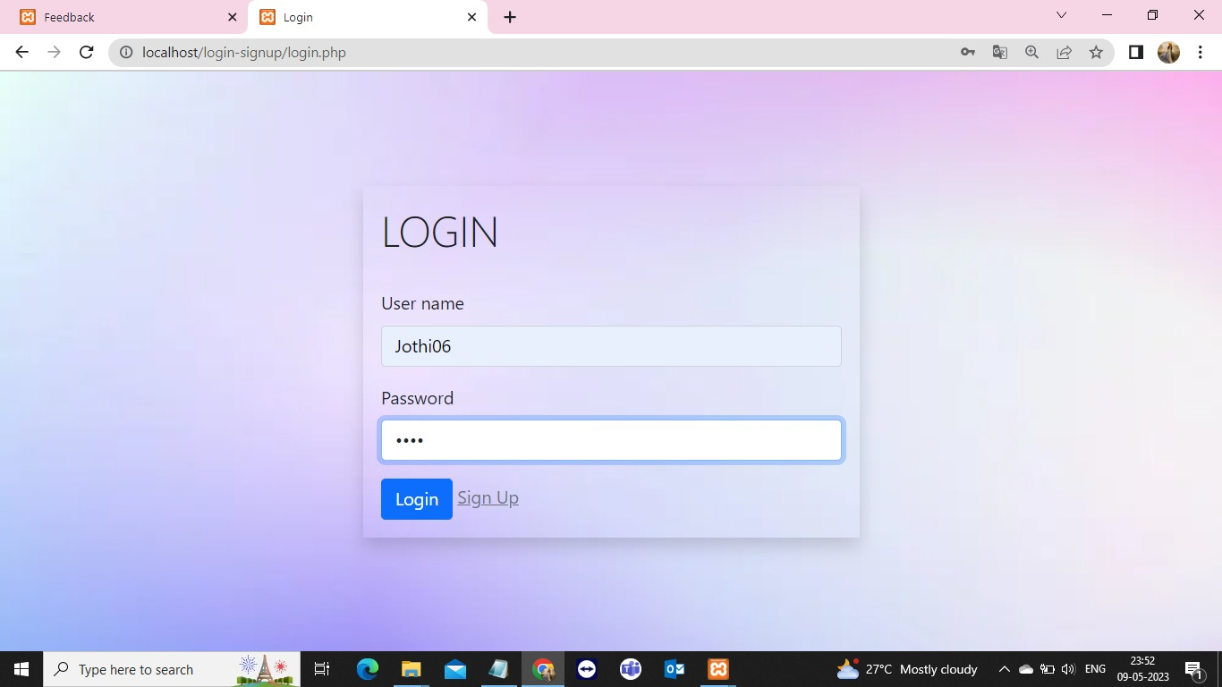

Fig 4.1 STUDENT LOGIN

B) ADMIN LOGIN
Visit the platform or website for the student feedback system. This might be from a third-party feedback system or the educational institution. On the main page or landing page, look for the login button or link. It could have a label like "Admin Login," "Log In," or something like. Type in the admin login information, which usually consists of a username and password. These may have been offered by the educational facility or set up by the administrator when they first had access to the feedback system. To enter the admin dashboard of the student feedback system, click the "Log In" button.The administrator should be able to examine all student feedback data and control the feedback system settings after they have successfully signed in.

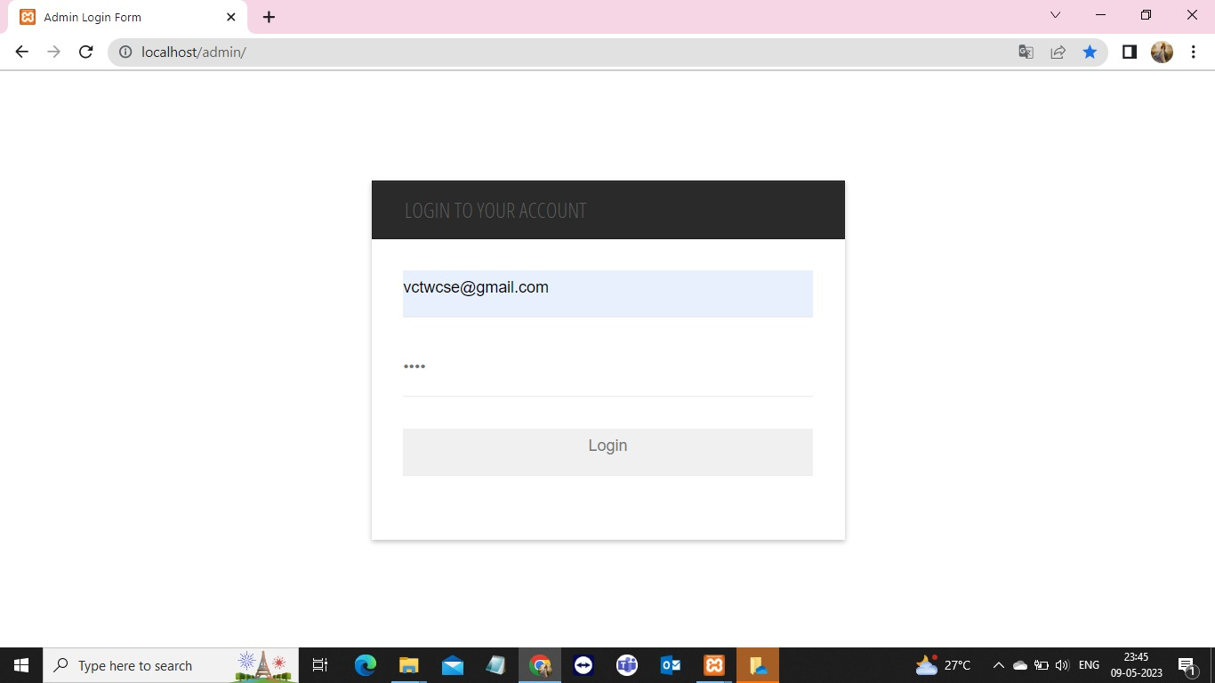

Fig 4.2 ADMIN LOGIN

C)FEEDBACK AND DATABASE

A feedback module in a student feedback system is a tool that enables students to provide feedback about their learning experiences, courses, and instructors. It is an essential component of an effective student feedback system, as it provides valuable information to educators and administrators on how to improve their teaching methods.
The feedback module typically consists of a series of questions or prompts that students can answer to provide feedback on various aspects of their learning experience.
Some common areas that a feedback module might cover include:
- The effectiveness of the course materials and curriculum
- The clarity and effectiveness of the instructor's teaching
style
- The quality and frequency of feedback provided by the
instructor
4) The course's general structure and organisation
5) The degree of contact and involvement with the other instructors in the course.

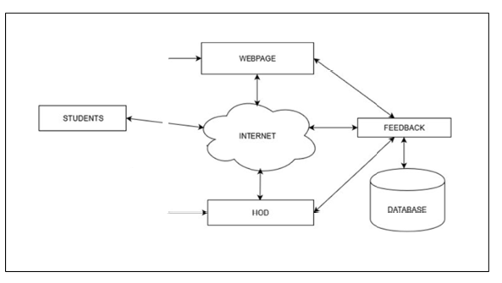
DM
ADMIN
Fig 4.3 BLOCK DIAGRAM

D)ANALYZE THE REPORT

Insights into the performance and contentment of students may be gained from analysing an Excel report in a student feedback system. You may use the following procedures to analyse such a report:
1) Determine the report's goal: Identify the report's intended point of presentation. Is it a general overview of student comments, or does it concentrate on particular topics like course material, instruction methods, or evaluation?
2) Examine the info: Take a look at the report's statistics. This might include student evaluations, remarks, or other comments. Take into account the variety of replies and any patterns or trends that could appear.

V CONCLUSION

A web-based feedback system that can be adopted by tertiary institutions has been designed in this study with the aim of evaluating the performance of academic staffs in higher institutions. The web-based system involves student feedback on specific academic staff members about the various courses they teach, and these feedbacks improve academic staff performance with regard to teaching and lecturing.

VI FUTURE ENHANCEMENT

This project Student Feedback System has been developed in such a manner, that the future requirements of the user are met. The project is flexible to adapt the changes efficiently without affecting the present system. Due to the lack of time, the design part is not done so attractive. Further enhancements can be made in designing the screens. Some more forms can also be added so as to better retrieve the feedback details

VII SAMPLE OUTPUT

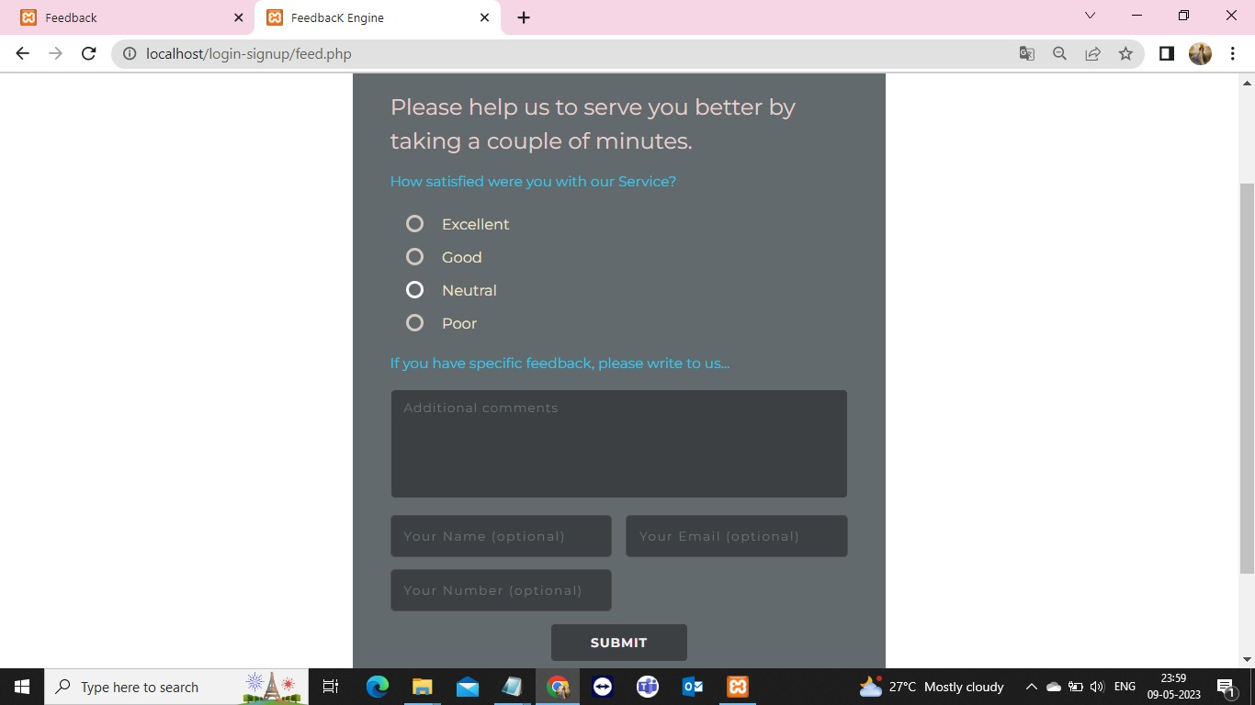

Fig 7.1 FEEDBACK SESSION

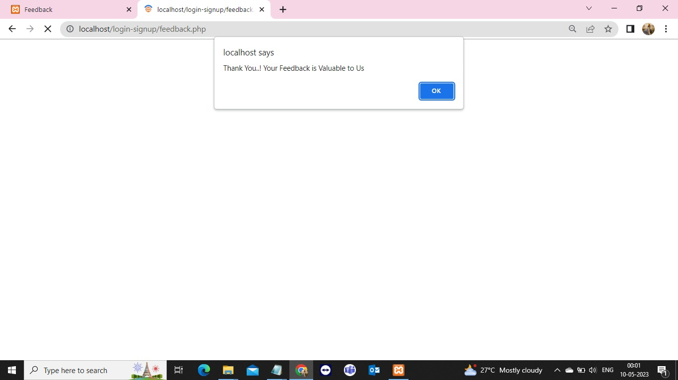

Fig 7.2 FEEDBACK SUBMISSION

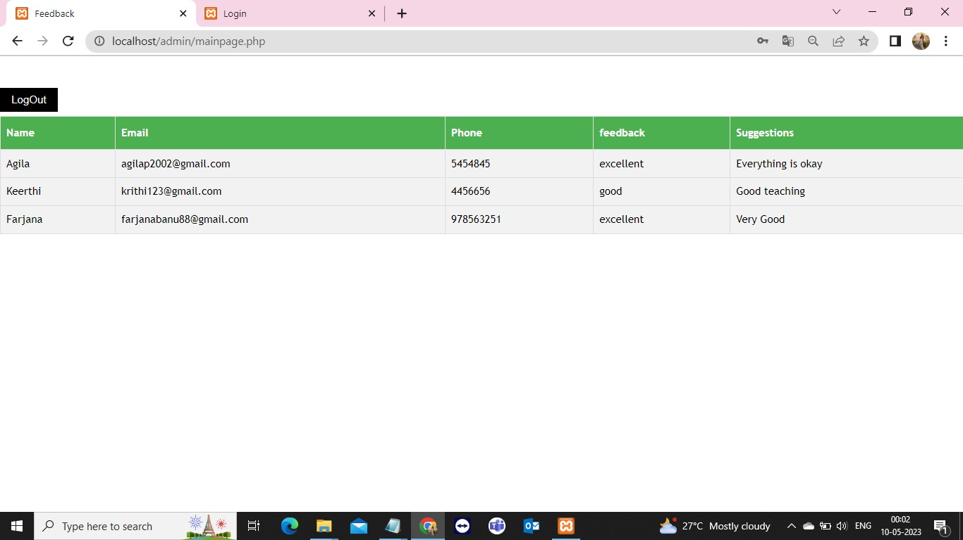

Fig 7.3. FEEDBACK REPORT

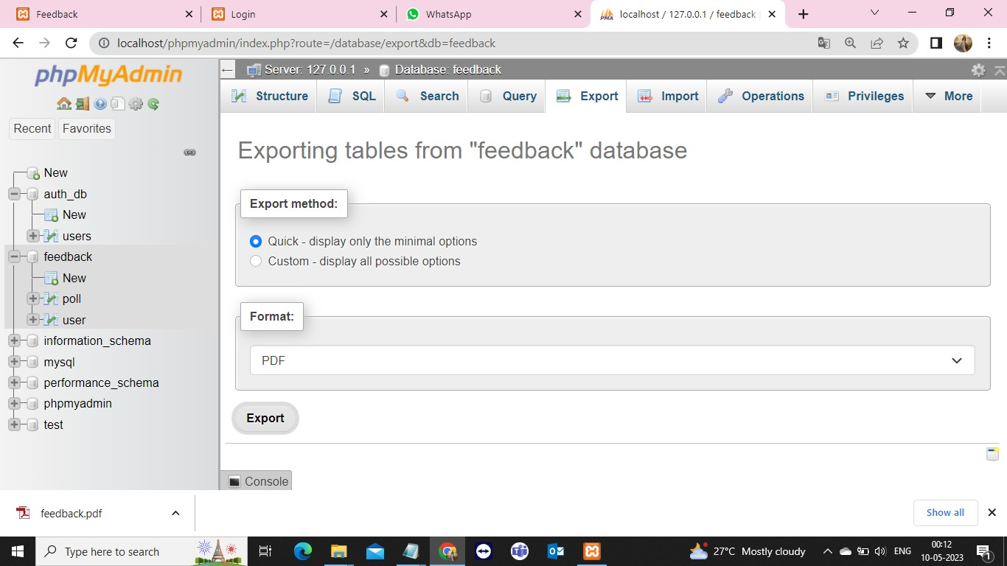

Fig 7.3. FEEDBACK DOWNLOAD

REFERENCES

[1] Rosni Abu Kassim, Juliana Johari, Muhammad Izzat Rahim, Norlida Buniyamin on "Lecturers' perspective of student online feedback system: A case study" in 2017 IEEE 9th International Conference on Engineering Education (ICEED), Kanazawa, Japan 2017.

[2] Bambang Dwi Wijanarko, Dina Fitria Murad, Yaya Heryadi, Lukas, Hapnes Toba, Widodo Budiharto on "Questions Classification in Online Discussion Towards Smart Learning Management System" in 2018 International Conference on Information Management and Technology (ICIMTech) Jakarta, Indonesia 2018.

[3] Nikhil H.M, Varada Sunitkumar, Shruti Basapur, R. Vinil Shah on "Design and implementation of Student feedback System at Education System" in IJERCSE 2018.

[4] Rajeev Patel, Omkar Agarwal, Yash Gangani, Ashish Vishwakarma on "Andriod based Student Feedback System for Improved Teaching" in IJERCSE 2019.
[5] Bhagyashree Gore “Sentiment Analysis of Parent Feedback” to guage their Satisfaction level pp.march 2018.
[6] A. Rashid, “Feature level opinion mining of educational student feedback data using sequential pattern mining and association rule mining,” International Journal of Computer Applications (0975-8887). 81 (10), pp. 31-38, 2020.

