***Railway Track Electricity Generation***

**MUIZZ SHAIKH, AHAD PATEL, ARSHAN KHAN, RAEES ANSARI, Prof. NAINA.N.KHARE**

1 2Diploma Scholar, Jumma Masjid Charitable Trust’s, JMCT Polytechnic, Nashik

3Head of Mechanical Engineering, Jumma Masjid Charitable Trust’s, JMCT Polytechnic, Nashik

4 5Lecturer, Mechanical Engineering, Jumma Masjid Charitable Trust’s, JMCT Polytechnic, Nashik

**ABSTRACT**

. With the growing demand for energy due to globalization, electric energy has become the most common form of energy as it is highly compatible with available systems. Meeting this demand has led to increased production rates and costs. To address this, various methods such as non-conventional energy sources and regenerative systems are being used. A proposed method for power generation is using railway tracks, where the mechanical movement of the train is converted into electric energy.

Key Words: Energy Demand, Alternate energy source, Regeneration, Railway. Track, etc

1. **INTRODUCTION**

Man has needed and used energy at an increasing rate for his requirement. Man required energy primarily in the form of food. He derived this by eating plants or animals, which they hunted. With further demand for energy, man began to use the wind for sailing ships and for driving windmills, and the force of falling water to turn water for sailing ship sand for driving windmills, and the force of falling water to turn water wheels. Till this time, it would not be wrong to say that the sun was supplying all the energy needs of man either directly or indirectly and that man was using only renewable sources of energy. World is growing at the faster rate with regards to consumption of fuel and so the scarcityof energy as the sources producing them are depletable in nature. Around the world, there were 8,06,000 cars and light trucks on the road consuming 260 billion US gallons 980000 liters of gasoline yearly. The extensive usage of energy has resulted in an energy crisis and there is a need to develop methods of optimal utilization, which will not only ease the crisis but also preserve the environment

1. **METHODOLOGY**

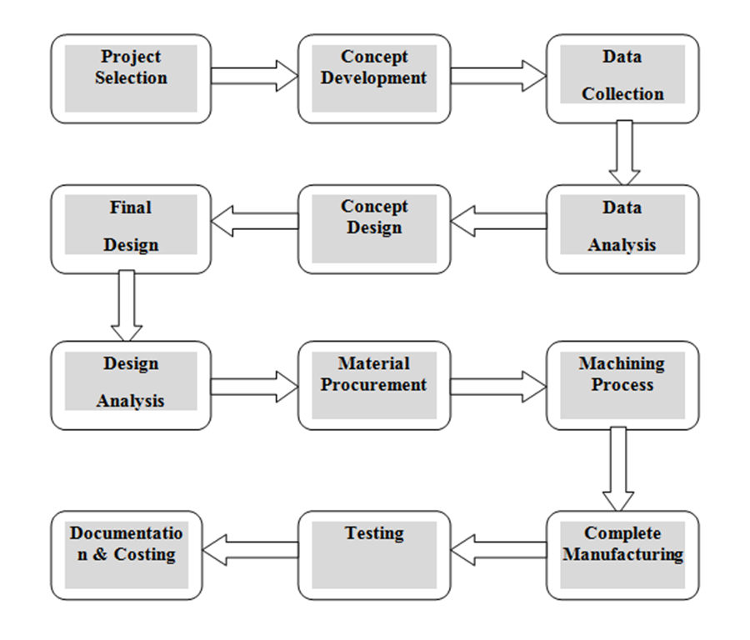

1. **FABRICATION :**

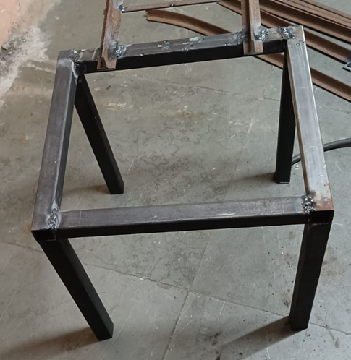

**Figure 4.5** Base Frame

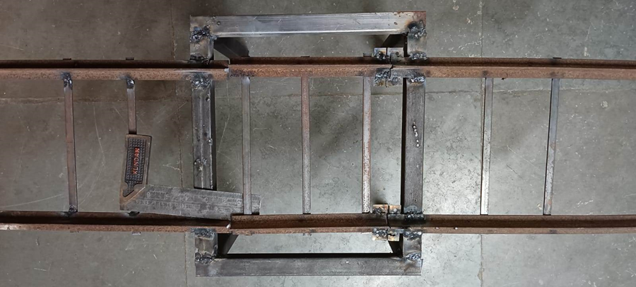

**Figure 4** Fixture

1. WORKING:

The Railway Track Energy Generation system. In which the track is made in such a way that it provides some downward movement when force acted on it. Later the downward movement is then converted to electricity by providing the mechanical linkages, pneumatic assemblies, Piezo electric crystal etc. Railway Track Energy Generation used to generate the electricity when train passes over it. As the train moves on the railway track the track moves downward due to contact of train wheel to the train track because of the weight of the train. During downward motion the track comes in contact with piezoelectric crystal and generates electricity as id deforms. As the train wheel breaks the contact with the track the track is lifted due to the torsion spring attached at the track. This downward and upward motion is continued till the train passes over it and the system generated electricity. The working is again repeated for the next train arrival.

**5. Conclution :**

As discussed in the working, the practice is carried out foe electricity generation and it is observed that the electricity is generated during the forward motion of the track hence by The Railway track electricity generation project it can be concluded that the system gives at about 4 to 4.5 v when the railway track is push downward. It can also be concluded that the generated electricity can be used for the domestic application with the use of transformer.

1. **Refrence:**

[1]Sergey V. Mitrofanov, Natalya G. Kiryanova and Anna M. Gorlova, “Stationary Hybrid Renewable Energy Systems for Railway Electrification: A Review” Stationary Hybrid Renewable Energy Systems for Railway Electrification: A Review. Energies 2021, 14, 5946.

[2]Loganathan M, Prabhakaran V, Nifasath Nowsin N, E.Sivasanjeev, M.Naveen, M.Natarajan, P.Manirathinam, “POWER GENERATION FROM TRAIN TRACK’, International Journal of Scientific & Engineering Research Volume 8, Issue 6, June-2017 1 ISSN 2229-5518

[3]Lovepreet Kaur, Alankrit Kumar , Aditya Lakde, Aakanksha Sharma, Ashutosh Ra , Mousam Sharma, presented “Railway Tracks Based Energy Generation

Using Racks and Pinion and Its Application” International Journal of Advanced Research in Electrical, Electronics and Instrumentation Engineering, Vol. 7, Issue 4, April 2018

[4]Prof. Jagdish Chahande, Bhakti S. Shirke, Vikas B. Goswami, Adnan Ali Malnas and Ganesh R. Zakane, Electricity Generation using Railway Tracks” and discussed about, GRD Journal for Engineering | Volume 2 | Issue 5 | April 2017 ISSN: 2455-5703

[5]Yash Lethwala, Rishabh Jain, "Generation of Electrical Energy from Railway Track Conference Paper • November 2018 DOI: 10.14445/23488360/IJME-V5I10P103

[6]Abhishek Kumar Gond, Aniket Kumar, Atul Pandey, Hariom Singh, “Electric Power Generation using Railway Track”, International Journal of Research in Engineering, Science and Management Volume-2, Issue-5, May-2019

[7]Saurabh D. Bhusate, Prachi S. Chaware, Prof. Ashvini B. Nagdewate, presented “GENERATION OF POWER USING RAILWAY TRACK” International Research Journal of Engineering and Technology (IRJET)