**AUTOMATIC SOLAR TRACKING SYSTEM USING ARDUINO**

**V.Saranyadevi1, A.Mariyachithramary.M.E.,2 .**

1Research Scholar, Electrical and Electronics Engineering, SreeSowdambika College of Engineering,

Anna University, Virudhunagar District,Tamil Nadu,India

2Professor,Electrical and Electronics Engineering,SreeSowdambika College of Engineering,

Anna University, Virudhunagar District, Tamil Nadu, India.

**ABSTRACT**

Solar energy has become an increasingly important and popular renewable energy source. By using a solar tracking system, we can produce an abundance of energy and improve the efficiency of solar panels. The solar panel's efficiency lies in its perpendicular proportionality with the sun's rays. Although cheaper options are also available, its installation charge is high. A prototype solar panel is discussed in this paper based on the sun's rays as the reason for its design and construction. Arduino is used as the main control circuit. As a result of the programming of this device, the LDR sensor, when it detects sun rays, will provide direction to the Servo Motor in order to move the solar panel. Consequently, the solar panel is positioned so that it can receive the maximum amount of sunlight.

1. **INTRODUCTION**

Systems analysis is a process of collecting factual data, understand the processes involved, identifying problems and recommending feasible suggestions for improving the system functioning. This involves studying the business processes, gathering operational data, understand the information flow, finding out bottlenecks and evolving solutions for overcoming the weaknesses of the system so as to achieve the organizational goals.

1. **METHODOLOGY**

The solar tracking system comprises of a solar panel. Arduino microcontroller and sensors. For this system to operate there must be emission of light through the sun. The LDR’s serve as the sensors to detect the intensity of light entering the solar panels. The LDR then sends information to the Arduino microcontroller. The servo motor circuit is then constructed. The servo has 3 pins of which the positive side is connected to the +5v of the Arduino microcontroller. The negative side of the servo is connected to ground. The data point on the servo is connected to the analog point on the microcontroller.

1. **MODELLING OF PROJECT**

**3.1 Components Description**

**3.2.1 Arduino UNO Microcontroller**

Arduino Uno Rev. 3 Microcontroller Board is based on the Microchip Technology ATmega328 8-bit Microcontroller (MCU). Arduino Uno features 14 digital input/output pins (six of which can be used as PWM outputs), six analog inputs, and a 16MHz quartz crystal. Uno also includes a USB connection, a power jack, an In-Circuit Serial Programming (ICSP) header, and a reset button. This Arduino MCU board contains everything the user needs to support the MCU. The user can get started by connecting the Uno to a computer with the USB cable or by powering it with an AC/DC adapter or battery. The Uno can be programmed with Arduino Software (Integrated Development Environment). The ATmega328 on the Uno comes preprogrammed with a boot loader that allows the user to upload new code to the MCU without the use of an external hardware programmer.

**3.2.3 Power Supply**

Power supply is an electrical device which supplies electric power to an electrical load. The first function of a power supply is to convert electric current from a source to the correct voltage, current and frequency to power up the load. As a result, power supplies are also referred to as electric power converters. Some power supplies are separate standalone pieces of equipment while others are built into the load appliances that they power.

**3.2.4 SOLAR PANEL**

A single solar module can produce only a limited amount of power; most installations contain multiple modules adding their voltages or currents. A photovoltaic system typically includes an array of photovoltaic modules, an inverter, a battery pack for energy storage, a charge controller, interconnection wiring, circuit breakers, fuses, disconnect switches, voltage meters, and optionally a solar tracking mechanism. Equipment is carefully selected to optimize output and energy storage, reduce power loss during power transmission, and convert from direct current to alternating current.

**3.2.5 LDR SENSOR**

Light Dependent Resistor is one type of variable resistor. It is also known as a photo resistor. The Light Dependent Resistor (LDR) works on the principle of “Photo Conductivity”. The LDR resistance is change according to the light intensity falls on the LDR.  When light intensity increase on the LDR surface, then the LDR resistance will decrease and the element conductivity will increase. When light intensity decrease on the LDR surface, then the LDR resistance will increase and the element conductivity will decrease.

**3.2.6 MOTOR DRIVER**

Motor drive means a system that includes a motor. An adjustable speed motor drive means a system that includes a motor that has multiple operating speeds. A variable speed motor drive is a system that includes a motor and is continuously variable in speed. If the motor is generating electrical energy rather than using it – this could be called a generator drive but is often still referred to as a motor drive.

**Working of Components**

**3.3.2 Working of solar panel**

Solar panels collect clean renewable energy in the form of sunlight and convert that light into electricity which can then be used to provide power for electrical loads. Solar panels are comprised of several individual solar cells which are themselves composed of layers of silicon, phosphorous (which provides the negative charge), and boron (which provides the positive charge). Solar panels absorb the photons and in doing so initiate an electric current. The resulting energy generated from photons striking the surface of the solar panel allows electrons to be knocked out of their atomic orbits and released into the electric field generated by the solar cells which then pull these free electrons into a directional current. This entire process is known as the Photovoltaic Effect. An average home has more than enough roof area for the necessary number of solar panels to produce enough solar electricity to supply all of its power needs excess electricity generated goes onto the main power grid, paying off in electricity use at night.

In a well-balanced grid-connected configuration, a solar array generates power during the day that is then used in the home at night. Net metering programs allow solar generator owners to get paid if their system produces more power than what is needed in the home. In off-grid solar applications, a battery bank, charge controller, and in most cases, an inverter are necessary components. The solar array sends direct current (DC) electricity through the charge controller to the battery bank. The power is then drawn from the battery bank to the inverter, which converts the DC current into alternating current (AC) that can be used for non-DC appliances. Assisted by an inverter, solar panel arrays can be sized to meet the most demanding electrical load requirements. The AC current can be used to power loads in homes or commercial buildings, recreational vehicles and boats, remote cabins, cottages, or homes, remote traffic controls, telecommunications equipment, oil and gas flow monitoring, RTU, SCADA, and much more.

**Working of motor driver**

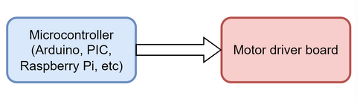

First, the microcontroller sends signals to the motor. Then, the signs received are interpreted and stepped up in the engine afterward. The motor has two voltage input pins. Pin one turns on the driver, whereas pin 2 applies voltage to the motor via the motor IC.

If the microprocessor transmits a high input to the driver IC, the driver IC will send the same input. Consequently, this explains that the IC does not change the type of signal it receives.

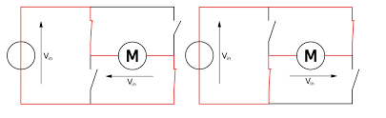

(When the moves in a clockwise direction)  (When the motor moves in an anticlockwise direction.)

For the motor to rotate clockwise, S2 and S3 switch open while switches S1 and S4 close. Then, S1 will allow its voltage to flow through the engine directly to S4. During this current flow, the circuit becomes fully complete. Further, this current will flow from point V to point M via switches S1 and S4. As a result, the motor stays on and turns clockwise.

First, we give the switches an input voltage. As a result, switches S1 and S4 will eventually close. Moreover, this forms a positive connection since we connect two parallel switches. Consequently, the motor will rotate in an anticlockwise direction. On the other hand, for an engine to turn in the anticlockwise focus, we activate the S3 and S2 switches.

**Working of LDR Sensor**

This resistor works on the principle of photo conductivity. It is nothing but, when the light falls on its surface, then the material conductivity reduces and also the electrons in the valence band of the device are excited to the conduction band. These photons in the incident light must have energy greater than the band gap of the semiconductor material. This makes the electrons to jump from the valence band to conduction.

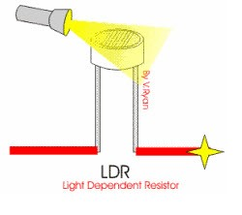

These devices depend on the light, when light falls on the LDR then the resistance decreases, and increases in the dark. When a LDR is kept in the dark place, its resistance is high and, when the LDR is kept in the light its resistance will decrease.

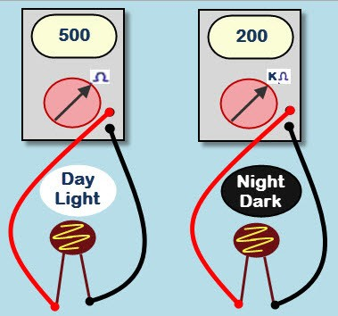

f a constant “V’ is applied to the LDR, the intensity of the light increased and current increases. The figure below shows the curve between resistance Vs illumination curve for a particular light dependent resistor.

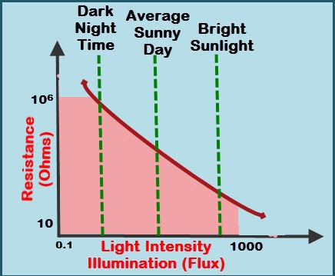

1. **CIRCUIT DIAGRAM**

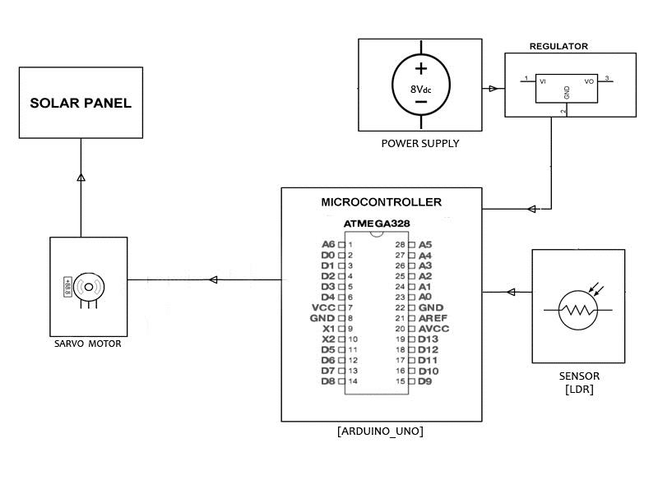

1. **CIRCUIT DIAGRAM OPERATIONS**

Two LDR’s (Light Dependent Resistor) LDR1&LDR2 are connected to Analog Pins of the Arduino. A Solar Plate is attached to the axis of the servo motor and both are sensors are kept on the solar plate.The design& the arrangement is done in such a manner that the movementof the sun.

Case 1: Sun in the Left side

Light on LDR1 is high because the shadow of barriers falls on LDR2 so solar plate moves clockwise.

Case 2: Sun is in Right Side

Light on LDR2 is high because the shadow of barriers falls on LDR1 so solar plate moves anticlockwise.

Case 3: Sun is in the Center

Light on both LDR’s is equal so,plate will not rotate in direction.

1. **CONCLUSION**

In conclusion, it can be said that the systems have no significant difference in between them while considering all the factors what affect the output power of solar panel. According to comparison, the electrical output is quite little of single-axis sun tracking solar panel system and has no significance over dual-axis sun tracking solar panel system’s electrical output. In terms of cost effectiveness

.

1. **ACKNOWLEDGEMENT**

I am extremely grateful thank to our Head of the Department **Dr.R.SIVASANGARI.,M.E.,Ph.D,** professor of EEE forherable guidance, continuous encouragement and moral support throughout the project work.

I wish to express my deep sense of gratitude to my internal Project Guide **Mrs.A.Mariyachithramary., ME., AP/EEE.,** Professor, Department of EEE for his able guidance continuous encouragement and moral support throughout the project work.

1. **REFERENCES**

* 1.Juan Reca-Cardeña, Rafael López-Luque, Chapter 9- Design Principles of Photovoltaic Irrigation Systems, “Advances in Renewable Energies and Power Technologies”, Elsevier Science, 2018
* 2. C. Chang, Chapter 5 Tracking solar collection technologies for solar heating and cooling systems, “Advances in Solar Heating and Cooling”, Woodhead Publishing, 2016
* 3. Kamrul Islam Chowdhury, Md.Iftekhar-ul-Alam, Promit Shams Bakshi, “Performance Comparison between Fixed Panel, Single-axis and Dual-axis Sun Tracking Solar Panel System,” BRAC University, Department of Electrical and Electronic Engineering, 2017.
* 4. Oloka Reagan Otieno, “SOLAR TRACKER FOR SOLAR PANEL”, University of Nairobi, Dept. of Electrical and Electronic Engineering, 24th August 2015