**Structural Health Monitoring of Bridges**

**Dhirajkumar Saindane, Pranav Jare, Yash Gabale**

UG Students, Electronics and Telecommunication, NDMVPS’s Adv. Karmaveer Baburao G.Thakre College of Engineering, Nashik, Maharashtra, India

**ABSTRACT**

The Internet of Things is the collection of intelligent, linked objects with which we are starting to live and interact. Our civilization has new opportunities thanks to the IOT. However, the majority of the structural health monitoring (SHM) systems in use today are not IOT-connected. In this study, the IOT system is coupled with a full real-time SHM platform. SHM is a system to monitor the structural health of buildings and bridges. A Raspberry Pi and a Wi-Fi module make up the suggested platform. If any damage occurs, the system will locate it and communicate the location data to the cloud. The Raspberry Pi gathers data from numerous sensors. With a Wi-Fi module, the Raspberry Pi will transfer the data to the cloud. The information will be kept in the cloud and accessible remotely from any mobile device.

**Keywords:** cloud, Internet of Things (IOT), mobile devices, Raspberry Pi, Structural Health Monitoring (SHM), Wi-Fi module.

1. **INTRODUCTION**

Bridges are currently at a stage of rapid development, and the community has placed a high value on the operational safety of bridges. Thus, it has become a hot problem that is challenging to handle in this sector how to assure the safe functioning of long-span bridges. Bridges will be impacted by outside forces including traffic, the environment, and rivers over the course of their service life, which can last for decades or even a century. Internal influences on bridges, such as material ageing, fatigue, and other variables, will also have an impact. Damage and serious accidents are unavoidable results of these conditions.

One of the current issues facing the structural engineering community due to the maturation of smart technology is the creation of IOT SHM systems that could offer a potential answer for quick, precise, and affordable SHM systems. Moreover, services that are available everywhere and powerful processing of sensing data streams will be possible because to the integration of SHM, cloud computing, and the Internet of Things. The SHM data may be stored and used intelligently for smart monitoring and actuation with smart devices thanks to cloud platforms. We are employing IOT-based structural health monitoring of bridges to prevent any financial and human costs. Yet, there is no actual SHM implementation in the IOT. This study suggests a whole IOT-based real-time SHM platform.

1. **METHODOLOGY**

The paragraph above primarily discusses the need for IoT-based structural health monitoring (SHM) systems to ensure the safe functioning of long-span bridges. While it does not explicitly mention any research work or title, I can suggest a possible Method and Analysis section based on the topic of the paragraph. Here is an example:

Method:

To address the challenge of ensuring the operational safety of long-span bridges, an IoT-based real-time SHM platform was developed. The platform comprises various sensors installed on the bridge structure to monitor key parameters such as strain, displacement, and vibration. The sensor data is transmitted wirelessly to a cloud platform for storage and processing.

Analysis:

The sensor data obtained from the IoT-based SHM platform is analyzed using various algorithms and techniques to detect any anomalies or changes in the bridge's behavior. Machine learning algorithms are employed to analyze the data and generate real-time alerts when any deviations from the normal behavior of the bridge are detected. The platform also provides graphical representations of the sensor data and the results of the analysis, enabling engineers to identify potential issues and take appropriate measures.

Overall, the Method and Analysis section would describe in detail the steps taken to develop and deploy the IoT-based SHM platform and the analysis techniques used to process the sensor data.

1. **MODELING AND ANALYSIS:**

**SYSTEM DEVELOPMENT NEED**

- Bridges are the type of structures that need to be safe for transportation and connectivity.

- Long-span bridges are vulnerable to damage and accidents due to various external and internal factors.

- Structural health monitoring (SHM) systems can help ensure the safety of long-span bridges.

- An IOT-based real-time SHM platform can offer quick, precise, and affordable monitoring of long-span bridges.

- The platform should be designed to accommodate the different types of external and internal factors that affect the functioning of long-span bridges.

- The SHM system should be capable of detecting and measuring these factors and providing real-time feedback to engineers and maintenance crews.

- The platform should incorporate advanced technologies such as machine learning and artificial intelligence to improve the accuracy and reliability of the SHM system.

- The use of these technologies would enable the platform to learn from past data and predict future problems, thereby allowing for preventive maintenance and reducing the risk of damage and serious accidents.

- Developing an IOT-based real-time SHM platform is essential for ensuring the safety of long-span bridges and preventing financial and human costs.

**Block Diagram & Concept Description**

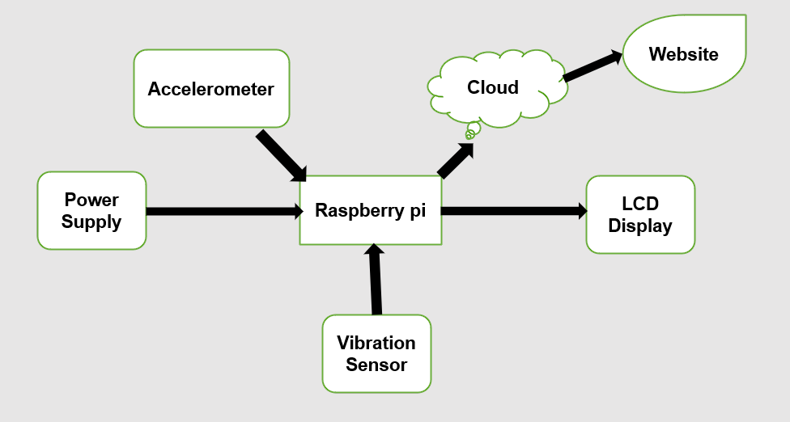

Fig. Block diagram of Structural Health Monitoring System

The system described in this article consists of a Raspberry Pi 3, an accelerometer, and a vibration sensor. These sensors are placed at various points on the bridge to monitor vibrations and any possible damage to the bridge. Whenever any of these parameters exceed their set limit, the system sends an alert to the monitoring office, indicating the need for precautionary measures. The Raspberry Pi 3 captures all the parameters of the bridge and sends them to the cloud. The communication between the devices uses a wireless transmitter and receiver circuit, which is facilitated by a Wii module. The receiver module collects the parameters from the transmitter and sends them, along with all other relevant data, to a database center.

The sensory inputs collected from the bridge are analyzed to assess the state of the bridge in terms of vibrations, water level, and other important factors. If any of these parameters exceed their predefined limit, the system sends an alert to the monitoring center, indicating the need for immediate action. In response, the bridge barrier will be automatically closed and a loud alarm will be sounded to warn nearby individuals of potential danger.

**Selection Criteria:**

Raspberry Pi:

The Raspberry Pi 3 is a popular single-board computer that is part of the Raspberry Pi series. It is the latest product in the Raspberry Pi 3 range, boasting a 64-bit quad-core processor that can run at 1.4GHz. This makes it a powerful computing device, suitable for a range of applications. It also has dual-band wireless LAN, supporting both 2.4GHz and 5GHz frequencies, as well as Bluetooth 4.2/BLE for wireless connectivity. The Raspberry Pi 3 also has faster Ethernet and PoE (Power over Ethernet) capability, which can be enabled via a separate PoE HAT.

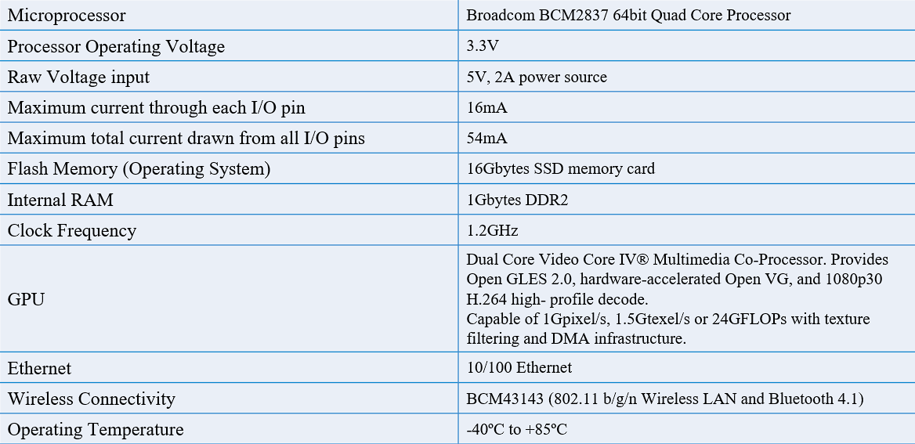

Accelerometer (Adxl 335)

The ADXL335 is a low-power, 3-axis accelerometer with the following specifications:

1. Measuring range: +/- 3g

2. Sensitivity: 330 mV/g

3. Frequency response: 0.5 Hz to 1.6 kHz

4. Bias: +/- 300 mg

5. Noise: 280 µg/√Hz

6. Linearity: +/- 0.3% of full-scale range

7. Cross-axis sensitivity: +/- 2% of full-scale range

8. Power consumption: 350 µA (typical)

9. Size and weight: 4 x 4 x 1.45 mm and 0.5 g

These specifications make the ADXL335 suitable for a wide range of applications, including tilt sensing, vibration monitoring, and motion detection. The low power consumption and small size of the ADXL335 make it particularly well-suited for battery-powered and portable applications.

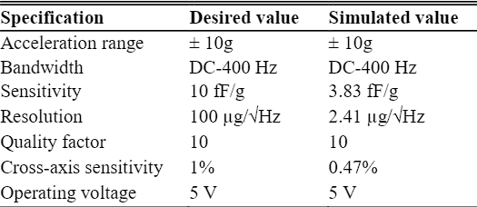

Vibration Sensor:

The SW420 is a vibration sensor module that can detect vibration or tilt in a system. It has the following specifications:

1. Operating voltage: 3.3V to 5V DC

2. Output signal: Digital signal (0 or 1)

3. Sensitivity: Adjustable using a potentiometer on the module

4. Detection range: Can detect vibrations in the range of 3.3Hz to 1.2kHz

5. Response time: <2ms

6. Operating temperature: -10°C to 70°C

7. Size: 29mm x 13mm x 13mm

8. Weight: 2g

These specifications make the SW420 suitable for a variety of applications such as anti-theft devices, seismic detectors, and shock sensors. The adjustable sensitivity feature allows users to fine-tune the module to detect vibrations at the required threshold. The fast response time and small size of the SW420 make it easy to integrate into systems where space is limited, and quick detection of vibration is critical.

LCD Display:

The 16x2 LCD (Liquid Crystal Display) module is a commonly used display module that can display two lines of up to 16 characters each. The specifications of the module include:

1. Display type: 16x2 character LCD display

2. Backlight: LED backlight (Blue or green)

3. Viewing area: 64.5mm x 16mm

4. Character size: 2.95mm x 4.75mm

5. Character set: ASCII and Japanese Kana

6. Operating voltage: 5V DC

7. Operating temperature: 0°C to 50°C

8. Connection: 16-pin header

9. Contrast adjustment: Potentiometer

Application:

Structural Health Monitoring (SHM) of bridges has the following applications:

1. Early detection of damage

2. Predictive maintenance

3. Improving safety

4. Optimizing bridge design

5. Evaluating load capacity

6. Monitoring environmental conditions

These applications help ensure the safe and efficient operation of bridges, reduce maintenance costs, and improve their longevity.

**Figure 1:** Pycnometer Test Procedure.

1. **RESULTS AND DISCUSSION**

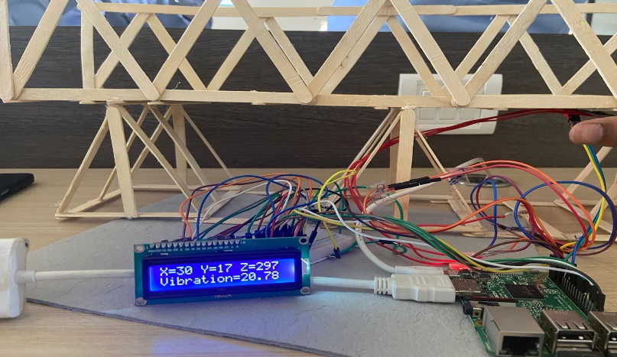

Fig. result

Bridges are crucial pieces of infrastructure that must operate safely for decades or even a century, but they face various internal and external influences that can cause damage or accidents. To address this challenge, the structural engineering community is exploring the potential of IoT-based structural health monitoring (SHM) systems that offer quick, precise, and affordable monitoring of bridge health. By integrating SHM with cloud computing and the Internet of Things, these systems can provide powerful processing of sensing data and enable smart monitoring and actuation with connected devices. However, despite the interest in such systems, there are currently no practical implementations. Thus, this study proposes a real-time IoT-based SHM platform that could enable continuous monitoring and analysis of bridge health data. By doing so, the proposed platform has the potential to prevent financial and human costs associated with bridge damage or accidents. Overall, this paragraph emphasizes the importance of adopting innovative solutions to ensure the safety and longevity of critical infrastructure like bridges.

1. **CONCLUSION**

Wireless technology has the potential to prevent bridge collapses, as more than one in four bridges in developed European countries are structurally deficient. This technology is significantly less expensive than current wired systems and can efficiently and reliably monitor bridges. The compact size, low energy consumption, immediacy, and affordability of this system represent a revolution in bridge safety monitoring. To further improve the efficiency of the Bridge Monitoring System (BMS), it is recommended to use a greater number and variety of sensors to monitor bridge damages

1. **REFERENCES**

Journal Papers:

* Structural Health Monitoring by Using Wireless Sensor Networks

     Authors:-Der-Cherng Liaw* , Chiung-Ren Huang, Hung-Tse Lee, and Sushil Kumar

* Structural health monitoring of a bridge structure using wireless sensor network

     Authors:-CheeKian Teng ,Western Michigan university

* Accelerometer Based Structural Health Monitoring System on the Go: Developing Monitoring Systems

     Authors:-Salami Ifedapo Abdullahi(*), Nurul Arfah Che Mustapha, Mohamed Hadi Habaebi and Md. Rafiqul Islam

* STRUCTURAL HEALTH MONITORING SYSTEM – AN EMBEDDED SENSOR APPROACH

     Authors: Dhivya. A#1, Hemalatha. M*2 # M.Tech-Embedded System SASTRA University Thanjavur, Tamil Nadu, India