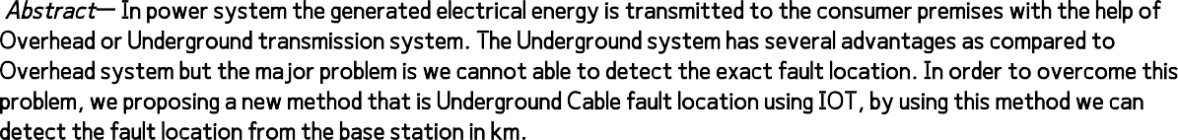

*Abstract***— In power system the generated electrical energy is transmitted to the consumer premises with the help of Overhead or Underground transmission system. The Underground system has several advantages as compared to Overhead system but the major problem is we cannot able to detect the exact fault location. In order to overcome this problem, we proposing a new method that is Underground Cable fault location using IOT, by using this method we can detect the fault location from the base station in km.**

*Keywords-UndergroundCable,IOTModule,ArduinoUno,Faultdetection,LCD,LED,Buzzer.*

1. **INTRODUCTION**
   1. **OBJECTIVE OF THE PROJECT**

**Normally underground cables using transmits the power. If that cable gets any damage means we have to check to start to end. But in this project, we developed on the method we monitoring the cable in IoT. If any damage will happen means the particular place find in IoT cloud. We tend to use IOT technology that permits the authorities to observe and check faults over the web. The system detects a fault with the assistance of a possible divider network set across the cable.**

* 1. **IMPORTANCE OF THE PROJECT:**

**This protects use IOT technology that permits the authorities to observe and check faults over the web. The system**

**detects a fault with the assistance of a possible divider network set across the cable. Whenever a fault gets created to some extent shorting 2 lines along, a selected voltage gets generated as per the resistors network combination. This voltage is detected by the microcontroller and is updated to the user.**

1. **EXISTING FAULT DETECTION METHODS**

In power system underground cables are used to transmit the electric power from generators stations to distribution point then it is transferred to the consumer ends. Underground cables face various problems due to aging and different types of faults. To overcome these problems in cables, lots of research work has been done previously. Here we proposed a method to rectify these problems. Previously there are so many methods available for detection of fault. These methods are used for fault detection of underground cables. They are

* **Murray Loop method**
* **Sectionalizing method**
* **Thumping method**
  1. **Murray Loop Method:**

This method is basically used for identifying the faults in earth cables. This scheme is based on the principle of the Wheatstone bridge. The fault location in an earth cable can be finding by arranging a Wheatstone bridge. For fault exposure Murray loop technique is used. This method is very straightforward. For observation of short circuit faults in underground line this method is used. This loop test is usually used for identifying the faults in earth cables. This trial is based on the law of Wheatstone bridge. By using this experiment, fault site in an earth cable may be finding by arranging a Wheatstone bridge in it. In this scheme we first need to place a sound cable of equal length as of defective cable. The cable without any error is called as sound cable and we have to short circuit the ends of sound cable & faulty cable. Now we connect a galvanometer in between beginning of both working cable & not working cable. Now we connect two resisters crosswise the working cable & not working cables in such manner that these both the resisters are variable. Now the entire loop will form as a Wheatstone bridge. Then we connect one battery via the ground. For balancing the bridge, we regulate the value of both the resisters till the galvanometer shows the zero value. We shall carry out the shortcoming spot by comparing the resistances. We should have to know the values of both the resistances.

* 1. **Sectionalizing Method:**

This method requires physically cutting and splicing the cable, which can reduce the cable’s reliability. In this method the cable needs to be divided into small sections which enable us to find the fault. Example on a 400-ft length cable, the cable is cut into 200-ft length sections each, and reading is measured in both ways with the help of Ohmmeter or high-voltage insulation resistance (IR) tester. If the reading on the IR tester shows low then the cable is in fault condition. One has to

repeat this procedure until we reach the fault location.

* 1. **Thumping:**

This method requires noise to detect the fault. When a high voltage is supplied to a cable (faulted), then arc is produced due to high currents. This arc makes a loud noise enough to be heard. This method is easy as compared to Sectionalizing but thumping requires a high current at a voltage as high as 25 KV to produce an underground noise. When cable is subjected to high currents then the temperature of the cable increased. The high temperature will damage the cable insulation.

1. **IoT BASED FAULT DETECTION METHOD**

Internet of Things is an Internet-connected object system that can store and transmit data on a wireless network without human interference. Internet of Things is a wireless system. IoT has its major contribution in fault

diagnosis and prediction of the physical devices by analysing the device without the knowledge of the physical manufacturing system. Underground cables due to underground stresses, wear and tear, rodents, etc. They are subject to a variety of defects. It is also difficult to detect fault sources. To inspect and repair the failure, the whole line has to be dug. We, therefore, propose an Underground Cable Fault Detector using IoT that detects the exact position of the defect and simplifies the repair. To locate the root of the problem, the repairmen know which component is defective and only the region must be dug. This saves a lot of time, money, and effort and enables simple underground cable maintenance. This saves a great deal of time, money, and effort and allows for easy cable maintenance in the underground. We use Ohm’s law principle to detect and verify failures over the internet by authorities, here the Arduino board that is an IoT component functions as a machine brain and handles the sensor data. The machine detects errors by using the future cable-wide divisor network. When a failure occurs when two lines are cut, a certain voltage will be generated according to a combination of the resistance network. The microcontroller senses this voltage and is modified. The information the consumer receives is the distance that corresponds to this voltage. The microcontroller collects fault line data and displays it over an LCD monitor so that this data is transferred to the internet for online access.

* 1. **Block diagram:**

The block diagram of this system consists of Arduino Uno, LCD, Buzzer, IOT, Relay, Indicator LED, Power supply etc. Arduino Uno is the main equipment of the system, it performs all operations regarding to user requirement. One program is created and dumbed into Arduino Uno. The kit is activated by turn on the power supply, under normal condition (no fault) there is no any indication through Buzzer, LED, LCD etc. Whenever fault occurs at that time initially, we getting indications through equipment’s which are mentioned above and one information also received by user to mobile with the help of IOT module. The first indication gives Voltage fault in the form of sound, light, display on LCD and information to mobile of user which helps the user to maintain the continuity of the system at a time by changing the supply. Second indication also gives cable fault in terms of light, buzzer, display on LCD screen and information to user mobile which helps the user for finding exact fault distance from the base station.

The below figure shows

circuit diagram of Underground Cable Fault detection using IOT.

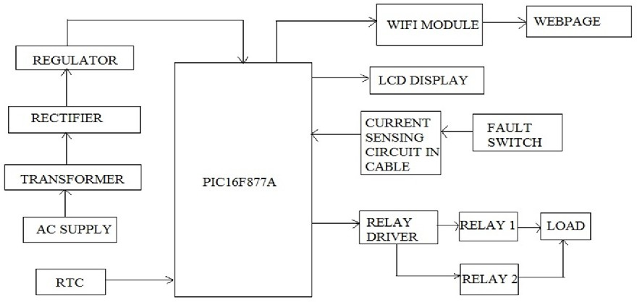



**3.2 Circuit Diagram:**

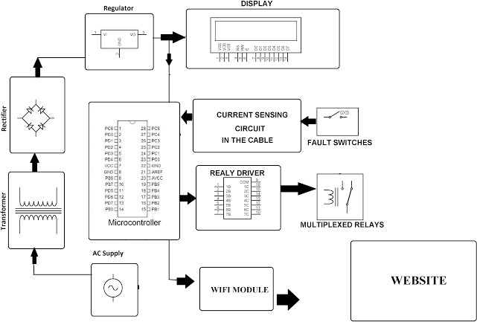

The above figure shows the circuit diagram of Underground Cable fault detection using IOT. In this circuit the main equipment is Arduino Uno, we can say this is a heart of the system. The underground cable

shows in the form of resistance as shown in the figure.

The power supply is provided to the kit with the help of USB cable (DC) or Barrel Jack (AC). The input signal to the Arduino Uno is cable fault and output signal produced by the Arduino is given to the output devices such as LCD, LED, Buzzer and mobile through IOT as shown in figure.



**Major Components:**

|  |  |  |
| --- | --- | --- |
| **Components** | **Type** | **Ratings in DC** |
| **Arduino** | **Uno R3** | **5V** |
| **IOT Module** | **ESP8266** | **5V** |
| **Power Supply** | **DC** | **5V** |
| **Buzzer** | **Electromagnetic** | **up to12V** |
| **LED** | **White LED 8mm** | **3.4V** |
| **Relay** | **Single-Channel** | **5V** |
| **Wire Jumpers** | **Female/Male** | **12V** |
| **Sensor** | **Voltage Sensor** | **up to 25V** |

3.4 Arduino IDE Software:

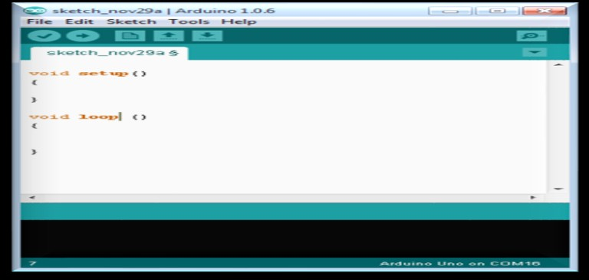

The Arduino IDE (Integrated Development Environment) or Arduino Software basically used for

used for generating code for Arduino board depending upon our requirement. This software consists of text

editor for writing code, a message area, a text console, a toolbar with buttons for common functions and a series of menus. It connects to the Arduino hardware with the help of USB cable to upload programs and communicate with them. In this software mainly we write code in C++, C++ is a superset of C. The following figure shows Arduino software.

1. **RESULTS**

The Underground Cable Fault Detection using IOT Kit is made as per the circuit diagram (Fig 2) which is mentioned in the chapter Proposed system. The designed kit is given below.

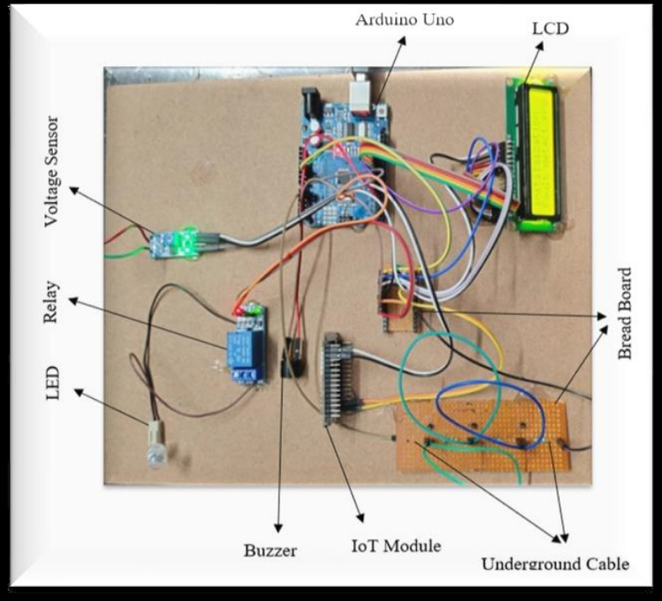

The Underground Cables are less affected as compared to Overhead transmission lines. Whenever fault occurs in Underground Cables, we are receiving two kinds of outputs.

Conclusion:

The drawback we are faced in the Underground Cable transmission system is we cannot detect the exact fault location from the base station. This drawback overcome by using this method that is we can detect the fault location from the base station in km. It makes easy to skill persons for clearing the fault in less time.

Future scope:

This project only detects the exact fault location in Underground Cable from the base station. In future it may be possible to do project on automatically clear the fault by designing one Robot.

REFERANCES

1. **Computerized underground cable fault location expertise, E.C. Bascom .in Proc. IEEE Power Eng. Soc. General Meeting, Apr. 1015, 1994, pp. 376382.J.**
2. **R. Salat and S. Osowski, “Accurate Fault Location in the Power Transmission Line Using Support Vector Machine Approach,” IEEE Transactions on Power Systems, vol. 19, no. 2, pp. 979–986, 2004.**
3. **A line to ground fault location algorithm for underground cable system, M.-S. Choi, D.-S. Lee, and X. Yang. KIEE Trans. Power Eng., pp. 267273, Jun. 2005.**
4. **R. Salim, M. Resener, A. Filomena, K. R. C. D. Oliveira, and A. Bretas, “Extended Fault-Location Formulation for Power Distribution Systems,” IEEE**
5. **Transactions on Power Delivery, vol. 24, no. 2, pp. 508–516, 2009.**