**SMART WASTE MANAGEMENT SYSTEM**

**M Mohanapriya1, Manjunath J2, Johnson Rozario3, Venkatesh Prasad G4 , Mahesh S K5**

1Assistant Professor, CSE, Sambhram Institute of Technology, Bengaluru, Karnataka, India

2345Student, CSE, Sambhram Institute of Technology, Bengaluru, Karnataka, India

**ABSTRACT**

The Smart Waste Management System is a modern-day product that addresses the most required need for green waste control in families and public regions. The gadget integrates a completely unique waste segregation function that separates dry and moist waste, promoting sustainable residing and minimizing environmental impact. Additionally, it includes a proximity sensor that detects the presence of someone near the bin, offering a touchless and hygienic solution for waste disposal. The machine makes use of a Blynk software to notify the user in actual-time about the bin's status, showing the fill level and alerting the user when the bin is complete. This function prevents overflowing, lowering littering and promoting a smooth surroundings. Overall, the Smart Waste Management System is a clever, green, and progressive answer that enhances waste management, improves hygiene, and promotes sustainable residing.

***Key Words*:** Smart Waste Management System, Waste segregation, Proximity sensor, Blynk app.

1. **INTRODUCTION**

The Waste management is a important issue that needs to be addressed so that you can maintain a smooth and healthful environment. The quantity of waste generated in India on my own is a first-rate situation, and it's miles vital that powerful measures are taken to manage it successfully.

The conventional approach of gathering and segregating waste manually isn't best time-ingesting but additionally inefficient, main to fitness dangers and unhygienic surroundings. Therefore, a more superior and automatic waste segregation and tracking gadget is required to control waste effectively.

The waste control hierarchy has been commonplace international as a framework for growing strong waste control policies. In line with this framework, we endorse an innovative Automated Waste Segregator and Monitoring System that could reveal the extent of waste in containers. Once the bin is eighty% full, it will send a notification to acquire the waste directly. This will prevent the overflow of rubbish containers, for you to assist hold the encompassing regions easy and hygienic.

Proper segregation of waste at the preliminary level is important for powerful waste control. Therefore, the proposed system contributes to the automation of waste segregation on the source. By doing so, a full-size part of the waste management cycle is blanketed, decreasing the workload of guide segregation and improving the general performance of the procedure.

In end, the implementation of a sophisticated automated waste segregation and monitoring machine can considerably improve waste control efficiency while decreasing health risks related to manual segregation. It is high time that we pass faraway from the traditional methods of waste management and adopt more modern and sustainable solutions.

1. **PROBLEM STATEMENT**

The growing quantity of waste generated by means of urban areas poses a substantial task to waste management authorities global. Inefficient waste disposal systems frequently cause environmental pollution, fitness dangers, and the depletion of natural sources. This problem necessitates the want for smart waste management answers which can sell sustainable living, minimize environmental effect, and decrease the charges related to waste disposal. The Smart Waste Management System is a progressive solution that integrates superior technologies along with ultrasonic sensors, servos, and Blynk IoT platform to manage waste efficiently. The device's capability to segregate dry and moist waste, discover the level of waste within the bin, and offer actual-time updates to the person via a mobile software reduces the want for human intervention and ensures proper waste disposal. The integration of the proximity sensor and touchless disposal mechanism complements hygiene and decreases the risk of go-infection. The device's remote monitoring talent permit waste management authorities to optimize waste collection and disposal schedules, decreasing operational expenses and improving sustainability. The Smart Waste Management System is a promising answer that could assist deal with the growing waste control challenges confronted by way of urban regions global.

1. 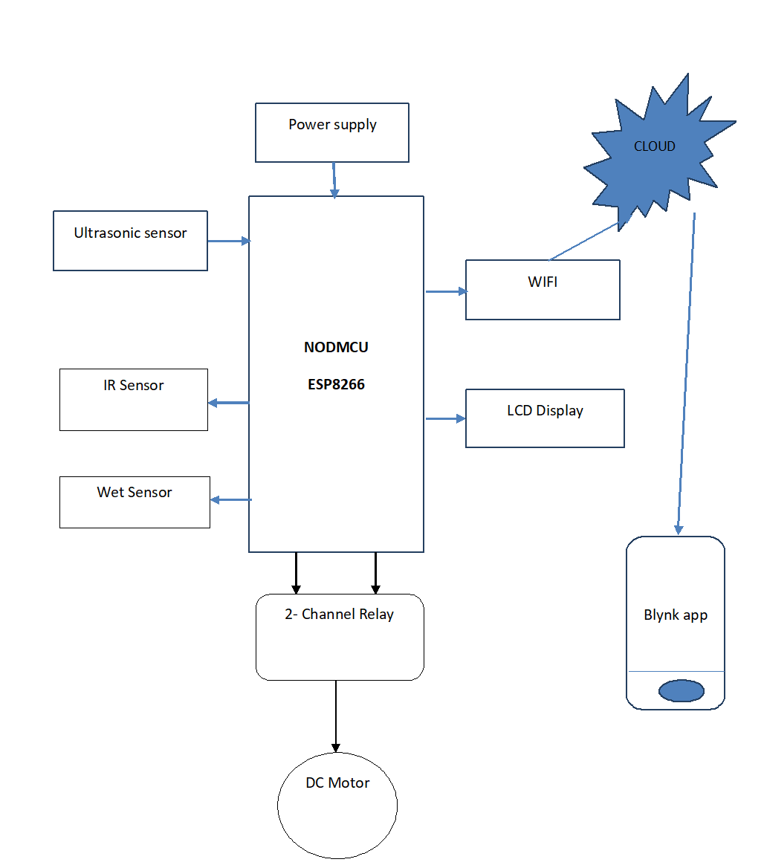**BLOCK DIAGRAM**

When the waste is dumped into the smart dustbin, The Ultrasonic sensor detects the waste and calculates whether the bin is Full or Empty, activates microcontroller .Generally Ultrasonic sensor is used to sense certain characteristics of its surroundings by either emitting and/or detecting infrared radiations.

The sensor’s coil receives retransmitted field and alerts the user by producing a target response. Next sensor connected is the moisture sensor which uses capacitance to measure dielectric permittivity of the surrounding medium. Wet waste has higher relative dielectric constant than that of dry waste because of presence of moisture, oil and fat. By this we come to know whether the waste is wet or dry. Also it displays different messages. The initialization of all modules ensures that any dynamic changes in the environment do not affect the sensing.

**4. COMPONENTS**

**ESP8266 WI-FI MODULE:**

ESP8266 wifi module is low cost standalone wireless transceiver that can be used for end-point IOT developments.

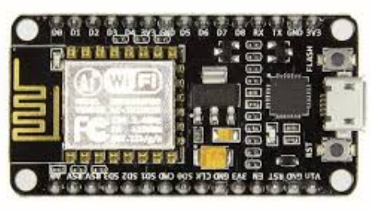ESP8266 wifi module enables internet connectivity to embedded applications. It uses TCP/UDP communication protocol to connect with server/client.

To communicate with the ESP8266 Wifi module, microcontroller needs to use set of AT commands. Microcontroller communicates with ESP8266-01 Wifi module using UART having specified Baud rate (Default 115200).

**DC motors**

A DC motor is a mechanically commutated electric motor powered from direct current (DC). The stator is stationary in space by definition and therefore so is its current. The current in the rotor is switched by the commutator to also be stationary in space. This is how the relative angle between the stator and rotor magnetic flux is maintained near 90 degrees, which generates the maximum torque.

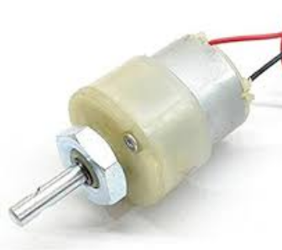

**2-Channel Relay:**

This module contains **two relays** that are electrically isolated from the controlling input. The **relays** can be used to switch higher voltage and current loads than a microcontroller can traditionally accomplish.

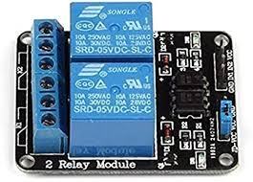

**IR SENSOR:**

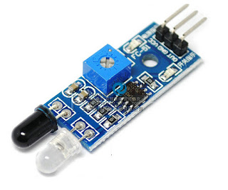

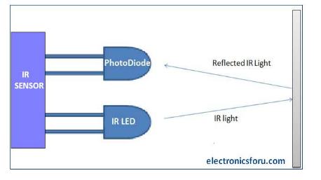

IR sensor is an electronic device that emits the light in order to sense some object of the surroundings. An **IR sensor** can measure the heat of an object as well as detects the motion. Usually, in the infrared spectrum, all the objects radiate some form of thermal radiation. These types of radiations are invisible to our eyes, but infrared sensor can detect these radiations.

**ULTRASONIC SENSOR**

An Ultrasonic sensor is a device that can measure the distance to an object by using sound waves. It measures distance by sending out a sound wave at a specific frequency and listening for that sound wave to bounce back. By recording the elapsed time between the sound wave being generated and the sound wave bouncing back, it is possible to calculate the distance between the sonar sensor and the object.

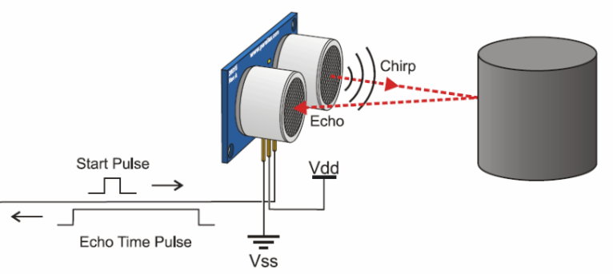Since it is known that sound travels through ultrasonic at about 344 m/s (1129 ft/s), you can take the time for the sound wave to return and multiply it by 344 meters (or 1129 feet) to find the total round-trip distance of the sound wave. Round-trip means that the sound wave traveled 2 times the distance to the object before it was detected by the sensor; it includes the 'trip' from the sonar sensor to the object AND the 'trip' from the object to the Ultrasonic sensor (after the sound wave bounced off the object). To find the distance to the object, simply divide the round-trip distance in half.

**5. RESULT**

As a result, the servo motor is at 90 degrees in the initial position, further it rotates 180 degree when it is wet waste and rotates 0 degree when it is dry waste. Database gives the information to the application regarding weather the bin is full or empty and which bin is full or empty. All in all, the proposed system is working as planed in real time situation.

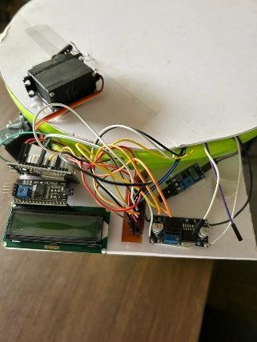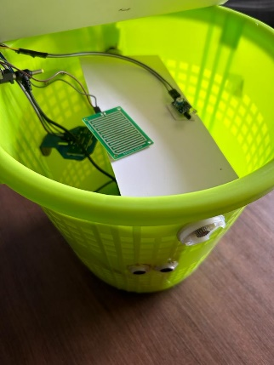

**6. CONCLUSIONS**

The Smart Waste Management System is a relatively powerful and reasonably priced solution for managing waste in plenty of settings, such as homes, offices, and public areas. The system's superior capabilities allow it to robotically locate the level and form of waste inside the bin and offer actual-time updates to customers through a mobile application. The use of ultrasonic sensors and servos to control the bin's lid and segregate waste by means of type reduces the need for human intervention and guarantees right waste disposal, contributing to a cleanser and healthier environment.

In addition, the combination of the Blynk IoT platform makes it possible to remotely monitor the machine, including to its comfort and person-friendliness. The machine's LCD show provides local updates at the bin's fame, which enables protection personnel to manage the waste useful to the society.

Overall, the Smart Waste Management System is a especially progressive solution which can help cope with the growing waste control challenges going through city regions global. By selling proper waste disposal and lowering the environmental effect of waste, this machine represents a considerable step in the direction of a greater sustainable future.

**7. REFERENCES**

[1]. Vikrant Bhor, Pankaj Morajkar, MaheshwarGurav, Dishant Pandya, Smart Garbage Management System‖, March 2015.

[2]. S.S. Navghane, M.S. Killedar, Dr.V.M. Rohokale,‖IoT Based Garbage and Waste Collection Bin‖, May 2016.

[3]. Ghose, M.K., Dikshit, A.K., Sharma, S.K. A GIS based transportation model for solid waste disposal – A case study on Asansol municipality. Journal of Waste Management‖.

[4]. Guerrero, L.A., Maas, G., Hogland, W.: Solid waste management challenges for cities in developing countries. Journal of Waste Management .

[5]. Alexey Medvedev, Petr Fedchenkov, ArkadyZaslavsky, Theodoros, Anagnostopoulos Sergey Khoruzhnikov,‖Waste Management as an IoT-Enabled Service in Smart Cities‖.

[6]. Meghana K C, Dr. K R Nataraj,‖ IOT Based Intelligent Bin for Smart Cities‖.

[7]. KasliwalManasi H., SuryawanshiSmitkumar B, A Novel Approach to Garbage Management Using Internet of Things for Smart Cities‖.

[8]. Vishesh Kumar Kurrel,‖ Smart Garbage Collection Bin Overflows Indicator using Internet of Things.

[9]. Monika K A, Nikitha Rao, Prapulla S B, Shobha G, Smart Dustbin-An Efficient Garbage Monitoring System.

[10]. Parkash, Prabu,‖IoT Based Waste Management for Smart City.

[11]. Basic Feature, Solid waste Management Project by MCGM‖. DOI: 10.18535/ijecs/v5i11.04 Ruhin Mary Saji, IJECS Volume 05 Issue 11 Nov., 2016 Page No.18749-18754 Page 18754

[12]. Microtronics Technologies, GSM based garbage and waste collectionbins overflow indicator‖, September 2013.

[13]. S. Thakker and R. Narayanamoorthi, "Smart and wireless waste management," Innovations in Information, Embedded and Communication Systems (ICIIECS), 2015 International Conference on, Coimbatore, 2015.

[14]. Riondaet al., "UrVAMM A full service for environmental-urban and driving monitoring of professional fleets," new Concepts in Smart Cities: Fostering Public and Private Alliances (Smart MILE), 2013 International Conference on, Gijon, 2013.

[15]. Narayan Sharma, NirmanSingha, Tanmoy Dutta, Smart Bin Implementation for Smart Cities‖, International Journal of Scientific & Engineering Research, vol 6, Issue 9, 2015, pp-787-789.