**MEDICINE REMINDER AND MONITORING SYSTEM USING IOT**

**B.Parthasarathy,T.Vaishnavi,S.Venkatesan**

**DEPARTMENT OF INFORMATION TECHNOLOGY**

**ADITHYA INSTITUTE OF TECHNOLOGY, COIMBATORE-641107.**

**ABSTRACT:**

Our smart pill box is programmable that enables medical caretakers or clients to determine the pill amount and timing to take pills, and the service times for every day. Our shrewd pills box contains nine separate sub-boxes. In this manner, medical caretakers or clients can set data for nine distinct pills. At the point when the pill time has been set, the pillbox will remind clients or patients to take pills utilizing sound and light. The warning of pills should be taken will be shown by an android application which is held by the patient. Contrasted and the conventional pill box that requires clients or attendants to stack the crate each day or consistently. Our shrewd pill box would essentially discharge medical attendants or clients’ weight much of the time preloading pills for patients or clients and overlook the measurements which must be taken.

**KEYWORDS-**PILLBOX,ARDUINO UNO,BUZZER,PUSH BUTTON,ANDROID APPLICATION,ETC...

**1.INTRODUCTION:**

Currently, worldwide aging and regularity of persistent diseases are flattering a broad concern. Numerous countries are undergoing hospital restructuring by reducing the number of hospital beds and escalating home healthcare, which is envisioned to perk up health care quality, has fascinated wide-ranging attention. In order to track the physical status of the elderly and, in the meanwhile, to keep them healthy, the proposed idea will be helpful. IOT expands the Internet into our everyday lives by wirelessly connecting various smart objects and will bring significant changes in the way we live and interact with smart devices.

The new wave in the era of computing will be outside the sphere of the conventional desktop.

Internet of Things (IOT) is a network where many of the objects that surround us will be networked in one form or another. By using this technology the health statistics of medication are observed. In this process of encryption the schedule data or doctor’s prescription are sent to the pill box through a mobile app. The LEDs are placed for indication and buzzer for alarm alerts and reset button is used to count for medicine in cloud platforms. The existing techniques to the market for the reminder include a pill box. But this does not help in checking the medicine. This proposed idea is a valuable solution to the medical noncompliance problem.The innovation scheme to help patients keep track of their medicine consumption through a series LED alarm indicator signal and audio alarm indicator signals.

**2.PROBLEM STATEMENT:**

The project's objectives are that the existing framework depends on android operating framework which will remind the clients to take medicine on time through notice and programmed caution ringing framework.

**3.PREVIOUS RESEARCH AND PROPOSED SYSTEM:**

**A.** An overview on some previous rationing systems.

To ensure the people consume medicines as per schedule time table, here we developed a smart pill box. The schedule data/configuration data is sent to the pill box through IoT. The smart pill box contains Arduino MCU, LED display, LEDs, buzzer, buttons ,Pulse Sensor and Temperature Sensor. The LEDs are used to display the commands in the pill box by MCU. The Wi-Fi module is configured with IoT. The configuration data is sent to the smart pillbox when the configuration is in ON mode. The concerned LED glows with a buzzer at schedule time .

**B.** **Proposed System**:

The Medicine reminder system, which consists of a pill box with a set of compartments. The typical individuals can utilize it effectively for their medicine. The control arrangement of the pill box comprises LEDs for giving the visual alarms to the patient for medication. There is a ringer in the framework which alarms the patient in sound structure. It will buzz for a specific time, inside that time just the individual needs to press the key by taking the medication, generally the alarm will be given as an SMS to the overseer of the patient by GSM that patient has not taken the drug at the time endorsed by the specialist. The ringer and LEDs are giving the cautions at the correct time set by the guardian

**4.OBJECTIVES:**

The project's goal is to effectively automate the process of item distribution. The project aims to halt fraud and inconsistencies produced in distribution stores. Here, the system needs to accomplish the following.

* Verify the beneficiaries ration smart cards.
* Verify the appropriate beneficiaries.
* Preventing inconsistencies in grain distribution.

**5.BLOCK DIAGRAM:**

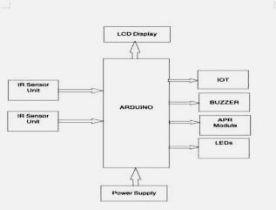

**6.COMPONENTS USED:**

**Hardware requirements:**

* ARDUINO UNO with power supply Unit
* IR Sensor
* Wi-Fi module ESP8266 NODEMCU
* Buzzer
* LCD Display
* APR Module
* Power Supply

**Software requirements:**

* ARDUINO IDE
* Blynk APP
* **ARDUINO UNO:**

Arduino is an open-source electronics platform based on easy-to-use hardware and software. Arduino boards are able to read inputs - light on a sensor, a finger on a button, or a Twitter message - and turn it into an output - activating a motor, turning on an LED, publishing something online. Messages can be sent to the board about what to do by sending a set of instructions to the microcontroller on the board. To do so the Arduino programming language and the Arduino Software (IDE) are used.ATMEGA328Pis a high performance, low power controller from Microchip. ATMEGA328P is an 8-bit microcontroller based on AVR RISC architecture. It is the most popular of all AVR controllers as it is used in ARDUINO boards.

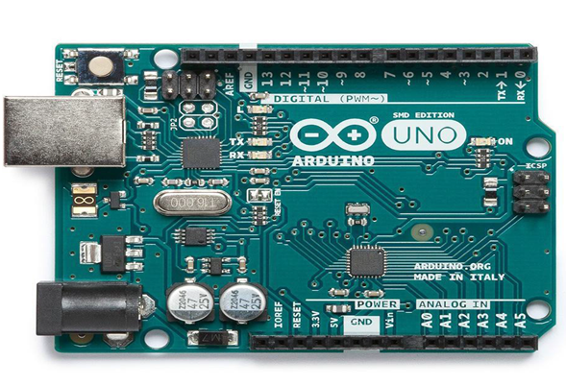

* **Wi-Fi MODULES ESP8266 NODEMCU:**

Node MCU Dev Kit/board consist of ESP8266 wifi enabled chip. The ESP8266 is a low-cost Wi-Fi chip developed by Es press if Systems with TCP/IP protocol. For more information about ESP8266, you can refer to ESP8266 WiFi Module. There is Version2 (V2) available for Node MCU Dev Kit i.e. Node MCU Development Board v1.0 (Version2),which usually comes in black colored PCB.

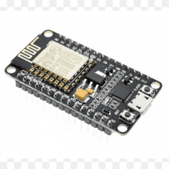

Here is another way of developing NodeMCU with a well-known IDE i.e. Arduino IDE. We can also develop applications on NodeMCU using the Arduino development environment. This makes it easier for Arduino developers than learning a new language and IDE for NodeMCU.

.

* **LCD:**

This project uses a 16x2 LCD screen. The Liquid Crystal Display (LCD) is a very simple display module that is electronic. It has a wide range of programs in the field of electronics. In this project, it is used to display the welcome message, details about the user, the weight of units, the amount of liquid and the amount of credit on the card.

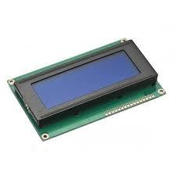

* **BUZZER:**

A buzzer is a mechanical, electromechanical, magnetic, electromagnetic, electro-acoustic or piezoelectric audio signaling device. A piezoelectric buzzer can be driven by an oscillating electronic circuit or other audio signal source. A click, beep or ring can indicate that a button has been pressed.

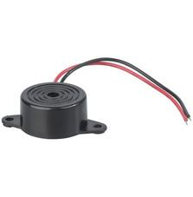

Types of Buzzers There are several different kinds of buzzers. At Future Electronics we stock many of the most common types categorized by Type, Sound Level, Frequency, Rated Voltage, Dimension and Packaging Type. The parametric filters on our website can help refine your search results depending on the required specifications**.**

* **IR SENSOR:**

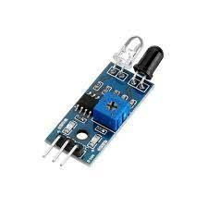

The IR sensor, also known as an infrared sensor, is a type of electrical component used to detect particular features in its environment by producing or detecting IR radiation. These sensors can also be used to track or measure a target's motion and heat. The IR sensor circuit is an extremely important module in many electrical gadgets. This type of obstacle detection sensor is comparable to the human visual senses. In this sensor, the photodiode serves as the detector while the IR LED acts as the emitter.

* **APR MODULE:**

APR33A3 Voice Record &amp; Playback Module &amp; its interfacing with Arduino. APR33A3 is a 8 Channel Voice Record &amp; Audio Playback Board integrated with APR33A series IC which is a powerful audio processor along with high-performance audio analog-to-digital converters (ADCs) and digital-to-analog converters (DACs).

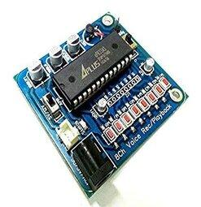

The HC-SR04 Module is an ultrasonic sensor used to measure distance. To display the measured distance, I used a 0.96″ I2C OLED Display. The APR33A3 Voice Recorder &amp Playback Module has 8 output pins from M0-M8. One of the pins can be connected to Arduino. The digital low input will activate the module pin and can be used to playback the recorded voice message. I selected an M1 &amp; connected it with an Arduino D8 pin.

* **POWER SUPPLY:**

Rectifier is a diode circuit which is used to transform the complete cycle of Alternating Voltage (AC Supply) to Direct Voltage (DC Supply).In full wave rectification, current flows through the load in the same direction for the complete cycle of input AC Supply.The full wave bridge rectifier eliminates the need of centre tapped transformer. It contains four diodes connected to a formabridge.

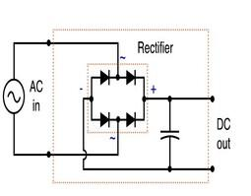

Using a rectifier in the power supply helps in converting AC to DC power supply. Bridge rectifiers are widely used for large appliances, which can convert high AC voltage to low DC voltage.

**7.FLOW CHART:**

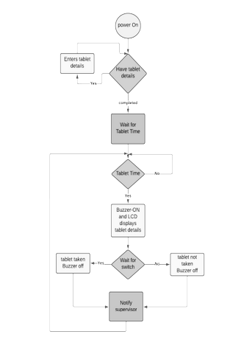

**8.RESULT:**

If you download the Blynk App, you’ll need to create a New Blynk account. This account is separate from the accounts used for the Blynk Forums, in case you already have one.We recommend using a real email address because it will simplify things later.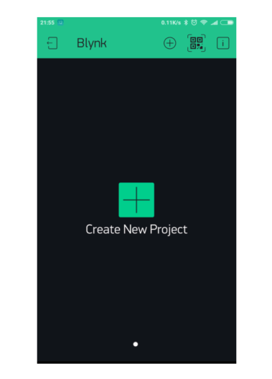

After you’ve successfully logged into your account, start by creating a new project.Select the hardware model you will use. Check out the list of supported hardware.

.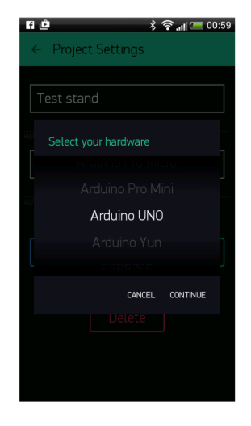

Auth Token is a unique identifier which is needed to connect your hardware to your smartphone. Every new project you create will have its own Auth Token. You’ll get AuthToken automatically on your email after project creation. You can also copy it manually.

Click on devices section and selected required device

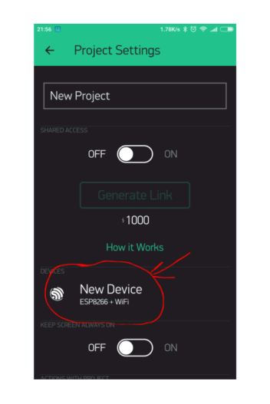

And you’ll see token

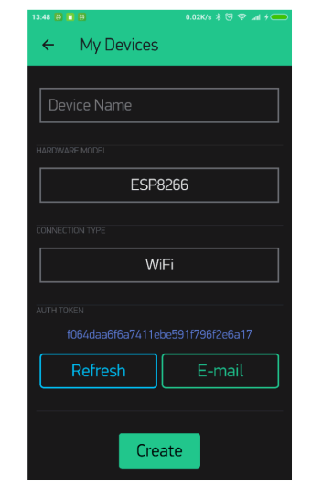

let’s add a button to control our LED.Tap anywhere on the canvas to open the widget box. All the available widgets are located here. Now pick a button.

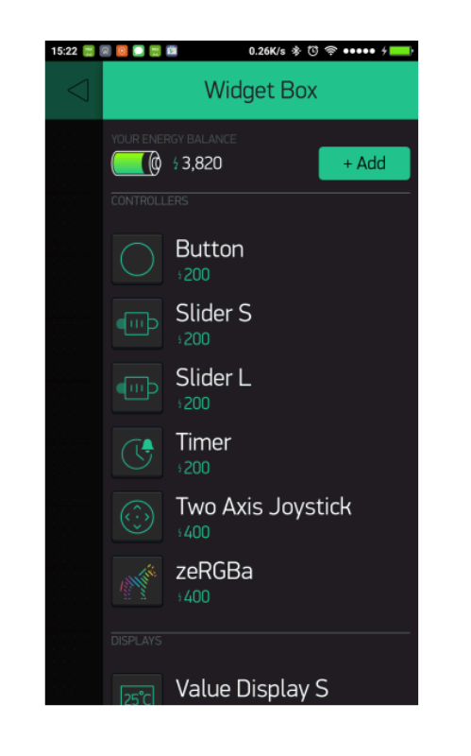

The most important parameter to set is PIN . The list of pins reflects physical pins defined by your hardware. If your LED is connected to Digital Pin 8 - then select D8 (D - stands for Digital).

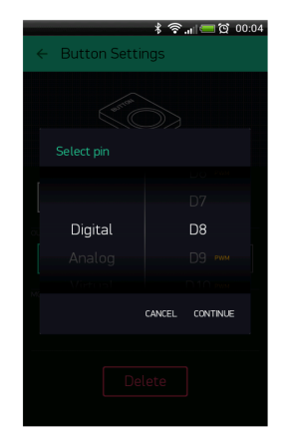

When you are done with the Settings - press the PLAY button. This will switch you from EDIT mode to PLAY mode where you can interact with the hardware. While in PLAY mode,you won’t be able to drag or set up new widgets, press STOP and get back to EDIT mode.You will get a message saying “Arduino UNO is offline”. We’ll deal with that in the next section.

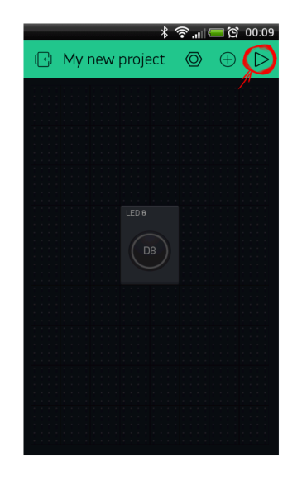

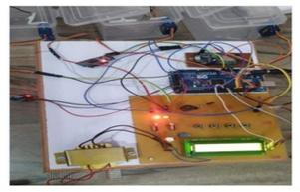

**9.CONCLUSION:**

Integrating Hardware modules Node MCU, Buzzer, push Button and Mobile application to PILL Box and every module has been placed carefully to give reasonable output, thus contributing to the best working of the unit. This system assures the safety of the people and also prevents the wrong dosages. It reduces the effort in remembering medicine and people will get the schedule of the medicine containing medicine name timing and give the information if a person is in an emergency.

**10.FUTURE SCOPE:**

* When we start this system, the real time clock runs the time on a 16×2 LCD. And if we want to set alarm time for medication we have to press the set_mad button which is connected with pin number 8 of arduino. After pressing this button the LCD shows Set Time 1. And then we can select the time we want to set for medication by using the INC and Next button which is connected to pin 9 and 10 respectively of the arduino. After set time 1, LCD shows set Time 2. Now using the previous process set the time again. And after the second time set, LCD shows again set time 3. And set this time like previous. In this system “Group medicine” indication (take group 1 medicine, take group 2 medicine and take group 3 medicine) is used instead of the medicine name. When any alarm occurs LCD indicates Group medicine 1, Group medicine 2, Group medicine 3. Medication alarm time is also fed in arduino’s internal eeprom to save from lost data after light failure. And real time is continuously checked with saved Arduino’s internal eeprom time. If any match occurs. LCD shows medication group name and buzzer starts beeping continuously. Buzzer is directly connected with pin number 13 of arduino for medication time indication.
* 16×2 LCD’s data pins D4, D3, D2, D2 are connected with pin5, 4, 3, 2 of arduino. And the command pin RS and EN is directly connected with pin 7, 6 of the arduino. The pin of the LCD is directly connected to the ground.

**11.REFERENCES:**

[1] Wissam Antoun, Ali Abdo, Suleiman Al-Yaman, Abdallah Kassem, Mustapha Hamad and Chady El-Moucary, “Smart Medicine Dispenser (SMD)”, 2018 IEEE 4th Middle East

Conference on Biomedical Engineering (MECBME), pp. 20-23, 2018

[2] A. V. Dhukaram and C. Baber, &quot;Elderly Cardiac Patients#39; Medication Management: Patient Day-to-Day Needs and Review of Medication Management System,&quot; 2013 IEEE International Conference on Healthcare Informatics, pp. 107-114, 2013

[3] World Health Organization, http://www.who.int/medicines/en/ , accessed on July 21, 2017.

[4] S. L. Gray, J. E.Mahoney, and D. K.Blough, “Medication Adherence in Elderly Patients Receiving Home Health Services following Hospital Discharge.” Annals of Pharmacotherapy, 35(5), pp. 539-545, 2001.

[5] https://iotdunia.com/iot-architecture/

[6]https://www.researchgate.net/figure/nternal-architecture-of- SQLite_fig1_2 71891972

[7] C. Farcaú, I. Ciocan, N. PalaghiGa and R. Fizeúan, &quot;Weekly electronic pills dispenser with circular containers,&quot; 2015 IEEE 21 st International Symposium for Design and Technology in Electronic Packaging (SIITME), pp. 125-129, 2015.

[8] N. B. Othman and O. P. Ek, &quot;Pill dispenser with alarm via smart phone notification,&quot;2016 IEEE 5th Global Conference on Consumer Electronics, pp. 1-2, 2016.

[9]https://www.activeforever.com/medelert-automatic-pill-dispenser-16-alar ms