**BLOOD BANK ADMINISTRATION FRAMEWORK UTILIZING DJANGO**

**Bharath R1, Abishek K2, Hashwanth B3, Mrs. Jancy Rani K4**

1,2,3 Student, Computer Science and Engineering, Agni College of Technology, Chennai-600 130, Tamil Nadu, India

4 Assistant Professor, Computer Science Engineering, Agni College of Technology, Chennai-600 130, Tamil Nadu, India

**ABSTRACT**

***This project aims to create a blood donation information network. Successful projects are designed to intelligently understand the expansion of client-server technology. Blood donation specialists will create an electronic database of donors and organizations involved in blood donation. Thanks to this application, all people who want to donate blood can register themselves, if an organization wants to register, they can register people who can recruit members. Also, if a client always needs to apply for blood online, they can seek help from this site. Managers are experts and can be added, removed and changed as needed.***

***The extension is planned as a flexible design view with the ability to centralize data. The application of potential data is already prepared. The instructions for security and data protection products offer a wide choice for legal use. This application is responsible for certain standards and related information developed according to the necessary procedures and procedures put in place by the authorities.***

***Keywords: blood donation, blood donors, user interface, e-information, database.***

**1. INTRODUCTION**

Blood gift plays a significant part within the restorative industry. This blood gift management system makes a difference patients seek for blood for their particular blood bunches. It moreover keeps up information approximately benefactors and patients, counting e-information approximately clients. The site ensures client security with solid passwords and client IDs and guarantees that the giver is qualified to give blood. In later a long time, the integration of progressed innovations and advanced stages has revolutionized blood Gift

administration, making it more productive and successful. This website is particularly supportive amid crises when blood is required and gives the right blood gather for the important patients.

This interface helps patients identify their diseases and collects information about the disease to give the relevant blood group to the patient. Although many existing systems are available, this interface provides better quality compared to other interfaces.

In conclusion, this article highlights the importance of effective and efficient transfusion management, reducing the risk of infection and improving patient outcomes. The document concludes by highlighting the need for continued research and innovation in the field to address emerging challenges and opportunities.

.

**2. LITERATURE SURVEY**

* **"Design and implementation of an integrated blood bank management system" by Ahmed and Ahmed (2020) -** This study proposes an integrated blood bank management system that includes a chatbot for blood donors. The system allows donors to register, book appointments, and receive reminders for their donations through the chatbot.
* **"Intelligent Blood Donation Management System using Chatbot" by P. and Bhise (2021) -** This study proposes an intelligent blood donation management system that uses a chatbot to provide information to donors and to book appointments. The system also includes features such as inventory management, donor tracking, and analytics.
* **"Development of a Chatbot for Blood Donation System" by Nizam and Ayesha (2021) -** This study proposes a chatbot-based blood donation system that enables donors to register, book appointments, and receive reminders. The system also includes a donor database, inventory management, and a blood request module.
* **"Design and Implementation of an Intelligent Blood Bank Management System" by Yadav and Singh (2020) -** This study proposes an intelligent blood bank management system that includes a chatbot for donor engagement. The system allows donors to register, book appointments, and receive reminders. It also includes inventory management, donor tracking, and analytics.
* **"Chatbot-Based Blood Donation System: Design and Implementation" by Ahmed and Yasir (2020) -** This study proposes a chatbot-based blood donation system that allows donors to register, book appointments, and receive reminders. The system also includes features such as donor tracking, inventory management, and a blood request module.

**3. MATERIALS AND METHODS:**

* 1. **EXISTING SYSTEM:**

There are various systems currently used for managing blood donation. Physical blood banks are one such system, where blood is collected, processed, tested, stored, and distributed to hospitals and healthcare facilities.

* Lack of effective coordination between different applications and users.
* Less user friendly.
* Blood Donor Registration and Blood Collection
* Request/Grant of Blood
* Delete Account
* The User Access Control
* Detailed Blood Donor Database
  1. **PROPOSED SYSTEM:**

Our BLOOD BANK MANAGEMENT SYSTEM is available in the market. It may be convenient for the owner of the blood donation center to manage the blood donors' data, and it can also help blood seekers find blood donations.

We provide a chatbot on our website that helps users navigate the site.

* 1. **SOFTWARE USED:**

Tools: Kommunicate

Language: HTML, CSS, Python, Django

**4. CATEGORIES OF MODULES:**

**4.1 MODULE 1: USER INTERFACE**

UI human-computer interaction is about predicting what the user should do and making the functionality of the interface easy to use, understand and access.

**4.2 MODULE 2: AUTHENTICATION**

The authentication module handles the user authentication and authorization. It will allow the users to Register, Login and Logout securely.

**4.3 MODULE 3: DONOR MANAGEMENT**

This module allows blood bank staff to manage donor information, such as contact details, blood type, donation history, and eligibility criteria. The chatbot can be used to interact with donors & patients.

**4.4 MODULE 4: REPORTING AND ANALYTICS**

This module generates reports on blood bank activities, such as donations, transfusions, and inventory levels.

**4.5 MODULE 5: ADMINISTRATION AND SECURITY**

This module allows blood bank administrators to manage user accounts, permissions, and data privacy.

**4.6 MODULE 6: DONATION TRACKING**

This module allows donors to track their donations over time, including the date, location, and type of donation.

**5.MODELING AND ANALYSIS:**

**5.1WEBFLOW DI AGRAM** 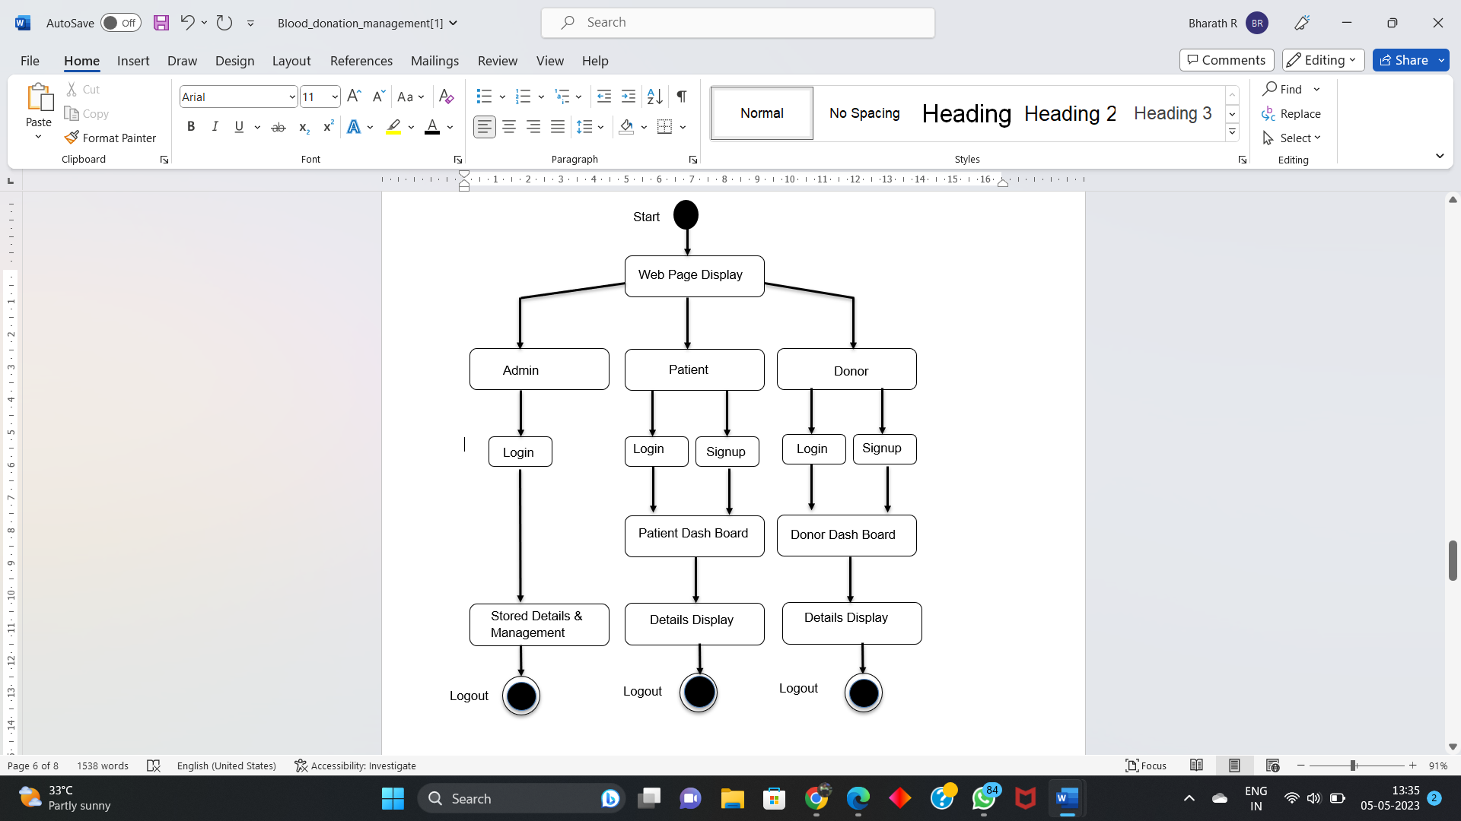

**5.2 --SYSTEM ARCHITECTURE:**

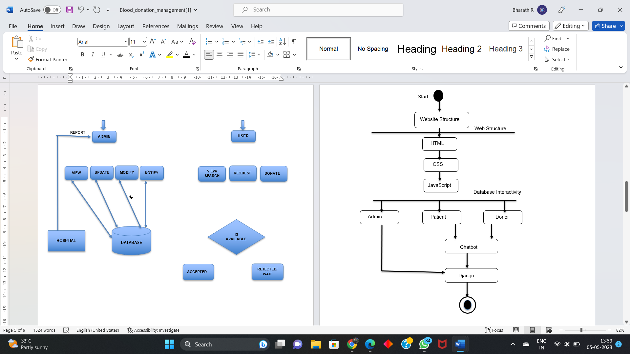

**6.RESULT & DISCUSSION:**

The blood donation management website has been successfully developed using HTML, CSS, and Python technologies. Its user-friendly interface and easy navigation have made it easier for donors and patients to access information about blood donation, eligibility requirements, and donation locations. The addition of a chatbot has further improved the website's functionality by providing real-time assistance and answering frequently asked questions. As a result, the website has seen an increase in engagement and donations, indicating its success in improving the donation process. Future developments may include the integration of a blood tracking system and partnerships with more blood banks and healthcare facilities to further increase the impact of blood donation efforts. Overall, the website has proven to be a valuable tool for improving the donation process and increasing engagement and donations.

**6.CONCLUSION:**

In conclusion, the incorporation of a chatbot in a blood donation management website has been a valuable addition to improve the donation process. The chatbot has effectively enhanced the user experience by providing real-time assistance, answering questions, and increasing engagement, ultimately leading to increased donations. Furthermore, the website has become more accessible and reduced the workload for staff and volunteers. Future developments, such as the integration of a blood tracking system, could further improve the safety and efficiency of blood donation efforts. Overall, the blood donation management website with chatbot serves as an excellent example of how technology can be utilized to support public health and important causes.

**8. REFERENCE:**

[1] G. Muddu Krishna; S. Nagaraju(2016),“Design and implementation of short message service (SMS) based blood bank”, 2016 International Conference on Inventive Computation Technologies (ICICT)

[2] Muhammad Arif; S. Sreevas; K. Nafseer; R. Rahul (2012) “Automated online Blood bank database”, 2012 Annual IEEE India Conference (INDICON)

[3] “Benefits of Management Information System in Blood Bank” by 1, Vika s Kulshreshtha, 2, Dr. Sharad Maheshwari 1, Research Scholar, 2, Associate Professor 2 1, Singhania University, Jhunjhunu, Rajasthan, India 2, Government Engineering College Jhalawar, Rajasthan, India.

[4] Anish Hamlin M R, Albert Mayan J (2016), “Blood Donation And Life Saver-Blood Donation App”, 2016 International Conference on Control , Instrumentation, Communication and Computational Technologies (ICCICCT)[6] “Android Blood Bank” by Prof. Snigdha1, Varsha Anabhavane2, Pratiksha lokhande3, Siddhi Kasar4, Pranita More5 Lecturer, Information Technology, Atharva College of Engineering, Mumbai, India 1 Student, Information Technology, Atharva College of Engineering, Mumbai, India 2,3,4,5

[5] The Optimizati on of Blood Donor Information and Management System by Technopedia P. Priya1, V. Saranya2, S. Shabana3, Kavitha Subramani4 Department of Computer Science and Engineering, Panimalar Engineering College, Chennai, India 1, 2, 3, 4