**Smart Medicine Box**

Pooja kalgude,Dhanshree Sonawane,Gayatri Bhamare,Viraj Sonawane

Department of E&TC Engineering ,KBTCOE ,Nashik -422013,Maharashtra,India

**Abstract**

With rapidly growing population, it has become extremely difficult to monitor as well as look after the health of the patients who suffer from chronic diseases specially in the case of older people who find it difficult to look after their own selves. Hence, we have come up with a smart system that can monitor the health and the patient’s dosage. Android app will continuously monitor the health of the patient and send the readings to the NodeMCU. The NodeMCU will also be interfaced with boxes that will contain prescribed medicines for the patient. Each box will have its own timing information which will be continuously compared to real world time. If the information matches the buzzer will start to ring and will remind the patient to take his medicine.

**Keywords**: NodeMCU, Buzzer, Data cloud, Internet of Things (IOT), Health monitoring, Medicine box.

**I. INTRODUCTION**

Numerous people, such as the elderly, may want ongoing assistance. Additionally, the timing of administering a medication to family members can have an impact on their health. Since pills have become such an integral part of daily life, there has been a rise in medical neglect cases involving improper medication administration to patients in recent years. One such instance involves a nurse who gave a patient a paralytic instead of an antacid as directed by the doctor, which resulted in the patient's death.

Looking at the data, we discovered that the majority of passings are a result of patients not taking their medications in the proper dosage. They either intentionally take too much medication or they take too little, which results in some useless health advice. Additionally, some patients weren't able to afford the cost of a caretaker, thus they had to cope with cost viability. We came up with the idea to create a pill update that is affordable and easy to use for a typical, intelligent patient.

To address the aforementioned issues by inventing and developing a tool that will allow the owner to track each pill they take in an easy and straight forward manner without the need for complicated training on their part

To develop a Medicine box which track number of dosage need to take at a particular time for senior citizen patients.

**II. LITERATURE SURVEY**

Pratiksha Katore et. all presented a safety-related and low-cost medicine box that can assist and monitor patients concerning the accurate intake of their medication. This system is able to detect the faulty dose of pills taken, the missed medications and the unavailability of pills in the medical box. Alarms are being generated with medication box and via a mobile application that can be installed on the patient relative's phones in order to help monitoring him.[1].

Nausheen fatima et. all proposed IoT Driven Smart Pill Box to Remind of Consumption used for those clients who normally take drugs and the course of action of their answer be extended as it be difficult to recall to patients what's more designed for their parental figure. In like way sold age patients practice the abhorrent effect of issue of negligence toward get pills on credible time which cause unsure therapeutic issues designed for patients have Permanent sicknesses like diabetes, circulatory strain, breathing issue, heart issues, destructive improvement illnesses, and so forth [2].

**III. IMPLEMENTATION AND RELATED WORK**

The medicine box comes with many sections. Each compartment's top-mounted LED identifies the relevant box. Through the MQTT protocol server, the Android application may transfer user data to the smart medication box. The NodeMCU ESP8266 coupled to MQTT protocol can connect objects and allow data transfer using the Wi-Fi protocol. A messaging protocol for constrained low-bandwidth networks is known as MQTT.

In Smart Medicine Box project, we can use 5V Power Supply for NodeMCU ESP8266 and 12V Power Supply for the Latch lock. With the help of latch lock the compartments of box is going to open on specific timings.

The Message Queuing Telemetry Transport protocol is the best one for machine-to- machine (M2M) communication since it is tailored for low-bandwidth, high-latency settings. As a result, the MQTT protocol is lightweight and suitable for millions of devices. Connecting equipment across unstable networks: Even when connections between devices are unstable, MQTT in the IoT uses QoS levels to assure message delivery to recipients.

The Firebase Realtime Database is a cloud-hosted NoSQL database that lets you store and sync data between your users in realtime.

* **Design of proposed syatem:**

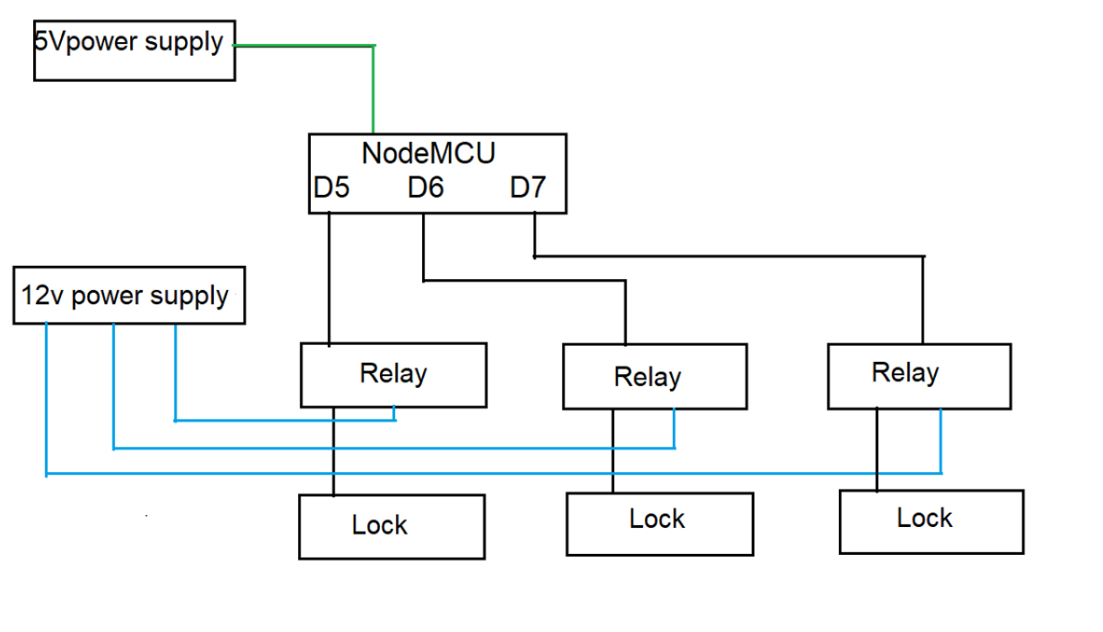

**IV.System Components**

### 1.NodeMCU ESP8266

### 

NodeMCU is a development board and open-source Lua-based firmware designed specifically for Internet of Things (IoT) applications that can link objects and allow data transfer using a Wi-Fi module.

However, as a chip, the ESP8266 is also hard to access and use. You must solder wires, with the appropriate analog voltage, to its pins for the simplest tasks such as powering it on or sending a keystroke to the “computer” on the chip. You also have to program it in low-level machine instructions that can be interpreted by the chip hardware. This level of integration is not a problem using the ESP8266 as an embedded controller chip in mass-produced electronics. It is a huge burden for hobbyists, hackers, or students who want to experiment with it in their own IoT projects.

2.LED (Light Emitting Diode):

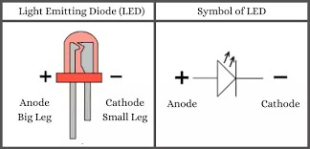

When an electric current passes through a semiconductor device called a light-emitting diode (LED), the LED emits light. When current flows through an LED, the electrons and holes recombine and produce light. LEDs only let current flow in one direction—forward—and stop it from going the other way.

3.**Relay:**

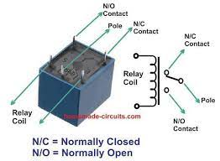

A relay is an electrically operated switch. It consists of a set of input terminals for a single or multiple control signals, and a set of operating contact terminals. The switch may have any number of contacts in multiple contact forms, such as make contacts, break contacts, or combinations thereof.

**V.Features,Limitations and Applications**

**Features:**

* + - * Time to time Reminder to take Medicine.
      * Easy Android User Interface to Monitor.
      * Easily accessible to family members.
      * Avoiding taking of wrong medicine.
      * No complex connection
      * User friendly
      * Especially very useful for aged people.

**Limitations:**

* + - * The disadvantage is that there is no initiative to remind the function of taking medicine, users tend to forget to take medicine, so the security is not high.

**Applications**:

* Can be a life savior at times, as it reminds patient to take medicines.
* Can be use as modern smart medical equipment.
* Helps BLIND & partial DEAF person to take medicines without any assistance
* Device security can be enabled by using Face recognition of the patient

**VI. conclusion**

The global healthcare system has recently undergone changes. Hospital medication and healthcare now have a new dimension thanks to IOT-based applications of smart healthcare systems. His project's goal is to concentrate on giving them the right medication. Through this project, older persons who require ongoing medication monitoring will gain. This project incorporates a server for storing drug administration times and other data, a mail transfer protocol, and a temperature sensor for accurate patient body temperature monitoring.

**V. REFERENCES**

[1]. Pratiksha Katore et. all “Smart Medicine Box System” IEEE-2018

[2]. Nausheen fatima et. all “IoT Driven Smart Pill Box to Remind of Consumption” IRJET-2018

[3]. Eric J. Braude, “Based Smart Medicine Box” International Journal of Scientific Research in Science, Engineering and Technology 2019

[4]. Harshitha V et. All “IOT Based Smart Health Care Medical Box for Elderly People” INCET-2020