A Study on the Design and Performance of Electric Go-Karts

Aatif Khan ¹*, Sahil Pooniwala² , Shivraj Shinde²

¹,2 UG student , Department Of Electrical Engineering , Thakur Shiv Kumar Singh Memorial Engineering , Jhiri,Dist Burhanpur, India

*Corresponding Author : khanaatif275@gmail.com

**Abstract** –

This paper presents the design, analysis, and testing of an electric go-kart that is designed for use on flat racing circuits. The go-kart is engineered to achieve high performance, with a focus on safety and reliability. The design process involved modeling and analysing the system using software tools such as SOLIDWORKS and CREO3.0. The go-kart was designed iteratively, with consideration of various factors such as cost, available resources, and design objectives. The main design objectives were to ensure durability, safety, ergonomics, lightweight construction, and high performance. To achieve these goals, four key design principles were applied to every element of the vehicle. The steering mechanism was designed with a simple mechanical arrangement using the Ackermann steering geometry to provide a making it . Finite element analysis (FEA) was conducted on the chassis under regular loading conditions, and modifications were made accordingly to prevent any design failures. Furthermore, DFMEA and DVP were performed for each individual part during the design process to enhance quality standards. The resulting go kart is well-equipped to conditions, as each element was design with. The power chain was specifically design to achieve speed or performance, surpassing that of any other geared vehicle. The electric go-kart’s performance, handling, and safety make it an excellent choice for both amateur and professional racing enthusiasts

**Keywords**:- Safety , Durability, ergonomics , Ackerman steering geometry, finite element analysis, handling

**INTRODUCTION**-

Karts are specialized vehicles designed for flat track racing, without any suspension system. They have been in use since the mid-20th century, with a wide range of karts available for racing. The current trend in automotive design emphasizes eco-friendliness to minimize emissions. In this regard, electric motors are gaining popularity as they offer comparable power to traditional engines, and can be implemented in karting as well. An electric kart requires a frame that is both sturdy and rigid to withstand heavy loads, while also being lightweight and flexible. The design process emphasizes safety as the top priority, with every subsystem integrated into the final design. To achieve this, 3D modeling and assembly are completed using software like SOLIDWORKS 13 and PTC CREO3.0, and Finite Element Analysis is performed using ANSYS14.5 to test for front, side, and rear impacts. Based on the test results, the design is modified to ensure optimal stability. The center of gravity is kept low to maximize stability, and the length of the vehicle is reduced to minimize weight. The wheelbase and track range are selected accordingly, with the frontal track range kept to a minimum to increase the project and reduce the turning radius.

**Frame Design:**

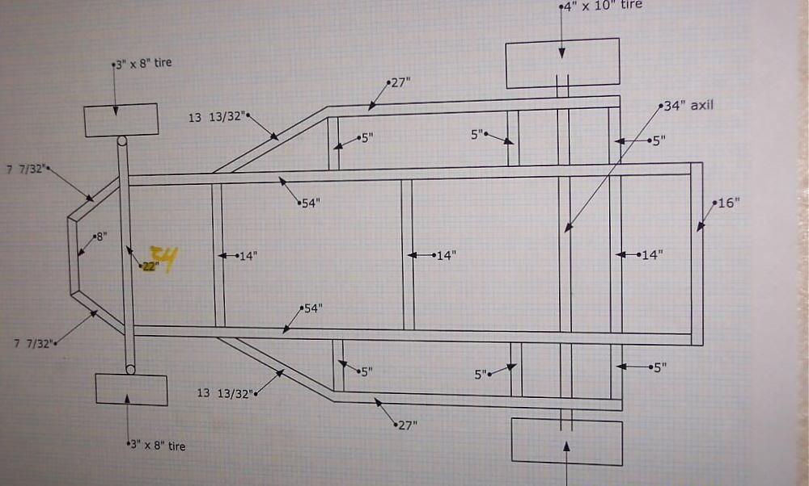A electric go kart chassis essentially framework constructed using pipes and various materials with different cross sections. It is critical for the chassis to have sufficient stability, torsional rigidity, and a certain degree of flexibility since there is no suspension. Additionally, the chassis must possess adequate strength to support the weight of the operator and any accessories. Safety and convenience are key considerations when designing the chassis for a go-kart, ensuring that it can support the load without compromising its structural integrity, providing a safe ride for the operator

**Fig:- 1 Chassis design**

**❖ SAFETY**

The implementation of roll cage features was initially driven by safety requirements. The primary safety standard that was prioritized during the design process was ensuring the driver’s body had sufficient clearance from other rigid parts such as the engine compartment and firewall structure. Once these crucial requirements were met, additional safety designs were integrated. The chasis was design to offer occupants more space to maneuverer the vehicle easily.

**❖ STEERING SYSTEM DESIGN**

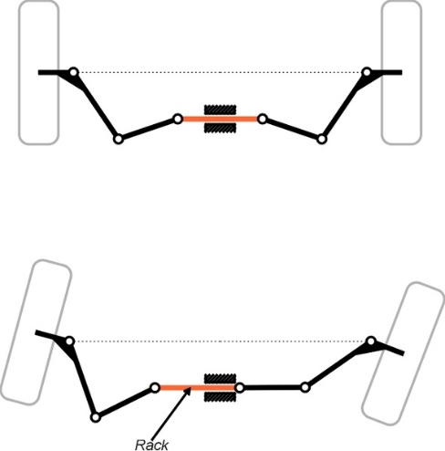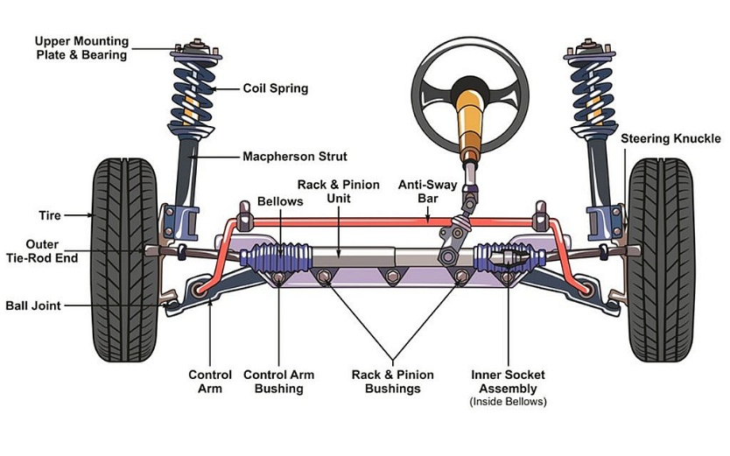The steering mechanism of the Electric Vehicle was designed using a straightforward mechanical arrangement with a 1:1 steering ratio. To achieve this, a mechanical linkage system was employed, utilizing the Ackermann steering geometry. This was chosen due to its ability to provide a 60° lock to lock turn of the steering making it extremely suitable for use. The Ackermann geometry allows for quick turns with minimal input, while maintaining precision at the same time.

. **fig:-2 Ackerman steering system**

**BRAKING SYSTEM DESIGN**

The braking system utilized in our Electric Vehicle is the Hydraulic Disc Braking System. This system was chosen for its ability to provide sufficient braking force to fully lock the wheels at the end of a specified acceleration run while remaining cost-effective. Through market research, suitable components such as the disc, calliper’s, and master cylinders were identified and selected for use in the braking system. First determined the total weight of the vehicle, including the driver, to be 240 kg .We then calculated the kinetic energy of the kart at a maximum speed of 50 km/h, which came out to be 17,361.11 joules. Using the coefficient of friction between the brake pads and the rotor, we determined the braking force required to stop the vehicle in a distance of 10 meters. This value was calculated to be 603 N Next, we determined the braking torque required at the rear wheels to achieve the required braking force. The radius of the brake rotor was measured to be 0.075 meters, and the distance between the center of the rotor and the ground was 0.04 meters. We then calculated the braking torque required to be 178.67 N-m.Based on these calculations, we selected a hydraulic disc brake system with dual piston callipers and a rotor diameter of 180 mm. This system provides us with a braking force of 1100 N and a braking torque of 218 N-m, which exceeds the required values. We also installed a regenerative braking system to recover some of the kinetic energy and recharge the battery, which improves the efficiency of the go-kart.

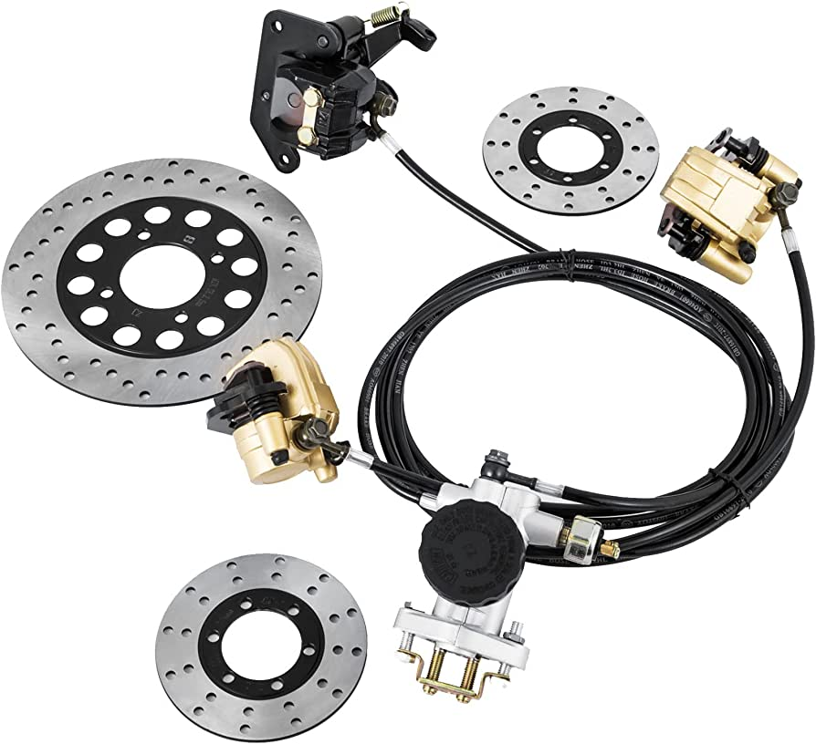

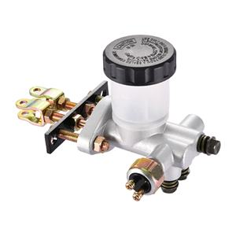

**Fig:-3 Braking system. Fig:-4 Master cylinder**

**TRANSMISSION SYSTEM**

• Power developed by the motor is transferred to the wheels by transmission system .We use CHAIN AND SPROCKET mechanism in our kart and it consist of reverse gear mechanism for moving vehicle in reverse direction.

• We are using BLDC motor which is better than the PMDC & AC motor.

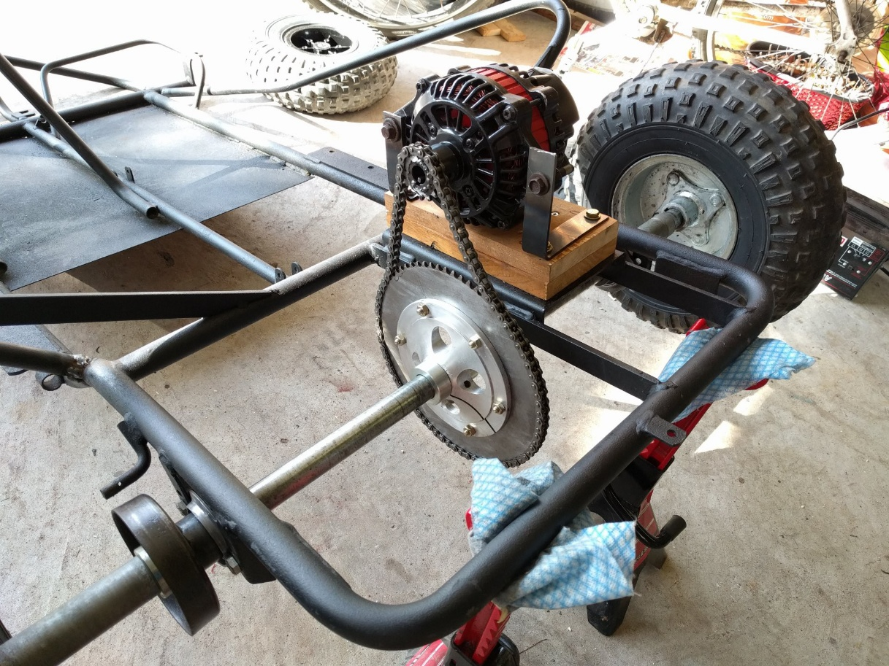 **Fig:-5 Transmission system**

**ELECTRICAL SYSTEM**

**Motor** :- We have opted for a 2.5kW 48V BLDC motor with a 3500rpm rating for our electric go-kart. Our decision was based on our calculations, which indicated that a mechanical output torque of 67.36 N-m is required to move the vehicle. The motor provides torque to the wheels of approximately 151.8N-m, which meets our requirements and also provides maximum torque at the start of the race. This selection allows us to achieve optimal performance and efficiency, while also ensuring that the motor is capable of withstanding the demands of racing.

* **Controller**:- On the behalf of motor we are choosing controller, we are using kunreycontroller.

**Voltage:- 48v Rated current :- 61ampere Rated torque:- 8.90Nm**

**output torque:- 300% of rated value= 43Nm.**

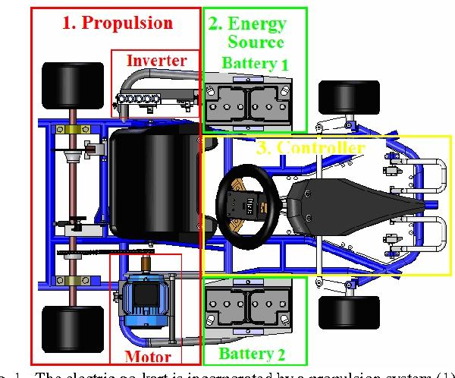 **Battery**:-we are using Li-ion battery of 48v, 50AH,. Battery

**Fig:-6 Electrical system**

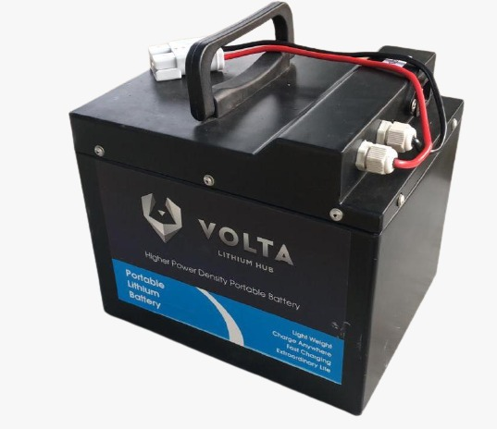

**Fig:-7 Battery**

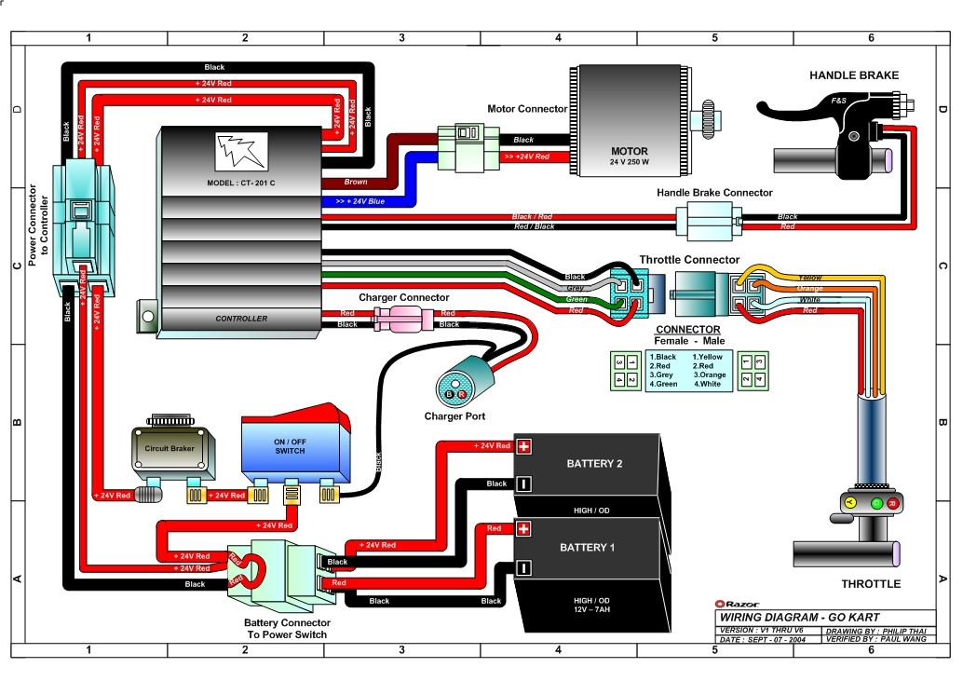**Circuit diagram**

**Fig 8:- circuit diagram**

**CONCLUSION-**

The design and engineering of an electric go-kart require careful consideration of various factors such as safety, performance, reliability, and cost. The go-kart’s frame must be designed to be rigid, torsion-free, and able to withstand adverse road conditions, while the power train should be securely mounted and optimized for maximum speed and performance. The steering mechanism, such as the Ackermann steering geometry, must be designed to provide precise handling and quick turns on the track.

The use of software tools such as SOLIDWORKS and CREO3.0 for modeling and analysis, as well as techniques like FEA, DFMEA, and DVP, are crucial for achieving the desired design objectives and safety standards. The application of four key design principles, including durability, safety, ergonomics, and lightweight construction, is essential for a successful design.

Overall, the design and engineering of an electric go-kart require a balance between safety, performance, and cost, while also considering the preferences of racing enthusiasts. The resulting go-kart should be able to meet high standards of quality and reliability, providing an exhilarating racing experience for both beginners and experienced drivers

**Result –**

The performance of an electric go-kart can vary depending on several factors, such as the power and capacity of the electric motor, the weight and size of the kart, and the quality of its components.In general, electric go-karts can provide a fast and thrilling ride while being quiet and environmentally friendly. They can accelerate quickly and reach high speeds, with some models capable of reaching 40-50 mph or more. However, the top speed and range of an electric go-kart can be limited by factors such as the capacity of the battery and the terrain.The handling and maneuverability of an electric go-kart can also be affected by its design and components, such as the suspension and steering system. Overall, the performance of an electric go-kart can be impressive, offering a fun and exhilarating ride for enthusiasts of all ages

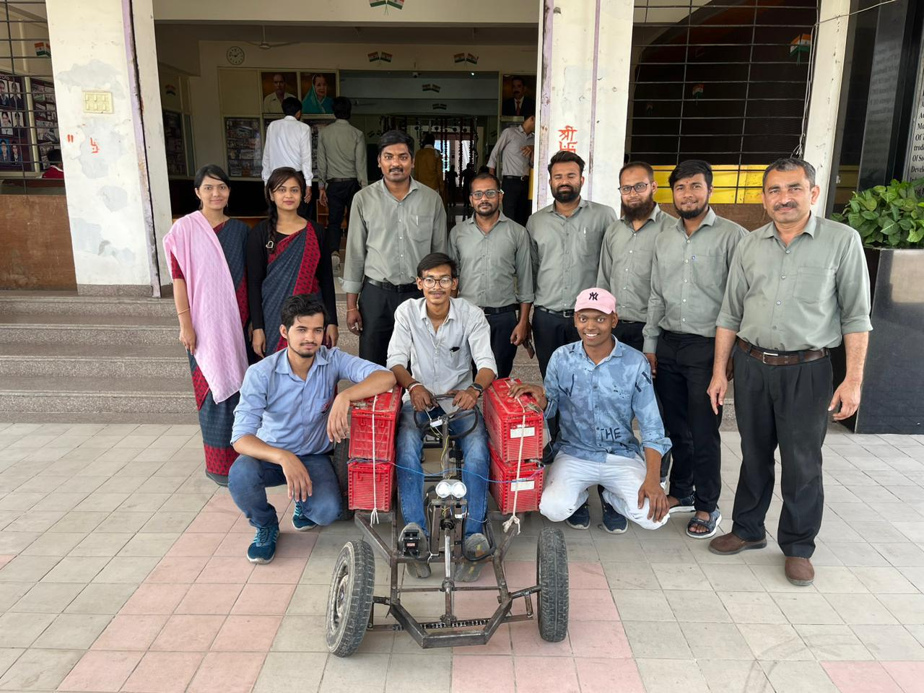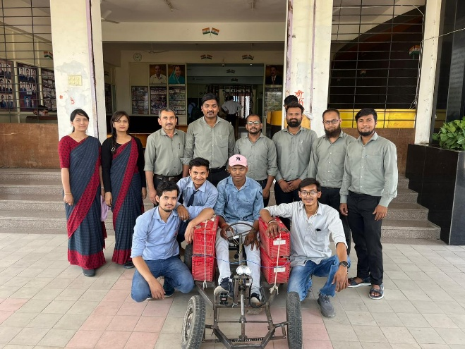

Fig:-9 Result  Fig:-10 Result

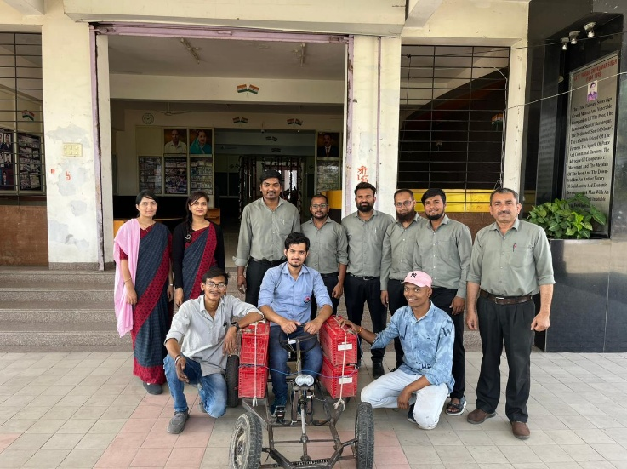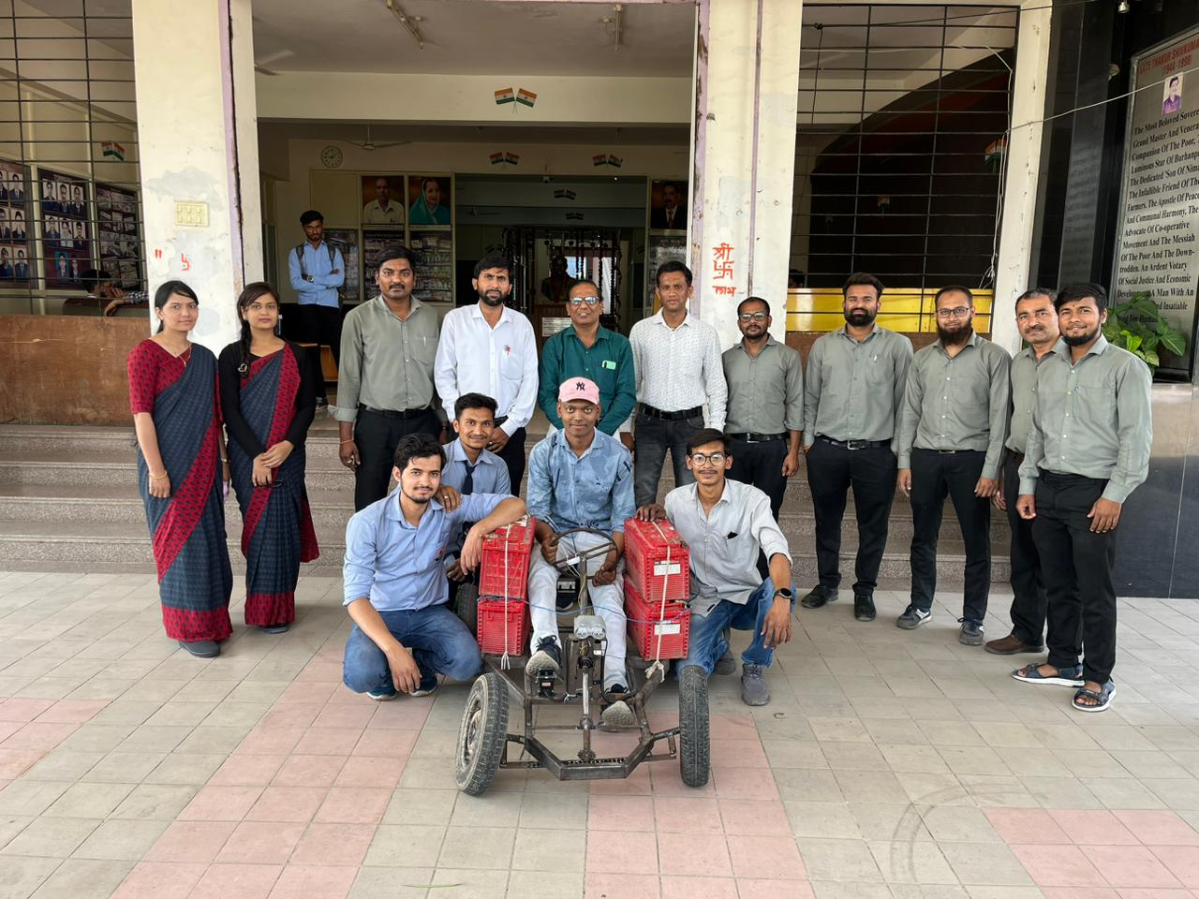

Fig:-11 Result  Fig:-12 Result

**REFERENCES –**

[1] Abhinay Nilawar, Harmeet Singh Nannade, Amey Pohankar, Nikhil Selokar, “DESIGN OF GO-KART”, Maharashtra,India, IJFEAT, ISSN: 2321-8134

[2] Baja 09 design report: Paper Number-TTTITM2 Uploaded by Midhun Davis

[3] Kanaad Bhardwaj , Mahesh Kumawat, Abhinav Pamecha , Aryan Sharma, Hemant Choudhary , Dhruv Rana , Ajit Singh Gour, Atul Katara “ Design and Performance Evaluation of an Electric Go-Kart “ IJARIIE-ISSN(O)-2395-4396 Vol-6 Issue-3 2020

[4]”Design and Fabrication of an Electric Go-Kart” by K. Vinoth Kumar, S. Gowtham, K. Gokulnath, and K. Vinoth Kumar. This paper discusses the design and fabrication of an electric go-kart using a DC motor and lithium-ion batteries. It includes details on the selection of components, design considerations, and performance testing.

[5] Electric Race Technologies – <https://electricracetech.com/>

[6] Bintelli Karts – <https://bintellikarts.com/electric-go-karts/>

[7]Karting Distributors – <https://www.kartingdistributors.com/electric-go-karts/>

[8] Image references by <http://www.google.com/>.

[9] Razor Ground Force Electric Go-Kart

[10]Hauk bat mobile pedal go kart

[11]Berg Buddy electric go kart

[12]Ninebot electric go kart