**Analysis Of Strength of Concrete by Partially mixing of sand with Artificial Sand**

**Akshay Thakur1, Vicky Rathore2, Komal Devgirkar3**

Students of Thakur shivkumar singh memorial group of institute jhiri Department

of civil engineering

Research guide and head of the Department of Thakur shivkumar singh memorial group

of institute jhiri Department of civil engineering

**ABSTRACT**

An abstract is a summary of entire paper should An enormous quantity of concrete is consumed by the construction industry. About 37.5 % volume of concrete is comprised of sand. A good class concrete is produced by cautious mixing of cement, fine and coarse aggregates, water and admixtures as required to obtain an optimum quality and economy. Generally, cement and coarse aggregates are factory made products and their quality and standards can be easily controlled and maintained. Water used for mixing of concrete is usually tap water. The fine aggregates or sand used is usually obtained from natural sources particularly river beds or river banks. Nowadays due to constant sand mining, the natural sand is reducing at an alarming rate. Sand dragging from river beds has led to several environmental issues. Due to various environmental issues Government has expelled the dragging of sand from rivers. This has led to a scarcity and substantial increase in the cost of natural sand. There is a vital need to find an alternative to Natural Sand. The only long term replacement for sand is Artificial sand. In the present study, an attempt has been made to experimentally study the properties of concrete and mortar by replacing the 100% natural sand with artificial sand.

The results have shown that the natural sand can be replaced with the artificial sand to produce concrete and mortar of satisfactory strength and Durability.

.

1. **INTRODUCTION**

Sand is a vigorous element in making two most used construction materials viz. cement concrete and mortar. Usually, Natural Sand, which is made by natural enduring of rocks over many years, is preferred as fine aggregate. The economic growth fuelling the growth of infrastructure and housing generates huge demand for building materials like sand. They indiscriminate mining of sand from riverbeds is posing a serious threat to an environment such as destruction of riverbed and banks, triggering landslides, loss of vegetation on the bank of rivers, lowering the underground water table etc. Hence, sand mining from riverbeds is being controlled or banned by the authorities. Regulatory extraction along rivers has caused the illegal activities to spread into hillside and farmlands, creating public hazards such as landslide, deep ponds, and hanging cliffs (Priyanka A. Jadhav and Dilip K. Kulkarni, 2013). This sand removed from fields, in addition to depleting the fertile top soil, impairs the quality of concrete/mortar. Artificial sand, which is obtained by crushing the rock, is emerging as a viable alternative to Natural Sand. This material is in use for quite some time in developed countries. The use of this sand (also called artificial sand, Artificial sand, Robo Sand etc.,) is picking up in India in major cities. Use of methodically produced Artificial Sand as an alternative to Natural Sand is the requirement of the hour and will provide a long term solution to Indian Construction Industry.

1. **MATERIAL AND METHOD**

**2.1 CEMENT**

Cement-is the hydraulic binder (hydraulic = hardening when combined with water) which is used to produce concrete. Cement paste (cement mixed with water) sets and hardens by hydration, both in air and under water. Cement is the “glue” that binds the concrete ingredients together and is instrumental for the strength of the composite. Although cements and concrete have been around for thousands of years, modern Portland cement was invented in 1824 by Joseph Asp din of Leeds, England. The name derives from its resemblance of the natural building stone quarried in Portland, England The main base materials, e.g. for *Portland cement,* are limestone, marl and clay, which are mixed in defined proportions. This raw mix is burned at about 1450 °C to form clinker which is later ground to the well-known fineness of cement.

**2.2 Concrete mix proportioning and preparation**

The physical and mechanical properties of the aggregates were tested prior to being used in production of concrete

mixes. Sieving of the fine and coarse aggregates were done using British Standards Institution (2000) BS 410-1:2000

test sieves. Both the NCA and RCA were washed and air-dried, and the portion passing through 5-20 mm sets of BS

410-1:2000 sieves were used. The specification given in British Standards Institution (1997) BS 8110-1:1997 is used

as the guideline in concrete mix preparation. British Standards Institution (1997) BS 8110-1:1997 recommends that for

reinforced concrete construction, the maximum water/cement ratio of 0.7 and a minimum cement content of 250

kg/m3. Since the density of concrete is about 2449 kg/m3, the cement content should be about 10.2% by weight (Ettu

et al., 2013). The batching of concrete was therefore done by weight using concrete mix ratio of 1:2:4

**2.3 Testing of concrete**

Workability refers to the ease with which a fresh concrete mix can be handled, and it can be measured using the slump

test. Slump test was conducted for each batch of fresh concrete according to the requirements of British Standards

Institution (1983) BS 1881-102:1983. The bulk densities of the hardened samples were obtained in accordance with

British Standards Institution (1983) BS 1881-114:1983 for concrete at 7, 14, 21, and 28 days of curing respectively.

On the day of testing, the cubes were removed from the curing tank and subjected to room temperature for about three

hours before their densities were determined prior to crushing. A compressive testing machine was used to conduct the

compressive strength test on the concrete cubes at 7, 14, 21, and 28 days respectively in accordance with British

Standards Institution (1983) BS 1881-116:1983.The mean values of the bulk density and compressive strength of

twelve concrete cubes for each curing age and coarse aggregate group were calculated and recorded.

1. **RESULTS AND DISCUSSION**

**3.1 Properties of aggregates**

The particle size distribution curve for river sand is while the particle size distribution curves for both NCA and RCA

, coefficient of curvature, Cc is 0.91, and the uniformity coefficient, Cu is 5.45. The fineness modulus is 2.91. The

fineness modulus shows that the fine aggregate lie between the range of medium sand and coarse sand, and is suitable

for production of satisfactory concrete . The coefficient of curvature, Cc, from the particle size distribution curves of

NCA and RCA given in are 1.57 and 1.74 respectively, while uniformity coefficient, Cu, of NCA and RCA are 2.55

and 3.40 respectively. It is observed that the coarse aggregate grains were well-graded since the values of Cc are less

than 3.0 but greater than 1.0 . The physical and mechanical properties of NCA and RCA . It can that the specific

gravity of RCA was slightly less than the range for coarse aggregate. The 24-hour water absorption of RCA is less

than 2%, the maximum value of water absorption for most normal coarse aggregates . Thus, RCA has a higher

capacity to absorb water than NCA. Results of the aggregate crushing value, aggregate impact value and Los Angeles

abrasion value respectively measure the strength, toughness and hardness. According to Shetty (2012), the value for

these mechanical properties should not be more than 30% for concrete used for wearing surfaces. Researchers also

reports that for concrete other than wearing surfaces, aggregate impact value should not be more than 45% and Los

Angeles abrasion value should not more than 50%. It can be observed from Table 1 that RCA has the higher aggregate

crushing, aggregate impact, and Los Angeles abrasion values than NCA. It can be noticed that RCA did not satisfy the

requirements for aggregate crushing value and aggregate impact value for use in wearing surface concrete. NCA has

lower crushing, impact, and abrasion values in comparison with RCA and thus possesses better resistance to shock and

wear. Both NCA and RCA have good resistance to abrasion

**3.2 Work-ability**

The slump of fresh concrete mixes of NAC and RAC were 90 mm and 100 mm. The slump of different concrete

samples fell within the range of 25-100 mm, indicating medium work ability . Based on work-ability, both NAC and

RAC using the given concrete mix and water/cement ratios can be applied in construction work involving heavily

reinforced concrete sections with vibration, and simply reinforced concrete sections without vibration. Fresh concrete

mix of RAC showed lower work ability than NAC for 1:2:4 mix ratio of and water/cement ratio of 0.5.

**3.3 Bulk density**

The results of the bulk density of NAC and RAC . The bulk density of both NAC and RAC increases with concrete

age with 7 days corresponding to the lowest bulk density and 28 days corresponding to the highest bulk density. The

bulk density of normal weight concrete ranges from 2200-2600 kg/m3, and it can be observed that bulk density of

both the NAC and RAC mixes fell within this range. The corresponding values for unit weight of normal weight

concrete (taking acceleration due to gravity, g, to be equal to 9.81 m/s2) range from 21.58-25.51 kN/m3. As expected,

the bulk density of RAC was marginally lower than that of NAC. Table 1 shows the reduction in bulk density of RAC

in comparison with NAC. From Table 2, 7-day old RAC gave the lowest reduction in bulk density while the 28-day

old RAC gave the highest reduction in bulk density.The bulk density of NAC for 28 days is approximately 2574

kg/m3 while the bulk density of RAC for the same age is 2328 kg/m3. The corresponding unit weights of NAC and

RAC are approximately 25.25 kN/m3and 22.83 kN/m3respectively. The unit weight of RAC is reasonably lower than the nominal value of 24 kN/m3assumed in British Standards Institution (1997) BS 8110-1:1997 for traditional normal

weight concrete. This implies that RAC would produce structural members with lower self-weight than traditional

concrete. The reduction in bulk density of RAC could be attributed to the lower specific gravity and lower bulk

density of recycled concrete aggregate in comparison with virgin coarse aggregate.

**3.4 Compressive strength**

The test results of the 7, 14, 21, and 28 days compressive strength of concrete are presented in Figure 4. Both NAC

and RAC concrete types had similar compressive strength development with increase in time. As expected, the

compressive strength of each concrete mix increased with age with the 7-day concrete cube attaining the lowest

compressive strength while the 28-day concrete had the highest strength. This is due to increased amount of hydration

products with the longer curing age. Both NAC and RAC types had approximately similar compressive strength

development with time. The 7-day compressive strength of concrete generally ranges from 60-80% of the 28-day

compressive strength for traditional concrete under standard curing conditions (Neville and Brooks, 2010). The 7-day

compressive strength of NAC obtained in this study was 85.1% of its 28-day compressive strength, while the 7-day

compressive strength of RAC was 76.4% of its 28-day compressive strength. The compressive strength of 7-day NAC

was slightly higher than the expected range probably due to higher cement content. High cement content contributes to

produce a greater early-age compressive strength . The recommended percentage of cement in a structural concrete

mix is 10.2% while the 1:2:4 concrete mix used in this study represents 14.2% cement the reduction in compressive

strength of RAC in comparison with NAC. The reduction in compressive strength of RAC ranged from 30-40%. The

compressive strength of RAC for 28 days represents 32.9% reduction of the 28-day compressive strength of NAC. The

reduction in compressive strength of RAC could be attributed to the lower quality of the recycled aggregate in

comparison with virgin coarse aggregate. It should be noted that the RCA was obtained from a demolished concrete

structure of unknown The 28-day compressive strength of RAC was 29.42 N/mm2 which exceeds the characteristic

compressive strength of 25 N/mm2for normal weight concrete specified in British Standards Institution (1997) BS

8110-1:1997. The characteristic strength is defined as the value below which not more than 5% of the test results will

fall and results from the compressive strength test should possess a value greater than this. This is given by

Fk=Fm − 1.64

where fk is the characteristic strength, fm is the mean strength, and s is the standard deviation. If the number of test

results of a particular group is less than twenty, then it is expected that all the test results should be equal to or greater

than the value of the characteristic compressive strength. In this study, the compressive strength values of twelve

batches of the 28-day RAC were greater than characteristic compressive strength of 25 N/mm2.compressive strength

**4 RESULTS AND FINDINGS**

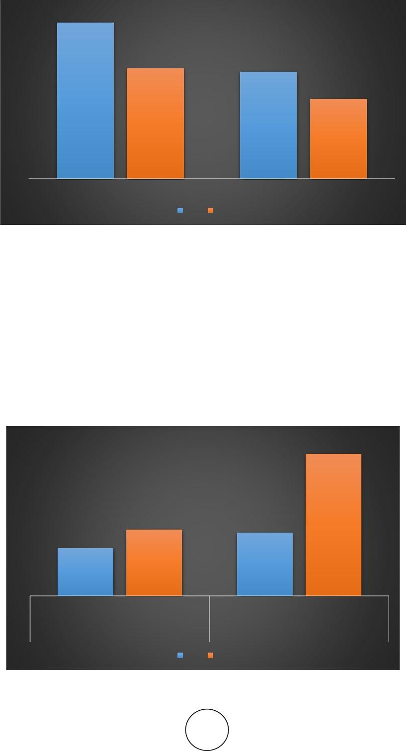Figure 1 shows the results of work-ability of concrete. This was measured by showing slump test. Keeping the water-cement ratio at 0.45 and using super plasticize (at 15 ml per kg of cement as specified by the manufacturer), the slump values were determined for both M20 and M30 mixes using Natural Sand and Artificial Sand as fine aggregate. Concrete with Natural Sand gave higher slump value. IS 456 codes stipulating a minimum slump of 50 mm for medium work-ability

112

76.5

79

57

Slump-cone test using natural sand

Slump-cone test using Artificial sand

M30

M20

**4.2. Compressive Strength of Concrete**

Compressive strength was resolute by testing the 28 days cured cube specimens. The mean compressive strength values of cube specimens are reported in Figure 2. The compressive strength of M20 and M30 grade concrete with Artificial S and as a fine aggregate is 6.5 – 9% higher when compared to the results using Natural Sand as fine aggregate.

32

29

21.56

19.86

Compressive Strength With Artificial Sand

Compressive strength With Natural Sand

M30

M20

.

**5. REFERENCES**

1. T. Mohana Priya, Dr. M. Punithavalli & Dr. R. Rajesh Kanna, Machine Learning Algorithm for Development of Enhanced Support Vector Machine Technique to Predict Stress, Global Journal of Computer Science and Technology: C Software & Data Engineering, Volume 20, Issue 2, No. 2020, pp 12-20
2. Ganesh Kumar and P.Vasanth Sena, “Novel Artificial Neural Networks and Logistic Approach for Detecting Credit Card Deceit,” International Journal of Computer Science and Network Security, Vol. 15, issue 9, Sep. 2015, pp. 222-234
3. Gyusoo Kim and Seulgi Lee, “2014 Payment Research”, Bank of Korea, Vol. 2015, No. 1, Jan. 2015.
4. Chengwei Liu, Yixiang Chan, Syed Hasnain Alam Kazmi, Hao Fu, “Financial Fraud Detection Fluid: Based on Random Forest,” International Journal of Economics and Finance, Vol. 7, Issue. 7, pp. 178-188, 2015.
5. Hitesh D. Bambhava, Prof. Jayeshkumar Pitroda, Prof. Jaydev J. Bhavsar (2013), “A Comparative Study on Bamboo Scaffolding And Metal Scaffolding in Construction Industry Using Statistical Methods”, International Journal of Engineering Trends and Technology (IJETT) – Volume 4, Issue 6, June 2013, Pg.2330-2337.