**DESIGN AND FABRICATION OF GUIDERS DROP WEIGHT IMPACT TESTER**

**Shaikh Mohd. Kaif1, Tadvi Arshad2, Prof. Shaikh Zeeshan Akil3, Prof. Naina N. Khare4, Prof. Shaikh Umair M.**

1 2Diploma Scholar, Jumma Masjid Charitable Trust’s, JMCT Polytechnic, Nashik

3Head of Mechanical Engineering, Jumma Masjid Charitable Trust’s, JMCT Polytechnic, Nashik

4 5Lecturer, Mechanical Engineering, Jumma Masjid Charitable Trust’s, JMCT Polytechnic, Nashik

**ABSTRACT**

A Drop Weight Impact tester is fabricated for the objective of testing of composite and laminated composite like polymer, natural fibers and ceramics which are applied with rop weight impact energy and thereby the deformation of the component is measured and the impact strength of the materials can be identified

**Keywords:** Impact Energy, Drop Weight.

1. **INTRODUCTION (Font-Times New Roman, Bold, Font Size -12)**

Mechanical testing is an important part of design or manufacturing processes, and testing services can be conducted in-house or carried out by external testing laboratories. Regardless of where they are conducted, the primary purpose of mechanical testing is to ensure the safety of any final products or structures. Because of this, environmental conditions are important, so tests should be performed under similar conditions to those faced by the final product.

**Figure 1** Types of Mechanical Testings

The drop Impact test is a mechanical test, in which a defined weight falls onto a specimen from a specified height. Following the drop impact test the appearance of the fracture surfaces is evaluated. Here the proportions of the deformation fracture surface and brittle fracture surface are determined visually. The evaluation can also be based on the effective absorbed energy of the specimen.

1. **METHODOLOGY**

**Figure 2** Methodology

1. **FABRICATION :**

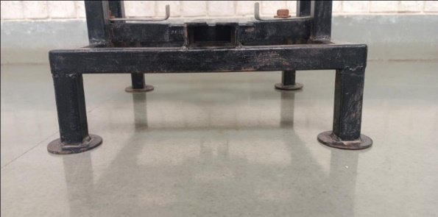

**Figure 3** Base Frame

It’s made up of 25*25*3 Mild Steel Pipe. Following Are the Dimensions Of Base:

* Length= 345mm
* Width = 345m
* height = 100mm
* It Consist 4 foundation plate having 62 diameter.

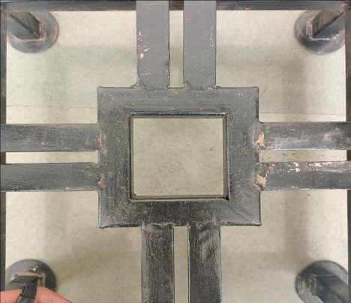

**Figure 4** Fixture

IT’s Made Up Of 25*25*3 Mild Steel Pipe And Angle. It’s Height Is 25mm. and Other Dimension Are Given In The Draft.

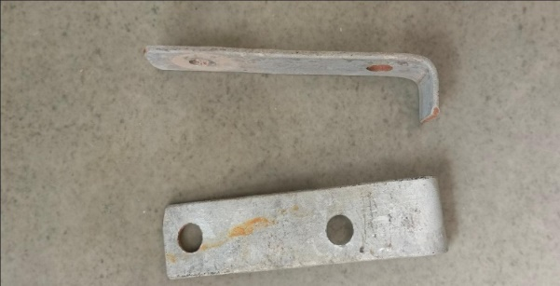

**Figure 5** Clampers

It’s 28*3 MS Flat Strip Having Bend On 25mm And Total Length Is 115mm. It Consist Two Holes For Adjusting.

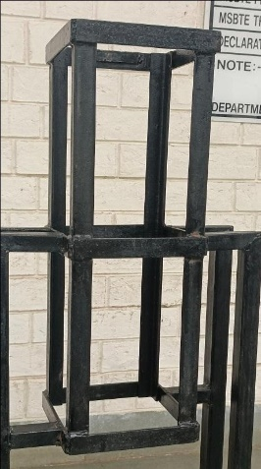

**Figure 6** Pipe Frame

The Material Is Use To Construct The Pipe Frame Is: 25*25*3mm MS Angle 28*5 mm MS Flat Strip The Total Height Of Pipe Frame Is 608mm. L*W= 162*162 mm

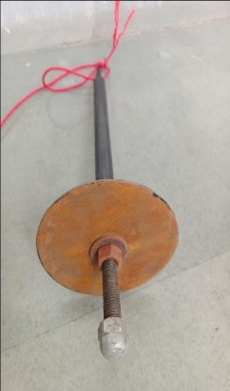

**Figure 7** Impactor

Impactor’s Part:

* Disc Having 160 Diameter
* 16*80 MS Bolt
* 25*3 MS Pipe
* Pipe Length Is 330 mm

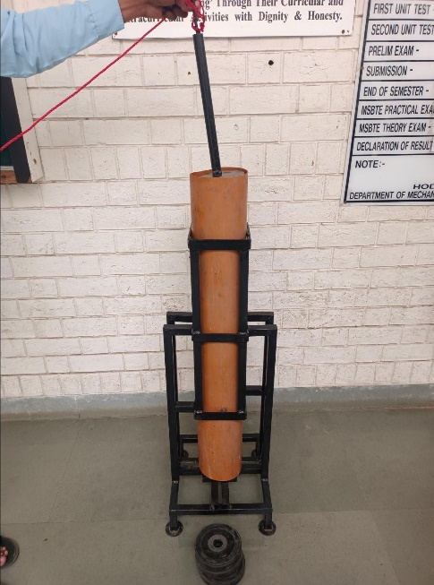

**Figure 8** Final Assembly

1. **CONCLUSION :**

* This project is designed by us to check the strength of the material.
* It will behave on the material after applying a separate upper load on the material at the specific height .the different types.
* The different types of material example Aluminium, nylon bar, ms pipe is selected for trial to check the strength and depth of impact if it is required.
* Some material can be broken it depends upon how much load are drop on it so we calculate the depth.
* After loading up. We will click the depth with the vernier depth gauge.
* It knows exactly what material can bear how much load.
* While we were making the project, we faced a problem to align the pipe frame, for which we provided a balance point on the end of pipe frame due to which the pipe frame, fixture and base are collinear

1. **REFERENCES**
2. Aditya Chandrashekhar Gole , Rushikesh Rajesh Bhandare , Meher Rigved Prakash , Pansare Rishabh Narendra , Prof. Pranija P. Bartere, “Design And Development Of Automatic Ground Clearance System”, International Journal Of Advance Scientific Research And Engineering Trends, 2020.
3. Sanjyoti Choudhari , Navnath Kuchekar , Dnyaneshwari Nehate , Rahul Shikokar , Prof. S. B. Patil, “Review on Development of Automatic Ground Clearance Adjustment System in Cars using Pneumatic Lifting”, International Journal for Research in Applied Science & Engineering Technology, Volume 8 Issue 6 June 2020.
4. Anup Pendor, Vaibhav Nalawade, Abhishek Kulkarni, Siddeshwar Parshetty, Renu Shashtri, “Design & Development of Automatic Ground Clearance Adjustment car by using Pneumatic System”, International Research Journal of Engineering and Technology, Volume 08 Issue 1, Jan 2021.
5. Sagar Gopale, Prasad Padale, Pramod More, Tanvi Avhad, “Automatic Ground Clearance Adjustment System”, International Journal for Scientific Research & Development, Vol. 8, Issue 3, 2020.
6. Shivaraj Chandrakant Patil, “Adjustable Ground Clearance Mechanism”, International Conference in Engineering Science and Management”, December 2016.
7. Jagadeesh H, Navinesh B C, “Development of Advanced Pneumatic Lifting and Ground Clearance Technique in Car”, International Journal of Innovative Research in Science, Engineering and Technology, Volume 7, Special Issue 7, June 2018.
8. Varatharaju.P, K.Vigneshwaran, N.Suresh Kumar, D.Muthu Harish, A.Vasantha Kumar, “Automatic Ground Clearance Adjustment System”, International Journal of Science and Engineering, 2018.