**Automated HTML Code Generation from Hand Drawn Images using Machine Learning Methods.**

**P Swathi1, Prajwal V2, Abhishek B M3, Prof. Deepa S Bhat4**

1,2,3Students, Dept of CSE, Sambhram Institute of Technology, Bangalore, India.

4 Asst.Prof, Dept of CSE, Sambhram Institute of Technology, Bangalore, India.

**ABSTRACT**

This paper introduces a novel method for deep learning-based HTML code generation from hand-drawn pictures. The suggested technique uses a convolutional neural network (CNN) to figure out how to transfer hand-drawn diagrams to the corresponding HTML code. The CNN is trained using a sizable dataset of HTML code and annotated hand-drawn illustrations. The trained model is fed a hand-drawn drawing during testing, and the model outputs the equivalent HTML code. The results show that the suggested method is effective at producing precise HTML code when applied to a series of hand-drawn designs. The suggested method could greatly cut down on the time and work needed for web development, especially for designers that like to sketch their concepts instead of using computer-aided design tools.

Keywords: Deep learning, HTML code generation, hand-drawn pictures, convolutional neural network, dataset, annotated illustrations, testing, web development, designers, computer-aided design tools.

1. **INTRODUCTION**

The advancement of modern technology has greatly raised the significance of Internet websites. The face of today's states, institutions, communities, and people is reflected on websites. There are websites in practically every industry, including knowledge, social work, games, training, and many more. Websites made by businesses are more prominent for commercial reasons like product promotion or advertising. Official institutions, on the other hand, strive to offer more effective services. Developers are in charge of creating client-side software based on a designer's mock-up of the Graphical User Interface (GUI). On the other side, the implementation of GUI programming consumes time and distracts engineers from concentrating on the actual functionality and logic of the product. They're growing. Additionally, the computer additionally, the computer languages used to create these GUIs are unique to each target runtime system, requiring tedious and repetitive work when the product is intended to operate on different platforms using native technologies. In order to imitate sequences of spatiotemporal visual information, we provide a model trained end-to-end with stochastic gradient descent to generate variable-length strings of tokens from a single GUI picture as input. In this work, an algorithm for automatically producing HTML code for a hand-drawn mock-up of a web page was developed. The purpose of this is to identify the elements created in the mock-up drawing and to encode them in accordance with the hierarchy of web pages.

1. **LITERATURE SURVEY**

A scientific paper's text that incorporates the most recent information, including important discoveries, as well as theoretical and methodological contributions to a given subject is called a literature survey. Reviews of the literature rely on secondary sources and do not present brand-new or unique experimental research. A literature review typically comes before the methodology and findings sectional, however this is not always the case. A literature review is most frequently connected with academic-oriented material, such as a thesis, dissertation, or peer-reviewed journal article. In a search proposal or prospectus, which must be authorised before a student can start working on a dissertation or thesis, literature evaluations are also frequent. Its primary objectives are to place the current study within the context of the body of literature and to give the reader specific context. Review of the literature constitute the foundation for almost all academic study. academic area. The following are included in a literature review:

* Broadly recognised theories that are now available on the subject.
* Both general and specialised books have been produced on the subject.
* In the field, research is often done from oldest to newest.

1. **PROBLEM STATEMENT**

The project's primary goal is to automatically create HTML code from a hand-drawn mock-up of a web page. A hand-drawn image of a shape is given as input, and after analysis, many of its components are found. Following component identification, deep learning CNN algorithms are used to crop the components and identify them. when the equivalent component is identified. HTML code is generated by the HTML builder algorithm.

Creating web pages that effectively answer to these objectives is a time consuming task. Graphic designers, software professionals, end-users, business authorities, and people employed in a variety of fields are all required to collaborate in the creation of web sites.

Typically, the process begins with graphic designers or mock-up artists creating a mock-up design of the user interface in accordance with the institution's demands, either on paper or through graphic editing software.

On the basis of these draughts, software specialists build code for web sites. The web pages that result may alter as a result of the feedback obtained from the end users. There are a lot of repetitive jobs in their process.

The process of rewriting code for components with similar functionalities and page structures that change over time is tedious.

1. **SYSTEM ARCHITECTURE**

System architecture tells us how the system works in the view of the user. It consists of 4 main modules:

• Obtaining the UI Sketch (Uploading of the screenshot of the

Sketch)

• Region of Interest

• Element Recognition

• Code Generation

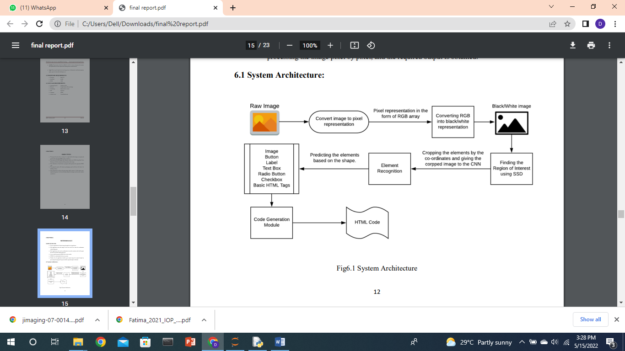

**Figure1:** System Architecture

**Image Preprocessing**: The hand-drawn images are first preprocessed to enhance their quality and make them suitable for further processing. This step may include resizing, cropping, and converting the images to a suitable format, such as PNG or JPEG.

**Image Analysis:** The preprocessed images are then analyzed using computer vision algorithms to detect and classify the different elements present in the image. This may involve techniques such as object detection, shape recognition, and character recognition.

**HTML Generation:** Based on the results of the image analysis, HTML code is generated to create a web page that displays the hand-drawn image in a user-friendly format. This may involve creating HTML tags for the different elements detected in the image, such as text boxes, buttons, and images.

**Web Development Framework:** To generate the HTML code, you can use a web development framework such as React, Angular, or Vue. These frameworks provide a set of tools and components for building interactive web applications. You can use these tools to create a user interface for the HTML code generated in step 3.

**Server-side Integration:** To integrate the web application with the server-side, you can use a server-side programming language such as Python, Ruby, or PHP. You can use web application frameworks such as Flask or Django to build the server-side of the web application. The server-side can handle communication with the client-side and perform further processing, such as saving the generated HTML code to a database or sending it to other systems for further processing.

**User Interaction:** The web application can be accessed by users using a web browser. The user can upload a hand-drawn image to the web application, which is then processed using the system architecture described above. The user can interact with the generated HTML code using a mouse or touch screen, and the results can be saved or shared as needed.

1. **DATA FLOW DIAGRAM**

**Level: 0** describes the overall process of the project. We are using sketch image as input. System will use RESNET50 a deep learning algorithm to predict the HTML elements in the sketch and generate HTML code as result.

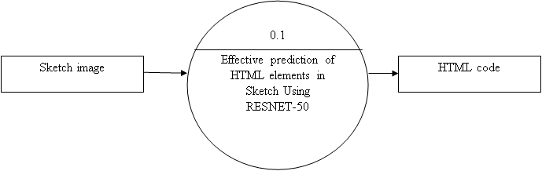

**Figure2: level 0**

**Level: 1** describes the first step of the project. We are using sketch image dataset as input. System will use image processing techniques to preprocess the data and extract the important features.

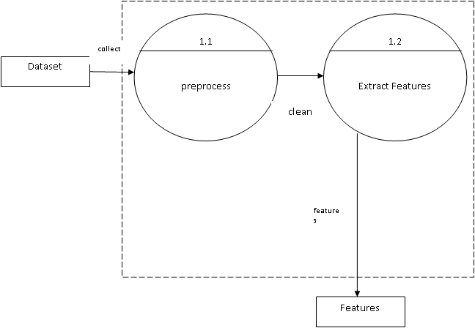

**Figure3: level 1**

**Level: 2** describes the final step of the project. We are using features from level-1 and sketch image as input. System will apply Resnet Classifier and generate HTML codes.

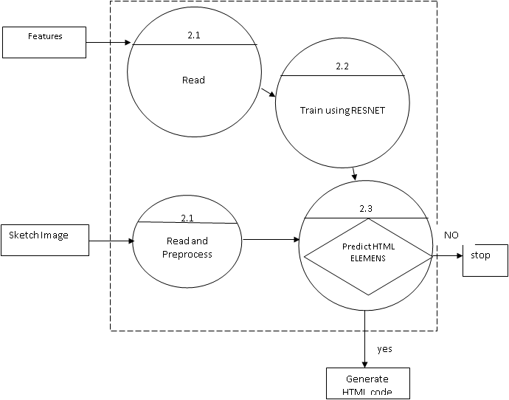

**Figure4: level 2**

1. **ALGORITHMS**
2. **Faster R-CNN with Resnet 50**

Faster R-CNN with ResNet-50 is a popular object detection model that combines the Faster R-CNN framework with the ResNet-50 deep neural network architecture. The ResNet-50 architecture is used as the backbone network for the model, providing high-level features that are used by the RPN and object detection network. The ResNet-50 architecture is a deep convolutional neural network that has been pre-trained on the large-scale Image Net dataset. This pre-training provides a strong initialization for the model and helps it generalize well to new datasets.

2. Canny Edge Algorithm

The Canny edge detection algorithm is a popular image processing technique used for detecting edges in digital images. It was developed by John F. Canny in 1986. The output of the Canny edge detection algorithm is a binary image where edge pixels are marked as white and non-edge pixels as black. The Canny edge detection algorithm is widely used in computer vision and image processing applications, such as object detection, image segmentation, and feature extraction. It is a robust algorithm that can detect edges even in noisy images with low contrast.

1. **RESULTS AND DISCUSSION**

**User Interface:**

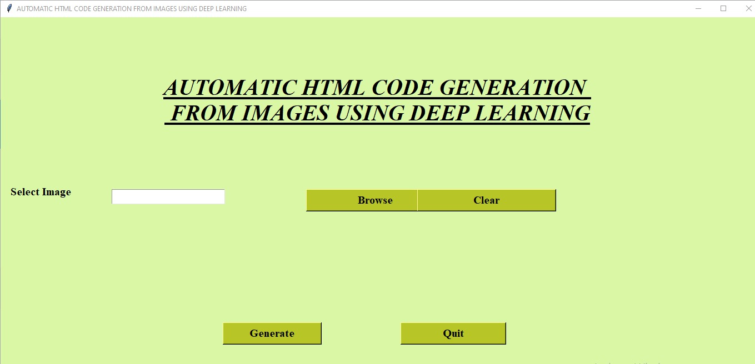

**Grey Scale Image:**

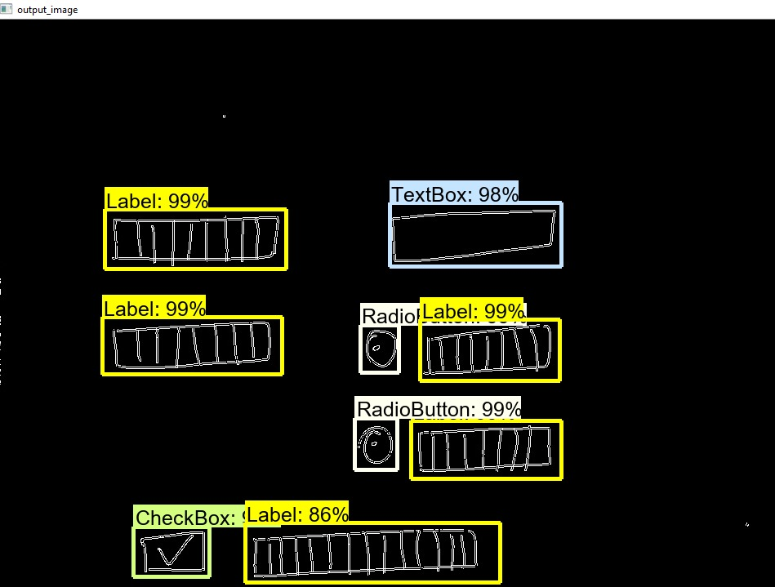

**Final Result:**

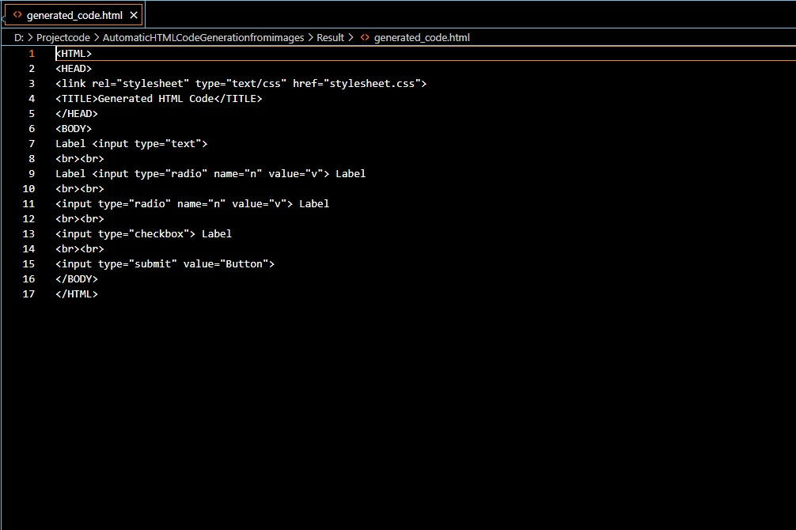

1. **FUTURE SCOPE**

* Increasing system versatility by allowing users to create front-end designs using a variety of image formats.
* Improving the system in order to produce more appealing designs.
* Improving system quality by adding a new function that allows users to customise the CSS for the website's front end.

1. **CONCLUSION**

Websites are an important aspect of today's rapidly evolving technological environment since they are beneficial for product marketing and advertising. As a result, it is critical to create a website that will attract a significant number of visitors. We devised a method for taking web page mock-ups, processing them, and producing structured HTML code. A picture-based data collection was used, which included several prototypes of web page architectures. The RCNN model is trained using this dataset. Building a website under the current system is a time-consuming task. Hand-drawn graphics

of online forms are converted into HTML code using the suggested technique. As a result, the system will use less time and resources than the current system.

1. **REFERENCES**

1. T. Automatic HTML Code Generation from Mock-up Images Using Machine Learning Techniques978-1-7281- 1013-4/19/$31.00 © 2019 IEEE.
2. Convolutional Neural Network (CNN) for Image Detection and Recognition 978-1-5386-6373-8/18/$31.00 ©2018 IEEE
3. pix2code: Generating Code from a Graphical User Interface Screenshot arXiv:1705.07962v2 [cs. LG] 19 Sep 2017.
4. Norhidayu binti Abdul Hamid, Nilam Nur Binti Amir Sjarif, “Handwritten Recognition Using SVM, KNNandNeuralNetwork”[www.arxiv.org/ftp/arxiv/papers/1702/1702.00723](http://www.arxiv.org/ftp/arxiv/papers/1702/1702.00723).
5. Convolutional Neural Network (CNN) for Image Detection and Recognition 978-1-5386-6373- 8/18/$31.00 ©2018 IEEE.
6. T. Beltramelli, “pix2code: Generating code from a graphical user interface screenshot,” CoRR, vol. abs/
7. 1705.07962, 2017. [Online]. Available: <http://arxiv.org/abs/1705.07962>.
8. Mahmoud M. Abu Ghosh; Ashraf Y. Maghari, “A Comparative Study on Handwriting Digit Recognition Using Neural Networks”, IEEE, 2017.
9. T. A. Nguyen and C. Csallner, “Reverse Engineering Mobile Application User Interfaces with REMAUI (T),” in 2015 30th IEEE/ACM International Conference on Automated Software Engineering (ASE). IEEE, nov 2015, pp. 248–259. [Online]. Available: http: //ieeexplore.ieee.org/document/7372013/.
10. S. Natarajan and C. Csallner, “P2A: A Tool for Converting Pixels to Animated Mobile Application User Interfaces,” Proceedings of the 5th International Conference on Mobile Software Engineering and Systems - MOBILESoft ’18, pp. 224–235, 2018.
11. T. Beltramelli, “pix2code: Generating code from a graphical user interface screenshot,” CoRR, vol. abs/1705.07962, 2017. [Online]. Available: http://arxiv.org/abs/1705.07962