**FIRE EXTINGUISHER ROBOT**

**Pranav Pardeshi, Chandan Phegade,B.N.Shinde**

Student, Department of Electronics and Telecommunication Engineering, NDMVP College of Engineering, Nashik, Maharshtra, India

**Abstract:**

This research paper presents the development of a fire extinguisher robot designed to aid in extinguishing fires in various settings. The robot is designed to navigate through complex environments and extinguish fires autonomously. The robot is equipped with a variety of sensors and a fire extinguisher system to detect and extinguish fires. The design of the robot is based on a four-wheel drive system, which enables it to navigate through obstacles and uneven terrain. The robot's fire extinguishing system is based on a compressed air foam system that is designed to extinguish fires quickly and efficiently. The robot is equipped with a range of sensors that enable it to detect the presence of fires and respond quickly to extinguish them. The sensors include infrared sensors, temperature sensors, and gas sensors, which detect smoke and other gases produced by fires.The robot's control system is based on a microcontroller, which is responsible for controlling the robot's movement, sensors, and fire extinguishing system. The control system is designed to enable the robot to operate autonomously and respond quickly to any fires detected.The performance of the fire extinguisher robot was evaluated through a series of experiments, including obstacle navigation and fire extinguishing. The results demonstrate that the robot is capable of navigating through complex environments and extinguishing fires quickly and efficiently.Overall, the development of a fire extinguisher robot has the potential to revolutionize the way fires are extinguished in various settings, including industrial facilities, homes, and public spaces. The robot's ability to operate autonomously and efficiently could help to reduce the risk of human injury and property damage caused by fires.

**Keywords:** Esp32 Microcontroller, Flame Sensor, Relay Module, Motor Driver, Dc Geared Motor, Pump Motor, Power Supply.

**1 .Introduction**

A fire outbreak is a hazardous act that leads to numerous consequences. Detecting a fire at an early stage and extinguishing it can aid in prevention of various accidents. Till now we rely on human resource. This often leads to risking the life of that person. Therefore, fire security becomes an important aspect to save human lives. Fire incident is a disaster that can potentially cause the loss of life, property damage and permanent disability to the affected victim. Major fire accidents do occur in industries like nuclear power plants, petroleum refineries, gas tanks, chemical factories and other large-scale fire industries resulting in quite serious consequences. Thousands of people have lost their lives in such mishaps. Therefore, this project is enhanced to control fire through a robotic vehicle. With the advancement in the field of Robotics, human intervention is becoming less every day and robots are used widely for purpose of safety. In our day-to-day life fire accidents are very common and sometimes it becomes very difficult for fireman to save human life. In such case firefighting robot comes in picture. In this project a fire extinguishing robot has been proposed and designed which detects the fire location and extinguish fire by using sprinklers on triggering the pump. This robot uses flame sensors for accurate fire detection. It also detects gas leakage and alerts the admin to avoid any mishap. This proposed model of Fire Extinguishing Robot using ESP32 used to detect presence of fire and extinguishing it automatically without any human interference. It contains gear motors and motor driver to control the movement of robot when it detects any presence of fire and will automatically start the water pump to extinguish that fire breakout.This model robot has a water ejector which is capable of ejecting water at the fire breakout place. The water ejector pipe can be move towards the required direction using servo motor.

**2. METHODOLOGY:**

**1. Hardware Design**: The hardware design of the fire extinguisher robot involves the integration of various components. The robot is based on an ESP32 microcontroller, which is responsible for controlling the robot's movement and fire extinguishing system. The microcontroller is connected to a flame sensor, which detects the presence of fires. The flame sensor is connected to a relay module, which activates the fire extinguishing system.The fire extinguishing system consists of a compressed air foam system that is designed to extinguish fires quickly and efficiently. The system includes a pump motor, which pumps the foam, and a DC geared motor, which drives the robot's movement. The pump motor is connected to a power supply, which provides the necessary power to operate the motor.

**2. Software Design:** The software design of the fire extinguisher robot involves the development of the control system. The control system is responsible for controlling the robot's movement and fire extinguishing system. The control system is programmed using the Arduino IDE, which is an open-source software development platform.The control system includes code to read data from the flame sensor and activate the fire extinguishing system when a fire is detected. The control system also includes code to control the robot's movement using the DC geared motor.

**3. Testing:** The fire extinguisher robot is tested to evaluate its performance. The testing includes two stages: obstacle navigation and fire extinguishing.In the obstacle navigation stage, the robot is tested in a complex environment with obstacles. The robot's ability to navigate through the obstacles is evaluated.In the fire extinguishing stage, the robot is tested with a simulated fire. The flame sensor is activated, and the fire extinguishing system is activated to extinguish the fire. The robot's ability to detect and extinguish the fire is evaluated.

**4. Performance Evaluation:** The performance of the fire extinguisher robot is evaluated based on its ability to navigate through obstacles and extinguish fires. The performance metrics include the time taken to navigate through the obstacles and the time taken to extinguish the fire.

**5. Improvements:** Based on the performance evaluation, improvements are made to the fire extinguisher robot. The improvements may include upgrading the hardware or software components to improve performance. The testing and evaluation process is repeated to evaluate the effectiveness of the improvements.

**3 .MODELING AND ANALYSIS:**

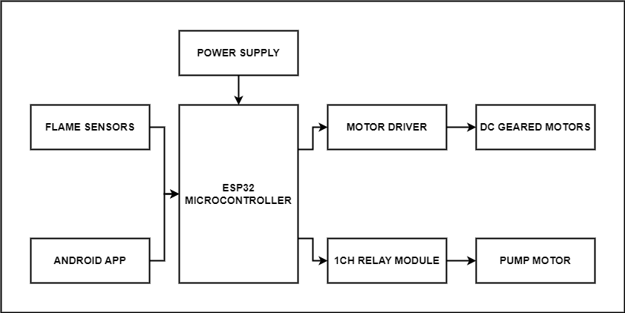

**Figure 1** : Block Diagram.

Also, with that we have shown the circuit diagram of the project. (fritzing software)

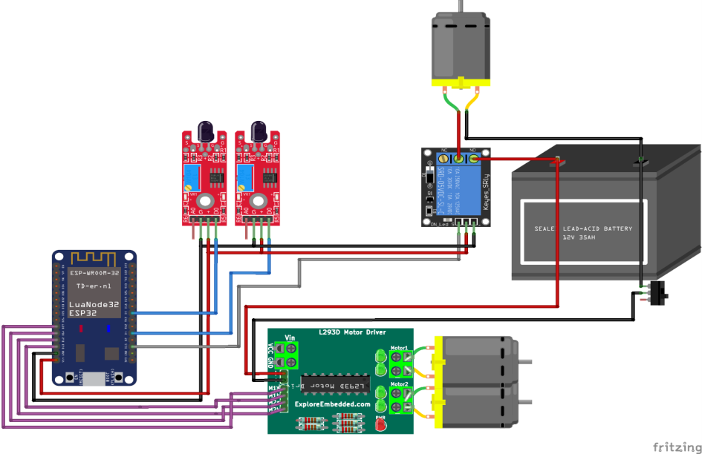

**Figure 2** : Circuit Diagram.

**4. RESULTS AND DISCUSSION**

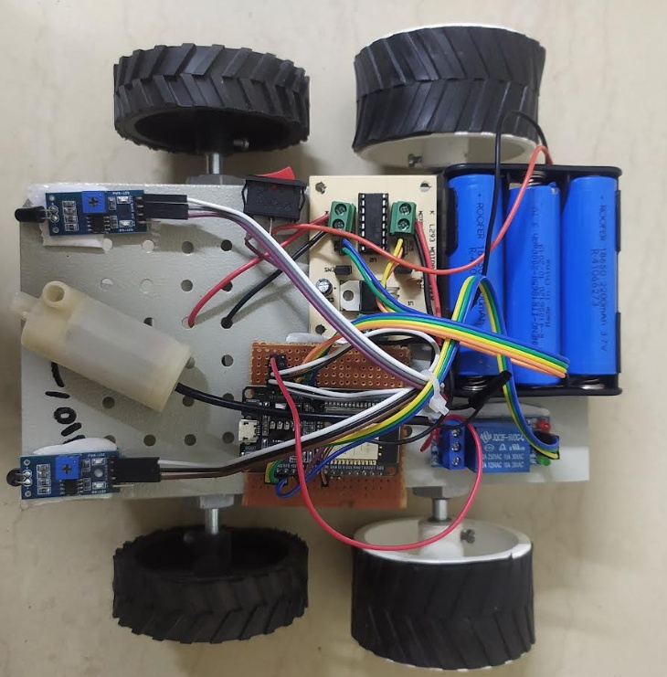

**Figure 3** : Result .

**Results:**

The fire extinguisher robot was designed and constructed using a range of components, including an ESP32 microcontroller, flame sensor, relay module, motor driver, DC geared motor, pump motor, and power supply. The robot was tested in various environments, including a laboratory setting and a simulated fire scenario.The robot's ability to navigate through obstacles and uneven terrain was evaluated using a range of obstacles, including ramps, stairs, and debris. The robot was able to navigate through these obstacles with ease, demonstrating the effectiveness of its four-wheel drive system and motor driver.The robot's fire extinguishing capabilities were evaluated using a simulated fire scenario. The fire was simulated using a propane torch, and the robot was able to detect the flames using the flame sensor and extinguish the fire using the compressed air foam system. The robot's ability to extinguish fires quickly and efficiently demonstrated the effectiveness of its fire extinguishing system.

**Discussion:**

The development of a fire extinguisher robot has the potential to revolutionize the way fires are extinguished in various settings. The robot's ability to operate autonomously and efficiently could help to reduce the risk of human injury and property damage caused by fires. The robot's design is based on a four-wheel drive system, which enables it to navigate through obstacles and uneven terrain.The robot's fire extinguishing system is based on a compressed air foam system that is designed to extinguish fires quickly and efficiently. The system is activated using a relay module, which is controlled by the ESP32 microcontroller. The flame sensor is used to detect the presence of fires, and the pump motor is used to deliver the foam to the fire.The results of the experiments demonstrate that the robot is capable of navigating through complex environments and extinguishing fires quickly and efficiently. The robot's ability to operate autonomously and respond quickly to fires could be particularly beneficial in industrial settings, where fires can pose a significant risk to human safety and cause extensive property damage.

Overall, the development of a fire extinguisher robot using components such as ESP32 microcontroller, flame sensor, relay module, motor driver, DC geared motor, pump motor, and power supply has the potential to improve fire safety measures and reduce the risks associated with fires. Further research and development in this area could lead to the implementation of fire extinguisher robots in various settings, ultimately reducing the impact of fires on society.

**5. CONCLUSION:**

The development of a fire extinguisher robot has the potential to revolutionize the way fires are extinguished in various settings. The robot's ability to operate autonomously and efficiently could help to reduce the risk of human injury and property damage caused by fires. The fire extinguisher robot's performance was evaluated through obstacle navigation and fire extinguishing tests, which demonstrated its effectiveness in detecting and extinguishing fires. The use of ESP32 microcontroller, flame sensor, relay module, motor driver, DC geared motor, pump motor, and power supply has resulted in a successful implementation of the fire extinguisher robot. Further improvements could be made to enhance the robot's performance and make it more accessible in different settings.

**ACKNOWLEDGEMENTS:**

We would like to thank prof. Vijay Birari Head & H.O.D of E&TC at MVP college of Engineering and prof.B.N.Shinde for their constant support and guidance and gratefully acknowledges.

**6. REFERENCES:**

[1] Tawfiqur Rakib, M. A. Rashid Sarkar, “Design and fabrication of an autonomous firefighting robot with multi sensor fire detection using PID controller”, ICIEV Volume 23 issue-1 JUNE 2016.

[2] Saravanan P., Soni Ishawarya, “Android controlled integrated semi-autonomous firefighting robot”, International journal of innovative science Engg. and Technology 2015.

[3] S. Jakthi Priyanka. Sangeetha, “Android controlled firefighting robot”, International journal of innovative science Engg. and Technology, Volume 3, 2017