**Remote monitoring of thermal power plant water flow level using microprocessor and GSM**

P.Arulmozhi1, A.Abitha2, I.Aiswarya3, J.Bindhu Mathi4, T.L.Gayathri5

Assistant Professor1, UG Scholar2, UG Scholar3, UG Scholor4, UG Scholar5.

Department Of Electronics and Communication Engineering, Vivekanandha College of Technology for Women, Namakkal, Tamil Nadu, India.

Abstract -Modern thermal power plants generate electricity by turning water into steam, which is then passed via a turbine that is attached to a generator. Sand and lignite are used in NLC as a heating fuel to heat a boiler and create steam from water. Boilers cannot be fed with raw water because it causes corrosion and the production of scale. because it contains gases, suspended particles, dissolved minerals, and salts. Demineralized (DM) water is created from raw water. Three chemicals are then injected to lessen corrosion and scale formation. This essay provides a thorough examination of the SWAS system's analysis of the boiler's stages' pH, conductivity, silica, residual hydrazine, ammonia, sodium phosphate, and dissolved oxygen. Additionally, analysis is carried out manually.

**Keywords*:* LCD, Raspberry Pi, Wi-Fi, and buzzer.**

**I. INTRODUCTION**

Water is incredibly valuable and essential for many kinds of activities. Water conservation is similarly crucial and has negative consequences in different ways. Water storage is crucial for home, commercial, industrial, agricultural, and other uses. Due to the growing population and their avaricious desires for urbanization, industry, and other forms of development, safe drinking water is becoming more polluted and harmful. As a result, there is a desire for more aggressive methods of monitoring the water quality. Manual labor was required for the testing of the water quality. Such methods take more time and are no longer effective. Additionally, some homeowners turn on the electric water pumps before leaving for work or bed without turning off the mains.

This results in water waste and frequent flooding. Studies claim that over time when a tank or reservoir is built on top of a lot of buildings, the weight of the tank may have an impact on the construction of the structures. It can also be a waste of resources and a type of environmental contamination, especially in homes without access to boreholes. Therefore, a consistent and reliable water supply is essential for meeting human needs.

Agriculture, transportation, energy, security, financial and healthcare services, portable gadgets, automation, and notable nanotechnology are just a few of the industries that employ the Internet of Things. The populace does not have access to enough potable water, and an aqua crisis is imminent.

The United Nations and many other international organizations take into consideration a variety of areas that are concerned about the global water crisis. There is no water crisis there, according to other organizations like the Food and Agriculture Organization, but required precautions must still be done to avoid one crucial problem. The Government of India's announcement of the Smart City Mission, which combines various Information and Communication Technology (ICT) and Internet of Things (IoT) technologies, brought encouragement. Utilizing a water monitoring system allows us to easily control water usage for our generation while reducing power consumption and water waste. This device automatically turns on and off when the tank or reservoir reaches a certain volume of water.

**II. OBJECTIVE**

The main aim of this system is to monitor the water level, so that they help in detecting the wastage of water and measures can be taken to avoid unnecessary overflowing of water in the areas where monitoring is a difficult task.

**III.** **LITERATURE REVIEW.**

GOKULA NANTHAN.S of the Department of Electronics and Communication of Engineering graduate student is working on an IOT-based water quality monitoring system. Water quality is declining year after year as a result of urbanization and rapid development, which causes water-borne illnesses.

Since protecting water and other resources is highly valued in the modern world, various authors have proposed various solutions following the issues surrounding them. IoT-based water monitoring is a lively topic for students, engineers, researchers, and in public management. These setups have shown that human interference can result in a significant increase in efficiency. Due to its potential to change numerous practices, IoT-related new technologies are becoming increasingly popular, however, only a small portion is now available.

**IV. RESEARCH WORK**

1. For the implementation of this project, the technology of the Arduino Uno board, a 16x2 LCD screen, an ultrasonic sensor, and a mini pump will be used, which will be fed with a DC voltage, it is intended to have manual control of every time, otherwise, the work will be fully automatic.

1. The inspection of the level height of a fluid by ultrasound encompasses a family of methods based on the transmission of a high-frequency wave.

1. In this paper, we have addressed the issue of performance analysis of three control schemes, PI (based on pole placement, ZN, and Ciancone correlation tuning methods), PI-plus-feedforward, and MPC which have not been done in the present kinds of literature.

1. Ultrasonic Sensors use high-frequency ultrasonic waves to detect the levels of any medium liquid or solid.
2. The ultrasonic sensor is connected to the Arduino NANO to transmit the measured distance to the microcontroller and make the decision to stop the water overflow.
3. The main motivation for this study is to deploy computing techniques in creating a safety mechanism that will automatically shift the pump according to the level of water in the well and also will turn on/off the pump as the use of water for watering.
4. The system consists of two modules, a transmitter, and a receiver. The transmitter module performs water level detection and transmits it to the receiver module as a data collector. The receiver module then displays the data on the screen.
5. Embedded systems are one way that Arduinos can be introduced into industrial automation. Due to the low cost, Arduinos can be appealing solutions for specific parts of industrial manufacturing processes.
6. C++ is a programming language designed in 1979 by Bjarne Stroustrup. Its creation intended to extend the C programming language and add object manipulation. In that sense, from the point of view of object-oriented languages, C++ is a hybrid language mechanism that allows.
7. This system alerts the authorized person by informing them about the disconnected phase through an SMS When the power is re-connected to the system, it informs that the phase is working fine through a text message, to the authorized person's mobile number. This is the way by which the authorized person gets notified about the power failure and he can take the necessary steps to solve the issue.
8. The Arduino UNO is the best board to get started with electronics and coding. If this is your first experience tinkering with the platform, the UNO is the most robust board you can start playing with. The UNO is the most robust board you can start playing with. The UNO is the most used and documented board of the whole Arduino family.

1. The water level in the tank and sump is noted and sent to the Blynk IoT cloud, which a user can monitor remotely. The water in the tank is replenished immediately when it goes below the prescribed level and stops pumping when the tank reaches the prescribed full level. The Blynk IoT also sends a notification to the user whenever the tank is empty or full. The user is also given manual control to turn the pump on and off.

1. The Ultrasonic sensor is placed on the top of the tank which continuously keeps track of the water level in real-time, which will inform the users about the level of liquid and automatically turn on/off the water pump as per the defined functions.
2. This paper reviews the use of Internet of Things (IoT) devices in monitoring water systems to conserve and manage precious resources. The IoT technology is synonymous with the latest wireless system for data acquisition for real-time monitoring surveillance.

**HARDWARE REQUIREMENT SPECIFICATION**

**OVERVIEW**

A major role of this project is to monitor the water flow level in thermal power plants, the LEDs turn on when water is detected, and the ultrasonic sensor is used in this to find movement. The different levels will be displayed.

**HARDWARE REQUIREMENTS**

A complete collection of functional, operational, performance, interface, quality factors, design, criticality, and test criteria must be defined and analyzed for hardware. Together with the ultrasonic sensors, the Arduino board is used at Water Level.

Arduino board: system.

IR sensors are used.

HDMI to VGA conveyors, power supply, and relay.

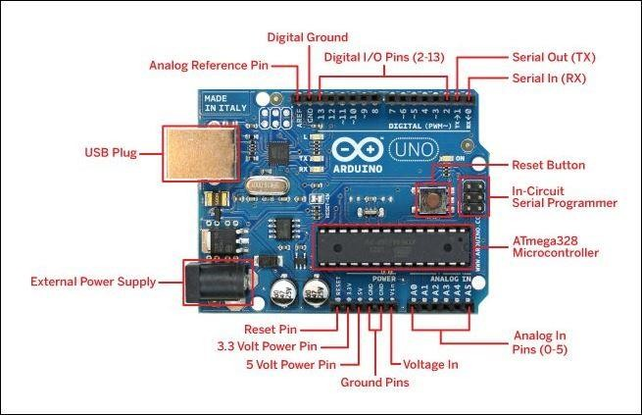

### FIG -1: ARDUINO BOARD DESCRIPTION

**A) POWER SUPPLY**

An external power supply can be used to power the Arduino if a USB connection is not available. A battery or an AC to DC-adapter is the major component of the outside power supply (6 to 20 volts). A center-positive plug (2.1mm) can be inserted into the board's power jack to connect an adapter. The battery connections can be inserted into both the Vin and GND pins.

**B) GSM MODULE**

Global Packet Radio Service (GPRS) is an extension of GSM that enables a higher data transmission rate. GSM/GPRS module consists of a GSM/GPRS modem assembled with a power supply circuit and communication interfaces (like RS-232, USB, etc.) for the computer.

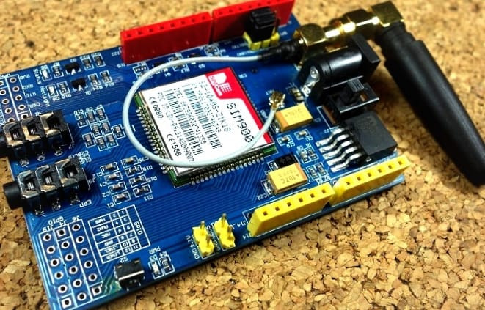

**FIG-2: GSM MODULE**

**C) Ultrasonic Sensor**

The ultrasonic sensor may be up to 5 meters away from the sensor and will provide an accurate distance reading with minimal error. In our project, we employ this ultrasonic sensor to determine the river's water level. The D3 pin of our Node MCU is connected to the echo pin of the ultrasonic sensor, and the D4 pin of the Node MCU is connected to the trig pin of the ultrasonic sensor.

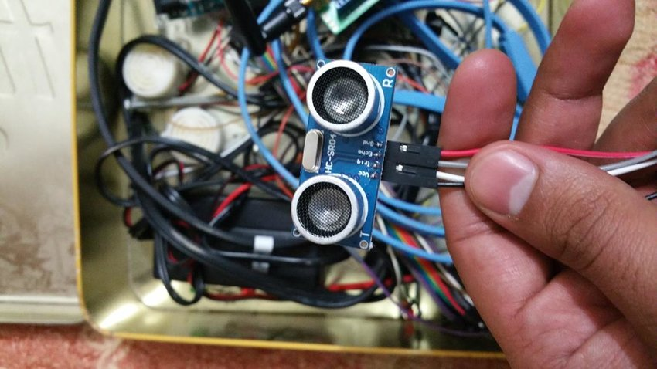

**FIG -3: ULTRASONIC SENSOR**

**D) Water Tank**

When it comes into contact with water at the designated level, the water level detector is set off. The three low water levels in the tank that need to trigger an alert are shown by the water level detector. Low level (L1), extremely low level (L2), and critical level (L3) are the three levels. When a detector circuit does not detect any water, a signal is given to that circuit and a notification is sent to the microprocessor. The signal is conveyed to GSM and the person in charge through SMS from the microprocessor. To notify the person in control of the water tank's level, three SMS sequences are sent.

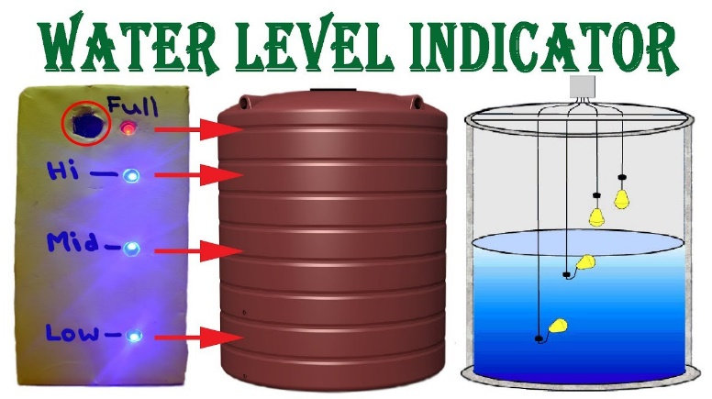

**Fig-4 Water Tank**

**SOFTWARE REQUIREMENTS**

A specification of software requirements is an abstract description of the functions that a system should perform and the limitations that it must adhere to. System design features should not be defined; only the system's outward behavior should be. System of operation: Windows IDE dialect: MATLAB

### SOFTWARE SYSTEM ATTRIBUTES

### Reliability:

### The consistency of measurement across time. If a measurement consistently yields similar results, it is considered to have high dependability.

### Availability:

### The degree to which a system, subsystem, or equipment is in a specified operable and committable state at the start of a mission, when the mission is called for at an unknown.

### Security:

### Degree of resistance to any harm.

### Portability:

### Using the same software in different environments.

1. **Maintainability:**

Measures the ease and speed with which a system can be restored to operational status after a failure occurs.

1. **Performance:**

To analyze if the system meets its goals.

**Features of the System**

1. Regulates the water levels in the supply, storage, and utility water tanks and operates the pumps appropriately.
2. Users' mobile phones may be able to get level and pump status updates and control and adjust them as well.
3. Worldwide connectivity for access.
4. Real-time operation.
5. Web-based control or completely wireless access are all options.
6. Both manual and automatic/remote operations are available.

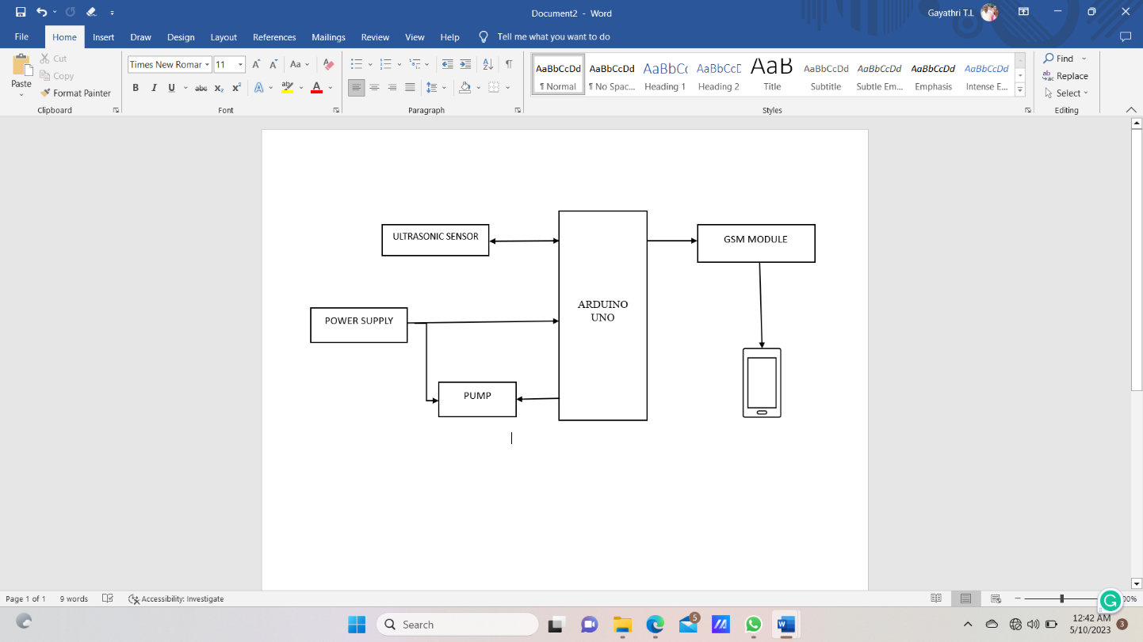**V. DESIGN**

MOBILE(SMS)

**Fig 5: BLOCK DIAGRAM**

**VI. RESULTS AND SNAPSHOTS**

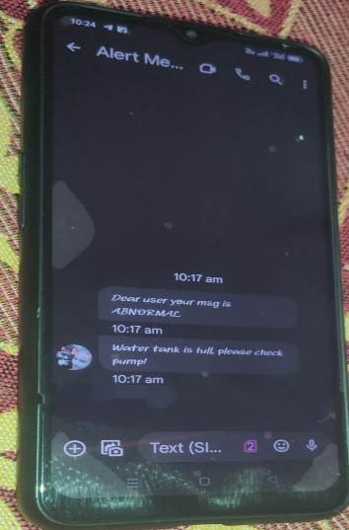

Fig.6: Result Analysis

**VII. CONCLUSION**

Utilizing GSM technology, the water tank level is monitored and reported via SMS notification. It can recognize when the water level in the tank is low and alert a GSM modem to send an SMS to the targeted user's handphone or the person in charge. the water distribution system to identify leaks. Due to leaks, inaccurate meters, burst pipes, illegal connections, and customer fraud, a significant loss is more likely when there is a lack of current and historical data about water networks. We have outlined a useful leak detection system in this work.

Future Work can involve the analysis of the water level in a particular area so that the wastage of water is prevented. We can also include the GSM-based system where the message will be sent to the particular authorized person when the water level is below the required level.

### REFERENCES

[1] Consorcio Evaluación de Riesgos Naturales – América Latina, Perú: Gestión de Riesgo de Desastres en Empresas de Agua y Saneamiento, 1st ed., vol. 1. Lima - Perú: Programa de Agua y Saneamiento del Banco Mundial, 2012.

[2] J. Perez, “Automatic Supply, Tanking and Leak Detection System in a Long Distance Drinking Water Network using ZIGBEE Technology,” Universidad Autonoma del Estado de México, Atlacomulco - México, 2019.

[3] K. Bohorquez, D. Fonseca, and S. Gutiérrez, “Didactic System for Level Control with Coupled Tanks,” Universidad Católica de Colombia, Bogotá - Colombia, 2017.

[4] R. Astudillo, “Design and Implementation of a Prototype of a Water Level Meter through an Ultrasonic Sensor for Depressed Steps,” Universidad Tecnológica Israel, Quito - Ecuador, 2016.

[5] Y. Núñez Tordecilla and M. Martínez Vélez, “Design and implementation of a system for the control of water consumption based on Arduino technology and controlled through a web application in a house in the municipality of Lorica Cordoba,” Facultad de Ingeniería, Córdoba - Colombia, 2018.

[6] Morales Arévalo. Flavio and L. Flores Valencia, "Implementation and Monitoring of an Automatic Control System utilizing Arduino GPRS board for a Hydraulic Pumping System installed in a well and in two drinking water pumping stations," Quito, Quito - Ecuador, 2019.

[7] W. U. A. Depaz Sandon, “Prototype using Arduino technology for water level measurement in dangerous lagoons of the Huascarán National Park. 2018,” Universidad Nacional Santiago Antúnez de Mayolo, Huaráz - Perú, 2018.

[8] A. Ríos Caicho and R. Peñafiel Adrián, “Prototype of an automated system for small-scale industrial applications based on a mobile graphical interface controlled by Arduino,” Universidad de Guayaquil. Facultad de Ciencias Matemáticas y Físicas. Carrera de Ingeniería En Networking Telecommunications, Guayaquil - Uruguay, 2018.

[9] Aprendiendo Arduino, “Lenguaje de programación C++,” Wordpress, 2018. <https://aprendiendoarduino.wordpress.com/2015/03/26/lenguajede-programacion-c/> (accessed Feb. 23, 2021).

[10] A. Mejía Palomino, "Design and simulation of a dehumidification system for diesel bulk storage tanks controlled through an Arduino board," GUAYAQUIL/UIDE/2018, Guayaquil - Ecuador, 2018.

[11] Arduino Official Store, “Arduino Uno Rev3,” Arduino Official Store, Mar. 02, 2016. https://store.arduino.cc/usa/arduino-uno-rev3 (accessed Feb. 23, 2021).

[12] Akshay Sharma. A.S (2018) IOT Based water level sensing and controlling, Department of Electronics and Communication Engineering.

[13] Y. Li, Y. Wang, M. Cong, and H. Lang, "Design and Development of a water quality monitoring Network and System,".

[14] S. Jadhav, S. V. Patil, T. C. Thanuja, M. P. Shivu, and G. Shankar, ‘‘Monitoring of industrial water usage by using Internet of Things,’’ in Proc. Int. Conf. Inf., Communication., Eng. Technology. (ICICET), Pune, Indian, Aug. 2018, pp. 1–4.