**CLUSTEROIDS APP**

**Dr. Ranjit K N1, ,S KUMAR DHANANJAYA2, SHASHANK GOWDA N M 3, SHASHANK S4, YASHWANTH S M 5**

*1Professor, Dept. of Computer Science & Engineering,  
Maharaja Institute Of Technology Thandavapura Karnataka, India  
2-5Students, Dept. of Computer Science & Engineering,  
Maharaja Institute Of Technology Thandavapura Karnataka, India*

---------------------------------------------------------------------***---------------------------------------------------------------------

**Abstract -** Clusteroids is a comprehensive Flutter-based mobile application designed to cater to the needs of various users in educational institutions. The app comprises five modules, namely Admin, Student, Teacher, Management, and Alumni, each equipped with unique features and functionalities. The admin module allows authorized personnel to manage the app's content, user accounts, and various settings. The student module provides access to student-specific information such as schedules, grades, attendance records, and other academic-related details. The Teacher module enables teachers to access their class schedules, manage attendance records, grade assignments, and communicate with students and parents. The Management module allows institutional management employees to monitor student and staff records, track finances, manage human resources, and perform other administrative functions. The Alumni module enables former students to stay connected with the institution, access their academic records, and participate in alumni events.

**1. INTRODUCTION**

It is a feature-rich application that aims to streamline communication, improve efficiency, and enhance the overall educational experience for all users, including students, teachers, institutional leaders, alumni, and administrators.

The app comprises five modules, each equipped with unique features and functionalities to meet the specific needs of its users. The admin module is designed for authorized personnel, enabling them to manage the app's content, user accounts, and various settings. With this module, administrators can easily update the app's content, add new users, and modify the app's features to suit their institution's requirements.

The student module provides students with access to information relevant to their academic progress, including their schedules, grades, attendance records, and other academic-related details. Students can use the app to monitor their performance, stay up-to-date with their assignments, and communicate with their teachers and classmates.

The Teacher module is designed to help teachers manage their classes and monitor their students' progress. With this module, teachers can access their class schedules, manage attendance records, grade assignments, and communicate with students and parents. The module's features enable teachers to efficiently manage their workload, provide timely feedback to their students, and monitor student progress.

The Management module is designed for institutional leaders to monitor student and staff performance, track finances, manage human resources, and perform other administrative functions. With this module, leaders can quickly access relevant data, generate reports, and monitor their institution's overall performance.

Finally, the Alumni module enables former students to stay connected with the institution, access their academic records, and participate in alumni events. The module's features enable alumni to network with their peers, stay up-to-date with institution news, and contribute to their institution's development.

Overall, clusteroids provides a user-friendly, centralized platform that makes it easier for all users to access critical information, perform academic-related tasks, and stay connected with their institution. With its comprehensive features and intuitive interface, clusteroids is designed to enhance the educational experience for all users, from students and teachers to institutional leaders and alumni.

**1.1 PROBLEM STATEMENT**

In today's world, most institutions have their websites, but accessing the information through them can be time-consuming.

This is where mobile applications come in handy, as they offer a faster and more efficient way of accessing the required information. Mobile applications are known to work 1.5 times faster than web pages and allow users to complete activities quickly and easily with just a few clicks. With the increasing popularity of smartphones, mobile applications have become an essential tool for organizations to provide their users with easy and quick access to information and services. By developing mobile applications, institutions can enhance their reach and offer a more seamless experience to their users.

**1.2 OBJECTIVE**

The project objective could be to develop a mobile application for an institution (such as a school, university, or company) that provides quick and easy access to information and services. The application should offer a user-friendly interface that enables users to navigate and access the desired information quickly, without the need to browse through a website. Additionally, the application should be designed to be fast and efficient, providing a faster and more convenient experience for users compared to accessing the same information on a website.

**1.3 SCOPE**

The mobile application should be designed to provide a user-friendly experience with an intuitive interface that makes it easy for users to navigate through the different sections. The mobile application should allow users to quickly browse through various sections such as admission, courses, events, news, and other relevant information.

**2. LITERATURE SURVEY**

**[A]Title: -** Design and development of Android mobile application for students of engineering education in Saudi Arabia.

**Authors: -** Zulfiqar Ali, Roslan Ismail, Published (First Online): 21-10-2013, Publisher Name: IEEE

**Summary: -** This research paper proposes a mobile solution for students enrolled in the senior design project capstone course of the Bachelor of Engineering Technology program at Yanbu Industrial College (YIC), Saudi Arabia. The paper highlights the problem that students rely heavily on their supervisors for the completion of their projects and remain unable to learn engineering project management tools and techniques. This puts pressure on the advisor and creates a communication gap between the students and management. To address this issue, the paper suggests the use of a mobile application for an Android platform called "m-research" which can be used as an integral component of the m-learning model of engineering education. The paper describes the step-by-step design and development process of the app, which helps students to learn engineering project management tools and techniques anytime and anywhere. The proposed solution is expected to reduce the pressure on the advisor and enable students to take more responsibility for their projects.

**[B]Title: -** Android based mobile application for college students

**Authors: -** C K Marigowda, Rajat Porwal, Srajal Singhal, Srijan Sinha, Vaishnavi M, Published (First Online): 11-10-2018, Publisher Name: IEEE

**Summary: -**This emphasizes the need for a mobile application that can provide students, parents, and employees with easy access to educational information such as examination schedules, lecture notes, placement opportunities, notifications, events, and transportation details. The author notes that most educational institutions offer limited services to their users, which makes it difficult for students to navigate and use them effectively, resulting in a decrease in interest in educational institutions. The proposed solution is a mobile application that utilizes the latest technology, such as Java, Android, and GPS, to improve students' experience with educational institutions by making educational information more accessible.

**[C]Title: -** Development of mobile application upon mechanical engineering students’ learning styles

**Authors: -** S Kannairan, C G C Kob, R C Rus, A Shah, N R Devi, Published (First Online): April 2017., Publisher Name: IOP

**Summary: -** This paper discusses the development of a mobile application, PolyMES, for Polytechnic Mechanical Engineering Students in Malaysia. The study aims to identify the student's learning styles and develop a user-friendly mobile application that can enhance mobile learning. The application includes features such as notes, videos, images, quizzes, exercises, formulas, and sample calculations. The design of PolyMES is developed to cater to different learning styles and to be used on smartphones. The study shows the importance of understanding students' learning styles to enhance mobile learning and may be useful for further implementations of e-learning.

**3. IMPLEMENTATION**

The below diagram shows the design and sequence diagram of the Clusteroid app with all the modules,

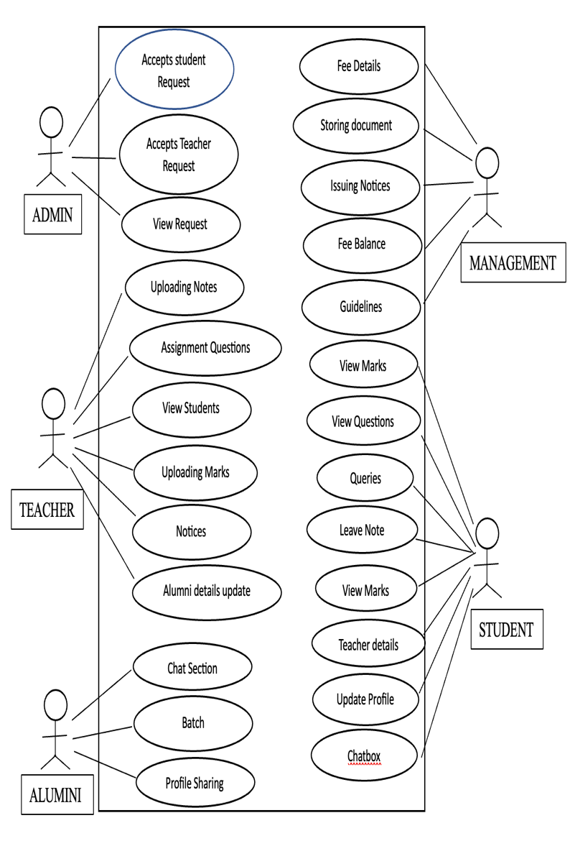

**Fig 1: Use Case Diagram**

**4. METHODOLOGY**

**Requirements gathering:**Meet with the owner and gather their requirements for each module. Identify the features that are required in each module and document them.

**Designing the user interface:**Design the user interface for each module. Create wireframes and mockups for each feature. Get feedback from the owner and iterate on the design until the owner is satisfied.

**Database design:** Design the database schema for the app. Identify the tables, their fields, and the relationships between them. Ensure that the database design is optimized for performance and scalability.

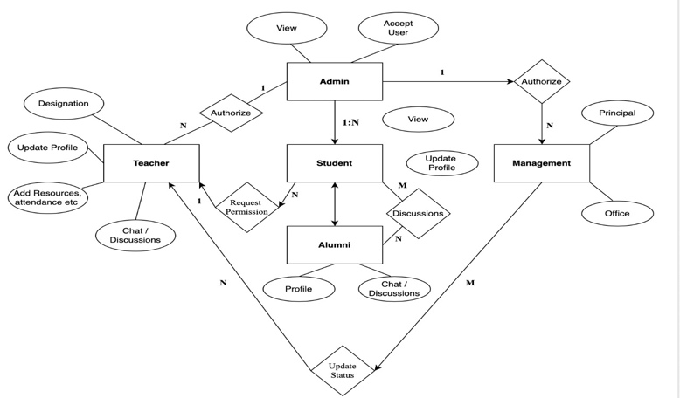

**Fig 2: Entity Relationship Diagram**

**Implementation:**Implement the app using Flutter. Begin by creating the basic framework for the app and then build out each module one by one. Ensure that each module is fully functional before moving on to the next one.

**Testing:** Test the app thoroughly to ensure that it is free of bugs and meets the requirements of each module. Test the app on various devices and platforms to ensure that it works correctly on all of them.

**Deployment**: Deploy the app to the app store and make it available for download. Ensure that the app meets the app store's guidelines and requirements.

**Maintenance:** Monitor the app regularly to ensure that it is running smoothly. Address any bugs or issues arising and update the app as necessary. Update the app as new versions of Flutter are released.

**5. RESULTS**

**Login Pages:**The login pages would require the student to enter their credentials to access the app. The login page may also include a "forgot password" option to help students who have forgotten their login details. Once the student has successfully logged in, they would be redirected to their respective dashboards.

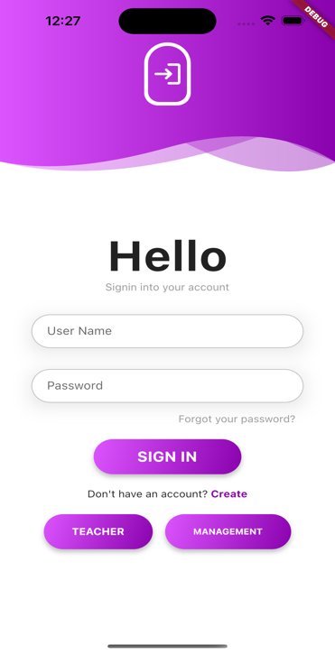

**Fig 3: Login pages**

**Dashboards:** Dashboards are a crucial component of many software applications, including educational management systems like the Clusteroids app. A dashboard is a visual representation of key data and metrics that allow users to quickly and easily understand the state of the system and make informed decisions based on that information. In the context of the clusteroids app, there would be dashboards for each user type - admin, teacher, student, and management.

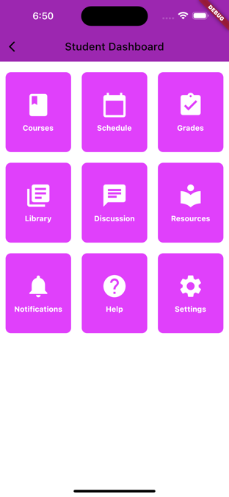

**Fig 4: Student Dashboard**

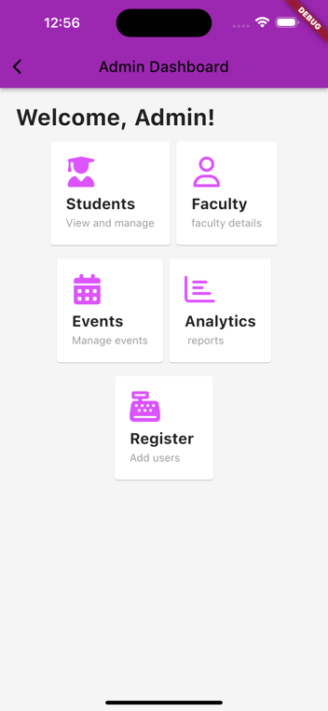

**Fig 5: Admin Dashboard**

Similarly, there are various features in every module and they are

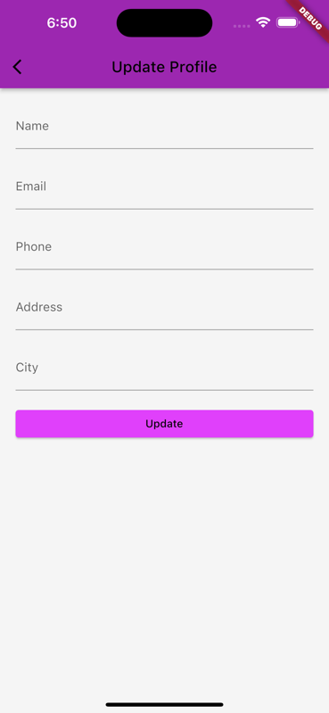

**Fig 6: Update Profile**

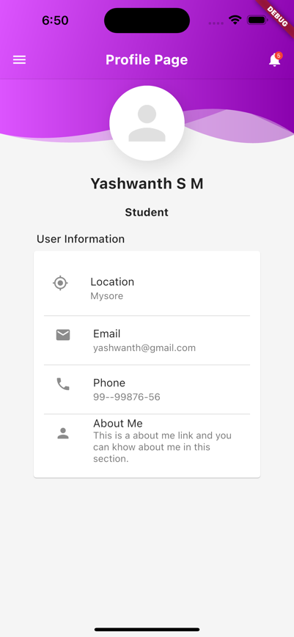

**Fig 7: Student Profile**

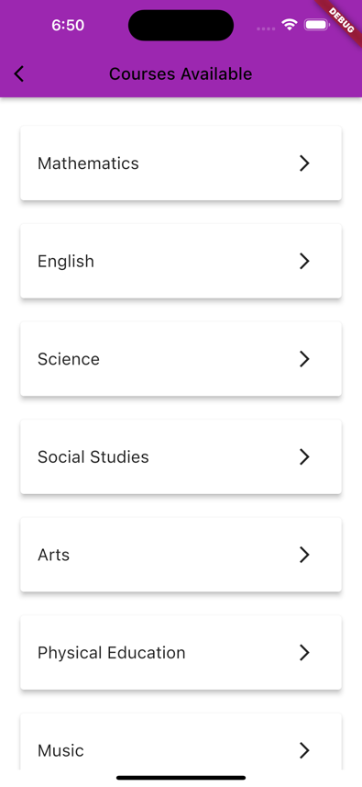

**Fig 8: Courses Offered**

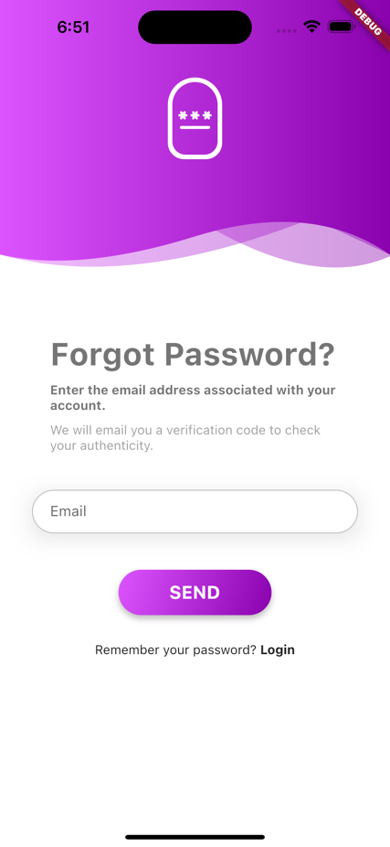

**Fig 9: Forgot Password**

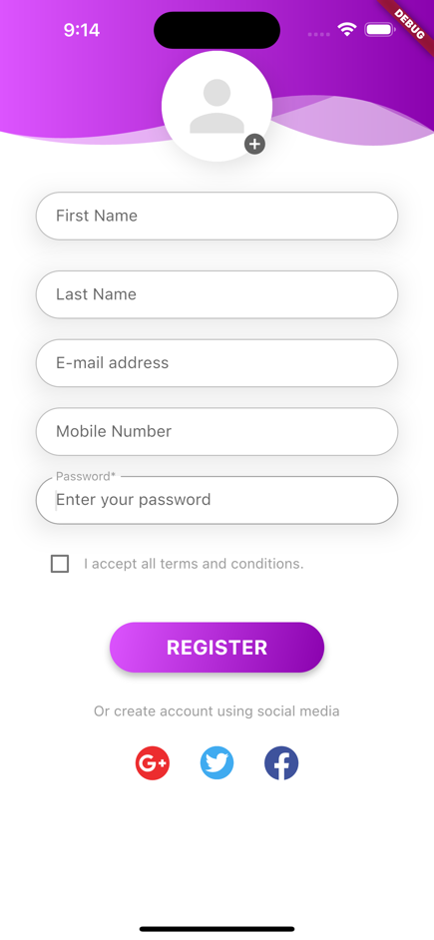

**Fig 10: Register Page**

**6. CONCLUSION**

In conclusion, the implementation of a cluster ids app with five modules, including admin, student, teacher, management, and alumni, can greatly enhance the educational experience for all involved parties. This app allows for easy communication and access to information, making it more convenient for students to keep track of their academic progress, teachers to manage their classes, and administrators to oversee the operations of the institution. The alumni module also allows graduates to stay connected with the institution and keep up-to-date with news and events.

**REFERENCES**

1. Nakkeeran, R., & Vaithiyanathan, V. (2020). Development of a Mobile Application for E-Learning Using Flutter. International Journal of Innovative Technology and Exploring Engineering, 9(4S), 51-55.
2. Khan, M. R. (2019). Mobile Application Development with Flutter. International Journal of Advanced Trends in Computer Science and Engineering, 8(2), 33-36.
3. Vengatesan, G., & Rajagopalan, S. (2021). A Comparative Study of Flutter Mobile App Development Framework. International Journal of Emerging Trends in Engineering Research, 9(5), 2045-2048.
4. Ahmed, R., Hussain, A., & Ahmed, S. (2020). Design and Development of a Mobile Application Using Flutter. International Journal of Computer Applications, 178(38), 28-31.
5. Yadav, S., & Thakur, A. (2021). Flutter-based Mobile App Development for Educational Institutes. International Journal of Control and Automation, 14(2), 260-270.
6. Gautam, M., & Singh, R. (2020). Development of a Mobile Application for College Management System Using Flutter. International Journal of Advanced Research in Computer Science and Software Engineering, 10(12), 291-294.
7. Kulkarni, S., & Arora, S. (2021). Design and Development of an Alumni Management Mobile Application Using Flutter. International Journal of Advanced Research in Computer Science, 12(1), 22-28.
8. Raj, M., & Singh, N. (2020). Development of a Mobile Application for Online Examination System Using Flutter. International Journal of Scientific Research in Computer Science, Engineering and Information Technology, 6(2), 22-28. Engineering (IJARECE).