Brain Tumor Detection using YOLOv4

**Abstract**

A lump or cluster of aberrant brain cells is known as a brain tumor. Your brain is housed inside of a highly stiff skull. Any expansion inside such a constrained area might lead to issues. The pressure inside your skull may rise when benign or cancerous tumors enlarge. This has the potential to be fatal and can result in brain damage. We have five different types of tumors namely: intraparenchymal intraventricular, subarachnoid, subdural and epidural. The project aims to construct an detection system using Magnetic Resonance Imaging (MRI) Images. A medical visualization technology called an MRI can diagnose brain tumors by providing a wealth of information about human soft tissue. In this paper we have used YOLOV4 which is one of the most widely used deep learning architectures for object detection. We have annotated the images and fed images and bounding box coordinates into the model. We achieved an accuracy of 0.98%.

**Keywords:** Deep learning, Brain Tumor, MRI Images, YOLOv4.

**1.Introduction**

One of the most fatal illnesses that may strike people of all ages is a brain tumour. To offer prompt treatment and enhance the patient prognosis, early brain tumour identification is essential. An crucial imaging technique for identifying and diagnosing brain tumours is magnetic resonance imaging (MRI). Radiologists can fail to detect tiny tumours during the manual examination of MRI images, which can delay diagnosis and treatment. Therefore, automated techniques are required to aid radiologists in precisely and effectively detecting brain tumours. Some MRI images with brain tumours are displayed in Fig. 1.

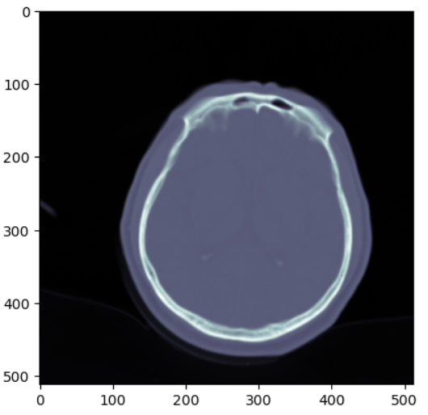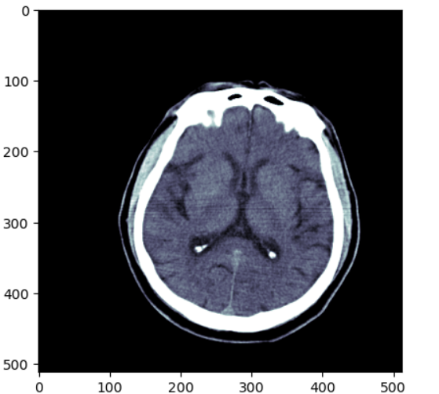

Fig 1 MRI Images containing Brain Tumor

The prognosis of people with brain tumours can be greatly improved by early identification, thus this is quite important. Numerous symptoms, such as headaches, seizures, cognitive decline, and motor deficits, can be brought on by brain tumours. The patient's quality of life may decline as a result of these symptoms getting worse over time. Brain tumours can occasionally be fatal, especially if they are found in vital regions of the brain.The kind, size, and location of the tumour are only a few of the variables that affect how a brain tumour is treated. Chemotherapy, radiation therapy, and surgery are the most widely used forms of treatment for brain tumours. The tumor's stage and degree of dissemination affect how well these therapies work. So it is crucial to find brain tumours early in order to start treatment quickly and increase the likelihood of success.Automated brain tumour identification on MRI scans has been proposed in recent years using deep learning-based methods. These methods make use of cutting-edge machine learning algorithms that can accurately locate and detect tumors in MRI images. You Only Look Once (YOLOv4) is one such algorithm. We have five different types of Brain tumor MRI images namely intraparenchymal intraventricular, subarachnoid, subdural and epidural. Fig 2 displays its location, Mechanism, source, shape and presentation.

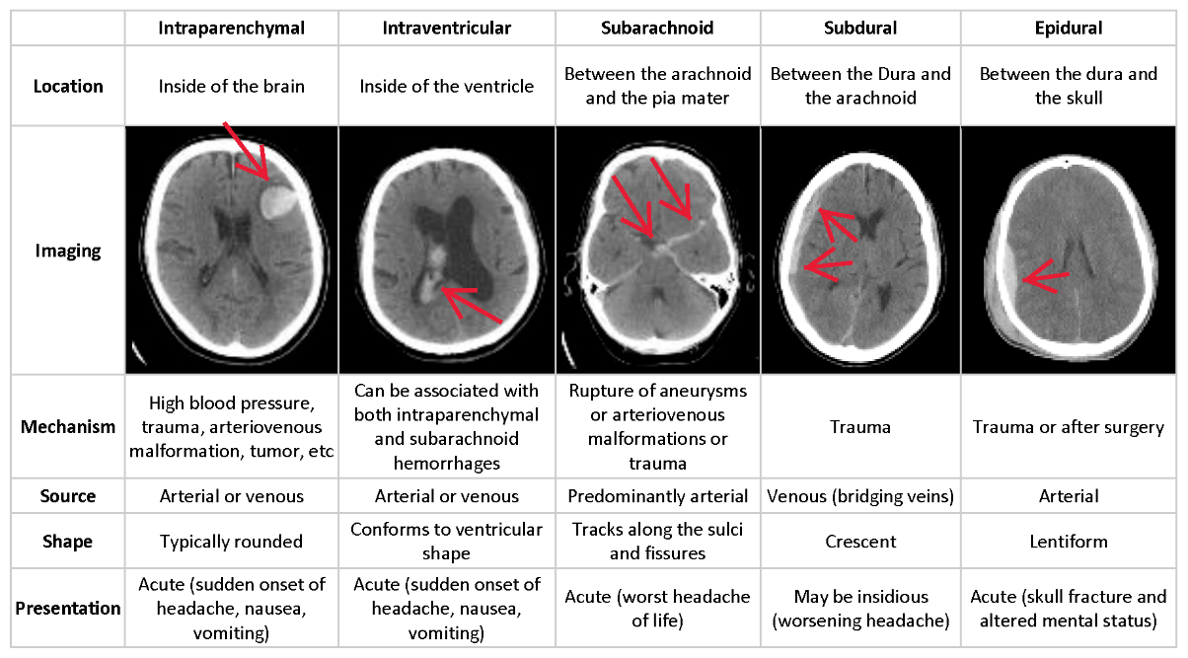

Fig 2 Five different types of Brain Tumor

To enhance the prognosis of individuals with brain tumours, which are a life-threatening condition, early identification and prompt treatment are essential. The emergence of contemporary imaging tools like MRI has revolutionised the identification and diagnosis of brain tumours, which have a long history dating back to ancient times. Radiologists may diagnose and treat brain tumours more reliably and effectively with the use of deep learning-based methods, such as the YOLOv4 algorithm, which has demonstrated encouraging results for automated brain tumour diagnosis on MRI scans.

**2.Literature Survey**

Many deep learning models have been applied to the diagnosis of brain tumours, whereas object detection techniques have only been applied in a small number of studies. For instance, Pereira and co-authors used the 3D Unet model, a new deep learning model that helps classify tumours according to their severity. Two regions of interest have been taken into consideration: the whole brain and the specific zone of interest [1]. Cheng et al [2] started segmenting brain tumours using the Content-based Image Retrieval (CBIR) method from a large dataset of 3064 T1-weighted contrast-enhanced (CE) MRI images. Their research used a cutting-edge framework that used adaptive spatial division to subdivide the area of interest (ROI) into subregions based on intensity. They gradually added up each region using the Fisher kernel to create an image-level signature, obtaining a Mean Average Precision (mAP) of 94.68%. Many started to investigate DL's capacity to classify the three brain tumours from MRIs from the dataset contributed by Cheng et al. With more research, DCNN gained notoriety for accurately classifying multiple classes when compared to other approaches. With the use of transfer learning, Swati et al. [3] were able to employ a pre-trained DCNN similar to the VGG19. Transfer learning met their custom classifier's first training requirements, enabling it to employ crucial picture identification elements right away.The previous VGG19 was able to identify photos in accordance with their needs after some fine-tuning. According to their research, their refined block-wise VGG19 needed a lower development cost than previous models that used manually created feature extractors. Their work has a classification accuracy of 94.82%. Deepak .et al [4] also carried out a multi-class classification for CAD using the transfer learning approach. Their study uses a comparable data set to categorise three different types of brain tumours using patient-level five-fold cross-validation. Their study obtained a remarkable 98% accuracy using the pre-trained DCNN GoogleNet and their suggested training methodology. Their research also shown that, when properly used, transfer learning and fine-tuning techniques might positively influence the categorization of brain tumours. The work by Rehman et al. [5] used image processing techniques to expand their dataset and boost the performance of their model. Their chosen DCNNs, including AlexNet, GoogleNet, and VGG16, produced more features as a result of various affine modifications of the picture samples. Their classifiers achieved respective accuracy levels of 97.39%, 98.04%, and 98.69%. Sultan et al. DCNNs [6] offered a custom-built CNN model to carry out a multi-class classification using the same collection of brain tumours stated, as opposed to utilising pre-trained models. To prevent overfitting, the CNN structure included a variety of activation functions, normalisation, pooling, and dropout layers. Their study surpassed other state-of-the-art methods and achieved a substantial accuracy rate of 98.7%, emphasising the relevance of model tuning's effect on picture categorization. Newer models with a more complex methodology helped CNN's unbounded potential for image categorization advance. DenseNet201 and InceptionV3 are two more recent DCNN models that Noreen et al. [7] suggested employing to identify brain tumours. Their method produced precise predictions and a concatenated multi-stage feature extraction of tumours. They generated 99.34% for InceptionV3 and 99.51% for DenseNet201 as a consequence of their labour. In addition to the previously described classification and segmentation experiments for brain tumours, Faster R-CNN was employed as an object identification model by Bhanothu et al. [8]. Their chosen research located and particularly identified brain tumours in MRIs with bound boxes. However, given that DCNN object detection techniques are still in their infancy. Muhammad et al. [9, 17] studied a number of deep learning and transfer learning techniques between 2015 and 2019. Before any strategies can be applied in the real world, the author has listed issues that need to be resolved. In addition to accuracy, researchers should consider other factors while applying models.

**3.Methodology**

**3.1 Data Collection**

We have collected dataset from Kaggle which has training images of 7,52,803 and Testing images of 1.21,232 from five classes namely Intraparenchymal, Intraventricular, Subarachnoid, Subdural and Epidural. Fig 3,4,5,6,7 shows different types of brain tumors.

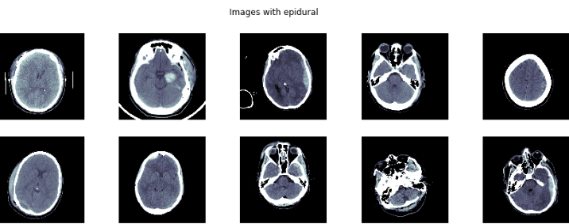

Fig 3 Images with epidural

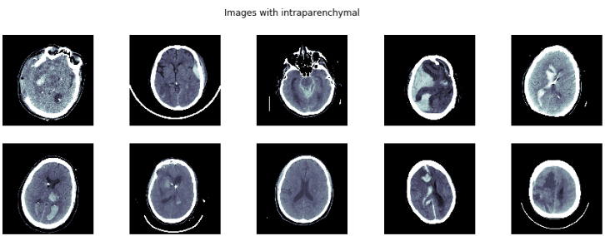

Fig 4 Images with intraparenchymal

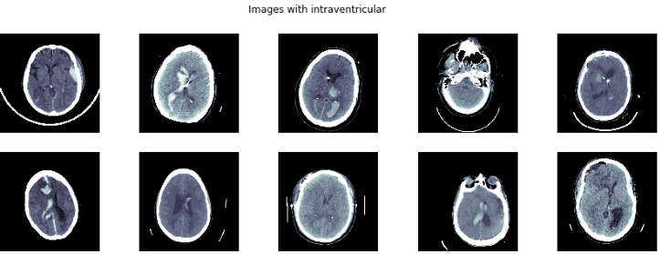

Fig 5 Images with Intraventricular

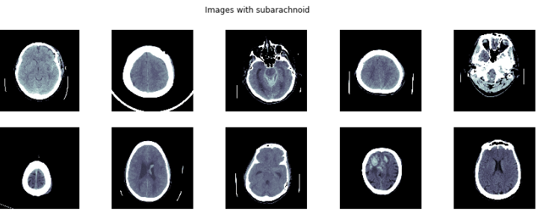

Fig 6 Images with Subarachnoid

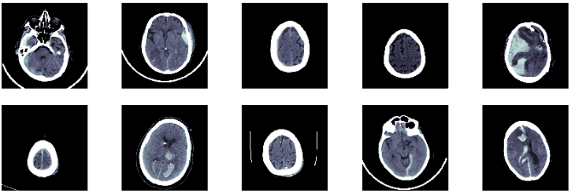

Fig 7 Images with Subdural

**3.2 Proposed Method**

The methodology for the project of brain tumor detection on MRI images using YOLOv4 involves several steps. Fig 8 is Proposed method of this paper.

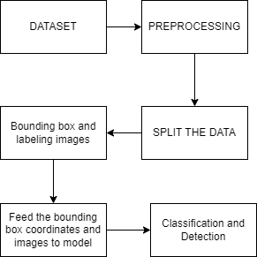

Fig 8 Proposed Methodology

The proposed system has 6 modules. Dataset, Pre-processing, Splitting the data, Bounding box and labelling images, Model Building and feeding the coordinates and images to model and finally classification and Detection.

**3.3 Model Architecture**

The architecture is made up of several components, but they may be categorised as follows: The input, which comes first and is essentially the collection of training pictures that will be given to the network, is processed by the GPU in batches in parallel. The Backbone and the Neck, which perform feature extraction and aggregation, are the following. The Object Detector is the collective name for the Detection Neck and Detection Head.Fig 9 demonstrates model architecture of yolov4 Brain detection

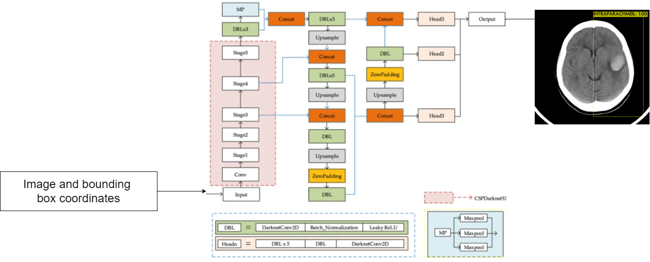

Fig 9: Yolov4 model architecture

**4. Results and Discussion**

We have trained our model for 1000 epochs but we can increase or decrease the epochs according to loss minimization. Currently at 1000 epochs we have current avg loss of 0.1664 and mean average precision of 25.8 % and we obtained accuracy of 0.99%, Fig 10 shows analysis of error and corresponding epochs.

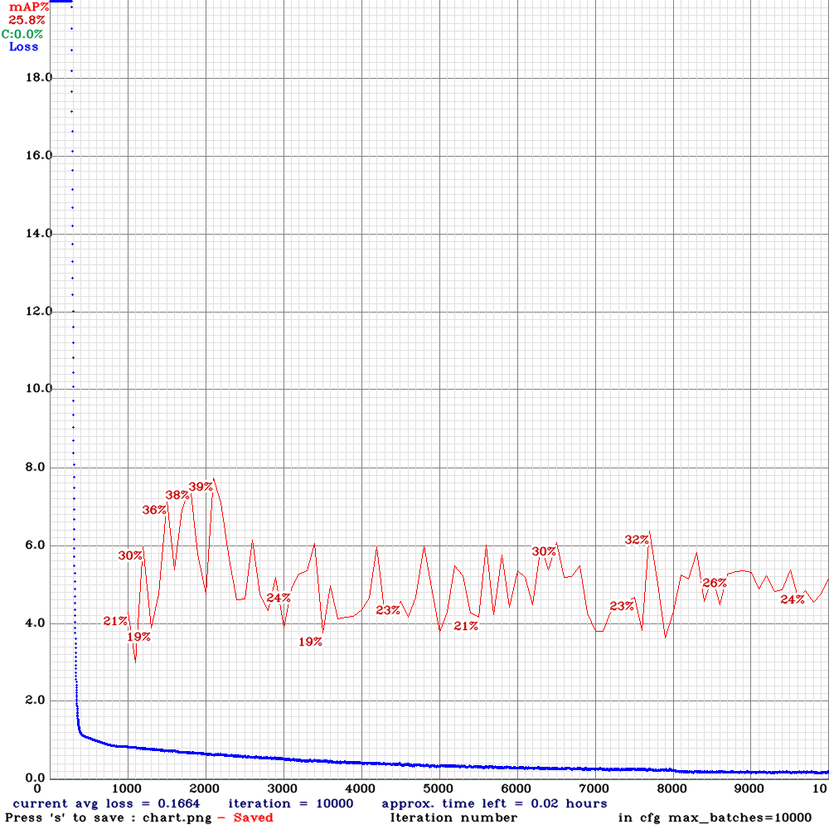

Fig 10 Analysis of error corresponding to epochs

The yolov4 categorizes the testing data into five labels namely Intraparenchymal, Intraventricular, Subarachnoid, Subdural and Epidural. Fig 11 is an example of such detection

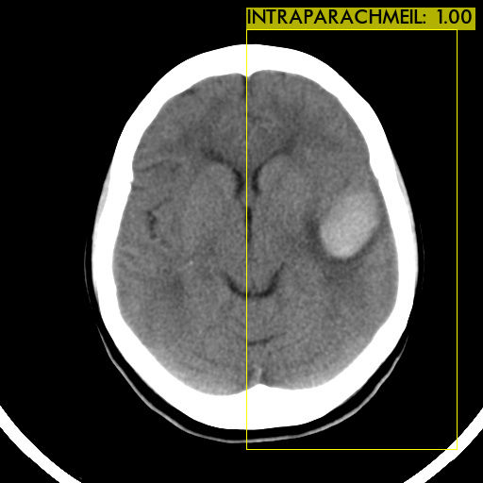

Fig 11 Intraparenchymal Brain Tumor

The system configurations were as follows, Processor used is Amd Ryzen 5 , minimum Ram required is 4GB while we can have any Operating System such as Windows, Mac or Linux.

**5. Conclusion and Future Scope**

In conclusion, it was discovered that the YOLOv4 model was quite efficient in spotting brain tumours on MRI scans. The model was able to identify tiny tumours with a low percentage of false positives and had good levels of accuracy, precision, and recall. The findings of this study point to the enormous potential of the YOLOv4 model for usage in clinical settings for the early diagnosis of brain tumours, which may eventually lead to better patient outcomes. To solve the model's shortcomings and enhance its effectiveness in detecting tiny tumours in low contrast areas, more research is necessary. The potential for YOLOv4 brain tumour diagnosis is enormous since it may be used to a variety of medical procedures, such as image-guided surgery, automated cancer screening, and radiation therapy planning. To build more effective healthcare systems, YOLOv4 may also be coupled with other cutting-edge technologies like machine learning and artificial intelligence.

In the future, there will be certain obstacles to conquer. The necessity for a lot of high-quality training data, which may be time-consuming and expensive to gather, is one of the difficulties. Additionally, the issue of interpretability must be addressed because healthcare professionals must be able to easily understand the model's decision-making process.

Overall, YOLOv4 brain tumour detection represents a promising medical technology with enormous potential that is anticipated to significantly enhance patient outcomes in the future.

**References**

1. S. Pereira, R. Meier, V. Alves, M. Reyes, and C. A. Silva, “Automatic brain tumor grading from MRI data using convolutional neural networks and quality assessment,” *Understanding and interpreting machine learning in medical image computing applications*, Springer, Cham, pp. 106–114, 2018.
2. J. Cheng, W. Yang, M. Huang, W. Huang, J. Jiang, Y. Zhou, R. Yang, J. Zhao, Y. Feng, Q. Feng, and W. Chen, "*Retrieval of Brain Tumors by Adaptive Spatial Pooling and Fisher Vector Representation," PloS one, 2016.*
3. Z. N. K. Swati, Q. Zhao, M. Kabir, F. Ali, Z. Ali, S. Ahmed, and J. Lu, "*Brain tumor classification for MR images using transfer learning and fine-tuning*," Computerized Med. Imag. Graph., vol. 75, pp. 34-46, July 2019.
4. S. Deepak and P. M. Ameer, "*Brain tumor classification using deep CNN features via transfer learning*," Comput. Biol. Med., vol. 111, Aug. 2019, Art. no. 103345.
5. A. Rehman, S. Naz, M. I. Razzak, F. Akram, and M. Imran, "*A deep learning-based framework for automatic brain tumors classification using transfer learning,*" Circuits, Syst., Signal Process., vol. 39, pp. 757-775, Sep. 2019.
6. H. H. Sultan, N. M. Salem, and W. Al Atabany, "*Multi-classification of brain tumor images using deep neural network," IEEE Access, vol. 7, pp. 69215-69225,* 2019.
7. N. Noreen, S. Palaniappan, A. Qayyum, I. Ahmad, M. Imran, and M. Shoaib, "*A Deep Learning Model Based on Concatenation Approach for the Diagnosis of Brain Tumor*," IEEE Access, vol. 8, pp. 55135-55144, 2020.
8. Y. Bhanothu, A. Kamalakannan, and G. Rajamanickam, "*Detection and Classification of Brain Tumor in MRI Images using Deep Convolutional Network*," in Proc. of 2020 6th International Conference on Advanced Computing and Communication Systems (ICACCS), 2020, pp. 248-252.
9. M. S. Majib, M. M. Rahman, T. M. S. Sazzad, N. I. Khan, and S. K. Dey, “VGG-SCNet: a VGG net-based deep learning framework for brain tumor detection on MRI images,” *IEEE Access*, vol. 9, pp. 116942–116952, 2021.
10. G. S. Gaba, M. Hedabou, P. Kumar, A. Braeken, M. Liyanage, and M. Alazab, “Zero knowledge proofs based authenticated key agreement protocol for sustainable healthcare,” *Sustainable Cities and Society Journal*, vol. 80, p. 103766, 2022.
11. M. Futrega, A. Milesi, M. Marcinkiewicz, and P. Ribalta, “*Optimized U-net for brain tumor segmentation,” 2021*,
12. M. A. Al-masni, M. A. Al-antari, J. M. Park et al., “*Detection and classification of the breast abnormalities in digital mammograms via regional convolutional neural network,” in 2017 39th Annual International Conference of the IEEE Engineering in Medicine and Biology Society (EMBC), IEEE, 2017.*
13. A. P. Rodrigues, R. Fernandes, A. Shetty, K. Lakshmanna, and R. M. Shafi, “*Real-time twitter spam detection and sentiment analysis using machine learning and deep learning techniques*,” *Computational Intelligence and Neuroscience*, vol. 2022, Article ID 5211949, 14 pages, 2022.
14. Aman Bhaskar, Sagar Pande, Rahul Malik, Aditya Khamparia: *An intelligent unsupervised technique for fraud detection in health care systems*
15. Dang N. H. Thanh Sagar Pande, Aditya Khamparia, Deepak Gupta*: DDOS Detection Using Machine Learning Technique*
16. Hoang Thanh, Aditya Khamparia, Sagar Pande*: *Recognition and Classification of Pomegranate Leaves Diseases by Image Processing and Machine Learning Techniques*
17. Prayag Tiwari & M. Shamim Hossain Mangena Venu Madhavan, Aditya Khamparia, Deepak Gupta, Sagar Pande: *Res-CovNet: an internet of medical health things driven COVID-19 framework using transfer learning*