# IMPLEMENT SMART FARM WITH IOT TECHNOLOGY

# AMSALEKA R1, DEEPIKA R2,DHIVYA N3, KALAISELVI V4,MADHU PRIYA P5

Assistant Professor1 ,UG Scholar2, UG Scholar3, UG Scholar4, UG Scholar5

Department of Computer Science and Engineering, Vivekanandha College of Technology for Women, Tiruchengode, Tamilnadu

**ABSTRACT**

Recent years have seen an increase in the importance of technology in all facets of our lives, including farming, which is greatly influenced by the environment. As a result, new techniques have had to be developed to increase agricultural productivity. Sequential learning is a supervised learning method that makes use of such parameters, but it comes with a number of downsides, including limited sensitivity and uncalculating errors from the input sensors of the source. The rise of information technology (IT) has led to several studies in industry and agriculture with the emergence of the Internet of Things (IoT) and industrialization. We may anticipate agricultural IT development from the automation of agricultural data collection since IoT technology, in particular, can get over the location and distance limitations of wired communication systems employed in existing farms. The system also uses the MQ Telemetry Transport (MQTT) communication mechanism, an IoT- specific protocol, to accomplish the monitoring and control functions, increasing the likelihood that agricultural IoT will emerge. Smart irrigation systems are created using sequential learning neural network algorithms and the Internet of Things to address these shortcomings. Each sensor is examined in depth based on the results of the first stage. Different sensor setups are examined using a sequential learning neural network technique based on an Arduino node MCU. Users have talked about how farmers may utilize IoT technology to help them identify important environmental factors, including temperature, humidity, soil moisture, and water level. When a signal is given through the Arduino controller, a water pump will open and close the flow to control the amount of water that is flowing. A rain cannon sprays water onto the plant's roots, one drop at a time. When the moisture level returns to normal, the sensor recognizes it and signals the controller to turn off the water pump. With the Internet of Things (IoT) and wireless sensor networks (WSNs)' high sensor systems and output, smart farming offers opportunities for more precise, networked, and long-lasting agriculture.

***Keywords: Internet of Things, Agriculture, Soil moisture sensor, Arduino, Smart Farming***

# INTRODUCTION

IOT has a big part to play in the world of agriculture. When dealing with field issues, a variety of strategies that are both efficient and successful can be put into use using the Internet of Things, helping farmers make their fields better. The agricultural crop monitoring system allows for precise, effective, and sustainable agriculture. Several functions, such as cultivating, harvesting, sowing, harvesting, water pumping, leveling, and other features, are implemented in this crop monitoring system on a single device. One machine is capable of handling all of these tasks without much assistance from a human. Utilizing this technology is preferable to performing one task at a time with a lot of human energy, which takes time. The device's official name is an agricultural robot. Agriculture has recently undergone a technological change in addition to industrialization and technology. Higher yields and more efficiency are the results of farmers using smart agriculture technology because they have a better understanding of the process of growing crops. There have been several agricultural revolutions, all of which are intimately related to

technical development. The application of IoT technology in farming is frequently referred to as "smart agriculture". IoT uses a variety of sensors to gather information about the environment and machinery, enabling farmers to improve many aspects of their operations, from raising cattle to growing crops. Farmers can plant seeds at the soil level by readily identifying soil management factors such as PH level, moisture content, and so on. Water management may be done effectively using IoT without wasting any water by employing sensors. Crop monitoring is an easy technique to keep tabs on how a crop is doing. IoT enables continuous monitoring of the environment so that early warning measures can be taken. It increases output, lessens manual labor, saves time, and enhances farming productivity. In a garden, the method has been used to irrigate a plant. In the field sector, sensors like soil moisture sensors are placed outside. The technology has been put to the test by watering a plant in a garden. In the field section, sensors, such as soil moisture sensors, are set up. The data collected from these sensors is sent to the database through the Android application. By pressing the on and off buttons in the application, the system can be started by utilizing

the control area of the application. Additionally, when the soil moisture level is low, the pump is turned on, and when the moisture level is determined, this system is turned on automatically. In the future, the program will water the field at the appropriate moment while using the user's time. In the field, there is a manual switch that may be used to make sure it is in manual mode. The Agriculture Application suggests a technique for exchanging agricultural data via the knowledge-sharing system. The system for data exchange, which also covers agricultural data, is commendable. The methodology employs two different data collection techniques. The first approach involves utilizing a sensor to automatically gather environmental data, and the second method involves physically gathering information from a farmer. A neural network logic technique is suggested as a solution for irrigation control in the best design of a neural network control irrigation system for growing green vegetable plants.

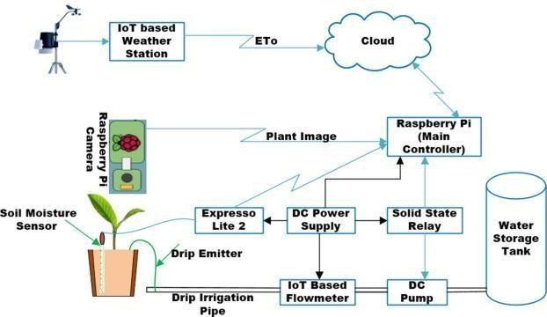

# Fig 1 Working Architecture of IOT based Agriculture Field Monitoring

1. **RELATED WORK**
   1. **Desai**, et.al,[1] proposed a method of greenhouse technology in agriculture to automation, information technology direction with the IOT (internet of Things) technology rapid development and wide application. In the method, control networks and information networks integration of IOT technology has been studied based on the actual situation of agricultural production. A remote monitoring system with internet and wireless communications combined is proposed. At the same time, taking into account the

system, an information management system is designed. The collected data by the system provided for agricultural research facilities. A simple, unobtrusive, and cost-effective system of item identification is critical for connecting everyday objects and devices to large databases and networks, and indeed to the network of networks (the internet).

**Puranik,** et.al,[2] implemented the system Connectivity to a wide range of devices – from Android and iOS-powered mobile, tablet, and TV devices to stand-alone devices IoT can be linked to almost anything that can be linked to and interfaced with internet. Minimizing human workers – Automation can aid in the reduction of human resources as well as human error. Quick Access – Crop and soil health can be remotely monitored from any device in any location. Time-Saving – Automatic report generation and remote monitoring can save farmers time and effort. Efficient Communication – Using the Android and iOS app platforms, a community of farmers, students, and enthusiasts can share their work and new agricultural growth methodologies. In Survey of Drones for Agriculture Automation from Planting to Harvest one can observe the use of Robotic Process Automation (RPA), image processing, pattern recognition, and machine learning to achieve automation in the case of large-scale farmlands the paper also discusses Precision Agriculture providing high-quality crops. In Advances in greenhouse automation and controlled environment agriculture: A Transition to plant factories and urban agriculture one can understand how a combination of environmental conditions interplay in the optimal growth of plants in different setups.

**Saini,** et.al,[3] the global growing population, agriculture has become the most important growth sector. The main challenge in agriculture is to increase farming efficiency and quality without constant physical monitoring to meet the rapidly increasing demand for food. Aside from the growing population, the agricultural industry is also facing significant challenges due to the changing climate. The goal of this study is to propose a smart farming model based on the Internet of Things that employs clustering to deal with adverse conditions. People use various types of sensors in this model, such as soil moisture, air pressure, rain detection, and humidity sensors, for various purposes. The data will be collected in the cloud and automatically calculated. In every way, Smart Farming and Traditional Farming are very different from one another. Traditional farming employs the oldest and most traditional methods of agriculture, including the use of old machinery for agricultural work and the production of crops without regard for market demands or weather forecasts, whereas smart farming employs cutting edge technologies such as smart devices.

**Y. Bhojwani**, et.al,.[4] introduce IoT (Internet of Things) as the wave of the future. In every field, the Internet of Things (IoT) is a necessary change. The ability to monitor and control things from afar makes

any task simple. Agriculture is a critical field in which every technological advancement should be made. The demand for agriculture has risen dramatically as the world's population has grown, and farmers are unable to meet the never-ending demand. Instead of expanding the scale of agriculture, implementing smart or precision agriculture techniques using IoT will be a better option. Soil health, the environment, and irrigation management are all major challenges in farming. Discusses a system that uses IoT to gain control over such issues. It uses the cloud to connect both physical sensing devices and irrigation control mechanisms. This aids in the analysis of the architecture. Its final findings show that real-time data can be mitigated with low latency. Agriculture has been severely hampered by migration. Temperature, monitoring, security, moisture, and GPS sensing are all used to improve agriculture. Users can access these features via remote devices or the internet. A smart IoT communication design is presented, which requires the integration of IoT, Wireless Sensor Networks, and aerial mapping. The amount of time it takes for different commands and data to be processed.

**P. Rekha,** et.al,[5] The monitoring of urban wastewater for agricultural use provides a smart solution for testing water quality using an array of sensors, with the measured value displayed on an LCD. The main of this method is to estimate water quality parameters such as pH, turbidity, temperature, BOD, and TDS, which will aid in identifying deviations in the parameters and sending out alert messages when the value exceeds the predefined threshold or the standard value set in the Arduino Controller. These extreme values indicated chemical spills, treatment plant issues, or supply pipe issues, all of which could pose a serious problem in terms of crop cultivation and soil quality anomaly detection. Because laboratory techniques are too slow to develop an operational response, the current system for monitoring water bodies does not provide a level of public health safety in real-time. improve and expand tracking and evaluation tools to ensure a statistically sound and complete picture of the status of agricultural and cultivation land for environmental safety by providing a detailed survey using the tools and techniques in the water quality monitoring system that are proposed by the implementation of the sensor that enables to provide the dates in an LCD Display that can be viewed by the user and the data is also sent.

**Nuchhi** et.al,…[6] Agriculture is the economic backbone that will benefit from the advancement of new technologies because they will be able to perform better farming activities. It will be difficult for farmers to have an effective cultivation process if they do not have information about the soil's nature. The traditional method of farming is a time-consuming process because it relies on human workers to collect data and transport it to a laboratory for testing. The Internet of Things (IoT) addresses the challenges that must be overcome to design intelligent farming techniques. The

current work presents a soil monitoring system based on a wireless sensor network-enabled Thing speak cloud platform that uses sensors to measure soil moisture, temperature, humidity, and NPK value remotely.

**Vangala,** et.al,[7] Estimates of the amount of damage caused by a device capture attack can be made by calculating the probability of compromised communication a) between two noncompromised devices and b) between a noncompromised device and a user, given that device in the network has already been compromised. The first is taken into account in access control, device authentication, and key management schemes. Various smart devices, including the limited battery lifetime, are resource- limited in an IoT-based agriculture environment. Furthermore, other constraints, such as storage, may exist for IoT smart devices. Furthermore, for secure communication, IoT devices may require frequent communication. As a result, a welldesigned security protocol should include as little computation and communication overhead as possible, as well as storage overhead to store secret credentials such as session keys for secure communication with other nodes.

**V. G and S. Thangam** et.al,[8] Agriculture is a critical area for humanity's survival, encompassing manufacturing, security, traceability, and long-term resource management. With resources rapidly dwindling, it's more important than ever to develop new techniques to aid agriculture's survival. As two rapidly emerging fields, the Internet of Things (IoT) and Blockchain technology, the current state of the food chain can be improved. A thorough literature review was conducted to assess the state-of-the-art development of schemes that use blockchain technology to provide information security. A basic aspect of chain-based security architecture has been proposed after identifying the core requirements of smart agriculture. The schemes under consideration were subjected to a thorough cost analysis. In a central cloud, processing and evaluating massive data volumes generated locally in fields and stables necessitates significant storage and combination efforts at the network layer. The Internet of Things' interconnection raises serious security, authenticity, and privacy concerns. All data is wirelessly transmitted and collected from a wide range of users, allowing for viral interventions and sabotage. Market participants, who are required to share their business data and operate on a common information system architecture, have difficulty accepting the interconnection of all stakeholders in the food supply chain in a distributed and market-oriented economy.

1. **Parasuraman,** et.al,…[9] Data can be transmitted over long distances, eliminating the need for physical labor. The country's population is rapidly growing, and the demand for food is rising in lockstep with it. Farmers' traditional strategies are insufficient to

meet rising demand, so they must wreak havoc on the soil by using more toxic pesticides. This has a lot to do with farming methods, and the soil remains unfertile as a result. This covers a wide range of robotization topics, including the Internet of Things, wireless communications, machine learning, deep learning, and artificial intelligence. Crop diseases, a lack of board capacity, pesticide control, weeds, nonattendance of the water framework, and watering the board are just a few of the issues that plague the horticulture sector, and these issues are caused by several factors. Even though its underlying use has been credited to an advanced development specialist, the term has been defined by a diverse group of people.

**A. K. Singh,** et.al,[10] In both definitions, it's a common assumption that the first type of information on the Internet was created by people, and the second type was created by objects. The Internet of Things (IoT) is a "dynamic global institution framework with self organizing capacities based on norms and interoperable correspondence shows; physical and virtual 'things' in an IoT have characters and attributes and are ready to use savvy interfaces and be connected as an informal association. Food demand has risen steadily over the last six decades as the world's population has grown. Green revolution and genetically modified crop methods have been proposed by scientists as ways to meet this demand. Liquid fertilizers, pesticides, and genetically modified seeds are examples of unnatural methods for increasing yield; while these may be beneficial in the short term, they can disrupt the internal body mechanism over time. Consumers have become more concerned about their food intake in recent years, preferring food that is free of adulteration and harmful pesticides.

# EXISTING SYSTEM

The Water Pump Irrigation System is used in the current technology for GSM-based automated irrigation control. The second aperture has a rain gun irrigation system attached to it and is kept close to the plant's root system. A pipe is connected to the water pump. A solenoid valve regulates the pipe's ability to discharge water. A microcontroller operates the solenoid valve, opening and closing it. The valves respond to a signal from the microcontroller by opening. When the moisture content in the soil around the plant's roots reaches a certain level, the sensor detects it and sends a signal back to the microcontroller. The buzzer is turned off by clicking the button in the calling function once more.

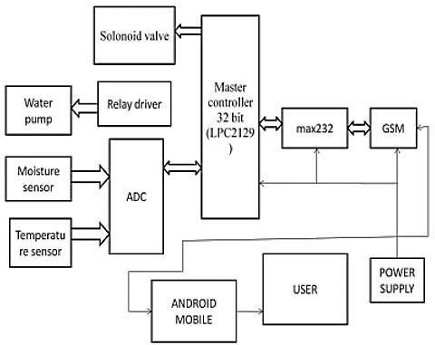

**Fig 2: Existing system**

1. **PROPOSED SYSTEM**

This work's major goal is to give the farmer based sequential learning neural network algorithm an automatic watering system, which will save it time, money, and electricity. The root-depth sensors are attached to an Arduino controller, which continuously senses the data from them. The sensors measure the data and send it to a USB interface through IoT for analysis. To determine how much water is required, wireless transfer of soil condition data from sensors to a web server database is used. The authors use the dashboard concept and save the data in the proposed server database; the dashboard controls the farm's water pump via a protocol. Using the Internet of Things (IoT), which can turn on and off water pumps, the state of the soil is monitored based on the parameters of soil-like wetness and water flow amount. In this case, a comparator serves as an interface between the controller and the sensing system. On the LCD that is connected to the controller, the condition of the soil and the output motor is shown. Similarly, to this, the controller instructs the relay to turn off the motor when the sensor detects that the soil is wet.

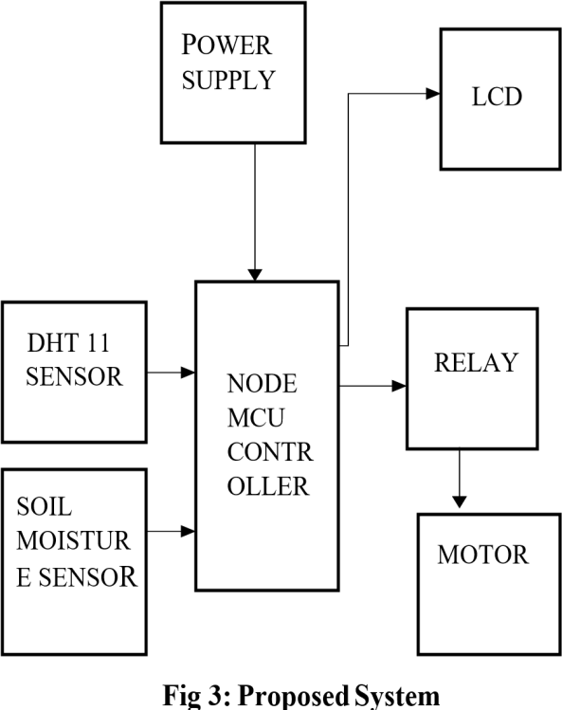

# HARDWARE SPECIFICATION

1. **Power Supply**

The primary purpose of a power supply is to convert electric current from a source to the appropriate voltage, current, and frequency to power the load. Because of this, power supplies are sometimes referred to as electric power converters. A power supply is an electrical device that provides electric power to an electrical load.

# Transformer

A transformer is a passive electrical device that uses electromagnetic induction to transmit electrical energy from one circuit to another. The most frequent uses of it are to step up or step down the voltage levels between circuits**.**

# Rectifier

An electrical device called a rectifier changes alternating current (AC), which occasionally flips direction, into direct current (DC), which only flows in one direction. The inverter handles the reverse process.

# Voltage Regulator

A system created to automatically maintain a constant voltage is known as a voltage regulator. Negative feedback or a straightforward feed-forward architecture can be used in a voltage regulator. It could make use of an electrical component or an

electromechanical device. It may be used to control one or more AC or DC voltages, depending on the design.

# DHT 11 Sensor

Humidity is a measurement of the amount of water vapor in the atmosphere. Numerous chemical, biological, and physical processes are influenced by the air's humidity level. Employee health and safety, business expenditures related to the products, and employee safety can all be impacted by humidity. Therefore, it is essential to measure humidity in the semiconductor and control system industries. Relative humidity determines how much moisture is present in a gas, which could be a mixture of water vapor, nitrogen, argon, or pure gas, for example. The two types of humidity sensors can be separated based on their measuring units. They are what they are: a relative humidity sensor and an absolute humidity sensor. The DHT11 is a digital temperature and humidity sensor.

# Relay Module

The relay is the mechanism that activates or deactivates the contacts to activate other electric controls. When an allocated area experiences an unbearable or unpleasant situation, the circuit breaker is instructed to disconnect that region. thereby guarding against harm to the system.

# Pump

The basic purpose of a pump, which is defined as a common mechanical device, is to push gas that would normally flow through a pipeline. These are also used to compress gases so that wheels don't have to be inflated with air. Pumps pressurize the liquids to pull them in and release them throughout the exit by using mechanical energy. The primary energy sources for pumps include wind power, human power, electricity, and engines.

# Arduino uno

The Arduino is a microcontroller board based on the ATmega328. Arduino is an open-source electronics prototyping platform and it is intended for designing, creating interactive objects or environments. Arduino boards are relatively inexpensive compared to others microcontroller.

# RESULT

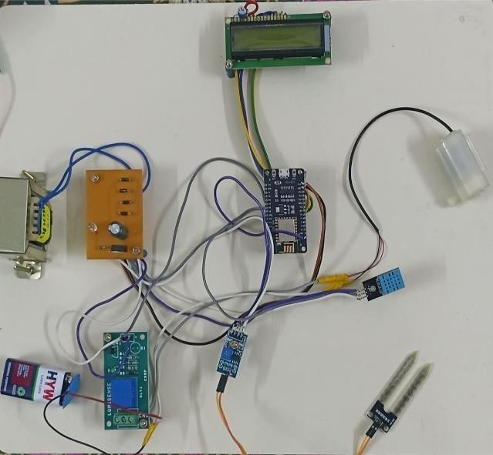

**The Output of smart farm with IoT Technology**

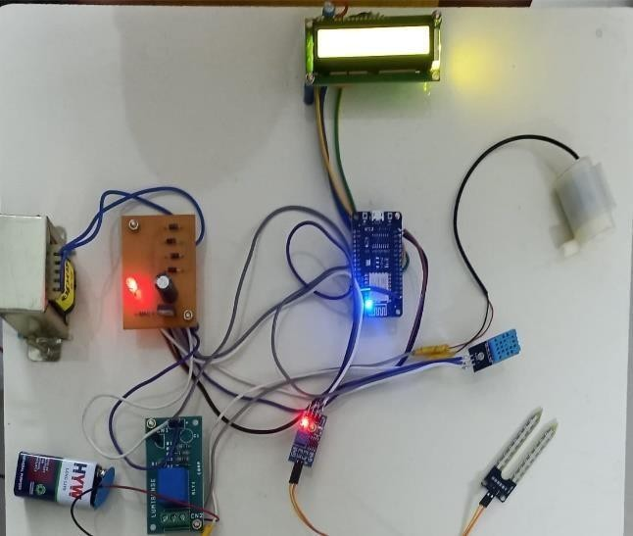

# The status of various sensors displayed

1. **CONCLUSION**

Thus, the smart irrigation system based on four different sensors using IOT has been designed and tested successfully. It has been developed by integrating features of all the hardware components used. The moisture sensors measure the moisture content (water content) of the different plants. If the moisture level drops below the desired and limited level, the moisture sensor sends a signal to the Arduino controller using a sequential learning neural network algorithm, which triggers the motor to turn on and supply water to the respective plant. When the desired environment condition level is reached, the system halts on its own, and the water level is turned off. As a result, a high yield can be achieved. This experiment is concerned with increasing the yield of agricultural fields by establishing a monitoring structure that allows for the effective and efficient use of water supplies. As a result, further development will result in increased agricultural effectiveness.

# REFERENCES

1. Desai, I. Mukhopadhyay and A. Ray,"Technoeconomic-environment analysis of solar PV smart microgrid for sustainable rural electrification in the agriculture community", IEEE 48th Photovoltaic Specialists Conference (PVSC), pp , 2021.
2. Puranik, V. Sharmila, Ranjan, A., & Kumari, A. “Automation in agriculture and IoT”.

International Conference on Internet of Things: Smart Innovation and Usages (IoT-SIU), 2019.

1. Saini, M. K., & Saini, R. K. “Agriculture monitoring and prediction using Internet of

Things (IoT)”. Sixth International Conference on Parallel, Distributed and Grid Computing (PDGC).

1. Y. Bhojwani, R. Singh, R. Reddy, and B. Perumal, "Crop selection and IOT-based monitoring system for precision agriculture", International Conference on Emerging Trends in

Information Technology and Engineering (ICETITE), 2020, pp. 1-11.

1. P. Rekha, K. Sumathi, S. Samyuktha, A.

Saranya, G. Tharunya and R. Prabha, “Sensorbased wastewater monitoring for agriculture using IoT”, 2020 6th International Conference on Advanced Computing and Communication Systems (ICACCS), pp. 436- 439, 2020.

1. Nuchhi, S., Bengali, V., & Annigeri, S. “IOT based soil testing instrument for agriculture purpose”. IEEE Bangalore Humanitarian Technology Conference (BHTC).
2. Vangala, Anusha; Das, Ashok Kumar; Kumar, Neeraj; Alazab, Mamoun, “Smart secure sensing for

IOT-based agriculture: block chain perspective”. IEEE Sensors Journal, 1–1. 2020.

1. V. G and S. Thangam, “Smart agriculture and role of IOT”, Third International Conference on Inventive

Research in Computing Applications (ICIRCA), pp. 2021.

1. K. Parasuraman, U. Anandan, and A. Anbarasan, "IoT-based smart agriculture automation in

artificial intelligence", Third International Conference on Intelligent Communication Technologies and Virtual Mobile Networks (ICICV), 2021, pp. 420-427.

1. A. K. Singh, K. Verma, and M. Raj, "IoTbased smart agriculture system", 5th International Conference on Information Systems and Computer Networks (ISCON), pp. 1-4, 2021.
2. O.K. Ogidan and K. R. Afia, "Smart irrigation system with an Android-based remote logging and control," 2019 IEEE AFRICAN, pp. 1-4, 2019.]
3. H. Benyezza, M. Bouhedda, K. Djellout, and A. Saidi, "Smart Irrigation System Based Thingspeak and Arduino," International Conference on Applied Smart Systems (ICASS), pp. 1-4, 2020
4. K. K. Namala, K. K. Prabhu A V, A. Math, A. Kumari, and S. Kulkarni, "Smart irrigation with embedded system," IEEE Bombay Section Symposium (IBSS), 2019, pp. 1-5,
5. S. C. Mungale, M. Sankar, D. Khot, R. Parvathi, and D. N. Mudgal, "An Efficient Smart Irrigation System for Solar System by using PIC and GSM," International Conference on Inventive Computation Technologies (ICICT), pp. 973-976, 2020.
6. S. N. Ishak, N. N. N. A. Malik, N. M. A. Latiff, N.

E. Ghazali and M. A. Baharudin, "Smart home garden irrigation system using Raspberry Pi," IEEE 13th Malaysia International Conference on Communications (MICC), pp. 101-106, 2022.