**Shopping With Interactive Showroom Experience**

**Dinesh Kumar DL1, Adarsh A2, Dhanush N3, Mrs.Srinidhi S4**

1,2,3 Student, Computer Science and Engineering, Agni College of Technology, Chennai-600 130,Tamil Nadu, India

4 Assistant Professor, Computer Science Engineering, Agni College of Technology, Chennai-600 130, Tamil Nadu, India

**ABSTRACT**

**In this project, we developed an Interactive Showroom Experience solution to enhance the user interface and experience. It provides a new form of web interactivity with images and gives a new experience to users than traditional shopping experience. It uses Interactive Images which is an idea that allows users to interact with images and receive information about specific objects or items within the image. It enables the shopping experience like a showroom experience. Our idea has a wide range of scope in various fields, including education, marketing, gaming, and entertainment.**

***Keywords—Interactive Images, Showroom experience, Shopping, User interface; User experience, Interactivity, Immersive shopping.***

**1. INTRODUCTION**

Online shopping has become increasingly popular in recent years, with more and more people opting to purchase goods from the comfort of their own homes. However, one of the main drawbacks of online shopping is the inability to better interactivity with the products before making a purchase. This can make it difficult for shoppers to make informed decisions and can lead to dissatisfaction with their purchases. To address this issue, we have developed a new user experience for shopping websites that allows users to interact with product images in a more intuitive and engaging way.

Our approach is focused on a touch-based interface that allows users to simply touch or click on an image to reveal more information about the product. This information includes specifics like the cost, size, available colours, and client feedback. By providing this information in a clear and concise manner, we aim to make the online shopping experience more user-friendly and informative.

Our system uses Figma to enable the interactivity in images and label products in images. This allows users to easily navigate through large collections of products and find the ones that best suit their needs. Furthermore, our touch-based interface provides a more tactile and engaging experience than traditional scrolling or clicking interfaces, which can help to keep users interested and focused on the task at hand.

Overall, our new user experience for shopping websites has the potential to revolutionize the way people shop online. By providing a more intuitive and engaging interface, we hope to make online shopping more accessible and enjoyable for people of all ages and backgrounds.

**2. LITERATURE SURVEY**

**[1] "Designing Interactive Shopping Interfaces: A Review of the Literature and Guidelines for Future Research" by M. C. Ferreira and A. S. Ruocco (2014):** This paper provides a comprehensive review of the literature on interactive shopping interfaces, covering topics such as usability, user experience, and personalization. The authors also present guidelines for future research in this area.

**[2] "Interactive Shopping: A Consumer-Centered Approach" by H. M. Jeong and J. Y. Park (2017):** This study explores the factors that influence consumers' attitudes toward interactive shopping interfaces, such as perceived ease of use, perceived usefulness, and perceived enjoyment. The authors also propose a consumer-centered approach to designing interactive shopping interfaces.

**[3] "An Interactive Shopping Interface Using Mobile Augmented Reality Technology" by S. H. Park and S. H. Kim (2018):** This paper describes the development of a mobile augmented reality shopping interface that allows users to try on clothes and accessories virtually. The authors conducted user tests to evaluate the interface's usability and user experience.

**[4] "Designing Interactive Shopping Experiences for Gen Z Consumers" by J. Y. Kim and J. E. Lee (2020):** This study investigates the preferences and behaviours of Gen Z consumers (born between 1997 and 2012) when shopping online. The authors propose design principles for interactive shopping experiences that are tailored to this demographic.

**[5] "Interactive Shopping Interfaces: A Systematic Literature Review" by R. A. Al-Sharhan, M. Al-Husain, and A. Al-Jarrah (2020):** This paper presents a systematic literature review of interactive shopping interfaces, covering topics such as user interface design, personalization, and gamification. The authors identify research gaps and propose future research directions.

**3. MATERIALS AND METHODS:**

* 1. **EXISTING SYSTEM:**

There are thousands of Ecommerce websites with only similar features provided to the users. In the case of VR shopping it is becoming popular but it is not assured that everyone has the VR setup to fully utilize the technology. The main drawbacks of ecommerce websites are having only the traditional scrolling or clicking interfaces with similar features and the inability to better interactivity with the products.

* 1. **PROPOSED SYSTEM:**

In the proposed system, we enable the interactivity in images and label products in images. This allows users to easily navigate through large collections of products and find the ones that best suit their needs. A user can touch on any part of the image to view the information of that item. This information includes specifics like the cost, size, available colours, and client feedback. Furthermore, our touch-based interface provides a more tactile and engaging experience than traditional scrolling or clicking interfaces, which can help to keep users interested and focused.In such a way we can create a new experience to the users.Rather than traditional feature, more interactivity with the customer is assured.No additional setup is required as needed in VR shopping.

* 1. **SOFTWARE USED:**

Tools: Figma; Language: HTML, CSS, JavaScript

**4. CATEGORIES OF MODULES:**

**4.1 MODULE 1: USER INTERFACE**

The UI human-computer interaction is to anticipate what users would need to perform and make the interface's features simple to use, understand, and access.

**4.2 MODULE 2: AUTHENTICATION**

The authentication module handles the user authentication and authorization. It will allow the users to Register, Login and Logout securely.

**4.3 MODULE 3: INTERACTIVE USER EXPERIENCE**

The interactive user experience for shopping website allows users to interact with product images in a more intuitive and engaging way. It enables the touch feature on the Image and the user can view the details of the items or products.

**4.4 MODULE 4: PAYMENT**

It handles the product that are added to the cart and after the payment process is successfully completed, the product will be assigned to the user for delivery process.

**4.5 MODULE 5: DEPLOYMENT**

This module delivers all the necessary contents over the internet. It deploys all the various stacks into a single system makes it available on internet.

**5. MODELING AND ANALYSIS:**

**5.1 WEBFLOW DIAGRAM**

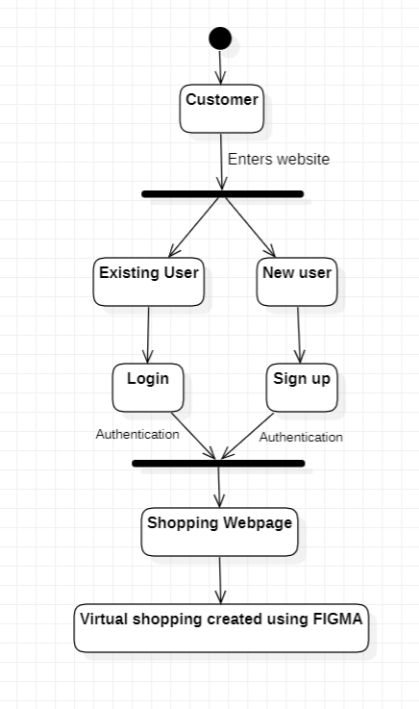

**5.2 SYSTEM ARCHITECTURE:**

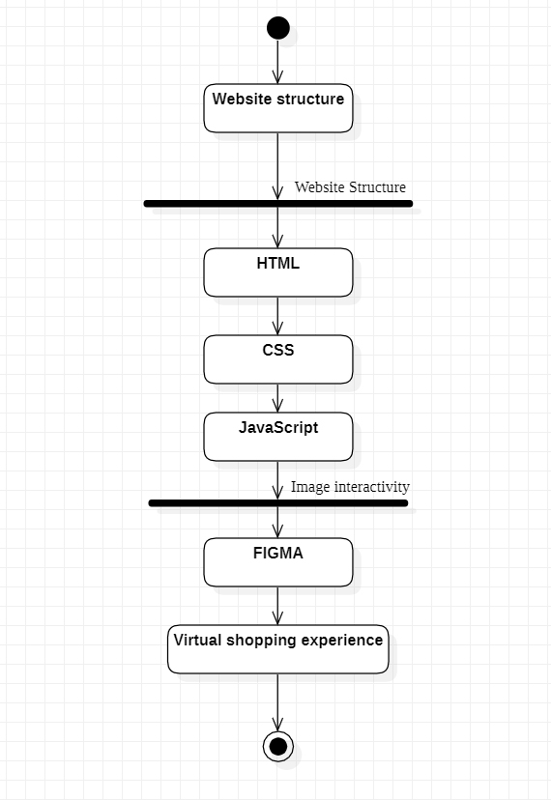

**6.RESULT & DISCUSSION:**

Overall, our new user experience for shopping websites has the potential to revolutionize the way people shop online. By providing a more intuitive and engaging interface, we hope to make online shopping more accessible and enjoyable for people of all ages and backgrounds.

**6.1 SCREENSHOTS**

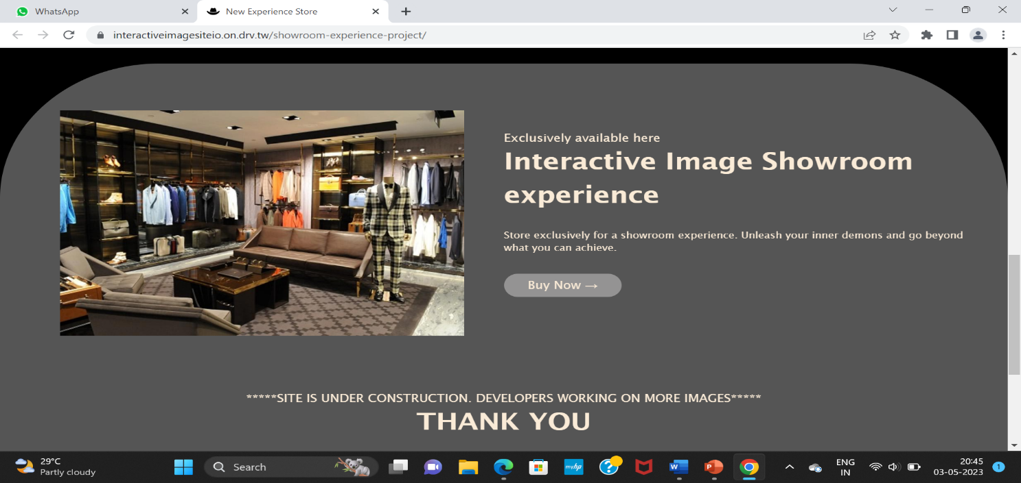

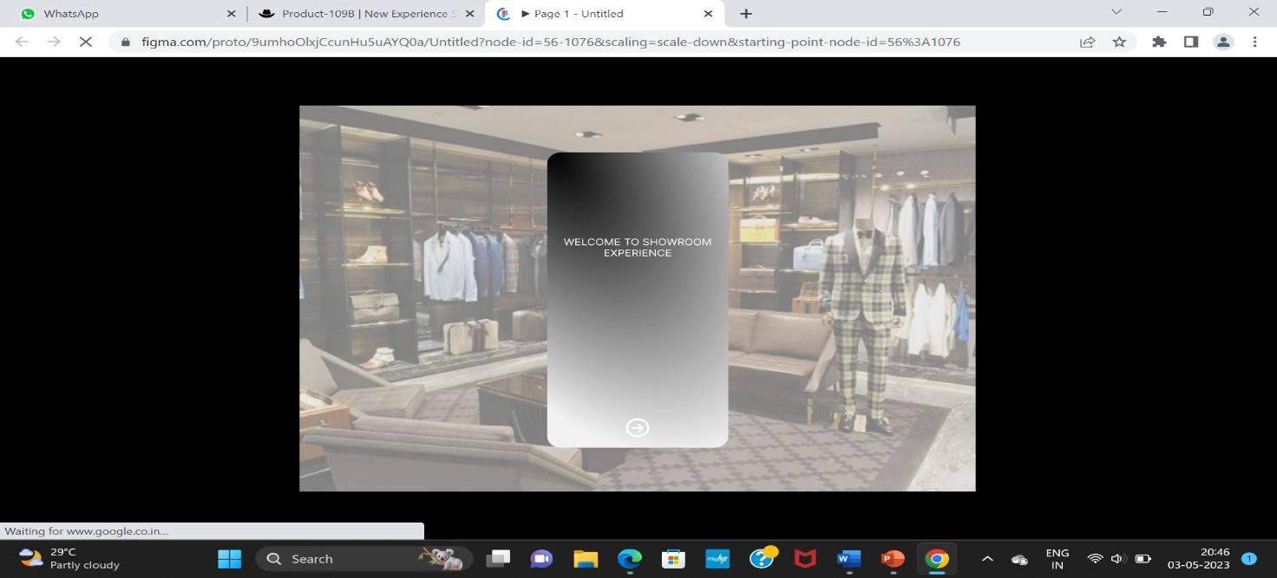

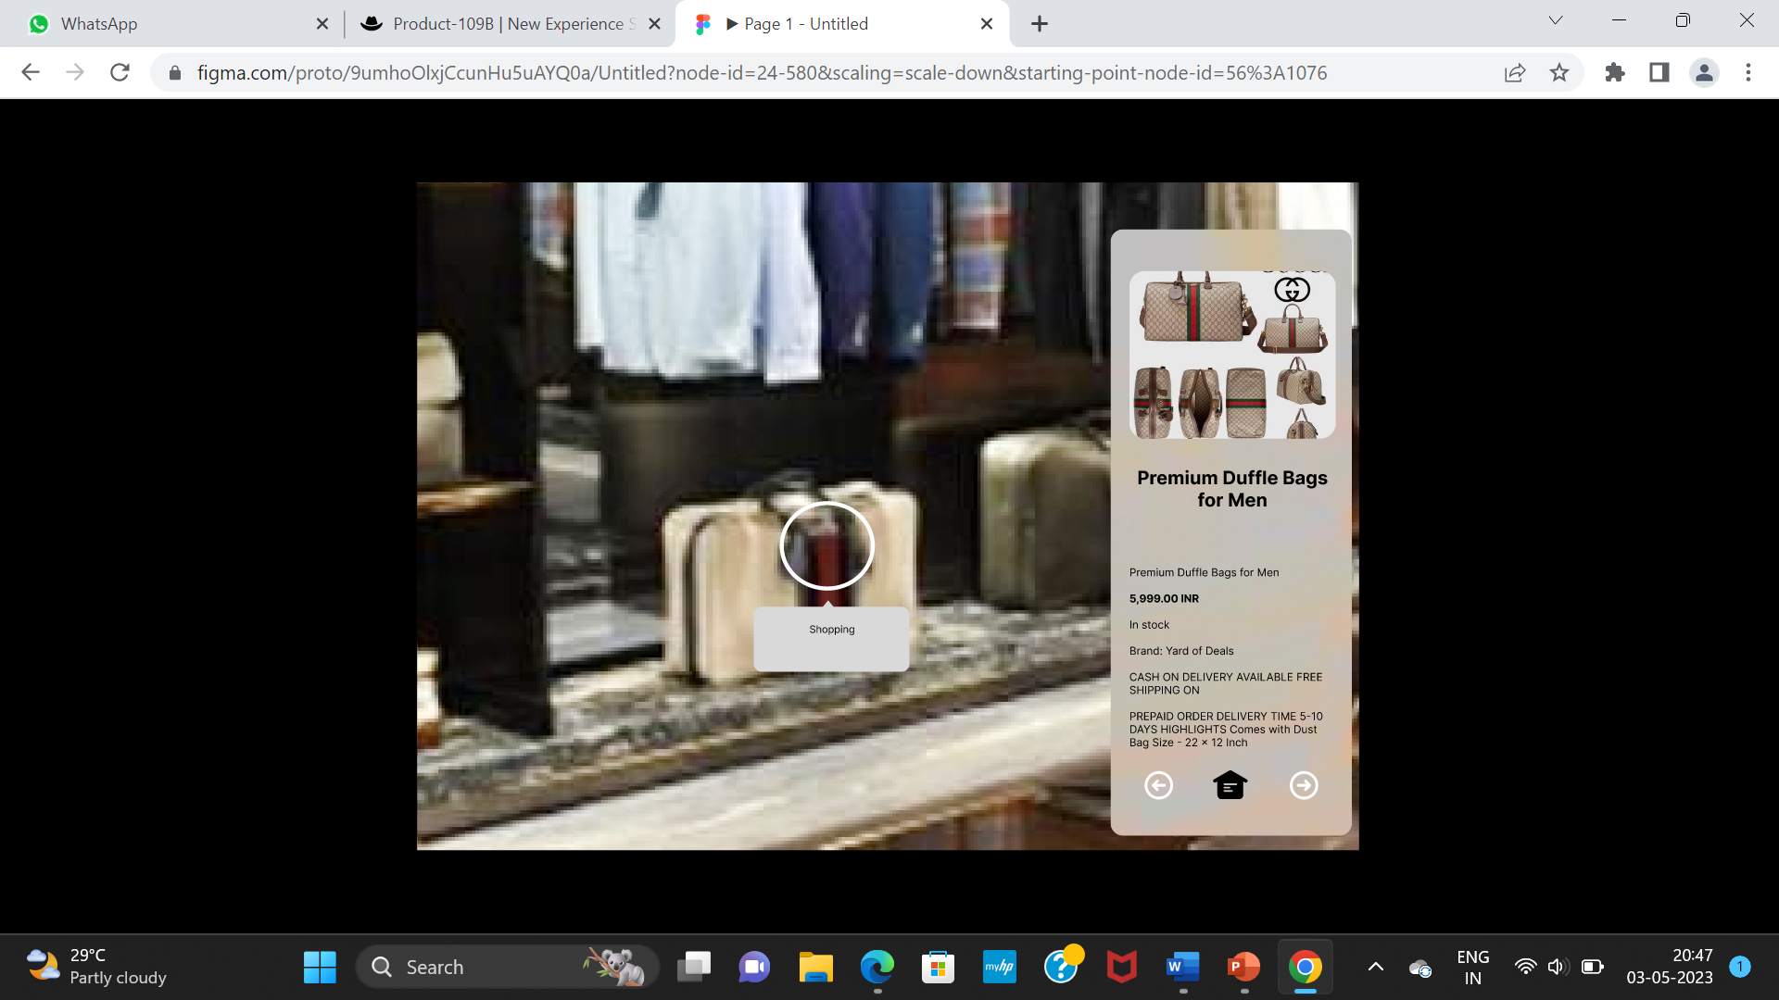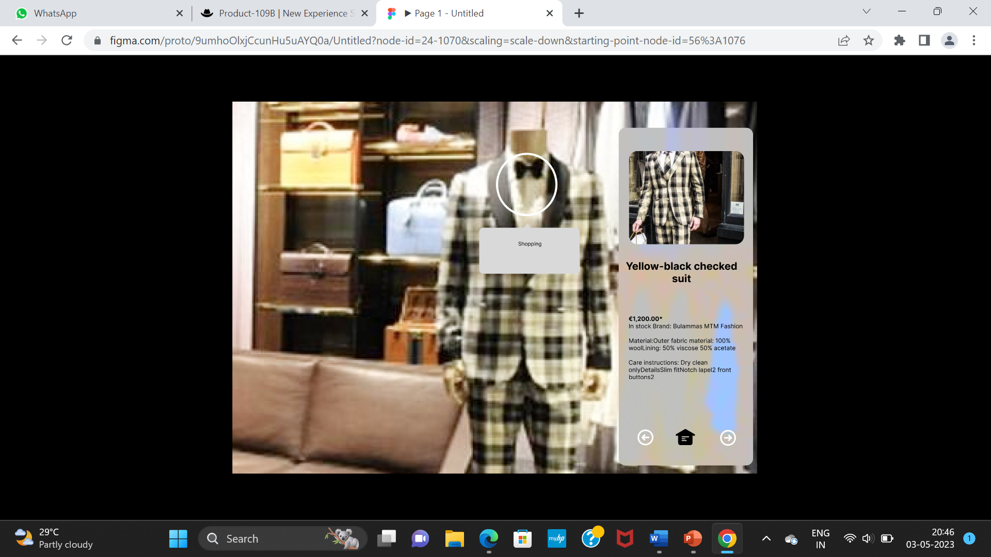

**7.CONCLUSION:**

In conclusion, our project has impact on customer experience and suggests possible research in the field of human-computer interactions. As a future work we can add 3600 images to provide more interactivity with products. It has a wide range of scope in various fields, including education, marketing, gaming, and entertainment.

**8. REFERENCE:**

[1] Enhancing the Shopping Experience through Interactive Showrooms: An Exploratory Study" by B. L. Chen, R. L. Daugherty, and C. L. Hess (2016)

[2] "Integrating Interactive Showroom Technology into Physical Retail Environments" by Y. Wang and R. Pavlou (2019)

[3] "Interactive Showroom Experience and Customer Attitude toward a Brand and Its Products" by M. C. Su, C. H. Chang, and Y. H. Liu (2021)

[4] "Designing Interactive Showrooms for Augmented Retail Experiences" by A. N. Chiu, T. F. Liu, and J. H. Liao (2020)

[5] "The Influence of Interactive Showroom Technology on Consumer Behavior" by X. Chen, Y. Yang, and Y. Zhang (2019)