# **DERMA - SKIN INFECTION DETECTOR**

**Hari Baskaran P1, Maadhavan N1, Jeevitha N1**

1Students, Computer Science and Engineering, Agni College of Technology, Chennai-600 130,

Tamil Nadu, India

**Mr. Rajesh Kanna R2**

2Assistant Professor, computer Science Engineering, Agni College of technology,

Chennai-600 130, Tamil Nadu, India

**ABSTRACT**

A web application for employing Deep learning to diagnose skin conditions is what our suggested mini project wants to create. Users of the web-application will be able to upload pictures of the damaged areas, which will then be examined by a Conventional Neural Network (CNN) that has already been trained to deliver a diagnosis. The application will also offer details on various skin health treatments and educational materials. For the storing of user data to be secure, user authentication will be necessary. To increase its accuracy in identifying skin illnesses, the machine learning model will be trained using a dataset of picture data and will make use of different techniques such data augmentation and transfer learning.

*Keywords--- Deep learning, Upload pictures, Skin health treatments, Data augmentation, Transfer learning.*

**1.INTRODUCTION**

People have skin conditions than other sicknesses. Skin conditions can be caused by viruses, germs, allergies, fungal infections, and more. The tone or texture of the skin might change due to a skin disorder. Skin infections may vary according to their threat levels. To prevent the emergence and spread of skin diseases, hence early diagnosis is necessary. A skin infection usually takes time to diagnose and treat, and the patient may be affected both financially and physically.

Common people are usually unaware of the type and stage of their skin infections. Some skin conditions take months to display symptoms, giving the illness time to grow and spread. This is a result of layman ignorance about medicine. A dermatologist( a medical practitioner who specializes in skin related problems) may occasionally have trouble in diagnosing a condition and also need to conduct expensive laboratory tests to ascertain its type and stage. Considerably skin problems can now be identified more rapidly and precisely, hence thanks to improvements in photonics- and laser-based medical technologies. Such a diagnosis nevertheless comes at an excessively high cost. As a result, we suggest using image processing to find skin problems.

**2. LITERATURE SURVEY**

To identify the many types of skin diseases, several researchers have suggested image processing-based approaches. Here, we quickly go over a few of the methods that have been reported in the literature.

* The first step in the diagnosis of skin disorders in [1] is the extraction of picture characteristics. In this method, the more image features that are extracted, the more accurate the system becomes. With an accuracy rate of 70%, [1] applied the procedure to three different forms of skin disorders. A contagious disease named Melanoma may lead to fatal if not treated earlier.
* [2] centred on the investigation of various segmentation methods that could be utilised to identify melanoma through image processing. The segmentation procedure that uses the boundaries of the diseased spot to extract more information is discussed.
* A melanoma diagnosis tool for pigmented skin was presented in [3] using databases of specialised algorithms and photos from several melanoma resources.
* [4] proposes a novel method for detecting skin disorders that combines computer vision and machine learning. While machine learning is used to identify skin diseases, computer vision is used to extract features from images. The system performed 75% properly on tests involving four different skin disease kinds.

**3. DESCRIPTION OF THE DATASET**

The dataset we used is the “HAM10000” which is a collection of images of pigmented skin lesions. It consists of 10015 dermatoscopic images, which were collected from various sources, including medical centres, research centres, and individuals. The images were collected from 7 different diagnostic categories, which are:

* Melanocytic nevi (nv) - These are benign neoplasms of melanocytes, which are the cells that produce pigment in the skin.
* Melanoma (mel) - This is a malignant neoplasm of melanocytes.
* Benign keratosis (bkl) - These are benign growths on the skin, which are often caused by sun damage.
* Basal cell carcinoma (bcc) - This is a type of skin cancer that arises from the basal cells in the skin.
* Actinic keratosis (akiec) - These are precancerous growths on the skin, which are caused by sun damage.
* Vascular lesions (vasc) - These are abnormal blood vessels that can appear on the skin.
* Dermatofibroma (df) - This is a benign growth that arises from fibroblasts in the skin.

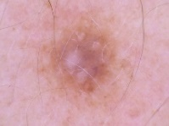 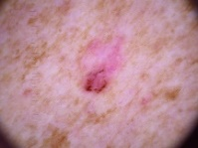 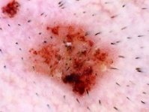 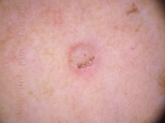 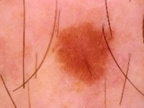 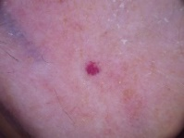 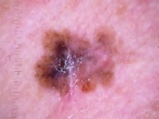

(df) (bcc) (akiec) (bkl) (nv) (vasc) (mel)

**4. METHODOLOGY**

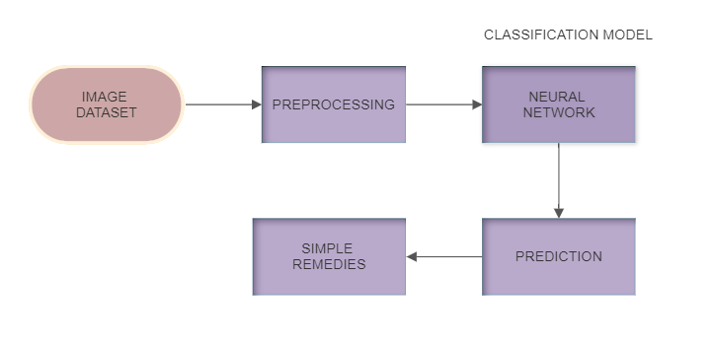As you can see from the block diagram, the proposed system is trained with the dataset HAM10000 using deep-learning convolutional neural networks (CNN) for image processing and analysis, and with the architecture Mobilenet for image recognition. The web application is developed using Flask, a lightweight and efficient web framework. By utilizing these technologies, DERMA can accurately detect and analyze skin infections from uploaded images and provide educational resources to users about the specific infection. The classification model (CNN) detects common skin diseases like Melanocytic nevi, Melanoma, Benign keratosis, Basal cell carcinoma, Actinic keratosis, Vascular lesions, Dermatofibroma. In this proposed system we used, JUPYTER NOTEBOOK based python script for experimental results.

**5. PREPROCESSING**

Pre-processing plays a vital role in deep learning model. To get over the difficulties, such as processing and resizing the image from the dataset, in order to achieve high accuracy rate of the skin infection identification system.

The technique used in image resizing is explained below,

* *Image resizing*

Increasing or decreasing the dataset's size will fix the issue of varied image sizes. The same number of features will be obtained from all input images by standardising the image size. thus, resizing an image speed up system performance by decreasing processing time.

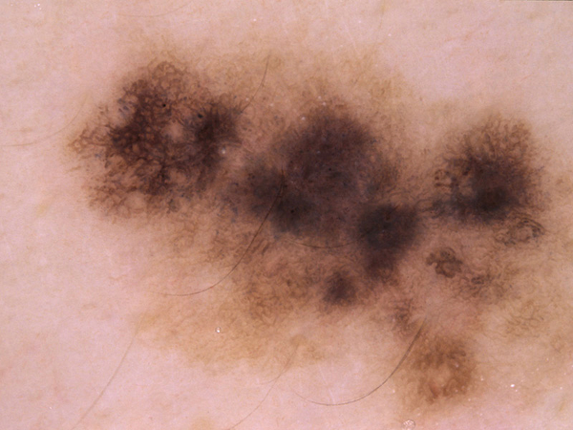

*Example of original image from dataset HAM1000 -size(600x450)*



Resized image of size (224x224)

**7. EXISTING SYSTEM**

There are various software applications and tools available for detecting skin infections. Some of them are:

* VisualDx: This software application uses a database of images and clinical information to aid in the diagnosis of skin conditions. It allows healthcare professionals to search for symptoms, compare images, and develop differential diagnoses.
* Miiskin: This application provides a skin tracking and monitoring tool that allows users to take pictures of their skin and track any changes over time. It can be used to monitor moles, rashes, and other skin conditions.
* SkinVision: This is a mobile application that uses AI to analyse skin lesions for skin cancer. It allows users to take pictures of their skin.
* First Derm: This is an online dermatology service that allows users to submit pictures of their skin conditions and receive a diagnosis within 24 hours.

Most of the existing systems are offline which consumes more time and money for consulting a dermatologist.

**8.EXPERIMENT AND RESULTS**

In our web application we have created a login page for the user’s privacy and security of their data.

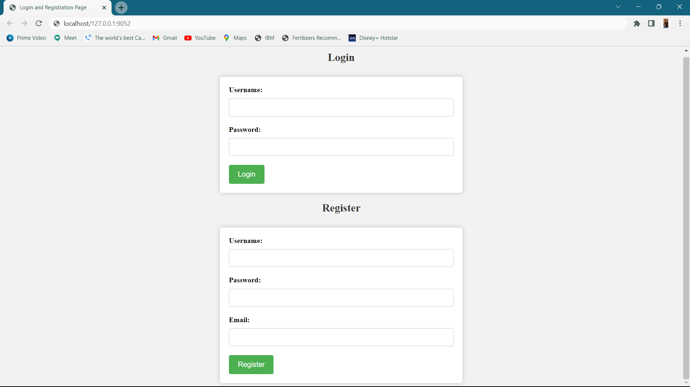

Then our web-application will allow the user to upload the image of an infected area to predict the infection with the help of the trained model. The uploaded image gets processed at the backend.

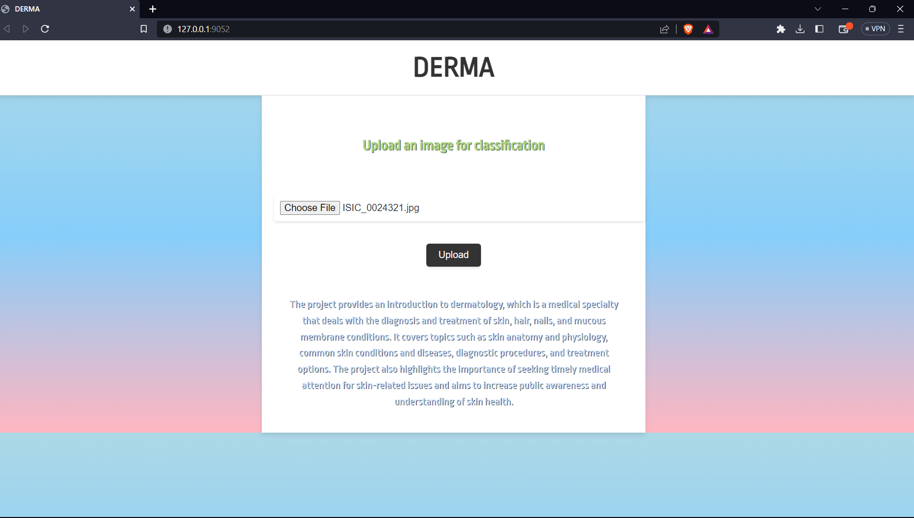

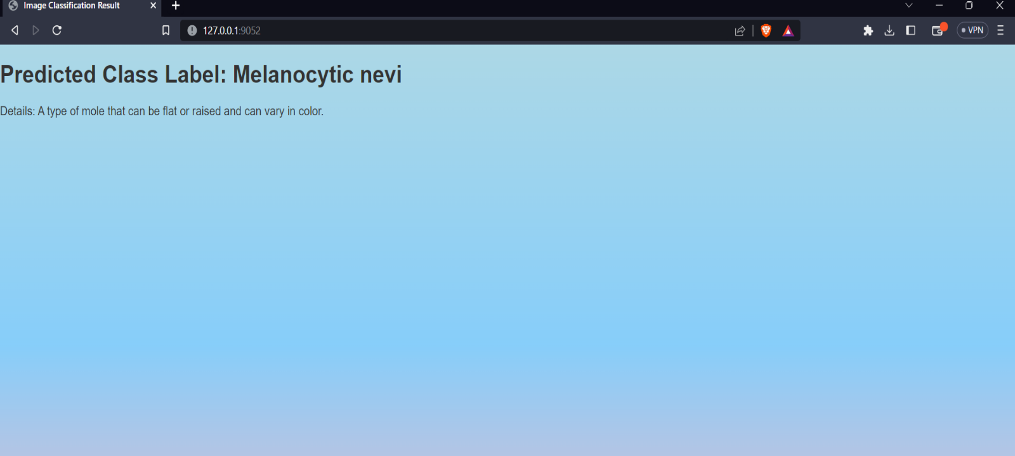

Thus, our proposed model will display the detected infection from the uploaded image and also provide you with the basic information’s about it.

**9.FUTURE DEVELOPMENT**

In the future, DERMA plans to enhance its image analysis capabilities by analysing threat levels of detected infections. If the threat level is high, DERMA will provide the user with the nearest dermatologist location for further treatment.

Additionally, DERMA aims to expand its database of dermatology conditions and educational resources to provide even more comprehensive information to users.

**10.CONCLUSION**

DERMA is a valuable resource for anyone looking to detect and learn more about skin infections. By utilizing deep-learning models and pre-trained algorithms.

We can certainly state that the results are quite encouraging after evaluating the deep learning model for detecting infections in uploaded photos. The model has demonstrated amazing accuracy in detecting a wide variety of infections, which may enhance patient care and healthcare outcomes.

Deep learning technology has made enormous strides in the medical domain, and it has the potential to completely change how we approach healthcare. These models allow medical practitioners to recognise infections with speed and accuracy and administer the proper care, thereby improving patient outcomes.

Deep learning algorithms for virus detection can also significantly improve the effectiveness of healthcare systems. Medical experts can devote more time to patient care and treatment by automating the detection and diagnosis process.

The deep learning model has demonstrated excellent performance in testing, and it has the potential to have a substantial impact on the healthcare industry.

**REFERENCE**

* Okuboyejo, Damilola A, et al. "Automating Skin Disease Diagnosis Using Image Classification." Proceedings of WCECS 2013, October 23 - 25, 2013, San Francisco, USA, IAENG Open Access Publication, 24 Oct. 2013, [www.iaeng.org/publication/WCECS2013/](http://www.iaeng.org/publication/WCECS2013/).
* Ajith, Archana, et al. "Dermatological Disease Detection Using Image Processing and Artificial Neural Network." Dermatological Disease Detection Using Image Processing and Artificial Neural Network - IEEE Conference Publication, 15 June 2015, ieeexplore.ieee.org/document/7026918/.
* Ambad, Pravin S., and A. S. Shirat. "An Image Analysis System to Detect Skin Diseases." Index of /Iosr-Jvlsi/Papers/vol6-issue5/Version-1, 1 Oct. 2016, [www.iosrjournals.org/iosr-jvlsi/papers/vol6-issue5/Version-1/](http://www.iosrjournals.org/iosr-jvlsi/papers/vol6-issue5/Version-1/).
* Srushti, Varshitha Makam, Sushmitha Shet, and Swathi V A. "Skin Disease Detection Using Deep Learning." International Journal for Research Trends and Innovation (IJRTI), vol. 5, no. 8, 2020, pp. 12-18, ISSN: 2456-3315, [www.ijrti.org](http://www.ijrti.org).
* E H. Page, MD, Assistant Clinical Professor of Dermatology; Physician, Harvard Medical School; Lahey Hospital and Medical Center "Diagnosis of skin disorders", MSD Manual Consumer Version,2017. [Online]. Available: www.merckmanuals.com/home/skindisorders/biology-of-the-skin/diagnosis-of-skindisorders. [Accessed: 07- Oct2016].
* M. Rodri & shy; Guez, "The median filter problem", Tracer.lcc.uma.es. [Online]. Available: http://tracer.lcc.uma.es/problems/mfp/mfp.html. [Accessed: 07- Oct- 2016].
* P. Miami, "10 most common skin diseases", Positive Med, 2014. [Online]. Available: http://positivemed.com/2014/04/22/10-commonskin-diseases/. [Accessed: 04- Aug- 2016].
* "Discrete cosine transform - MATLAB& Simulink", In.mathworks.com,2016. [Online]. Available: https://in.mathworks.com/help/images/discrete-cosine-transform.html [Accessed: 21- Oct- 2016].
* "The discrete cosine transform (DCT)", Users.cs.cf.ac.uk, 2017. [Online]. Available: https://users.cs.cf.ac.uk/Dave.Marshall/Multimedia/node231.html. [Accessed: 18- Apr- 2017].
* M. Sifuzzaman, M.R. Islam and M.Z. Ali, "Application of wavelet transform and its advantages compared to Fourier transform", Journal of Physical Sciences, Vol. 13, 2009