**Energy Saving Street Light using IoT based on Motion Detection**

Mr. P. Dinesh Kumar1, P. Aruna2, P. Aruna3, R. Devashree4, R. Kavya5.

Assistant Professor1, UG Scholar2, UG Scholar3, UG Scholor4, UG Scholar5.

Department Of Computer Science and Engineering, Vivekanandha College of Technology for Women, Namakkal, Tamil Nadu, India.

**Abstract - The smart lighting system discussed in this study employs sensors to effectively dim and brighten the street light as needed. IoT (Internet of Things) is the foundation of this system. It also helps to conserve a significant amount of power and electricity while lowering the number of accidents that occur on the roadways. It offers more efficiency and improves safety. By lighting the area, it also creates a secure environment for nighttime pedestrians.**

**Keywords *–* Power supply, LDR sensor, NODEMCU ESP8266, LEDs, IR sensor, Jumper wires, Arduino UNO, Thing speak.**

**I. INTRODUCTION**

The cost of a city's street lighting is among its largest energy expenses. A street lighting system can cut municipal street lighting costs by 50% to 70%. To adapt light output to usage and occupancy, the smart street lighting system automatically identifies walkers, bicycles, and cars. The goal of any engineer working in this field is to create a new streetlight system that consumes the least amount of electricity while offering the brightest illumination over a large region. Street lighting is one of a city's most important and costly responsibilities. Lighting accounts for 10–38% of the total energy bill in typical cities around the world. The street lights are one of the most important aspects.

Street lighting is a significant issue for public authorities in growing nations due to its strategic importance for the stability of the economy and society. Each year, poor lighting results in significant financial losses and negatively affects the environment. The price of street lighting can be reduced by using energy-efficient technologies and design principles. Manual control is difficult to use to manually dim lights in the middle of the night, wasteful of energy, and prone to error. Additionally, it is impossible to manually track the light intensity dynamically. At the moment, automated and remote management systems for street lighting are common.

The majority of the time, technology is employed to create autonomous street lights that can distinguish between day and night and switch on and off by the time of day and night. A street light will only glow if it is dark and someone is crossing the street. Using a real-time system, the street light (ON/OFF Status) will be available via the Internet at any time and from any location. It is necessary to mount the NodeMCU ESP8266 street controller on the pole light. To monitor the system, data can be transmitted wirelessly from the street light controller to the base station. Whether the system is operated automatically or not, the control system will switch the lights on and off at the appropriate times.

**II. RELATED WORKS**

Many efforts have been made in recent years to automate the streetlighting system that is currently in place. For any knowledgeable. For the streetlight system to be as effective and efficient as possible, it must work methodically. Consequently, using a more dependable system can eliminate significant costs associated with street lighting and save labor costs as well. However, many techniques continue to use conventional light sources; as a result, although they may require less human effort, energy waste, and light pollution still exist.

In 2016, Manish Kumar et al [12] released a study about streetlight management utilizing a wireless Zigbee module. LDR, a microcontroller, and a gearbox module were among them. Wireless contact with the lamp module is possible thanks to Zigbee. Two LDR sensors make up the system, which looks at day-night variations and lamp health. After the microcontroller processes the data, the LDR's results are sent there and then into the transmission module. To monitor and regulate each streetlight, the wireless Zigbee transmits the necessary data to the control room. The system makes use of the Zigbee network, which has a fairly limited range [7].

**III.PRINCIPLES OF PROPOSED SYSTEM**.

The system consists of an Arduino Uno, a power source, relays, and an LDR. The system is illustrated in Figure 1.1, which is below:

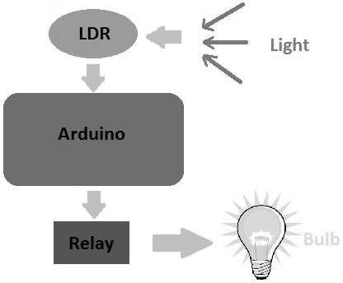

**Fig 3. Architecture Diagram of proposed System**

Light is detected by the LDR, which then sends the information to Arduino. The Arduino examines the data using the relay mechanism and then reacts by manipulating the LEDs. The Arduino is programmed to automatically adjust the illumination to deliver the most precise results.

The primary objective of this system is to implement an IoT-based Automated Street Lighting System. To save energy, as traffic gradually decreases through the late hours of the night, the intensity gradually decreases till morning; as a result, street lights automatically turn on at sunset and off at dawn. The process is performed every day. White Light Emitting Diodes (LED) are used in place of conventional HID bulbs in the street lighting system to enable dimming.

High-intensity discharge (HID) lamps, which are frequently employed in city street lights, cannot be utilized to vary the intensity. LED lights are the lighting of the future due to their long lifespan and low energy usage. LED lights are fast displacing conventional lights because the pulse width permits intensity control. An Arduino board is the suggested hardware for this system. LED string and Arduino board are connected. Using a programmed Arduino board, different intensities are offered throughout the night. This method is improved by combining the LDR to carefully monitor the switching operation and IOT to report the condition of the street on a web browser and help with regulation.

**IV. SYSTEM SPECIFICATION**

This technology aims to provide information on the IoT smart streetlight system. You can more effectively control street lighting with Thingspeak technology. An ESP8266 node MCU, an IR sensor, and an LDR sensor are all interfaced by this system. One of the main problems India is currently facing is the maintenance of street lights. Streetlights are manually maintained in India. It has been demonstrated that leaving the lights on during the day wastes energy because of human activity. To reduce human mistakes during deployment, Thingspeak is employed for effective communication.

1. **HARDWARE SYSTEM**

The following equipment is used in this system:

A) Power supply

B) LDR sensor

C) NODEMCUESP8266

D) IR sensor

E) LEDs

F) Jumper wires

1. **POWER SUPPLY**

The term "power supply" refers to an electrical power source. A device or system that supplies electrical or other types of energy to an output load or collection of loads is known as a power supply unit, or PSU. The phrase is most often used concerning electrical energy sources, although it is also occasionally used concerning mechanical and other energy sources. The power supply component is required to lower the signal's amplitude and transform AC signals into DC signals. A DC voltage with an amplitude of +5V and +12V is required for a variety of applications, but the mains voltage signal, which is 230V/50Hz, is an AC voltage.

**B) LDR SENSOR**

A light-dependent resistor is sometimes known as a photo-resistor or LDR. The quantity of light that LDR receives determines how resistant it is because it is light-sensitive. It is made of a semiconductor with high resistance, and resistance rises in the absence of light. When light intensity rises above a predetermined threshold, the LDR absorbs photons, allowing electrons to move into the conduction band. The amount of light that strikes LDR has an impact on the variation in resistance it produces. It is mostly used in electric circuits, including those in street lights, alarm clocks, and devices with automatic brightness and contrast settings.

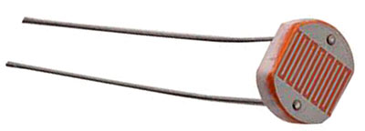

**FIG 4.1.1 DIAGRAM** **LDR SENSOR**

**C) NODEMCUESP8266**

The NodeMCU (Node MicroController Unit) is an open-source software and hardware development environment that is based on the ESP8266, a very inexpensive System-on-a-Chip (SoC). Furthermore, you have to program it using low-level machine instructions that are compatible with chip technology. The ESP-8266 is a low-cost Wi-Fi microchip that has full TCP/IP (Transfer control protocol/Internet protocol) capabilities. The IOT panel can connect to the internet thanks to it. The ESP8266 offers independent, full-featured Wi-Fi.

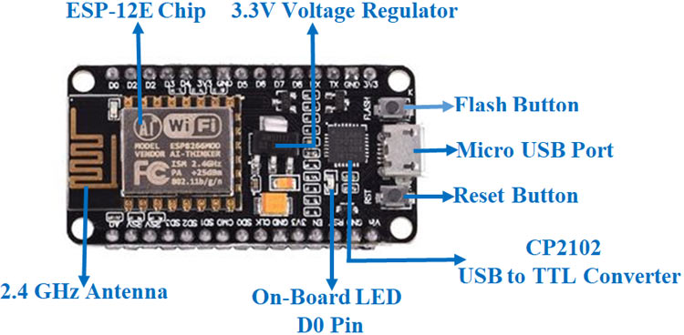

**FIG 4.1.2 DIAGRAM** **NODEMCUESP8266**

**D) IR SENSOR**

IR sensors are used to assess whether a person is crossing the street or not. It detects any surrounding movements or impediments. The IR rays being sent out by the transmitter are reflected when they come into contact with a person, an animal, or a vehicle. The receiver diode will catch the reflected beam and illuminate the appropriate LED to signal the object's existence. This tactic will drastically cut the amount of electricity used because the street light will only turn on if someone is on the roadway. An IR sensor hasthree pins, two of which are used for ground and VCC, and one of which isan output pin. This connection is made to a NodeMCU GPIO pin so that the street light will turn on if an IR sensor detects a person crossing the street. This time, only one LED will be illuminated.

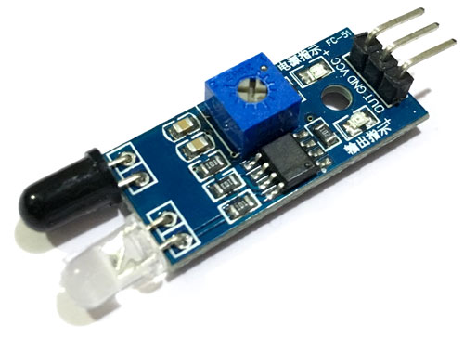

**FIG 4.1.3 DIAGRAM IR SENSOR**

**E) LEDs**

A light-emitting diode (LED) is a semiconductor light source that emits light when current flows through it. The semiconductor releases energy in the form of photons as a result of the recombining of electrons and electron holes. The energy of the photons, which correlates to the color of the light, is determined by the energy required for electrons to cross the semiconductor's band gap. White light can be produced on a semiconductor device using a layer of light-emitting phosphor or several semiconductors. Infrared LEDs are utilized in remote-control circuits, such as those used in a variety of consumer electronics.

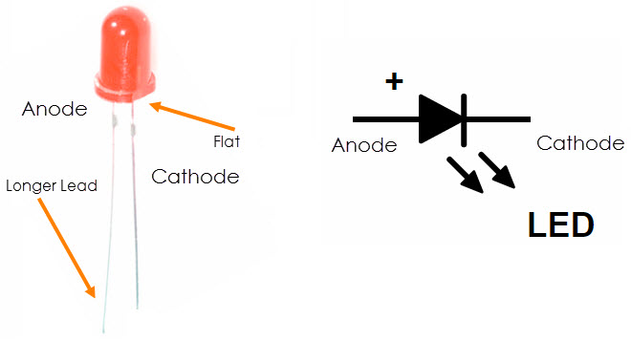

**FIG 4.1.4 DIAGRAM LEDs**

**F) JUMPER WIRES**

A jump wire (also known as a jumper, jumper wire, or DuPont wire) is an electrical wire, or group of electrical wires in a cable, with a connector or pinat each end (or sometimes without them - simply 'tinned'), and it is typically used to connect the pieces of a breadboard or other prototype or test circuit internally or with other machinery or components without soldering.

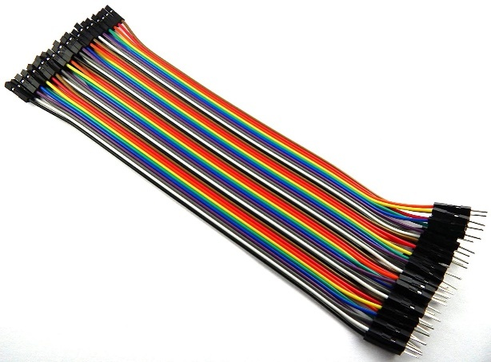

**FIG 4.1.5 DIAGRAM JUMPER WIRES**

1. **SOFTWARE SYSTEM**

Software used in this Proposed system is,

A) Arduino IDE

B) Thingspeak

**A) Arduino IDE**

Writing code and uploading it to a board are both made simple by the free and open-source Arduino Software (IDE). It uses a platform different from Windows, MAC OS, and Linux. After installing the IDE C application on the computer, any Arduino board can be used with the environment, which was created in C.

**B) Thingspeak**

ESP8266 With the help of Thingspeak, an analytical IoT platform service, you can gather, visualize, and analyze real-time data streams in the cloud. Thing Speak is an open-source web of things (IoT) utility and API to buy and recover data from problems using the hypertext transfer protocol and MQTT protocol over the internet or through a close-to-space network. Thing Speak grants licenses for the presentation of the area following bundles, informal communities of things, and component work programs that detect moving parts.

**V.SYSTEM ARCHITECTURE**

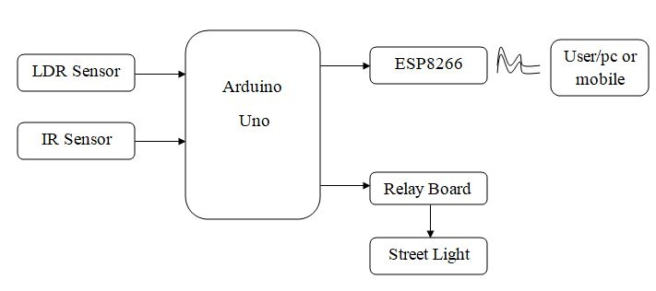

**FIG 5.1 BLOCK DIAGRAM**

**VI.WORKING**

A block diagram is a visual representation of a system's key elements or operations made up of blocks connected by arrows that show the relationships between the blocks. Process flow diagrams, software design, electronic design, and hardware design, are frequently used in engineering**.** Using blocks connected by lines that show the links between the blocks, a block diagram represents a system's key components or functions. The sensor's resistance increases at night since there is no light to illuminate it, which turns on the light. The IR sensor is connected to the microcontroller via a relay driver, which functions as both an automated switch and an electromagnetic switch. It is very trustworthy and automatically turns on and off the lights.

**VII. RESULTS**

**SCREENSHOTS**

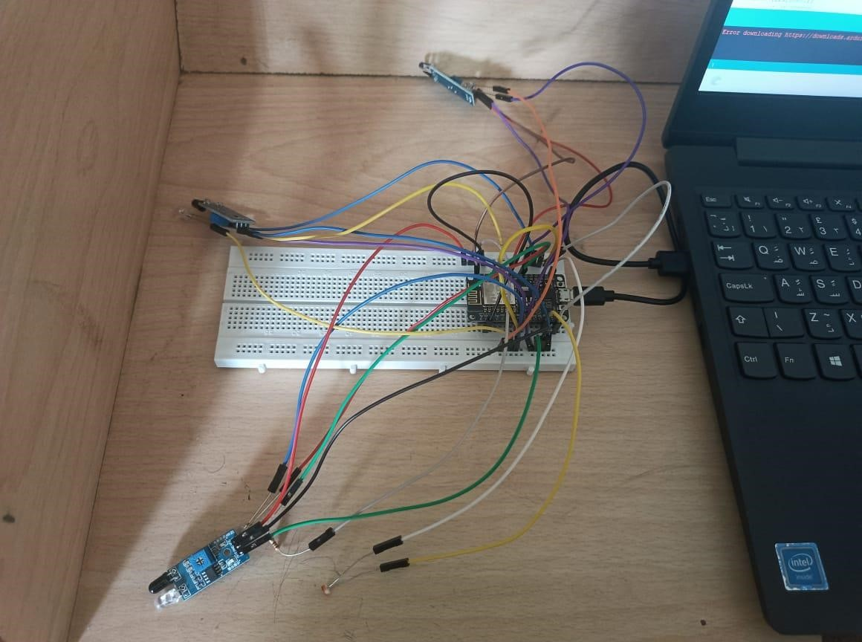

**Figure.7.1 Initial setup**

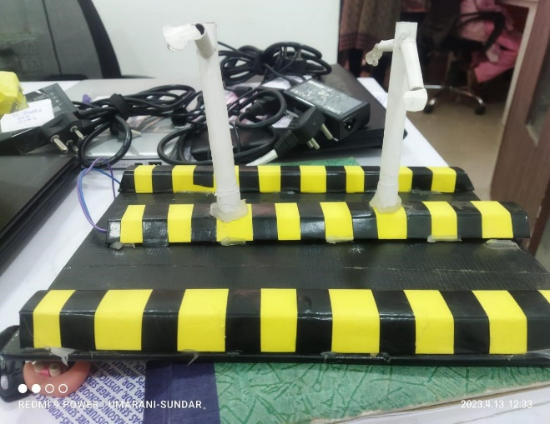

**Figure.7.1. Energy Saving Street Light using IOT based on Motion Detection**

**VIII. FUTURE WORK**

It is feasible to further enhance the system by adding logic to the code and automating the process of turning on the street light at sunset and turning it off at sunrise by getting the time of sunrise and sunset from a reliable weather reporting source. This lessens the requirement for human interaction even more because a manual visit to the location of the street lights is only required in the case of a problem. Using smart street lights is a cost-effective strategy for cities looking to reduce energy consumption, enhance public safety, and encourage the creation of intelligent infrastructure. For cities looking to engage in smart technology, intelligent street lighting provides the potential to reap significant benefits for a relatively cheap cost. Networked LED lighting, in its most basic version, uses motion detectors to only turn on the lights when necessary, to save energy. City planners can employ networks of smart street lights to lay the foundation for complex smart city applications that go beyond energy efficiency and advanced lighting capabilities.

Out of all the smart city projects that can benefit both authorities and residents, adaptive lighting offers city planners the best value for their money. First and foremost, by simply replacing antiquated street lights, it may be implemented gradually without necessitating a large redesign of the current infrastructure.

Smart street lights can be equipped with a variety of sensors and cameras to collect crucial data, help cities make educated decisions, and improve how usable cities are for residents. Streetlights may wirelessly communicate with one another and the Internet of Things (IoT) to track maintenance updates, monitor traffic conditions, alert authorities to potential security risks, and more. When cities grow, intelligent lighting systems will probably be at the forefront of urban development.

**IX. CONCLUSION**

The proposed method is easier to install and maintain than the system that is currently in existence. Automated processes are more effective than manual ones. Additionally, these devices can be reprogrammed to meet our needs. Using the API key, the generated data is added to the Thingspeak database.

This Smart Street light has applications outside of urban areas, such as in rural areas. Because progress calls for more electricity, using renewable resources is beneficial.

It enables access to light status information from any location at any time and is the most effective, practical, environmentally friendly, and safe way to conserve energy. Both the need for energy conservation and the proper disposal of incandescent bulbs are properly addressed.

**X. REFERENCES**

1. Soledad Escolar, Jesus Carretero, Maria-Cristina Marinescu and Stefano Chasse (2014) “Estimating Energy Savings in Smart Street Lighting by using an Adaptive Control System” International Journal of Distributed Sensor Networks Volume, Article ID 9715.
2. 2017 IEEE Region 10 Humanitarian Technology Conference (R10-HTC)
3. Kolban, Kolbans. N(2015) http://espressif.com/en/products/esp8266/ and Book on ESP8266, an introductory book on ESP8266.
4. Isah Abdulazeez Watson, Oshomah Abdulai Braimah, Alexander Omoregie (March 2015) “Design and Implementation of an Automatic Street Light Control System” International Journal of Emerging Technology and Advanced Engineering, Volume 5, Issue 3.
5. Deepanshu Khandelwal, Bijo M Thomas, Kritika Mehndiratta, Nitin Kumar (April- 2015) “Sensor Based Automatic Street Lighting system” International Journal of Education and Science Research Review Volume-2, Issue-2.
6. Bruno, A., Di Franco, F. and Rascona, G. 2012. Smart street lighting. EE Times.
7. P. Dinesh Kumar, T. Jeyashree, S. Kaaviya, A. Parevaakhini & C. Sathika (April-2022) “Sound Sensor Based Emergency Vehicle Preemption System using Micro controlled Nodes” IIJSR Vol.6, Issue-2.
8. In 2016, Manish Kumar at El [12] released a study about streetlight management utilizing a wireless Zigbee module