2D-Floor plan Generator

## Jholline Jepson J1, Jagan K2, Balakrishnan S3, Mr, Rajesh Kanna4

1,2,3 Student, Computer Science and Engineering, Agni College of Technology, Chennai-600 130,Tamil Nadu, India

4 Assistant Professor, Computer Science Engineering, Agni College of Technology, Chennai-600 130, Tamil Nadu, India

# ABSTRACT

**In order to develop a 2D floor plan generator, this project uses the Godot game engine and procedural generating techniques. The goal of this project is to construct an application that uses user-defined parameters to automatically generate floor plans for houses, apartments, or structures. Users of this model will be able to select the basic layout, room types, and room counts for the building.**

# INTRODUCTION

These days, everyone aspires to possess their own home. They worked hard to build the house of their dreams. Everyone has their own thoughts about their home and has previously considered what it should look like. The floor plan for their home must come first if they want to develop their dream home. Everyone will probably rely on their designer. The designers strive to create a decent strategy that may meet the requirements of the clients. This is how everyone attempts to create their floor layout.

There are certain persons who are knowledgeable about creation and design. They will concentrate on their own concepts and make an effort to make their designs stand out more.

Each and every house, flat or structure that an architect constructs has to have a distinctive design. A formal approach to achieve this is for architects to design their blueprints on paper sheets. But now they can draw their designs with so many sophisticated tools.

The architect can get additional resources and cutting-edge software from websites to facilitate the completion of their work when drawing a floor plan.However, all of the software and tools that are accessible online which is not more different from doing these works physically.

Our model will make it so easy,that it will generate floor plans with the help of AI.

In our project, creating a floor plan is the goal, but the client only needs to provide a few parameters about their home, and our 2D-floor plan generator model will produce a customised floor plan that satisfies the user's requirements. Every user will receive a unique design from our model.

# LITERATURE SURVEY

1. **"Generation of Floor Plan Variations with ConvolutionalNeural Networks and Case-based Reasoning" by Viktor Eisenstadt, Christoph Langenhan, Klaus-Dieter Althoff:** The major objective of this technique is to notify the designer about potential future changes to the current floorplan in order to guide the design process.
2. **"Hybrid Evolutionary Algorithm applied to Automated Floor Plan Generation" by Maciej Nisztuk and Paweł B. Myszkowski:** In the article, automated floor plan generation is tackled using hybrid evolutionary and greedy-based algorithms. The optimisation problem discussed is a smaller area of Computer-Aided Architectural Design.
3. **"When AI meets store layout design: a review" by Kien Nguyen, Minh Le, Brett Martin, Ibrahim Cil & Clinton Fookes:** This paper presents retail establishments may now utilise their existing CCTV equipment to gather in-store customer and business insights thanks to recent advancements in artificial intelligence techniques, particularly in the disciplines of computer vision and deep learning. This study intends to perform a thorough analysis of current methods for designing store layouts and cutting-edge AI tools that can be used to the task.
4. **MATERIALS AND METHODS:**

# EXISTING SYSTEM:

Only a small number of websites offer all the features and tools needed to create a floor plan. There are no comparable websites when it comes to automatically creating the floor plans. The websites that are accessible only include capabilities that provide an all-angle view of the user's floor layout. A floor layout was not produced by these systems on their own.

# PROPOSED SYSTEM:

We used the Godot engine and procedural generation to build an AI model for the suggested system. This AI model automatically creates floor designs for homes, apartments, or other constructions using user-defined parameters. The user of this model only needs to enter a few parameters, and our AI model will then generate a variety of original floor plans that can suit their desired floor plan requirements .

# SOFTWARE USED:

Tools:HTML, CSS, Javascript,Godot engine

# CATEGORIES OF MODULES:

## MODULE 1: USER INTERFACE

* The goal of user interface (UI) human-computer interaction is to anticipate user needs and make interface features easy to use, comprehend, and access.
  1. **MODULE 2:INTERACTIVE WITH USER**
* Get input from the user about the number of rooms per room type
* Create room and set room type
* Get more specifications from users like the rooms total space and what are the objects need to be present can also be included by the user
* The Godot engine will generate a unique floor plan with the

parameters the user have given

## MODULE 3: MODEL RESULTS

* This AI model will generate 2D floor plan basic structure that will provide a more basic structure about the plan design.

# SYSTEM ARCHITECTURE:

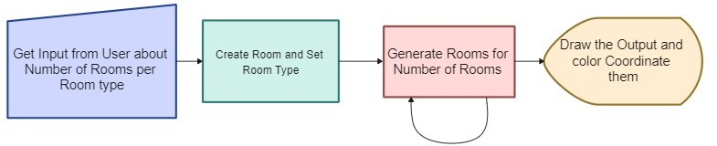

* + Obtain the user's feedback regarding the number of rooms per room type.
  + Establish a room and its type.
  + Create as many rooms as you need according to the room type's parameters.
  + Create the output and assign colours to the rooms in accordance with the ones the user has selected.

# RESULT & DISCUSSION:

Overall, our AI model offers a simple technique to create 2D floor plans, making it quick and simple to create a floor plan. We introduced additional specs room for users to provide their own thoughts, which will make the design more distinctive, to help our AI model produce results that are more accurate and meet the users' parameters.

# SCREENSHOTS

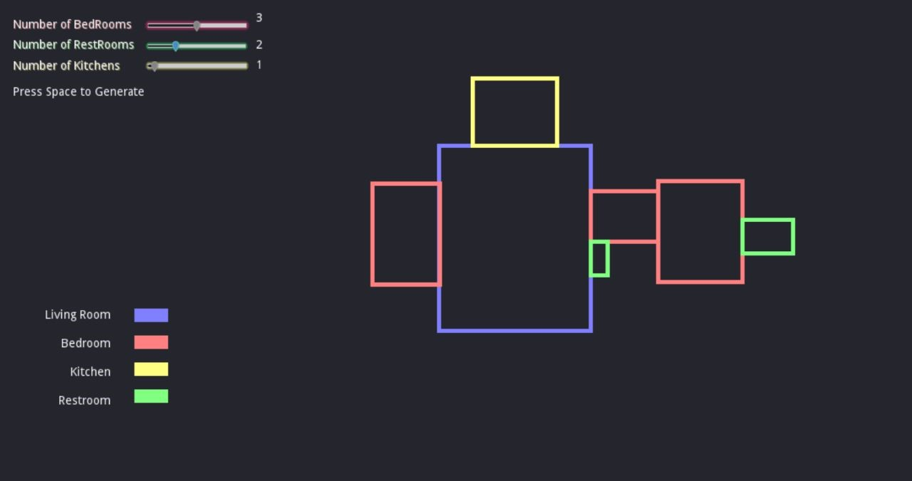

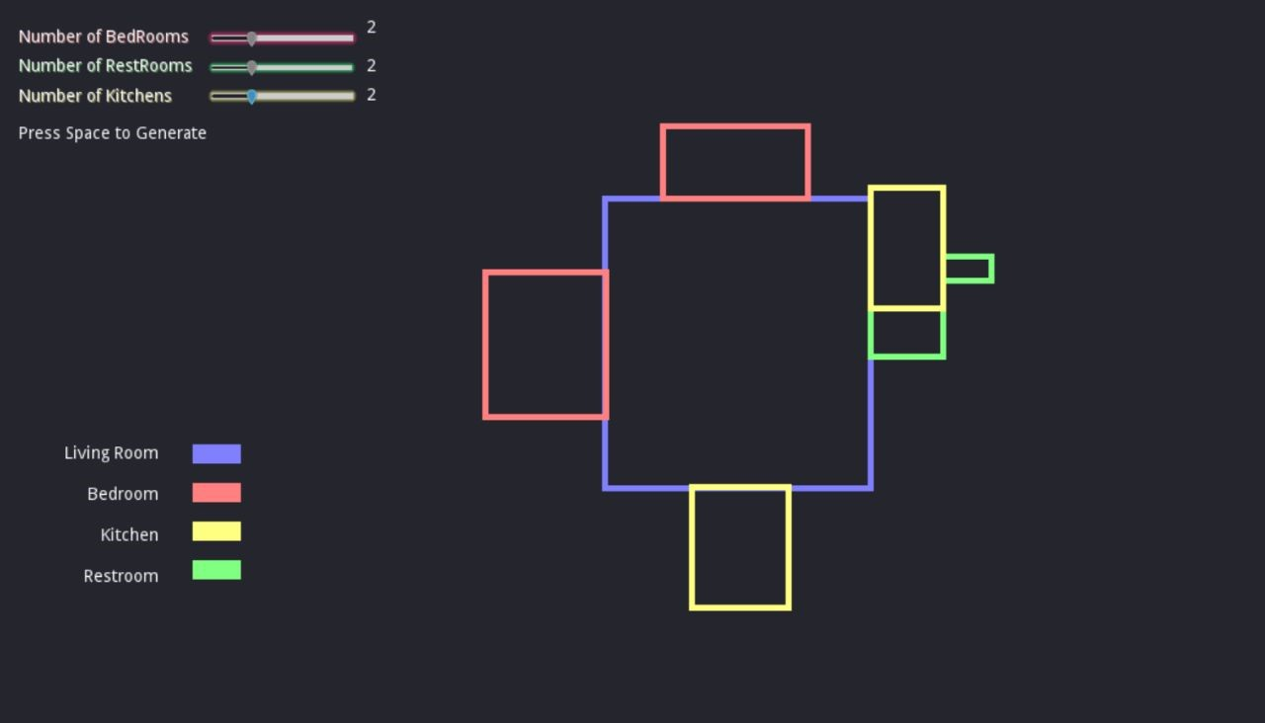

**7.CONCLUSION:**

In conclusion, our AI has a wider range of applications than the current floor plan creation tools and software. In the future, we intend to expand our project by teaching our AI to produce results that are more accurate by having users input more precise parameters for each individual room as well as information about how many people should be in each room and what kinds of objects should be present.

# 8. REFERENCE:

1. "Generation of Floor Plan Variations with ConvolutionalNeural Networks and Case- based Reasoning" by Viktor Eisenstadt, Christoph Langenhan, Klaus-Dieter Althoff
2. "Hybrid Evolutionary Algorithm applied to Automated Floor Plan Generation" by Maciej Nisztuk and Paweł B. Myszkowsk
3. "When AI meets store layout design: a review" by Kien Nguyen, Minh Le, Brett Martin, Ibrahim Cil & Clinton Fookes