BLOCKCHAIN IMPLEMENTATION IN MEDICAL PRODUCTS SUPPLY CHAIN MANAGEMENT

Punam Deshmukh , Utkarsha Erande, Rahul Khemnar, Vishal Chavhan,

Prof . Sharad Rokade .

Sir Visvesvaraya Institute Of Technology, Nashik, India.

ABSTRACT

In today’s global market, supply chain management is critical. It has a significant influence on the global economy. SCM is often defined as the movement of goods from producer to consumer. It is divided into phases, starting with the supply of raw materials and ending with the client, and includes the producer, distributor, and retailer. It is a global process in which components are sourced from a single location, packaged, and supplied globally. The supply chain can benefit from the blockchain’s transparency and immutability. Authentication of Products is very crucial to stop counterfeiting. this system is also used for the identification and verification of products and detects fake products so that users do not need to rely on third-party users for confirmation of product safety.

Although much attention has been paid to blockchain technology research in the area of supply chain management, neither the research findings nor the blockchain technology decision-making model has been developed to address the control of the supply chain for medical products and medicines. This study examines and develops a blockchain-based supply chain management system for medical equipment. Based on the entire life cycle supply chain management model, a medical product supply chain supervision model and a medical equipment supply chain supervision system based on blockchain technology were created. Using blockchain technology and full life cycle theory, a medical product management system that covers the entire production, supply, tendering, procurement, storage, application, export, use, destruction, and traceability of medical equipment was designed.

Keywords: Blockchain Technology, Full Life Cycle, Medical Equipment Supply Chain, Management Methods

1. INTRODUCTION

Medical products supply chains are complex networks that go across numerous organizational and geographic boundaries and serve as the structural backbone for many services that are essential to daily living. Such systems' intrinsic complexity makes it possible to add impurities like erroneous data, a lack of transparency, and weak data provenance. Supply chain management involves many phases wherever the info flows in each direction to/from suppliers, makers, distributors, retailers, and users for fulfilling the market needs. It includes the demand for medical products from the market and provides the products through totally different phases of supply chain management.

Counterfeit medicine is one consequence of such limitations at intervals existing provide chains that not solely have a serious adverse impact on human health but conjointly cause severe economic loss to the tending business. Consequently, existing studies have stressed the requirement for a strong, end-to-end track and trace system for pharmaceutical provide chains. a careful review of the literature presents many gaps and opportunities for a comprehensive application of blockchain technology for drug traceability. during this context, the first contributions of this text may be summarized as follows:

* We tend to propose a blockchain-based resolution for the pharmaceutical provide chain that gives security, traceability, fixity, and accessibility of knowledge birthplace for pharmaceutical medicine.
* We tend to design a contract capable of handling varied transactions among pharmaceutical provide chain stakeholders.
* We present, implement and take a look at the smart contract that defines the operating principles of our planned resolution.

1. LITERATURE SURVEY

Srikrishna Shastri C1 et. al. proposed a Fake Product Detection Using Blockchain Technology. This technique does have a limitation that is lack of transparency Throughout the Supply Chain. Absence of an immutable ledger on this other paper. If there is any, then it is not secure enough. As a result, the website was hacked [1].

Dnyaneshwar J. Ghodea et.al. proposed Architecture to Enhance Transparency in Supply Chain Management using Blockchain Technology but it meet to difficulties when scaling up the implementation[2].

Bhagya Hegde et.al. proposed a Supply Chain Management Using Blockchain Technology but it have improper information flow, lack of trust between partners. There is no proper use of smart contracts. As a result, there’s a risk that critical information will be tampered with [3].

Ajay Funde et.al. proposed a Blockchain based fake product identification in supply chain have limitation that is the transaction system is broken. Both the vendor and the buyer’s trust are affected, they provide a very difficult refund procedure. Because of this, many unwanted situations are faced by customers [4].

EXISTING SYSTEM

However, the existing supply chain management processes lack in offering transparency of information, user’s privacy, timely updates on demand peaks, improper tracing of information, quality management, deal repudiation and trust among users.

RELATED WORK

In literature, only a few attempts are made towards pharmaceutical chain management using blockchain. Dnyaneshwar J. Ghodea et.al proposed an Architecture to Enhance Transparency in Supply Chain Management using Blockchain Technology.

The main idea behind Supply Chain Management is that various organizations in SC by exchanging data concerning market variations and product abilities. A simple network of SC consists of a manufacturer, distributor, retailer, and consumer that has been use to test the Blockchain Technology [3].

1. It allows two parties to perform direct transactions using their distributed ledgers without a centralized third party's interference to achieve more transparent transactions than traditional systems.
2. Here, consequently, the architecture of BT in SC has been developed based on factors identified that lead to offering tracking and monitoring of the entire SC.
3. It has difficulties when scaling up the implementation. It contains a lack of improvement in the level of security of data.
4. IMPLEMENTATION / PROTOTYPE
   1. OBJECTIVE AND DESIGN GOALS:
      * Objective is to style a trustworthy and distributed framework for pharmaceutical supply chain management, whereas fulfilling the subsequent needs.
      * The planned framework offers user privacy, knowledge transparency, fixity, high convenience and real time chase and tracing capability. additionally, it ought to perform drug quality management and demand foretelling, which may facilitate for higher readiness to avoid any

drug crisis.

* + - Designing anti counterfeit medical product supply system using blockchain.
    - System will reduce main challenges of medical product supply chain like paper work, counterfeiting, high cost, intractability, lack of transparency in data.
    - System will offer security to the product information that cannot be modified easily and also verify products detail or identity.
  1. SYSTEM ARCHITECTURE

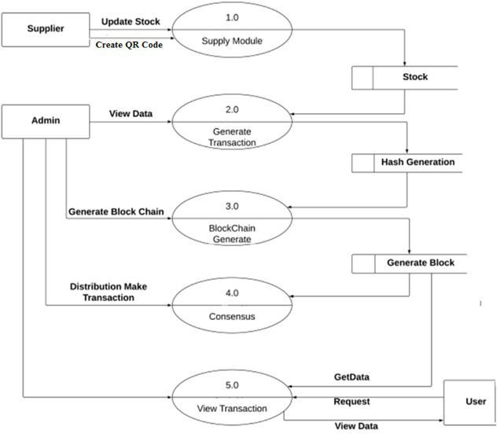

Fig 1: Data Flow Diagram

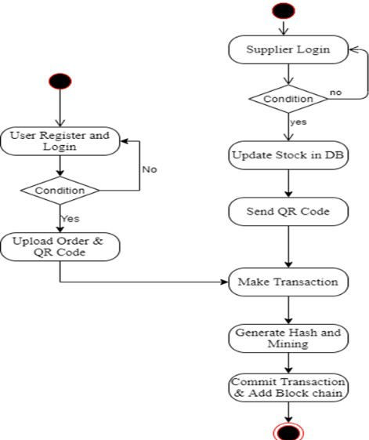

Fig 2: Activity Diagram

- SYSTEM FEATURE

The system contains following modules:

1. Admin
2. Make transaction
3. Block Generation and blockchain validation
4. Consensus Algorithm validation and block chain recovery
5. Results Generation

The specific roles and functionalities :

1. Owner
   1. CREATE a new user to be added to the chain.
   2. READ the information of any user.
   3. UPDATE the roles of a user.
   4. DELETE a user from the chain.
2. Transporter
   1. Verify the package (Raw Material or Medicine).
   2. Pick the package from an entity (based on transporter type).
   3. Deliver the product to an entity.
3. Supplier
   1. CREATE a Raw Material.
   2. GET the addresses of the Raw Materials created.
4. Manufacturer
   1. Receive the Raw Material from the Supplier through the Transporter.
   2. Verify the source of the product received.
   3. CREATE a new Medicine using received raw materials.
5. Wholesaler
   1. Receive the medicine from the manufacturer through the Transporter.
   2. Verify the source of the medicine.
   3. Transfer the ownership of the medicine.
6. Distributor
   1. Receive the medicine from the Wholesaler through the Transporter.
   2. Verify the source of the medicine.
   3. Transfer the ownership of the medicine.
7. Customer
   1. Receive the medicine from the Distributor through the Transporter.
   2. Verify the source of the medicine.
   3. Place orders using the Rasa chatbot.
   4. Get medical drug information.
8. ALGORITHMS

Algorithm 1: Hash Generation

Hash algorithms are use to create unique hash value each time when block is generated. Throughout this we use create DataNode() to create data nodes . we create four data nodes to distribute the transaction of blockchain running on different node to enhance security which helps to implement Smart Contracts.

Algorithm 2: Mining Algorithm for valid hash creation.

Mining is performed using chain consensus algorithm. Mining algorithm calls to check previous transaction with the help of previous hash generated.

Algorithm 3: Validating Blockchain.

It’s used to check whether given blockchain is valid or not on the bases of previous hash generated using isChainValid() function.

Algorithm 4 : QR generation

To implement product verification QR code check is performed.

It uses com.google.zxing liberary for generation of unique QR for each running blockchain to validate transaction performed and product verification.

1. OUTPUT

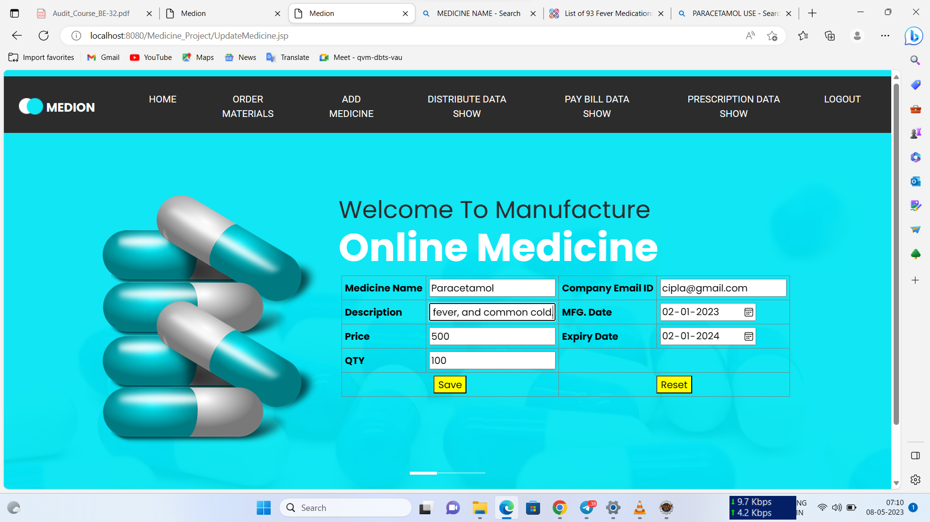

Fig . Manufacturer – Add product

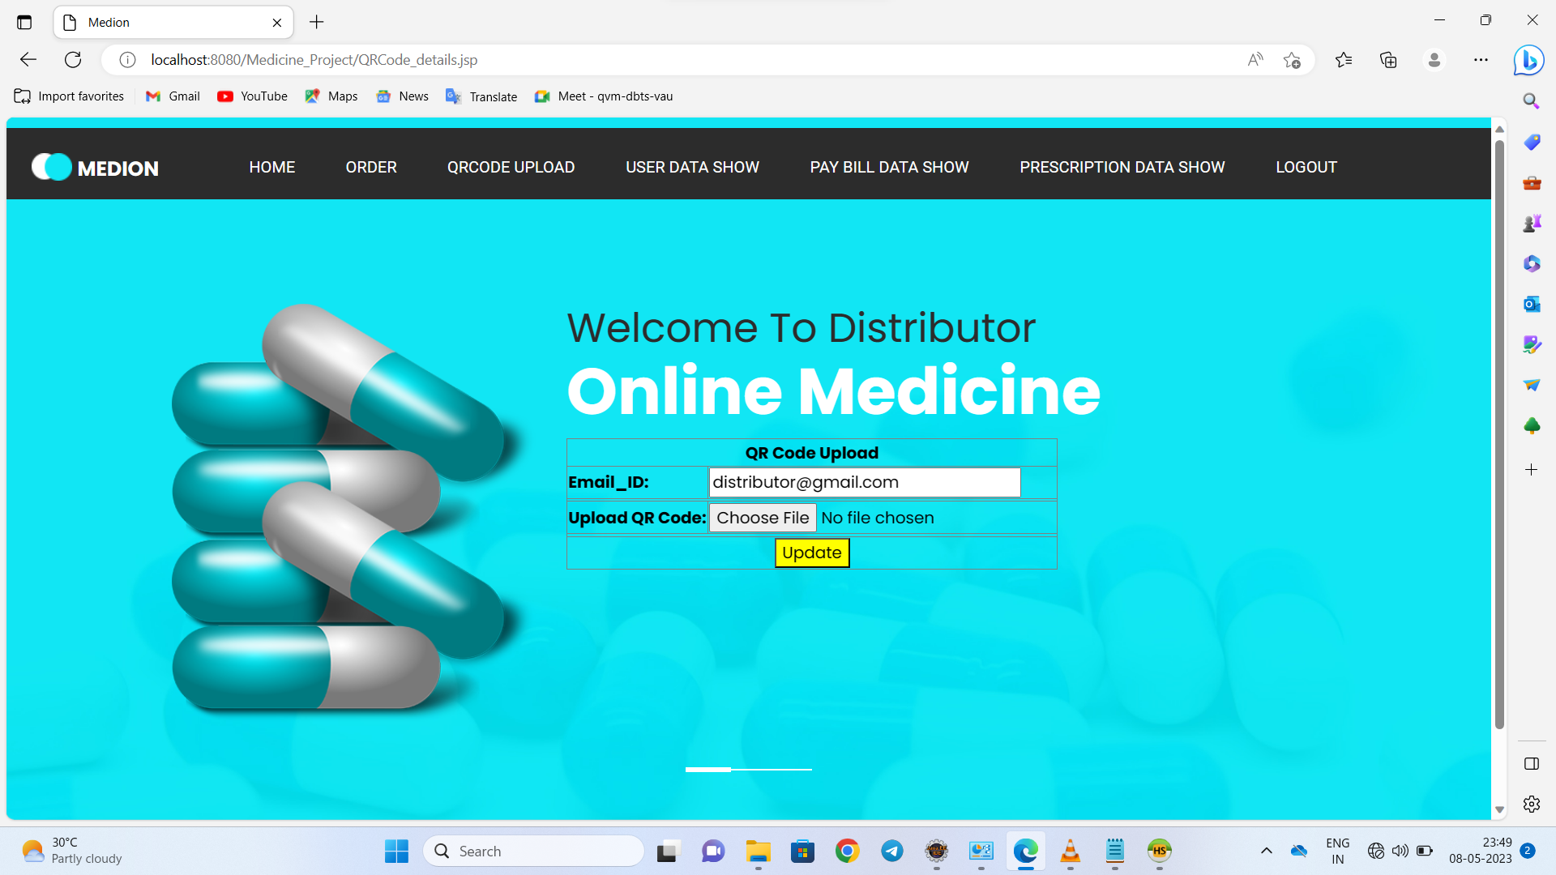

Fig . Distributor – Upload QR for product verification

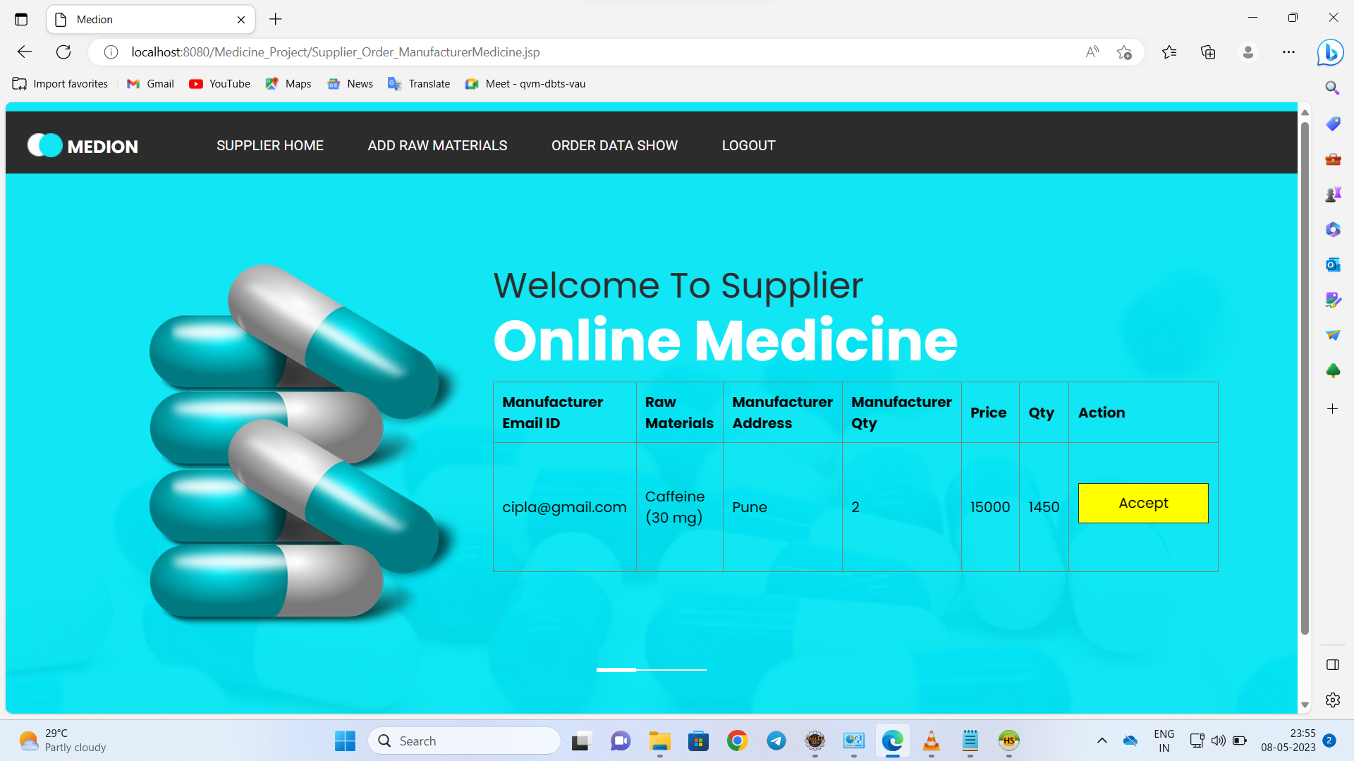

Fig . Accept Order form customer

1. CONCLUSION

In this paper, we have proposed a framework for medical products supply chain management using the distributed ledger technology and smart contracts. The proposed smart contracts deployed over Ethereum blockchain help in achieving user privacy, data transparency, immutability, high availability, no single point of failure, non-repudiation, real time tracing of drug, and demand supply management. The experimental results and analysis of the proposed system is very encouraging to develop a proof of concept of the proposed system. In future, different machine learning techniques can be investigated for the demand prediction. Blockchain has a scalability issue, and thus the transaction speed may be slow down in the proposed system. Researchers are still focusing on addressing this issue.

1. REFERENCES
2. Srikrishna Shastri C1 et. all “Fake Product Detection Using Blockchain Technology” IJARCCE - 2021.
3. Dnyaneshwar J. Ghodea et.al. “Architecture to Enhance Transparency in Supply Chain Management using Blockchain Technology” Elsevier Ltd 2021.
4. Bhagya Hegde et. Al. “Supply Chain Management Using Blockchain Technology” IEEE 2020
5. Ajay Funde et. all “Blockchain based fake product identification in supply chain” IRJET – 2019
6. A. Gaffney, “How blockchain could help secure the pharmaceuticalsupply chain,” PwC, 2018. [Online.] Available:https://[www.pwc.com/us/en/industries/health-industries/library/blockchain-could-](http://www.pwc.com/us/en/industries/health-industries/library/blockchain-could-) helpsecure-the-pharmaceutical-supply-chain.html
7. D. Kapoor, R.B. Vyas, and D. Dadarwal D, “An Overview on Pharmaceutical Supply Chain: A Next Step towards Good Manufacturing Practice,” Drug Designing Intellectual Properties International Journal, 2018.
8. D. Vujicic, D. Jagodic, and R. Sinisa, “Blockchain technology, bitcoin, and Ethereum: A brief overview,” 17th International Symposium INFOTEH-JAHORINA (INFOTEH), 2018, pp. 1-6.
9. S. Chen, R. Shi, Z. Ren, J. Yan, Y. Shi and J. Zhang,” A Blockchain based Supply Chain Quality Management Framework”, The Fourteenth IEEE International Conference on e-Business Engineering, 2018, pp. 172-175