The effect of grading on the hydraulic properties of the GSB mixture

Rahul Kumar Singh1**,**Mr. Pardeep**2 ,** Shubham Sharma3**,**

1M.tech Scholar, Satpriya group of institutions, Rohtak, India.

2Assistant Professor, Satpriya group of institutions, Rohtak, India.

3M.tech Scholar, Satpriya group of institutions, Rohtak, India.

**ABSTRACT**

The main purpose of providing granular subgrades (GSB) in road pavements is to serve stability and drainage function. In India, pavement design guidelines recommend design thickness of GSB based on subgrade strength and design traffic conditions. By studying the permeability of the GSB mixture, it is necessary to understand the significance of the drainage capacity of the GSB mixture in pavement design. The main objective of this study is to compare the permeability properties of GSB mixture prepared with different grain sizes based on the Talbot method in order to assess their ability to drain water based on permeability criteria. The permeability test is carried out in the laboratory to obtain the hydraulic characteristics of the GSB mixture. Laboratory studies were performed according to Talbot guidelines. Conclusion from the laboratory studies that the gradation specification needs to be appropriately changed to use locally available materials in the specified range of 90.00 mm to 200 µm with permeability criteria along with strength parameter CBR value.

**Keywords :** Talbot, CBR value, permeability, GSB layer, consolidation, deformation

INTRODUCTION

Granular Sub Base Course (GSB) provided as one of the structural layer of pavement should also serve as an effective drainage layer. In India current guidelines recommend using natural sand, moorum, gravel, crushed stone, or combination of these, in GSB layer. Crushed slag, crushed concrete, brick metal and kankar may be allowed in specific cases. While the above combinations may fulfil the structural requirement, it is not clear whether they meet the minimum drainage requirements of 300 m/day (3.47mm/sec.) as per AASTO specification. Drainage quality is an important parameter which affects the highway pavement performance. Excessive water content in the pavement base, sub-base, and sub-grade soils can cause early distress and lead to early failure of the pavement. Thus, when selecting appropriate maintenance strategies the cost of pavement maintenance needs to be compared with the cost of improving the quality of drainage. Hence,

there is a need to quantify the effect of various 3) types of drainage quality on performance of the of pavement However, very few studies have e investigated to what extent quality of drainage es affects the performance of pavement. Therefore, , this study identifies a simple framework for 3 quantification of effect of drainage quality on performance of the pavement.

Granular sub base layer is used in the construction of flexible pavement to provide a stress transmitting medium to spread the surface wheel loads in such a manner as to prevent the shear and consolidation deformation.

Besides these layers are also acting as drainage layer so that capillary water cannot rise above the GSB layer. The capillary rise is likely to be detrimental if the water is reaching the subgrade. These layers are made of a granular materials (mixing with the crushed aggregates, murrum, gravel) of specified gradation, limit size of the ingredients. Generally the material used are rarely available with the required gradation the required strength parameter CBR. Therefore a proper mixing of the locally available material is satisfies the CBR value but still there is still debate over permeability of GSB layer. An improper mechanism of mix design may leads to the lesser resistance to sinking in to weak subgrade soil leads to GSB materials to penetrate in to the soil forming the undulations and uneven surface in the flexible pavement.

The GSB generally make up the greatest thickness for the pavement structure and provide bearing strength and drainage for the pavement structure. Hence, proper size, grading, shape, and durability are important attributes to the overall performance of the pavement structure. The GSB layers particularly bottom layers should be designed to have sufficient permeability offering negligible resistance to the flow and also to resist the flowing of foundation material (Sub-grade) resulting in problems like piping at transverse pavement joints in roads subjected to a large volume of traffic.

OBJECTIVES  
  
In order to study the drainage properties of pavement base materials, an experimental study was conducted to determine the coefficient of permeability of different types of grading of pavement base materials. The following objectives were established for this research: 1. To determine the physical properties of aggregates to be used in various gradings of GSB mixes.

II. LITERATURE REVIEW

* Cedergren et al. (1973), Due to subsurface water in Portland cement pavement (PCC) ejection of water and fines, called pumping, occurs at the joints between slabs and/or edges between slabs and shoulders. If pavement structure and subgrade becomes saturated by infiltration, its ability to transmit the dynamic loading imposed by traffic can be greatly impaired.
* Moulton (1980), (1). Subsurface water can contribute to slope instability by increasing the stress level and decreasing the shear strength of the soil or rock mass along a potential sliding surface. (2) The effect of excessive subsurface water reduces the pavement performance by increasing the growth of premature rutting, cracking, faulting, increasing roughness, and a relatively rapid decrease in the level of serviceability.
* Veeraragavan and Shailendra (2010) carried out "sub surface drainage is a key element in the design of pavement system. An optimum performance of a pavement system can be achieved by preventing Water entering by means of a well designed subsurface drainage system. Inadequate subsurface drainage continues to be identified as a major cause of pavement distress. The entrapment of water within the pavement leads to a "bathtub" condition resulting in premature failures and pavement distresses. This leads to large amount of costly repairs or replacement to the pavements long before they reach their design life. Hence there is need to carry out research work in India to demonstrate and quantify the impact of drainage on pavement performance to reduce the future maintenance cost and preserve the road assets.
* Rokade et al. (2012) "The drainage design criteria used in the past have been based on the assumption that both the flow of water through pavements and the drainage of pavement layers can be represented with saturated flow assumptions. The detrimental effects of water can be reduced by preventing water from entering the pavement, providing adequate drainage to remove infiltration, or building the pavement strong enough to resist the combined effect of load and water. Pavement service life can be increased by 50% if infiltrated water can be drained without delay. Similarly, pavement systems incorporating good drainage can be expected to have a design life of two to three times that of un-drained pavement sections".

III. RESEARCH METHODOLOGY

Material properties & methods of testing

Specific Gravity: The specific gravity tests were conducted on material to know the porosity of the material to be filled in permeameter for hydraulic test. The tests were carried out using Pycnometer method and following equation was used for calculating specific gravity Gs.

Gs = (W2-W1) / (W4-W3)+(W2-W1)

Where

W1- weight of empty Pycnometer

W2- weight of Pycnometer + dry material

W3- weight of Pycnometer + material + water W4-weight of Pycnometer + water

Bulk Density: The bulk density of aggregates is measured by using a mould having diameter six times more than the size of aggregate. The following equation is used to find out the bulk density of aggregate.

Ýb = Ms/Vt

Where

Ýb - bulk density

Ms - mass of aggregate

Vt – total volume of aggregate

Impact test: Impact test is carried out tp determine the impact value of coarse aggregate passing through 12.5mm IS sieve and retained on 10mm IS sieve. Following formula is used to determine the aggregate impact value

AIV = [C/A]*100

Where

AIV - Aggregate impact value

C – weight of fraction passing through 2.36mm IS sieve

A – total weight of original sample

Water absorption test: Water absorption of aggregate is carried out to determine the resistance of aggregates against weather action. The maximum value of water absorption of aggregate should not be more than 0.6 percent of total weight of dry aggregate.

Water absorption = wt. of water absorbed

Total wt. of aggregate

Talbot method for gradation:

For over one hundred years, efforts have been made to achieve desired properties through adjustment in aggregate gradation.

Fuller and Thomson research on aggregate gradation in 1907 and developed an ideal shape of gradation and concluded that aggregates should be graded in sizes to give the greatest density. But, unfortunately it was noted that the conclusion given by them does not always give the maximum strength or density.

So later on, in 1923 Talbot and Richard created the formula for gradation. This method is used to prepare the proportion of different size of aggregate for making the sample

P = {d/D} n

Where

P- percentage of aggregate passing through the sieve

d- Sieve size

D- Max. size of aggregate

n- Talbot coefficient

Table 1 Physical properties of aggregate

|  |  |  |  |  |
| --- | --- | --- | --- | --- |
| Size of agg. | Specific Gravity | Bulk Density  (kg/m3) | Impact value  (%) | Water absorption (%) |
| 4.75 | 2.66 | 1392 | 17.92 | 0.53 |
| 9.5 | 2.67 | 1435 |
| 19 | 2.75 | 1495 |
| 26.5 | 2.83 | 1503 |
| 37.5 | 2.85 | 1515 |

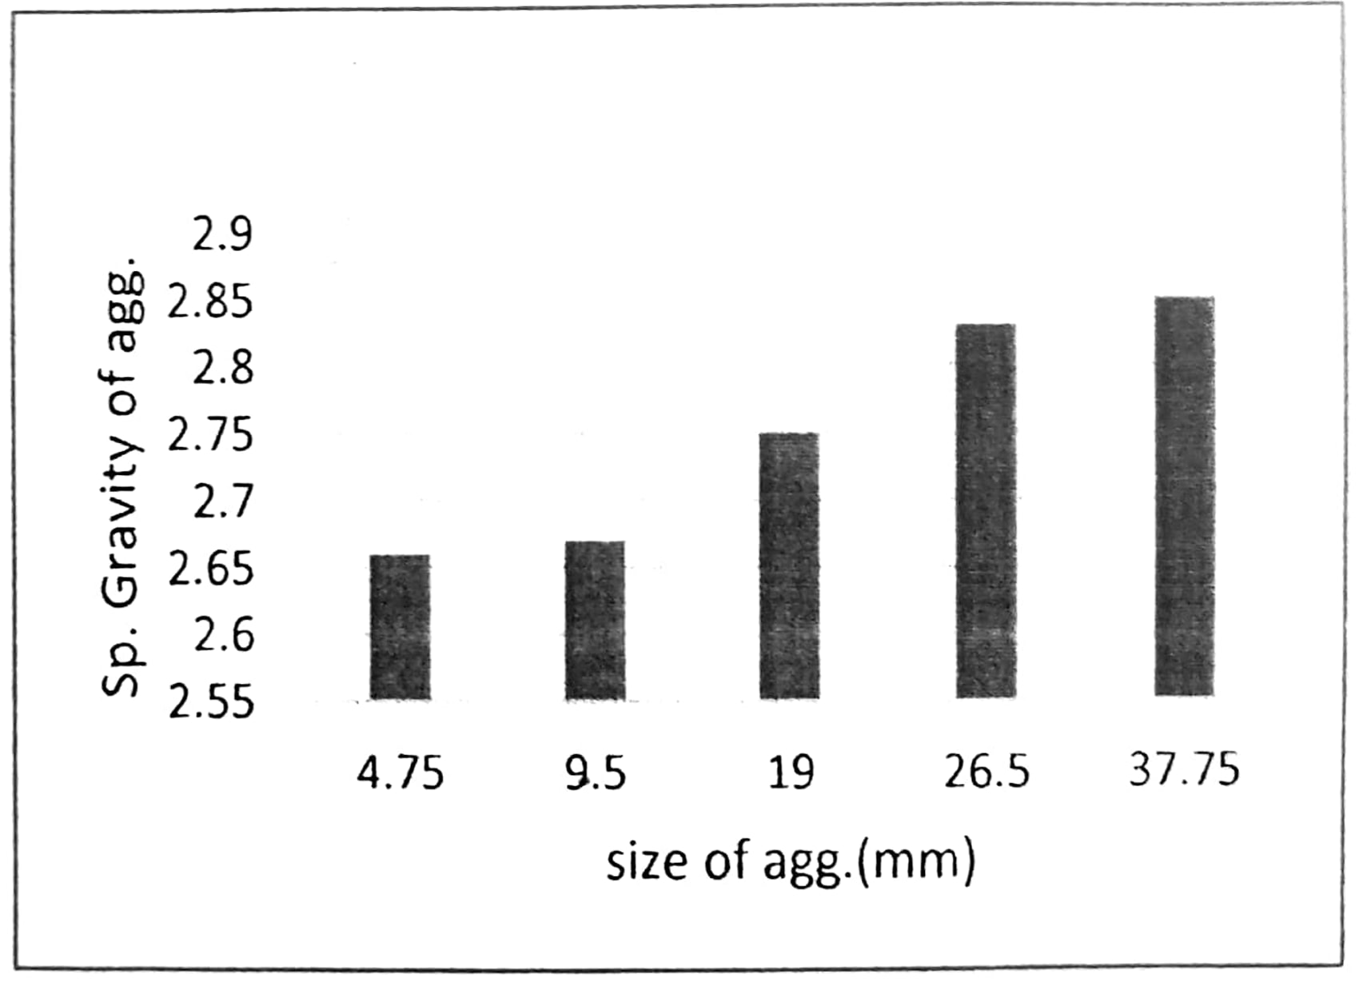

Fig.1: Specific Gravity of aggregates

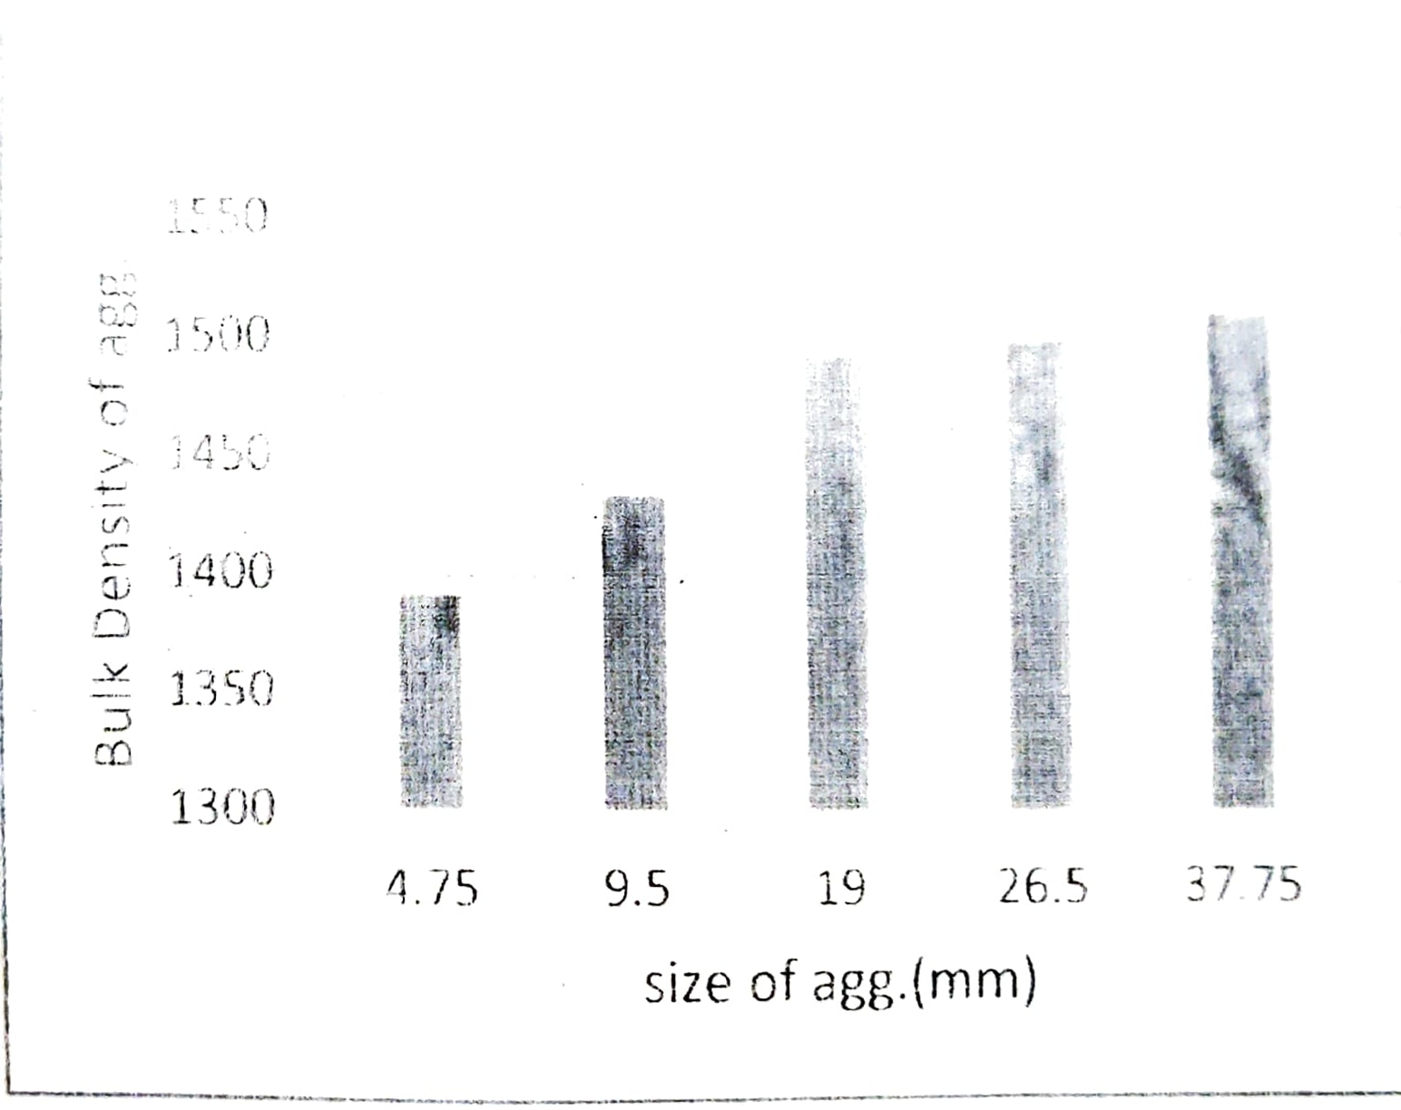

Fig. 2: Bulk density of aggreagtes

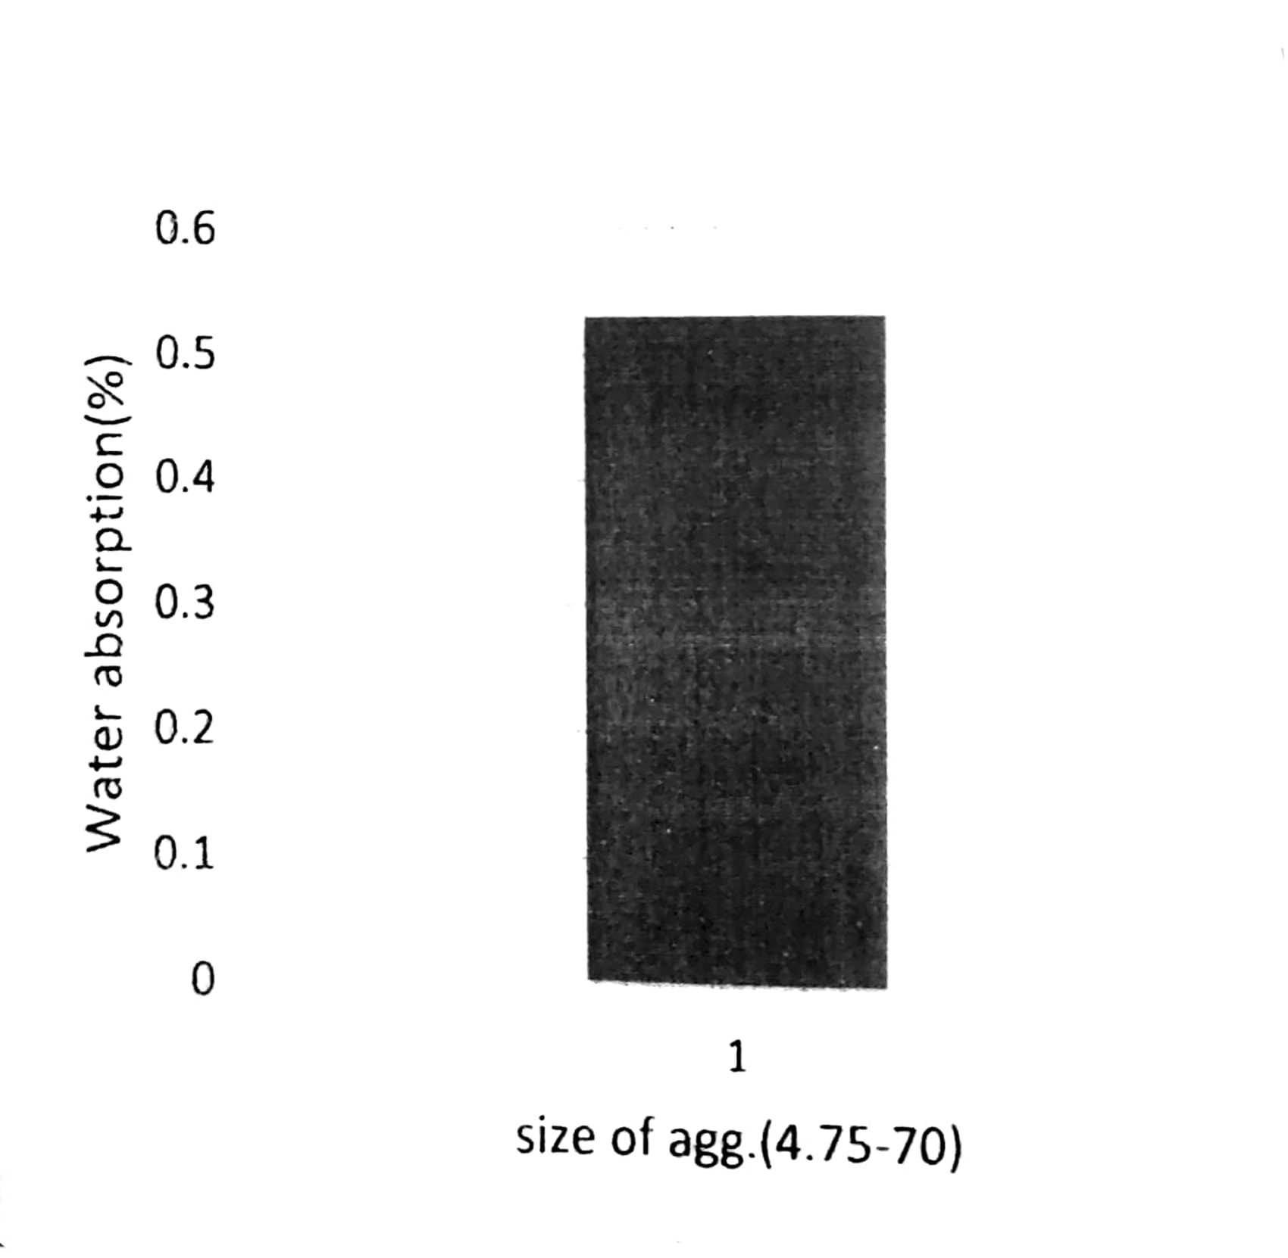

Fig.3: Water absorption of 4.75-75mm aggregates

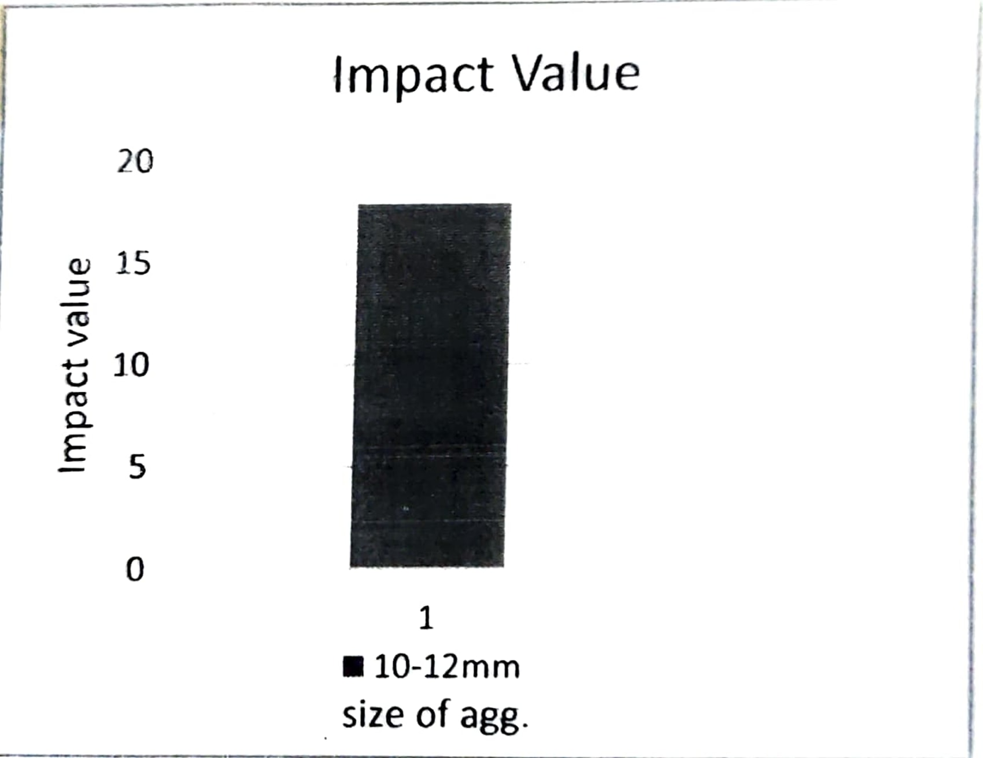

Fig.4: Impact value of aggregates

IV CONCLUSION

* Drainage is a key element in the design of pavement system. However inadequate drainage leads to major cause of pavement distress due to large amount of costly repairs or replacements long before reaching their design life.
* There is an urgent need to study the effect of drainage quality on pavement performance in India and quantify the benefit of the good drained system with respect to un-drained or poor drainage system.
* Effective drainage in roads is a critical requirement for ensuring stability and preventing the failure of pavement.
* It is expected that this study will useful to quantification of effect of drainage quality on pavement performance and improve the highway drainage system, thus to reduce the maintenance cost of highway pavement system and hence will be useful to preserve huge highway network in India.

V REFERENCES

* IS 2386 part III (1963), Method of test for aggregate for concrete, Specific Gravity, Density, Impact value, and Water absorption, Bureau of Indian Standards (BIS).
* IS: 2720 (Part 4) (1985), Determination of Impact Value, Aggregate crushing value and Abrasion value, Bureau of Indian Standards, New Delhi, India.
* IS: 2720 (Part 17) (1986), Laboratory Determination of permeability, Bureau of Indian Standards, New Delhi, India.
* IRC: SP 42 (1994), "Guidelines on Road Drainage", Special Publication, Indian Roads Congress, New Delhi.
* IRC: SP 50 (1999), "Guidelines on Urban drainage". Special Publication, Indian Roads Congress, New Delhi.
* Khanna, S.K., and Justo, C.E.G., (2001). "highway engineering", New Chand and Bros Publication, 8th edition, New Delhi. • IRC: 37 (2001), "Guidelines for the Design of Flexible Pavements" Indian Road Congress New Delhi.
* Kumar, P.. Chandra, S. and Vishal, R. (2006): "Comparative study of different sub-base materials" Journal of materials in civil engineering ASCE /July/august, pp576-580.
* Veeraragavan, and G. Shailendra, (2010). "Research Need in Subsurface Drainage for Long Lasting Pavements." Highway Research Journal, January -June 2010,pp. 1-23. Rokade, S.. Agarwal, P.K., and Shrivastava, R. (2012), Drainage and Flexible Pavement Performance. International Journal of Engineering
* Science and Technology, Vol. 4, 2012, pp. 1308.
* IRC: 37 (2012), tentative guidelines for the design of flexible pavements. Ministry of Roads, Highways and Transport (2013). 5th revision, Government of India.