**AUTOMATED RAILWAY MONITORING SYSTEM**

**Prof. Bharath Bharadwaj B S1, Mr. Bharath H R2, Ms. Roopa B3, Ms. Shruthi M4, Ms. Varsha M5**

1 Assistant Professor, Dept. of Computer Science and Engineering, Maharaja Institute of Technology Thandavapura

2,3,4,5 Student, Dept. of Computer Science and Engineering, Maharaja Institute of Technology Thandavapura

**Abstract**

**Telecommunication and computing technologies are crucial in solving real-world problems, particularly in developing countries where issues with railway-level crossings remain prevalent. The consequences of level-crossing accidents can be severe, resulting in fatalities, injuries, and vehicle damage, which can have a significant impact on a country's economy. To address this issue, an IoT-based framework for an automatic railway gate controller has been designed. The primary objective of this framework is to automate the opening and closing of railway gates upon the arrival and departure of trains, respectively, the primary objective of the proposed model is to minimize the occurrence of accidents, especially at unmonitored railway crossings. This system also reduces the time for which the gate remains closed, providing a more efficient and reliable operation. The proposed gate controller is suitable for unmanned level crossings, where accidents are more likely to occur, and manual operation errors can be prevented through the automatic operation of the system. The system operates using an Arduino-based system, which receives input signals from two sensors and sends information to the gate motor driver to open and close the gate. The arrival and departure of trains are monitored, and the gate is operated accordingly. Overall, the implementation of an automatic railway gate controller utilizing IoT technologies has the potential to significantly reduce the number of accidents at level crossings, promoting safer and more efficient transportation.**

***Key Words*: IoT Technologies, Arduino, Sensors.**

# **Introduction**

India has the largest railway network in the world, with hundreds of trains operating on its tracks daily. However, it is difficult to stop a moving train immediately in the event of an emergency, resulting in serious consequences such as loss of human life, injury, and damage to railway property. Therefore, railway safety is of utmost importance for rail operations worldwide. Railway safety is particularly crucial in India, where the railway is the cheapest mode of transportation, resulting in an increased likelihood of accidents due to careless manual operations. Currently, the Indian Railways currently has a total of 31,846 level crossings, out of which 18,316 are manned while 1,350 remain unmanned. A survey conducted by the Indian Railway found that 38.2% of total railway accidents in India are crossing accidents, the majority of which occur at passive railway crossings. This underscores the importance of implementing an "automatic gate controller" to enhance safety and security for railway travelers.

Unmanned railway crossings are particularly prone to accidents, often caused by the carelessness of road users or the lack of workers. We can leverage the benefits of the proposed model to overcome the challenges faced by the current system. Firstly, it aims to reduce the time for which the gate is kept closed, and secondly, to provide safety to road users by minimizing accidents caused by the carelessness of road users and the errors of gatekeepers. The system uses sensors placed at a distance from the gate to detect train departures. The system operates by transmitting information about the train's departure to a microcontroller that then operates the motor and opens the gate. As a result, the gate is closed for a shorter time compared to manually operated gates since the gate's opening and closing are determined by a telephone call from the previous station. Additionally, the system is highly reliable since it is not subject to manual errors.

# **RELATED WORK**

1. In 2022, Prof. R M Sahare authored a paper titled "Automatic Railway Gate Control System". The study aims to develop an automatic system for controlling railway gates at unmanned level crossings, which will replace the need for gatekeepers or semi-automatic gates, while also preventing accidents that may result from manual gate operation and inadequate knowledge about obstacles on the railway track. The major components of the model are a railway track, a toy train, IR sensors, AVR microcontroller, LED signals, servo motors, LCD Display, a buzzer. By reducing human intervention and ensuring accurate gate operation, this system improves safety, quality of service, and helps prevent accidents at unmanned railway level crossings. To make it completely automated it is needed to equip a never-ending source of energy that could operate the gates and the appropriate solution is the solar energy that can be obtained through the solar panels.
2. In 2019, Mst. Shamima Hossain conducted researched on “Automated Railway Track Changing Model with Real-Time Centralized Monitoring Interface”. This prototype capable of changing tracks automatically based on direction and position of the train and also can be controlled manually from a central office and also includes a real-time computer interface that can continuously monitor the position and movement of the trains that move along the tracks. This design is hoped to render a concept, proper execution of which may bring about a great change in the present railway system increasing efficiency, increasing profit and most of all rendering people a low-cost, time-efficient railway transport system.
3. In 2015, Karthik Krishnamurthy Monica Bobby and their team conducted research on the "Sensors-based automatic railway gate." The study aimed to develop a system that automates the operation of gates at level crossings using a microcontroller and detects collisions at the crossing level. The components used for the automation of the railway gate were infrared sensors. An infrared (IR) sensor detects radiation to sense movement in the surrounding environment. The study concluded that an automatic railway gate control system could reduce human involvement in the opening and closing of railway gates, thus preventing accidents involving vehicles and pedestrians crossing railway tracks. Therefore, automating the gate can enhance the safety and reliability of gate control.
4. In 2014, Anil M.D. and his team conducted research on the "Advanced Railway Accident Prevention and Controlling System Using Sensor Networks". The study focused on managing the increasing railway traffic worldwide and preventing accidents through the use of components such as IR sensors, fire sensors, Zig bee technology, and embedded systems to control track management. When the train arrives at a specific location, the transmitter IR sensors generate their respective signals, and at the same time, the receiver IR sensor receives the signal and stops the train.

# **EXISTING SYSTEM**

In India, railway crossings are manually operated by railway operators who are responsible for opening and closing the gates based on the arrival and departure of trains. The operator receives information about train schedules through communication tools. However, this system is prone to errors and has resulted in numerous accidents at railway crossings. Train information is relayed from one system to another as the train moves towards the crossing. Unfortunately, more than 50% of train accidents in India occur at railway crossings due to the existing flaws in the system. The current approach used by the Indian Railway system is not safe and has led to increasing accidents every year.

# **PROPOSED SYSTEM**

This paper aims to automate the lifting of railway crossing gates using a micro servo motor and gear arrangement. Two ultrasonic sensors are installed on either side of the gate. The Ultrasonic sensor transmitter, which is located in the engine and guard, transmits a signal to the receiver on the track when the train is approaching the crossing. When the receiver receives the signal, the gate is closed, and when the train passes through the other receiver on the other side of the gate, the motor is activated and the gate is opened. This system reduces the chance of accidents at unguarded crossings, where accidents are more likely to occur. It is fully automatic, reducing the likelihood of human error and making it more reliable. Advantages of this system include a reduced chance of human error, faster operation, improved safety and quality of service, and accident prevention.

# **SYSTEM ARCHITECTURE**

The system architecture of the Automated Railway Monitoring System using Arduino includes multiple components that work together to achieve the project goal. The main components include the Arduino Uno board, two ultrasonic sensors, a servo motor, red and green LED lights, and a buzzer. The two ultrasonic sensors are placed on either side of the railway track to detect the presence of a train approaching the crossing. The sensor data is processed by the Arduino Uno board, which sends a signal to the servo motor to open the gate and activate the red LED lights and buzzer to warn pedestrians and drivers to stop.

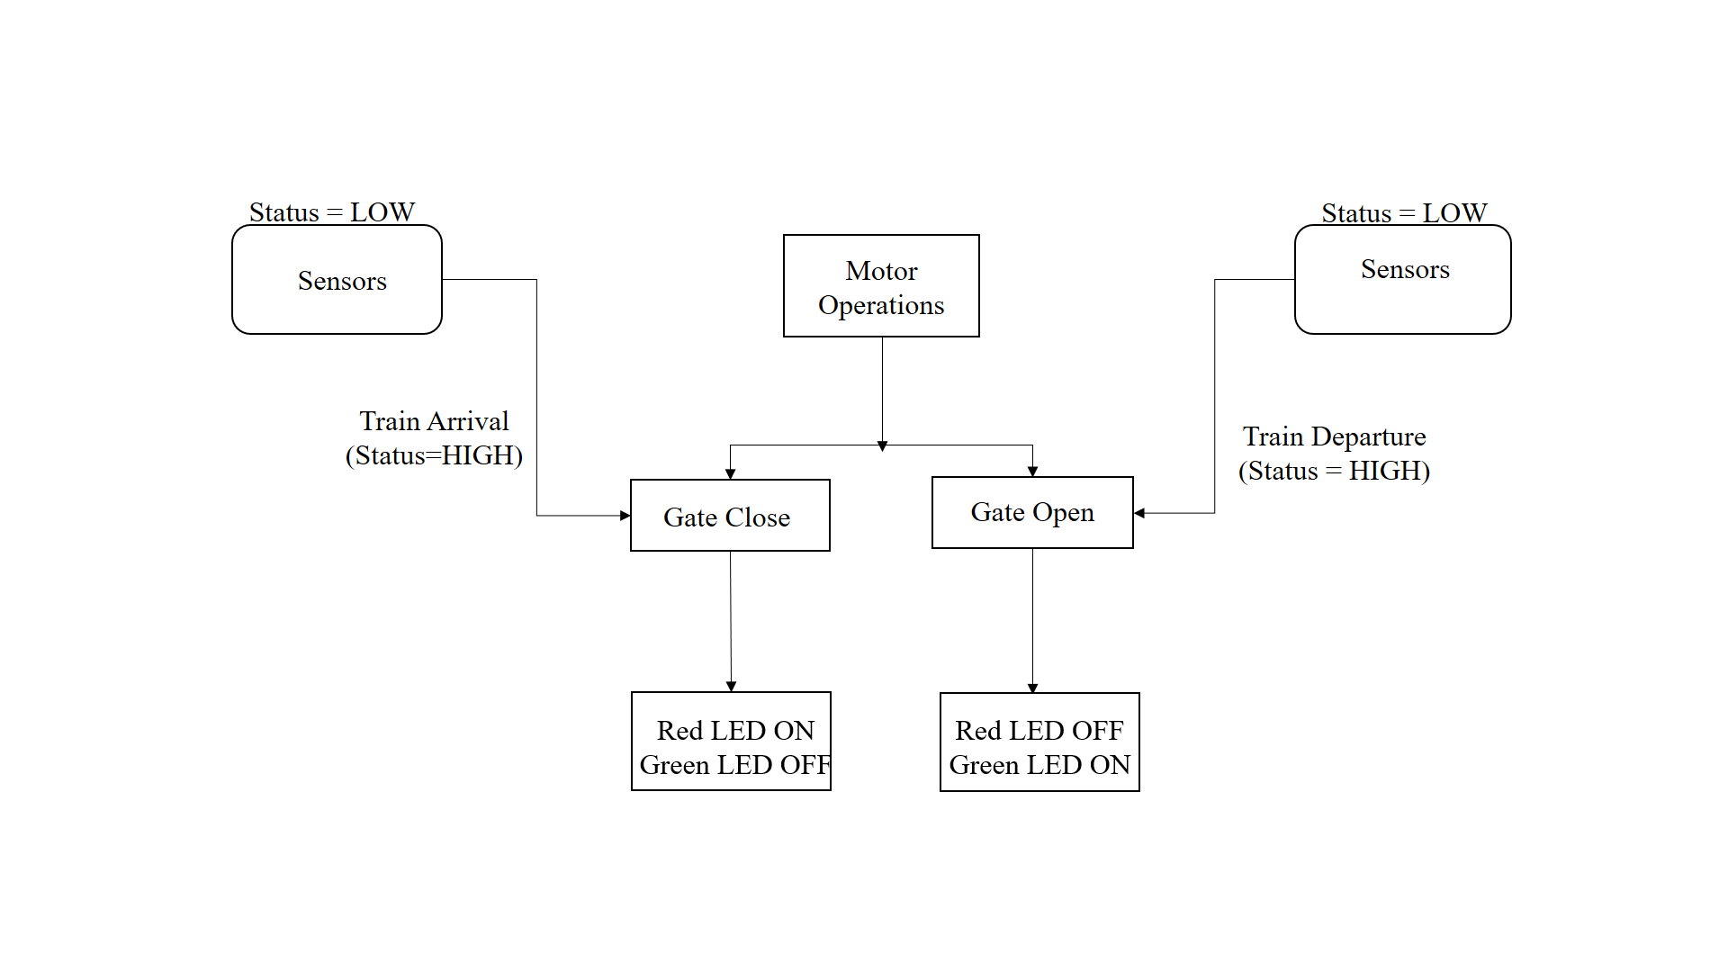

**Fig -1:** System Architecture

# **ALGORITHM**

Step 1: Start

Step 2: Set up the sensors to detect trains.

Step 3: Check for the arrival of train using sensors. If the train is detected, proceed to step 4 Otherwise, repeat step 3.

Step 4: Activate warning signals to alert road users of the oncoming train.

Step 5: Close the railway crossing gate to prevent road users from crossing the tracks.

Step 6: Check for the departure of the train using the sensors. If the train has departed, proceed to step 7 Otherwise, repeat step 6.

Step 7: Open the railway crossing gate to allow road users to cross the tracks.

Step 8: Return to step 2 to start the process again and wait for the next train arrival.

# **FLOW CHART**

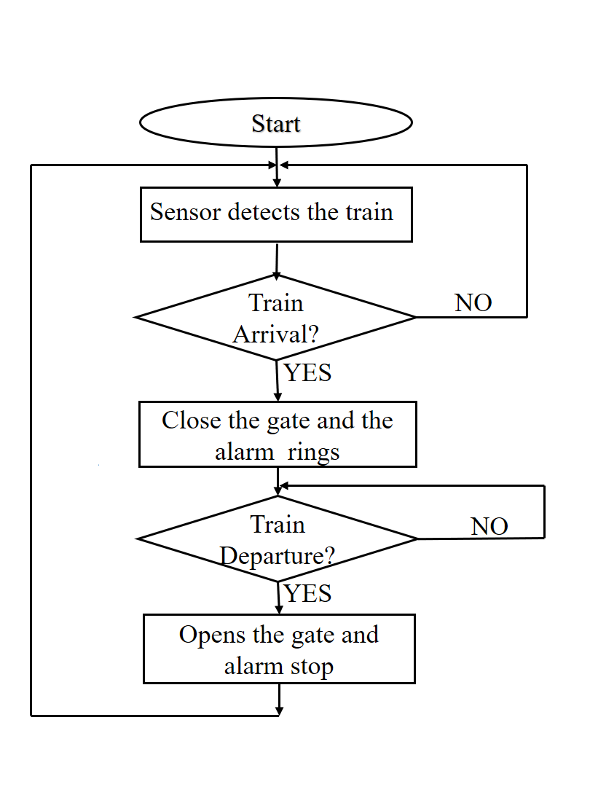

**Fig -2:** Flow Chart of Proposed System

# **SEQUENCE DIAGRAM**

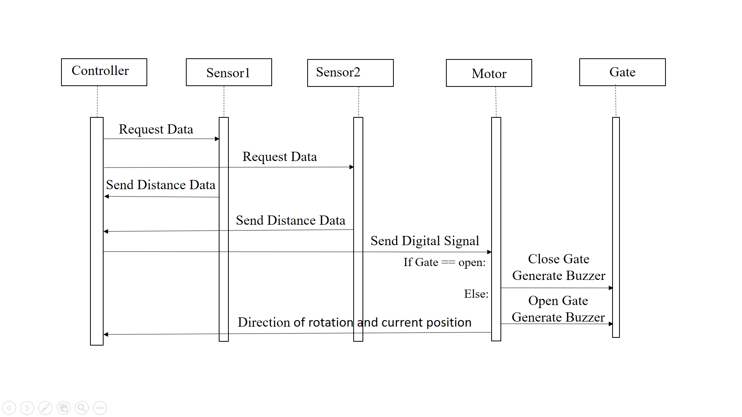

**Fig -3:** Sequence Diagram

In the context of the automated railway monitoring system, a sequence diagram can be used to depict the interactions between different components of the system. For example, the diagram can show how the ultrasonic sensors detect the presence of a train and send a signal to the Arduino board. The diagram can also illustrate how the Arduino board then activates the servo motor to open the gate and turn on the red LED lights and buzzer to warn pedestrians and road users. Once the train passes through the railway crossing, the diagram can show how the Arduino board deactivates the servo motor to close the gate and activates the green LED lights to signal the road users and pedestrians to proceed. Overall, the sequence diagram helps to visualize the flow of messages and actions between different components of the system.

# **IMPLEMENTATION OF THE PROPOSED SYSTEM**

The circuitry for this project includes various components such as Ultrasonic Sensors, Arduino Uno, servo motors, Buzzer, LED lights, Jumper wires and Breadboard. The sensors used in the project are responsible for detecting the arrival and departure of trains. These sensors send the data send to the microcontroller, which processes the input and sends necessary signals to the motor drivers. The motor drivers are responsible for executing the signals sent by the microcontroller. They control the flow of traffic based on the different cases identified by the system. The gates, which are operated by the servo motors, are initially open. The servo motors receive signals from the motor drivers to close the gates when necessary.

Connect the ultrasonic sensors to the breadboard and then connect them to the Arduino Uno board using jumper wires. Connect the VCC pin of both the sensors to the 5V pin of the Arduino board. Connect the GND pin of both sensors to the GND pin of the Arduino board. Connect the Trigger pin of the first sensor to Pin 3 of the Arduino board and the Echo pin of the first sensor to Pin 2 of the Arduino board. Connect the Trigger pin of the second sensor to Pin 6 of the Arduino board and the Echo pin of the second sensor to Pin 7 of the Arduino board.

Connect the Servo motors to the breadboard and then connect them to the Arduino Uno board using jumper wires. Connect the Signal pin of the first Servo motor to Pin 8 of the Arduino board and the Signal pin of the second Servo motor to Pin 9 of the Arduino board. Connect the VCC pin of both the servo motors to the 5V pin of the Arduino board. Connect the GND pin of both servo motors to the GND pin of the Arduino board.

Connect the Buzzer and LED Lights to the breadboard and then connect them to the Arduino Uno board using jumper wires. Connect the positive pin of the Buzzer to Pin 13 of the Arduino board and the negative pin of the Buzzer to the GND pin of the Arduino board. Connect the positive pin of the Red LED light to Pin 10 of the Arduino board and the negative pin of the Red LED light to the 5V pin of the Arduino board. Connect the positive pin of the Green LED light to Pin 11 of the Arduino board and the negative pin of the Green LED light to the 5V pin of the Arduino board.

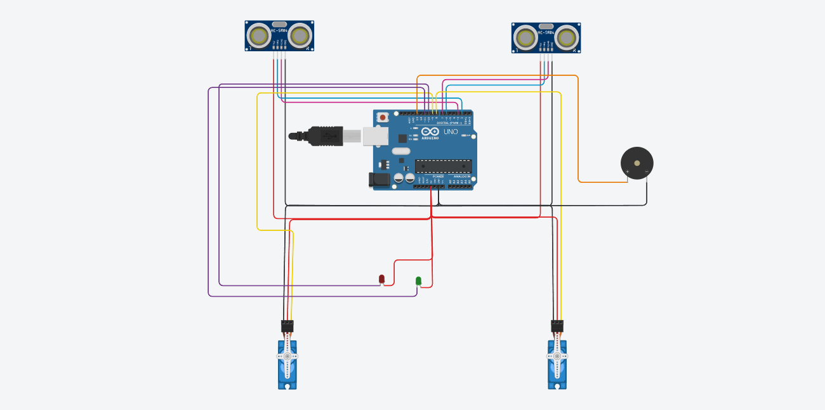

**Fig -5:** Circuit Diagram for Proposed System

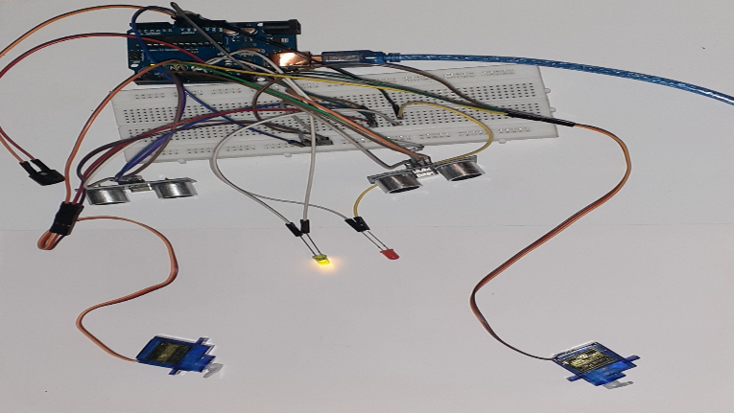

**Fig -6:** Circuit Connection of Proposed System

# **RESULT AND SDISCUSSION**

The experimental automatic gate control system for railway level crossings includes a plastic track for testing purposes. Two gates or barriers are linked with two servo motors. The results of extensive laboratory testing on the automated railway monitoring system indicate that the system functioned effectively. Arduino based automatic railway monitoring system ensure safety for road users and deal with the time-consuming process of gate opening and closing. The objective of this thesis is to create a railway level crossing gate control system utilizing Arduino technology that is both affordable and efficient. The proposed Arduino based automatic railway level crossing gate control system ensures human safety. Also, it is highly reliable and has a fast operational speed. The applications of Arduino based automated system are huge in our country.

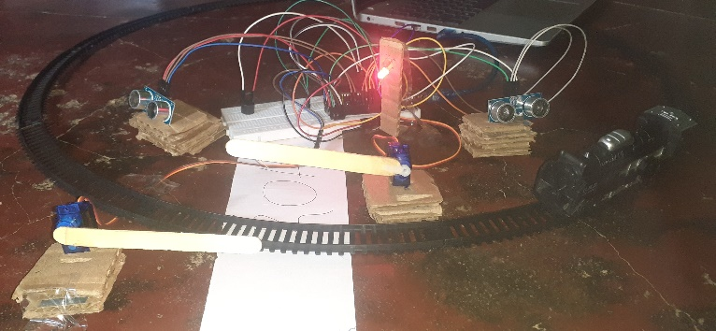

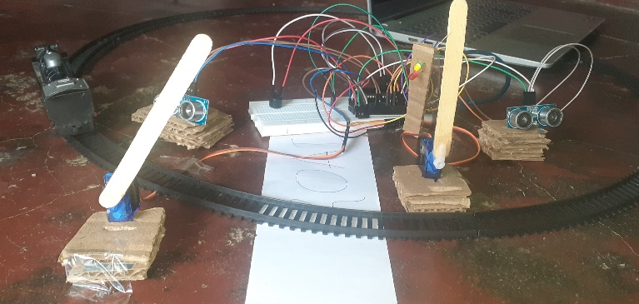

**Fig -12:** Final Implementation of Proposed System.

# **CONCLUSION**

The automatic railway monitoring system is an effective and best solution to the problems that occur in a system used by Indian trains. This program offers superior benefits to road and railway uses managers. This program minimizes the risks involved occurs at intersections and reduces waiting time of high-speed rail crossings. As this the system does not require any human resources at all made in any remote and rural areas there is no railway guard. Servo motors are utilized in the proposed system for lifting the gates, offering high reliability and accuracy in raising or lowering the gate to a specific angle of rotation. Finally we will conclude that the proposed system will have high, reliability performance and lower cost compared to existing ones currently in use.

**References**

1. <https://www.researchgate.net/publication/313787552_Automatic_Railway_System/download>
2. Railways to eliminate over 6,000 unmanned level crossings, article in the Indian Express, 30th July 2016 by PTI.
3. Indian Railway develops warning system for unmanned level crossings, article in Times of India, 25th October 2015 by PTI.
4. Swati Rane, Mayuri Pendhari, Pooja Patil, Prakash Sakari, Yashmith Shetty, Automatic Railway Gate Control and Track switching with automated train, International Journal of Science, Engineering and Technology Research (IJSETR), Volume 4, Issue 4,April 2015 ,-pp 1062-1066.
5. K. Vidyasagar, P. Sekhar Babu, R. Ram Prasad, Anti Collision and Secured Level Crossing System, International Journal of Computer Applications Volume 107 ,No 3, December 2014, pp.1-4.
6. HninNgwe Yee Pwint, ZawMyoTun, HlaMyoTun, Automatic Railway Gate Control System Using Microcontroller, International Journal of Science, Engineering and Technology Research (IJSETR), Volume 3, Issue 5, May 2014 ,pp 1547-1551