**POVERTY: THE CAUSE OF ADOLESCENT PREGNANCY AND PARENTHOOD IN THE ISLAND GARDEN CITY OF SAMAL**

**Khryzz Lynn M. Jimenez**

Graduate School of College of Development Management, University of Southeastern Philippines,

Philippines

Klmjimenez00454@usep.edu.ph

**ABSTRACT**

This study investigates the role of poverty on adolescent pregnancy and motherhood. There are various connections between teen pregnancies and poverty. We argue that adolescent pregnancy of women born from 1985 to 2005 in Babak District, Island Garden City of Samal is consequence of poverty. The case studies that were discussed in this study, investigate and learn firsthand whether or not teen pregnancy is primarily caused by poverty and through the result of this research, help the government to create and implement programs that could support teenagers and prevent them from becoming adolescents mothers. Poverty has several effects that can result in unintended or coerced pregnancies, including a lack of sexual health education, inadequate access to birth control and reproductive health services, peer pressure, poor mental health, and pressure from partners. Teenagers who live in poverty are more likely to become teenage moms. Teenage pregnancies can be decreased with the aid of sex education programs, better access to contraception and high-quality healthcare, and investments in excellent education. Teaching teens how to make educated judgments about their sexual behavior and how to safeguard themselves from potential repercussions and unwanted pregnancies among teens will make it simpler for teens to prevent pregnancy.

**Keywords:** (5-6 Keywords, Font-Times New Roman, Font Size – 10)

**1. INTRODUCTION**

This study explores poverty as the cause of adolescent pregnancy and parenthood of women born from 1985 to 2005 in the Island Garden City of Samal. I make the case that adolescent pregnancy and parenthood of women born from 1985 to 2005 in Babak District are consequences of poverty, which caused these women to lose educational opportunities to gain knowledge and be equipped with skills for better opportunities.

This is a poverty study that looks into the dynamics of capabilities (Nussbaum, 2011; Sen, 1999), gender (Kabeer, 1991; Moser, 2003), deprivation (Chambers, 1983), policies (Scott, 1998), and participation (Cornwall, 2003; Gaventa & Bivens, 2014) to explain the resonance of the experiences of the individuals that would become part of the study selected through snowball and theoretical sampling (Auerbach & Silverstein, 2003).

Adolescent pregnancy is a global issue that has an impact on entire cultures in addition to the adolescent mother and her child. (Holness, 2015) The World Health Organization estimates that 16 million girls aged 15–19 give birth each year, with the majority of births occurring in low- and middle-income countries. Research shows that most births are unwanted, and young moms have disadvantages in terms of their access to school, jobs, finances, housing, and health care. (Maheshwari, Khalid, Patel, Alghareeb, & Hussain, 2022).

Teenage pregnancy and poverty are linked in several ways. (Johnson, 1974) Poverty can be linked to teenage pregnancy, due to a lack of access to contraception, education on sexual health, and other resources that can help prevent teen pregnancy.

In the Philippines, it has been shown that adolescents who have neither parents, especially those who reside in low-income homes, are at significant risk of becoming pregnant as teenagers. (Tabei, Cuisia-Cruz, Smith, & Seposo, 2021) The Philippines' teenage fertility rate is within the range of average compared to the rest of the globe. Compared to its Southeast Asian neighbors. (Natividad, 2013) However, the frequency of adolescent pregnancies was deemed a "national social emergency" by the Philippines National Economic and Development Authority (NEDA) in 2019. As the Commission on Population and Development reported that 2,411 females between the ages of ten and fourteen gave birth that year, the President of the Philippines Rodrigo Duterte became aware of the issue. (Sherpa, 2021)

Teenage motherhood and parenting are increasingly common and difficult situations for many young people. The challenges of pregnancy and parenting can be overwhelming, and teens may feel unprepared and unsupported.

**3. METHODOLOGY**

Participatory Action Research (PAR) will be used in this project to determine if poverty contributes to adolescent pregnancy. PAR is a democratic process that involves active learning while also critically analyzing the methods we currently use to address local issues. (Ariyadasa & McIntyre-Mills, 2015)

This study will conduct key informant interviews with women who were pregnant while still teenagers in the Island Garden City of Samal. We will investigate how their adolescent years before they became teenage moms, were affected by poverty. This preliminary report of findings is mostly based on the three (3) fieldwork case studies that have thus far been obtained using theoretical sampling. (Auerbach & Silverstein, 2003)

The main goal of the study was to explore the reality of adolescent poverty as a primary cause of teen. The result of this research will help the government to implement programs that could help prevent teenagers from unplanned pregnancies.

Participatory Action Research (PAR) is useful in this study for us to engage a wide range of stakeholders in research and responding to their needs and ultimately lead to more meaningful and effective intervention strategies to address complex social issues.

**3. RESULTS AND DISCUSSION**

This section includes three case studies that are based on the personal stories of women born from 1985 to 2005 who became teenage mothers in the Island Garden City of Samal. Case 1 is about the experiences of Jeanalyn, who became pregnant at the age of 19 years old, growing with resentment toward those who have families that live together. Case 2 concerns Joy who admittedly didn’t enjoy her singleness enough due to being a mom at such an early age. Case 3 is about Lynie, who is still in pain because of the brokenness of her own family today and the brokenness of her family when she was a child.

**4.1. Case Study 1 – Jea and her unfinished school biz**

The case of Jea, not her real name, highlights a less favorable family environment that stems from poverty. It lessens parents' capacity to exhibit reassuring, reliable conduct. (Kuruvilla & Jacob, 2007) She honestly stated that she became pregnant when she was newly transferred to a new school in college. She claimed that it was due to stress. (Corcoran, 2016). She said:

“I grew up having resentment toward

people with families that stay and live together.

My father is working far from our home.”

A youngster who lives in poverty may also face additional difficulties in life. Poor parenting and an unfavorable home environment are effects of poverty. (Kuruvilla & Jacob, 2007) Poverty may lead to a family splitting up, with one or more members leaving in search of work, leaving the remaining family members behind.

Being a mother at 19, and still studying in college was not in Jea’s intention. She said:

“I became pregnant when I had difficulty

adjusting to my new environment as

I was transferred to a new school and met

a group of friends with different personalities

and behaviors that I couldn’t comprehend.”

Being a transferee can be stressful. Women with stress symptoms have higher pregnancy rates when contrasted to women without signs of stress. (Corcoran, 2016)

When she was asked to give tips to young girls based on her experiences, she said:

“It is better to focus yourselves on your future goals

and dreams in life. Do not fall into the trap of

the excitement of engaging in premarital intercourse

or your future will be shattered”

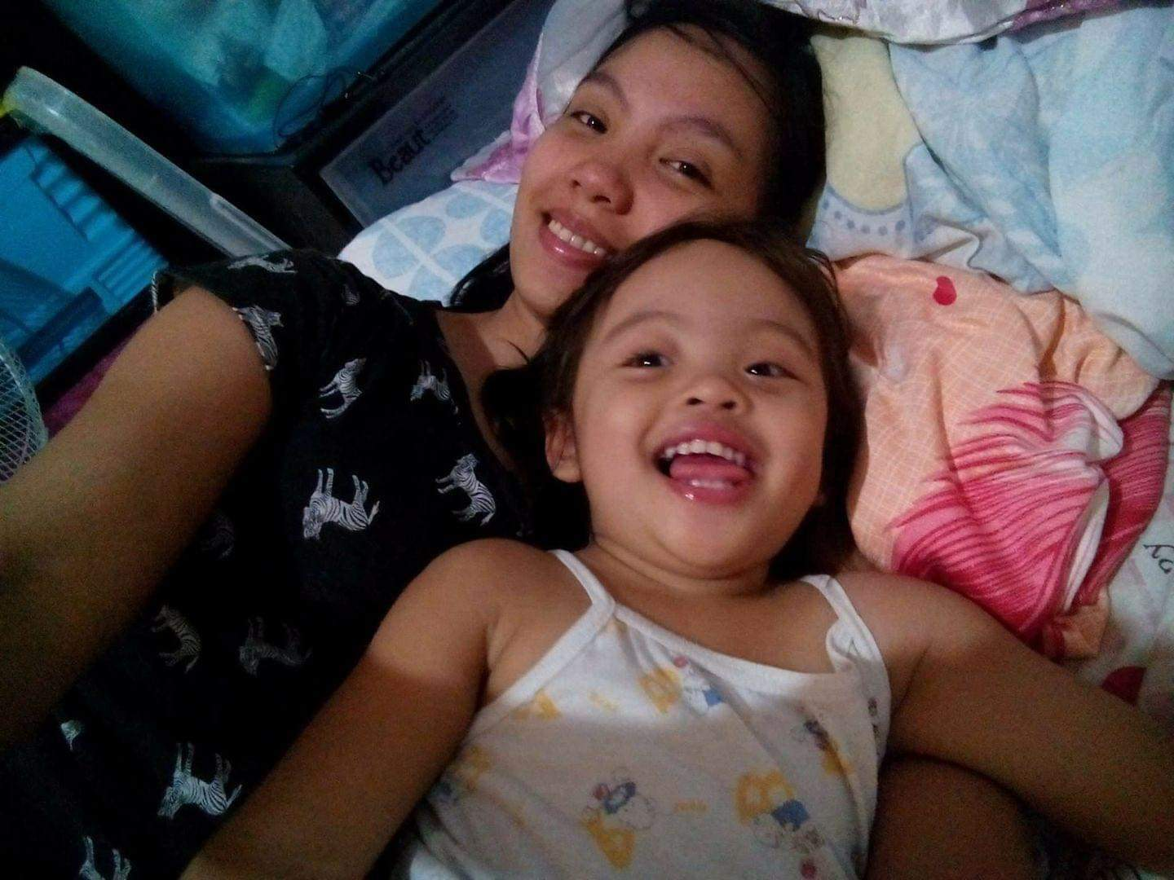

Jea and her eldest child

**4.2 Case study 2 – Joy’s unen(joy)able single years**

An unmarried lady named Joy got pregnant at the age of 19 years old. She was still studying at that time and managed to graduate high school. She is currently living with her mother and stepfather, whom she grew up with. Joy is living separately with the father of her child, though they are still in a relationship and on good terms.

During the interview, Joy was asked if she was aware of the consequences of engaging in premarital intercourse. She answered:

“I didn’t know engaging in intercourse

would result in an unwanted pregnancy.”

Joy had not visited a health facility and was not told of family planning caused her to experience teenage pregnancy. (Akanbi et al., 2021) Poverty prevented her from having access to health facilities, such as doctors, clinics, hospitals, and pharmacies. (Peters et al., 2008) People living in poverty may not be able to afford the cost of health care or may not have the means to travel to a health facility.

Joy never really enjoyed the fun of her single life enough. She has so much more to experience and these are her words for the young ladies:

“Don’t rush into entering motherhood

and married life. Wait for the right time,

cherish, and enjoy singleness.”

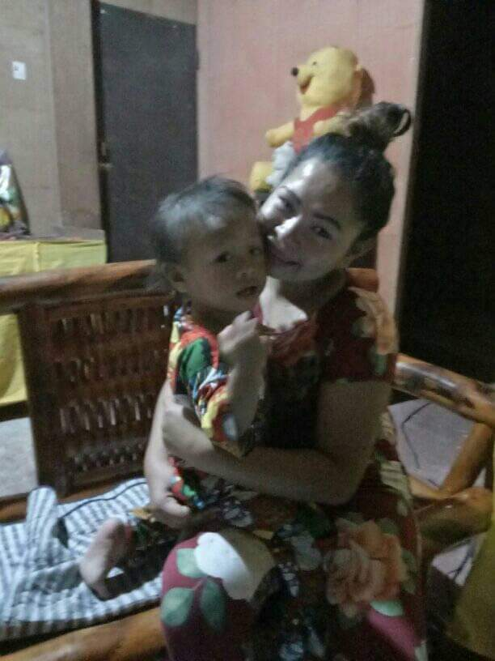

Joy and her happiness, Uno

**4.3. Case Study 3 – Lynie’s Two Broken Homes**

Lynie who is now living alone, away from her husband and two (2) children came from a broken family in her childhood. She grew up living with her grandmother and aunties since her father chose to live with his new family and her mother is working abroad due to poverty. She was 16 years old and was still a student when she had her 1st child and has never gone back to school since she became a mom.

Pain is still present in Lynie’s heart and was never healed through time. In the middle of the interview, she said: “All the painful memories and experiences of the past just flashed back and still hurt me”

Lynie lacks parental supervision and role models. (Thobejane, 2015) This occurrence resulted in poor parenting and an unfavorable home environment. (Kuruvilla & Jacob, 2007) According to her, she was never emotionally attached to her parents.

Lynie had no access to contraception because she was too young and wasn’t even aware of its existence. She didn’t even know that engaging in unprotected intercourse would result in an unplanned pregnancy. She said:

“Though I was always reminded and warned

by my Lola and aunty not to practice premarital

intercourse, my friends have encouraged and

influenced me to engage in it.”

Due to a lack of parental supervision, Lynie was influenced by her friends who also don’t know about contraception. (Thobejane, 2015) Since her parents weren’t there to guide her due to poverty, (Kuruvilla & Jacob, 2007) she look to her peers for guidance and validation of their decisions, which lead to risky behaviors, including intercourse.

To conclude the interview, Lynie was asked for tips that she could give to the young girls based on her life experience. Her answer was:

“Prioritize your studies first. Entering into

relationships and married life can always wait.”

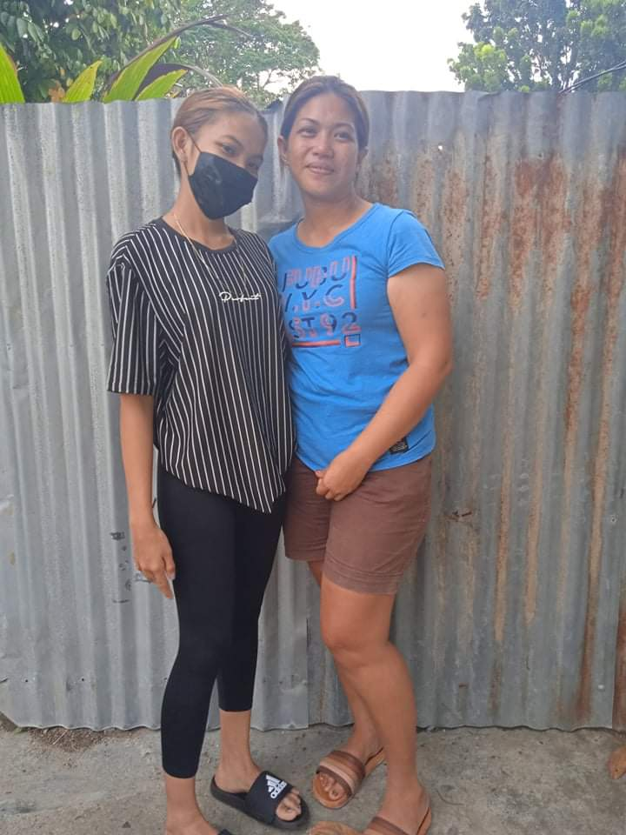

Lynie and her faraway daughter

**4. CONCLUSION AND RECOMMENDATIONS**

Adolescent pregnancy is significantly influenced by poverty. The story of Jea and Lynie young ladies engaging in unprotected sex clearly showed us that their experiences were influenced by poverty which lead to a lack of parental supervision.

Having no guidance from Lynie’s parents, she looks to her peers for guidance and validation of her decisions, which leads to risky behaviors, including intercourse. Poverty results in Jea’s demotivation and feelings of pessimism during her stressful adjustment in her college days. This experience increased her propensity of becoming a teenage mom.

On the other hand, Joy, including Jea and Lynie, hampered by poverty, never had access to contraception, sexual health education, and quality healthcare which also resulted in unintended and teenage pregnancies.

Based on the results, Lack of Education on Sexual Health, Inadequate Access to Birth Control and Reproductive Health Services, Pressure from Peers or Partners, and Poor Mental Health, are all consequences of poverty and can all lead to unplanned or forced Pregnancies.

Investment in quality education increased access to contraceptives and quality healthcare, and implementation of sex education programs are important tools to help reduce the rate of teenage pregnancy. These will make it easier for teens to prevent pregnancy by teaching teens how to make informed decisions about their sexual activity and how to protect themselves from potential consequences and unintended pregnancies among teenagers.

1. **6.** **REFERENCES**
2. Akanbi, M. A., Ope, B. W., Adeloye, D. O., Amoo, E. O., Iruonagbe, T. C., & Omojola, O. (2021). Influence of socio-economic factors on the prevalence of teenage pregnancy in Nigeria. *African Journal of Reproductive Health, 25*(5s), 138-146.
3. Ariyadasa, E., & McIntyre-Mills, J. (2015). Quality of life of Sri Lankan children: participatory action research to address the governance issues of voluntary children’s homes. *Systemic Practice and Action Research, 28*(5), 453-478.
4. Auerbach, C. F., & Silverstein, L. B. (2003). *Qualitative data: an introduction to coding and analysis*. New York: New York University Press.
5. Chambers, R. (1983). *Rural Development: Putting the Last First*. UK: Routledge.
6. Corcoran, J. (2016). Teenage pregnancy and mental health. *Societies, 6*(3), 21.
7. Cornwall, A. (2003). Whose Voices? Whose Choices? Reflections on Gender and PaDOIcipatory Development. *World Development, 31*(8), 1325-1342. doi:<http://dx.doi.org/10.1016/S0305-750X(03)00086-X>
8. Gaventa, J., & Bivens, F. (2014). *Co-constructing Democratic Knowledge for Social Justice*. Basingstoke: Palgrave Macmillan.
9. Holness, N. (2015). A global perspective on adolescent pregnancy. *International journal of nursing practice, 21*(5), 677-681.
10. Johnson, C. L. (1974). Adolescent pregnancy: Intervention into the poverty cycle. *Adolescence, 9*(35), 391.
11. Kabeer, N. (1991). *Gender, production, and well-being: rethinking the household economy*. Brighton, England: Institute of Development Studies, University of Sussex.
12. Kuruvilla, A., & Jacob, K. (2007). Poverty, social stress & mental health. *Indian Journal of Medical Research, 126*(4), 273.
13. Maheshwari, M. V., Khalid, N., Patel, P. D., Alghareeb, R., & Hussain, A. (2022). Maternal and neonatal outcomes of adolescent pregnancy: a narrative review. *Cureus, 14*(6).
14. Moser, C. (2003). Gender Planning and Development : Theory, Practice and Training.
15. Natividad, J. (2013). Teenage pregnancy in the Philippines: Trends, correlates and data sources. *Journal of the ASEAN Federation of Endocrine Societies, 28*(1), 30-30.
16. Nussbaum, M. C. (2011). *Creating Capabilities: The Human Development Approach*. London: The Belknap Press of Harvard University Press.
17. Peters, D. H., Garg, A., Bloom, G., Walker, D. G., Brieger, W. R., & Hafizur Rahman, M. (2008). Poverty and access to health care in developing countries. *AnnalsNew the new York Academy of Sciences, 1136*(1), 161-171.
18. Scott, J. C. (1998). *Seeing Like a State: How Certain Schemes to Improve the Human Condition Have Failed*. New Haven and London: Yale University Press.
19. Sen, A. (1999). *Development as freedom*. New York: Knopf
20. Sherpa, T. (2021). 210—Factors Affecting Teenage Pregnancy in the Philippines.
21. Tabei, K., Cuisia-Cruz, E. S. S., Smith, C., & Seposo, X. (2021). *Association between Teenage Pregnancy and Family Factors: An Analysis of the Philippine National Demographic and Health Survey 2017.* Paper presented at the Healthcare.
22. Thobejane, T. D. (2015). Factors contributing to teenage pregnancy in South Africa: The case of Matjitjileng Village. *Journal of Sociology and Social Anthropology, 6*(2), 273-277.