**Evaluation of Nephroprotective activity of *Ficus religiosa* by Gentamicin in Wistar Rats**

**Surbhi Jangir1, Kamini Kumari2, Prashant Kumar Dhakad3\***

1Associate Professor, Jaipur College of Pharmacy, ISI - 15 RIICO Institutional Area, Tonk Rd, Sitapura, Jaipur, Rajasthan 302022, India. Email Id: ssurbhikjangir@gmail.com

2Research Scholar, Jaipur College of Pharmacy, ISI - 15 RIICO Institutional Area, Tonk Rd, Sitapura, Jaipur, Rajasthan 302022, India. Email Id: kumarikamini103@gmail.com

3Professor, Jaipur College of Pharmacy, ISI - 15 RIICO Institutional Area, Tonk Rd, Sitapura, Jaipur, Rajasthan 302022, India. Email Id: dhakadprashant654@gmail.com

**ABSTRACT**

Medicinal plants play a crucial function in enhancing human health. Since ancient times, hundreds of medicinal plants have been used to treat various diseases. *Ficus religiosa* (Peepal) holds a prominent position among medicinal plants. Almost every portion of this tree, including its leaves, bark, seeds, and fruits, is used to make herbal remedies. This study evaluates the nephroprotective activity of *Ficus religiosa* when administered Gentamicin to Wistar rodents. Twenty-four young and healthy male Wistar rats were used in the experiment, which was conducted for one week before the rodents were sacrificed at the conclusion. Gentamicin induced nephrotoxicity at a dose of 42 mg/kg per day. At the conclusion of the study, biochemical parameters revealed that both 150 mg/kg and 300 mg/kg of *Ficus religiosa* extract exhibited significant nephroprotective activity.

**Keywords:** Nephroprotective activity, *Ficus religiosa*, Gentamicin, Medicinal plants, Kidney

1. **INTRODUCTION**

The use of herbs as a therapeutic modality dates back to the dawn of humankind. Traditional medicine was crucial to the development of human civilizations and remains the primary medical approach in most countries [1]. It is estimated by the WHO that 80% of the world's population, or 4 billion people, are currently using herbal medicine as a main form of healthcare [2]. Peepal, or Ficus religiosa, a member of the Moraceae family, is widely planted across Southeast Asia for its traditional Unani and folk medicinal uses. Traditional practitioners have found success using it to treat a wide range of conditions, including those affecting the CNS, endocrine system, digestive tract, reproductive system, respiratory system, kidneys, and even infections. When it comes to human health, medicinal plants are vital. For thousands of years, people all around the world have turned to dozens of different medicinal plants in order to treat their illnesses. For its medicinal properties, the *Ficus religiosa*(Peepal) tree is revered. The leaves, bark, seeds, and fruits of this tree are all put to good use in the creation of herbal remedies. Thereare a great number of pharmaceutical medications that are generated biosynthetically from secondary metabolites found in plants. Flavonoids, glycosides, protein, isolated amino acids, essential, volatile oil, and steroids are all found in Ficus religiosa. Parasitic, antiparkinson, anticonvulsant, amnesic, anticholinergic, antidiabetic, analgesic, cytotoxic, ulcer, wound healing, antioxidant, asthmatic, hepto, dermato, protective properties of *Ficus religiosa*have been documented in previous pharmacological studies. A wide variety of medicinal plants found on Earth have been utilised for centuries to heal human illness. Low-cost medicine for the populace may be provided through the use of numerous medicinal plants, allowing for the establishment of a proper health care system. Alternative medical practises like ayurveda, Unani, and others are more likely to make use of medicinal plants, especially in rural regions. The use of herbal remedies in place of conventional pharmaceuticals is on the rise. Peepal, or Ficus religiosa, is a species of tree in the family Moraceae that is widely planted in Southeast Asia for its traditional Unani and folk medicinal uses. Traditional practitioners have found success using it to treat a wide range of conditions, including those affecting the CNS, endocrine system, digestive tract, reproductive system, respiratory system, kidneys, and even infections [3].

1. **MATERIAL AND METHODS**

**Drug and reagents**

Gentamicin sulfate was purchased from Manus Aktteva Biopharma in Gujarat , India.

**Plant material**

In April of 2022, latex from a *Ficus religiosa* L., Moraceae tree was gathered from the CSIR-CDRI in Lucknow, Western India. Dr. Deepak Kumar Mishra, Principal Scientist in the Department of Botany at the Central Institute of Scientific Research and Development in Agriculture (CSIR-CDRI), Lucknow, has confirmed the plant's identity using voucher specimen number 25460. The Preparation of Samples The latex from F. religiosa was obtained using a maceration procedure (48 hours) in methyl alcohol, after defatting with petroleum ether for 72 hours at room temperature. The concentrate was dehydrated using a rotary vacuum dryer. The latex production rate was 18.56 percent (weight for weight). TLC and high performance TLC (HPTLC) (CAMAG Switzerland, Linomet 5, and Scanner 3, Win Cat Software); mobile phase: butanol: formic acid: water) were used for the phytochemical identification and standardisation of F. Religiosa latex (7.5:1.5:1). Several substances were seen on the extract track of an HPTLC examination utilising a panel of standard amino acid markers (glutamine, glycine, cysteine, methionine, lysine, arginine, tyrosine, leucine, etc.). The Rf value of 0.56 at one location in the extract was very close to the reference value for methionine. Standardized F. religiosa latex extract contained 0.648 ±0.0425% methionine.

***In-Vitro Study***

**Maceration process**

The drug's leaves, stem bark, or root bark are finely pulverised and placed in a container for the extraction process. The menstruum is then poured on top of the drug material until it is completely submerged. When you're done, seal the container and let it sit for at least three days. If the mixture is to be stored in a bottle, shaking it at regular intervals is recommended to ensure that all of the contents are extracted. Filtration or decantation is used to separate the micelle from the marc at the conclusion of the extraction process. Thereafter, the micelle is evaporated in an oven or on top of a water bath to isolate it from the menstruum. Thermosensitive plant material benefits greatly from this strategy

**Experimental Animals:**

The National Laboratory Animal Facility at the CSIR-CDRI in Lucknow, Uttar Pradesh, India, bred young and healthy male Wistar rats measuring 150-200g between the ages of 5-7 weeks. All procedures involving the care and housing of animals were conducted in accordance with the ethical criteria established by the Institutional Animal Ethics Committee. The average age and weight of the animals included in the study was 1.2 years, and they weighed 250 grams. Over the duration of the experiment, Wistar rats were kept in polypropylene plastic cages with a constant temperature of 23.2°C, relative humidity of 5020%, and a 12hr light/day cycle.

**Experimental Design:**

A total of 24 young and healthy Wistar male rats were used in the experiment, and the study was conducted for the period of one week and then the rats were sacrifice at the end.

Animals were divided into four groups of 6 animals each (n=24)

**Experimental design for Animals**

|  |  |
| --- | --- |
| Group 1 | Controlled group will receive water and food ad libitum |
| Group 2 | Gentamicin (42mg/kg/day + vehicle control) |
| Group 3 | (Gentamicin 42mg/kg/day) + (150mg/kg/day Ficus Religiosa) |
| Group 4 | (Gentamicin 42mg/kg/day) + (300 mg/kg/day Ficus Religiosa). |

Food water uptake and body weight was recorded on weekly basis. Blood will be collected then animals will be sacrificed at the end of the experiment, the kidney were taken out and organ weight were recorded. The histopathological examination will be carried out and other analyses was carried out by various assays.

**Biochemical Assays:**

Serum was extracted by centrifuging the collected blood at 3000 g in a REMI tabletop centrifuge. Antioxidant enzyme levels, reduced glutathione (GSH), and lipid peroxidation as measured by Thiobarbituric acid-reactive substances (TBARS) were all assessed from the supernatant using calorimetric methods and a spectrophotometer (Merck ThermoSpectronic, Model No. UV-1, double beam). Mishra and Fridovich's technique was utilised to ascertain superoxide dismutase (SOD) (1972) 50 mL of serum was combined with 500 mL of working reagent (prepared by kits reagent 1 and 2 ratio 4:1) in a test tube, mixed well, incubated for 60 seconds at 37 degrees Celsius, and the absorbance at 340 nanometers was recorded after the first reading. The ALT and AST levels were calculated using the U.V. Kinetic IFCC method (Bergmeyer et al., 1986). To get the answer, we adjusted the absorbance per minute and multiplied the result by a factor. The serum ALP level was measured using the lab-care diagnostic kit and the improved IFCC technique and process (Tietz, 1995).

**Dose Preparation:**

Aqueous extract was prepared by adding weighed dose into a beaker in 5 ml of water and then mixed the extract well with the help of vortex. The dose was given orally.

**Histopathological examination**:

On the day when their blood was drawn, the Wistar rats were euthanized. After removal, processing, and embedding in paraffin wax, kidneys were preserved. Mounted permanently for viewing and reporting, the haematoxylin-and-eosin-stained sections were ready for examination [4,5].

**Statistical Analysis**

The data was shown as a mean with a standard deviation. Graph Pad Prism version 5.03 was used for statistical analysis, and one-way analysis of variance (ANOVA) was used to determine statistical significance [8].

1. **RESULTS AND DISCUSSION**

**Mortality/Morbidity**

No mortality/morbidity was observed in any animal during the study period

**Clinical Signs**

No apparent treatment-related clinical signs were observed in any animal throughout the research study

**Detailed Clinical Observation**

No clinical observation was seen in any animal pre-dose and thereafter daily during dosing.

**Body Weight**

A decrease in body weight was observed from Day 1 to Day 7 gentamicin induce group G2 male as compared to the control animals (G1) which are consistent and related to Gentamicin. Other groups do not show the change in animals in comparison to the control group animals.

|  |  |  |  |  |
| --- | --- | --- | --- | --- |
| **Parameter** | **Control** | **Gentamicin Induced** | **Gentamicin + Treatment (150mg/kg/day)** | **Gentamicin + Treatment (250mg/kg/day)** |
| GPTM (IU/L) | 66.5±6.40 | 57.2±16.59*** | 83±5.77 | 72.6±2.31 |
| GOTM (IU/L) | 150.6±12.39 | 164.5±36.37*** | 210.6±22.12*** | 155.9±3.71*** |
| ALPU (U/L) | 505.0±92.60 | 449±110.01*** | 283.7±75.75*** | 528±54.58*** |
| CRE (mg/dl) | 0.60±0.03 | 1±0.15*** | 0.5±0.04*** | 0.6±0.01*** |
| PHOS (mg/dl) | 13.0±1.16 | 10.5±4.16*** | 5.9±0.91*** | 9.7±1.08*** |
| UREA (mg/dl) | 39.1±4.76 | 44.3±4.6*** | 32.8±9.25*** | 39.5±3.67*** |
| BUN1 (mg/dl) | 18.3±2.08 | 20.7±2.08*** | 15.3±4.51*** | 18±1.73*** |
| GLU (mg/dl) | 185.7±41.30 | 157.7±79.57*** | 89.5±13.26*** | 156.1±11.56*** |
| TGM (mg/dl) | 43.3±19.60 | 71.6±40.37*** | 48.5±5*** | 46.1±4.44*** |
| CHOL (mg/dl) | 48.0±9.54 | 51±11.27*** | 47.7±2.89*** | 51.3±8.14*** |
| CA (mg/dl) | 12.5±0.38 | 8.4±6.67*** | 1.3±0.42*** | 11.6±0.35*** |
| ALB (g/dl) | 2.3±0.03 | 4.7±4.22*** | 4.4±3.8*** | 2.2±0.06*** |
| PRO (g/dl) | 6.4±0.39 | 5.5±1.98*** | 5±2.32*** | 6.5±0.1*** |
| BIT1 (mg/dl) | 0.0±0.01 | 2.5±4.34*** | 2.3±3.83*** | 0.1±0.01*** |

Data were expressed as mean±S.D. (n=6) and analyzed by one way ANOVA followed by dunnets comparison test.

*-(P<0.05),**-(P<0.01), ***-(P<0.001) when gentamicin induced v/s extracts

**Gross pathology**

External: No abnormality observed as compared to the control

Internal: No abnormality observed in the G1, G3 and G4 groups and the G2 groups of the animal’s kidneys were larger in size as compared to the G1.

**Histopathology**

**Microscopic Finding**

The presence of pathological alterations in Renal (interstitial) fibrosis, such as that caused by chronic interstitial inflammation, is linked to the renal parenchyma. The fibrosis is mild, with only minor damage to the renal parenchyma.Renal tubule regeneration occurs as a reparative response to previous degeneration and/or necrosis of the renal tubular epithelium. It is one of the most common test-article-related lesions observed in the kidney. Regeneration is characterized by a spectrum of histologic changes, including cytoplasmic basophilia, karyomegaly, and nuclear crowding along the affected tubule segment.

There were observed the Gentamicin induce groups showed mild to moderate changes in the kidney whereas the Gentamicin + extract groups revealed minimal to no changes in the kidney histology.

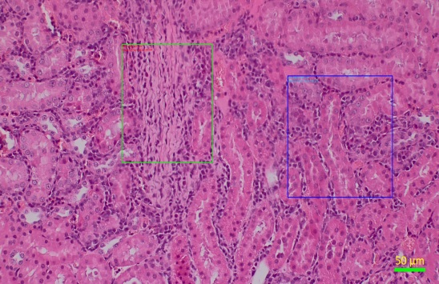

G2- Fibrosis + Regenerative tubules

Control

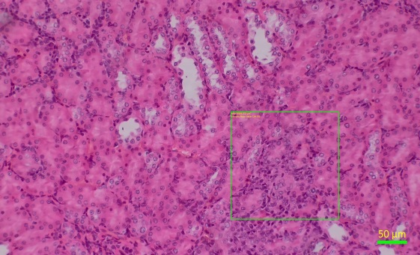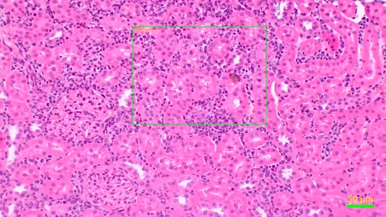

G3 -Regenerative tubules

G2-MNC infiltration + Regenerative tubules

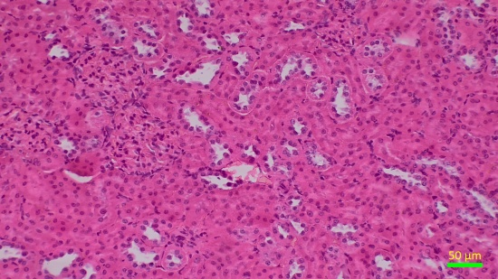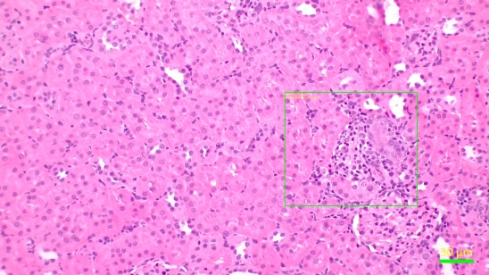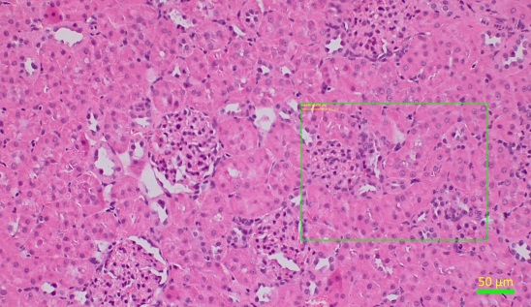

G4- Regenerative tubules

G4- Regenerative tubules

G3 -Regenerative tubules

1. **CONCLUSION**

The purpose of this study was to evaluate the effects of the determined amelioration effect of *Ficus religiosa* (latex) on gentamicin-induced acute kidney disease in rats. A detailed clinical sign of all animals was carried out once before dosing and thereafter daily to note any abnormal findings and/or indications of normality. No clinical sign was observed in any animal from the G1 to G4 groups. Weighing of animals was performed once before dosing and daily thereafter. Except significant decrease observed in the Male group body weight on Day 1 and Day 7 of the inducing groups, there was no statistically significant difference observed in body weight of all animals respective control group animals. In the case of Clinical chemistry parameters, all Males of the G2 group showed a significant Increase in Creatinine, Urea and, BUN as compared to the control group. A Statistically significant decrease in kidneys of G2 males was observed as compared to other groups. Various pathological changes were observed in kidneys regenerative tubules, fibrosis in the Gentamicin induce groups, and other groups showing limited changes which is considered spontaneous changes. Based on the results, it can be concluded that Gentamicin induces groups showing changes in organ weight, body weight, biochemical parameters, and histology change, and that changes amelioration by the *Ficus religiosa* (latex) in both dosed groups (150 mg/kg and 300 mg/kg).

1. **REFERENCES**
2. <https://craighospital.org/resources/herbs-herbal-medicine>.
3. Davidson-Hunt, I. Ecological Ethnobotany: Stumbling Toward New Practices and Paradigms.
4. Al-Snafi, AE. 2016. Medicinal plants with anticancer effects (part 2)-plant based review. Sch Acad J Pharm, 5, 175-193.
5. Cuppage FE, Tate A. 1967. Repair of the nephron following injury with mercuric chloride. Am J Pathol 51:405-429.
6. Dube PH, Almanzar MM, Frazier KS, Paredes AI. 2004. Osteogenic protein-1 (rhOP-1) treatment induces tubular regeneration