**Renewable Energy Harvesting Inverter using Supercapacitor**

**Author Name**

1. Rakesh Yergude 2 Roshan Maske 3 Prof Dimpal Zade

Student(EE) SSCET , Student(EE) SSCET , Asst.Professor(EE) SSCET

***Abstract- Nowadays the availability of non renewable sources are decreasing so we can use the renewable sources in the form of sunlight. The requirement of electrical energy is increasing day by day that is the reason we can create the module, “Solar Inverter Using Super Capacitor”. A Solar inverter is a type of electrical converter which converts the variable direct current (DC) output of PV solar panel into a utility frequency alternating current (AC) that can be used to fulfill many domestic purpose. Super capacitors are governed by the same fundamental equation as conventional capacitor, but can achieve greater capacitor value due to its large surface area of electrode and thinner dielectric, hence it act as a battery which can stores large amount of charges[1]***

***Key words- Solar panel, Inverter, MPPT Microcontroller, DC to DC convertor Super capacitor***

**Introduction:**

The photovoltaic (PV) effect is a property of semiconductors that may be used to convert solar energy into direct current electricity. Solar panels with photovoltaic cells are used to generate electricity in photovoltaic systems. Since its inception, solar PV power production has been largely accepted as the most environmentally friendly and abundant source of renewable energy on the planet—the sun. During operation, sunlight is converted directly into electricity without the need of moving components or emitting any emissions into the environment. The use of photovoltaics (PV) in today's technology environment has grown significantly in recent years. Currently, solar photovoltaics are the third most widely installed renewable energy source worldwide, after hydropower and wind power. Solar PV is used in more than 100 countries. It's important to note that the typical PV system has three components: a photovoltaic (PV) array for harvesting sunlight, a charge controller, and a load controller. One of the most important components of any PV battery charging system is a competent, sturdy, and dependable PC charge controller, which may provide several advantages to the user while still being reasonably priced. Its primary job is to manage the voltage and current flowing from a r echargeable battery to the PV solar panels in a PV system. PV chargers are also designed to prevent the battery from overcharging by disconnecting the array when it is completely charged, thereby avoiding battery damage. It may also prolong the life of the batteries in the PV system from excessive discharge and avoid battery damage. Non-renewable resources like as gas and coal are used to generate electricity from the national grid. A long-term contribution cannot be assumed since both fuels are limited and will be depleted over time. This pollution comes from the incomplete combustion of fossil fuels, which releases greenhouse gases, non-biodegradable waste products, etc. In addition, even as conditions in cities improve, the electricity problem persists in rural regions.[2]

**Block Diagram**

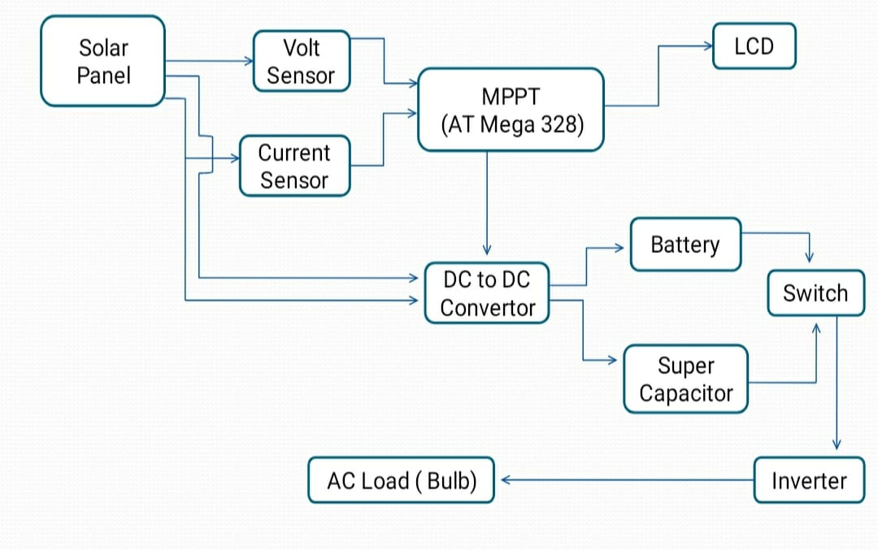

M

**Major Components**

**Solar panel**:It is used to collect the solar energy from the solar or photovoltaic cells ,which can be used to generate electricity through photovoltaic cell. These cells are arranged in a grid-like pattern on the surface.

**Inverter:** It is the power electronic device which is used to convert the direct current (DC) into alternating current (AC). Inverters are static, using electronic power switches to synthesize an AC waveform from the DC input. [3]

**IC Voltage Regulator(IC 7805)**:IC 7805 is a three terminal device. It is also a linear voltage regulator IC with a fixed output voltage of 5V which is used in many applications .

**DC-DC Converter:** The DC-DC converter(boost converter) is the power electronic converter with an output voltage greater than the source voltage. It is used to step-up the maximum voltage from the solar panel.[3]

**Supercapactior** :A super capacitor (SC), also called an ultra capacitor, is a high-capacity capacitor with a capacitance value much higher than other capacitors, but with lower voltage limits, that bridges the gap between electrolytic capacitors and rechargeable batteries The electrical properties of these devices, especially their fast charge and discharge times, are very interesting for some applications, where super capacitors may completely replace batteries[4]

**Microcontroller MPPT** : MPPT (maximum power point tracking) based charge controller using pic microcontroller is a controller that could be used for charging the batteries after tracking maximum power from [**solar panel**](https://microcontrollerslab.com/solar-panel-parameters-measurement/). As we know, the demand of energy is increasing day by day as well as the nonrenewable energy resources such as hydro, coal and oil are also depleting day by day, beside this these resources are not environmental friendly therefore we must need to search the renewable energy resources such as solar, wind soil, trees and grass to full fill the energy demand.[11]

**Working:** It consists of Solar panel, boost converter, charge controller, super-capacitor, battery, inverter, Arduino, LCD display, transformer. As sun light fall on the solar panel radiation energy is converted into the electrical energy by the photovoltaic effect. In this model mono translucent cell are utilized having most extreme proficiency. At that point this electrical energy is given to the lift converter it is support the voltage level to 14 volt continually. Super-capacitor bank and battery framework utilized equal As the flood current necessity of burden is builds then extra current is taken care of by the super capacitor bank to improve the existence of inverter. Inverter is used for converting the dc source into the ac source. and then step transformer is used here for matching the load voltage and system voltage. As parallel capacitor bank provide the additional supply when load is increases so the load fluctuation on battery is keep to constant value so overall system performance get improved.[5]

**Advantages**

* It offers high energy density and high power density compare to common capacitor.
* It offers high capacitance(from 1 mF to >10000 F).
* It offers fast charging ability.
* It offers superior low temperature performance(from -40oc to 70oc).
* It offers longer service and long life about 10 to 15 years as compare to 5 to 10 years Li-ion battery.
* It offers virtually unlimited cycle life and can be cycled millions of times.
* It offers higher reliability of performances.

**Conclusion**: The need of the hour is to save power. Green energy sources are the solution to the environmental, political and social problems of this lifetime. By spending more on these technologies, no country will have to depend on another or even a corporation for their power needs because green energy sources are self-dependent and free. Thus, a highly reliable and versatile system has been designed and developed to convert vibrations into electrical energy. Green energy harvesting is encouraged because it causes no negative impact to the environment. Also, this method of power generation saves the cost spent for other renewable sources of energy and the biggest advantage of green energy is that we will never run out of it. Thus, energy is conserved effectively.[14]

**Future Scope** : The strategic motto of this project is to promote the use of renewable energy sources and battery with supercapacitor to increase storage capacity. This research is focused towards balancing circuit. The future scope of the renewable energy solar inverter is to integrate advanced technologies with soft-computing system for effective solar tracking, charge control, etc. Furthermore advancements in this field for the energy stream and solar energy need to incorporate using machine learning.[13]

**References:**

[1] Prof. Vishal Pimpalkar, Shilpa B. Totade, Rasheena R. Sheikh, Payal R. Amte, Rahul K. Kaithwas, Amol B. Dadmal.” Solar Inverter Using Super Capacitor” International Research Journal of Engineering and Technology (IRJET) e-ISSN: 2395-0056 Volume: 07 Issue: 03 | Mar 2020

[2] Vijaya Musale , Dr. D. Tutkane,” A Review On Approach To Implement Capacitor Based Charging System With Relay Using Solar System In Grids” International Journal of Research Publication and Reviews Journal homepage: www.ijrpr.com ISSN 2582-7421

[3] Dr.P.Rajendran, S.Kalpanadevi, K.Radha,” Design and Development of Fuzzy Based Inverter Controller for Solar/Battery Hybrid Power System” International Journal of Scientific Research & Engineering Trends Volume 6, Issue 2, Mar-Apr-2020, ISSN (Online): 2395-566X

[4] Piyush Kumar Yadav, Dr. Rajnish Bhasker and Satyam Kumar Upadhyay,” Performance Evaluation Of Energy Management System For Domestic Purpose Using Super- Capacitor With Dc-Dc Converter” International Journal of Advanced Research in Engineering and Technology (IJARET) Volume 11, Issue 10, October 2020, pp. 1178-1192,

[5] Mahesh Bhosale, Kushal Rawade, Akshay Wadmare, Shankar Kumbhare,” A Review On Solar Hybrid Energy Storage System” Innovative Journal For Opportunities And Development In Science & Technology, Volume 1, Issue 9, May 2021

[6] Mr. A. Om Prakash , R.S. Dhivya , V. Kalaiarasi,” Energy Harvesting Using Renewable Sources for Aeronautics Application” International Journal Of Innovative Research In Electrical, Electronics, Instrumentation And Control Engineering Vol. 4, Issue 5, May 2016

[7] Dr. G. Mahesh Manivanna Kumar” Intelligent Control of Standalone Photovoltaic/Fuel Cell Power Plant with Super Capacitor Energy Storage” IJSRSET | Volume 3 | Issue 8 | Print ISSN: 2395-1990 | Online ISSN : 2394-4099 Themed Section: Engineering and Technology

[8] Suman Jana, Pabitra Kumar Biswas,” Feasibility Analysis of Supercapacitor for Lightning Energy Conversion System”, International Journal of Innovative Technology and Exploring Engineering (IJITEE) ISSN: 2278-3075 (Online), Volume-9 Issue-10, August 2020s

[9] D.Shobana , M.Divya , S.Mohanapriya , R.Ramapriya , J.Ramya, “Multisource Battery and Free Energy Harvesting Architecture for Home Appliances” 4 ISSN 2321 3361 © 2016 IIJESC

[10] J. Ajay Daniel, M. Moovendan*,A. Mohanbabu, Mohamed Ismail. A, Sivakumar. D, Senthilkumar. V, Lakshmipriya, “Advancement of a Hybrid Energy Storage Framework (HESS) For Electric and Plug-in Hybrid Electric Vehicles: A Modern Control Technique”Mhttps://www.pnrjournal.com/index.php/home/article/download/1192/964/1386

[11] Vaneeta Ma* ,Dr. Sangeetha Vb,Dr. S Swapna Kumar,” Renewable Energy Harvesting Inverter using Supercapacitor” [*Proceedings of the International Conference on Innovative Computing & Communication (ICICC) 2021*](https://papers.ssrn.com/sol3/papers.cfm?abstract_id=3835072)

[12] Z. I. Rizman , F. R. Hashim, I. M. Yassin, A. Zabidi , F. K. Zamanand K. H. Yeap,” smart Multi-Application Energy Harvester Using Arduino” Journal of Fundamental and Applied Sciences ISSN 1112-