**WEB APPLICATION ERP FOR SCHOOL MANAGEMENT SYSTEM**

Sarvesh kumar Master of Computer Application, School of Computer Application, Lovely Professional University, [sarvesh0829@gmail.com](mailto:sarvesh0829@gmail.com)

Kumari Shivani Master of Computer Application, School of Computer Application, Lovely Professional University, [shivaniyadav4972@gmail.com](mailto:shivaniyadav4972@gmail.com)

Yuvraj Singh, Master of Computer Application, School of Computer Application, Lovely Professional University, [yuvsingh768@gmail.com](mailto:yuvsingh768@gmail.com)

Rishu Kumari, Master of Computer Application, School of Computer Application, Lovely Professional University, [rishu78589@gmail.com](mailto:rishu78589@gmail.com)

**ABSTRACT**

Schools are complex organizations that require efficient management systems for smooth functioning. With the advent of technology, school management systems have witnessed a revolutionary transformation. The school ERP app is one such system that has drastically changed the way schools are run. This app integrates various functions such as student information management, attendance tracking, fee management, payroll management, library management, enquiry management and so on. It makes the entire school administration process more efficient and easier. With features like real-time data updates, automated reminders and notifications, the school ERP app has made the tedious task of school administration simpler. It is a one-stop solution for all school-related activities. It helps in streamlining the overall functioning of the school by providing a comprehensive overview of the day-to-day activities. Furthermore, this app also helps in reducing paperwork and saving time. It effectively manages all the data and information related to students, teachers and staff members. A central database for organising and preserving information about students, instructors, staff, and parents is offered by the school management system. Authorised users may safely access the data at any time and from any location thanks to the system. Additionally, it has several reporting options that may be used to create reports on student performance, attendance, and other crucial indicators. All in all, the school ERP app is a great tool that has revolutionized the way schools are managed, making the entire process quicker and more efficient. This research paper explores the benefits of the school ERP app and its impact on school management.

**Keywords**: School, management, database, student, staff, parents.

**INTRODUCTION**

The educational system is one of the most important institutions in every civilisation. They have a crucial role in shaping how the next generation will mature. However, managing a school necessitates balancing a variety of conflicting interests, such as those of the students, parents, teachers, and administrators. The management of student information, attendance, fees, and tests were just a few of the responsibilities that schools used manual processes to accomplish in the past. These manual processes required a lot of time and were error prone.

A "school management system" is a piece of software designed to help schools organise their administrative and academic processes. With the use of modern technology, schools may handle student information, attendance, test scheduling, library management, and much more from a one location. The technology provides a forum for in-person communication between all parties involved, including students, parents, teachers, and administrative staff. The technology simplifies and automates repetitive tasks, relieving the administrative and instructional personnel of some of their workload. They may then focus on their main responsibilities, which include teaching and helping students, as a result. The goal of school management systems is to be flexible and user-friendly so that each institution may personalise them to suit their needs. The system's web-based interface and mobile apps make it simple for users to access and use the system while on the go. In general, a school management system is an essential tool for organisations that aim to boost productivity, effectiveness, and communication between teachers, parents, and students. By automating routine tasks and centralising information, schools may better manage their resources, provide students with better services, and achieve their goals.

**REVIEW OF LITERATURE**

F. M. Pong, S. K. Au-Yeung, and K. Y. Lee (2014): The pros and limitations of the current school management systems are reviewed in-depth in this essay. According to the authors, a well-designed school administration system should be adaptable, user-friendly, and able to interface with other systems.

R. A. Zainuddin, T. Jalaluddin, and A. Z. Aziz (2015): This essay discusses the assessment of a Malaysian school management system. According to the authors, the method increased school management's efficiency and effectiveness and had a favourable influence on teacher and student satisfaction.

S. M. S. Tabatabaey-Montazeri and R. A. Salehi Omran (2018): The effectiveness of Iran's elementary schools is examined in this study in relation to a school management information system. The findings imply that using such a method enhances student success and school administration.

S. S. Alhajri and S. A. Alqurashi (2019): The framework for creating a school management system that considers the interests and requirements of many stakeholders is proposed in this study. A well-designed system, according to the authors, should be user-centered, data-driven, and flexible enough to meet changing requirements.

T. Okereke and C. E. O. Ukwueze (2019): This study looks at how a school management information system affects the productivity and motivation of teachers in Nigeria. According to the findings, the approach enhances instructor productivity and motivation, which benefits students.

**PROPOSED METHODOLOGY**

The approach taken to accomplish the project's goals. The Software Development Life Cycle (SDLC) is a framework for the design, development, and maintenance of software. The software development process is illustrated, including the procedures, stages, milestones, and evolution. In the design and development of software, numerous models are employed. Spiral models, rapid development models, evolutionary models, waterfall models, prototyping models, and others are among them.This application has been created using a prototyping model. A rapid way to create a functional but unfinished model of the information system is through prototyping. There are various types of prototypes, but they all aim to lower risk by creating a shoddy imitation or mockup of the intended system. When the technical risk is high, it might be utilised to show technical viability. Additionally, it can be applied to learn more about and elicit user requirements. In either situation, the objective is to increase awareness of suggested solutions prior to allocating further resources in order to reduce risk and restrict expenses.

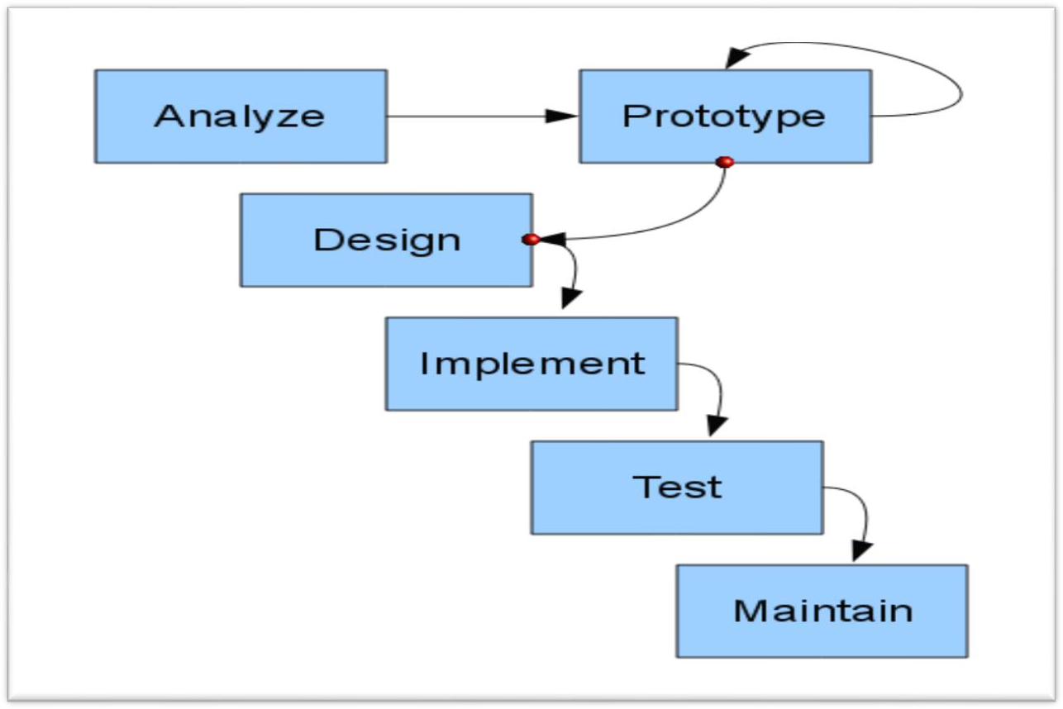

**Prototype Model Process**

### System description

The main goal of our web-based system, My School (SMS), which serves students, teachers, headmasters, and parents, is to give students access to information about school activities and grades. It also gives parents continuous access to the teachers and headmaster for any concerns, suggestions, or other matters pertaining to their children. And teachers see it as a simple method to run their workday, stay in touch with the students, and enter grades or anything else they want the children to see or get. The system is completely under the headmasters' supervision, and they operate much like

### User description

The administrator, student, teacher, and parent are the system's four primary users. When using the system, each user can carry out a variety of tasks. These features were chosen in accordance with the system's design and user-friendly features to increase the system's effectiveness and efficiency. The activities that each user undertook are listed in Figure.

|  |  |
| --- | --- |
| ACTORS | FUNCTIONS |
| ADMIN ( Headmaster ) | * Log In/Out * Add New Subject * Add New Class * Add New Teacher * Edit Teacher * Add New Student * Edit Student * Add New Parent   -Edit Parent   * Post tasks and any updates |
| TEACHER | * Log In/Out * Enter students grades * Post tasks and any updates   -View complaints and recommendations |
| STUDENT | * Log In/Out * View subject’s grades * Post complaint and recommendation |
| PARENT | * Log In/Out * View their kids grades * Post complaint and recommendation * Pay fee and see the due. |

**BENEFITS OF THE SCHOOL ERP APP**

The benefits of a school management system for schools include:

1. **Enhanced Effectiveness:** By automating and streamlining mundane administrative processes, school management systems lessen the stress of teachers and administrative personnel and free them up to concentrate on more crucial responsibilities like student teaching and mentoring. As a result, the operations of the school become more effective.
2. **Enhancing Communication:** A school management system offers a forum for real-time communication amongst all parties involved, including instructors, parents, students, and staff members. With the help of tools like chat, alerts, and announcements, it makes it possible for these groups to work together and communicate effectively.
3. **Integrated Data Management:** A central database is provided by school administration systems for the storage and management of information about students, instructors, staff, and parents. It is simple to monitor and keep track of crucial information because this data is always securely accessible from anywhere.
4. **Easy Information Access:** Access to data on student attendance, academic performance, and the status of fee payments is made simple by school administration systems. This makes it easier for instructors and parents to monitor pupils' development and, if necessary, take appropriate action.
5. **Enhancing Decision-Making:** For the purpose of producing reports on student performance, attendance, and other important indicators, school management systems offer a variety of reporting tools. Informed decisions concerning staffing, resource allocation, and curriculum development may be made by school administrators with the assistance of these reports.
6. **Fewer documents:** By automating common administrative chores like student attendance, report preparation, and fee administration, school management systems contribute to a reduction in paperwork. Time is saved, and the expense of maintaining records on paper is decreased.

**IMPACT ON SCHOOL MANAGEMENT**

The operation of a school as a whole is significantly impacted by the deployment of a school management system. A school management system has a number of important effects, including:

1. **Better Administration:** Administrative chores are automated by a school management system, which speeds up and improves the process. This results in better management, which benefits students through better outcomes.
2. **Better Interaction:** All stakeholders have a platform for real-time communication thanks to a school management system. Better communication between kids, parents, teachers, and office personnel results from this.
3. **Improved Educational Results for Students:** Teachers can spot areas where kids need extra support by using a school management system to evaluate student performance, attendance, and other crucial information. Students' learning results are improved as a result of this.
4. **Parental Involvement Has Increased:** Parents may have access to data on their child's development in school, including grades, attendance, and other crucial information. Increased parental participation in their children's education results from this.
5. **Resource Allocation Is Better:** Data on student and teacher performance, attendance, and other important indicators are provided through a school management system. This information may be utilised to better efficiently distribute resources, which will enhance student results.

**PURPOSE**

The goal of a school management system is to simplify and automate the administrative processes and tasks of a school, such as student enrolment, attendance monitoring, academic progress monitoring, grading, scheduling, resource allocation, and staff and student communication.

Utilising a school management system allows for time and resource savings, the reduction of mistakes and duplication, enhanced data security and accuracy, more cooperation and transparency, and improved experiences for all parties engaged in the educational process. Insightful data and reports produced by a well-designed school management system may also assist administrators in making wise choices and maximising the effectiveness of the school's operations and results.

**SYSTEM ARCHITECHURE**

1. Administrative panel: Administrators or other staff personnel who need to oversee the system's general operation frequently utilise this interface. Features like user administration, data management, and system setup may be available through the admin interface.
2. Teacher Panel: Teachers administer their classrooms, take attendance, enter grades, and make lesson plans using this interface. Features like communication capabilities for interacting with parents and students might be included in the instructor interface.
3. Student Panel: Students may view their grades, plans, and assignments through this portal. For student cooperation, the student interface could additionally provide tools like chat rooms and discussion boards.
4. Parent Panel: Parents use this interface to monitor their children's academic progress, connect with instructors, and get alerts or notifications about their kids' performance or attendance.
5. Library Panel: The management of the school library, including cataloguing books, overseeing lending and returning books, and monitoring book availability, is done by librarians using this interface.

**Sequence Diagram**

**ADVANTAGES:**

* An effective school administration system helps speed up time-consuming administrative tasks including monitoring attendance, grading, scheduling, and parent communication.
* A school management system's digital record-keeping of student attendance, grades, behaviour, and other crucial information lowers the possibility of mistakes while facilitating simple data retrieval and analysis.
* School management systems offer secure platforms for storing and sharing sensitive student data with controlled access through user permissions and regular data backups to prevent loss.

**DISADVANTAGES:**

* Especially for smaller schools with tighter finances, putting in place a school administration system may be expensive.
* School management systems rely significantly on technology, which makes them prone to technical problems like network outages or system breakdowns. These problems may affect how schools operate and cause data loss.
* Adapting to a new system might take some time and effort to get used to. For school employees who are already overworked from other duties, this might be difficult.

**CONCLUSION**

A comprehensive management solution for schools, the school ERP software improves communication, automates procedures, and provides stakeholders with real-time data. This software may improve student performance, encourage improved decision-making, and raise the efficacy of school administration through cost-effectiveness and data security. By streamlining procedures, the app has the potential to increase accountability and stakeholder confidence. However, it's important to keep in mind that thorough planning and preparation are crucial for a successful deployment. To meet their specific needs, schools must offer the necessary infrastructure, staff development, and app customisation. As a management tool for schools, School ERP software offers benefits including improved efficacy, improved communication, better decision-making, higher student success, and data security; nevertheless, its implementation needs careful planning and preparation. Overall, school management systems are a game-changer for schools, and their adoption can greatly improve the functioning and success of educational institutions.

**REFERENCES**

1. **Kumar, R., & Kumar, P. (2017).** Analysis of system capabilities and functions for school management information systems in developing nations. 37(6), 531–540, International Journal of Information Management. <https://doi.org/10.1016/j.ijinfomgt.2017.05.001>
2. **Goyal, S., & Singh, R. (2019).** Challenges and issues with the school management system. 9(3), 491-498, in International Journal of Advanced Research in Computer Science and Software Engineering. <https://doi.org/10.23956/ijarcsse.v9i3.756>
3. **Adewumi, A. A., & Oyelade, O. J. (2019).** A case study of Nigeria's school management system is included in the comparative analysis. 10(1), 1-16. Journal of Information Technology and Economic Development. <https://doi.org/10.4018/JITED.2019010101>
4. https://www.powerschool.com/
5. Brumbulli, M., Topçiu, B., & Dalaçi, A. (2008). SMIS: A Web-Based School Management
6. Soliman, M., & Karia, N. (2015). Enterprise Resource Planning (ERP) System as an Innovative Technology in Higher Education Context in Egypt. International Journal of Computing Academic Research (IJCAR), 4(5), 265-269.
7. <https://www.researchgate.net/publication/315380267_School_Management_Information_System_An_Effective_Tool_for_Augumenting_the_School_Practices>
8. <https://www.researchgate.net/topic/School-Management/publications>
9. <https://www.academia.edu/35479453/INTRODUCTION_TO_SCHOOL_MANAGEMENT_SYSTEM>
10. <https://link.springer.com/chapter/10.1007/978-981-16-8052-6_237>