**A COFFEE SUPPLY CHAIN MANAGEMENT SYSTEM USING BLOCKCHAIN**

**Pooja M. V 1, Abdul Raheem2, Abhay Desai3, Brahmendra A4, Hedaythullah Sheikh5**

1Associate Professor, CSE, SaIT, Bengaluru, Karnataka, India

2Student, CSE, SaIT, Bengaluru, Karnataka, India

3Student, CSE, SaIT, Bengaluru, Karnataka, India

4Student, CSE, SaIT, Bengaluru, Karnataka, India

5Student, CSE, SaIT, Bengaluru, Karnataka, India

**ABSTRACT (Font-Times New Roman, Bold, Font Size -12)**

The coffee Industry involves various actors throughout the supply chain process, some of the major actors include farmers, transporters/logistics, producers, distributors and retailers. Therefore, ensuring the quality and traceability of the coffee beans throughout the supply chain is a necessity in the existing coffee industry. However, it faces several challenges such as lack of transparency, data inconsistency, and vulnerability to fraud. To overcome these challenges, we propose a smart contract-based solution for coffee transport and traceability by using blockchain technology, the proposed system aims to enhance trust, transparency and efficiency in the coffee supply chain which will enable the various participants/actors to participate in the decentralized network in which the transactions and data will be recorded immutably on the blockchain. Therefore, by the implementation of these proposed solution, tracking of coffee shipments becomes possible and easier, allowing various actors to monitor the progress of the coffee beans at each stage without having to worry about the tampering of data as it is handled by blockchain, which ensures that the recorded data cannot be tampered with providing a reliable source of information for auditing, quality control, and compliance purposes.

**Keywords:** Blockchain, Decentralized, Smart Contracts, Traceability, Transparency, Supply chain

1. **INTRODUCTION**

The coffee industry is vast with numerous stakeholders, including coffee producers, exporters, importers, roasters, and retailers, are a part of the industry's extensive and intricate network. To guarantee the quality, traceability, and sustainability of coffee beans from their origin to the final customer, it is essential to manage the coffee supply chain effectively and securely. The integrity of the coffee supply chain might be jeopardized by traditional supply chain systems' frequent problems with data inconsistency, transparency, and vulnerability to fraud. Recent advancements in blockchain and smart contract technologies have showed promise in overcoming these difficulties. The decentralized blockchain network that smart contracts operate on offers transparency, immutability, and automation of transactions. Smart contracts are self-executing agreements that are encoded into code. Stakeholders can do away with middlemen and lessen the chance of supply chain fraud or human error by adopting smart contracts.

This research paper examines the application of smart contracts in the context of coffee transport. The objective is to demonstrate the potential of a smart contract solution that enhances trust, transparency, and efficiency throughout the coffee supply chain. The smart contract solution facilitates the transfer of ownership and monitoring of coffee shipments from the producer to the retailer. It automates key processes and documentation of handling conditions during transport and storage. Additionally, the solution integrates robust data validation techniques, including digital signatures and hash functions, to ensure the integrity and authenticity of critical information recorded on the blockchain. By using this smart contract solution, stakeholders in the coffee supply chain may benefit from greater traceability, decreased operational expenses, and higher participant trust. Coffee producers can precisely track their shipments, which helps them better schedule their output and estimate delivery dates. Coffee bean quality and provenance can be confirmed by importers and sellers, allaying worries about sustainability and moral sourcing.

By investigating the potential of smart contracts in the coffee supply chain and offering a framework for their application, this research adds to the body of literature. The proposed approach can serve as a basis for other supply chains, showcasing how blockchain technology and smart contracts can improve accountability and transparency.

1. **LITERATURE REVIEW**

In the work done by Andry Alamsyah et al [1], The paper proposes a blockchain-based smart contract system for coffee traceability and quality control. They have followed a research methodology that is broken down into four stages namely business process & understanding, model construction, application creation & system evaluation. It proposes a design and traceability model that aims to reduce the number of stakeholders of a general model to suit distinct conditions.

In the work done by Angelo Marchese et al. [2] they have proposed a complete model of a blockchain based agri-food supply chain traceability system. The main focus of the system was to take advantage of the blockchain features to allow supply chain members to store product related traceability information in a transparent, reliable and tamperproof way.

Wolfram Groschopf et al.[3] in their work proposes the potential impact of smart contracts on supply chain management and sustainability. The authors have provided a comprehensive definition of smart contracts and analyze the current state of the field through a literature review. They have identified possible effects of smart contracts on supply chain sustainability and proposed a conceptual framework to map relationships between supply chain maturity, sustainability, and technology. The paper also offers research propositions and trade-offs for smart contracts regarding technology development, business processes along the supply chain, and sustainability. However, the authors acknowledge limitations resulting from their literature-based and conceptual research approach. Overall, it contributes to the growing body of literature on smart contracts and supply chain sustainability and highlights areas for future research and practical applications.

Vinesh Thiruchelvam et al. [4] emphasized the importance of adopting technology in the Burundi coffee industry. To address the current technological gap, the study proposes the adoption of blockchain to streamline the supply chain process through digitization and automation of various processes, including payment and inventory auditing. By leveraging blockchain, the study suggests that the Burundi coffee industry can ensure fair trade and pricing for all stakeholders. The adoption of blockchain technology offers increased transparency, greater sustainability, and scalability, as well as better safety and security for the industry. Furthermore, the study highlights the role of smart contracts in eliminating costly delays and reducing paper waste in the supply chain process.

Hana Trollman et al. [5] highlights the potential of blockchain technology to support ecological embeddedness of the coffee supply chain. The study reveals that blockchain can contribute to environmental relationships by facilitating information sharing, valorizing waste, and improving supply chain relations with greater transparency. The results of this research add to the body of knowledge by identifying means of bridging gaps to achieving ecological embeddedness and how blockchain technology can support it. Furthermore, the study indicates that companies may be experiencing decoupling by superficially accommodating institutional pressures without implementing related practices, indicating a need for a more comprehensive approach to technology adoption. These findings are important for understanding the potential benefits of blockchain in the coffee industry and can inform future research and adoption strategies.

1. **BLOCKCHAIN SYSTEM**

Blockchain based System architecture of the coffee supply chain consists of four layers the business layer, information layer, blockchain layer and the application layer.

1. **Business Layer:** This layer involves all the business logic and information, it also involves the participants of the coffee supply chain such as farmers, producers, logistics/transport, distributers, and retailers who collaborate and exchange the information on the blockchain network. Information of transactions such as buying and selling price of the coffee beans, transportation, location, processing details and other distribution information are generated in this layer.

For example, a farmer cultivates the coffee beans and provides the information such as harvesting process, quality of the beans, quantity of the beans and this information is stored in the blockchain. Later it is used by smart contracts which automate the payment process between the farmers and the other participant that is involved, smart contract only executes when certain conditions are met. Likewise, the produces also update the information about the coffee products Information about the processing and transforming of coffee is recorded.

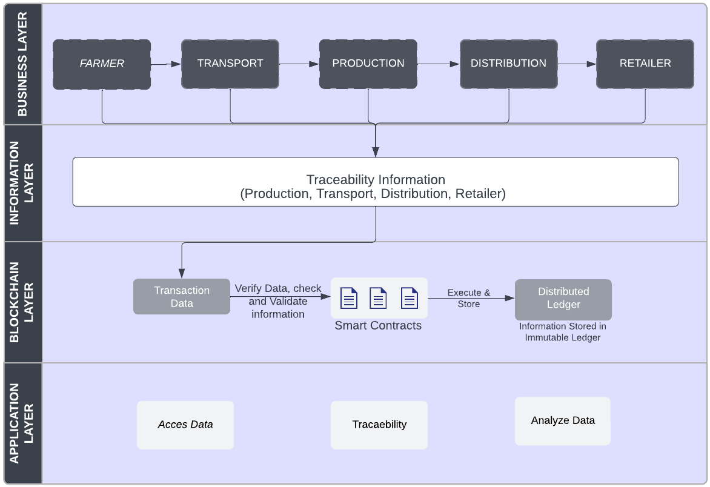The distributor will then take the coffee product from the producers and distribute them to the retailers. The blockchain based coffee supply chain is a decentralized database system where information is recorded at each stage of the process this is monitored by all the participants involved in the coffee supply chain, and any change in the ledger must be validated and approved by other participants.

**Figure 1:** **Blockchain Based System Architecture of Coffee Supply Chain.**

1. **Information Layer:** This layer consists of the blockchain network, all the information pertaining to the coffee supply chain is recorded, secured and stored immutably. This layer plays a crucial role in maintaining the integrity and traceability information of the supply chain. Every time a transaction occurs between one or two participants it is recorded on the blockchain network.

The nodes in the network validate these transactions and enter into the blockchain to ensure that the transaction is valid and was not tampered. After the transaction is verified it will be added to the block, a block is collection

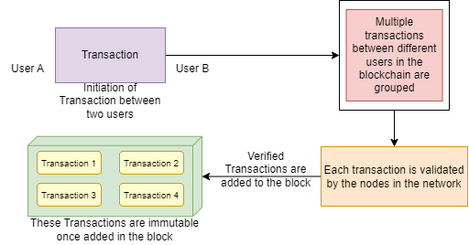**Fig. 1(a) Overview of how transactions are added in the block**

of verified transactions that are linked together in a chronological sequence. The data in the block becomes immutable once it has been added and cannot be altered. The stored information can be accessed by any participant in the blockchain network this ensures transparency and allows participants to track the coffee beans at every stage.

1. 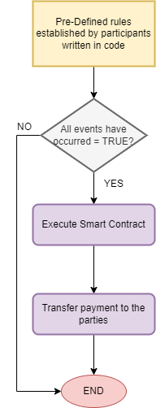**Blockchain layer:** This layer functions as a secure immutable decentralized database for storing data it facilitates transparency and data security through the use of smart contracts.

**Fig.1(b) Flow chart for Smart contract execution**

Smart contracts are self-executing pre-defined set of rules written in the lines of code, smart contracts make sure that payments are only made when all the conditions that are defined have been met, this can make the supply chain more efficient and reduce the likelihood of fraud. For instance, a smart can be set up to transfer the amount only when certain quality standards have been met by the coffee beans.

1. **Application Layer:** Through this layer the users will be able to access various functionalities such as tracking, tracing and monitoring the coffee through each stage of the supply chain process. One of the key functionalities enabled by this is traceability it can be achieved by a decentralized application (DApp) or through an web interface to interact with underlying blockchain network. It will allow participants to perform transactions securely and transparently.
2. **CONCLUSIONS**

In In conclusion Blockchain can help solve the problems of complex coffee supply chain it helps to overcome the inefficiency in the supply chain process, by automating tasks and providing transparency to all the participants involved thereby reducing the likelihood of fraud. Blockchain also provides an immutable database ledger in which the data cannot be altered once it has been stored, and would require the consent of each member if any changes has to be made. This will allow the information to be stored digitally, rather than on papers, and can be distributed among other participants but cannot be edited.

1. **REFERENCES**
2. Andry Alamsyah, Sri Widiyanesti, Puspita Wulansari, Eva Nurhazizah, Andrieta Shintia Dewi, Dadan Rahadian, Dian Puteri Ramadhani, Muhammad Naufal Hakim, Prenzeline Tyasamesi: “Blockchain traceability model in the coffee industry (2023)”.
3. Angelo Marchese, Orazio Tomarchio: “A Blockchain‑Based System for Agri‑Food Supply Chain Traceability Management (2022)”.
4. Wolfram Groschopf, Mario Dobrovnik and Christian Herneth: “Smart Contracts for Sustainable Supply Chain Management: Conceptual Frameworks for Supply Chain Maturity Evaluation and Smart Contract Sustainability Assessment (2021)”.
5. Vinesh Thiruchelvam, Alexandre Shaka Mughisha, Maryam Shahpasand, Mervat Bamiah: “Blockchain-based Technology in the Coffee Supply Chain Trade: Case of Burundi Coffee (2018)”.
6. Hana Trollman, Guillermo Garcia-Garcia, Sandeep Jagtap and Frank Trollman: “Blockchain for Ecologically Embedded Coffee Supply Chains (2022)”.