IoT Based Aeroponics System

Sahana R Kulakarni  
Dept. of Electronics and Communication Engineering  
S. G. Balekundri Institute of Technology.Belagavi, Karnataka, India.  
kulkarnisahana516@gmail.com

Raksha M Itekar  
Dept. of Electronics and Communication Engineering  
S. G. Balekundri Institute of Technology.Belagavi, Karnataka, India.  
raksha.itekar.1@gmail.com  
Shreenidhi J Daddi   
Dept. of Electronics and Communication Engineering  
S. G. Balekundri Institute of Technology.Belagavi, Karnataka, India.  
shreechinnu6366@gmail.com

Dr. Suresh Akkole  
 Head of the Department, Dept. of Electronics and Communication Engineering  
S. G. Balekundri Institute of Technology.Belagavi, Karnataka, India.  
 [hod-ec@sgbit.edu.inAshwini](mailto:hod-ec@sgbit.edu.inAshwini) F Gudumkeri   
Dept. of Electronics and Communication Engineering  
S. G. Balekundri Institute of Technology.Belagavi, Karnataka, India.  
ashwinigudumkeri186@gmail.com

*Abstract*— An aeroponic system is a type of hydroponic system that uses misting method to deliver nutrients and water to the plant roots. In an aeroponic system plants are grown in soilless environment, suspended in the air with their roots exposed to a fine mist of nutrient-rich water. This method allows for sufficient use of resources, as the misting process uses less water and nutrients than traditional soil-based systems. Aeroponic system have the potential to increase crop yield, decrease water usage, and provide a more sustainable form of agriculture. However, they require careful management and monitoring of environmental conditions to ensure optimal plants growth and health.

Keywords—IoT, misting method.

# Introduction

An aeroponic system is a modern method of growing plants that allow them to thrive without the use of soil or solid medium. Instead, the plants are suspended in a chamber or structure and their roots are misted with nutrients-rich water. This method of growing plants is highly efficient in water and nutrients usage, and allows for greater control over the plants environment, resulting in faster growth and healthier plants.

Aeroponic system are becoming increasingly popular in urban farming and indoor gardening due to their space-saving design and ability to grow plants without the need for traditional gardening equipment. They are also great solution for areas with limited access to arable land or for people who want to grow their own fresh produce year-round.

With aeroponic system, it is possible to grow a wide variety of crops, from leafy greens to tomatoes and strawberries, making it a versatile solution for those who want to grow their own food. While it does require some technical expertise and can be more expensive to set up than traditional growing methods, the benefits of an aeroponic system can outweigh the initial costs.

There are several different types of aeroponic systems, including high-pressure, low-pressure, and ultrasonic systems. Each has advantages and limitations, and the system chosen will be determined by the unique needs of the plants being cultivated.

Some potential areas of work related to aeroponic systems includes:

* Research: There is still much to be learned about the optimal conditions for aeroponics plant growth. Researchers may study factors such as nutrient level, pH balance, temperature and lighting to determine the best ways to grow a variety of crops in an aeroponic system.
* Design and engineering: Engineers and designer may work on developing new and innovation aeroponic systems that are efficient, less expensive, and friendly to the environment. This may involve experimenting with different types of pumps, nozzles, and misting system, as well as developing software to monitor and control the system.
* Farming and agriculture: As aeroponics become more widely adopted, there will likely be a growing need for farmers and agriculture professionals who are skilled in operating and maintaining aeroponic systems. This may involve learning how to balance nutrient levels, troubleshoot technical issues, and maximize crop yields.

## Background

The concept of aeroponic systems dates back to the 1920s when researchers first began experimenting with growing plants in a soilless environment. However, it wasn’t until the 1940s and 1950s that aeroponic systems were developed into a practical growing method.

In the early 1950s, researchers at the university of California began studying aeroponic system in earnest. They found that plants grown in an aeroponic system were able to grow faster and produce higher yields than those grown in soil-based systems. This was because the plants were able to absorb nutrients and water more efficiently, as well as get more oxygen to their roots.

In the 1970s and 1980s, NASA began experimenting with aeroponic systems to grow plants in space. These systems were developed to provide fresh food for astronauts on long-duration space missions. NASA found that aeroponic systems were an effective way to grow crops in microgravity, and that the plants grew faster and produced higher yields than those grown in soil-based systems.

## Related Work

An Overview of the systems that are currently in place in this domain was done before the project began. The work of eminent researchers is carefully surveyed, and an excerpt from that work is presented here in a review of the literature.

M E Karar, Faris Alotaibi, Abdullah AI Rasheed, Omar Reyad [1] proposed an agriculture monitoring system. It was implemented with aid of Arduino microcontroller boards, Wi-Fi modem, water pumps and electronic environmental sensors.

V. Sagar Reddy, Gujjala Ramya, V. Moneesh Reddy [2] implemented project on a small scale and mentioned that this can be extended to a big scale by replacing the sensors with a sensor network. As a result, smart greenhouses do not have to be limited to only one or a few plants and can thus replace traditional agriculture operations.

Federico Viani, Michael Bertolli, Alessandro Polo [3] proposed a low-cost wireless sensor for agrochemical dosage reduction in precision farming. In this, to address pesticide dosage reduction an innovative integration of wireless sensor network technology and fuzzy logic theory is applied.

Minwoo Ryu, Jaeseok Yun, Ting Miao, Il-Yeup Ahn, Sung-Chan Choi, Jaeho Kim [4] proposed a paper on smart farming systems. In this paper, they have presented a connected farm based on IoT systems for smart farming systems.

S.R.M Prasanna, and S.R Balasundaram [5] proposed a project related to aeroponics system using IoT. In this, an IoT based aeroponics farming system that can track and regulate several parameters like temperature, humidity, pH and fertilizer level. It includes a mobile system also, which enables a farmer to monitor and manage their crops from the distance.

P.J Singh, et al [6] created an IoT- enabled aeroponic system that has the capacity to monitor and regulate a number of different conditions, including temperature, humidity, and nutrient levels. The system automates the monitoring and management of plant growth through the use of actuators and sensors. Farmers can remotely monitor and manage their crops a smartphone application that is part of the system.

Y. Chen and H. Ma [7] developed an IoT-based smart aeroponic system that can track and regulate different variables including temperature, humidity, and nutrition levels. To automate the process of tracking and managing plant development, the system makes use of sensors and actuators. An additional component of the system is a mobile app that enables farmers to remotely monitor and manage their crops.

M.N.M. Ansari, et al [8] proposed Smart Farming using IoT-based Aeroponic System along with controlling and monitoring parameters, also conducted tests to gauge the system’s effectiveness in terms of crop growth and resource usage.

In all these, the aeroponic system was developed using Arduino, Sensors, and other mobile application. But out of all, this system can also implement using PIC microcontroller as these are consistent and faulty.

# Methodology

The illustrative diagram below shows the working principle of the project. As shown in the illustrative diagram, the system consists of a Peripheral interface controller (PIC), Relays, Wi-Fi modem, Temperature sensor, water level sensor, Cooling fan, LCD display, Buzzer, and Android mobile application.

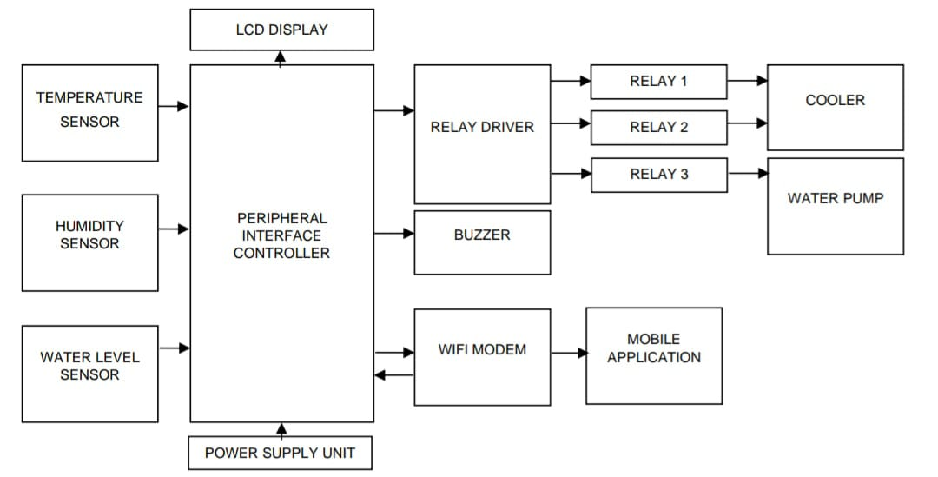

**Fig. Block diagram of the project**

PIC is used to control all the actions in this system. It will give proper timing and duties to the corresponding components on the bases of the program which uploads it.

For user interaction, Wi-Fi automation applications can be used. Here, we are using HK4u_WIFI Home_2022 application to monitor the temperature, humidity, water level and to check whether the aeroponic environment is safe or not.

**Various sensors used in this system:**

In an IoT based aeroponic system, sensors play a crucial role in monitoring the environment and collecting data for analysis. Here are some ways sensors can be used in such a system.

1. Temperature Sensor: Temperature sensors can be used to monitor the temperature in the aeroponic environment. This information can be used to adjust the temperature, ensuring optimal plant growth.
2. Humidity Sensor: Humidity sensor can be used to monitor the humidity levels in the aeroponic environment. This information can be used to adjust the humidity levels, ensuring optimal plant growth.
3. Water level Sensor: Water level sensor can be used to monitor the water level in the aeroponic system. This information can be used to ensure the system has enough water to support optimal plant growth.
4. IR Sensor: Infrared sensor can be used for security purposes in aeroponic system to protect the plants from the third person.

By using sensors in an IoT-based aeroponic system, we can collect data on the environment and use this data to adjust the environment. This can lead to higher yields, better quality crops, and more efficient use of resources.

There are three relays used in this used for three different sensors to executed. Relays are used to give power signals to output devices like water pumps, cooling fans, etc. on the basis of microcontroller signals. Generally, 230V power supply can get. Regulator are employed to convert that 230V power supply to 12V as this worked at 12V.

ESP8266 Wi-Fi modem is used as a mediator to send the input sensor data to the Android mobile application.

Temperature and Humidity sensor is used to measure air temperature in the system. If it is not within the normal range, the cooling fan gets activated to bring the temperature to the normal range. Cooling fans turn on when the temperature range exceeds 30 degrees Celsius and stay on till it does. Circuits are opened and closed using relay mechanisms.

# Result

Our proposed system has been set up with correct measures and has been studied over a particular period of time for growth progress and usage interactions. Seeing the increase was a definite success.

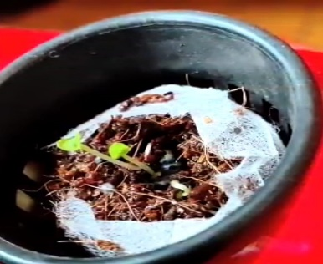 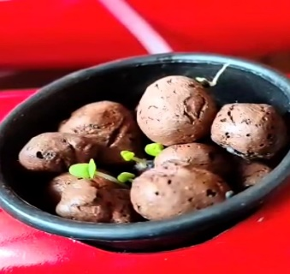

**Fig 2. Growth progress of plants**

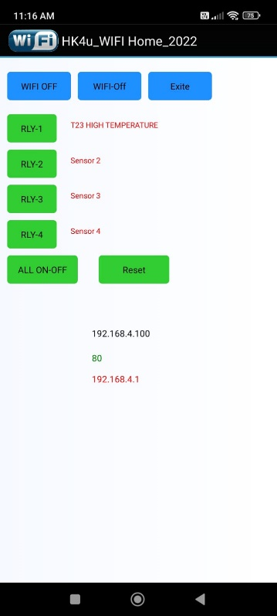

**Fig 3. Result collected from the mobile application**

**Acknowledgement**

We thank Dr. Suresh Akkole for his expertise and assistance in arranging and writing the manuscript.

We also thank Mr. Shankargoud Patil for guiding us.

##### References

1. World Population Review. Dhaka Population. [online]. http://worldpopulationreview.com// (Accessed 18 Nov, 2017.)
2. Aeroponics. [online]. https://www.maximumyield.com/definition/137/aeroponics (Accessed

18 Nov, 2017)..

1. I. S. Jacobs and C. P. Bean, “Fine particles, thin films and exchange

anisotropy,” in Magnetism, vol. III, G. T. Rado and H. Suhl, Eds. New

York: Academic, 1963, pp. 271–350.

1. AeroFarms [online]. http://aerofarms.com/technology (Accessed 18

Nov, 2017).

1. P Mithunesh, K. Gupta, S. Ghule, Prof. S. Hule, “Aeroponic Based

Controlled Environment Based Farming System”, IOSR Journal of

Computer Engineering, Vol. 17, No. 6, Ver. II, 2015, PP. 55-58.

1. S. C. Kerns, Joong-Lyul Lee, “Automated Aeroponics System Using

IoT for Smart Farming,” 8th International Scientific Forum, ISF 2017,

7-8 September 2017, UNCP, USA.

1. Jonas P, Maskara A, Salguero A and Truong A 2015 Garduino: A

Cyber-Physical Aeroponics System (Preprint arXiv:1011.1669v3).

1. [online]. https://www.youtube.com/watch?v=RNHO05sNv_I (Accessed 19 Nov, 2017.)
2. Raut R., Varma H., Mulla C., Pawar V.R. (2018) Soil Monitoring,

Fertigation, and Irrigation System Using IoT for Agricultural Application. In: Hu YC., Tiwari S., Mishra K., Trivedi M. (eds) Intelligent Communication and Computational Technologies. Lecture Notes in Networks and Systems, vol 19. Springer,Singapore.

1. [12] C.Jestop Jeswin, B. Marimuthu, K. Chithra, “Ultrasonic water level indicator and controller using AVR microcontroller,” Int. Conference on Information, Communication & Embedded Systems (2017).
2. A.M.M. Rahman, Q. Mehdi, R. Hossain, M. R. Shwon, and J. Uddin,

“An Automated Zebra Crossing Using Arduino-UNO,” The International Conference on Computer, Communication, Chemical, Material and Electronic Engineering (IC4ME2-2018), University of Rajshahi in Bangladesh.

1. C. Weltzien, N. Diekhans, H. Heinrich Harms; “Distance Measurement, Applications with Automotive Radar Sensors in Agricultural Environment,” CIGR World Congress, 2006 , Bonn, At Bonn, Vol. VDI-Berichte Nr. 1958, 173-174.
2. M E Karar, Faris Alotaibi, Abdullah Al Rasheed, Omar Reyad*. “Smart Precision Agriculture-Intelligent Control Systems and Robotics”*, DOI:10.18576/isl/100115 January 2021 Information Sciences Letters 10(1):131.
3. V. Sagar Reddy, Gujjula Ramya,V. Moneesh Reddy. A Novel Methodology, for the design of *“Greenhouse Environment Monitoring and Automation using Intel Galileo gen and IoT”*. International Journal of Innovative Technology and Exploring Engineering (IJITEE) ISSN: 2278-3075, Volume-8 Issue-7S2, May 2019.
4. Federico Viani, Michael Bertolli, Alessandro Polo. *“Low-Cost Wireless System for Agrochemical Dosage Reduction in Precision Farming”*. Project: Wireless Sensors for Decision Support in Smart Irrigation, DOI:10.1109/JSON.2016.2622244, October 2016 IEEE Sensors Journal PP (99):1-1.
5. Nugaliyadde, M.M., de Silva, H.D.M., Perera, R., Ariyaratna, D., Sangakkara, U.R., An Aeroponic System for the Production of Pre-Basic Seeds of Potato, Annals of the Sri Lanka Department of Agriculture, 7, 199-208, 2005.
6. Minwoo Ryu, Jaeseok Yun, Ting Miao, Il-Yeup Ahn, Sung-Chan Choi, Jaeho Kim. *“Design and Implementation of the connected farm for smart farming system”*. Embedded Software Convergence Research Center Korea Electronics Technology Institute Seongnam, S. Korea 13509. Conference: 2015 IEEE Sensors, DOI:10.1109/ICSENS.2015.7370624, November 2015.