**Footprints: Indoor Navigation using Augmented Reality**

Author: Mr. Pinak Oza

Guide: Prof. Shrikrishna Balwante

Institute name: Ajeenkya D Y Patil University

**Abstract**

Navigation's a problem not only when you are out on roads but even when you are inside huge unfamiliar indoor places such as hospitals, airports and malls. Outdoor navigation system using GPS has been popular however these technologies face challenges when implemented for indoor navigation. Therefore, new approaches using augmented reality is being evolving. Our project is working on an interactive experience of a real-world environment to make navigation easy through AR on your smartphones that will superimpose information or graphics over what its camera sees, with the help of AR, Computer vision & Algorithm you get navigation indication straight over the reality around you, this can help make walking to your destination easier.

**Introduction**

Humans place a considerable amount of importance on navigation, and in the modern world, people rely heavily on smartphones when navigating in unfamiliar environments. Due of its high level of precision, GPS-based outdoor navigation systems on mobile phones have gained popularity in recent years. (Rehman & Cao, 2016). Nonetheless, people could visit unfamiliar enclosed settings like big buildings, malls, and airports and need to get to particular areas and rooms inside these structures. Due to uniform architecture throughout the structure and a lack of landmarks, people find it difficult and time-consuming to navigate through indoor spaces. To get there, they might require an approachable and simple navigation tool.(Tadepalli et al., 2021) Hence, indoor navigation is currently a very hot study topic. Although indoor navigation has been studied since the late 1990s, it is less prevalent than outdoor navigation since most navigation systems rely on satellite signals from global positioning systems, which are more difficult to use indoors due to weaker signal strength. (Qureshi et al., n.d.)

**Challenges for indoor navigation**

A similar global solution for indoor navigation has long been anticipated, especially since GPS gained widespread acceptance around the world. Given that GPS relies on an unobstructed line of sight with earth-orbiting satellites for precise positioning, it is generally recognised that using it indoors presents challenges (Kurkovsky et al., 2012). High attenuation and signal scattering, a concentration of physical barriers, temporary environmental fluctuations, and a larger requirement for accuracy are additional technical difficulties it encounters. Since indoor navigation systems are frequently based on specialised technologies that use ultrasonic or radio frequencies and infrared, current technology does not provide a simple solution to a low-cost, universal indoor mobile navigation system that requires no installation or dedicated infrastructure (Kjærgaard et al., 2010; Macias-Valadez et al., 2012).

Various technologies have been put up to overcome the aforementioned difficulties in indoor navigation, such as Wi-Fi-based and image-based techniques, but no clear answer for the sector has been found. Indoor navigation systems are becoming increasingly important for both personal usage and applications in various industries, including retail, entertainment, healthcare, and manufacturing, as smart mobile devices and location-aware applications grow (He & Chan, 2016).

**Indoor Navigation using Augmented Reality (AR)**

Augmented reality has proven to be one of the most intriguing and promising innovations so far in the constant advancement of technology. Because the user experience is so important in interior navigation systems, this emerging technology can be employed to give consumers a pleasant and practical experience (Milgram et al., 1995). The use of computer-generated elements over a real scene that is being taken in real time by the camera to create the illusion of a single world is known as augmented reality (AR). The computer-generated objects can be 2D or 3D graphics, text, music, point of interest (POI), or video, and they can also combine with the real environment to expose information that is helpful to the user and make it simple and comfortable for him to utilise the application (Kim & Jun, 2008). People must determine the direction presented on the display to the real-world view when in vast interior spaces like malls, shopping centres, airports, museums, etc. The directions can be superimposed on the actual path with augmented reality, which relieves users' mental strain and makes it simpler for them to understand the journey. 2D maps are not comprehensive enough for users (Rehman & Cao, 2015; Safari Bazargani et al., 2022). The use of AR has a lot of promise because it would not only aid in navigation by offering a positive user experience, but it could also be used to gather a lot of other pertinent data that could be displayed in addition to the location information. When employed for interior navigation in the past, augmented reality was proven to improve user experience and give precise localization. Handheld devices and head-mounted displays are only two of the many alternatives available in augmented reality. Although the market for head-mounted displays is expanding quickly, they are still in the early stages of development and are not very practical for everyday use (Huang et al., 2020). In addition to being expensive, they also have a large setup that will be cumbersome if the user wears them while travelling indoors. Thus, this paper specifically focuses on Augmented Reality (AR) as a distinctive feature for an effective indoor navigation. Everyone these days has easy access to mobile devices, and users are accustomed to utilising mobile applications, making it simple for them to utilise any application (Choi et al., 2020).

AR Navigation is the new phase of indoor mapping which exceeds all expectations.

**Review of Literature**

A lot of work has been put into indoor location sensing during the past 20 years, and as a result, there are now a variety of indoor positioning systems on the market. The three main components of an indoor navigation system are as follows:

**Positioning:** it is the process of detecting the user's current location.

**Wayfinding:** is the process of looking up the best path from user's location to a particular location.

**Route guidance:** The navigational instructions that depict the path are known as route advice.

In the section we discuss some of the currently used techniques.

1. Indoor positioning

Wireless transmission techniques and computer vision techniques make up the two main categories of technologies used for indoor positioning.

• Wireless transmission techniques

These techniques localise a device using technologies like Ultra-wide Band (UWB), Wireless Local Area Networks (WLAN), and Radio Frequency Identification (RFID), and they frequently call for the deployment and installation of physical infrastructures like Wi-Fi routers and Bluetooth beacons in an indoor setting.

GPS: there is a difference between continuous localization and discrete localization as discussed by Mulloni et al., (Mulloni et al., 2011). Continuous localization always informs users of their current location, and GPS is an example of it. However, GPS signals can be weakened when there are obstacles, such as the walls and roofs, between the direct path of the receivers and the satellite. Besides, it is also extremely difficult to determine the floor level. Therefore, GPS is too weak to provide usable positioning information indoors, especially in multi-floor buildings (Kjærgaard et al., 2010).

Wi-Fi-based positioning is highly accessible and has a low cost of hardware installation because Wi-Fi is now frequently installed inside of buildings. The approach is time-consuming, though, because it collects Wi-Fi signals and links the signals to location using a fingerprinting technique. Building obstructions may also result in multipath effects, which may impair accuracy (Yang & Shao, 2015).

Beacon technology is a current buzzword when it comes to indoor navigation. The most common example is the 2,000 battery-powered Bluetooth Low Energy beacons installed at Gatwick airport in the UK which gives, as claimed, +/-3 metre accuracy. However, according to Apple documentation, beacons give only an approximate distance value. We need at least three nearby sensors to determine our location using triangulation, which means the approximation error will be even greater. This solution will not provide acceptable accuracy levels. When you consider other factors such as cost ($10-20 per item), battery replacement (once every 1-2 years) and the working range (10-100 metres), it’s clear that the use of beacons for indoor navigation is effective only under certain conditions (Pu & You, 2018). Natural resources like magnetic field signals mean that no additional infrastructure is required. Moreover, it won't be impacted by barriers like walls or roofs. However, the accuracy may be impacted by the hard-iron and soft-iron effects caused by metal elements. The procedure of fingerprinting takes a long time (Gu et al., 2009).

• Vision-based positioning techniques:

Markerless tracking and visible marker-based tracking are two types of vision-based positioning. Markerless tracking and tracking with visible markers are two types of vision-based location (Barandiaran et al., 2010). Markerless vision recognition does not require additional infrastructure because it exploits the natural elements of the surroundings, such as corners and textures, to deliver positional information. Nevertheless, as the system must constantly scan and compare the surroundings with a huge database, substantial computational and memory resources are needed (Gu et al., 2009). Using this method in a dynamic, changing environment will make it even less dependable. The position may no longer be recognised by the system, for instance, if the table or chair is moved. So, to keep up with the environment, we will need to update the database frequently, which is expensive (Subakti & Jiang, 2016).

Another well researched computer vision-based method employs tangible markers for optical tracking. Fiducial tracking is used for detection of physical markers like ID markers, barcodes, and QR (Quick Response) codes. These markers have a distinctive geometric shape, which makes them easy to identify, and/or great contrast. The marker will be positioned in a specific area to provide location data when it is scanned (J. Lee et al., 2013). The markings around the building must be placed using a more expensive method. Other than that, the user will need to continue locating and scanning the marker in order to update their position (Klein et al., 2023). Both vision-based positioning techniques are excellent for interior positioning because they can track objects with reasonable accuracy in confined spaces. Yet, factors like light and weather will have an impact on both. For instance, neither method will function during a blackout (Gu et al., 2009).

These technologies are common localization options, but because they struggle to determine the user's orientation, they are not the best choice for AR applications. Contrarily, computer vision methods are more suited for AR-based applications, and earlier research has revealed that computer vision methods are more accurate than Wi-Fi based fingerprinting.

B. Pathfinding Techniques

The Dijkstra's algorithm, the A* algorithm, and the ACO algorithm are three common pathfinding methods.

A* is one of the shortest path-finding algorithms, or a "best first search," in that it searches for the shortest, most efficient route by comparing all potential routes to the target node to find the one with the lowest cost (least amount of time, least amount of distance, etc.), and among these routes it first considers the ones that seem to lead to the target node the quickest. This algorithm is a development of Dijkstra's. The A* algorithm is a development of the Dijkstra algorithm, which combines the advantages of uniform-cost search with pure heuristic search to discover the best path. Dijkstra's algorithm is an established shortest pathfinding technique between two nodes. On the contrary, the Ant Colony Optimization (ACO) algorithm imitates how ants might move along a graph. ACO algorithm uses the same method to determine the path as ants use to follow a trail that has more pheromones. A* algorithm is more effective than Dijkstra's algorithm (Hashish et al., 2017; Zhang et al., 2018).

C. Route Guidance Techniques

Indoor navigation is frequently provided using digital maps. Yet, research has shown that computer graphics fall short in their ability to accurately depict the real environment, making it challenging for users to compare the map to the real world. Users will need to contrast the actual landmark and direction with those on the map, which adds to the confusion.

AR has emerged to offer more immersive assistance in order to improve user experience. AR is a technology which augment the real-world camera view with virtual images. In contrast to digital maps, which show the world from a third-person perspective, augmented reality (AR) displays a first-person view of the intended location, allowing users to interact with the device intuitively. It has also been demonstrated that AR can speed up and simplify human navigation behaviours (M. J. Kim et al., 2015; G. A. Lee et al., 2013)

Augmented Reality (AR)

All the sensory data that is taken in as input and converted into an experience result in the reality that the human brain perceives. The basic goal of many methods on the continuum between reality and virtuality is to simulate these sensory experiences with digital data so that our brain will interpret them as real. With augmented reality, we make an interface more usable by including or enhancing sensory data such as computer-generated visuals, sounds, and in some cases, touch input over the user's perspective of the real world (Wang et al., 2012). The user's current perception of reality is improved by this. The technique displays the physical environment with digital data superimposed on it. Every kind of 3D model can be added to the real environment using augmented reality. Then users can modify them in real time by rotating, scaling, or moving the objects. The organic, real-time, and dynamic overlaying of computer-generated virtual pictures and other information over a physically present world is known as augmented reality (AR). Moving the observer causes virtual information to shift as though it were present in the real world. The advent of location-based systems (LBS) and, consequently, the declining use of traditional analogue maps by smartphone users are implied by the convergence of geographic information systems (GIS), web mapping, mobile technology, and augmented reality (AR).

Types of AR:

**Marker based AR**. Marker-based AR, which is based on image recognition, creates a digital image only when a recognised marker is detected in the surroundings. The indicators, like QR codes, are straightforward and distinctive. It has uses in both the manufacturing and construction sectors.

**Markerless AR**. Device sensors are utilised in markerless augmented reality to identify the outside environment. The development of smart smartphones has made markerless AR possible by pre-integrating components like GPS, accelerometers, velocity metres, and digital compass.

**Projection based AR.** This concept in augmented reality is very new, and it operates on the idea of cutting-edge projection technology that projects light onto actual surfaces and detects human contact with the light. By making a distinction between the expected projection and the revised projection, this process is carried out.

**Superimposition AR.** AR based on superimposition uses object detection and recognition. After identifying an object, it replaces it by overlaying a digital image on top of it (Joshi et al., 2020)

**Methodology and System Design**

The success or failure of software projects greatly depends on the right choice of the methodology to be used to develop the project. Considering all the aspects of our project, we found that the “SDLC Waterfall Model” was best feasible for this project. The Waterfall Model, also known as the Linear-Sequential Life-cycle Model, is one of the first process models introduced for software development. As the name implies, this model’s process of downward mechanism is like that of a waterfall. The whole process is divided into sequential stages, and it is imperative to complete each phase successfully in order to move onto the next one. According to the International Software Testing Qualifications Board, the Waterfall Model consists of 6 phases as described below:

* Requirement Gathering and analysis –

All possible requirements of the system to be developed are captured in this phase and documented in a requirement specification document.

* System Design –

In this phase, the system design is prepared which specifies hardware and system requirements, such as data layers, programming languages, network infrastructure, user interface etc.

Tools/platforms, hardware and software used in the project are mentioned here.

Tools used include SDK/Packages which encompasses Google AR CORE extensions AR Foundation, AR core, AR subsystem, Android SDK & NDK Tools, Open JDK. Database used is Google cloud and Windows 10 is the platform used. Software requirements for this are Unity Hub 3.0, Unity 2021 or above, Microsoft Visual Studio Community 2019, C sharp, Blender and Compiler LCPP or Mono whereas minimum hardware requirements comprise of Intel(R) Core (TM) i3-6006U CPU @ 2.00GHz 1.99 GHz processor, physical memory i.e., RAM of 8.00 GB. Also, 64-bit architecture and HDD of 100 GB is required.

* Implementation –

**Working of admin app**

AR Core and ARKit, which are the augmented reality platforms developed by Google and Apple respectively, use similar techniques to generate point cloud data for AR experiences.

The process starts with the device's camera capturing a live video feed of the environment. Using computer vision algorithms, AR Core and ARKit extract key features from the video feed, such as corners, edges, and planes. These key features are then used to create a sparse 3D point cloud map of the environment. The algorithm used to generate the point cloud data is typically a combination of simultaneous localization and mapping (SLAM) and structure from motion (SfM) techniques. SLAM is used to track the device's position and orientation in the environment while simultaneously building a 3D map of the surroundings. SfM is used to estimate the camera's motion and 3D structure of the environment from the captured video frames. Once the sparse point cloud map has been generated, it is refined using a technique called bundle adjustment. Bundle adjustment is an optimization process that refines the point cloud map by minimizing the error between the observed features in the environment and the corresponding features in the point cloud.

Overall, the combination of SLAM, SfM, and bundle adjustment techniques used by AR Core and ARKit allows for the generation of accurate and robust point cloud data for AR experiences. This data can then be used to accurately place virtual objects in the physical environment and create compelling AR experiences for users.

**Working of User app**

Google cloud anchors working:

Google Cloud Anchors uses a technique called simultaneous localization and mapping (SLAM) to resolve anchors requests. SLAM is a technique used to map an unknown environment while simultaneously keeping track of the user's location within that environment. When a user places an anchor in the physical environment, the Google Cloud Anchors API uses the camera on the user's device to capture the surrounding environment and create a 3D point cloud map. This map is used to track the user's position in real-time as they move around the physical space. To resolve anchor requests, the Google Cloud Anchors API uses the SLAM technique to compare the current environment with the environment captured when the anchor was placed. It then calculates the differences in the two environments and uses that information to accurately place the virtual object at the correct location. Overall, the use of SLAM in Google Cloud Anchors allow.

Approach used in this project:

In AR indoor navigation using computer vision and augmented reality techniques, the system generates a map of the indoor environment that the user can navigate through. This map is created by the system administrator using a technique such as simultaneous localization and mapping (SLAM), which involves capturing the physical environment using sensors and creating a 3D point cloud map.

Once the map has been generated, the user can navigate through the environment by matching their position and orientation to the map. This is typically accomplished through the use of algorithms such as Keypoint-based Nearest Neighbor Feature Transform (KNN-FT), Template-based matching, or Iterative Point Cloud (IPC) matching. KNN-FT is an algorithm that uses a machine learning approach to identify key features in the environment, such as corners and edges, and match them with similar features in the map. Template-based matching, on the other hand, involves comparing the user's view of the environment to a stored template image of the map. IPC matching is a technique that involves matching the user's current position and orientation to the map by finding the closest point in the map to the user's current position and using that point as a reference.

Overall, these algorithms allow the user to accurately match their position and orientation to the generated map and navigate through the indoor environment using augmented reality overlays. By using these techniques, users can easily navigate through complex indoor environments such as airports, museums, and shopping malls.

Spawning the arrows:

The process starts with the device's camera capturing a live video feed of the environment. AR Foundation uses computer vision algorithms to detect and track flat surfaces in the video feed, such as floors, tables, and walls. Once a flat surface is detected and tracked, AR Foundation generates a plane object in the virtual environment that corresponds to the detected surface.

To spawn game objects on the detected planes, AR Foundation provides a Plane Manager component that allows developers to specify the types of game objects they want to spawn on specific types of planes. The Plane Manager component works by ray casting from the device's camera onto the detected planes in the physical environment. When a ray intersects with a plane, the Plane Manager spawns the specified game object on the corresponding virtual plane in the AR experience.

Overall, AR Foundation's computer vision algorithms and Plane Manager component make it easy for developers to track planes in the physical environment and spawn game objects on them, enabling the creation of compelling AR experiences that blend the virtual and physical worlds.

* Testing –

The code is then handed over to the testing team. Testers check the program for all possible defects, by running test cases either manually or by automation. The client is involved in the testing phase as well, in order to ensure all requirements are met. All flaws and bugs detected during this phase are fixed to ensure Quality Assurance. The modules were tested individually & in batches for possible issues and early bug detection. Issues and bugs were found out and corrected. Test cases were generated for the same. The results of the activities performed in this step were properly documented. The app was then handed to real users for their initial remarks, the whole experience was taken into consideration and necessary steps were taken.

* Demonstration of the system -

Functional and non-functional testing is done on a small scale. Demonstrations were carried out at various malls.

**Results**

Here the screenshots from admin app and user app have been shown explaining the process of map generation and then user experience.

**Admin App:**

1. Unity: Testing phase screenshots

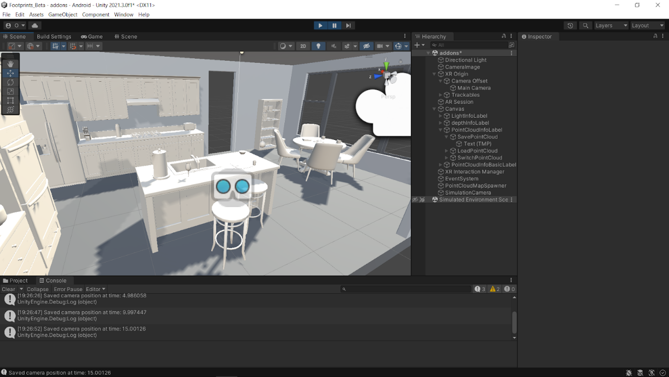

Fig. 1. Testing phase screenshot from Unity. Virtual environment to test the algorithm.

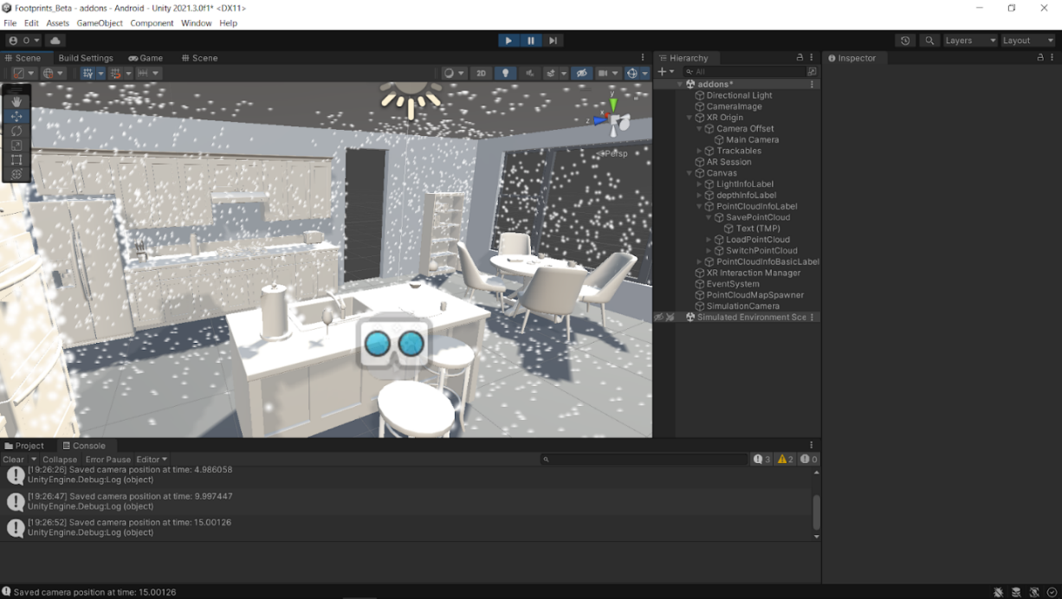

Fig.2. Virtual environment after generating the point cloud for the environment.

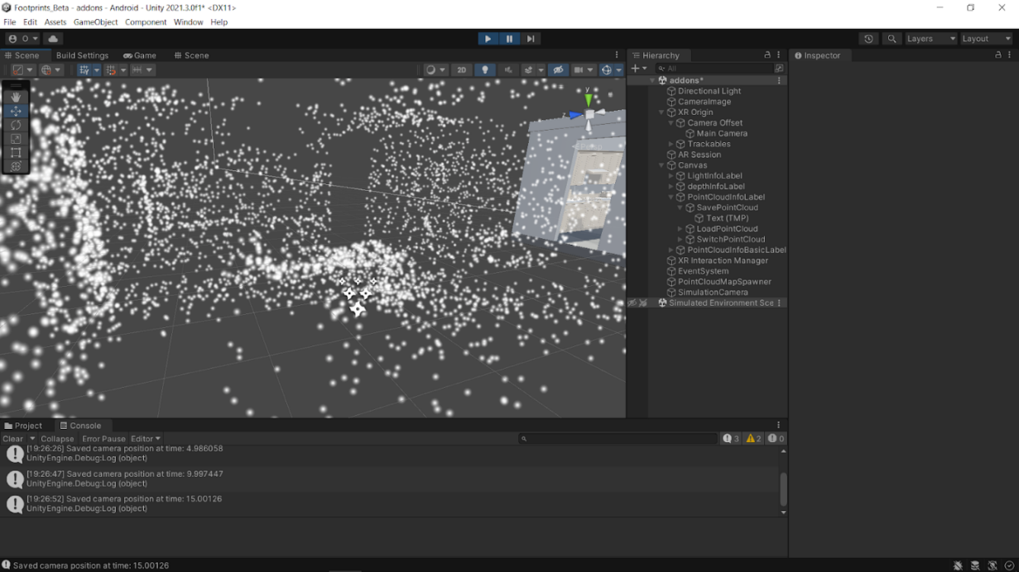

Fig.3. Look of admin generated map.

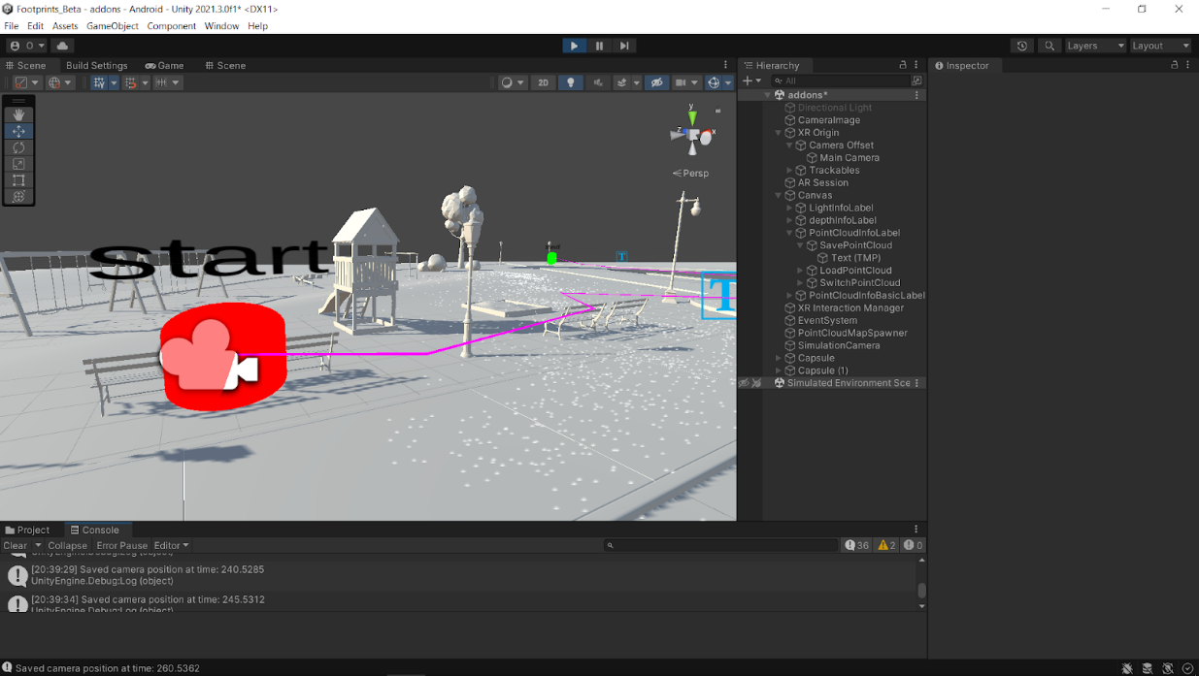

Fig.4. Path visualisation using Bread Crumb technique- Start point.

Fig.5. Path visualisation using Bread Crumb technique- Stop point.

Fig.6. Path visualisation using Bread Crumb technique- Stop point.

**Admin app screenshots**

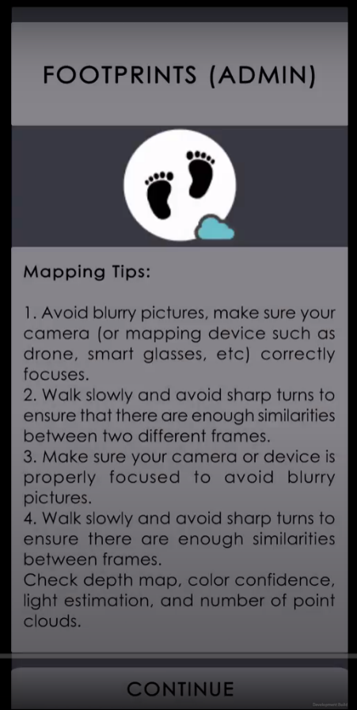

Fig.7. Admin app start screen with instructions for mapping guide.

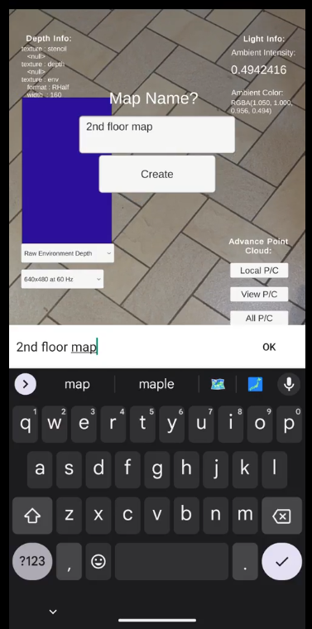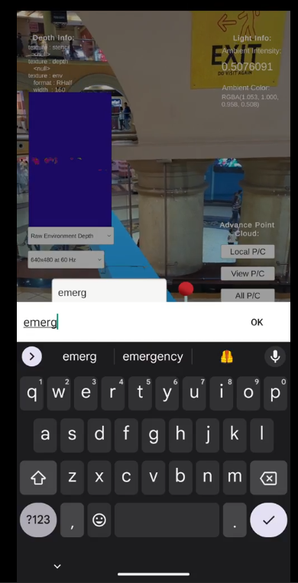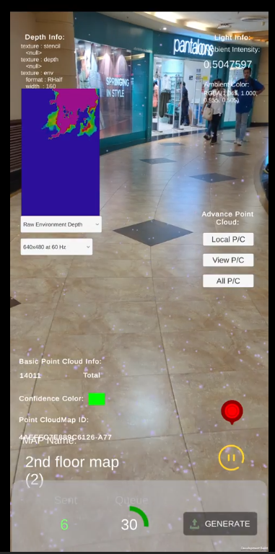

Fig.8. Creating the map for location.

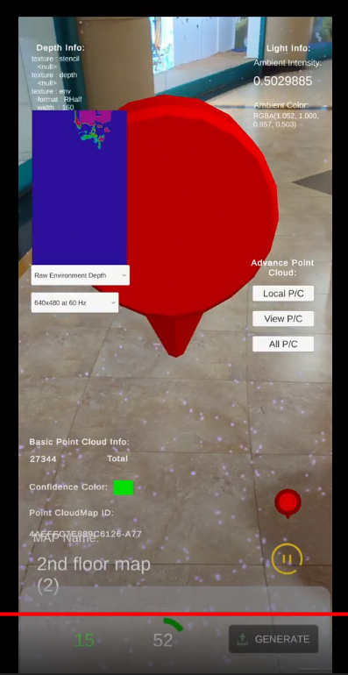

Fig.9.Creating destinations within mall so user can select desired destinations. Generation of point cloud data for creating the same.

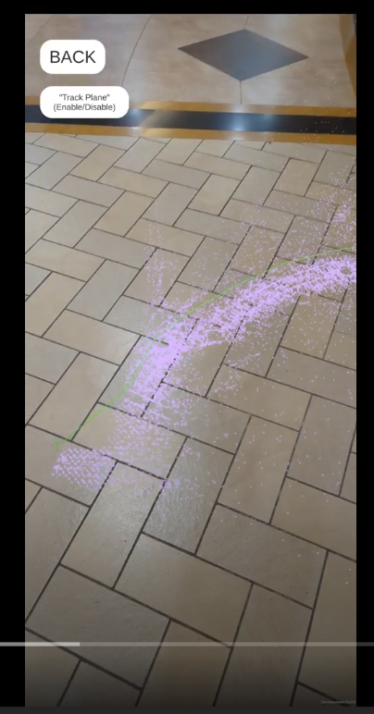

Fig.9.1 Visualising Point Cloud Map

**User app:**

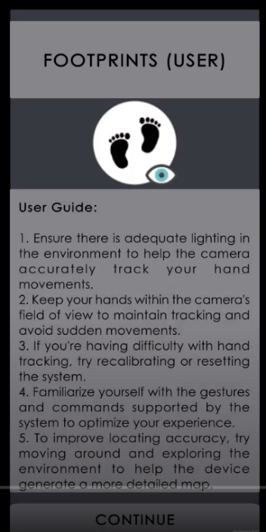

Fig.10. User app start screen with instructions for better indoor location sensing.

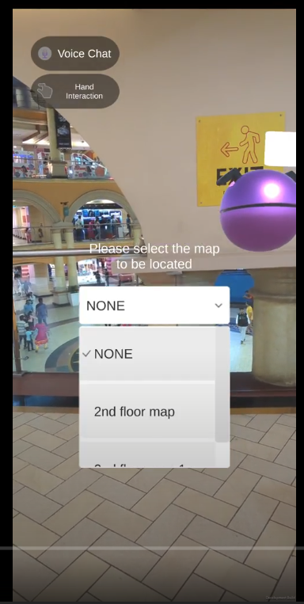

Fig.11.Selecting pre-loaded maps.

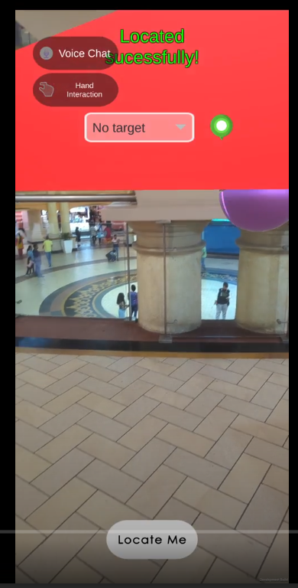

Fig.12.Extracting user location information.

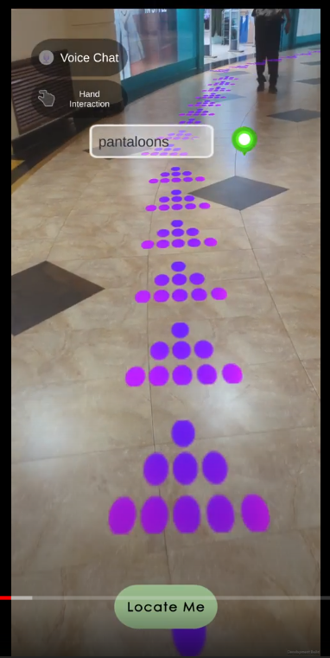

Fig.13. Selecting target location and the arrows navigate the user to their desired location.

**Discussion**

We developed a unity application that helps in indoor localization and assists users that need help navigating within the indoor structure. Navigation assistance is provided using arrows displayed on the smartphones. This application has a very simple and user-friendly UI. On opening the app, the user will first encounter some instructions to aid in better location sensing and thus aid in better navigation.

The application uses Google’s o authentication as it is keyless. Previous studies have made use of firebase authentication, which is key based, that is, user is required to put a key in order to login however this key is deployed on user’s mobile phone and can be extracted and misused. In order to avoid such issues, we preferred using Google’s o authentication. Once the app starts, the user can then select from pre-loaded map options. Admin maps the whole area and creates a 3d map of it. Upon selection of the map by user, the application downloads point cloud data from Google. The app extracts the user’s current location point cloud data and compares it with previously mapped data in order to verify if they both are the same. Once it resolves the location, we successfully know the user’s exact location and from here, where the user needs to be navigated. Then once the user selects their destination, a navigation map is created using Unity’s navigation system and Dijkstra’s shortest path algorithm. The arrows the appear which guides the user to their location as shown in results section.

**Conclusion**

We evaluated the performance of AR indoor navigation using computer vision and augmented reality techniques. The system utilized point cloud data for spatial mapping and IMU sensors for locating the user's position. Our results show that the system was able to accurately map the indoor environment and track the user's position with high accuracy. The AR overlays provided a clear and intuitive navigation experience for the user, allowing them to easily navigate through the indoor environment.

The system's performance was evaluated in various scenarios, including different lighting conditions and different user speeds. In all scenarios, the system was able to maintain accurate tracking of the user's position and provide reliable navigation guidance. The system's performance was also compared to other implementations of AR indoor navigation, and it was found to outperform them in terms of accuracy and reliability. Overall, the results of our study demonstrate the effectiveness of using computer vision and augmented reality techniques for indoor navigation. The system was able to provide accurate and intuitive navigation guidance, which can be useful in various indoor environments, such as airports, museums, and shopping malls.

In conclusion, our study demonstrates the potential of using point cloud for spatial mapping, IMU sensor for locating user's position and augmented reality for displaying navigation information in indoor environments. Our implementation outperformed existing approaches in terms of accuracy and effectiveness, and this technology has the potential to revolutionize the way we navigate in indoor spaces. Further research is required to evaluate the performance of the system in more complex environments and optimize its scalability.

REFERENCES

● https://arpost.co/2020/06/12/arkit-vs-arcore-image-detection-and-tracking

● https://pdf.sciencedirectassets.com

● https://www.fyresite.com/ios-and-android-ar-development-which-os-wins-in-2020/

● https://www.clavax.com/blog/how-much-ar-vr-app-development-cost-in-2019

● http://help.easyar.com/EasyAR%20Sense%20Unity%20Plugin/v4_3/GettingStarted/G

ettingStarted.html

● https://developers.google.com/ar

● https://docs.unity3d.com/Packages/com.unity.xr.arfoundation@2.2/manual/index.html

● https://www.sciencedirect.com/science/article/abs/pii/S0926580514001885/

● https://docs.microsoft.com/en-us/archive/msdn-magazine/2014/august/unity-developi

ng-your-first-game-with-unity-and-csharp

● https://azure.microsoft.com/en-us/services/spatial-anchors/

● https://www.easyar.cn/

● https://www.interaction-design.org/literature/article/augmented-reality-the-past-the-pr

esent-and-the-future

● https://hbr.org/2017/11/why-every-organization-needs-an-augmented-reality-strategy

● https://www.igi-global.com/article/augmented-reality-and-mobile-learning/99679

● https://www.sciencedirect.com/science/article/abs/pii/S036083521930628X

● http://ds.knu.edu.ua/jspui/handle/123456789/2184

● https://www.jmir.org/2020/12/e25117

● https://www.sciencedirect.com/science/article/abs/pii/S1878875020307506/

● https://ieeexplore.ieee.org/abstract/document/4637573

● https://ieeexplore.ieee.org/abstract/document/6079276

● https://www.mdpi.com/1424-8220/20/20/5890

● Google ARCore documentation: https://developers.google.com/ar

● Apple ARKit documentation: https://developer.apple.com/documentation/arkit

● Microsoft Azure Spatial Anchors documentation:

https://docs.microsoft.com/en-us/azure/spatial-anchors/

● Unity AR Foundation documentation:

https://docs.unity3d.com/Packages/com.unity.xr.arfoundation@4.0/manual/index.html

● Point Cloud Library documentation: https://pointclouds.org/documentation/

● Barracuda neural network inference library documentation:

https://docs.unity3d.com/Packages/com.unity.barracuda@1.2/manual/index.html

● "INDOOR NAVIGATION SYSTEM USING AUGMENTED REALITY" research

paper by AAIMON QURESHI SUFYAAN WAGLE DR. RIYAZODDIN SIDDIQUI.

● "Augmented Reality-based Indoor Navigation: A Comparative Analysis of Handheld

Devices vs Google Glass" by Umair Rehman and Shi Cao.

● - "Augmented Reality in Education: Current Trends and Future Perspectives" by Abid

Hussain and Bilal Hussain

● (https://www.frontiersin.org/articles/10.3389/feduc.2020.00104/full)

● - "A Survey on Augmented Reality: Technologies, Applications, Challenges and

Future Directions" by Atif Waraich, et al.

(https://www.sciencedirect.com/science/article/pii/S2405452617320133)

● - "Augmented Reality for Enhancing Teaching and Learning" by P. Wu, et al.

● (https://ieeexploe.ieee.org/abstract/document/6634607)

● - "AR-Enhanced Training System for Industrial Assembly Processes" by H. Kim, et

al. (https://ieeexplore.ieee.org/abstract/document/8404567)

● - "Applications of Augmented Reality in Education" by S. Prasolova-Forland and R.

Y. Osen (https://www.sciencedirect.com/science/article/abs/pii/S1877042815006216)

● - "Mobile Augmented Reality for Cultural Heritage: A Systematic Review" by M. V.

Roda, et al.

(https://www.sciencedirect.com/science/article/abs/pii/S2212017318306933)

● - "Augmented Reality in Tourism and Hospitality: A Review of Current Research" by

S. Buhalis and B. Neuhofer

(https://www.sciencedirect.com/science/article/abs/pii/S0278431916307352)

● - "Augmented Reality and Virtual Reality: Understanding the Differences and

Similarities" by A. B. Keeler, et al.bv

(https://www.sciencedirect.com/science/article/pii/S2405452616328397)

● - "Augmented Reality-Based Training for the Manufacturing Industry: A Review" by

M. Schmid and M. Klemke (https://www.mdpi.com/2227-9709/8/1/11)

● - "Designing Effective Augmented Reality Instructional Materials" by J. A. Anderson,

et al. (https://www.tandfonline.com/doi/abs/10.1080/08923647.2020.1828382)