ANALYSIS OF STRENGTH OF CONCRETE BY USING RECYCLED AGGREGATES

Researchers:-

Afsha Khan b* , Bhavna Patil b* , Satish Patel b*

Research Guide:-

Prof. Chetan Hankare a*

#### b*= Students of Thakur shivkumar singh memorial group of institute jhiri ( Department of civil engineering )

#### a*= Research guide and head of the Department of Thakur shivkumar singh memorial group of institute jhiri (Department of civil engineering)

Abstract

An experimental study of recycled aggregate concrete (RAC) using recycled coarse aggregate (RCA) is reported. The RCA was obtained from construction and demolition waste (C&DW) and used as full replacement of natural coarse aggregate (NCA) for production of RAC. Crushed granite was used as NCA while crushed concrete rubble from a demolished concrete building was used as RCA. Batching of concrete was done by weight using concrete mix ratio of 1:2:4 and water/cement ratio of 0.5. A total of 96 standard concrete cubes were cast and cured. Two groups of concrete mixtures were tested: 100% NCA as control and 100% RCA. Bulk density and compressive strength of concrete cubes were conducted at 7, 14, 21, and 28 curing days respectively. The results showed that bulk density and compressive strength of natural aggregate concrete (NAC) were higher than those of RAC for different ages of concrete. The bulk density and compressive strength of the 28-day RAC were 2328 kg/m3and 29.42 N/mm2respectively which satisfied British Standards Institution (1997) BS 8110-1:1997 requirements for structural concrete.

.

1. Introduction

Concrete is undoubtedly one of the most widely used materials in construction because of its undeniable benefits in terms of strength, durability in corrosive environments, inexpensive cost, application, etc. On the other hand, since natural aggregate (NA) are one of the main components of concrete mixtures, concrete is claimed to raise significant environmental complications by (a) using natural resources of aggregate, (b) CO2 emission, (c) deposition of concrete buildings’ demolition and landfill saturation. As a result, application of innovative materials (e.g., elastomeric material), supplementary cementitious materials (SCMs), alkali-activated materials (AAMs) or recycled materials (e.g., glass particles) as a replacement for natural aggregate has been assessed in several studies.

Among several proposed materials, recycled concrete aggregate generated from reinforced concrete (RC) buildings’ demolition has attracted researchers’ attention because of reusing wasted concrete aggregate released in the nature which leads to remarkable advantages including: (a) reducing CO2 emission, (b) preserving natural resources, (c) reducing waste deposition, (d) decreasing areas required for landfill disposal and overall (e) eliminating harmful influences of wasted concrete on environment

1. Material And Method

**2.1Component material**

Cement: Ordinary Portland cement bought from a cement depot in Owerri, Imo State, Nigeria was used. The cement complied with the specifications of Nigerian Industrial Standards (2003) NIS 444-1:2003.

Water: Potable water obtained from a tap in Owerri, Imo State was used for mixing and curing. The water quality was in conformity with the specifications of British Standards Institution (1980) BS 3148:1980.

Fine aggregate: River sand obtained from Otammiri River in Owerri, Imo State was used as

fine aggregate. It was found to be sharp and clean in accordance with British Standards Institution (1992) BS 8

Coarse aggregate: Gravel obtained from crushed granite rock in Okigwe, Imo State was used as natural coarse aggregate (NCA), while recycled coarse aggregate (RCA) was obtained from crushed rubble of a demolished concrete building in Owerri, Imo State82:1992.

**2.2 Concrete mix proportioning and preparation**

The physical and mechanical properties of the aggregates were tested prior to being used in production of concrete mixes. Sieving of the fine and coarse aggregates were done using British Standards Institution (2000) BS 410-1:2000 test sieves. Both the NCA and RCA were washed and air-dried, and the portion passing through 5-20 mm sets of BS 410-1:2000 sieves were used. The specification given in British Standards Institution (1997) BS 8110-1:1997 is used as the guideline in concrete mix preparation. British Standards Institution (1997) BS 8110-1:1997 recommends that for reinforced concrete construction, the maximum water/cement ratio of 0.7 and a minimum cement content of 250 kg/m3. Since the density of concrete is about 2449 kg/m3, the cement content should be about 10.2% by weight (Ettu et al., 2013). The batching of concrete was therefore done by weight using concrete mix ratio of 1:2:4 and water/cement ratio of 0.5. The constituent materials were thoroughly mixed before potable water was added to produce fresh concrete. A total of 96 concrete mixes forming two groups of the coarse aggregate types were designed such that Group (1) was the control group made up of 100% NCA while Group (2) was made up of 100% RCA. Fresh concrete was cast in cast iron moulds with internal dimensions of 150 × 150 × 150 mm. The concrete cubes were constructed manually and cured in water tanks after 24 hours of moulding such that each coarse aggregate type was used in twelve specimens for 7, 14, 21, and 28 days of curing respectively.

**2.3 Testing of concrete**

Workability refers to the ease with which a fresh concrete mix can be handled, and it can be measured using the slump test. Slump test was conducted for each batch of fresh concrete according to the requirements of British Standards Institution (1983) BS 1881-102:1983. The bulk densities of the hardened samples were obtained in accordance with British Standards Institution (1983) BS 1881-114:1983 for concrete at 7, 14, 21, and 28 days of curing respectively. On the day of testing, the cubes were removed from the curing tank and subjected to room temperature for about three hours before their densities were determined prior to crushing. A compressive testing machine was used to conduct the compressive strength test on the concrete cubes at 7, 14, 21, and 28 days respectively in accordance with British Standards Institution (1983) BS 1881-116:1983.The mean values of the bulk density and compressive strength of twelve concrete cubes for each curing age and coarse aggregate group were calculated and recorded.

3 Results And Discussion

3.1Properties of aggregates

The particle size distribution curve for river sand is while the particle size distribution curves for both NCA and RCA , coefficient of curvature, Cc is 0.91, and the uniformity coefficient, Cu is 5.45. The fineness modulus is 2.91. The fineness modulus shows that the fine aggregate lie between the range of medium sand and coarse sand, and is suitable for production of satisfactory concrete . The coefficient of curvature, Cc, from the particle size distribution curves of NCA and RCA given in are 1.57 and 1.74 respectively, while uniformity coefficient, Cu, of NCA and RCA are 2.55 and 3.40 respectively. It is observed that the coarse aggregate grains were well-graded since the values of Cc are less than 3.0 but greater than 1.0 . The physical and mechanical properties of NCA and RCA . It can that the specific gravity of RCA was slightly less than the range for coarse aggregate. The 24-hour water absorption of RCA is less than 2%, the maximum value of water absorption for most normal coarse aggregates . Thus, RCA has a higher capacity to absorb water than NCA. Results of the aggregate crushing value, aggregate impact value and Los Angeles abrasion value respectively measure the strength, toughness and hardness. According to Shetty (2012), the value for these mechanical properties should not be more than 30% for concrete used for wearing surfaces. Researchers also reports that for concrete other than wearing surfaces, aggregate impact value should not be more than 45% and Los Angeles abrasion value should not more than 50%. It can be observed from Table 1 that RCA has the higher aggregate crushing, aggregate impact, and Los Angeles abrasion values than NCA. It can be noticed that RCA did not satisfy the requirements for aggregate crushing value and aggregate impact value for use in wearing surface concrete. NCA has lower crushing, impact, and abrasion values in comparison with RCA and thus possesses better resistance to shock and wear. Both NCA and RCA have good resistance to abrasion

**3.2Workability**

The slump of fresh concrete mixes of NAC and RAC were 90 mm and 100 mm. The slump of different concrete samples fell within the range of 25-100 mm, indicating medium workability . Based on workability, both NAC and RAC using the given concrete mix and water/cement ratios can be applied in construction work involving heavily reinforced concrete sections with vibration, and simply reinforced concrete sections without vibration. Fresh concrete mix of RAC showed lower workability than NAC for 1:2:4 mix ratio of and water/cement ratio of 0.5.

**3.3Bulk density**

The results of the bulk density of NAC and RAC . The bulk density of both NAC and RAC increases with concrete age with 7 days corresponding to the lowest bulk density and 28 days corresponding to the highest bulk density. The bulk density of normal weight concrete ranges from 2200-2600 kg/m3, and it can be observed that bulk density of both the NAC and RAC mixes fell within this range. The corresponding values for unit weight of normal weight concrete (taking acceleration due to gravity, g, to be equal to 9.81 m/s2) range from 21.58-25.51 kN/m3. As expected, the bulk density of RAC was marginally lower than that of NAC. Table 1 shows the reduction in bulk density of RAC in comparison with NAC. From Table 2, 7-day old RAC gave the lowest reduction in bulk density while the 28-day old RAC gave the highest reduction in bulk density.The bulk density of NAC for 28 days is approximately 2574 kg/m3 while the bulk density of RAC for the same age is 2328 kg/m3. The corresponding unit weights of NAC and RAC are approximately 25.25 kN/m3and 22.83 kN/m3respectively. The unit weight of RAC is reasonably lower than the nominal value of 24 kN/m3assumed in British Standards Institution (1997) BS 8110-1:1997 for traditional normal weight concrete. This implies that RAC would produce structural members with lower self-weight than traditional concrete. The reduction in bulk density of RAC could be attributed to the lower specific gravity and lower bulk density of recycled concrete aggregate in comparison with virgin coarse aggregate.

**3.4Compressive strength**

The test results of the 7, 14, 21, and 28 days compressive strength of concrete are presented in Figure 4. Both NAC and RAC concrete types had similar compressive strength development with increase in time. As expected, the compressive strength of each concrete mix increased with age with the 7-day concrete cube attaining the lowest compressive strength while the 28-day concrete had the highest strength. This is due to increased amount of hydration products with the longer curing age. Both NAC and RAC types had approximately similar compressive strength development with time. The 7-day compressive strength of concrete generally ranges from 60-80% of the 28-day compressive strength for traditional concrete under standard curing conditions (Neville and Brooks, 2010). The 7-day compressive strength of NAC obtained in this study was 85.1% of its 28-day compressive strength, while the 7-day compressive strength of RAC was 76.4% of its 28-day compressive strength. The compressive strength of 7-day NAC was slightly higher than the expected range probably due to higher cement content. High cement content contributes to produce a greater early-age compressive strength . The recommended percentage of cement in a structural concrete mix is 10.2% while the 1:2:4 concrete mix used in this study represents 14.2% cement the reduction in compressive strength of RAC in comparison with NAC. The reduction in compressive strength of RAC ranged from 30-40%. The compressive strength of RAC for 28 days represents 32.9% reduction of the 28-day compressive strength of NAC. The reduction in compressive strength of RAC could be attributed to the lower quality of the recycled aggregate in comparison with virgin coarse aggregate. It should be noted that the RCA was obtained from a demolished concrete structure of unknown The 28-day compressive strength of RAC was 29.42 N/mm2 which exceeds the characteristic compressive strength of 25 N/mm2for normal weight concrete specified in British Standards Institution (1997) BS 8110-1:1997. The characteristic strength is defined as the value below which not more than 5% of the test results will fall and results from the compressive strength test should possess a value greater than this. This is given by

𝑓𝑘 = 𝑓𝑚 − 1.64𝑠

where fk is the characteristic strength, fm is the mean strength, and s is the standard deviation. If the number of test results of a particular group is less than twenty, then it is expected that all the test results should be equal to or greater than the value of the characteristic compressive strength. In this study, the compressive strength values of twelve batches of the 28-day RAC were greater than characteristic compressive strength of 25 N/mm2.compressive strength

4 Conclusions

The scope of this investigation included an examination of the main factors of RA that influence the compressive strength of concrete. The main conclusions that can be drawn from this study are given below:

• As the quantity of recycled aggregates increases, there is a decrease in compressive strength, the extent of which mainly depends on the RCA’s type, size and origin.

• The recycled aggregate are found to be very resilient and useful in various situation. Their properties are almost similar to virgin aggregate.

• If the aggregates are properly selected, separated and graded from a good source will have more superior qualities. In near future, RCA will become backbone of construction industry and may come up as reliable and cheap construction material.

• The basic test results of both NCA and RCA satisfies the IS specifications. The specific gravity of RCA is lower and water absorption is greater than natural aggregate.

• The recycled aggregate is relatively weaker than the natural aggregate against mechanical actions but satisfies the IS requirements.

• The slump value of the mix was decreased with the increase in the percentage of RCA.

• Density of cement block decreases with increasing in RCA percentage.

• From this investigation it can be concluded that 50 %RCA block having more strength than conventional.

5 Results And Findings

5.1. FOR 7 DAY ’S CURING CUBE

450

400

350

300

250

200

CON.BLOCK

GLASSBLOCK

150

100

50

0

1

2

3

  
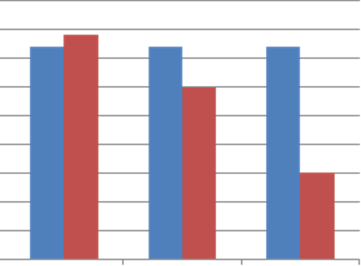

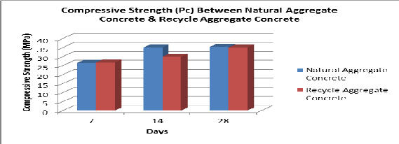

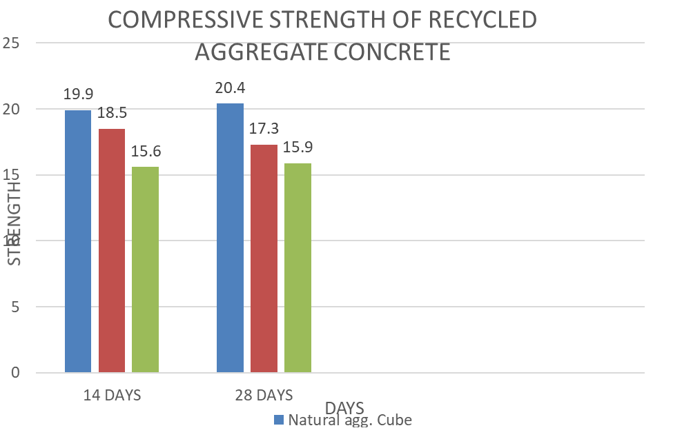

6 References

1.Patagundi B.R., Jadhav R.T., “Effect of Freezing and Thawing on the Properties of SFRC Containing Waste Glass Powder as Pozzolana”, 2012 Vol 3(1), pp 33-39.

2.U.S. Environmental Protection Agency. “Municipal solid waste generation, recycling and disposal in the United States”, tables and figures for 2010. <http:// [www.epa.gov/osw/nonhaz/municipal/pubs/2010_MSW_Tables_](http://www.epa.gov/osw/nonhaz/municipal/pubs/2010_MSW_Tables_) and_Figures_508.pdf> [last accessed 18.06.12].

3.Environmental Protection Agency (EPA). “Municipal solid waste generation, recycling, and disposal in the United States”: facts and figures for 2005. EPA-530-F06-039. October 2006.

4.National Environment Agency of Singapore. “Waste statistics and recycling rate for 2011”.

<<http://app2.nea.gov.sg/> topics_wastestats.aspx> [last accessed 18.06.12].