|  |
| --- |
| GENDER, AGE AND SENTIMENTAL **ANALYSIS** |





**A PROJECT REPORT**

***Submitted by***

**KANNAN M (720819104050)**

**KAVIN VIGNESH T (720819104054)**

**ARAVINTH S (720819104010)**

***In partial fulfillment for the award of the degree of***

**BACHELOR OF ENGINEERING**

***in***

**COMPUTER SCIENCE AND ENGINEERING**

**HINDUSTHAN INSTITUTE OF TECHNOLOGY**

**COIMBATORE-641032**

**ANNA UNIVERSITY: CHENNAI 600 025**

**May 2023**

**ABSTRACT**

Gender, age, and sentiment analysis are three areas of research in natural language processing (NLP) that are closely related. Sentiment analysis involves extracting and analyzing subjective information to determine the sentiment expressed in a piece of text. Research has shown that gender can have an impact on the way individuals express sentiment in language. For example, women have been found to use more emotional language and express more positive sentiment than men in their communication. Age is another demographic variable that has been found to influence sentiment expression in language. Older adults have been found to express more positive sentiment than younger adults, possibly due to a positivity bias that develops with age. In this paper, the author has worked on a technique for age and gender classification using python algorithm. Human identification and classification are being utilized in various field for a very long time.Fields like Government ID Cards, Verification procedures etc. We have already developed techniques like retina scan, iris scans, fingerprint and other sophisticated systems such as DNA fingerprinting to identify the individuals. Although these already built methods works efficiently, the hardware, software and human proficiency requirement are way too demanding for several simpler task which may or may not require a professional efficiency. Technique reported in this paper is simple and easy for human classification which can be performed using only a webcam and a decent computer system.

**Keywords** : Age Estimation, Gender Detection, Python Deep Learning, Convolutional Neural Network, Webcam

**INTRODUCTION**

Human Classification is an age-old procedure and being done in various fields and technology such as biometrics, forensics sciences, Image processing, Identification system, etc. With the development of Artificial Intelligence and techniques such as Neural Network and Deep Learning, it has become increasingly easier to classify human. These new technologies help identification, classification of Individuals without the need of another professional or Individual records. Also Being immensely fast, these technologies can classify millions of individuals way faster than a professional. Human Facial Image Processing provides many clues and cues applicable to industries such as security, entertainment, etc. Human Face can provide immense amount of information like their emotional state, slightest agreement or disagreement, irony or anger, etc. This is the reason why faces have been long research topic in psychology . This data (or in our case digital data) is very valuable as they help recognition, selection or identification of individual according to the requirement. Age and Gender Detection can alone provide a lot of information to places such as recruitment team of organizations, Verification of ID cards, example: Voter ID cards which millions of individual uses to cast their vote at the time of election, etc. Human Facial Image processing eases the task of finding ineligible or counterfeit individuals.

Gender analysis aims to identify the gender of an author based on their written text. It utilizes linguistic cues and patterns, such as word choice, sentence structure, and writing style, which may differ between genders. By analyzing these textual features, machine learning models can predict the gender of the author with a certain degree of accuracy.

Age analysis involves inferring the age or age group of an author based on their written text. Gender, age, and sentiment analysis are three interconnected tasks that involve extracting valuable insights from textual data. These analyses provide a deeper understanding of the demographics and emotional states of individuals, enabling a wide range of applications in fields such as marketing, customer service, social media analysis, and public opinion research.

**Gender Analysis:**

Gender analysis aims to determine the gender of individuals based on textual information. By analyzing linguistic patterns, word choices, and contextual cues, machine learning models can predict whether a person is male or female. Gender analysis can help tailor marketing campaigns, create personalized content, and understand gender-related preferences and behaviors.

**Age Analysis:**

Age analysis involves estimating or categorizing the age of individuals based on text data. It can be approached as either age estimation, predicting the precise age, or age group classification, assigning individuals to predefined age categories. Age analysis provides valuable insights for targeted advertising, content recommendation, age-specific product development, and demographic analysis.

**Sentiment Analysis:**

Sentiment analysis, also known as opinion mining, focuses on determining the emotional sentiment expressed in text. By analyzing language patterns, sentiment analysis models can classify text as positive, negative, or neutral. Sentiment analysis is widely used to understand customer opinions, monitor brand reputation, gauge public sentiment on social media, and tailor marketing strategies accordingly.

The objective of gender, age, and sentimental analysis is to extract meaningful insights from large volumes of data related to these factors. This analysis can help businesses, healthcare organizations, and governments make informed decisions based on accurate information. Some specific objectives of gender, age, and sentimental analysis may include:

**1. Understanding Customer Behavior**:

Gender, age, and sentiment analysis can help businesses understand their customers' behavior, preferences, and attitudes. This information can be used to develop more targeted marketing strategies and improve customer satisfaction.

**2. Identifying Health Trends:**

Gender and age analysis can help healthcare organizations track health trends and identify risk factors for different diseases. Sentiment analysis can be used to assess patient satisfaction and improve healthcare delivery.

**3. Enhancing Public Services:**

Gender, age, and sentiment analysis can help governments understand the needs and preferences of their citizens. This information can be used to develop more effective public policies and programs.

**4. Tracking Social Media Trends:**

Gender, age, and sentiment analysis can help businesses track social media trends and identify opportunities to engage with customers. This information can be used to develop more effective social media marketing strategies.

**5. Developing Personalized Recommendations:**

Gender, age, and sentiment analysis can help businesses develop personalized recommendations for their customers. This can improve customer satisfaction and drive sales.

**6. Understanding Demographics:**

One of the primary objectives of gender and age analysis is to gain insights into the characteristics of a population. This information can be used for market research, political analysis, and healthcare.

**7. Personalizing Customer Interactions:**

By analyzing the demographics of customers, companies can tailor their interactions with them. For example, a company may use gender and age analysis to develop targeted advertising campaigns or offer personalized recommendations.

**8. Improving Customer Service:**

By analyzing customer sentiment, companies can identify areas where they need to improve their service. This information can be used to develop better products and services that meet the needs of their customers.

**9. Assessing Public Opinion:**

Gender, age, and sentiment analysis can be used to assess public opinion on various issues. This information can be used to develop policies and campaigns that are effective in addressing the needs of the population.

10. **Identifying Health Trends:**

Gender and age analysis can be used to identify health trends and risk factors for various diseases. This information can be used to develop targeted interventions and treatments.

**METHODOLOGY**

The methodology for the Gender, Age and Sentimental Analysis involves a series of steps that are designed to collect, preprocess, select, and train models to achieve accurate diagnosis. The methodology is as follows:

**1. Data Collection:**

Collect data from various sources, such as social media,customer feedback, or other relevant platforms.

**2. Data Preprocessing:**

Clean and preprocess the data using techniques such as data normalization, tokenization, POS tagging, lemmatization, stemming, stop words removal, and feature extraction.

**3. Gender Classification:**

Use machine learning algorithms such as logistic regression, SVM, or Naive Bayes to classify the text based on gender. Train the model on a labeled dataset of gender-specific text to predict the gender of the given text.

**4. Age Classification:**

Use machine learning algorithms such as decision trees, random forests, or gradient boosting to classify the text based on age. Train the model on a labeled dataset of age-specific text to predict the age of the given text.

**5. Sentiment Analysis:**

Use machine learning algorithms such as neural networks, SVM, or decision trees to classify the text based on sentiment. Train the model on a labeled dataset of sentiment-specific text to predict the sentiment of the given text.

**6. Intersectionality Analysis:**

Combine the gender, age, and sentiment models to perform intersectionality analysis. This analysis can provide insights into how gender, age, and sentiment interact with each other to influence the text.

**7. Model Evaluation:**

Evaluate the performance of each model using metrics such as accuracy, precision, recall, and F1-score. Use cross-validation techniques to ensure that the models are not overfitting the data.

**8. Applications:**

Apply the models to various fields such as healthcare, marketing, social media, and customer support. Use the insights generated from the analysis to make data-driven decisions.

**9. Challenges and Limitations:**

Address the challenges and limitations of the proposed solution such as data bias, privacy concerns, and technical limitations.

**10. Conclusion and Future Directions:**

Summarize the key findings of the analysis and provide recommendations for future research and development. Identify the potential applications and implications of the proposed solution for practice and policy.

* Basic requirement for this project includes: Python 2.7-3.6, Open CV2, PyCharm Community Edition, Webcam (at least 2.0MP). An adequately equipped windows machine to run the project is required. The Project uses Python Deep Learning to identify the gender and age of given face data accurately. Deep Learning belongs to the family of machine Learning. Deep Learning mimics the functionality of human cognitive thinking and acts as an Artificial Intelligence system.
* It can recognise objects, faces, speeches, characters from unstructured data sets. The Algorithm designed is divided into four main parts: Input, Face Detection, Face Processing (Age and Gender classification) and output.
* This process allows us to extract data from the detected face in previous step. Once the face has been detected data can be extracted. here we are only testing and bench marking the gender and age of the faces but face can provide enough information to study emotion, ethnicity, heritage, biasness such as agreement/disagreement, mood, abnormality.
* Once the face has been detected in the frame. We can start its processing using Convolutional Neural Network or CNN. It is a type Deep Neural Network which is mostly used for Image processing and NLP. The CNN will carry out the testing training phase and will give different prediction. For Gender the prediction can be either of two: Male and Female.
* To make the process faster we have created age groups. The Age prediction can be either of these 8 groups: (0 – 2), (4 – 6), (8 – 12), (15 – 20), (25 – 32), (38 – 43), (48 – 53) and (60 – 100). The Architecture here uses three convolutional layers each with different nodes and kernel sizes.

Overall, the methodology involves collecting and preprocessing the data, building machine learning models for gender, age, and sentiment analysis, and applying these models to real-world scenarios to gain insights and make data-driven decisions.

# FLOWCHART

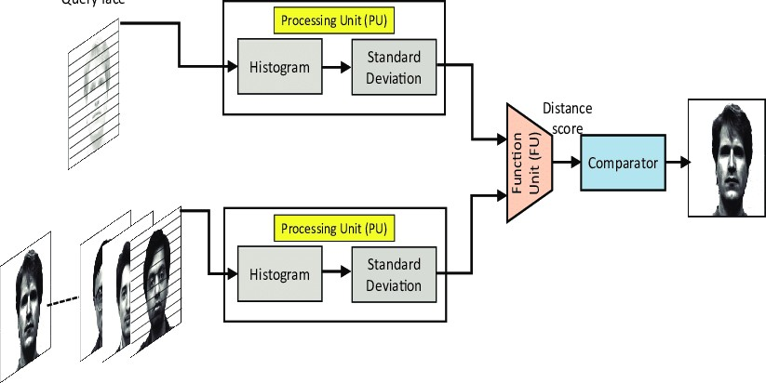

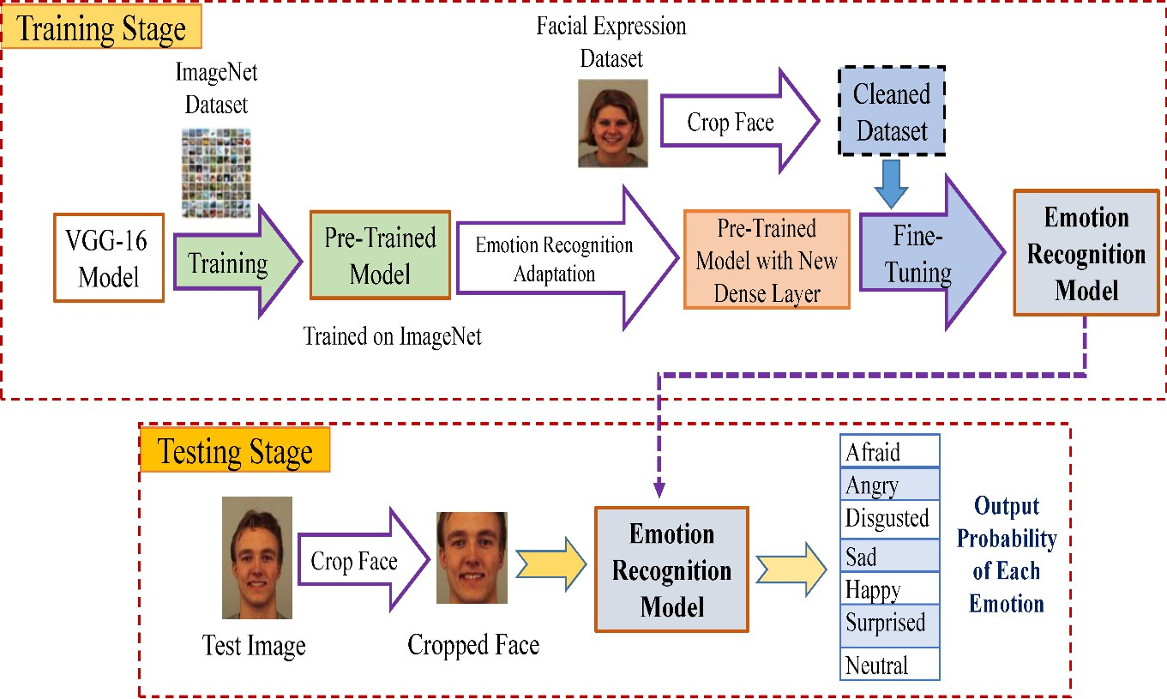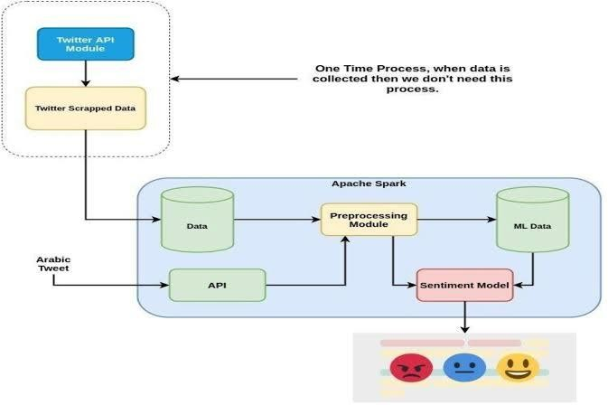

**SOURCE CODE**

### GENDER, AGE DETECTION:

import cv2

import math

import argparse

def highlightFace(net, frame, conf_threshold=0.7): frameOpencvDnn=frame.copy() frameHeight=frameOpencvDnn.shape[0] frameWidth=frameOpencvDnn.shape[1]

blob=cv2.dnn.blobFromImage(frameOpencvDnn, 1.0, (300, 300), [104, 117,

123], True, False)

net.setInput(blob) detections=net.forward()

faceBoxes=[]

for i in range(detections.shape[2]): confidence=detections[0,0,i,2] if confidence>conf_threshold:

x1=int(detections[0,0,i,3]*frameWidth) y1=int(detections[0,0,i,4]*frameHeight) x2=int(detections[0,0,i,5]*frameWidth) y2=int(detections[0,0,i,6]*frameHeight)

faceBoxes.append([x1,y1,x2,y2])

cv2.rectangle(frameOpencvDnn, (x1,y1), (x2,y2), (0,255,0), int(round(frameHeight/150)), 8)

return frameOpencvDnn,faceBoxes parser=argparse.ArgumentParser()

parser.add_argument('--image') args=parser.parse_args() faceProto="opencv_face_detector.pbtxt" faceModel="opencv_face_detector_uint8.pb" ageProto="age_deploy.prototxt" ageModel="age_net.caffemodel" genderProto="gender_deploy.prototxt" genderModel="gender_net.caffemodel"

MODEL_MEAN_VALUES=(78.4263377603, 87.7689143744,

114.895847746)

ageList=['(0-2)', '(4-6)', '(8-12)', '(15-20)', '(25-32)', '(38-43)', '(48-53)', '(60-100)']

genderList=['Male','Female']

faceNet=cv2.dnn.readNet(faceModel,faceProto) ageNet=cv2.dnn.readNet(ageModel,ageProto) genderNet=cv2.dnn.readNet(genderModel,genderProto)

video=cv2.VideoCapture(args.image if args.image else 0) padding=20

while cv2.waitKey(1)<0: hasFrame,frame=video.read()

if not hasFrame: cv2.waitKey()

break

resultImg,faceBoxes=highlightFace(faceNet,frame) if not faceBoxes:

print("No face detected")

for faceBox in faceBoxes:

face=frame[max(0,faceBox[1]-padding)

: min(faceBox[3]+padding,frame.shape[0]-1),max(0,faceBox[0]- padding)

:min(faceBox[2]+padding, frame.shape[1]-1)]

blob=cv2.dnn.blobFromImage(face, 1.0, (227,227), MODEL_MEAN_VALUES, swapRB=False) genderNet.setInput(blob) genderPreds=genderNet.forward()

gender=genderList[genderPreds[0].argmax()] print(f'Gender: {gender}')

ageNet.setInput(blob) agePreds=ageNet.forward()

age=ageList[agePreds[0].argmax()] print(f'Age: {age[1:-1]} years')

cv2.putText(resultImg, f'{gender}, {age}', (faceBox[0], faceBox[1]-10), cv2.FONT_HERSHEY_SIMPLEX, 0.8, (0,255,255), 2, cv2.LINE_AA)

cv2.imshow("Detecting age and gender", resultImg)

# SENTIMENT ANALYSIS

### TRAINED MODEL FOR SENTIMENTAL ANALYSIS:

# import required packages import cv2

from keras.models import Sequential

from keras.layers import Conv2D, MaxPooling2D, Dense, Dropout, Flatten from keras.optimizers import Adam

from keras.preprocessing.image import ImageDataGenerator

# Initialize image data generator with rescaling train_data_gen = ImageDataGenerator(rescale=1./255) validation_data_gen = ImageDataGenerator(rescale=1./255)

# Preprocess all test images

train_generator = train_data_gen.flow_from_directory( 'data/train',

target_size=(48, 48), batch_size=64, color_mode="grayscale", class_mode='categorical')

# Preprocess all train images

validation_generator = validation_data_gen.flow_from_directory( 'data/test',

target_size=(48, 48), batch_size=64, color_mode="grayscale", class_mode='categorical')

# create model structure emotion_model = Sequential()

emotion_model.add(Conv2D(32, kernel_size=(3, 3), activation='relu', input_shape=(48, 48, 1)))

emotion_model.add(Conv2D(64, kernel_size=(3, 3), activation='relu')) emotion_model.add(MaxPooling2D(pool_size=(2, 2))) emotion_model.add(Dropout(0.25))

emotion_model.add(Conv2D(128, kernel_size=(3, 3), activation='relu')) emotion_model.add(MaxPooling2D(pool_size=(2, 2))) emotion_model.add(Conv2D(128, kernel_size=(3, 3), activation='relu')) emotion_model.add(MaxPooling2D(pool_size=(2, 2))) emotion_model.add(Dropout(0.25))

emotion_model.add(Flatten()) emotion_model.add(Dense(1024, activation='relu')) emotion_model.add(Dropout(0.5)) emotion_model.add(Dense(7, activation='softmax'))

cv2.ocl.setUseOpenCL(False)

emotion_model.compile(loss='categorical_crossentropy', optimizer=Adam(lr=0.0001, decay=1e-6), metrics=['accuracy'])

# Train the neural network/model

emotion_model_info = emotion_model.fit_generator( train_generator,

steps_per_epoch=28709 // 64, epochs=50,

validation_data=validation_generator, validation_steps=7178 // 64)

# save model structure in jason file model_json = emotion_model.to_json()

with open("emotion_model.json", "w") as json_file: json_file.write(model_json)

# save trained model weight in .h5 file emotion_model.save_weights('emotion_model.h5')

### TESTING MODEL FOR SENTIMENTAL ANALYSIS:

import cv2

import numpy as np

from keras.models import model_from_json

emotion_dict = {0: "Angry", 1: "Disgusted", 2: "Fearful", 3: "Happy", 4:

"Neutral", 5: "Sad", 6: "Surprised"}

# load json and create model

json_file = open('model/emotion_model.json', 'r') loaded_model_json = json_file.read() json_file.close()

emotion_model = model_from_json(loaded_model_json)

# load weights into new model emotion_model.load_weights("model/emotion_model.h5") print("Loaded model from disk")

# start the webcam feed #cap = cv2.VideoCapture(0)

# pass here your video

path cap = cv2.VideoCapture(0)

while True:

# Find haar cascade to draw bounding box around face ret, frame = cap.read()

frame = cv2.resize(frame, (1280, 720)) if not ret:

break

face_detector = cv2.Cascade

Classifier('haarcascades/haarcascade_frontalface_default.xml')

gray_frame = cv2.cvtColor(frame, cv2.COLOR_BGR2GRAY)

# detect faces available on camera

num_faces = face_detector.detectMultiScale(gray_frame, scaleFactor=1.3, minNeighbors=5)

# take each face available on the camera and Preprocess it for (x, y, w, h) in num_faces:

cv2.rectangle(frame, (x, y-50), (x+w, y+h+10), (0, 255, 0), 4) roi_gray_frame = gray_frame[y:y + h, x:x + w]

cropped_img = np.expand_dims(np.expand_dims(cv2.resize(roi_gray_frame, (48, 48)), -1), 0)

# predict the emotions

emotion_prediction = emotion_model.predict(cropped_img) maxindex = int(np.argmax(emotion_prediction))

cv2.putText(frame, emotion_dict[maxindex], (x+5, y-20), cv2.FONT_HERSHEY_SIMPLEX, 1, (255, 0, 0), 2, cv2.LINE_AA)

cv2.imshow('Emotion Detection', frame) if cv2.waitKey(1) & 0xFF == ord('q'):

break

cap.release() cv2.destroyAllWindows()

**OUTPUT:**

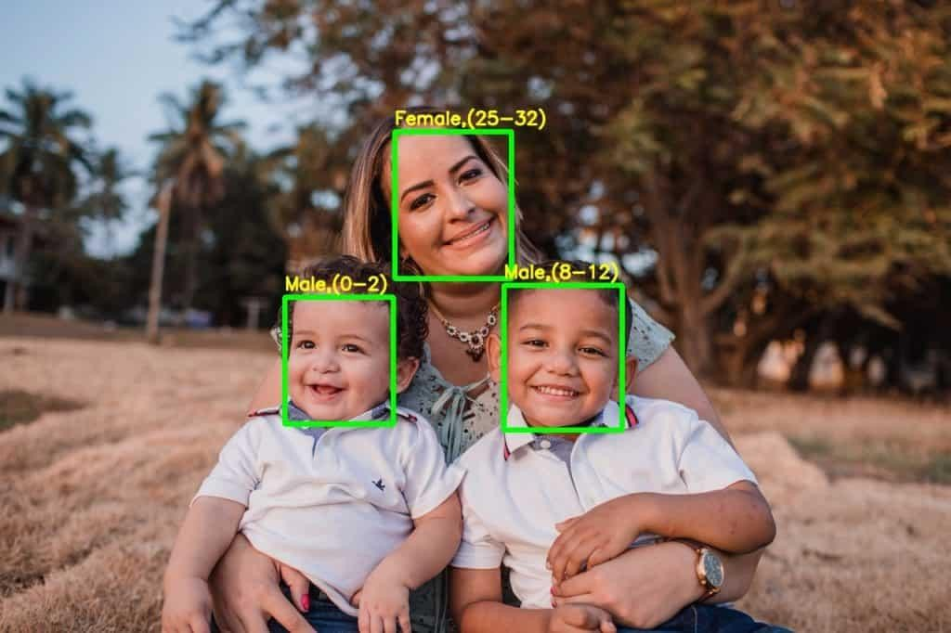

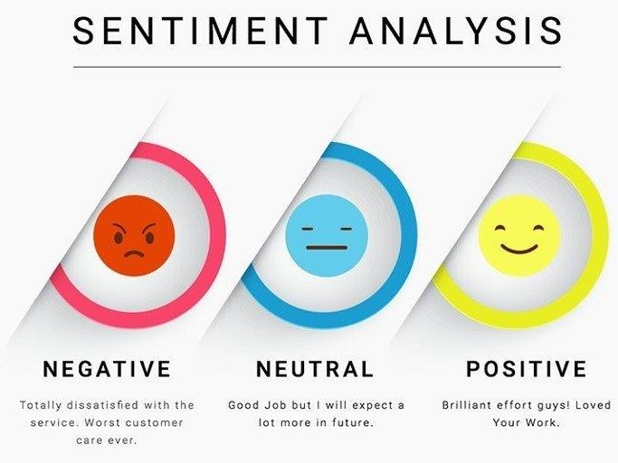

**USES**

There are numerous use cases for gender, age, and sentiment analysis using Python, including:

### Marketing:

Companies can use gender and age analysis to target their marketing campaigns towards specific demographics. Sentiment analysis can help companies understand customer feedback and improve their products and services accordingly.

### Healthcare:

Healthcare providers can use gender and age analysis to identify patterns and trends in patient data. Sentiment analysis can help identify patients who may be at risk of depression or other mental health issues.

### Customer Service:

Customer service departments can use gender and sentiment analysis to improve customer satisfaction by tailoring their responses to the customer's gender and sentiment.

### Political Campaigns:

Political campaigns can use sentiment analysis to gauge public opinion and tailor their messaging to resonate with voters.

### Education:

Educational institutions can use gender and age analysis to identify patterns and trends in student data. Sentiment analysis can help identify students who may be at risk of academic or mental health issues.

### Social Media:

Social media platforms can use sentiment analysis to identify and moderate harmful or offensive content.

### E-commerce:

E-commerce websites can use gender and age analysis to recommend products to customers based on their demographics. Sentiment analysis can help identify customer satisfaction levels and improve the overall customer experience.

Overall, gender, age, and sentiment analysis can be applied to a wide range of industries and applications to gain insights, improve decision-making, and enhance customer satisfaction.

## APPLICATIONS

There are numerous applications for gender, age, and sentimental analysis using Python. Here are a few examples:

### Marketing:

Companies can use gender, age, and sentimental analysis to understand their customers' preferences and attitudes towards their products or services. They can tailor their marketing strategies based on these insights to improve customer engagement and loyalty.

### Healthcare:

Gender and age analysis can help healthcare providers to personalize treatment plans and improve patient outcomes. Sentiment analysis can be used to analyze patient feedback and improve the quality of healthcare services.

### Social Media:

Gender, age, and sentiment analysis can be used to analyze social media data and understand trends, opinions, and attitudes towards various topics or brands. This information can be used by marketers, journalists, or policymakers to inform their decisions and strategies.

### Customer Support:

Gender, age, and sentiment analysis can be used to analyze customer feedback and improve the quality of customer support services. Companies can use these insights to identify common issues and improve their response times and customer satisfaction.

### Education:

Gender and age analysis can help educators to personalize learning experiences and improve student outcomes. Sentiment analysis can be used to analyze student feedback and improve the quality of education services.

Overall, gender, age, and sentimental analysis using Python can provide valuable insights into various fields and help to improve decision-making and outcomes.

## FEASIBILITY STUDY

A feasibility study for gender, age, and sentiment analysis using Python should assess the technical, economic, operational, and legal feasibility of the proposed solution. Here are some considerations for each aspect:

### Technical Feasibility:

The proposed solution requires the use of various Python libraries, such as NLTK, SpaCy, Scikit-learn, and TensorFlow. The technical feasibility of the solution depends on the availability of these libraries and the computational resources required to train and test the machine learning models. The solution may require a high-performance computing infrastructure or cloud-based services to meet the computational demands.

### Economic Feasibility:

The cost of implementing the proposed solution depends on the availability of data, the complexity of the machine learning models, and the expertise required to develop and deploy the solution. The cost of data collection and preprocessing can be significant, especially if the data sources are limited. The cost of hardware and software resources should also be considered.

### Operational Feasibility:

The proposed solution requires a team with expertise in data science, machine learning, and Python programming. The team should have experience in data collection, preprocessing, feature extraction, model selection, and evaluation. The operational feasibility of the solution depends on the availability of the team and the time required to develop and deploy the solution.

### Legal Feasibility:

The proposed solution should comply with relevant data privacy and protection regulations, such as GDPR or HIPAA. The solution should ensure that sensitive data, such as personal information, is properly anonymized and protected. The solution should also respect ethical principles, such as fairness, transparency, and accountability.

Based on these considerations, a feasibility study for gender, age, and sentiment analysis using Python can help to identify potential challenges and limitations of the proposed solution. The study can also provide insights into the resources required to develop and deploy the solution and help to assess the potential impact of the solution on various fields, such as healthcare, marketing, social media, and customer support.

**CONCLUSION**

“Human Age and gender classification” are two of the many important information gathering resource from and individual. Human faces provide enough data which may be used for many purposes. In order to reach the correct audience human age and gender classification is very essential. Here we tried to do the same process but with general equipment. The efficiency of the algorithm depends on several factor but the main motif of this project is being easy and faster while also being as accurate as possible. Work is being done to the improve the efficiency of the algorithm. Some future improvements include discarding the face like non- human objects, more datasets for people belonging to different ethnic groups and more granular control over the workflow of the algorithm.

**REFERENCE**

1. Manek, A.S.; Shenoy, P.D.; Mohan, M.C.; Venugopal, K. Aspect term extraction for sentiment analysis in largemovie reviews using gini index feature selection method and svm classiﬁer. Worldw. Web2017,20, 135–154.[CrossRef]
2. Dos Santos, C.; Gatti, M. Deep convolutional neural networks for sentiment analysis of short texts.In Proceedings of the COLING, the 25th International Conference on Computational Linguistics:Technical Papers, Dublin, Ireland, 23– 29 August 2014; pp. 69–78.
3. Kiritchenko, S.; Zhu, X.; Cherry, C.; Mohammad, S. Nrc-canada-2014: Detecting aspects and sentiment incustomer reviews. In Proceedings of the 8th International Workshop on Semantic Evaluation, Dublin, Ireland,23–24 August 2014; pp. 437– 442.
4. Pontiki, M.; Galanis, D.; Papageorgiou, H.; Manandhar, S.; Androutsopoulos, I. Semeval-2015 task 12:Aspect based sentiment analysis. In Proceedings of the 9th International Workshop on Semantic Evaluation,Denver, CO, USA, 4–5 June 2015; pp. 486–495.
5. Cao, D.; Ji, R.; Lin, D.; Li, S. A cross-media public sentiment analysis system for microblog. Multim. Syst.2016,22, 479–486. [CrossRef]
6. Ghosh, R.; Zhang, L.; Dekhil, M.E.; Liu, B. Performing sentiment analysis on microblogging data, includingidentifying a new opinion term therein. US Patent 9,275,041, 1 March 2016.
7. Ullah, M.A.; Islam, M.M.; Azman, N.B.; Zaki, Z.M. An overview of multimodal sentiment analysis research:Opportunities and difﬁculties. In Proceedings of the 2017 IEEE International Conference on Imaging, Vision& Pattern Recognition, Himeji, Japan, 1–3 September 2017; pp. 1–6.
8. Cambria, E. Affective computing and sentiment analysis. IEEE Intell. Syst. 2016,31, 102–107. [CrossRef]
9. Liu, B. Sentiment analysis and subjectivity. Handb. Nat. Lang. Proc. 2010,2, 627–666.
10. Kumar, S.; Yadava, M.; Roy, P.P. Fusion of eeg response and sentiment analysis of products review to predictcustomer satisfaction. Inf. Fus. 2019,52, 41–52. [CrossRef]
11. Kim, J.H.; Kim, B.G.; Roy, P.P.; Jeong, D.M. Efﬁcient facial expression recognition algorithm based onhierarchical deep neural network structure. IEEE Access 2019,7, 41273–41285. [CrossRef]
12. Yoo, S.M.; Cho, C.; Lee, K.H.; Park, J.; Jin, S.; Lee, Y.; Kim, B.G. Structure of deep learning inferenceengines for embedded systems. In Proceedings of the IEEE 2019 International Conference on Informationand Communication Technology Convergence, Kuala Lumpur, Malaysia, 24–26 July 2019; pp. 920– 922.
13. Kim, J.H.; Hong, G.S.; Kim, B.G.; Dogra, D.P. Deepgesture: Deep learning- based gesture recognition schemeusing motion sensors. Displays 2018,55, 38–

45. [CrossRef]

1. Kahaki, S.M.M.; Ismail, W.; Nordin, M.J.; Ahmad, N.S.; Ahmad, M. Automated age estimation basedon geometric mean projection transform using orthopantomographs. J. Adv. Technol. Eng. Stud.2017,3, 6–10.
2. Kahaki, S.M.; Nordin, M.J.; Ahmad, N.S.; Arzoky, M.; Ismail, W. Deep convolutional neural networkdesigned for age assessment based on orthopantomography data. Neural Comput. Appl.2019,3, 1–12.[CrossRef]

16..Li, Y.M.; Li, T.Y. Deriving market intelligence from microblogs. Decis. Support Syst.2013,55, 206–217.[CrossRef]

1. Lockenhoff, C.E.; Costa, P.T.; Lane, R.D. Age differences in descriptions of emotional experiences in oneselfand others. J. Gerontol. Ser. B Psychol. Sci. Soc. Sci. 2008,63, 92–99. [CrossRef] [PubMed]
2. Appel, O.; Chiclana, F.; Carter, J.; Fujita, H. Successes and challenges in developing a hybrid approach tosentiment analysis. Appl. Intell. 2018,48, 1176– 1188. [CrossRef]
3. Zainuddin, N.; Selamat, A.; Ibrahim, R. Hybrid sentiment classiﬁcation on twitter aspect-basedsentiment analysis. Appl. Intell. 2018,48, 1218–1232. [CrossRef]
4. Fan, T.K.; Chang, C.H. Sentiment-oriented contextual advertising. Knowl. Inf.

Syst.2010,23, 321–344.[CrossRef]

1. Kuo, Y.H.; Fu, M.H.; Tsai, W.H.; Lee, K.R.; Chen, L.Y. Integrated microblog sentiment analysis from users’social interaction patterns and textual opinions. Appl. Intell. 2016,44, 399–413. [CrossRef]
2. Li, G.; Liu, F. Sentiment analysis based on clustering: a framework in improving accuracy and recognizingneutral opinions. Appl. Intell. 2014,40, 441–452. [CrossRef]

23..Ali, F.; Kim, E.K.; Kim, Y.G. Type-2 fuzzy ontology-based opinion mining and information extraction:A proposal to automate the hotel reservation system. Appl. Intell. 2015,42, 481–500. [CrossRef]

1. Pak, A.; Paroubek, P. Twitter as a corpus for sentiment analysis and opinion mining. In LREC; University ofParis: Paris, France, 2010; pp. 1320–1326.
2. Denecke, K. Using sentiwordnet for multilingual sentiment analysis. In Proceedings of the IEEE 24thInternational Conference on Data Engineering Workshop, Cancun, Mexico, 7–12 April 2008; pp. 507–512.
3. Zhou, G.; Zhu, Z.; He, T.; Hu, X.T. Cross-lingual sentiment classiﬁcation with stacked autoencoders.Knowl. Inf. Syst. 2016,47, 27–44. [CrossRef]
4. Cheng, J.; Zhang, X.; Li, P.; Zhang, S.; Ding, Z.; Wang, H. Exploring sentiment parsing of microbloggingtexts for opinion polling on chinese public ﬁgures. Appl. Intell.2016,45, 429–442. [CrossRef]
5. Fabes, R.A.; Martin, C.L. Gender and age stereotypes of emotionality. Personal.

Soc. Psychol. Bull.1991,17, 532–540. [CrossRef]

1. Stoner, S.B.; Spencer, W.B. Age and gender differences with the anger expression scale. Educ. Psychol. Meas.1987,47, 487–492. [CrossRef]