**FILTRATION AND TREATMENT OF TEXTILE WASTE WATER**

**Aneesa M1, M A Chinnamma2**

1Student, Department of Environmental Engineering, MCET, Desamangalam-679532, Kerala, India

2Professor, Department of Environmental Engineering, MCET, Desamangalam-679532, Kerala, India

**ABSTRACT**

Textile industries are one of the major industries in the world. The textile industry utilizes various chemicals and large amount of water during production process. The waste water produced during this process contain large amount of dyes. If a textile mill discharges the waste water into the local environment without any treatment, it will have a serious impact on natural water bodies and land in surrounding area. In this project, vermifiltration technique is used for treatment of textile waste water. A non-vermifiltration technique is also used for treatment of textile waste water. The efficiency of vermifilter for making appropriate quantities of following parameters like, BOD, Color, pH, Hardness, Alkalinity, Chloride content, and TDS in both techniques at varying hydraulic loading rate are studied.

**Keywords:** Vermifilter, Non - Vermifilter, Hydraulic Loading Rate, textile industry, efficiency

1. **INTRODUCTION**

Textile industries are one of the industries that consume large amount of water and chemicals. Especially in dyeing and finishing processes it need large amount of water and chemicals. Water demand in textile industries has been estimated 100 - 200 liters per kilogram of products. Consequently, recovery and reuse of waste water after employing appropriate treatment methods is very important in present scenario. On average 60 – 90 % of total water consumption is spent in washing processes. High concentration of dyeing agents, Total Dissolved Solids (TDS) and Chemical Oxygen Demand (COD) and also high potential of toxic substances presence are the major problems associated with textile waste water.

The major effluents released along with textile waste water are dyes. It is estimated that around 10 – 15% of dyes were lost during the dyeing processes. The discharge of highly colored synthetic effluents can be very damaging to the receiving water bodies. These compounds alter the natural appearance of rivers and lakes. This will impact on aquatic life like water plants and phytoplankton, interfering in transmission of sunlight, reducing photosynthesis and oxygenation of water reservoirs. Dyes used in textile industry may be toxic to aquatic organisms and can be resistant to natural biological degradation. These dyes cause various diseases especially allergy, dermatitis, skin irritation, and also provoke cancer and mutation in humans. Therefore, low Concentrations (less than 1 ppm) of dyes in waste water and water is highly demanded due to their undesirable effects on environment.

Dyes are a kind of organic compound with a complex aromatic molecular structure that can bring a bright and firm colour to other materials. However, the complex aromatic molecular structures of dyes make them stable & difficult to bio-degrade. Most of the dyes used in the textile industry are monoazo, diazo and triazo dyes and considering their chemical stability and negative influence on the ecological systems. Most commonly used dyes are synthetic dyes. The currently existing techniques used for removal of dyes are chemical coagulation, ozonation, oxidation, chemical precipitation, ion exchange, reverse osmosis & ultrafiltration methods. These are very high cost, formation of hazardous by products and intensive energy requirement. Therefore, we need to development an efficient, low cost and eco-friendly technology for the filtration of textile waste water.

Biological processes are gaining prominence in the presence scenario because of their simplicity in application, cost effective construction and formation of non-toxic bio-degradable by-products. In this project, vermifiltration technique is used for treatment of textile waste water.

**1.1 Objective**

* To find the efficiency of vermifilter for making appropriate quantities of following parameters like BOD, pH, colour, TDS, TSS, Alkalinity, Chloride.
* A non-vermifiltration technique is also have been analyzed for the following parameters like BOD, pH, colour, TDS, TSS, Alkalinity, Chloride.
* To compare the performance of vermifilter and non- vermifilter for treating textile wastewater at varied hydraulic loadings.

**2. LITERATURE REVIEW**

**2.1 Characteristics of textile wastewater**

**Table 1:** General characteristics of textile wastewater (Hussain, 2013)

|  |  |  |
| --- | --- | --- |
| **Parameters** | **Unit** | **Typical range** |
| pH | - | 5.5 – 10.5 |
| BOD | Mg/l | 100 – 4000 |
| COD | Mg/l | 150 - 10000 |
| TDS | Mg/l | 1500 - 6000 |
| TSS | Mg/l | 100 – 5000 |
| Total Alkalinity | Mg/l | 500 – 800 |
| Sulphides | Mg/l | 5 – 20 |
| Chlorides | Mg/l | 200 – 6000 |

**2.2 Composition of textile wastewater**

**Table 2:** Composition of textile waste water (Yaseen D A et al., 2018)

|  |  |
| --- | --- |
| **Chemicals** | **Quantity** |
| Ramafix (Dye) | 100 mg/l |
| Sorbecol (Leveling agent) | 2 ml/l |
| Nylube C (Lubricant) | 4ml/l |
| Salt | 1g/l |
| 20% Caustic soda | 2ml/l |
| Wet soft (softener) | 20 ml/l |

**2.3 Vermiculture technology**

Vermiculture technology is a technology which needs very low energy and less chemical requiring zero waste technology. This will do with the earthworm. It is easy to construct, operate and maintain. Any vermiculture technology involves about 100-1000 times higher ‘value addition’ than other biological technologies. It has less operational cost since it requires energy only for pumping of waste and no skilled labor. Maintenance costs also minimal as it does not involve any mechanical devices.

**2.4 Advantages of vermifilter**

Vermifilter has lots of advantages:

* Economically viable

The setup requires minimum energy only for pumping of wastewater and does not involve any other mechanical devices. It incorporates locally available raw materials.

* Ecologically sustainable

Vermifiltration arrives to meet society’s needs of treated water and decentralized wastewater management. It is a zero waste technology which promotes circular economy.

* Decentralized

It combines both primary and secondary treatment units into one unit and is well established for the on-site treatment of various kinds of wastewater.

* High value end products

Vermi wash and vermin compost are rich in nutrients to make it bioavailable to plants and thus indicates the potential to be used for irrigation and agricultural purposes.

* No clogging

Due to the continuous burrowing action of earthworms, no clogging is observed which results in the smooth working of vermifilter.

* Operation and maintenance free

Unlike other technologies where major part of the capital is invested in operational management, skilled labour is not a prerequisite for establishment of vermifilter.

* Socially acceptable

Earthworms are being used for sustainable agricultural practices since ages and their effectiveness helps in the improvement of soil condition and crop productivity.

* Odor free

No odor is produced during the treatment as it is an aerobic technology and no sludge formation takes place. Therefore, this emits the need of excess sludge treatment and its disposal cost.

**2.5 Water quality standard for best designated usages**

**Table 3:** Water quality standards for best designated usages (IS 2296:1992)

|  |  |  |  |  |  |  |
| --- | --- | --- | --- | --- | --- | --- |
| **Characteristics** | **Designated best use** | | | | | |
| **Class A** | | **Class B** | **Class C** | **Class D** | **Class E** |
| DO (mg/l) | 6 | | 5 | 4 | 4 | - |
| BOD (mg/l) | 2 | | 3 | 3 | - | - |
| pH | 6.5 – 8.5 | | 6.5 – 8.5 | 6.0 – 9.0 | 6.5 – 8.5 | 6.0 – 8.5 |
| TDS (mg/l) | 500 | | - | 1500 | - | 2100 |
| Total hardness (mg/l) | 200 | | - | - | - | - |
| Colour (Hazon unit) | 10 | | 300 | 300 | - | - |
| Odor | Un objectionable | | | - | - | - |
| Taste | Tasteless | - | | - | - | - |
| Chlorides (mg/l) | 250 | - | | 600 | - | 600 |
| Sulphates (mg/l) | 400 | - | | 400 | - | 1000 |
| Nitrates (mg/l) | 20 | - | | 50 | - | - |

Class A – Drinking water source without conventional treatment but after disinfection

Class B – Outdoor bathing (organized)

Class C – Drinking water source after conventional treatment but after disinfection

Class D – Propagation of wildlife and fisheries

Class E – Irrigation, industrial cooling and controlled waste disposal.

Textile industries consume large quantities of water & chemicals, especially in dyeing and finishing processes. Various methods are introduced to reduce the pollution caused by textile waste water. Vermifiltration is one of them and so many researchers are done on these area.

A. Nirmala Natarajan et al. (2014) had conducted a study on reuse potential of textile dyeing wastewater through vermifiltration. They concluded that the pH value of raw wastewater diluted wastewater and filtered wastewater from vermifilter and non - vermifilter units were observed. The pH of the raw wastewater is 10.5 and diluted wastewater (20%, 40% and 60%) is 8.31, 8.36 and 8.38 respectively. The pH recorded at different concentrations after the experiments were 7.06, 7.32, 7.01 in VF and 7.60, 7.72, 6.90 in NVF. The BOD of the raw wastewater was 320mg/L. The earthworms in the VF removed BOD5 loads by about 82-85% while in NVF it was 85-89%. The COD of the raw wastewater was 667 mg/L. The average COD removal from the dyeing wastewater by earthworms is over 76-80% while that without earthworms is just over 64-66% for NVF.

B. Bhise H. S et al. (2015) had conducted a study on design and suitability of modular vermifilter for domestic sewage treatment. They concluded that the both the experimental units – one with earthworms (vermifilter unit) and the other without (non-vermifilter unit/control unit) were constantly observed for symptoms like foul odour, smooth percolation of wastewater through the soil bed, and appearance of the upper layer of soil bed. The vermifilter unit was also observed and monitored for the agility and movement of the earthworms, its growth, and health conditions.

C. Meiyan Xing et al. (2010) had conducted a study on treatment performance of small-scale vermifilter for domestic wastewater and its relationship to earthworm growth, reproduction and enzymatic activity. They concluded that the good performance of vermifilter was achieved and removal rates were COD (47.3 – 64.7 %), BOD5 (54.78 – 66.36 %), SS (57.18 – 77.90 %), TN (7.63 – 14.90 %), and NH4-N (21.01 – 62.31 %), respectively. An increase in hydraulic loading led to a decrease in treatment efficiency and adult earthworm abundance.

D. Sudipti Arora et al. (2021) had conducted a study on vermifiltration as a natural, sustainable and green technology for environmental remediation: A new paradigm for wastewater treatment process. The study shows that the removal efficiency of biochemical oxygen demand (BOD) and chemical oxygen demand (COD) for domestic wastewater, within the vermifilter were 92% and 74% as compared to a geo-filter where it was observed to be 74% and 68% respectively.

**3. METHODOLOGY**

**3.1 Collection of required materials**

**3.1.1 Textile wastewater**

Textile wastewater is collected from YFM cotton cloths and manufacturer, Vaniyambalam. This wastewater comes after the process like washing, bleaching, scouring, dyeing, printing and finishing treatment. It has a dark blue colour. It contains ramafix (dye), sorbecol (leveling agent), nylube C (lubricant), caustic soda and wet soft (softener).

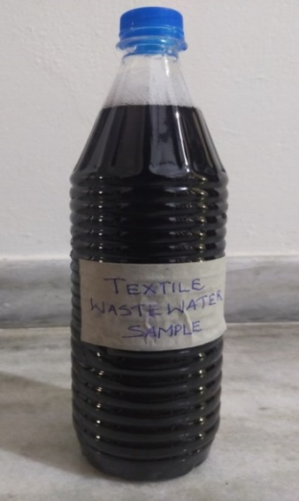

**Figure 1:** Sample of textile wastewater

**3.1.2 Earth worm**

The earthworms were collected from Mannuthi agricultural college. They belonged to Eisenia fetida species.

**3.1.3 Garden soil**

It is the topsoil, enriched with compost and other organic matter. It has heavier texture and hold water longer than potting mixes. Here we need the soil which passes through 2.36 mm sieve.

**3.1.4 Coarse aggregate**

Aggregate which can be retained on 4.75 mm sieve is called coarse aggregate. Here we need two types of coarse aggregate, one which can pass through 20 mm sieve and retained in 10 mm sieve and other which can pass through 10 mm sieve and retained in 4.75 mm sieve.

**3.1.5 Fine aggregate**

Aggregate that can pass through 4.75 mm sieve and retained in 0.075 mm sieve is called fine aggregate. Here we need fine aggregate that pass through 2.36 mm sieve.

**3.1.6 Coconut coir dust**

Coconut coir dust is brown, spongy particle of low weight which falls out when the fiber is shredded from the husk. The coconut coir dust is about 70% of weight of coconut husk. It is rich in lignin and tannins. It is a low cost dye absorbing material. It should have to pass through 2.36 mm sieve.

**3.2 Methods**

Collection of textile waste water from YMF cloths and manufacturer, Vaniyambalam. Preliminary test was conducted. Tests like BOD, pH, colour, total suspended solids, total dissolved solids, chloride and alkalinity were conducted. Preparation of synthetic dye water from the composition obtained was done. Collection of earthworms, gravels, sand, garden soil, coconut coir dusts. Construction of vermifilter and non - vermifilter. Synthetic dye water passed through both filters at varying hydraulic loading rate. BOD, dye concentration, etc. of the filtered water after filtration is tested at varying hydraulic loading rate. The water obtained after treatment from the filter system is tested for its characteristics. Results are tabulated and graph showing comparison between various chemical characteristics of vermifilter and non-vermifilter are analyzed.

**3.3 Vermifilter**

Vermifiltration is a new and innovative technology in which the combined action of earthworm’s activity and adsorption properties of other materials like, soil, sand & gravel particles on the organic pollutants are applied for treatment of waste water like effluents from textile industry.

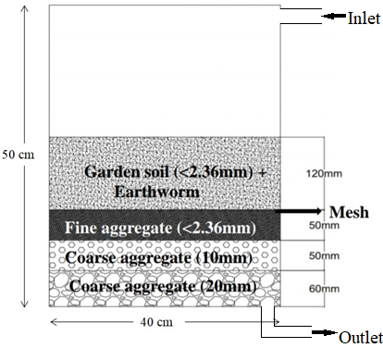

**Figure 2:** Design of vermifilter

Vermifilter is a rectangular shaped of 30×40 cm2 area and 50 cm depth, which is equipped with a tray having holes to ensure uniform distribution of influent on top. It is divided in to 4 parts of layers in which gravel, sand and vermifilter bed were placed from bottom layer to top. The bottom layer was made of aggregates of 20 mm size and it fills up to a depth of 60 mm. Above this lies aggregates of 10 mm size filling up to 50 mm height. On top of this, 50 mm thick layer of sand passing through 2.36 mm size sieve. The top most layer is about 120 mm height, consists of garden soil passing through 2.36 mm size sieve which mixed with saw dust at a volume ratio of 3:1 forms the vermifilter bed. The earthworms were added to this garden soil in alternate layers. About 100 grams of cow dung was added along with earthworms to facilitate their growth. The earthworms were added to this garden soil in alternate layers. A layer of net of wire mesh was placed below the layer of soil bed to allow only water to trickle down while holding the earthworms in the soil bed because it can crawl down to filter materials. The system has provisions to collect the filtered water from the bottom which opens out in to a bucket.

Earthworms were cultured in this vermifilter unit for one week. The textile wastewater was passed through the vermifilter at different hydraulic loads 4, 5 and 6 l/m²/day respectively. For each value of HLR, the wastewater percolated down through various layers in the vermifilter bed passing through the soil layer inhabited by earthworms, the sandy layer and the gravels and at the end was collected from the bottom of the system. Next day this treated wastewater was collected and analyzed for BOD, pH, TDS, alkalinity, chloride, colour etc. the test results corresponding to various HLR values for wastewater passed through vermifilter.

**3.4 Non – vermifilter**

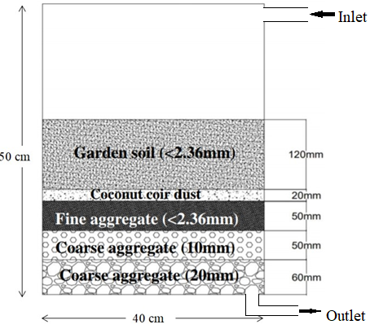

**Figure 3:** Design of non-vermifilter

Setup of non vermifilter is similar to vermifilter, except the presence of earthworm and the layer of coconut coir dust. The bottom layer was made of aggregates of 20 mm size and it fills up to a depth of 60 mm. Above this lies aggregates of 10 mm size filling up to 50 mm height. On top of this, 50 mm thick layer of sand passing through 2.36 mm size sieve. On top of this 20 mm layer of coconut coir dust which is pass through 2.36 mm sieve. The top most layer is about 120 mm height, consists of garden soil passing through 2.36 mm size sieve.

**3.5 Preliminary test result**

**Table 4:** Preliminary test result of textile wastewater

|  |  |
| --- | --- |
| **Tests Conducted** | **Results** |
| pH | 7.6 |
| BOD | 300 mg/l |
| Colour | Dark blue ( absorbance value = 2.5) |
| TDS | 1526 mg/l |
| TSS | 2.2 mg/l |
| Total Alkalinity | 614 mg/l |
| Hardness | 166 mg/l |
| Chlorides | 330 mg/l |

**4. RESULTS AND DISCUSSIONS**

The textile waste water has been treated using both vermifilter and non – vermifilter separately.

**4.1 Treated water characteristics of non- vermifilter and vermifilter**

**Table 5:** Treated characteristics of non-vermifilter and vermifilter

|  |  |  |  |  |
| --- | --- | --- | --- | --- |
| **Parameter** | **Influent concentration** | **Hydraulic loading rate (l/m2 /day )** | **Effluent concentration**  **in**  **non-vermifilter** | **Effluent concentration**  **in**  **vermifilter** |
| BOD (mg/l) | 300 | 4 | 260 | 175 |
| 5 | 275 | 210 |
| 6 | 282 | 245 |
| TDS (mg/l) | 1526 | 4 | 1170 | 772 |
| 5 | 1260 | 794 |
| 6 | 1320 | 810 |
| TSS (mg/l) | 2.2 | 4 | 0 | 0 |
| 5 | 0 | 0 |
| 6 | 0 | 0 |
| Alkalinity (mg/l) | 614 | 4 | 556 | 480 |
| 5 | 588 | 520 |
| 6 | 594 | 568 |
| Chloride (mg/l) | 330 | 4 | 255 | 68 |
| 5 | 278 | 94 |
| 6 | 292 | 128 |
| pH | 7.6 | 4 | 7.2 | 7.1 |
| 5 | 7.3 | 7.2 |
| 6 | 7.4 | 7.3 |
| Color (mg/l) | 100 | 4 | 75.5 | 32.8 |
| 5 | 87.7 | 58.4 |
| 6 | 96.4 | 72.6 |

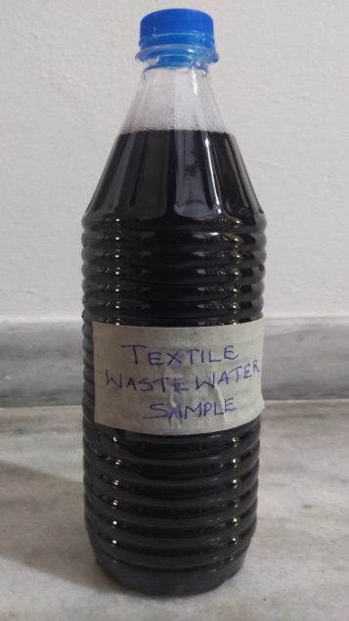 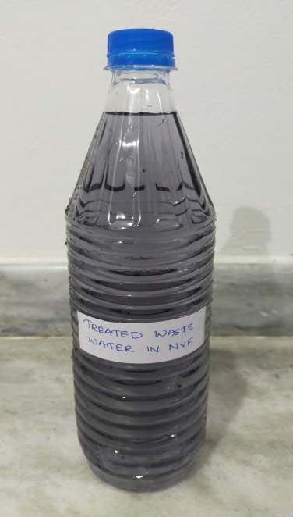

**Figure 4:** Textile wastewater before and after non-vermifiltration

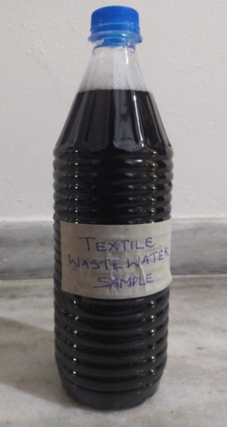 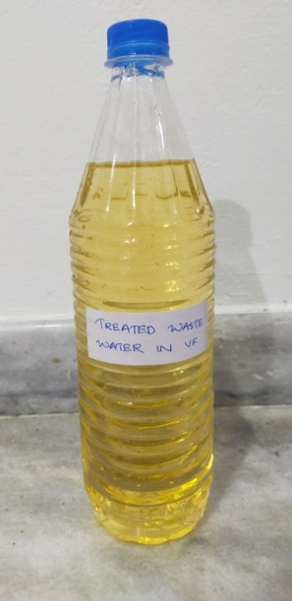

**Figure 5:** Textile wastewater before and after vermifiltration

The data obtained from treating textile waste water corresponding to hydraulic loading rates of 4 l/m2 /day, 5 l/m2 /day and 6 l/m2 /day was collected and its characteristics were found as same as non-vermifilter. It was found that about 41.67%, 30% and 18% of BOD was removed by vermifilter whereas these values are 13.33%, 8.33% and 6% respectively for non vermifilter. The TDS content and pH of waste water decreased accordingly. The TDS content was reduced by 49.4%, 47.96% and 46.92% in vermifilter and 23.33%, 17.43% and 13.5% in non-vermifilter respectively. The pH of the wastewater was reduced by average of 7.2 by vermifilter and 7.3 by non-vermifilter. The chloride content is reduced by 79.4%, 71.5% and 61.2% in vermifilter and 22.72%, 15.75%and 11.5% in non vermifilter.

Total suspended solids is completely removed in both vermifilter and non vemifilter, it is due to the adsorption process of soil. In vermifilter, the colour removal is about 67.2%, while in non vermifilter the colour removal is only 24.5%.

It is observed that removal efficiency of both vermifilter and non vermifilter are high at hydraulic loading rate of 4 l/m2 /day comparing to the hydraulic loading rates of 5 l/m2/day and 6 l/m2 /day.

According to IS 10500 (2012), Drinking water – specification, textile wastewater treated using vermifilter cannot be used for drinking purposes. But according to IS 2296:1992 it can be used for industrial, irrigational purposes and controlled cooling purposes.

**Table 6:** Water quality standards in India (IS 2296:1992)

|  |  |  |  |
| --- | --- | --- | --- |
| **Designated best usage** | **Class** | **Characteristics** | **Range** |
| Irrigation, Industrial cooling and controlled water disposal | E | pH | 6.0 – 8.5 |
| TDS (mg/l) | 2100 |
| Chlorides (mg/l) | 600 |
| Sulphides (mg/l) | 1000 |
| Electrical conductivity, micromhos/cm | 2250 |

**4.2 COMPARITIVE STUDY**

BOD is an important indicator of organic load of waste water. The BOD load in effluents from both vermifilter and non vermifilter was significantly lower than initial level but vermi-biofiltration should more removal efficiency than non-vermifilter unit. Results show that the earthworms can remove BOD loads by over 40%. BOD removal in non-vermifilter unit (where only the soil, sand and microbial system works) is just around 14%. It also indicates that the organic content in textile waste water has the expected degradation.

In case of a normal bio-filter the solids, the removed will accumulates overtime as sludge and chokes the system which then ceases to work properly. However in vermifilter bed these bio-solids were constantly ingested by earthworm and expelled as vermicomposting. This explains why there is no chocking and interrupted functioning of the vermifilter bed.

It is observed that removal efficiency of both vermifilter and non vermifilter are high at hydraulic loading rate of 4 l/m2 /day. It was found that the total alkalinity of textile waste water sample decreased by 9.44% in non vermifilter and 21.8% in vermifilter. Total dissolved solids (TDS) showed drastic reduction during vermifiltration as well as are non vermifiltration process.

The total reduction in TDS content is about 49.4% in vermifiltration unit and 23.3 % in non – vermifilter. The results clearly showed the better capability of earthworm during vermi-biofiltration processes.

Total suspended solids is completely removed in both vermifilter and non vemifilter, it is due to the adsorption process of soil. The color removal capacity of vermifilter is about 67.2%, while in non vermifilter the color removal is only 24.5%. The chloride content is also reduced by 79.4% in vermifilter while in non vermifilter it is only 22.72%.

**Figure 6:** Graph showing comparison of parameters in wastewater before and after vermifiltration

**Figure 7:** Graph showing comparison of parameters in wastewater before and after non-vermifiltration

**Figure 8:** Graph showing comparison of parameters in VF and Non-VF (HLR of 4 l/m2/day)

**Figure 9:** Graph showing comparison of parameters in VF and Non-VF) HLR of 5 l/m2/day)

**Figure 10:** Graph showing comparison of parameters in VF and Non-VF (HLR of 6 l/m2/day)

It is observed that removal efficiency of both vermifilter and non vermifilter are high at hydraulic loading rate of 4 l/m2 /day comparing to the hydraulic loading rates of 5 l/m2/day and 6 l/m2 /day.

**5. SCOPE**

The data obtained from this project may be useful for designing and fabrication of an economically cheap and ecologically sustainable treatment process using vermifilter. Earthworms are easily available in nature, the vermifilter can easily constructed and cheap, and have earthworm‘s potential to be used for the small scale industries which produced dyes as their effluent. This treated water can be used for irrigation, recycling and washing purposes.

**6. CONCLUSIONS**

As a part of project, a detailed literature review was conducted on the topic “Textile waste water treatment using vermifilter and non vermifilter”. As a preliminary step a sample of textile wastewater was collected from YFM cloths and manufacturer, Vaniyambalam and its chemical characteristics are analysed. Then the Vermifilter and non-vermifilter was made. The materials like aggregates, sand, garden soil are collected and placed in layers in the apparatus. Then the textile wastewater is poured to the non-vermifilter apparatus from top. The treated water after one day was collected from the bottom and its characteristics were analysed. The treated filtered dye water corresponding to hydraulic loading rates of 4 l/m2 /day, 5 l/m2 /day and 6 l/m2 /day was collected and its characteristics were found.

For the vermifiltration process the apparatus consisting with earthworm is set up and the synthetic dye water is poured and the treated filtered dye water corresponding to hydraulic loading rates of 4 l/m2 /day, 5 l/m2 /day and 6 l/m2 /day was collected and its characteristics were found as same as non-vermifilter and the results are compared and studied.

Vermifiltration of waste water using waste eater earthworm is a newly conceived technology. From the data obtained it was found that vermifilter is efficient for the removal of BOD, colour, TDS, reducing pH, chloride content and alkalinity etc. of textile waste water. About 41.67%, 30% and 18% of BOD was removed by vermifilter whereas these values are 13.33%, 8.33% and 6% respectively for non vermifilter. The TDS content of waste water decreased accordingly. The TDS content was reduced by 49.4%, 47.96% and 46.92% in vermifilter and 23.33%, 17.43% and 13.5% in non-vermifilter respectively. The chloride content is reduced by 79.4%, 71.5% and 61.2% in vermifilter and 22.72%, 15.75% and 11.5% in non vermifilter.

It is observed that removal efficiency of both vermifilter and non vermifilter are high at hydraulic loading rate of 4 l/m2 /day when comparing to the removal efficiency of hydraulic loading rate of 5 l/m2 /day and 6 l/m2 /day.

According to IS 10500 (2012), Drinking water – specification, textile wastewater treated using vermifilter cannot be used for drinking purposes. But according to IS 2296:1992 it can be used for industrial, irrigational purposes and controlled cooling purposes.

The earthworm production growth breed and survive in the moist environment is very well was observed during process of experiment. The advantages of this method is, it is simple and easy operation, low operating cost and maintenance cost, ecological, low energy input, no sludge formation i.e, treated water is nutrient rich and natural way of fertilization for better agricultural production and cost saving fertilizers. This process is aerobic and hygienic hence no odours. Results of vermifilter technology are most cost effective, odor free for treatment with efficiency, economy and potential decentralization.

**ACKNOWLEDGEMENT**

First of all I would like to thank God, the almighty for the divine grace bestowed on me to complete this mini project successfully on time.

I express my sincere thanks to **Dr. P Babu**, Principal of Malabar College of Engineering and Technology, for providing necessary facilities and his sincere co-operation.

I express my deep sense of gratitude to **Prof. Anil Kumar B**, Head of the Department of Civil Engineering for providing me the best facilities and atmosphere for creative work guidance and encouragement.

I express my deep sense of gratitude to **Prof. Chinnamma M A**, M. Tech Coordinator and guide, Department of Civil engineering, for providing me the best facilities and atmosphere for the creative work guidance and encouragement.

Finally I would like to convey my sincere thanks to all the faculty members of the civil Engineering Department for the co-operation. I am indebted to my parents and all my friends for their constant encouragement.

**7. REFERENCES**

1. Aguilera M L; (2003) “Purification of wastewater by vermifiltration”, Doctoral Thesis. University of Montpellier 2, France, p. 188.
2. Bhise H. S , Anaokar G. S; (2015) “Design and Suitability of Modular Vermifilter for Domestic Sewage Treatment”, International Journal of Emerging Engineering Research and Technology Volume 3, Issue 4, PP 44-51 ISSN 2349-4395 (Print) & ISSN 2349-4409 (Online).
3. Christeena Jomon and Chinnamma; (2021) “Treatment of textile waste water using vermifilter and non vermifilter”, International Research Journal of Engineering and Technology (IRJET), Volume: 08 Issue: 06, e-ISSN: 2395-0056, p-ISSN: 2395-0072.
4. Hussein F H; (2013) “Chemical properties of treated textile dye wastewater”, Asian Journal of Chemistry, 25:9393 – 9400.
5. K Samal, R R Dash, P Bhunia; (2018) “Design and development of a hybrid macrophyte assisted vermifilter for the treatment of dairy wastewater: a statistical and kinetic modelling approach”, Sci. Total Environment, https://doi.org/10.1016/ j.scitotenv.2018.07.118.
6. Korepriyanka S, Guravsagar V, PadwaseNilesh N, PotilNitin A, Desai Ramesh H; (2017) “An effective cost technology for domestic waste water”, International Research Journal of Engineering and Technology(IRJET), Vol. 4, issue: 4, e- ISSN: 2395-0056, p-ISSN: 2395-0072.
7. Lakshmi C, Ranjitha J, Vijayalakshmi S; (2014) “Waste water treatment using vermifiltration technique at institutional Level”, International Journal of advanced Scientific and technical research, ISSN: 2249-9954, Vol. 5, issue 4
8. Li Y S, Robin P, Cluzeau D, Bouché M, Qiu J P, Laplanche A, Hassouna M, Morand P, Dappelo C, Callarec J; (2008) “Vermifiltration as a stage in reuse of swine wastewater: monitoring methodology on an experimental farm”, Ecol. Eng. 32: 301-309
9. Meiyan Xing, Xiaowei Li and Jian Yang ; (2010) “Treatment performance of small-scale vermifilter for domestic wastewater and its relationship to earthworm growth, reproduction and enzymatic activity”, African Journal of Biotechnology Vol. 9(44), pp. 7513-7520.
10. Meiyan Xing, Xiaowei Li, Jian Yang, Baoyi L and Lu Y; (2012) “Performance and Mechanism of Vermifiltration System for Liquid-State Sewage Sludge Treatment Using Molecular and Stable Isotopic Techniques”, Chemical Engineering Journal, pp. 143-150.
11. Morand, P, Robin P, Escande A, Picot B, Pourcher A M, Jiangping Q, Yinsheng L, Hamon G, Amblard C, Fievet L S, Oudart D, Quere C P L, Cluzeau D and Landrain B; (2011) “Biomass production and water purification from fresh liquid manure-use of vermiculture, macrophytes ponds and constructed wetlands to recover nutrients and recycle water for flushing in pig housing”, Procedia Environmental Sciences, pp. 130-139.
12. N.Kannadasan, Dharshini, S. Eabinezer, Nirmala Natarajan, R. Krishnamoorthy, R. Sri Sakthi and Priyadarshini; (2019) “Potential of distillery effluents for safe water through vermifiltration”, Journal of Applied and Natural Science, 11(4): 768 – 777, ISSN : 0974-9411 (Print), 2231-5209 (Online).
13. Nirmala Natarajan and N. Kannadasan; (2014) “Reuse Potential Of Textile Dyeing Wastewater Through Vermifiltration”, International Journal of Current Research, Vol. 6, Issue, 02, pp.4936-4939.
14. R K Sinha Bharambe G, Chaudhari U; (2012) “Earthworms: nature’s chemical managers and detoxifying agents in the environment: an innovative study on treatment of toxic wastewaters from the petroleum industry by vermifiltration technology”, Environmentalist, https://doi.org/10.1007/s10669-012-9409-2.
15. R K Sinha, G Bharambe, U Chaudhari; (2008) “Sewage treatment by vermifiltration with synchronous treatment of sludge by earthworms: a low-cost sustainable technology over conventional systems with potential for decentralization”, Environmentalist, <https://doi.org/10.1007/s10669-008-9162-8>
16. R Singh, P Bhunia, R R Dash; (2019) “Optimization of organics removal and understanding the impact of HRT on vermifiltration of brewery wastewater”, Sci. Total Environ. (2019), https://doi.org/10.1016/j.scitotenv.
17. Rabbani D, Mahvi A.H, Gilasi H.R and Rasuli F: (2015) “Effect of Vermifiltration on COD and Color Removal from Textile Factories’ Waste Water”, International Archives of Health Science, 2(3):133-138.
18. Raniya K, Shaheer K, Shamla P and Farsana C; (2020) “Treatment of Textile Waste Water by using Vermifilter and Non Vermifilter”. International Journal of Innovative Research in Science, Engineering and Technology (IJIRSET), Volume 9, Issue 7, e-ISSN: 2319-8753, p-ISSN: 2320-6710.
19. Sinha R K, Agarwal S, Chauhan V and Soni B K; (2010) “Vermiculture technology: Reviving the dreams of Sir Charles Darwin for Scientific Use of Earthworms in Sustainable Development Prgrams” Tech. and Invest. (1): 155-172.
20. Sinha R K, Bharambe G and Bapat P; (2007) “Removal of high BOD and COD loadings of primary liquid waste products from dairy industry by vermifiltration technology using earthworms”, Indian Journal of Environmental Protection, 27(6), pp. 486-501.
21. Sinha R K, Bharambe G and Chowdhary U; (2008) “Sewage treatment by vermifiltration with synchronous treatment of sludge by earthworms a low-cost sustainable technology over conventional systems with potential for decentralization”, The environmentalist, 28: 409-420.
22. Sinha R K, Bharambe G, Chaudhari U; (2008) “Sewage treatment by vermifiltration with synchronous treatment of sludge by earthworm: a low-cost sustainable technology over conventional systems with potential for decentralization”, Environmentalist, 28: 409-420.
23. Sinha R K, Chauhan K, Valan D, Chandran V, Soni B K and Patel V; (2010) “Earthworms: Charles Darwin’s unheralded soldiers of mankind: Protective and productive for man and environment”, Journal of Environmental Protection, 1, pp. 251-260.
24. Sudipti Arora and Sakshi Saraswat; (2021) “Vermifiltration as a natural, sustainable and green technology for environmental remediation: A new paradigm for wastewater treatment process”, International Journal of Current Research in Green and sustainable chemistry, 2666-0865.
25. U.J. Etim, S.A. Umoren, U.M. Eduok; (2016) “Coconut coir dust as a low cost adsorbent for the removal of cationic dye from aqueous solution”, Journal of Saudi Chemical Society, S67 – S76.
26. Yaseen D A and Scholz M; (2018) “Textile dye wastewater characteristics and constituents of synthetic effluents: a critical review”, International Journal of Science and Technology, https://doi.org/10.1007/s13762-018-2130-z.