**DISPOSAL OF DIAPERS AND SANITARY NAPKINS AT**

**PARAPPANANGADI MUNICIPALITY**

**Aneesa M1, Anitha K Subash2**

1Student, Department of Environmental Engineering, MCET, Desamangalam-679532, Kerala, India

2Professor, Department of Environmental Engineering, MCET, Desamangalam-679532, Kerala, India

**ABSTRACT**

The improper disposal of diapers and menstrual waste is an obstacle for public hygiene. Disposable diapers are thrown away indiscriminately and this presents some challenges, environmental and health-wise. Implementation of modern techniques like incineration can help in safe disposal of diapers and menstrual pads and to promote public hygiene. Here, the used diapers are dumped into an incinerator for incinerating. The sanitary napkins are also incinerating by dumping into an incinerator. The sanitary waste generation rate in Parappanangadi municipality around 200 kg/day. An incinerator has been designed to treat the sanitary waste like diapers and sanitary napkins which is being generated in Parappanangadi municipality with a capacity of 100kg/day. The incinerator will work at 600 - 800 degree Celsius and there is no smoke and foul smell. Both solar energy and steam energy is used for the working of incinerator. The excess electrical energy generated can be selling to the Kerala State Electricity Board (KSEB). The 2D model of napkin incinerator created using both Auto CAD and ANSYS software. The 3D model of napkin incinerator created using ANSYS software. Computational Fluid Dynamics (CFD) is done in the incinerator with ANSYS software. The Cost estimation is also created. The disposal system of diapers and sanitary napkins are designed for Parappanangadi municipality in Malappuram district which contain 45 wards, for hygienic environment.

**Keywords:** Diapers, sanitary napkins, incinerator, CFD, ANSYS, Auto CAD

1. **INTRODUCTION**

This waste is problematic for many reasons. Heaps of sanitary napkins and diapers with a large amount of disease causing bacteria on them pose a significant threat to the hygiene in the surrounding area. Young girls and even certain older women’s are not aware of the hygiene problems cause by improper disposal of napkins and diapers. The best way to dispose menstrual waste and diapers is to burner is napkin using electrical fire based burner without allowing smoke generate in the process to escape into The atmosphere. These would bleach napkin and diapers utilizing fire, without letting the procedure generated in, by the smoke established burner. In this current project is focused on the design and analysis of a typical incinerator to produce the heat energy by burning the waste menstrual napkin pads and diapers, for Parappanangadi municipality for hygienic environment. The Parappanangadi Corporation is about 22.5 sq. km area which contain 45 wards.

**1.1 Needs**

* To design a smart diaper and sanitary napkin disposal system, this could be used to reduce the problem of disposing of sanitary waste.
* To reduce spread of infection due to unhygienic disposal of diapers and sanitary napkins.
* To reduce environmental pollution due to non-biodegradable diapers and sanitary napkins
* To reduce clogging of public drainage system due to spongy nature of diapers and napkins.
* To design a waste management system

**1.2 Objective**

* To understand the different types of sanitary napkins and diapers are used in Parappanangadi municipality.
* To understand the current different methods used for the disposal of sanitary wastes in Parappanangadi municipality.
* To calculate the amount of sanitary wastes like diapers and sanitary napkins wastes generated in Parappanangadi municipality per day.
* To design an incinerator for incinerating the sanitary napkins and diapers in Parappanangadi municipality for hygienic environment.
* To design 2D view of an incinerator with the help of Auto CAD software.
* To design 2D view of an incinerator with the help of ANSYS software.
* To design 3D view of an incinerator with the help of Auto CAD software.
* To find out Computational Fluid Dynamics (CFD) output stimulation of designed incinerator.
* To estimate the cost of designed incinerator.

**2. LITERATURE REVIEW**

**2.1 General knowledge on diapers**

Now-a-days, the development of the diaper industry is already massive, it showed by the release of various brands and types of diapers, using adhesive as well as pants models. The uses of diapers are unlimited in all circles. From birth, babies already use diapers to accommodate urine and feces. Even for the elderly, the use of diapers has also become normal.

**Table 1.** Average baby disposable diapers composition [8]

|  |  |
| --- | --- |
| **Material** | **Weight Percentage (%)** |
| Cellulose pulp | 35 |
| Superabsorbent Polymer (SAP) | 33 |
| Polypropylene | 17 |
| Polystyrene | 6 |
| Adhesives | 4 |
| Elastics | 1 |
| Others | 4 |

**2.2 The impact of disposal of soiled diapers**

There are several problems that arise as a result of throwing away used diapers into the field. The greatest impacts are related to exposure to pathogens (health impacts) and environmental aesthetics, pollution, and exposure to chemicals. Used diaper accommodates baby’s urine and feces become a breeding ground for pathogenic microorganisms. Microorganisms can transfer to humans and disturb health in the long term. The diseases that can be caused by this waste such as; cholera, typhoid, hepatitis, cryptosporidiosis, ascariasis, polio, and schistosomiasis. Meanwhile, the residential environment which piles up used diaper will cause water pollution, typhoid, skin infection, vomiting, sore throat, stomach ache, and malaria [6].

**2.3 Disposal options for soiled disposable diapers**

Soiled disposable diapers are solid waste, and are therefore disposed using popular disposal methods for solid waste. These include methods such as burning, composting, landfilling, and open dumping. Incinerators are designed for satisfactory burning of combustible refuse, provided air pollution standards are met. However, the use of incinerators for disposing solid waste is now obsolete even in western countries, because of the high capital and operating costs involved. Air pollution also makes it unattractive. Incineration is still not best option even when heat recovery is possible in this method, and volume reduction and residue sterilization are real.

**2.4 General knowledge on sanitary napkins**

Menstruation is a normal physiological phenomenon, yet is surrounded by taboos, myths and stereotypes. As a consequence of the culture of silence and shame, women and girls are 5 unprepared for menarche (the first menses) and are unable to manage their monthly periods in a safe and hygienic way.

The preference of sanitary protection material is based on personal choice, cultural acceptability, economic status, and availability in local market. Along with basic sanitation facilities, one should be also provided with soap and menstrual absorbents to manage menstruation hygiene. The choice of absorbents varies among rural and urban women and girls. In rural areas, the most preferred absorbents are reusable cloth pads and in urban areas women prefer to use commercial sanitary pads. Chlorine-bleached Kraft or sulphate pulp is used by manufacturers to produce fluff pulp as absorbent used to make disposable sanitary products. Nowadays, many deodorized and non-deodorized sanitary products are available in the market made of synthetic fiber rayon. These deodorized products contain chemicals like organochlorines which have antibacterial activity. Due to their chemical composition, these products when buried in the soil they kill the soils micro-flora and delay the process of decomposition.

**2.5 Incinerators for sanitary waste disposal**

Various types of incinerators exist in India (matkas, brick incinerators, electric incinerators, bio-medical waste incinerators, waste to energy incinerators etc.). These differ greatly in in terms of their operation, capacity, quality, and their ability to control for toxic fumes that are released when disposable sanitary napkins are burned.

* Central Pollution Control Board (CPCB) specifies standards for bio-medical and common incineration facilities and emissions.
* Incinerators must adhere to design and emission standards to be an effective and safe waste management solution. The World Health Organization (WHO) provides guidance on small scale incineration facilities for biomedical waste that can be applied for sanitary waste as well.

**2.6 Considerations for incinerators**

* Type of waste to dispose.
* The composition of the waste to dispose.
* The volume of waste dispose.
* Setting for use and placement of incinerator
* Minimum and maximum burning temperatures
* Adherence to CPCB standards for emissions
* Operations and maintenance

**2.7 Details for incinerator use characteristics of waste suitable for incineration (WHO)**

* Low heating value: above 2000 kcal/kg (8370 kJ/kg) for single-chamber incinerators, and above 3500 kcal/kg (14640kJ/kg) for pyrolytic double-chamber incinerators.
* Content of combustible matter above 60%.
* Content of non-combustible solids below 5%.
* Content of non-combustible fines below 20%.
* Moisture content below 30%.

**2.8 Stack height**

1. Stack height shall not be less than 30 meters, in any case.
2. Stack height requirement based on sulphur dioxide emissions by using the equation stack height = 14 (Q)0.3

[where, Q is the emission rate of SO2 in kg/hr]

1. By using simple Gaussian plume model to maintain ambient air quality requirements for all concerned parameters, in the receiving environment.

The required stack height shall be the maximum of the above three considerations.

A. Jyoti Choudhary and Dr Mahua Bhattacharjee (2018) had conducted a study on consumption pattern of sanitary napkin and environment degradation. According to primary data, it has been analyzed that, 61% of women’s population are aware of negative impact of synthetic sanitary napkins on environment. There is lack of awareness and availability of organic sanitary napkins, only 32% of women are aware of organic sanitary napkins and 28% of women find it easy to purchase them. The research paper concludes that according to the women preference in feminine hygiene products the sanitary napkin market fails as women preference is synthetic sanitary pads due to its low cost but such pads degrade environment and are non-decomposable.

B. Madheshwar Subhramaniyan et al. (2019) had conducted a research on Design of Domestic Incinerator for the Safe Disposal of Menstrual Waste in the Rural Areas. The present research deals with an effective solution to dump and dispose the menstrual waste with the help of an incinerator. The system involves an incinerator which uses electricity to heat the heating coil which in turn will lit up the sanitary napkins when dumped into the incinerator. As a responsible citizen of our country is to maintain the environment neatly, taking it in mind the model has been designed and also ensures the performance of it.

C. Rutujakulkarni et al. (2018): The problem of improper waste is major road block to our achieving ‘Swachha Bharat’ mission’s goal to create a clean India. This waste is problematic for several reasons. This project gives a solution for destroy napkins waste in a very hygienic way. This is portable system for destroy napkins waste using Incinerator. This system also helps to achieving the ‘Swachha Bharat’ mission and avoids the large amount of diseases. Insufficient information is available to women on the environmental impacts of menstrual waste and on alternative behaviors which reduce the impact. With no knowledge of how to dispose napkins, most women just throw them in the garbage bin which usually gets mixed up with dry, wet and hazardous waste.

D. S H Rahat et al. (2014): This study implied that considering the solid waste management practices of Dhaka city, biological treatment processes with composting could help reduce the municipal waste from the generation stream. Diapers it appears is a considerable part of the municipal waste fraction in developed countries and Bangladesh’s great potential for growth in the diaper market indicates a need in the future for better waste management practices to be available.

E. Shyam Swaroop Nigam (2014): In this study, incineration and its types is discussed in detail. The focus on low cost incinerator is made by highlighting on its advantages economically. The effective utilization of the by-products obtained during the process of incineration is the contribution made to the paper.

F. Chourasia Sandhya Bhagawat et al. (2019): This project gives a solution for destroying napkin waste in a very hygienic way. This is portable system to destroy napkin waste, using Incinerator. These systems also help to achieve the “Swachha Bharat” mission and avoid the large amount of diseases. Napkin disposer too can be fabricated and integrated with the vending machine, so that dispensing and disposing can be achieved in a single unit.

**3. METHODOLOGY**

**3.1. Data collection**

Parappanangadi municipality is a municipality in Tirurangadi taluk of Malappuram district, Kerala, India. It is a coastal town located close to the Arabian Sea. Parappanangadi railway station is one of the oldest railway stations in Kerala. It was a part of the first rail route (Tirur–Chaliyam) in Kerala. Parappanangadi is located 9 km (5.6 mi) north of Tanur on Tirur-Kadalundi Tipu Sultan Road. The town lies on the bank of Kadalundi River. Parappanangadi town is located north of the estuary of Poorappuzha River, which is a tributary of Kadalundi River, and south of the estuary of Kadalundi River, which lies in Vallikkunnu. Parappanangadi was one of the major ports in the southwestern coast of India during the medieval period. It was ruled by the kingdom of Parappanad, who was vassals to the Zamorin of Calicut, and had the jurisdiction up to Beypore port to the north. In the early medieval period, under the chiefs of Kozhikode and Parappanangadi, Parappanangadi developed as one of the important maritime trade center on the Malabar Coast. Later it became a part of Eranad Taluk in Malabar District under British Raj. The Parappanangadi Corporation is about 22.5 sq. km area which contain 45 wards.

**Table 2:** Parappanangadi municipality wards and population

|  |  |  |
| --- | --- | --- |
| **No.** | **Parappanangadi municipality wards** | **Population** |
| 1. | Vadakke kadappurama | 1603 |
| 2. | Laksham veedu | 1543 |
| 3. | Health center | 1525 |
| 4. | Chettipadi east | 1525 |
| 5. | Anappadi | 1667 |
| 6. | Moduvingal | 1483 |
| 7. | Keezhchira | 1630 |
| 8. | Kovilakam | 1668 |
| 9. | Ullanam town | 1478 |
| 10. | Ullanam north | 1446 |
| 11. | Edathiruthikkadavu | 1608 |
| 12. | Thayilappadi | 1700 |
| 13. | Panayathil | 1617 |
| 14. | Putharikkal | 1543 |
| 15. | Stadium | 1732 |
| 16. | Attakuzhingara | 1552 |
| 17. | Kalikkavu | 1520 |
| 18. | Karingalathani | 1580 |
| 19. | Palathingal | 1589 |
| 20. | Keezhanalloor | 1645 |
| 21. | Kottanthala | 1649 |
| 22. | Naseeb nagar | 1598 |
| 23. | Chiramangalam south | 1478 |
| 24. | Chiramangalam | 1700 |
| 25. | Uppunippuram | 1441 |
| 26. | Aviyil beach | 1510 |
| 27. | Kurikkal road | 1511 |
| 28. | Puthenpeedika | 1575 |
| 29. | Saddam beach | 1663 |
| 30. | Puthan kadappuram south | 1631 |
| 31. | NCC road | 1640 |
| 32. | Parappanangadi south | 1492 |
| 33. | Parappanangadi town | 1696 |
| 34. | Puthenkadappuram | 1599 |
| 35. | Ottumal south | 1585 |
| 36. | Chappappadi | 1511 |
| 37. | Anjappura | 1612 |
| 38. | Neduva | 1659 |
| 39. | Kodappaali | 1538 |
| 40. | Angadi | 1538 |
| 41. | Yarathingal | 1543 |
| 42. | Chengattupadam | 1691 |
| 43. | Chettipadi | 1580 |
| 44. | Alungal south | 1515 |
| 45. | Alungal north | 1594 |

Among the 45 wards, Stadium is the most populated ward followed by Thayilappadi and Chiramangalam and Uppunippuram is the least populated ward in Parappanangadi municipality.

**Table 3:** Population in Parappanangadi municipality

|  |  |
| --- | --- |
| Population | 71239 |
| Population growth | 18.09 % |
| Population density | 3166 person per km |
| Male population | 34343 |
| Female population | 36839 |
| Elderly people | 3145 |
| Children below 3 years | 1128 |

**3.2 Survey in Parappanangadi municipality**

As a part survey, a questionnaire is conducted in Parappanangadi municipality. The questionnaire is conducted for 100 households in Parappanangadi municipality in different wards. This questionnaire is conducted to know about the type of absorbent used in menstruation period, types of diapers used, methods of disposal used for sanitary waste etc.

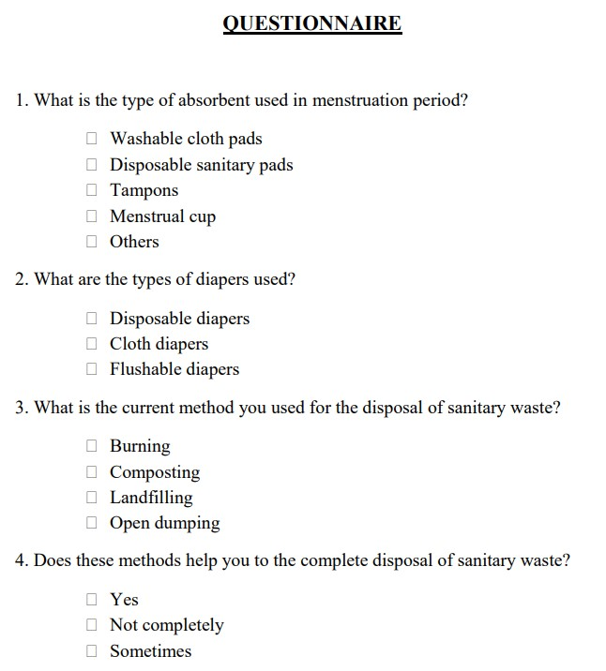

**Figure 1:** Questionnaire

**3.3 Proposed work**

The disposal of sanitary wastes is the main concern now-a-days. We can dispose the sanitary waste in different methods. But burning sanitary waste with the help of incinerator is the most hygienic way of disposal of sanitary waste like diapers and sanitary napkins. Therefore the current dilemma of this sanitary waste management can be resolved using a solar based sanitary waste disposer system, which can discard the sanitary wastes like diapers and sanitary napkins.

This sanitary waste disposer can be run on both electrical energy and organic energy. Additionally both solar power and steam power is utilized for this system. Solar power is utilized by means of solar panel and steam power with the help of steam turbine.

The proposed project aims at the reduction of air and soil pollution. This project provides a hygienic and safe disposal of sanitary napkins and diapers through the installation of eco – friendly sanitary waste incinerator machines at Parappanangadi municipality. The outcome of the proposed work is that it helps to reduce the sanitary waste disposal to a large extent. It also helps to reduce a large number of diseases by the safe disposal of sanitary napkins and diapers.

**3.4 Implementation**

The proposed project is an eco – friendly sanitary waste disposer system which can be run on both electrical energy and organic energy. Additionally both solar power and steam power is utilized for this system. Some of the major components of this sanitary waste disposer are given below:

* **Battery:** The battery gets charged either via the solar panel or via steam turbine generator and supplies power to the devices. The proposed work uses a 12 V battery to store the energy.
* **Grinder:** The sanitary wastes like diapers and sanitary napkins are first grinded and then downed to furnace.
* **Sterilizer:** It destroys the ability of the production of microbes. The human wastes from the diaper are first sterilized and then send to the furnace.
* **Furnace:** It is a device used for high-temperature heating. The furnace houses a removable tray at the bottom, which collects the ash.
* **Spider coil:** This coil burns the napkin and diaper to ashes.
* **Carbon filtering:** It is a method of filtering that uses a bed of activated carbon to remove impurities from a fluid using adsorption.

**3.5 Quantification of waste**

From the study it can be concluded that average wastes quantification in Parappanangadi municipality covering 5 collages, 17 schools, 6 health care institutions, government offices and villas and housing colonies is as mentioned in the Table.

**Table 4:** Quantity of sanitary napkins waste generation in Parappanangadi municipality

|  |  |  |
| --- | --- | --- |
| **Sl. No** | **Institutions** | **Quantity of napkin produced per day in Kg** |
| 1. | Colleges | 7.7 |
| 2. | Schools | 32.92 |
| 3. | Institutions in health sector | 1.57 |
| 4. | Govt. offices | 1.45 |
| 5. | Villas and housing colonies | 50 |

**Table 5:** Quantity of diaper waste generation in Parappanangadi municipality

|  |  |  |
| --- | --- | --- |
| **Sl. No.** | **Parameter** | **Wt. produced by diapers per day in Kg** |
| 1. | Elderly people (using diaper) | 5.6 |
| 2. | Children below 3 years | 90.24 |

**3.6 Parameters of incinerator**

The parameters of incinerator like capacity, temperature, stack height etc. have been calculated manually and listed below table.

**Table 6:** Designed Parameters of incinerator

|  |  |
| --- | --- |
| Capacity | 100 kg |
| Expected heat release from waste | 1,101,471.85 kJ |
| Amount of stoichiometry oxygen require | 100 kg |
| Amount of air needed at 21 percentage O2 | 478.571 kg |
| Natural gas require for auxiliary heat supply | 27.063 m3 |
| Temperature of primary chamber | 600 – 800 0C |
| Outer wall temperature | 31 0C |
| Stack Height | 30 m |

**3.7 2D model of sanitary waste incinerator**

The proposed project is an eco – friendly sanitary waste disposer system which can be run on both electrical energy and organic energy. Additionally both solar power and steam power is utilized for this system.

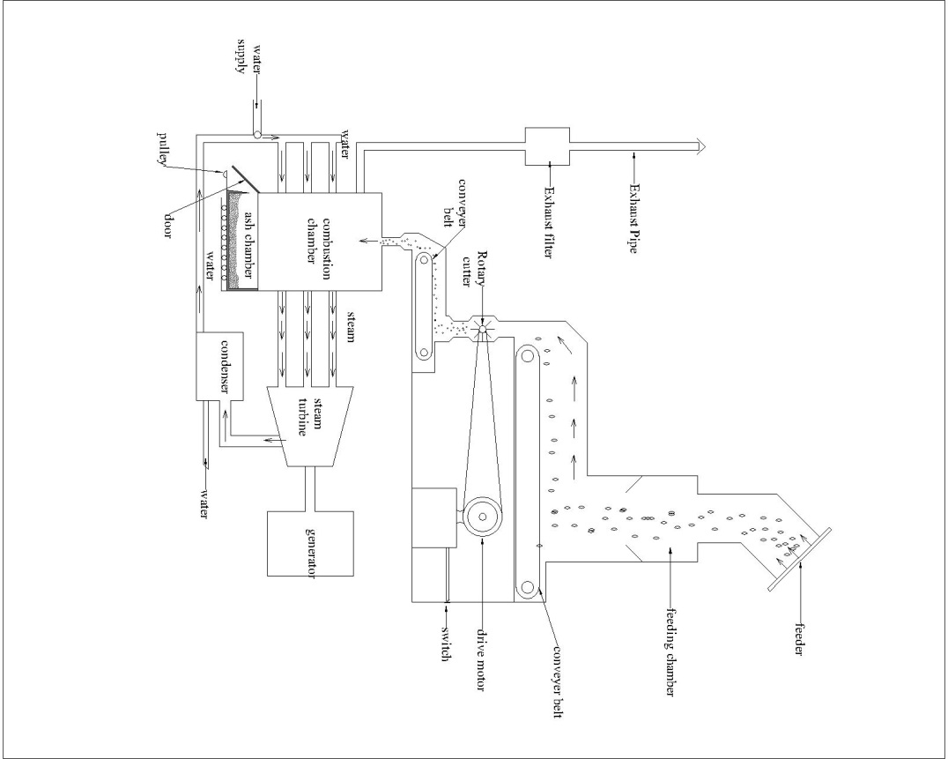

**Figure 2:** Auto CAD 2D view of sanitary waste incinerator

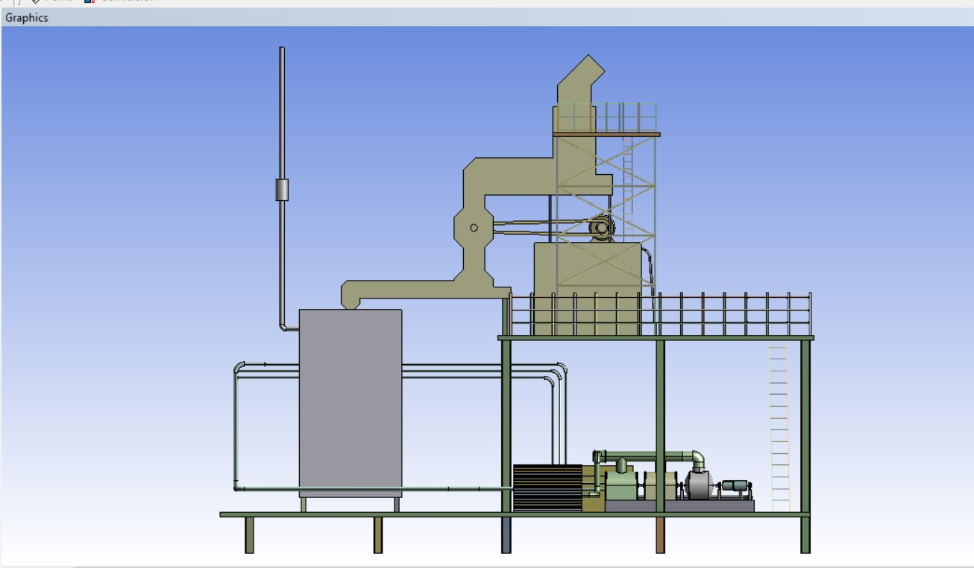

**Figure 3:** ANSYS Left side 2D view of sanitary waste incinerator

**3.8 Working of sanitary waste incinerator**

We can dispose the sanitary waste in different methods. But burning sanitary waste with the help of incinerator is the most hygienic way of disposal of sanitary waste like diapers and sanitary napkins. Therefore the current dilemma of this sanitary waste management can be resolved using a solar based sanitary waste disposer system, which can discard the sanitary wastes like diapers and sanitary napkins.

This sanitary waste disposer can be run on both electrical energy and organic energy. Additionally both solar power and steam power is utilized for this system. Solar power is utilized by means of solar panel and steam power with the help of steam turbine.

The sanitary waste incinerator consisting of a chamber having therein a heating unit arranged. The chamber has heat reflecting surfaces for concentrating the heat to a central portion in the chamber. The chamber also is provided with a napkin inlet and a removable tray, positioned below the heating unit. Communicating with the chamber, there is positioned tube heat exchanger to heat water and converts it into steam. Also there is a filter assembly to filter the undesirable odors and fumes emanating from the chamber. Therefore filtered gas goes out from this incinerator is clean and harmless. This present invention thereby contemplates an essentially simple construction which can efficiently and economically dispose of sanitary wastes like diapers and sanitary napkins.

A sanitary waste incinerator consists of:

1. A heating chamber having
2. A heating unit therein arranged for supporting and heating the napkin.
3. A heat reflecting plates having surfaces arranged therein to reflect the concentrated heat from the heating unit to a central portion of the chamber.
4. An inlet means for introducing the napkin to the heating unit.
5. A removable tray positioned below the heating unit.
6. A filter assembly positioned in communication with chamber and an outlet in chamber to filter undesirable odours and fumes from the chamber.
7. In the sanitary waste incinerator, the reflecting surfaces are spaced from one another and are positioned outwardly of said heating unit, said surfaces diverging upwardly from a point below the heating unit.
8. A door into the incinerator operatively connected to means for opening and closing said material inlet.
9. In the sanitary waste incinerator, of wherein said hood comprises a pair of walls which converge upwardly towards the filter assembly.
10. In the sanitary waste incinerator, the filter assembly comprises at least two filter elements arranged in juxtaposition, such that the odours and fumes can pass through both filter elements, one of said filter elements characterized by being susceptible to retaining undesirable odours, the other being susceptible to retaining undesirable fumes.
11. A clean gas outlet situated above the filter assembly.
12. A fan, positioned between the filter assembly and the clean gas outlet to aid in the removal of the gas passing through the filter assembly from the chamber
13. The sanitary waste incinerator of including a switch connected to the heating unit for activating and deactivating it.
14. This switch is provided with a temperature sensitive means for deactivating the heating unit in response to a temperature in the heating chamber.
15. In the sanitary waste incinerator, a switch is provided with a timer for deactivating the heating unit in response to a specified time interval.

The sanitary napkin incinerator of wherein said switch is provided with a means for activating the heating unit in response to the closure of said inlet means.

**3.9 Working of proposed design**

The steps involved in the working of sanitary waste incinerator are:

* After switching on the incinerator the first process that takes places is grinding.
* A conveyor belt will take the sanitary waste towards the grinder.
* The grinder grinds the napkin to small pieces of about 0.5 cm.
* Then the grinded pieces are then again passed on to conveyor belt.
* The grinded pieces are the passed on to combustion chamber via conveyor belt.
* At the combustion chamber, a nichrome coil which is preheated when the system is on receives the grinded napkins.
* The napkins piece thus gets burnt at the preheated coil and converts to ash.
* This ash is collected in the ash trolley.
* A heat tube exchanger is used to utilize the heat inside the chamber to receive heat water and convert the water into steam.
* The gases come out from the burning of the sanitary wastes like diapers and sanitary napkins are passed to the environment through exhaust pipe.
* A gas passes through carbon filter to undergo filtration process before it reaches the environment.

**3.10 ANSYS 3D model of sanitary waste incinerator**

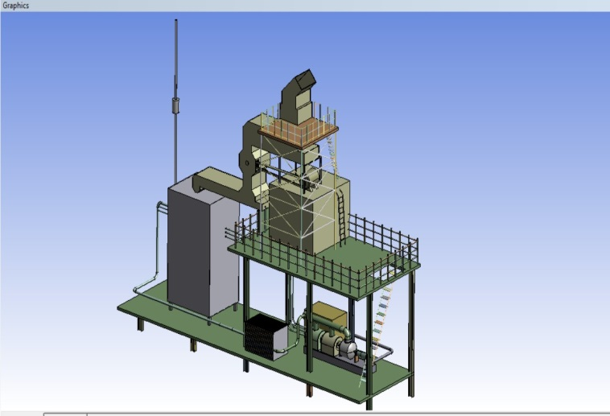

**Figure 4:** ANSYS 3D left side view of sanitary waste incinerator

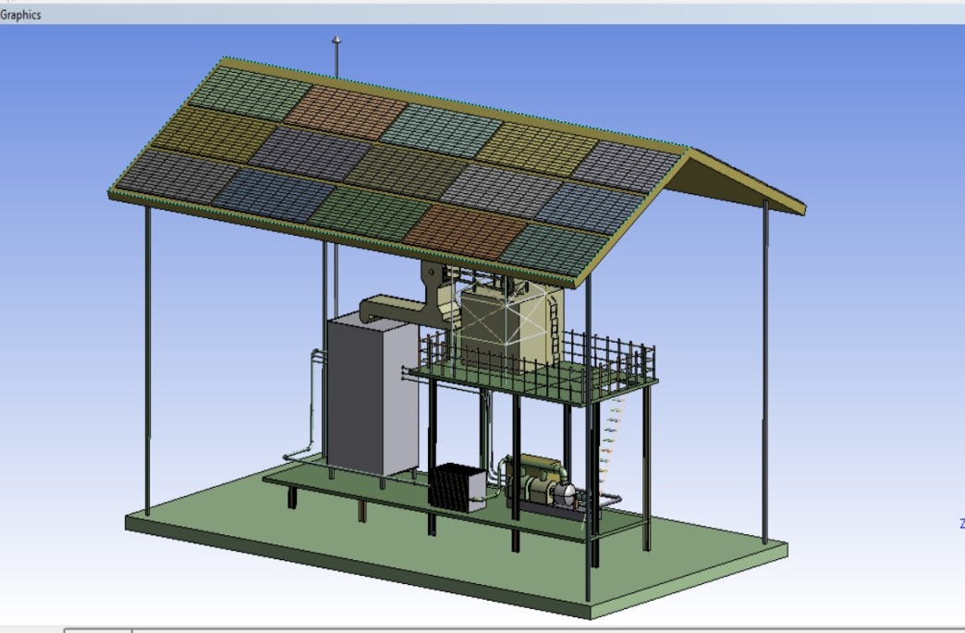

**Figure 5:** ANSYS 3D left side view of sanitary waste incinerator with solar panel

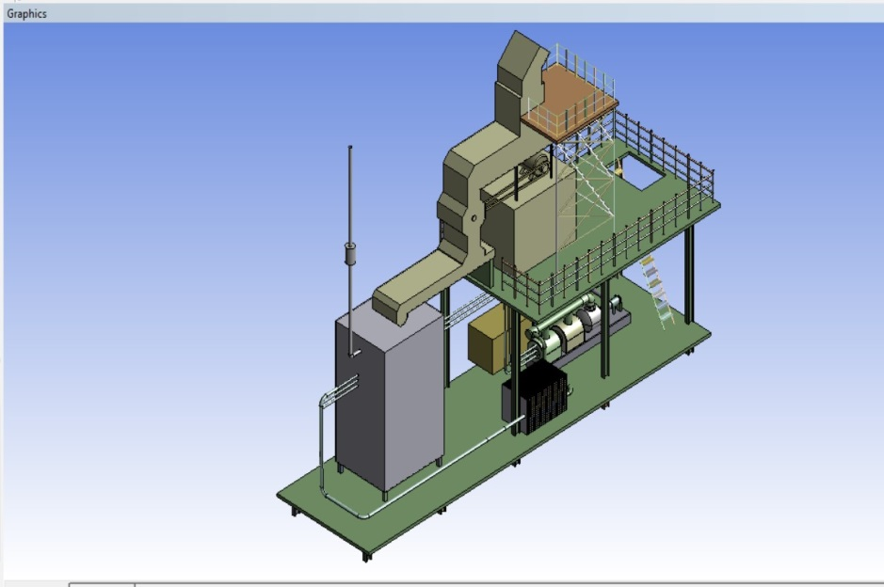

**Figure 6:** ANSYS 3D top view of sanitary waste incinerator

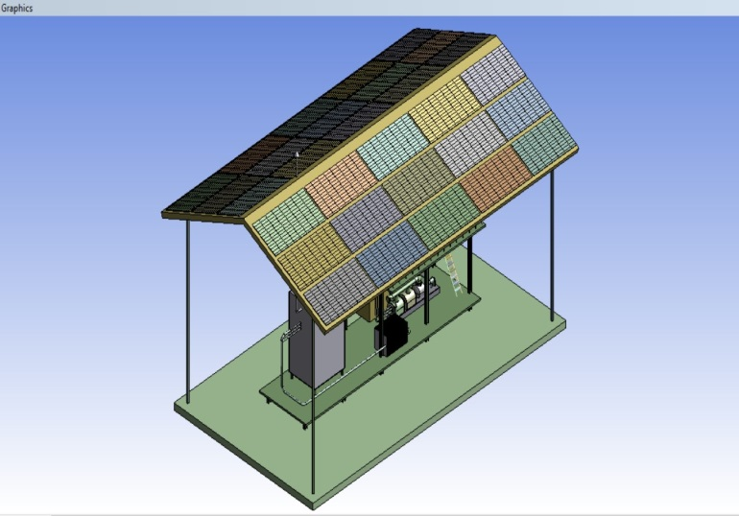

**Figure 7:** ANSYS 3D top view of sanitary waste incinerator with solar panel

**3.11 Inlet and outlet valves of incinerator**

The incinerator is designed according to the basic principles of ensuring a highly efficient combustion and a high degree of safety. There are many inlet and outlet valves are found in the incinerator for various purposes like:

* Primary and secondary air inlets are used for the supply of air which is suitable for the combustion.
* Fuel injectors are used for injecting fuel into the combustion chamber. Here the fuel we used is methane.
* Outlet valve is used for removing gases after the combustion.

|  |  |
| --- | --- |
| Primary air inlet valve | Secondary air inlet valve |
| Fuel injectors | Outlet |

**Figure 8:** Inlet and outlet valves of incinerator

**3.12 Applications**

The applications of sanitary waste incinerator are:

* The sanitary waste incinerator has a New Automatic Flush Technology, which will flush the waste ash residue just after the napkins are combust completely.
* In the sanitary waste incinerator, smoke passing from drainage is purified and the pollution contents are efficiently reduced with the help of carbon filter. The outlet is passed through the drainage pipe only.
* The sanitary waste incinerator has a smart display, which requires no manual tasks, and the combustion takes place automatically.
* The waste ash and smoke is drained out via flush and Carbon filters. The display indicates the status of the machine.
* The sanitary waste incinerator has a Foul Odour Emitting Technology, which removes the foul odour of the vicinity.
* The sanitary waste incinerator is lightweight and most importantly is cheap and affordable by various NGOs.

**3.13 Advantages**

* Higher burning ability within short period of time.
* Residues will be directly flushed out into drainage.
* Exhaust is released in the drainage.
* No odour nuisance.
* Ashes can be easily removed.
* Process is fully automatic.
* User-friendly interface.

**4. RESULTS AND DISCUSSIONS**

**4.1 Quantity of sanitary napkins waste generated in Parappanangadi municipality**

The sanitary waste like used sanitary napkins and diapers are generated from various institutions like colleges, schools, hospitals, government offices, villas and housing colonies etc. in Parappanangadi municipality.

**Table 7:** Quantity of sanitary napkins waste generated in Parappanangadi municipality

|  |  |  |
| --- | --- | --- |
| **Sl. No** | **Institutions** | **Quantity of napkin produced per day in kg** |
| 1. | Colleges | 7.7 |
| 2. | Schools | 32.92 |
| 3. | Institutions in health sector | 1.57 |
| 4. | Govt. offices | 1.45 |
| 5. | Villas and housing colonies | 50 |
| **Total** | | **93.64** |

There are 5 colleges run under Parappanangadi municipality. Among the 5 colleges Co-operative College generate large amount of napkin waste Malabar College generate least amount of napkin waste.

There are 17 schools run under Parappanangadi municipality which include 5 higher secondary schools, upper primary schools and lower primary schools. Among the all schools SNMHSS generate large amount of napkin waste and Anappadi GLPS generate least amount of napkin waste.

There are 6 health care institutions run under Parappanangadi municipality. Among the health care institutions Nahas hospital generate large amount of napkin waste and Govt. Ayurveda health Centre generate least amount of napkin waste.

From the villas and housing colony are placed in Parappanangadi municipality, approximately 50 kg napkin wastes are generated per day. So the grant total of sanitary waste generated in Parappanangadi municipality is 100 kg per day.

**4.2 Quantity of diaper waste generated in Parappanangadi municipality**

The amount of diaper generated per day in Parappanangadi municipality is calculated.

**Table 8:** Quantity of diaper waste generated in Parappanangadi municipality

|  |  |  |  |  |
| --- | --- | --- | --- | --- |
| **Sl. No.** | **Parameter** | **No. of people** | **Quantity of diapers used per day** | **Wt. produced by diapers per day in Kg** |
| 1. | Elderly people (using diaper) | 70 | 280 | 5.6 |
| 2. | Children below 3 years | 1128 | 4512 | 90.24 |
| **Total** | | | | **95.84** |

The large amount of diaper waste is generated by children below 3 years old, which is around 90.24 kg per day. The total amount of diaper waste generated per day is approximately 100 kg.

**4.3 Survey report**

As a part survey, a questionnaire is conducted in Parappanangadi municipality. The questionnaire is conducted for 100 households in Parappanangadi municipality in different wards. This questionnaire is conducted to know about the type of absorbent used in menstruation period, types of diapers used, methods of disposal used for sanitary waste etc.

**Chart 1:** Types of absorbent used for menstruation

From the survey, the most common type absorbent used for menstruation is disposable sanitary pads which is around 84%, followed by washable cloth pads which is 12%, then tampons which is 2% and then menstrual cup which is only 1%.

The most used absorbent is disposable diapers. Polymers in sanitary pads are non-biodegradable material. This may create many serious problems. But still we chose disposable sanitary pads due to its low cost and easy usage but such pads degrade environment and are non-decomposable. It can only use for one time and create large amount of sanitary waste.

**Chart 2:** Types of diapers used

From the survey, the most common type of diaper used is disposable diaper which is 88%, followed by cloth diapers which is 11% and then flushable diapers which is only 1%.

**Chart 3:** Methods of disposal

From the survey, among the all method of disposal of sanitary waste, the most common used method is burning which is 74%, followed by landfill which is 19%, then open dumping which is 4% and then composting which is only 1%.

Burning of commercially available pads at low temperatures can release toxins such as dioxins and furans into the surrounding atmosphere. Also the wet condition of disposable diapers due to it being soiled with feces makes it very difficult to be burnt by fire. Incinerators are designed for satisfactory burning of combustible refuse, provided air pollution standards are met.

**4.4 Specifications of sanitary waste incinerator**

**Table 10:** Specifications of sanitary waste incinerator

|  |  |
| --- | --- |
| Capacity | 100 kg |
| Charging rate(when necessary) | 20 kg/minute |
| Primary chamber | 1.2 m3 |
| Insulator thickness | 0.05 m |
| Expected heat release from waste | 1,101,471.85 kJ |
| Amount of stoichiometry oxygen require | 100 kg |
| Amount of air needed at 21 percentage O2 | 478.571 kg |
| Natural gas require for auxiliary heat supply | 27.063 m3 |
| Temperature of primary chamber | 600 – 800 0C |
| Outer wall temperature | 31 0C |
| Stack Height | 30 m |

**4.5 ANSYS 2D model of sanitary waste incinerator**

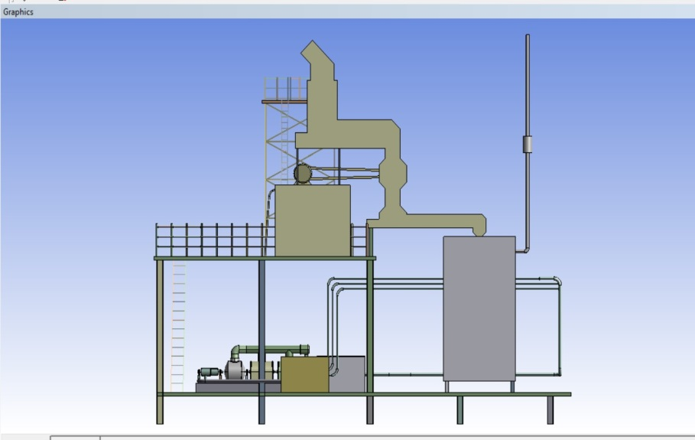

**Figure 9:** ANSYS right side 2D view of sanitary waste incinerator

**4.6 ANSYS 3D model of sanitary waste incinerator**

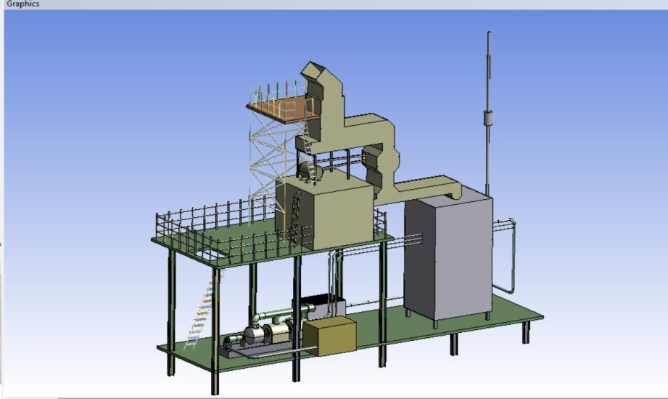

**Figure 10:** ANSYS 3D right side view of sanitary waste incinerator

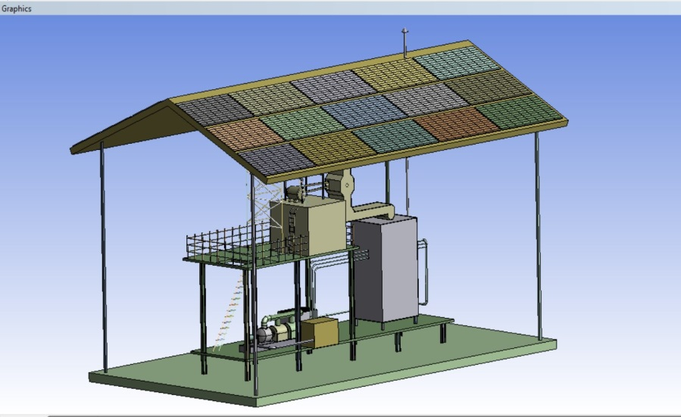

**Figure 11:** ANSYS 3D right side view of sanitary waste incinerator with solar panel

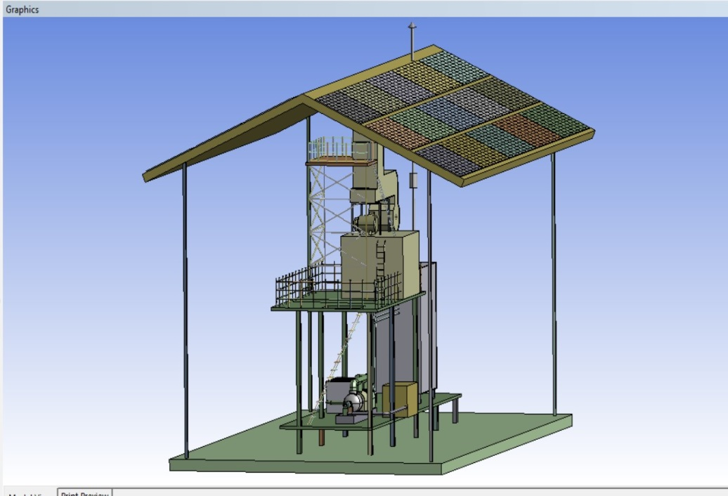

**Figure 12:** ANSYS 3D front view of sanitary waste incinerator with solar panel

**4.7 CFD output stimulation results**

Computational Fluid Dynamics (CFD) or flow simulation is the science of predicting fluid flow, heat transfer, chemical reactions etc. For the proposed design, CFD is done with the help of ANSYS software.

**4.7.1 Temperature**

The temperature inside the incinerator is shown in Figure 13. The maximum temperature is 800oC (1073.15 K) and the minimum is 600oC (873.15 K). The temperature at the center of chamber is high; this may be due to the excess air at that particular point. The excess air increases the combustion efficiency. The low heat zone at the bottom of the incinerator may be caused by insufficient air due to its position. Indeed, there is anomaly in the observed temperatures. A direct explanation to what is happening can be elucidated if further studies are carried in these areas.

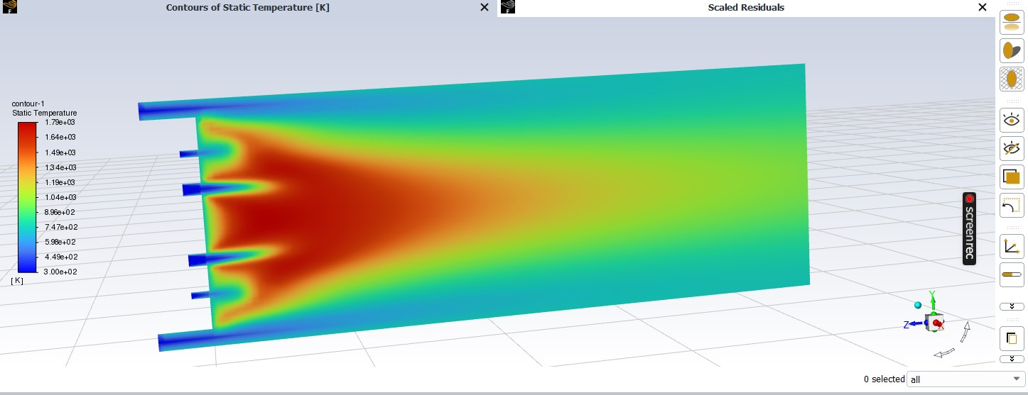

**Figure 13:** Contours of static temperature (K)

**4.7.2 Mass fraction of oxygen**

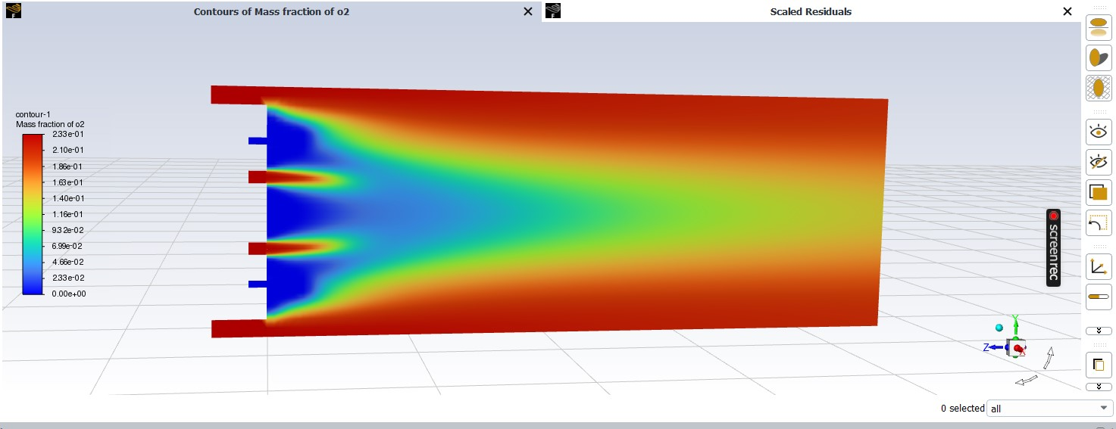

**Figure 14:** Contours of mass fraction of oxygen

The mass fraction for O2 was decreased. The value of oxygen to the effluent is caused by excess air to the combustion process. In this case, the value of oxygen to the practical experiment was exceeding as shown in Figure 14. The increasing oxygen may cause this during the period of refilling the waste by opening the door of the incinerator, there is recalculated air from the entrance door.

**4.7.3 Mass fraction of carbon monoxide released**

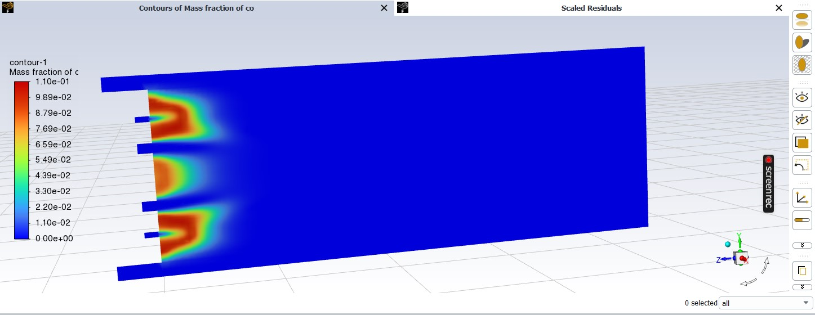

**Figure 15:** Contours of mass fraction of carbon monoxide

The simulation values for Carbon monoxide were deviated from practical values by as shown in Figure 15. This value is highly deviated. The percentage of Carbon monoxide increases as compared to practical results. The value is, however, within the permissible value of Carbon monoxide allowed in the environmental protection values [36]. This may be caused by the door opening in which excess oxygen to the combustion chamber is not considered during simulation.

**4.7.4 Mass fraction of carbon dioxide released**

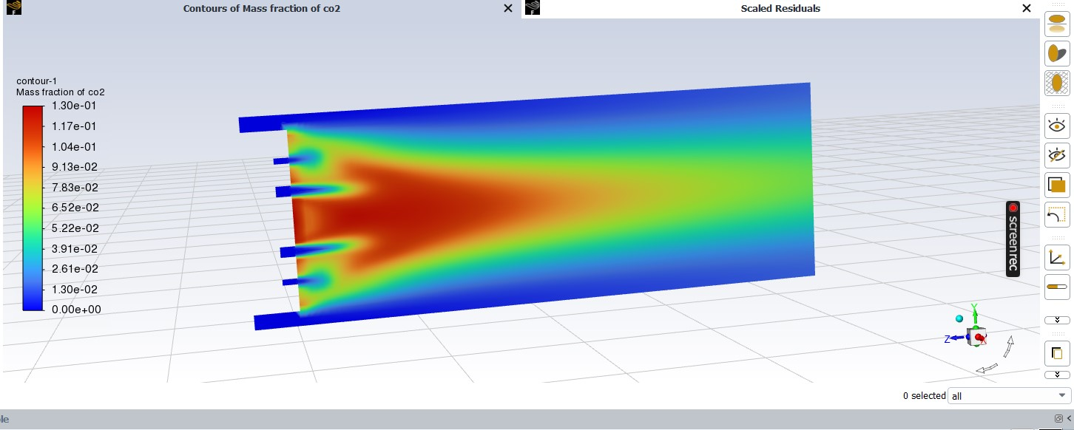

**Figure 16:** Contours of mass fraction of carbon dioxide

The values show that CO2 released were deviated from the value obtained practically. The percentage CO2 at the effluent gases was found to be 7.07% [36]. The practical experiment obtained was less. This variation is caused by increase in combustion efficiency of the incinerator [36].

**4.8 Cost estimation**

**Table 9:** Cost and quantity for sanitary waste incinerator unit

|  |  |  |  |  |  |
| --- | --- | --- | --- | --- | --- |
| **Sl.**  **No.** | **Item** | **Size** | **Quantity** | **Price per item** | **Total** |
| 1. | Al sheet  ASTM/AASME SB209 | 1220mmX 2440mm,5mm thickness | 18 nos | 150/kg | 7200 |
| 2. | Motor-Blade size 510mm,Belt size-B102, Rpm1440.Capacity - 360kG/Hr | 580X870X1300, 75Kg | 1 | 13000 | 13000 |
| 3. | L-section | 50X50X5 | 100 nos | 38/kg | 87400 |
| 4. | INTBUYING Flat conveyor Belt System | 7.8 inch width | 2 | 58000 | 116000 |
| 5. | DeWalt cutting blade | B-102,510mm | 5 | 1480 | 7400 |
| 6. | Heat-Exchanger | Dia-18mm,length 120 cm |  | 94/m | 6400 |
| 7. | GI Hollow pipe | Dia-18mm, length,5.5m | 30 | 94/m | 15500 |
| 8. | Steel pipe Exhaust | 63.5mm dia, 3.3m | 1 | 185/kg | 5735 |
| 9. | GI 90ELL | 90ELL-1.5XW | 18 | 50 | 900 |
| 10. | Screws and fittings |  |  | 2 kg | 2200 |
| 11. | Installation cost |  |  |  | 12000 |
| 12. | Transportation cost |  |  |  | 2500 |
|  | Total |  |  |  | 276235 |
|  | 10% profit |  |  |  | 27623.5 |
| **GRANT TOTAL** | | | | | **Rs.303858.5** |

**4.9 Incinerator output**

A complete combustion is takes place inside the incinerator. Therefore there is no carbon dioxide, carbon monoxide and water formed due to the incomplete combustion. The by-product formed is ash, flue gas and heat. The main gas output of the incinerator is dioxins and furans. They are very toxic. The dioxins are carcinogenic. It is filtered through the carbon filter. The efficiency of carbon filter is 95%.

**4.9.1 Steam energy**

With the help of heat exchanger in the incinerator, the water flows through the stainless steel pipe is converted into steam by using high temperature in combustion chamber. A steam turbine is given outside the incinerator. The hot gaseous steam passes through this steam turbine. When the steam flows past the turbine’s spinning blade, steam expands and cool off. This steam spins the blade continuously. The steam energy is converted into kinetic energy which will help to rotate the output shaft. Finally with the help of a generator, it will convert into electrical energy and stored in the battery.

The electricity generated with the help of steam turbine can be used for the working of incinerator along with the electricity generated by solar energy. Therefore this sanitary waste disposal system has a zero waste energy. Hence it is sustainable disposer system. The excess electrical energy generated can be selling to the Kerala State Electricity Board (KSEB).

**4.10 Scope**

* This project gives a solution for destroying diapers and napkin waste in a very hygienic way.
* This is portable system to destroy diapers and napkin waste, using Incinerator.
* These systems also help to achieve the “Swachha Bharat” mission and avoid the large amount of diseases.

**5. CONCLUSIONS**

The grand total sanitary waste generation rate in Parappanangadi municipality around 200 kg/day. An incinerator has been designed to treat the sanitary waste like diapers and sanitary napkins which is being generated in Parappanangadi municipality with a capacity of 100 kg/day. The most common type absorbent used for menstruation in Parappanangadi municipality is disposable sanitary pads which are around 84%. The most common type of diaper used in Parappanangadi municipality is disposable diaper which is 88%. The most commonly used method for the disposal of sanitary waste in Parappanangadi municipality is burning which is 74%, followed by landfill which is 19%. Design temperature of the incinerator is 600 – 800oC. The 2D model of napkin incinerator created using both Auto CAD and ANSYS software. The 3D model of napkin incinerator created using ANSYS software. Computational Fluid Dynamics (CFD) is done in the incinerator with ANSYS software. The temperature at the center of chamber is high; this may be due to the excess air at that particular point. The value of oxygen to the practical experiment was increasing. This may be occurred during the period of refilling the waste by opening the door of the incinerator, there is recalculated air from the entrance door. The percentage of Carbon monoxide increases as compared to practical results. This may be caused by the door opening in which excess oxygen to the combustion chamber is not considered during simulation. The values show that CO2 released were deviated from the value obtained practically. This variation is caused by increase in combustion efficiency of the incinerator. The estimated cost of incinerator is Rs.303858.5. The electricity generated with the help of steam turbine can be used for the working of incinerator along with the electricity generated by solar energy. Therefore this sanitary waste disposal system has a zero waste energy. Hence it is sustainable disposer system. The excess electrical energy generated can be selling to Kerala State Electricity Board (KSEB).

**ACKNOWLEDGEMENT**

First of all I would like to thank God, the almighty for the divine grace bestowed on me to complete this mini project successfully on time.

I express my sincere thanks to **Dr. P Babu**, Principal of Malabar College of Engineering and Technology, for providing necessary facilities and his sincere co-operation.

I express my deep sense of gratitude to **Prof. Anil Kumar B**, Head of the Department of Civil Engineering for providing me the best facilities and atmosphere for creative work guidance and encouragement.

I express my deep sense of gratitude to **Prof. Anitha K**, M. Tech Coordinator and my guide, Assistant professor of Department of Civil engineering, for providing me the best facilities and atmosphere for the creative work guidance and encouragement.

Finally I would like to convey my sincere thanks to all the faculty members of the civil Engineering Department for the co-operation. I am indebted to my parents and all my friends for their constant encouragement.

**REFERENCES**

1. Jyoti Choudhary, Dr Mahua Bhattacharjee, “A Study On Consumption Pattern Of Sanitary Napkin And Environment Degradation”, International Journal of Creative Research Thoughts (IJCRT), 2018, Volume 6, Issue 2, ISSN: 2320-2882.
2. S H Rahat, A T Sarkar, S A A Rafie, S Hossain, “Prospects of Diaper Disposal and Its Environmental Impacts On Populated Urban Area Like Dhaka City”, 2nd International Conference on Advances in Civil Engineering 2014 (ICACE-2014) 26 –28 December.
3. Mia Juliana Siregar, “Recent Technology for Recycling of Used Diapers Waste”, International journal of innovation in Engineering, 2022, Volume 2, Issue 2, page 13-25.
4. Noorhalieza Ali, Mohd Rozainee Taib, Ng Pang Soon, Onn Hassan, “Issues And Management For Used Disposable Diapers In Solid Waste In The City Of Kuala Lumpur”, Perintis, e-Journal, 2017, Volume 7, No. 1, pp. 43-5
5. Megha M V, M A Chinnamma, Anitha K Subash, “Design of Sanitary Napkin Disposal System at Thrissur Muncipality”, International Research Journal of Engineering and Technology (IRJET), 2021, Volume: 08, Issue: 06, e-ISSN: 2395-0056, p-ISSN: 2395-0072.
6. Ntekpe M, Mbong E, Edem E & Hussain S, “Diapers: Impact of Disposal Methods on Public Health and the Environment”, Journal of Medicine and Public Health, 2020, volume 1, Issue 2, page 1-8.
7. Counts J, Weisbrod A, & Yin S, “Common Diaper Ingredient Questions: Modern Disposable Diaper Materials Are Safe and Extensively Tested”, Journal of Clinical Paediatrics, 2017, 56(5S), page 23-27, doi: 10.1177/0009922817706998.
8. Mfon Emmanuel Ntekpe, Emem Okon Mbong, Ekom Ndifreke Edem and Sajjad Hussain, “Disposable Diapers: Impact of Disposal Methods on Public Health and the Environment”, American Journal of Medicine and Public Health, 2020, Volume 1, Issue 2, Article 1009
9. Mohsin M, Anwar MM, Iqbal MJ, “Practice and conditions of solid waste management in Ahmedpur East, Bahawalpur, Pakistan: A way forward” Sindh Univ Res Journal, 2016, 48(1), page 95-100.
10. Meseldzija J, Poznanovic D, Frank R, “Assessment of the differing environmental impacts between reusable and disposable diapers”, Dufferin Research, 2013, Retrieve 22 June, 2020.
11. Ramaswamy V, Sharma HR, “Plastic bags - threat to environment and cattle health: A retrospective study from Gondar City of Ethiopia”, The IIOAB Journal: Special issue on environmental management for sustainable development, 2011, volume 2, Issue 1, page 7-12.
12. Remigios MV, “The environmental health implications of the use and disposal of disposable child diapers in senga/nehosho suburb in Gweru City, Zimbabwe”, Global Journal of Biology, Agriculture and Health Sciences, 2014, Volume 3, Issue 2, page 122-127.
13. Madehow.com. How products are made. Volume 3: Disposable Diaper. Accessed on 23 June, 2020.
14. Chourasia Sandhya Bhagawat, Tambolishabanam, Mali Satish & Jamdadeamar, “Manufacturing of Cost Efficient Sanitary Napkins Incinerator Machine”, International Journal of Mechanical and Production Engineering Research and Development, 2019, volume 9, Issue 3, pp. 803- 812.
15. Madheswaran Subramaniyan, Anandha Moorthy Appusamy, Prakash Eswaran, Karthik Shanmugavel, Santhana Kumar Sadaiappan, Maheshwaran Periyasamy, “Design of Domestic Incinerator for the Safe Disposal of Menstrual Waste in the Rural Areas”, International Journal of Research in Engineering, Science and Management, 2019, Volume 2, Issue 3, ISSN (Online): 2581-5792.
16. Rutuja Kulkarni, Rajnandini Lohar, Neha Wani, “Sanitary Napkin’s Disposal System”, International Journal for Scientific Research & Development, 2008, Volume 4, Issue 4, pp.1142-1144.
17. Pooja G Nidoni, “Incineration Process solid waste management and effective utilization of by-products”, IRJET, 2017, Volume 04, page 378-382.
18. Vishakha Goyal, “Scope and Opportunities for Menstrual Health and Hygiene Products in India”, International Research Journal of Social Sciences, 2016, Volume 5, Issue 7.
19. Avinash A Patil, “Waste to energy by incineration”, Journal of computing technologies, 2014, volume 3, issue 6, page 12-15.
20. Shyam Swaroop Nigam, “Effective Utilization of Low Cost Incineration and its By Products in India”, 978-1-4799-7193, 2014.
21. Jereme, Chamhuri Siwar, M.D Anowar Hossain Bhuiyan, “Incineration and its implications”, International journal of environmental science, 2013, Volume 4, No 3; page no. 367- 378.
22. Adika V O, Yabga J, Apiyanteide F A, Ologidi P W and Ekpo K E, “Perception and behaviour on use of sanitary pads during menstruation among adolescent school girls in Bayelsa State”, Nigeria, 2011, volume 2, issue 6, page 9-15.
23. Yichun Yeh, Harutoshi Ogai, Ryouta Yui, Hiroshi Morita Yukinori Takabayashi, “Modeling of Waste Disposal System for Disposable Diapers”, IEEE, 2006.
24. C Block, J VanCaneghem, A Van Brecht, G Wauters, C Vandecasteele, “Incineration of hazardous waste”, Springer Science+ Business Media Dordrecht, 2000, volume 6, page no. 137–145.
25. Sharika C, Chithra Chandran Adumbil, Daina Joy, Elizabeth Jose Paul, Ashly Thomas, “Sanitary Waste Disposer”, International Research Journal of Innovations in Engineering and Technology (IRJIET), ISSN (online): 2581-3048, 2019, Volume 3, Issue 9, page 28-31.
26. Kimani Emily Wambui, Muchiri Joseph, Dr Stanley Makindi, “Soiled Diapers Disposal Practices among Caregivers in Poor and Middle Income Urban Settings”, International Journal of Scientific and Research Publications, 2015, Volume 5, Issue 10, ISSN 2250-3153.
27. Mutowo Jesca, Mzengi Junior, “Practices Regarding Disposal of Soiled Diapers among Women of Child Bearing Age in Poor Resource Urban Setting”, IOSR Journal of Nursing and Health Science (IOSR-JNHS), 2015, e-ISSN: 2320–1959, p- ISSN: 2320–1940, Volume 4, Issue 4, Ver. III, PP 63-67.
28. Rajanbir Kaur, Kanwaljit Kaur, Rajinder Kaur, “Menstrual Hygiene, Management, and Waste Disposal: Practices and Challenges Faced by Girls/Women of Developing Countries”, Journal of Environmental and Public Health, 2018, pp.01-04.
29. Madheswaran Subramaniyan, Anandha Moorthy Appusamy, “Design of Domestic Incinerator for the Safe Disposal of Menstrual Waste in the Rural Areas”, International Journal of Research in Engineering, Science and Management, 2009, volume 2, issue 3, pp.200-203.
30. Linda Scott, Paul Montgomery, Laurel Stinfielt, Catherine Dolan, “Sanitary Pad Acceptability and Sustainability Study”, Journal of Xi'an University of Architecture & Technology, 2013, Volume 12, Issue 3, ISSN: 1006-7930.
31. K. Samba Siva Rao; K. Harish; M. Kavin Kumar; D. Vishnu Harish, “Solar Powered IoT based Intelligent Sanitary Napkins Dispenser”, IJRASET, 2018, Volume 6, Issue 3, page 2321-9653.
32. Omari A M, John G R, Njau K N, Mtui P L, “Operating Conditions of A Locally Made Fixed-Bed Incinerator, a Case Study of Bagamoyo – Tanzania”, International Journal of Environmental Monitoring and Analysis, 2015, volume 3, page 80-90.
33. Arthur M. Omari, John P. John and Baraka Kichonge, “Simulation and Optimization of Municipal Solid Waste Combustion: A Case Study of a Fixed Bed Incinerator”, Journal of Engineering Research and Reports, 2020, volume 11, issue 3, page 5-19, Article no. JERR.51997, ISSN: 2582-2926.
34. Shiju Easo John and C Nanjunda Swamy, “Design of incinerator for the treatment of biomedical solid waste in Chickmangalur city”, Journal of Industrial pollution Control, 2011, ISSN (0970-2083).