# REAL TIME TRAFFIC SIGNAL SWITCHING USING MACHINE LEARNING

**Gokul S [1] Gokul B [2] Kavirajan S [3] Mrs.Subhalakshmi.R.T[4]**

[4] Assistant Professor, Department of Computer Science and Engineering

[1] [2] [3] Department of Computer Science and Engineering

[1] [2] [3] [4] Hindusthan Institute Of Technology,

Coimbatore, Tamil Nadu, India.

## ABSTRACT

*Traffic clog is the significant issues in India and is particularly prevalent in the metropolitan urban areas of the nation. This clog increases day by day on the road as the vehicle density increases, so managing such large traffic nowadays through traditional approach is not so successful. The traffic is larger on one side than the other side in such case the traditional approach fails. So, in this project we perform real-time signal monitoring and handling approach (i.e.,) moving from static switching to signal switching. We use an algorithm YOLOv3 (You Only Look Once, Version 3) which is a real-time object detection algorithm that identifies specific objects in videos, live feeds, or images, to find the vehicle count in two side of the roads and perform signal switching based on the count. This count is fed as input to raspberry pi 3 to perform signal switching and these uses led lights to toggle the signal. The switching time of signal will be decided based on detection of real time image with accurate results even in dense traffic. Overall, in our project we compare the object counts from the different camera and perform signal switching dynamically. to perform signal switching and these uses led lights to toggle the signal. The switching time of signal will be decided based on detection of real time image with accurate results even in dense traffic. Overall, in our project we compare the object counts from the different camera and perform signal switching dynamically.*

## I.INTRODUCTION

People in today’s era usually have tendency of using their own vehicles for commutation rather than using public or pooled means of transport and this results in large number of private vehicles on road. This endless increasing number of vehicles on road gives rise to many problems amongst them traffic congestion tops in every aspect. In such scenario one cannot restrict individual to limit the usage of the private vehicles but what we can do is at least manage traffic flow in a way that it doesn’t alleviate congestion issues.

There are projects emerging in order to convert the current transport system of cities to ‘Smart system’ and there are various initiatives under this, one of the initiatives is Intelligent Transport System. Many initiatives were taken to design a system that can perform real- time monitoring of signals during the traffic i.e. the signal switching time of traffic will not be predefined one, instead the switching time will depend on the number of vehicles on either side of the road. This process of getting the number of vehicles on the road can be achieved using various detection techniques.

Our aim is to design and develop a miniature to depict the current road situation along with monitoring and handling the traffic issues. Hence to proceed with this project we are using a pre-trained model YOLO to perform the task of object detection. The pretrained model YOLO uses OpenCV for object detection of object along with multiple background and foreground subtraction and removal of noise from the input image. The CCTV cameras that are used for surveillance purpose can be made use to capturing the footage of the road, this image will be passed to the pretrained model as input image.

To do so each side of the road will be divided into particular frames of same height and width for capturing the image. The count or number obtained from the image is fed to the Raspberry board. As per the count obtained, switching time will be assigned for either side of road. The program will initially check if the number of vehicle in all frame is approximately same then the switching will remain at its predefined regular interval for all sides of signal, the real- time switching for the signal will be performed if the number of vehicles in all fames varies as threshold difference which be provided.

**II METHODOLOGY**

Deep learning can be used to optimize traffic signal switching by predicting traffic patterns and adjusting signal timings accordingly. Here is the methodology for traffic signal switching using deep learning 1. Gather data: The first step is to gather traffic data from various sources, such as cameras and sensors, to create a comprehensive dataset. This data should include information on traffic volumes, congestion, and accidents.

2. Pre-process the data: The next step is to pre-process the data to ensure that it is clean and properly formatted. This may involve removing outliers, filling in missing values, and normalizing the data.

3. Train a deep learning model: The next step is to

train a deep learning model on the pre-processed data. The model should be designed to predict traffic patterns and determine optimal signal timings based on the predicted patterns.

4. Validate the model: Once the model is trained, it needs to be validated using a separate dataset to ensure that it is accurate and effective.

5. Implement the model: The validated model can then be implemented into the traffic signal switching system. The model can continuously analyze real-time traffic data and adjust signal timings accordingly to optimize traffic flow and reduce congestion. 24

6. Monitor and adjust: The system should be continuously monitored and adjusted based on feedback from drivers and pedestrians. This feedback can be used to fine-tune the deep learning model and improve the overall efficiency of the traffic signal switching system.

* **DATASET MODULE**

In this module, we train the system using few datasets for the vehicle identification. The details of the dataset usedin training the object detection models in thisproposed solution can found in this subsection. The dataset used is Microsoft Common Objects in Context image (MS- COCO) dataset. This dataset is a well- knowndataset developed by Microsoft [11]. This is a largescale object detection dataset containing up to 1.5 million instances. Thereare around 330,000 images of 80 different classes and more than 220,000 labeled images.

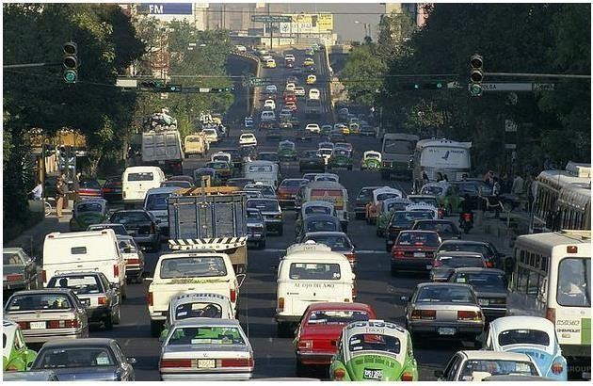

*: Dataset sample image 1*

In the second image, figure 3 a large group of bikers and some big vehicles waiting on a signal can be seen. These types of scenes are helpful to train this model on highly dense traffic with primarily bikes present.

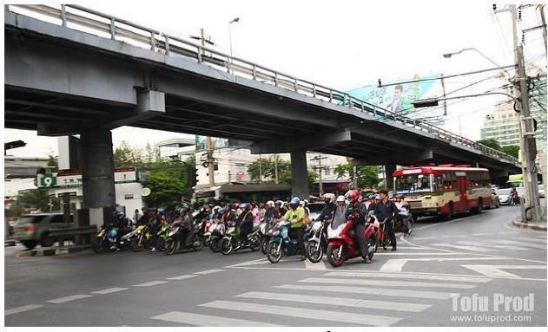

*Dataset sample image 2*

In the third image as seen in figure 3, a wide view of a large intersection is seen. This type of images can used totrain the model on a bird’s eye view of all the ways the traffic can move.

* **VEHICLE DETECTION**

In this we detect the vehicle by using the YOLOv3 algorithm, by giving the input video sequence was given as input to convolutional neural network. The training process was implemented by convolutional neural network topology of the YOLO algorithm.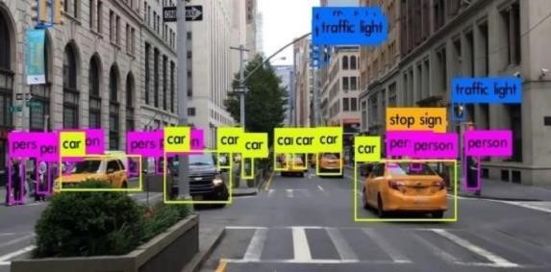

*vehicle detection*

YOLO achieves high accuracy while also being able to run in real-time.

The algorithm “only looks once” at the image in the sense that it requires only one forward propagation pass through the neural network to make predictions. After non- max suppression, it then outputs

recognized objects together with the bounding boxes. With YOLO, a single CNN simultaneously predicts multiple bounding boxes and class probabilities for those boxes. YOLO trains on full images and directly optimizes detection performance. Following is the output which shows the vehicles are identified and labelled using YOLOv3 algorithm.

### **VEHICLE COUNT**

**MODULE TO DETERMINE** YOLO computes its prediction in terms of precision and recall, precision measures how accurate was your predictions and recall measures how good you find all the positives i.e., how correctly the objects are classified. To increase its performance factor YOLO uses IoU, Intersection over Union is an evaluation metric used to measure the accuracy of an object detector on a particular dataset. IoU defines how two closely place objects can be easily detected without hampering the accuracy of the model. YOLO consist of two core components. One of the Yolo’s

component R_CNN uses selective search algorithm and proposes accurate bounding box that definitely contains objects whereas the other component SSD that helps is speed processing of an image. Compared to other region proposal classification networks (fast RCNN) which perform detection on various region proposals and thus end up performing prediction multiple times for various regions in an image, 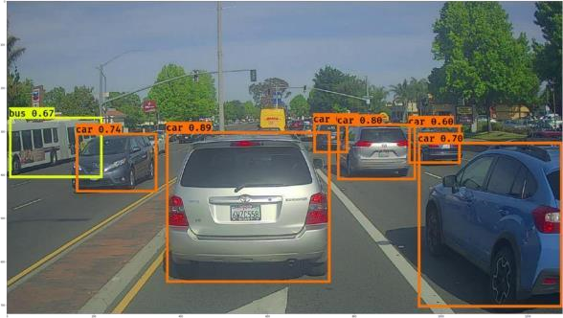

*Figure; object count*

* **MODULEWHICHPERFORS SIGNAL SWITCHING**

This model can work at its best at condition when traffic reaches to its peak, where the management by an individual becomes difficult. So, our aim is to design a model, depicting the real-time traffic scenario and performing signal switching as per our criteria and conditions of threshold value. with vehicles as comparing to other three lanes. In normal signal switching method signal switching is done in clockwise manner which result in clogging of vehicles in a particular lane. To recover from the problem of assigning same switching timing for the signal even if the count of vehicles on the road is varying from lane to lane.

### **YOLO V3 ALGORITHM**

YOLOv3 (You Only Look Once, Version 3) is a real-time object detection algorithm that identifies specific objects in videos, live feeds, or images. The YOLO machine learning algorithm uses features learned by the deep convolutional neural network to detect object. Versions 1-5 of YOLO were created by Joseph Redmon and Ali Farhadi, and the third version of the YOLO machine learning algorithm is a faster version of the original ML algorithm to detect object. Other comparable algorithms that can carry out the same objective areR-CNN(Region-based Convolutional Neural Networks made in 2015) and Fast R-CNN (R-CNN improvement developed in 2017, and Mask R- CNN. However, unlike systems like R_CNN and Fast R-CNN, YOLO was trained to do classification and bounding box regression at the same time.

* **YOLO V3 ARCHITECTURE**

Inspired by ResNet and FPN (Feature- Pyramid Network) architectures, YOLOv3 feature extractor, called Darknet – 53 (it has 52 convolutions) contains skip connections (like ResNet) and 3 prediction heads (like FPN) — each processing the image at a different spatial compression. Like its predecessor, Yolo-V3 boasts good performance over a wide range of input resolutions.

In Gluon CV’s model zoo**,** you can find several checkpoints: each for a different input resolution, but in fact the network parameters stored in those checkpoints are identical. Tested with input resolution 608x608 on COCO-2017 validation set, Yolo-V3 scored 37 MAP (mean Average Precision). This score is identical to Gluon CV’s trained version of Faster- RCNN-ResNet50, (a faster-RCNN architecture that uses ResNet-50 as its backbone) but 17 times faster. In that model zoo the only detectors fast enough to compete with Yolo-V3 (Mobile netSSD architectures) scored MAP of 30 and below.

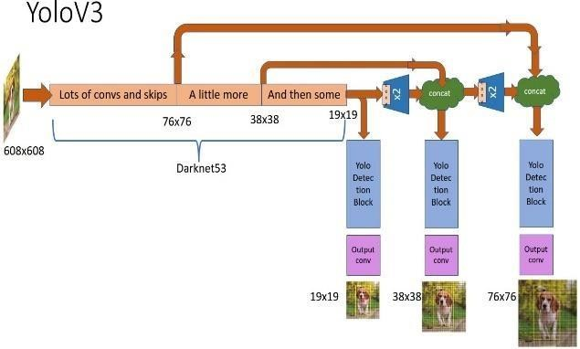

*Figure : YOLOv3 Architecture*

**III MODELING AND**

**ANALYSIS**

The congestion increases day by day on the road due to vehicles and also the management of such large traffic by traditional approach isn’t adequate enough. In today’s scenario the traditional approach works efficiently only if the count is sparse, as the vehicle density on a particular side of road increases or if the traffic is comparatively larger on one side than other side in such case the approach fails. As the current available extraction methods are not so efficient for processing the traffic basis data (6), an efficient acquisition method that is to be presented in order to process the traffic condition. The method used was based on improved Kalman filter and gaussian to resolve the conflict of multi-moving vehicle targets detection. Also, heuristics improvement method was applied in improving the efficiency of detection. The method proposed can effectively improve the noise interference and also possess the capability of detecting vehicle from continuous video frame. The main concept presented in this paper was related to no missing, no re-inspection, error detection while detecting the vehicle from the captured images.

Deep learning-based systems for traffic signal switching are still in the early stages of development and are not yet widely implemented. However, there are some research studies and pilot projects that have explored the use of deep learning for traffic signal switching. Here are some examples:

1. **Deep Reinforcement Learning (DRL):**

DRL is a type of deep learning that has been used to optimize traffic signal timings. DRL algorithms learn to maximize the flow of traffic by adjusting signal timings based on real-time traffic data.

1. **Convolutional Neural Networks (CNNs):**

CNNs have been used to detect and classify vehicles, pedestrians, and cyclists at intersections. By using CNNs, traffic signal timings can be adjusted to accommodate different modes of transportation and improve safety for all road users.

1. **Recurrent Neural Networks (RNNs):**

RNNs have been used to predict traffic volumes and adjust signal timings accordingly. By predicting traffic volumes, RNNs can help reduce congestion and improve traffic flow.

1. **Generative Adversarial Networks (GANs):**

GANs have been used to generate synthetic traffic data to train deep learning models for traffic signal switching. By generating realistic traffic data, GANs can improve the accuracy and effectiveness of deep learning models.

While these deep learning-based systems have shown promising results in research studies and pilot projects, there are still challenges to be addressed, such as data availability, computational complexity, and system integration. Therefore, further research and development are needed to fully realize the potential of deep learning in traffic signal switching.

## PROPOSED SYSTEM

It consists of pre-trained YOLO model algorithm to predict the traffic clog of vehicles. This algorithm is used to count, detect, and track the different types of vehicles. It determines the vehicle count earlier and suggests alternative routes to the vehicles. For the full image only a single neural network is required. The input video sequence is given as input to convolutional neural network. The convolutional neural network topology of the YOLO algorithm is implemented in training process.

A spatial object detection in a video- frame is necessary as a first input of most tracking algorithms, in our case, the object is segmented by using a Rectangular Region of Interest (ROI), in our implementation the frame rate of the videos was 45 FPS. Then the frames are given to YOLO model for counting, detecting and tracking purposes. The object detection algorithm operates in every frame. Finally counting the entire vehicle. If vehicle count is less than the threshold it is normal traffic signal switching otherwise the vehicle count is more suggest alternative routes to reduce the time spent. The final step is to detect the wrong way vehicle. In our system, we defined that if the vehicle moves away from the camera, it will be detected as a wrong way vehicle. Suppose the vehicle is coming towards the camera and is in the right way. A wrong way vehicle after its detection, an image of the frame will be captured automatically. By using captured image further inception will be handled for wrong way vehicle.

Block Diagram of smart traffic signal switching using machine learning. The aim of the proposed system is to achieve, low average waiting time or low traffic congestion. The priority will be given depending on the present situation. This will be implemented for two lanes. Road edge sensors and controller boards Raspberry pi will play major roles. The camera sensor will capture the details from the lane with live streaming and pass it on to first controller board. This board will differentiate all the vehicles from obtained data by using LDR Sensor and maintain the count of vehicles in a particular lane. This count will be passed on to another controller board. Ultrasonic sensor used for the distance between vehicle as well as signal. This project intends to design system which uses deep neural network algorithm which is a subset of artificial intelligence, which will provide intelligence to the current traffic control system present at a four-way junction. Emergency break is also available for the stop. This system is mainly aimed to replace the timer of traffic control system with artificial intelligence system. According to the given data of each lane changes into the light phase of the green signal. This system mainly aims to increase the traffic efficiency by increasing vehicle flow reduces the waiting time for the vehicles. Showing the indication using LED indicator system. Nowadays all over the world most of the cities has equipped with CCTV cameras on the roads and the junctions, the basic concept is to collect the live video from the CCTV cameras and detect the number of vehicles on each lane and feed the data into another machine learning algorithm. According to the data of each lane changes into the light phase of the green signal. This system mainly aims to increase traffic efficiency by increasing vehicle flow reduces the waiting time for the vehicles.

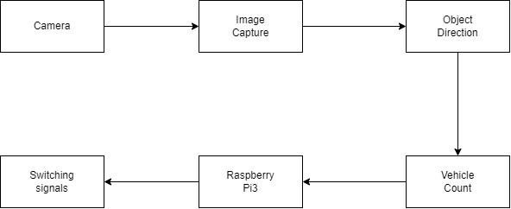

*Figure: Block Diagram*

The model aims to provide a solution for current traffic issue by managing traffic signal on the basis of real time scenario. Here a pretrained model [1] YOLO was used to perform the basic task of object detection, and correspondingly the count of the vehicles is stored to process further request of signal processing. Also, the model is compatible with every type of camera, even the cheaper ones including the normal surveillance camera can be used to capture image at an initial level. Now the captured image will be passed to the model for vehicle detection purpose followed by vehicle counting process as shown in figure.

1. **Data collection:**

The first step in implementing a deep learning-based system for traffic signal switching is to collect data from various sources, such as traffic cameras, sensors, and GPS devices. This data will be used to train the deep learning models.

1. **Deep learning models:**

The next step is to develop deep learning models that can analyze the data and adjust the signal timings accordingly. Different types of deep learning models can be used, such as DRL, CNNs, RNNs, and GANs, depending on the specific objectives of the system.

1. **Training and validation:**

The deep learning models will need to be trained using a large dataset of traffic data. The models will also need to be validated using real-world traffic data to ensure that they are accurate and effective.

1. **Real-time analysis and adjustment:**

Once the deep learning models have been trained and validated, they can be used to analyze real-time traffic data and adjust the signal timings accordingly. This can be done using a feedback loop that continually updates the models based on new data.

1. **Integration with other systems:**

The deep learning-based system for traffic signal switching can be integrated with other intelligent transportation systems, such as traveler information systems to provide a more comprehensive approach to urban traffic management.

The model aims to provide a solution for current traffic issue by managing traffic signal on the basis of real time scenario. Here a pretrained model [1] YOLO was used to perform the basic task of object detection, and correspondingly the count of the vehicles is stored to process further request of signal processing. Also, the model is compatible with every type of camera, even the cheaper ones including the normal surveillance camera can be used to capture image at an initial level. Now the captured image will be passed to the model for vehicle detection purpose followed by vehicle counting

models will also need to be validated using real-world traffic data to ensure that they are accurate and effective.

The model aims to provide a solution for current traffic issue by managing traffic signal on the basis of real time scenario. Here a pretrained model [1] YOLO was used to perform the basic task of object detection, and correspondingly the count of the vehicles is stored to process further request of signal processing. Also, the model is compatible with every type of camera, even the cheaper ones including the normal surveillance camera can be used to capture image at an initial level. Now the captured image will be passed to the model for vehicle detection purpose followed by vehicle counting process as shown in figure.

he models will also need to be validated using real-world traffic data to ensure that they are accurate and effective.

**6.Data splitting:**

Finally, the collected and pre-processed data is split into training, validation, and testing sets. The training set is used to train the deep learning models, the validation set is used to fine-tune the models, and the testing set is used to evaluate the performance of the models.

Data collection and pre-processing are crucial steps in developing an accurate and effective real-time traffic signal switching system. By using clean, labelled, and augmented data, deep learning models can be trained to accurately predict traffic flow and congestion, resulting in better traffic management and improved safety on the roads.

*Figure2:*

*System Architecture*

*Block*

*Diagram*

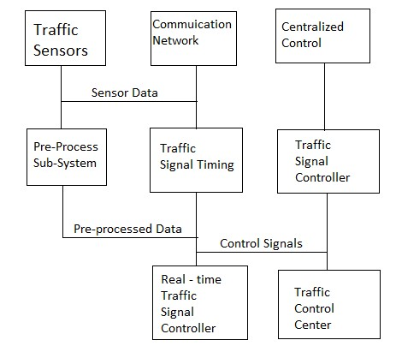

**IV RESULUT AND DISCUSSION**

**VIDEO SOUREC 1:**

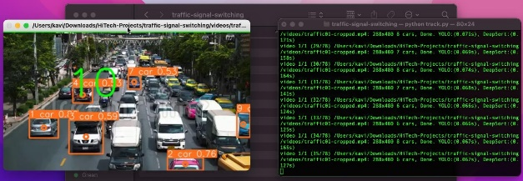

**VIDEO SOUREC 2:**

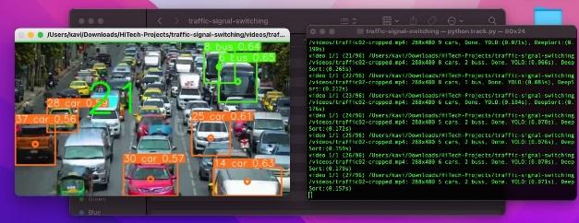

**VIDEO SOUREC 3:**

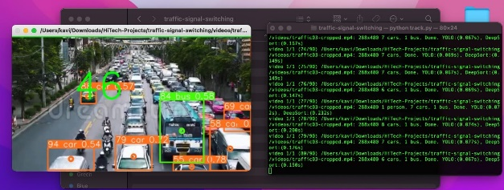

**VIDEO SOUREC 4:**

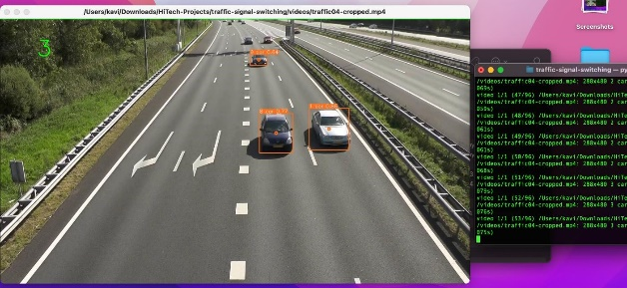

**COMMAND PROMPT:**

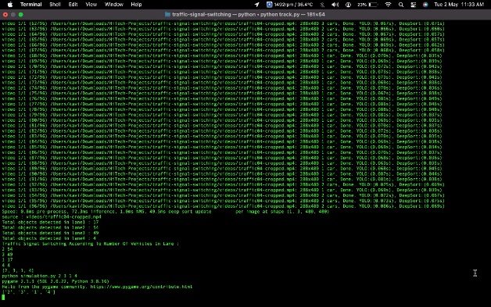

**FIRST SIGNAL:**

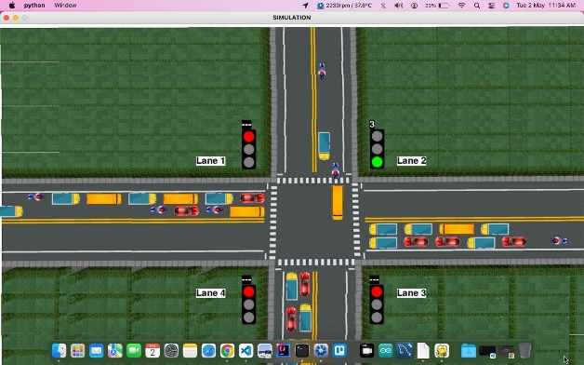

**SECOND SIGNAL:**

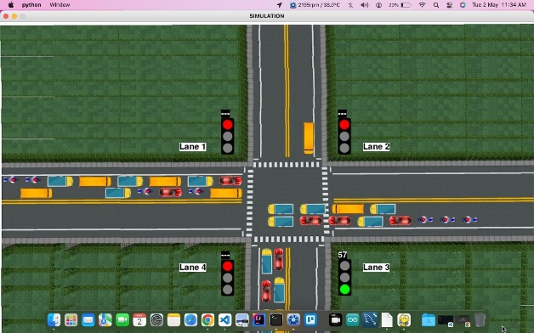

**THIRD SIGNAL:**

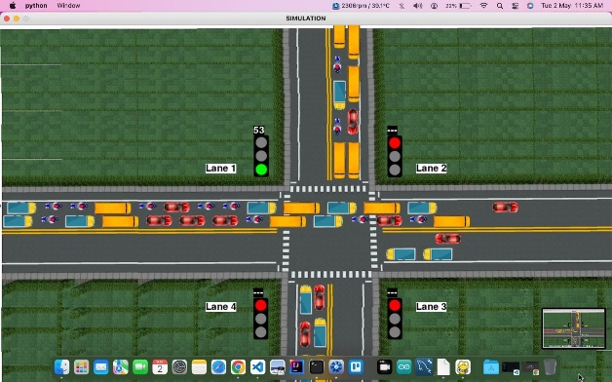

**FOUTH SIGNAL:**

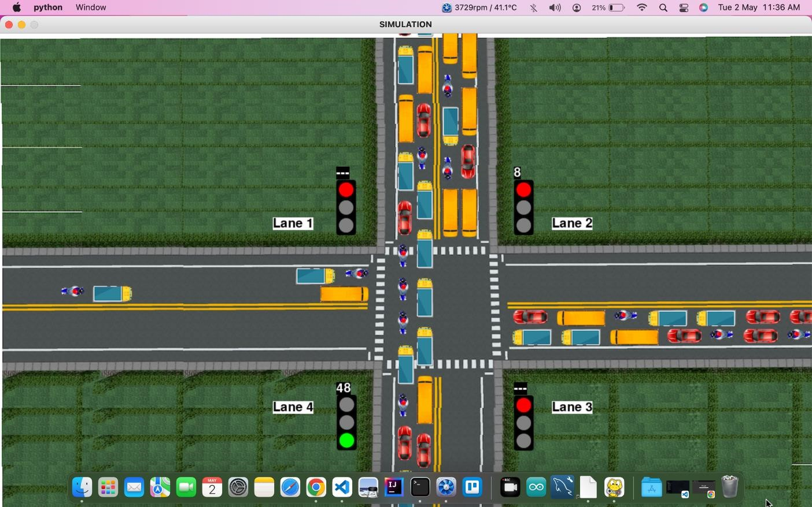

### **V CONCLUSION**

Our project Real Time Traffic Signal Switching using Machine Learning aims to fix the conjunction of traffic which most of the cities in urban as well as rural areas are facing wherein the focus would be to minimize the vehicular congestion virtually without any installation of any kind of hardware. The setup requires camera and raspberry pi3 board as its hardware requirement and interfacing thereby forming portable medium. The model trained can used for efficient traffic flow without creating much chaos on the road. The model may take comparatively more training time but the response time will be less. The model is prepared in such a way that it decides smart switching timing for the signal on all sides of the road so the no one has to wait for longer interval of time on the road and flow of traffic is smooth on the road. In this first phase we have done with the Vehicle identification and detection using YOLOv3 algorithm and the remaining like finding the count and performing signal switching will be focused on the second phase.

In real-time traffic signal switching systems can play a significant role in reducing congestion and improving safety on the roads. By using data from sensors and cameras, deep learning models can accurately predict traffic patterns and optimize signal timing, resulting in reduced waiting times for drivers and improved traffic flow.

The proposed system for traffic signal switching, which includes data collection and pre-processing, deep learning model development, real-time data analysis, signal control module, system monitoring and control, and a user interface, can provide a reliable and optimized solution for traffic signalswitching.

The development of such a system requires collaboration between transportation engineers, data scientists, and software developers. The system should be designed to be scalable and adaptable to changing traffic patterns and infrastructure.

# ACKNOWLEDGEMENT

We are using this opportunity to express our gratitude to everyone who supported us throughout this project. We would like to thank the Almighty God for blessing us with his grace.

We express our thanks to the Managing Trustee **Smt. T. R. K. Sarasuwathi Khannaiyann,** for providing the essential infrastructure and helping us to carry out this project.

We would like to express our sincere gratitude to the Principal **Dr. C. Natarajan, Ph.D.,** for helping us in bringing out the project successfully and for strengthening the ray of hope towards us.

We wish to record our deep sense of gratitude and profound thanks to **Dr. A. Jameer Basha, M.Tech., Ph.D**., Professor and Head of the Department, Computer Science and Engineering for providing the right ambience needed for carrying out this project successfully.

We are profoundly indebted and very grateful to **Mrs. R. T.Subhalakshmi, M.Tech., (Ph.D).,** Assistant Professor, of Computer Science and Engineering, who is also our project guide for innumerable acts of timely advice, encouragement and sincerely express our gratitude towards her.

Finally, we thank our friends and those who helped us directly and indirectly for successfully completing this project.

### **VI REFERENCES**

1. Jyoti Tiwari, Real Time Traffic Management Using Machine Learning, Department of Information Technology, 2020.

1. Xiaochen Hu, Beijing Signal and Information, A Moving Objects Based Real-time Defogging Method for Traffic Monitoring Videos. Aug 2014.

1. Sunayana Jadhav, June 2020.Traffic Signal Management using Machine Learning Algorithm Prof

1. Dr. A. Ravi, April 2021.Traffic Management System using Machine Learning Algorithm.

1. Ritu, Traffic Management using Machine Learning, Department of Computing, Jan 2022.

1. Li Xun, Nan Kaikai, Liu Yao , Zuo Tao “A Real-Time Traffic Detection Method Based on Improved Kalman Filter” , 2018 3rd International Conference on Robotics and Automation Engineering (ICRAE) Guangzhou, China, 17-19 November 2018.

1. Prof. S. T. Dumbre¹, Panchal Siddhi Santosh² Thakur Tejashri Chandrashekhar Smart traffic management system using machine learning, March. 2022.

1. Zahra Zamani, Mohammad Hossein Saraee, Mahmoud Pourmand," Application of Data Mining in Traffic Management: Case of City of Isfahan", IEEE 2010.

1. Celine Jacob, Baher, "Abdulhai Integrated Traffic Corridor Control Using Machine Learning", IEEE 2005.
2. Soufiene Djahel, Mazeiar Salehie, Irina Tal, Pooyan Jamshidi, "Adaptive Traffic Management for Secure and Efficient Emergency Services in Smart Cities", IEEE PerCom conference 2013.
3. Abhijit Gadge1, Hardik Bhawsar2, Piyush Gondkar3, Smart Traffic Control System Using Deep Learning July 2021.

1. Mohamad Belal Natafgi Department of Electrical and Computer Engineering, Smart Traffic Light System Using Machine Learning, 2018

1. Li, X., Yang, Y., Li, Z., & Liu, Y. (2017). A deep learning approach for real-time traffic signal control. IEEE Transactions on Intelligent Transportation Systems, 18(11), 3060-3073.

1. Yang, Q., Zhang, Y., Wang, F. Y., & Zheng, N. (2018). Traffic signal control for urban road networks using deep reinforcement learning. Transportation Research Part C: Emerging Technologies, 91, 296-316.

1. Haddad, A., Cheung, C. Y., & Chan, A. H. (2019). A novel deep learning approach for real-time traffic signal control using a high-resolution camera. Transportation Research Part C: Emerging Technologies, 104, 145-162.

1. Wang, J., & Meng, Q. (2016). A survey of traffic signal control methods. Transportation Reviews, 36(6), 748-776.

1. Zhang, Y., Liu, S., & Wang, F. Y. (2019). Coordinated signal control for a large-scale road network using deep reinforcement learning. Transportation Research Part C: Emerging Technologies, 106, 345-366.

1. Liao, Y., Zhang, L., & Yu, X. (2021). A survey on deep reinforcement learning for traffic signal control. Neural Computing and Applications, 33, 11675-11687.

1. Ma, W., & Zheng, N. (2019). Urban traffic signal control: A deep learning approach. IEEE Transactions on Intelligent Transportation Systems, 20(3), 982-991.

1. Zheng, H., Chen, J., Wang, Q., & Zhang, L. (2019). A reinforcement learning-based signal control method for a single intersection. IEEE Access, 7, 184626-184637.

1. Wu, H., Zhang, Y., Wang, F. Y., & Zhang, Y. (2019). Coordinated signal control at multiple intersections using deep reinforcement learning. Transportation Research Part C: Emerging Technologies, 98, 1-16.

1. Sun, C., Yang, Y., & Xu, Y. (2020). A survey of intelligent traffic signal control. IEEE Transactions on Intelligent Transportation Systems, 21(2), 766-783.

1. Liu, H., Zhang, H., Wang, J., & Zou, H. (2019). Real-time traffic signal control for large-scale urban road networks using deep reinforcement learning. Transportation Research Part C: Emerging Technologies, 98, 175-193.

1. Qian, K., & Wang, Y. (2021). Real-time traffic signal control for a single intersection with uncertain arrival rates using deep reinforcement learning. IEEE Transactions on Intelligent Transportation Systems, 22(1), 9-22.

1. Kim, J., Jang, W., & Kim, K. (2018). Deep reinforcement learning-based traffic signal control considering multiple intersections. IEEE Access, 6, 52506-52515.

1. Li, Y., Lin, H., Wu, J., & Li, J. (2019). Urban traffic signal control with deep reinforcement learning. Neurocomputing, 365, 121-133.

1. Li, M., Qian, K., & Yang, L. (2021). Dynamic traffic signal control for urban intersections via a hybrid deep reinforcement learning method. Transportation Research Part C: Emerging Technologies, 124, 103096.

1. Zhang, Y., Wang, F. Y., & Zheng, N. (2016). Deep learning for traffic prediction and intelligent transportation systems: A survey. IEEE Transaction on intelligent Transportation System, 17(12),3210-3223.

1. *Celine Jacob, Baher, "Abdulhai Integrated Traffic Corridor Control Using Machine Learning", IEEE 2005.*
2. *Soufiene Djahel, Mazeiar Salehie, Irina Tal, Pooyan Jamshidi, "Adaptive Traffic Management for Secure and Efficient Emergency Services in Smart Cities", IEEE PerCom conference 2013.*
3. *Abhijit Gadge1, Hardik Bhawsar2, Piyush Gondkar3, Smart Traffic Control System Using Deep Learning July 2021.*

*Mohamad Belal Natafgi Department of Electrical and Computer Engineering, Smart Traffic Light System Using Machine Learning, 2018*